**Lab Report: 209L – 01 Ngyuen**

**Gene Drumheller**

**Experiment 3**

**Transfer Functions**

**Objectives:** To measure the RC circuit, and calculate its transfer function.

**Equipment’s Used:**

* Oscilloscope
* AC Voltage Generator
* Multimeter
* Capacitor-Inductor Meter
* Clip leads
* BNC Cables
* Resistor (1kΩ and 10kΩ)
* Capacitor (0.1µF and 1µF)
* Unknown RC circuit

**Prelab:**

Question #1:

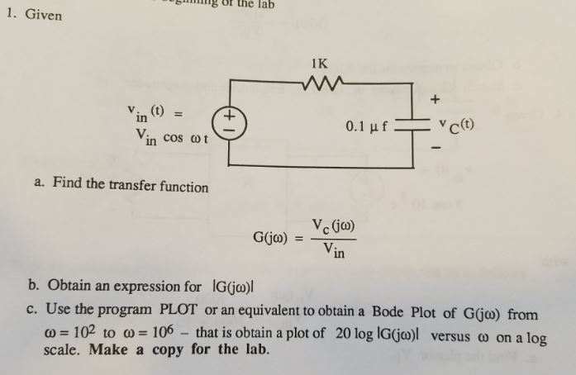

$$Nodal Analysis at Vc: \frac{V_{c}-V_{in}}{1k}+\frac{1}{\frac{1}{jw{10}^{-7}}}=0$$

$$Simpilify: \left(1+jw{10}^{-4}\right)V_{c}=V_{in}$$

$$G\left(jw\right)=\frac{V_{c}(jw)}{V_{in}}=\frac{1}{1+jw{10}^{-4}}$$

$$\left|G\left(jw\right)\right|=\frac{1}{\sqrt{1^{2}+{\left(w{10}^{-4}\right)}^{2}}}$$

Magnitude = 20 log (G(jw))

w = 100, Mag = -0.00043, θ = -0.573°

w = 1000, Mag = -0.04321, θ = -5.711°

w = 10000, Mag = -3.0103, θ = -45.0°

w = 100000, Mag = -20.0432, θ = -84.29°

w = 1000000, Mag = -40.004, θ = -89.42

Question #2:

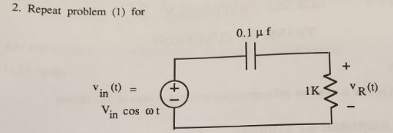

$$Nodal Analysis: \frac{V_{r}-V_{in}}{\frac{1}{jw{10}^{-7}}}+\frac{V_{r}}{1k}=0$$

$$Simplify: \left(1+jw{10}^{-4}\right)V_{r}=jw{10}^{-4}V_{in}$$

$$G\left(jw\right)= \frac{V_{r}}{V_{in}}= \frac{jw{10}^{-4}}{1+jw{10}^{-4}} \\ \left|G\left(jw\right)\right|= \frac{\sqrt{{\left(jw^{-4}\right)}^{2}}}{\sqrt{1^{2}+{\left(jw^{-4}\right)}^{2}}}$$

Magnitude = 20 log (G(jw))

W = 100, Mag = -40db θ = 89.42°

W = 1000, Mag = -20.04 dB θ = 84.28°

W= 10000, Mag = -3.01 dB θ = 45.0°

W = 100000, Mag = -0.04 dB θ = 5.71°

W = 1000000, Mag = -0.00043dB θ = 0.573°

Question #3:

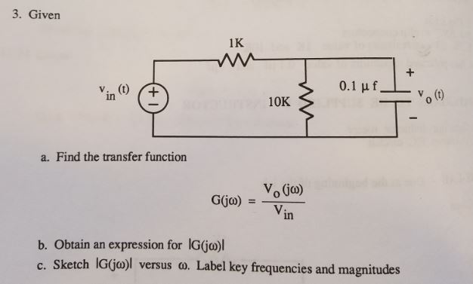

$$Nodal Analysis: \frac{V_{o}-V_{in}}{1k}+ \frac{V_{o}}{10k}+\frac{V_{o}}{\frac{1}{jw{10}^{-7}}}=0$$

$$Simplify: \left(11+ jw{10}^{-3}\right)V_{o}=10V_{in}$$

$$G\left(jw\right)= \frac{V_{o}}{V_{in}}= \frac{10}{11+jw{10}^{-3}}$$

$$\left|G\left(jw\right)\right|=\frac{10}{\sqrt{{11}^{2}+{\left(jw{10}^{-3}\right)}^{2}}}$$

Question #4:

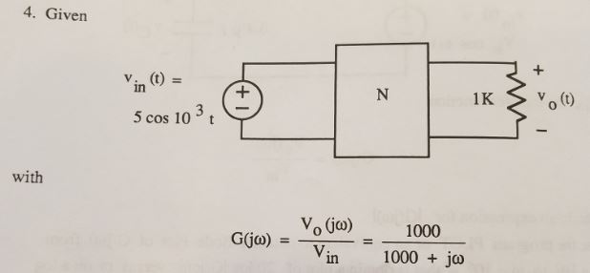

1. Find the Phasor Vin
2. Find Vo(j1000)
3. Find the Steady state Vo(t)
4. 5∠0° V
5. 3.526cos(10^3 - 45°)V
6. Steady state = 0V

**Lab Procedure:**

**Part 1**:

Measure your resistor and capacitor values:

Measured resistor value 1 = 380.0Ω

Nominal resistor value 1 = 390.0Ω

%difference = $\frac{380-390}{390} x 100 \%= -2.564\%$

Measured capacitor value 1 = 32.6nF

Nominal capacitor value 1 = 33.8nF

%difference = $\frac{0.326-0.338}{0.338} x 100 \%= -3.55\%$

Measured capacitor value 2 = 34.6nF

Nominal capacitor value = 33.8nF

%difference = $\frac{.346-.338}{.338} x 100 \%= 2.367\%$

Capacitor combination in serial = 16.8nF

Nominal value = 16.9nF

%difference = $\frac{.168-.169}{.169} x 100 \%= -0.592\%$

Nominal value Inductor = 10mH

Table 1: Measurement of tools

|  |  |  |  |
| --- | --- | --- | --- |
|  | Measured | Nominal | %difference |
| Resistor | 380.0Ω | 390.0Ω | -2.564% |
| Capacitor | 16.8nF | 16.9nF | -0.592% |
| Inductor | - | 10 mH |  |

**Part2:**

Circuit 1:

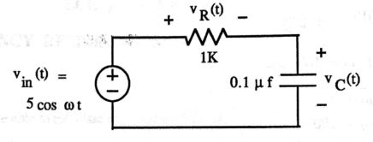

DATA FROM PREVIOUS LAB:

Given: Input voltage will always remain Vp = 5V or Vpp = 10V in this lab.

$$Angular Frequencies W used \left(\frac{rad}{seconds}\right)={10}^{2}, {10}^{3}, {10}^{4}, {10}^{5},{10}^{6}$$

$$Frequency used=\left(\frac{w}{2π}\right)=15.9Hz, 159Hz, 1590Hz, 15.9kHz, 159kHz$$

Table 2: Data from previous lab

|  |  |  |  |  |
| --- | --- | --- | --- | --- |
| Vin = | Frequency | Omega (w) | Vc(t) | Vr(t) |
| 5 Vp | 15.9Hz | 10^2 rad/s | 4.95 cos (2π15.9t - 0.6°)V | 0.095 cos (2π15.9t – 105.2°)V |
| 5 Vp | 159Hz | 10^3 rad/s | 4.95 cos (2π159t – 5.5°)V | 0.51 cos (2π159t – 94.4°)V |
| 5 Vp | 1590Hz | 10^4 rad/s | 3.5 cos (2π1590t – 42.8°)V | 3.355 cos (2π1590t – 134.5°)V |
| 5 Vp | 15.9kHz | 10^5 rad/s | 0.565 cos (2π15.9kt – 81.76°)V | 5 cos (2π15.9kt – 174.73°)V |
| 5 Vp | 159kHz | 10^6 rad/s | 0.09 cos (2π159kt – 86.8°)V | 5.05 cos (2π159kt – 179.4°)V |

$$Gc\left(s\right)= \frac{Output}{Input}= \frac{1}{\sqrt{1+w^{2}{10}^{-8}}}$$

$$Input*Gc\left(s\right)=Output$$

$$5* \frac{1}{\sqrt{1+w^{2}{10}^{-8}}}=V_{c}$$

Table 3: % difference from calculation and lab measurement

|  |  |  |
| --- | --- | --- |
| Frequency (w) | Vc (5 * Transfer function) | % difference |
| 10^2 rad/s | 4.999 V | 0.98% |
| 10^3 rad/s | 4.975 V | 0.51% |
| 10^4 rad/s | 3.536 V | 1.03% |
| 10^5 rad/s | 0.498 V | -11.86% |
| 10^6 rad/s | 0.05 V | -44.44% |

**(Part 3 skipped in this lab)**

**Part4:**

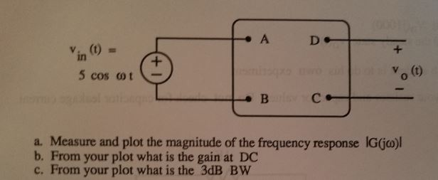

Given: Input voltage will always remain Vp = 5V or Vpp = 10V in this lab.

$$Angular Frequencies W used \left(\frac{rad}{seconds}\right)={10}^{2}, {10}^{3}, {10}^{4}, {10}^{5},{10}^{6}$$

$$Frequency used=\left(\frac{w}{2π}\right)=15.9Hz, 159Hz, 1590Hz, 15.9kHz, 159kHz$$

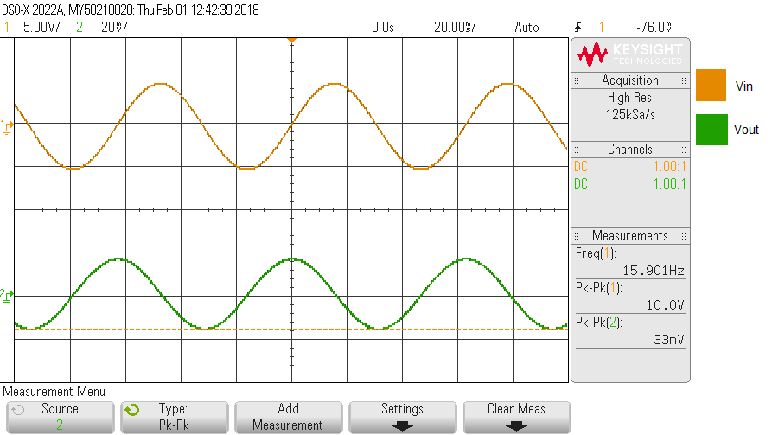

Graph 1: Measurements of Vin(t) and Vout(t) at F = 15.9Hz

Vin(t) = 10.0Vpp, Vin(t) = 5.0 cos (2π15.9t + 0°)V

Vout(t) = 0.033Vpp

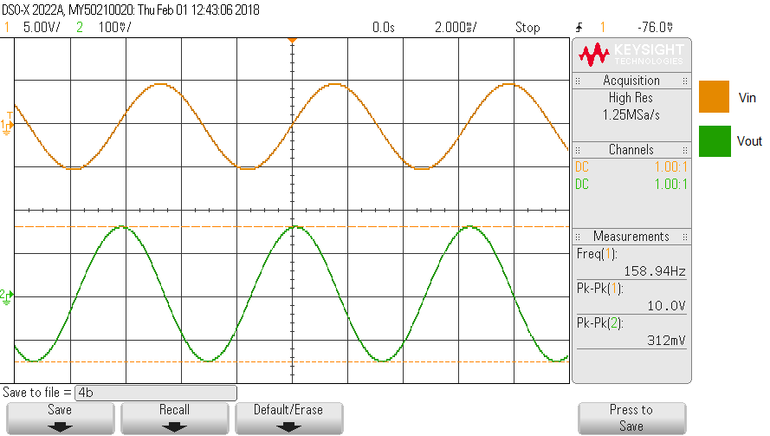

Graph 2: Measurements of Vin(t) and Vout(t) at F = 159Hz

Vin(t) = 10.0Vpp, Vin(t) = 5.0 cos (2π159t + 0°)V

Vout(t) = 0.312Vpp

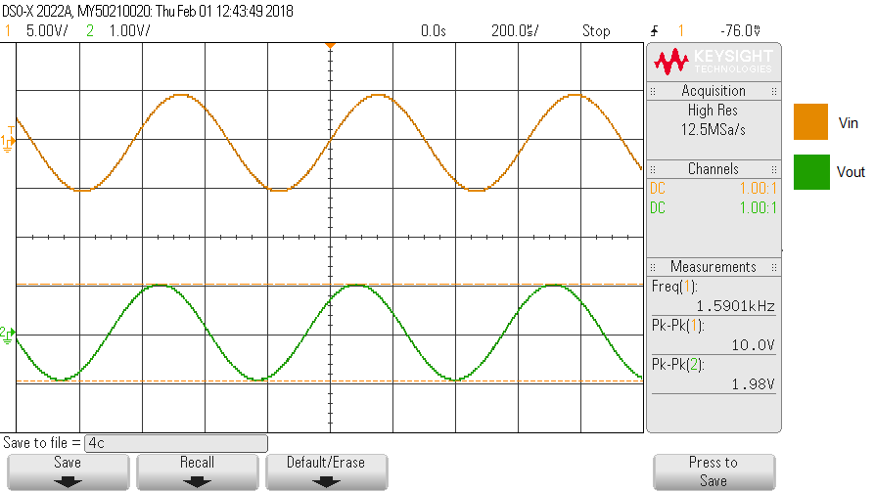

Graph 3: Measurements of Vin(t) and Vout(t) at F = 1590Hz

Vin(t) = 10.0Vpp, Vin(t) = 5.0 cos (2π1590t + 0°)V

Vout(t) = 1.98Vpp

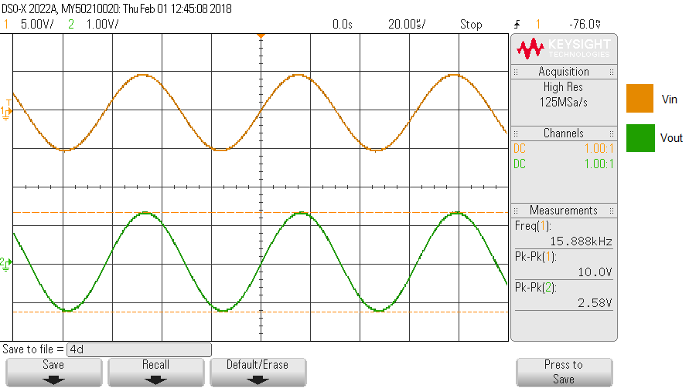

Graph 4: Measurements of Vin(t) and Vout(t) at F = 15.9kHz

Vin(t) = 10.0Vpp, Vin(t) = 5.0 cos (2π15.9kt + 0°)V

Vout(t) = 2.58Vpp

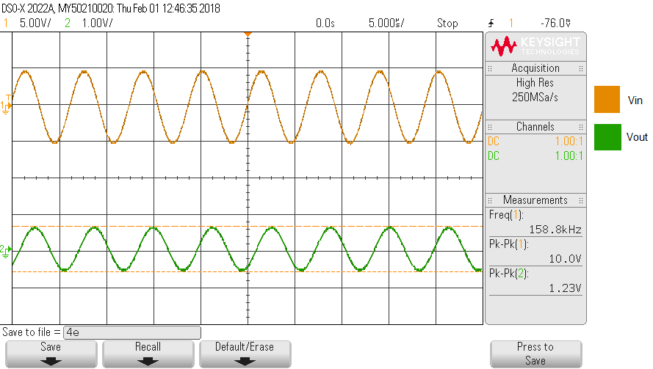

Graph 5: Measurements of Vin(t) and Vout(t) at F = 159kHz

Vin(t) = 10.0Vpp, Vin(t) = 5.0 cos (2π159kt + 0°)V

Vout(t) = 1.23Vpp

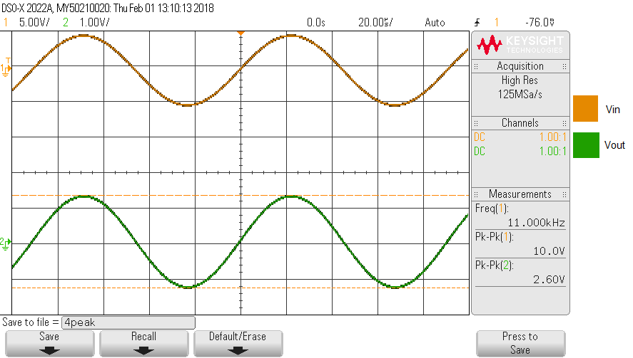

Graph 6: Measurements of Vin(t) and Vout(t) at F = 11.0kHz

Vin(t) = 10.0Vpp, Vin(t) = 5.0 cos (2π11kt + 0°)V

Vout(t) = 2.60Vpp, Peak voltage of the circuit

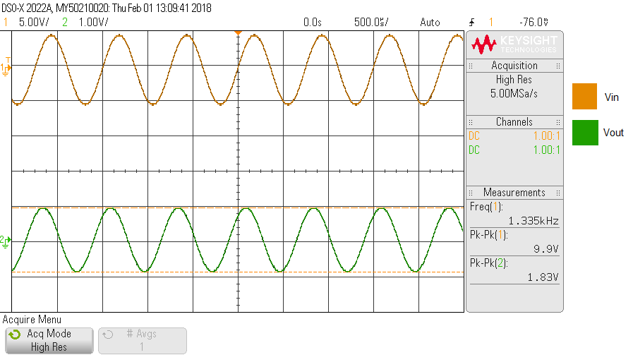

Graph 7: Measurements of Vin(t) and Vout(t) at F = 1.335kHz

Vin(t) = 10.0Vpp, Vin(t) = 5.0 cos (2π1335kt + 0°)V

Vout(t) = 1.83Vpp, Lower end of 3dB

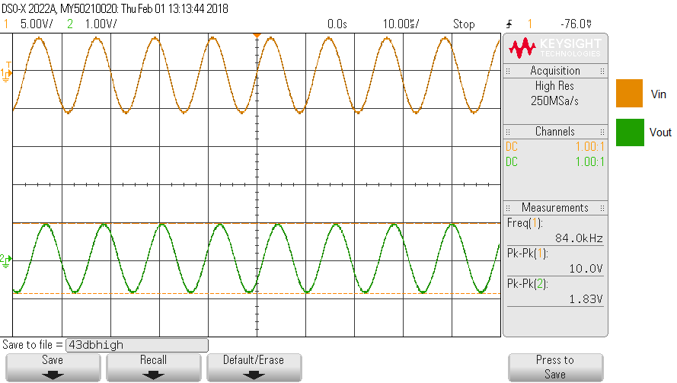

Graph 8: Measurements of Vin(t) and Vout(t) at F = 84.0kHz

Vin(t) = 10.0Vpp, Vin(t) = 5.0 cos (2π84kt + 0°)V

Vout(t) = 1.83Vpp, Higher end of 3dB

Table 4: Data of Part 4

|  |  |  |
| --- | --- | --- |
| Frequency | Vin | Vout |
| 15.9 Hz | 10 Vpp | 0.033 Vpp |
| 159 Hz | 10 Vpp | 0.312 Vpp |
| 1590 Hz | 10 Vpp | 1.98 Vpp |
| 15.9k Hz | 10 Vpp | 2.58 Vpp |
| 159k Hz | 10 Vpp | 1.23 Vpp |
| 11.0k Hz (F of Peak voltage) | 10 Vpp | 2.60 Vpp (Peak voltage) |
| 1.335k Hz (F of lower end 3dB) | 10 Vpp | 1.83 Vpp (Lower end 3dB Volt) |
| 84.0k Hz (F of higher end 3dB) | 10 Vpp | 1.83 Vpp (Higher end 3dB Volt) |

Graph 9: Plotting the data of Lab procedure part 4

The Gain at DC = V15.9Hz / Vin = 0.033 / 10 = 0.0033

BW = (W2 – W1 ) = 165330π

**Part 5:**

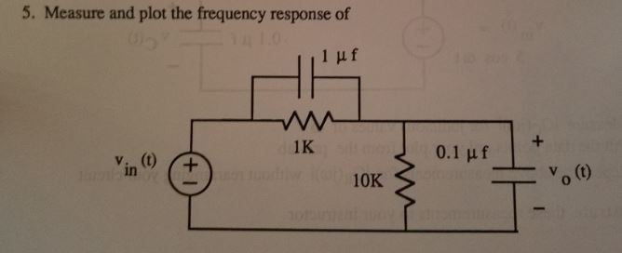

Given: Input voltage will always remain Vp = 5V or Vpp = 10V in this lab.

$$Angular Frequencies W used \left(\frac{rad}{seconds}\right)={10}^{2}, {10}^{3}, {10}^{4}, {10}^{5},{10}^{6}$$

$$Frequency used=\left(\frac{w}{2π}\right)=15.9Hz, 159Hz, 1590Hz, 15.9kHz, 159kHz$$

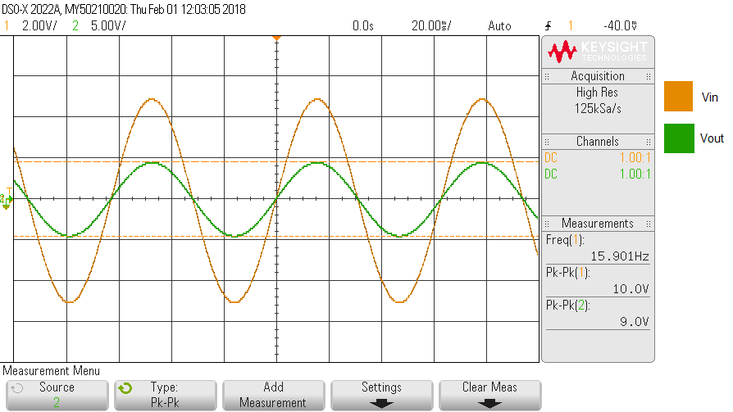

Graph 10: Measurements of Vin(t) and Vout(t) at F = 15.9kHz

Vin(t) = 10.0Vpp, Vin(t) = 5.0 cos (2π15.9kt + 0°)V

Vout(t) = 9.0Vpp

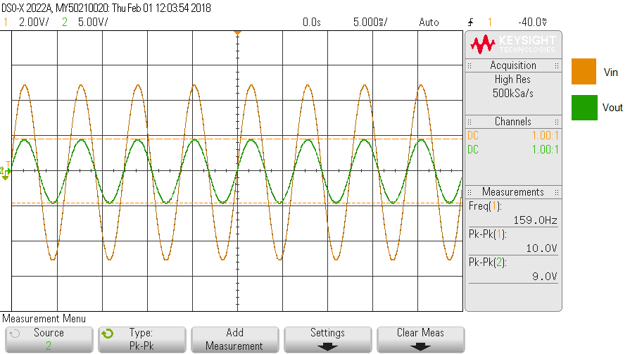

Graph 11: Measurements of Vin(t) and Vout(t) at F = 159kHz

Vin(t) = 10.0Vpp, Vin(t) = 5.0 cos (2π159kt + 0°)V

Vout(t) = 9.0Vpp

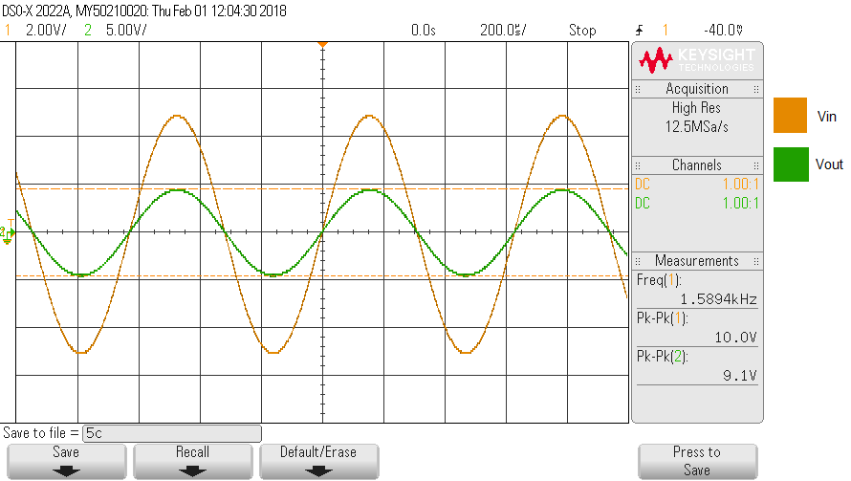

Graph 12: Measurements of Vin(t) and Vout(t) at F = 1590kHz

Vin(t) = 10.0Vpp, Vin(t) = 5.0 cos (2π1590kt + 0°)V

Vout(t) = 9.1Vpp

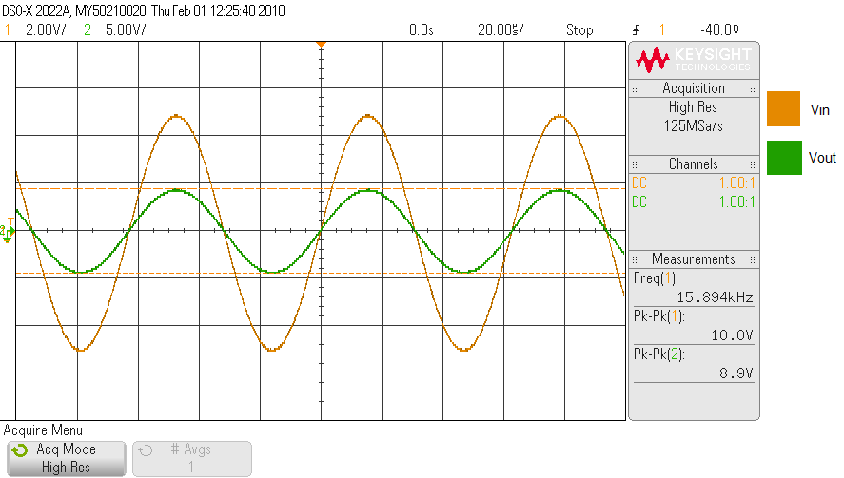

Graph 13: Measurements of Vin(t) and Vout(t) at F = 15.9kHz

Vin(t) = 10.0Vpp, Vin(t) = 5.0 cos (2π15.9kt + 0°)V

Vout(t) = 8.9Vpp

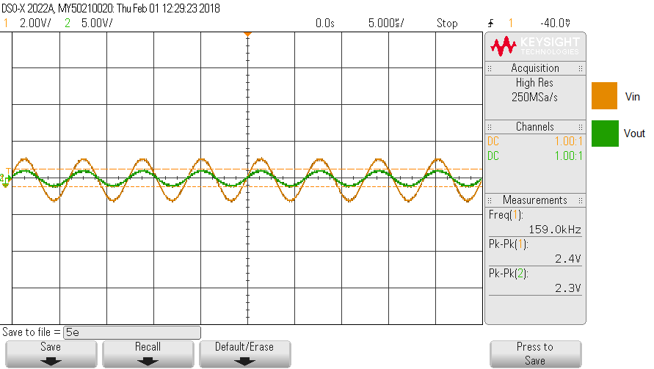

Graph 14: Measurements of Vin(t) and Vout(t) at F = 159kHz

Vin(t) = 2.4Vpp, Vin(t) = 1.2 cos (2π159kt + 0°)V

Vout(t) = 2.3Vpp

The Input voltage cannot go any higher than 2.4V.

Table 5:

|  |  |  |
| --- | --- | --- |
| Frequency | Input Voltage | Vout |
| 15.9 Hz | 10 Vpp | 9.0 Vpp |
| 159 Hz | 10 Vpp | 9.0 Vpp |
| 1590 Hz | 10 Vpp | 9.1 Vpp |
| 15.9 k Hz | 10 Vpp | 8.9 Vpp |
| 159 k Hz | 2.4 Vpp | 2.3 Vpp |

**Post Lab**

1. For the circuit of problem 2 of the lab, compare your experimental and predicted value for the 3dB frequency.

Measured value: 1623.7Hz

Calculated value: $3.5dB=20\log{\sqrt{1+w^{2}{10}^{-8}}}… w=11129.78\frac{rad}{s}→\frac{w}{2π}=1771.36 Hz$

% difference 9.094%

1. For the circuit of problem 5 of the lab, how did the gain depend on frequency

Gain did not depend on frequency, since all the G(s) = Vout / Vin = 0.9

1. Sketch |G(jw)| = |Vc(jw)/Vin|
   1. Sketch on the same graph if C increases
   2. If C decreases
2. S

$G\left(s\right)= \frac{Vo}{Vin}=\frac{6\cos\left({10}^{5}t-\frac{π}{4}\right)}{5cos{10}^{4}t+3cos{10}^{5}t}$