Inheritance继承

Superset超集

**Class relationship: Is-A**

Employee 🡨 Manager

**Base class/super class/ Parent** **derived class/sub/ child class**

#include <iostream>

using namespace std;

class A{

int i;

public:

A(): i(0){}

~A() {cout << “A::~A()” << endl;}

void set(int i) { this.i =i;}

}

class B: public A{

public:

void f(){

set(20);

i = 30;

print();

}

};

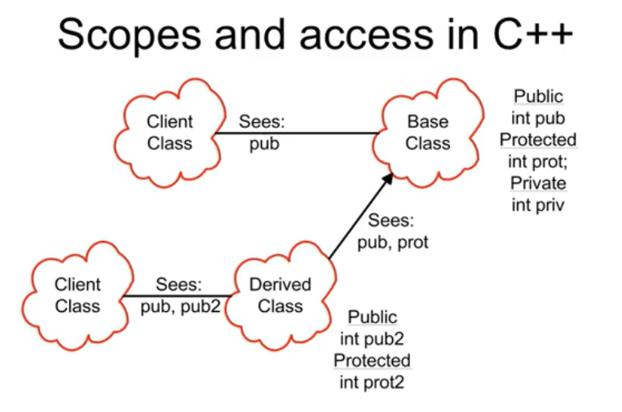

基类、子类、使用者