**Lecture 1 | Introduction to Convolutional Neural Networks for Visual Recognition**

What is this class?

* Computer vision
* Uses visual data

Computer vision

* Used in physics, biology, engineering, mathematics, computer science

History of computer vision

* Evolution’s big bang
  + Specific short term of time when # of species were ‘exploded’.
* Camera Obscura
  + Pin hole camera theory
  + Similar to early animals’ eye
* Hubel & Wiesel, 1959
  + To find neural response mechanism or visual recognition mechanism of mammals
  + Stick electrode in cat’s brain & checked what made neuron respond excited
  + Simple cells, responded in specific moving direction
* Block world
  + Reconstruct the structure
  + “The summer vision project”
* How can we recognize structure?
  + Generalized cylinder
  + Pictorial structure
* If object recognition is too hard, maybe we should first do object segmentation
  + Task of taking image and group the pixels into meaningful areas
  + **“Image Segmentation”**
* Face detection
  + AdaBoost to do real-time face recognition
* “SIFT” feature
  + SIFT & object recognition, David Lowe, 1999
* PASCAL visual object challenge (2006~2012)
  + 20 object categories
* ImageNet / ImageNet large scale visual recognition challenge
  + to recognize the objects / overcome the ML bottleneck of overfitting, ImageNet project is launched.
  + Error rate decreased, and made lower error(3.57%) than human(5%)

Goal of this course

* Learn about Convolutional Neural Network
* Focuses on image classification
* Object detection, image captioning

Difference of 1990’s and 2010’s

* # of transistors(speed of computation)
* # of labeled data

**Lecture 2 | Image Classification**

Image classification: a core task in computer vision

* Assume given set of discrete labels and recognize the object
* Image is just a big grid of numbers between [0,255] for 3 channels RGB
* Problem: semantic gap
  + Computer may recognize pixels, but don’t understand that the pixels are for one same object. We need ML to make computer learn this pattern and recognize the pattern
  + Pixel-level to semantic-level
* Challenges
  + Viewpoint variation: tilting camera
  + Illumination: different light condition
  + Deformation: cat’s various position
  + Occlusion: we can see only a part of cat
  + Background clutter: cat’s color may similar to environment
  + Intraclass variation: cat has various color and age(representation)
* Algorithm is unlike simple sorting numbers
* No obvious way to hard-code the algorithm for recognizing a cat, or other classes

Attempts have been made

* Find edges and corners
  + Edge is one of important point to classify objects
    - Doesn’t work well: brittle and have to start all over again for other objects
* Data-driven approach
  + 1. Collect a dataset of images and labels
  + 2. Use machine learning to train a classifier
  + 3. Evaluate the classifier on new images
  + Has two key modules: train, predict
  + First classifier: nearest neighbor
    - Train: memorize all data and labels
    - Predict: predict the label of the most similar training image
  + Example dataset: CIFAR10
    - 10 classes, 50k training images, 10k testing images

**K-nearest neighbors**

How to compare images? – Distance metric to compare images

* L1 distance (Manhattan)
  + Comparing single pixel of images
  + Add pixel-wise absolute value differences
* With N examples, how fast are training and prediction?
  + Train O(1), predict O(N)
  + Not good: we want fast at prediction. Slow for training is okay
* K-nearest neighbors
  + Instead of copying label from nearest neighbor, take majority vote from K closest points
  + If K is big, tends smother edges

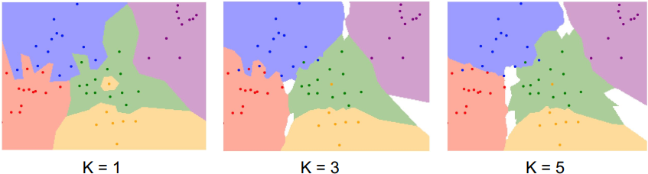

* L2 distance (Euclidean)

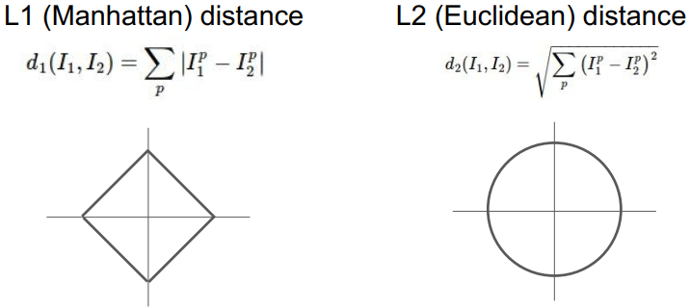

* L1 and L2 distance
  + L1 depends on choice of coordinate system
  + If we rotate the coordinate frame, L1 distance changes but L2 doesn’t.
  + If the input features or individual entries in vector has some important meaning for task, L1 distance is a natural fit
  + If the input vector is a generic vector in some space and don’t know which of the different elements does actually mean, L2 distance is a natural fit.
* K-nearest neighbors with L1/L2 distance
  + Boundaries changes slightly for each method.

Hyperparameters

* What is the best value of **k** to use?
* What is the best **distance** to use?
* Hyperparameter: k and distance, choices about the algorithm that we set rather than learn
* Problem dependent, must try them all out and see what works best

Setting hyperparameters

* Idea 1: choose hyperparameters that works best on the data
  + Very bad idea: k=1 always works perfectly on training data
  + If the k gets bigger, it might cause us to misclassify some of the training data.
  + But it leads to better performance on the data which were not in training data
  + Ultimately, we really care about how our classifier or method performs on unseen data out of training data.
* Idea 2: split data into train and test, choose hyperparameters that work best on test data
  + Seems more reasonable, but also a terrible idea.
  + No idea how algorithm will perform on new data
* Idea 3: split data into train, validation, test and choose hyperparameters on val and evaluate on test
  + Try many hyperparameters at the training set and evaluate on validation set. Choose hyperparameters that best for the validation set, and run once on the test set.
  + Better method
* Idea 4: cross-validation; split data into folds, try each fold as validation and average the results

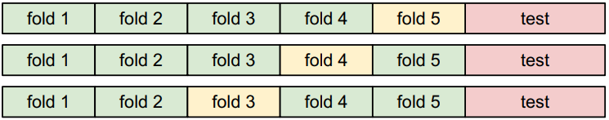

* + Change validation sets for each fold
  + Useful for small datasets, but not used too frequently in deep learning

k-nearest neighbor on images never used

* Very slow at test time
* Distance metrics on pixels are not informative
* Curse of dimensionality: needs more dots for bigger dimensions(grows exponentialy)

k-nearest neighbors: summary

* In image classification, we start with a training set of images and labels, and must predict labels on the test set
* The k-nearest neighbors classifier predicts labels based on nearest training examples
* Distance metric and k are hyperparameters
* Choose hyperparameters using the validation set; only run on test once at the very end

**Linear classification**

Parametric approach

* Recall CIFAR10; 50k different image with 32*32*3
* Input data: image, array of 32*32*3 numbers (3072 numbers total)
* Make function of input data and parameters or weights(W)
* Output: 10 numbers giving class scores

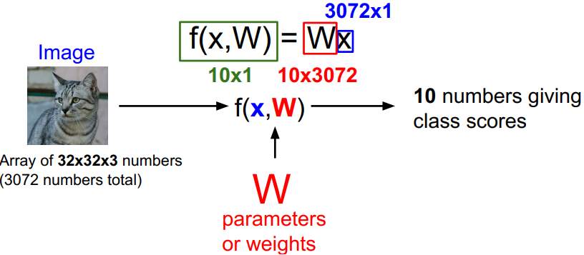

* Simple function: f(x, W) = Wx +b (b: bias)

Interpreting a linear classifier

* Make a single linear line of classifying objects
* If object is over the line, then it is classified with that group
* Hard cases for s linear classifier

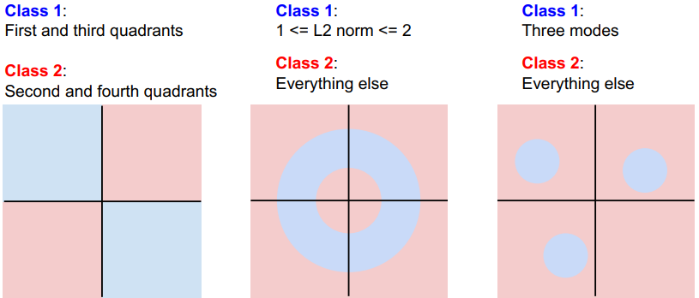

* + Hard to make a linear line to separate into two groups
  + Parity problem separating odd from even/multimodal situations

**Lecture 3 | Loss Functions and Optimization**

Recall from last time

* Challenges of recognition: semantic gap
* Data-driven approach, kNN, CIFAR-10
* Linear classifier: f(x, W) = Wx+b
  + High score means high probability of classification into specific class
  + TODO: define a loss function & minimize the loss function(optimization)

**Loss function**

* Represents how good or bad the current classifier is
* Given a dataset of examples where is image and is integer label (base truth)
* Loss over the dataset is a sum of loss over examples:

Multiclass SVM loss

* Let .
* Sum up all incorrect categories’ scores.
* Some type of Hinge loss 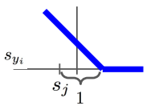
* Q. why +1 at the score?
  + A. Actually, it is an arbitrary value. If we rescale the data, value 1 doesn’t matter.
* Maximum possible loss is inf., minimum possible loss is 0.
* If W is too small so all s is about 0, loss will be N-1 for each class.
* What if we use ?
  + This will become different classifier.
* Why don’t we use squared errors?
  + This is a difference of caring errors of class.
* Suppose that we found a W such that L = 0, is this W unique?
  + No. 2W is also same.

Regularization

* We order to model that to find best fit in training data. (blue curves)
* However, what we really concern is how it works on test data.
* It may cause overfitting. (different with green line)

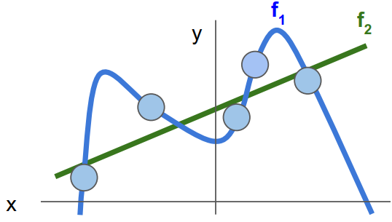

* To prevent overfitting, we add new regularization term at the loss function.
* Lambda means regularization strength. One of hyperparameter.

Types of regularization

* L2 regularization:
* L1 regularization:
* Elastic net (L1 + L2):
* Max norm regularization
* Dropout
* Batch normalization, stochastic depth, fractional pooling, etc.
* L2 regularization likes to “spread out” the weights.
* L1 regularization likes many 0s in weights. Especially, opposite tend of L2 regularization.

Why regularize?

* Express preferences over weights
* Make the model simple so it works on test data
* Improve optimization by adding curvature

Softmax classifier (Multinomial Logistic regression)

* Want to interpret raw classifier scores as probabilities.
* Softmax function:
* Min loss is 0, max loss is inf.

Softmax vs. SVM

* SVM cares only getting correct score to be greater than a margin above the incorrect scores.
* Softmax loss wants to drive the probability mass all the way to one.

Recap

* We have some dataset of (x, y)
* We have a score function:
* We have a loss function: softmax, SVM, regularization loss

**Optimization**

* We want to make loss function decrease
* Strategy 1: random search / very bad idea
* Strategy 2: follow the slope

Gradient

* In 1-D, derivative of a function is
* In multiple dimensions, gradient is the vector of partial derivatives along each dimension
* The slope in any direction is the dot product of the direction with the gradient.
* The direction of steepest descent is the negative gradient.
* We can use numeric gradient, but it is too slow, approximate.
* We can use calculus to compute an analytic gradient. It is exact and fast.
* We want .

Gradient descent

* Initialize W in some random value and compute loss and gradient.
* Update W in opposite direction of gradient.
* However, we have to determine learning rate(how far we move).

Stochastic Gradient Descent (SGD)

* Full sum is expensive when N is large.
* Approximate sum using a minibatch of examples 32/64/128 common.

**Lecture 4 | Introduction to Neural Networks**

Where we are?

* Scores function:
* SVM loss:
* Data loss + regularization:
* We want
* There were numeric/analytic gradient and both has pros and cons

Computational graphs

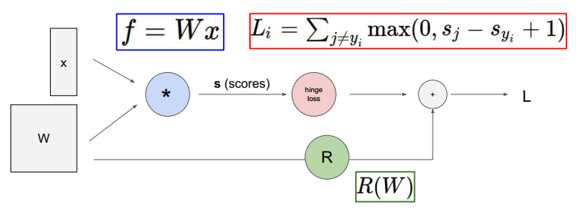

Backpropagation: a simple example

* 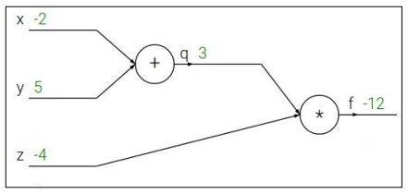
* We want
* Chain rule:

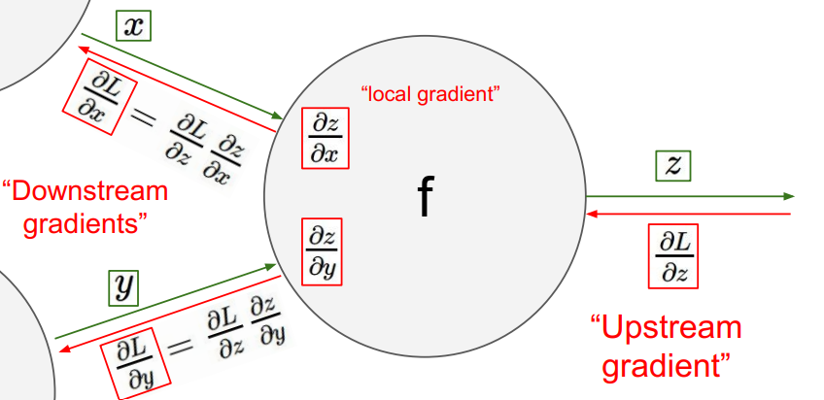

* Another example

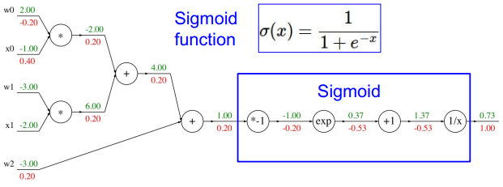

* Computational graph representation may not be unique. We can change some of graph to sigmoid function at the example.

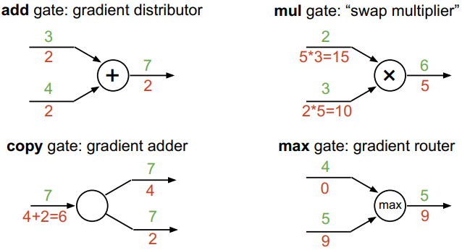Patterns in gradient flow

* Add gate: gradient distributor
* Mul gate: “swap multiplier”
* Copy gate: gradient adder
* Max gate: gradient router

Backprop with vectors

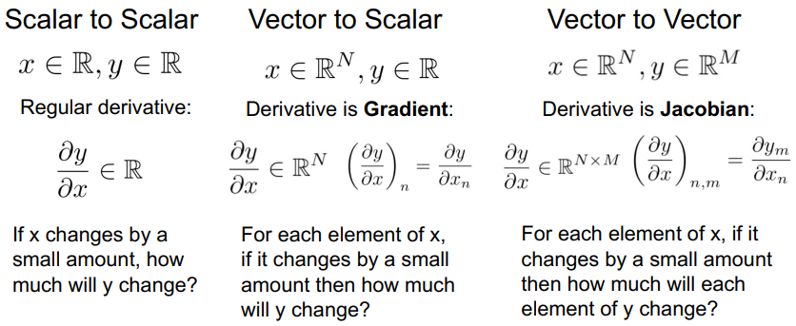

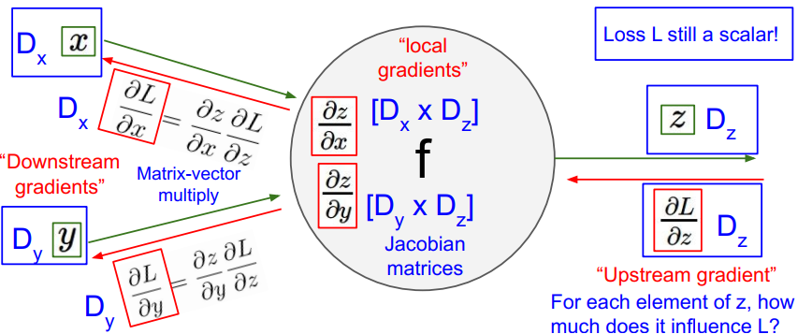

* is a vector with Dz dimension
* Each and become Jacobian matrices with [Dx * Dz] and [Dy * Dz] size
* become matrix-vector multiply and results Dx dimension vector

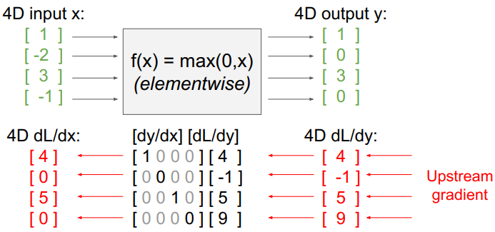

* The size of Jacobian matrix is 4 * 4 (4 squared).
* If the size of input increases, making Jacobian matrix is very inefficient.
* Actually, Jacobian matrix has 0s for non-diagonal elements(diagonal matrix). So we don’t have to make entire Jacobian matrix.

Vectorized example

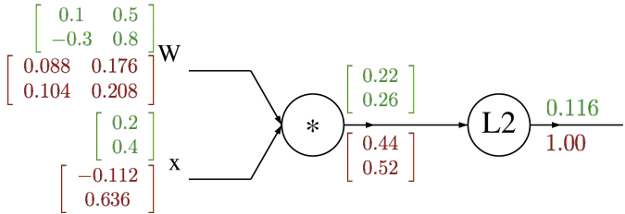

Summary

* Neural nets will be very large: impractical to write down gradient formula by hand for all parameters
* backpropagation = recursive application of the chain rule along a computational graph to compute the gradients of all inputs/parameters/intermediates
* implementations maintain a graph structure, where the nodes implement the forward() / backward() API
* forward: compute result of an operation and save any intermediates needed for gradient computation in memory
* backward: apply the chain rule to compute the gradient of the loss function with respect to the inputs

Neural networks: without the brain stuff

* before: linear score function:
* now: 2-layer neural network:
* “Neural Network” is a very broad term. These are more accurately called “fully-connected networks” or “multi-layer perceptrons” (MLP)

Next time

* Many activation functions
  + Sigmoid, tanh, ReLU, Leaky ReLu, Maxout, ELU
* Neural networks architectures

**Lecture 5 | Convolutional Neural Networks**

A bit of history

* Perceptron: Frank Rosenblatt, ~1957
* Adaline/Madaline: Widrow and Hoff, ~1960
* First time back-propagation becams popular: Rumelhart et al., 1986
* First strong results: speech recognition and Imagenet classification, 2012
* Receptive fields of single neurons in the cat’s striate cortex: Huble & Wiesel, 1959
* Hierarchical organization of cells
  + Simple cell: response to light orientation
  + Complex cells: response to light orientation and movement
  + Hypercomplex cells: response to movement with an end point
* AlexNet: ImageNet classification with deep CNN, 2012

ConvNets are everywhere

* Image classification
* Image retrieval
* Image detection
* Image segmentation
* Self-driving cars
* Face recognition
* Classifying video
* Pose estimation
* Playing games – Atari
* Image style transfer

Fully connected layer

* 32*32*3 image -> stretch to 3072*1 vector
* Input: 3072*1 vector -> Wx: 10*3072 weights -> acvitation: 10*1 vector

Convolution layer

* We keep the original structure of image(32*32*3).
* Then, we consider 5*5*3 filter, which has full depth(3).
* We locate the filter on the top of spatial location in the image, and to the dot product.
* We need to stretch out to calculate the dot product.
* **Convolve** the filter with the image – slide over the image spatially, computing dot products.
* Total output is 28*28*1 layer.

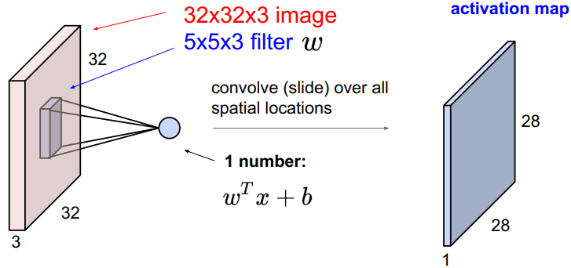

* We can make multiple activation layers with different filter and stack them to make another convolution layers.
* ConvNet is a sequence of convolution layers, interspersed with activation functions.

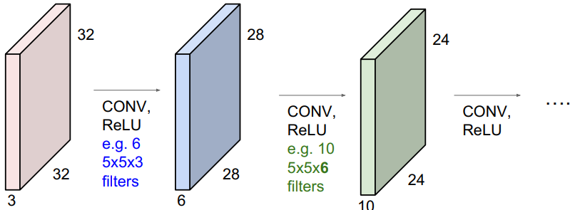

A closer look at spatial dimensions

* 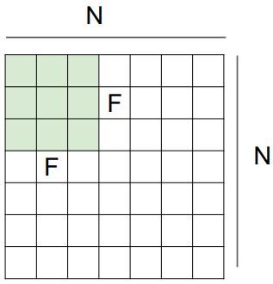Assume we have 7*7 input and 3*3 filter with stride 1.
  + We will get 5*5 output.
* Assume all the same bud stride is 2.
  + 3*3 output.
* Stride 3?
  + Ii doesn’t fit.
* Output size: **(N – F) / stride + 1**
  + If N = 7, F = 3, stride 1 -> 5 / stride 2 -> 3 / stride 3 -> 2.33

In practice: common to zero pad the border

* Input: 7*7 / filter: 3*3 applied with stride 1
* 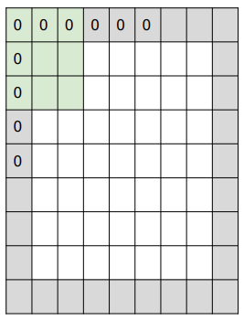Pad with 1 pixel border with 0. What is the output?
* We can get 7*7 output.
* Zero padding makes same output size to input
* In general, Conv layers with stride 1, filters of size F*F, zero padding is **(F-1)/2**
* With no zero padding, regenerated activation layers shrink too fast. This makes loss of data and make doesn’t work well.

Examples

* Input volume: 32*32*3
* 10 5*5*3 filters with stride 1, padding 2
* Q1. What is output volume size?
  + A1. 32*32*10 / (32+2*2-5)/1+1=32
* Q2. Number of parameters in this layer?
  + A2. 760. Each filter has 5*5*3+1=76 params(1 for bias) and 76*10=760

Brain/neuron view of Conv layer

* Activation map is a 28*28 sheet of neuron outputs.
* Each is connected to a small region in the input.
* All of them share parameters.
* 5*5 filter -> 5*5 receptive field for each neuron.

Pooling layer

* 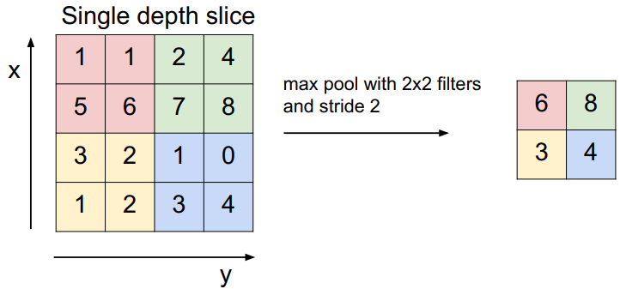Makes the representations smaller and more manageable
* Operates over each activation map independently
* Downsampling process
* One common way: max pooling
* Commonly, there are no overlaps and zero padding for pooling
* Why max pooling than average pooling?
  + A value can meaning of signal of neuron. So we want significant signal.

Fully connected later(FC layer)

* At the last, we want to have a fully connected layer.
* We take the ConvNet result output, and put in the vanilla neural network to get score.

Summary

* ConvNets stack Conv, pool, FC layers
* Trend towards smaller filters and deeper architectures
* Trend towards getting rid of pool/FC layers (just Conv)
* Historically architectures looked like

**[(CONV-RELU)*N-POOL?]*M-(FC-RELU)*K,SOFTMAX**

where N is usually up to ~5, M is large, 0 <= K <= 2.

* + but recent advances such as ResNet/GoogLeNet have challenged this paradigm