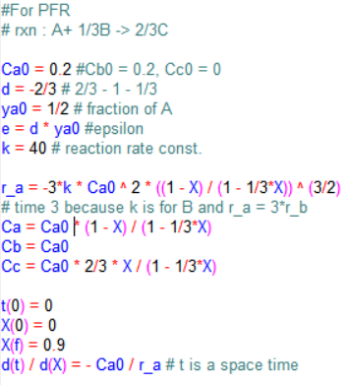 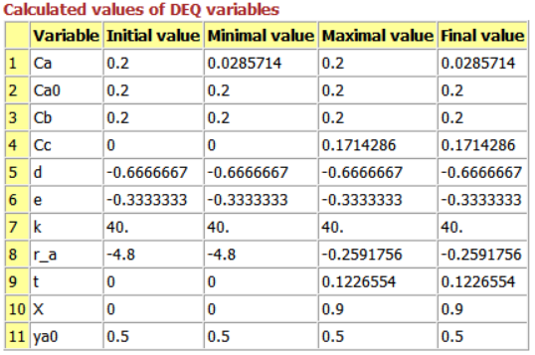

Figure 1. Coding for PFR (left)

Figure 2. Calculated values (right)

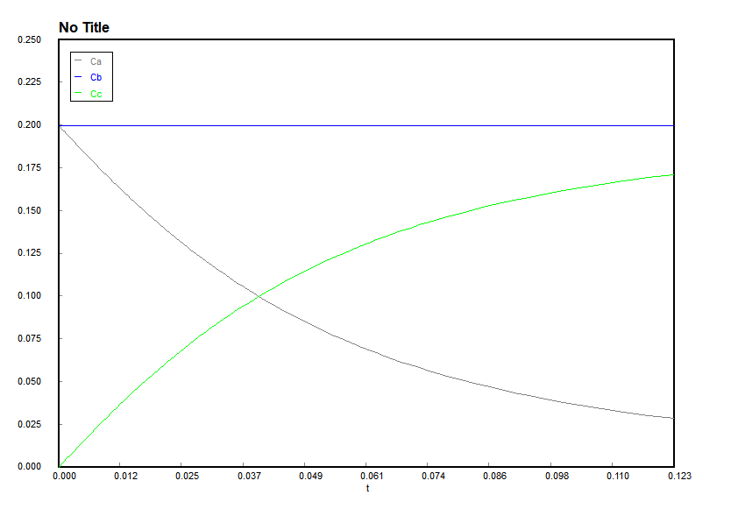

Figure 3. Graph of space time – concentration (PFR)

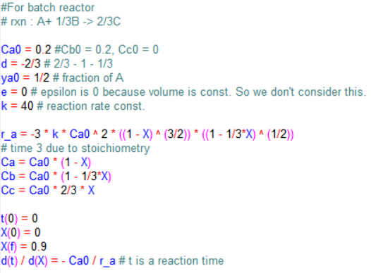 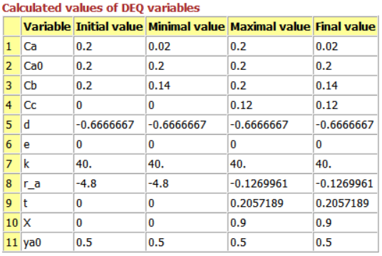

Figure 4. Coding for batch reactor (left)

Figure 5. Calculated values (right)

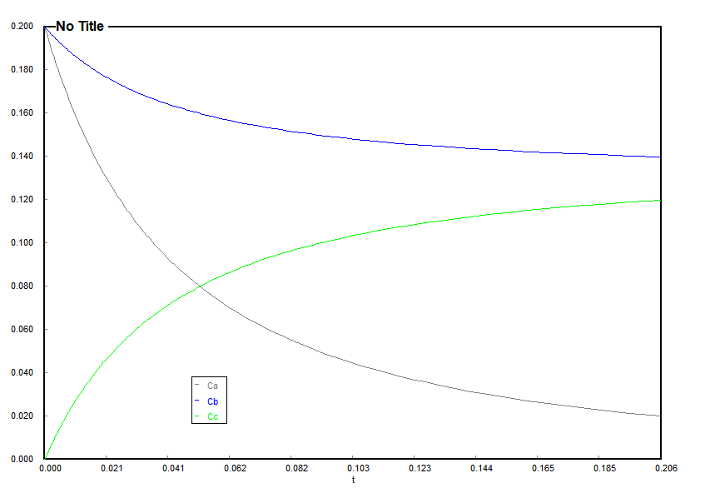

Figure 6. Graph of reaction time - concentration (batch)