[P4-7]

(C)

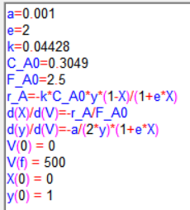 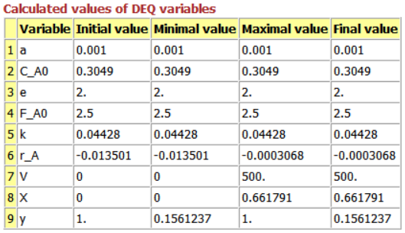

Figure . Coding for P4-7(c) & Polymath report

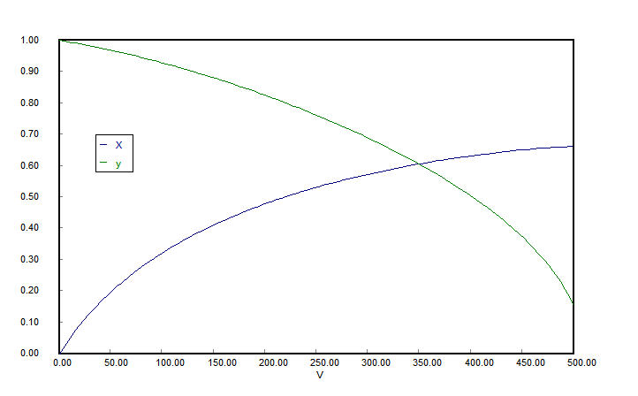

Figure . Graph for X and y for V

[P4-9]

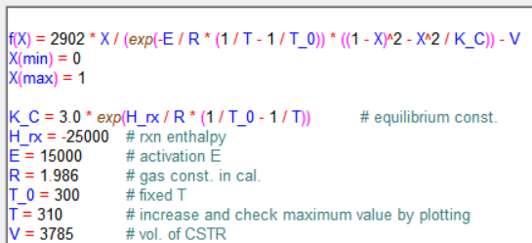

Figure . Coding for NLE

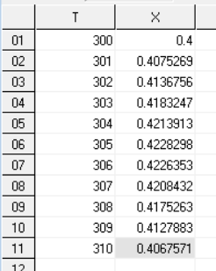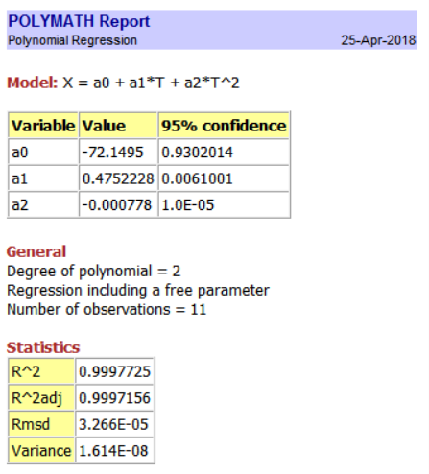

Figure . Gained data & Polymath report

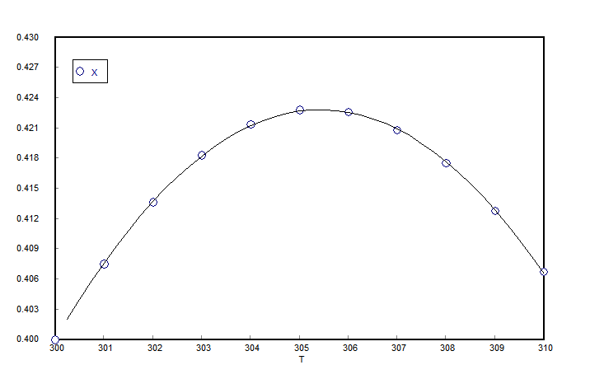

Figure . Graph for gained data (polynomial regression in 2nd degree)

5.

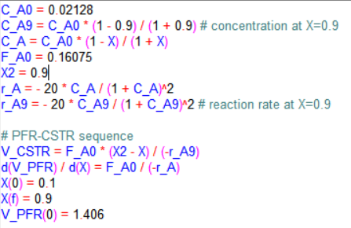

Figure . Coding for PFR-CSTR

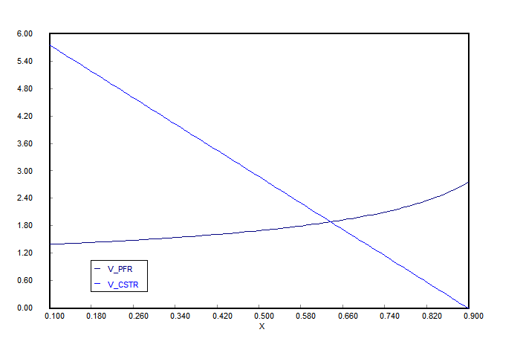

Figure . Graph for PFR-CSTR

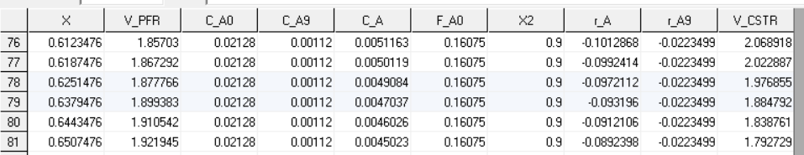

Figure . Chart of cross-section

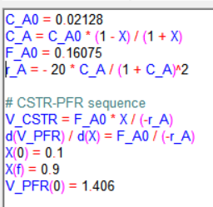

Figure . Coding for CSTR-PFR

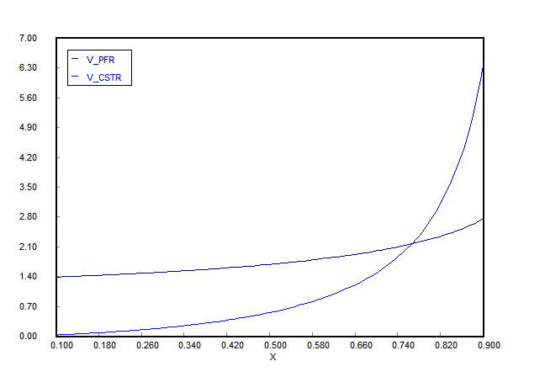

Figure . Graph of CSTR-PFR

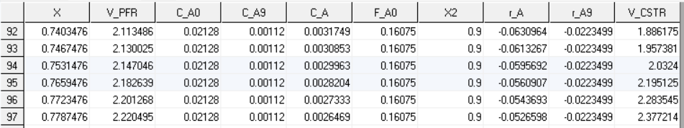

Figure . Chart of cross-section