**HW#5**

**[P4-2]**

**(e)**

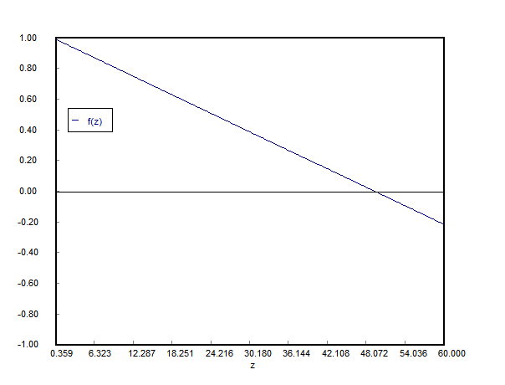

Figure 1. z - β0 (f(z)) graph

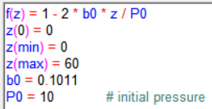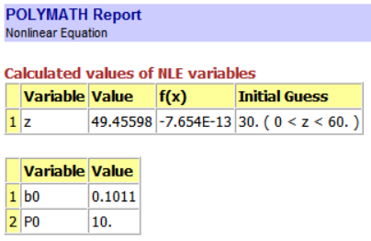

Figure 2. Coding and polymath report

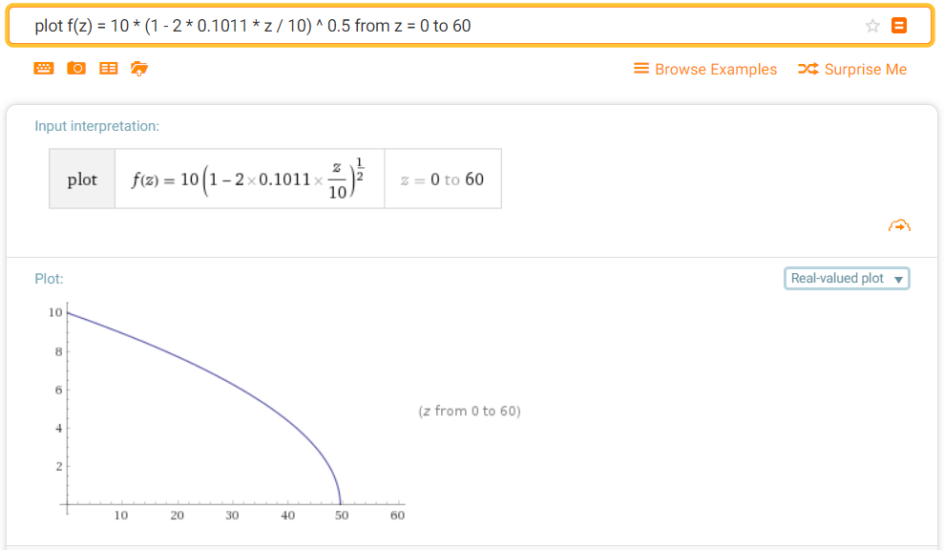

Figure 3. Graph of pressure about z(distance)

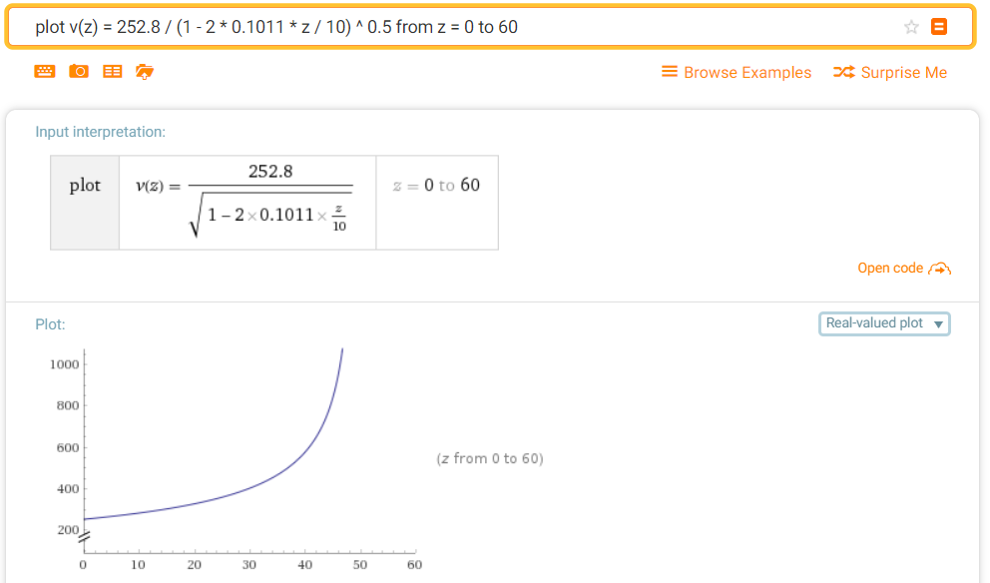

Figure 4. Graph of volumetric flow rate about z

**[P4-26]**

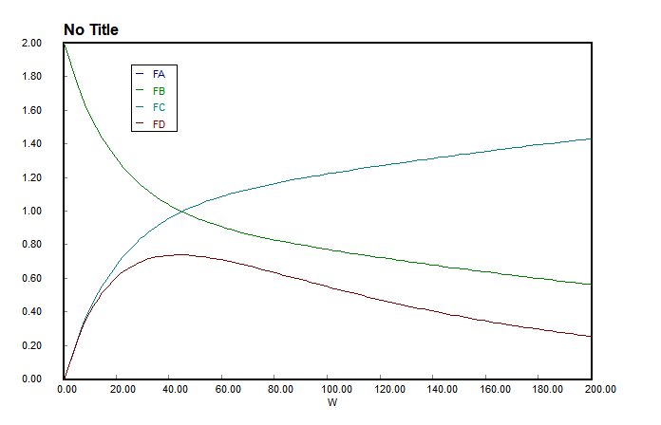

FA, FB는 같은 그래프

Figure 5. Graph of distance - flow rate for membrane reactor

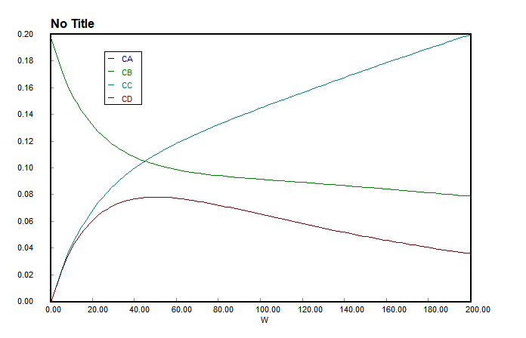

CA, CB는 같은 그래프

Figure 6. Graph of distance – concentration for membrane reactor

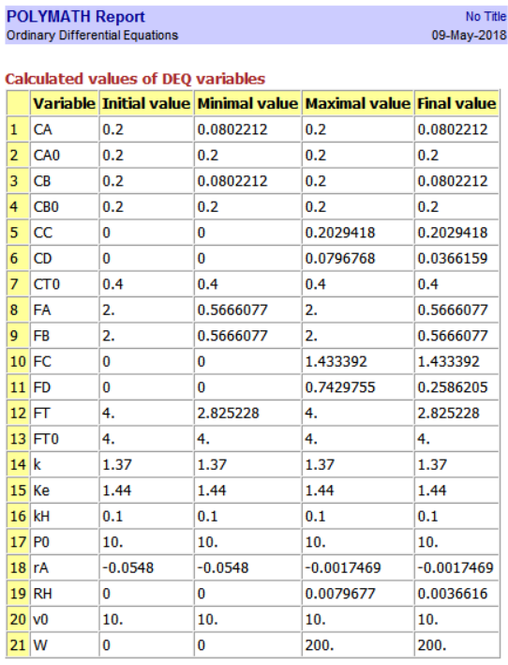

Figure 7. Polymath report for membrane reactor

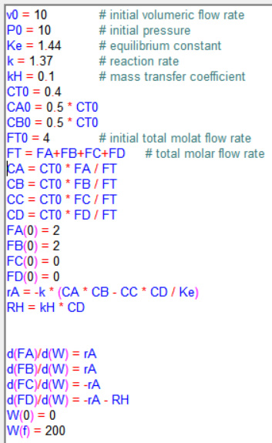

Figure 8. Coding result for membrane reactor

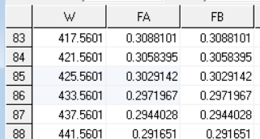

Figure 9. reactor volume of X=0.85 of CO, membrane reactor

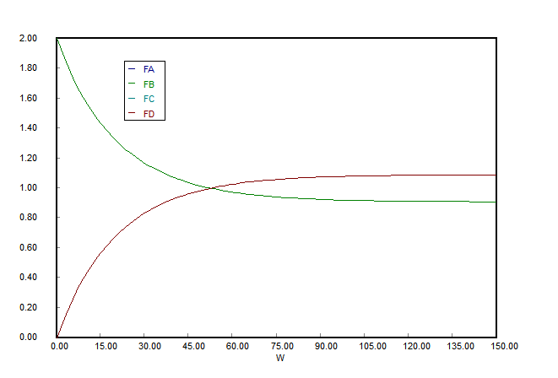

FA, FB / FC, FD는 같은 그래프

Figure 10. Graph of distance - flow rate for PFR

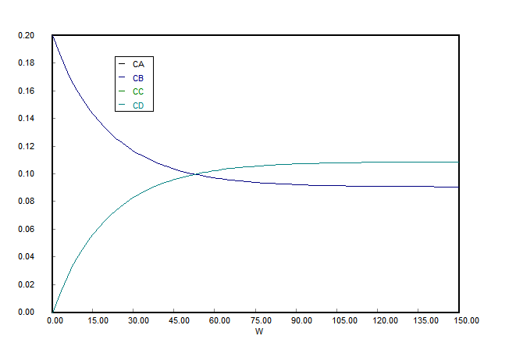

CA, CB / CC, CD는 같은 그래프

Figure 11. Graph of distance - concentration for PFR

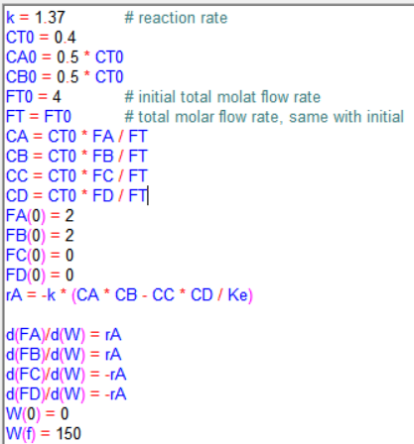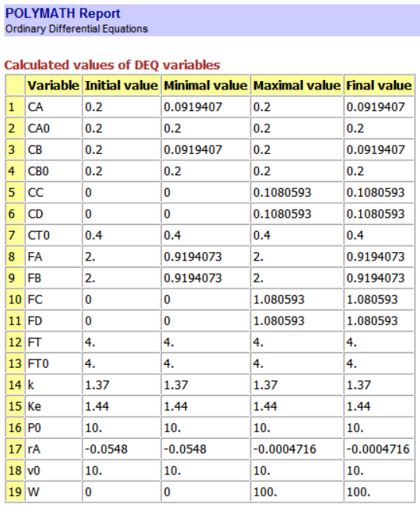

Figure 12. Coding and polymath report for PFR

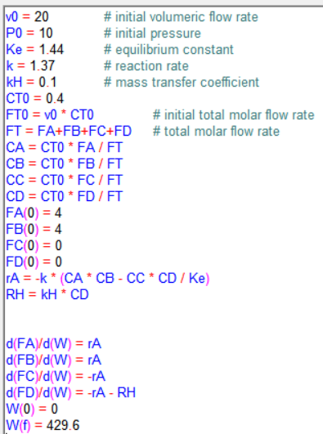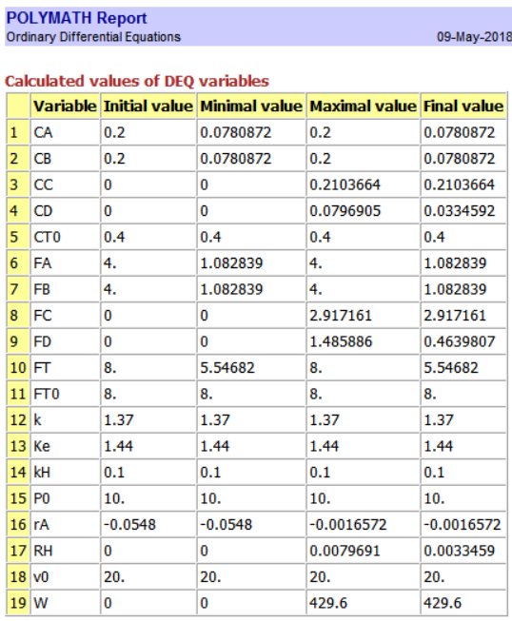

Figure 13. Coding and report for doubling feed rate

**[P5-1]**

**(i)**

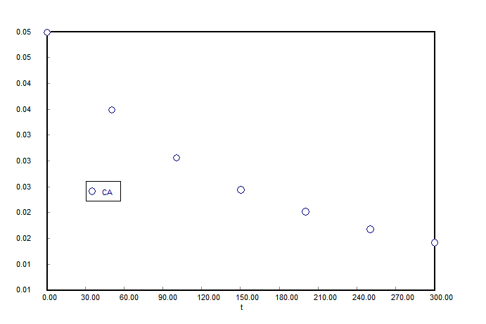

Figure 14. Zero-order assume graph (t - CA)

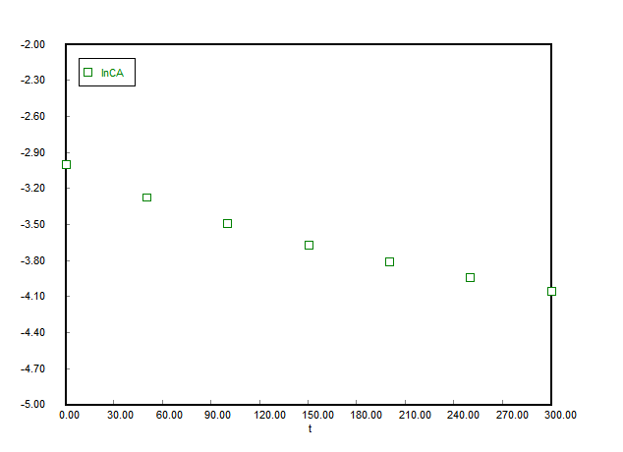

Figure 15. First-order assume graph (t - lnCA)

**[P5-6]**

**(a)**

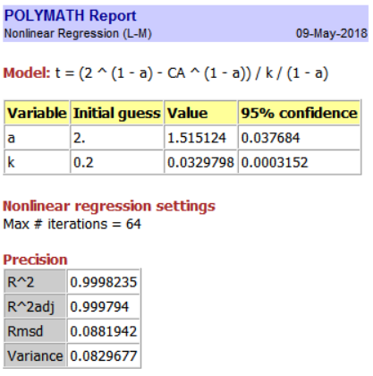

Figure 16. 1st regression result

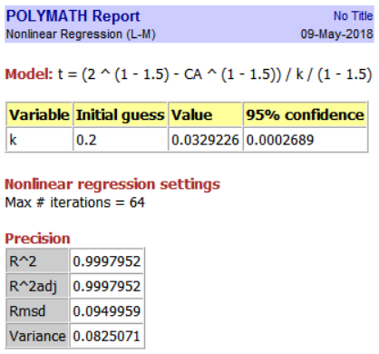

Figure 17. 2nd regression result

**(d)**

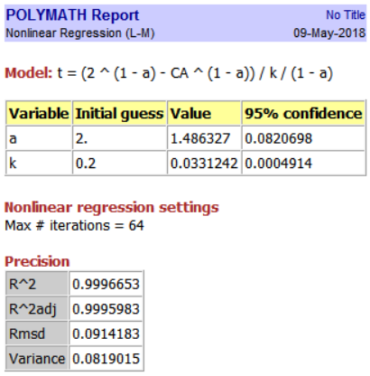

Figure 18. 1st regression result

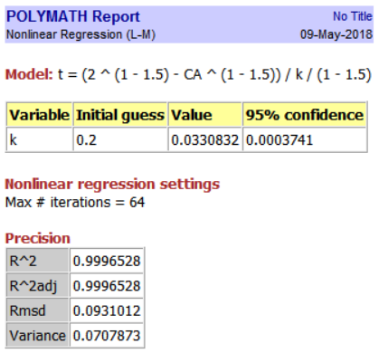

Figure 19. 2nd regression result

Figure 20. Excel plot of graphical method