**HW#6**

**[1]**

**(a)**

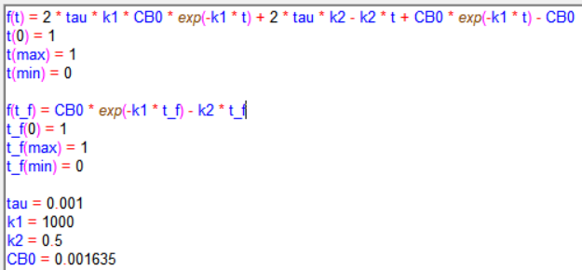

Figure 1. Polymath coding of parallel CSTR

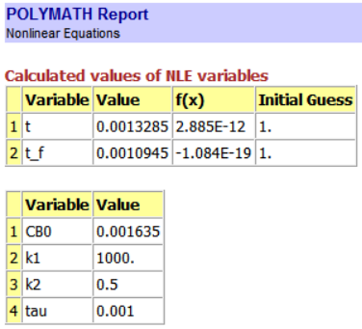

Figure 2. Polymath report of parallel CSTR

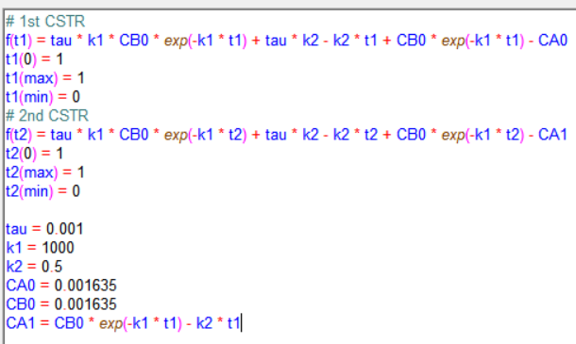

Figure 3. Polymath coding of series CSTR

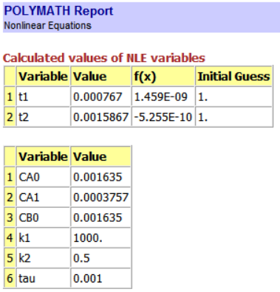

Figure 4. Polymath report of series CSTR

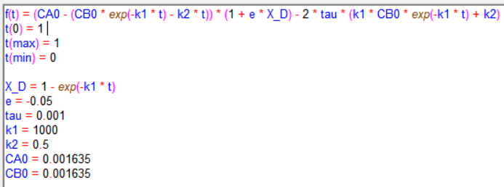

Figure 5. Polymath coding of parallel CSTR, nonzero ε

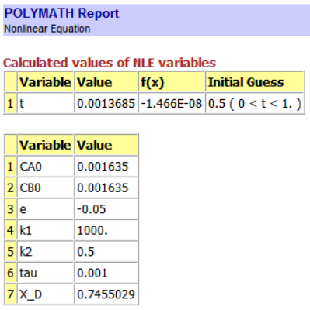

Figure 6. Polymath report of parallel CSTR, nonzero ε

**[P6-13]**

**(a)**

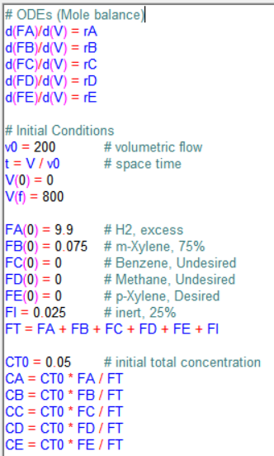 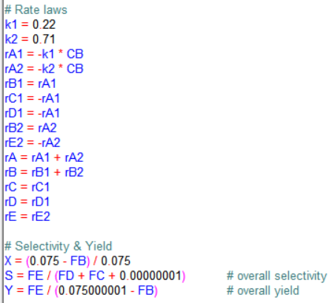

Figure 7. Polymath coding

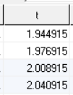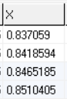

Figure 8. Space time near X=0.85

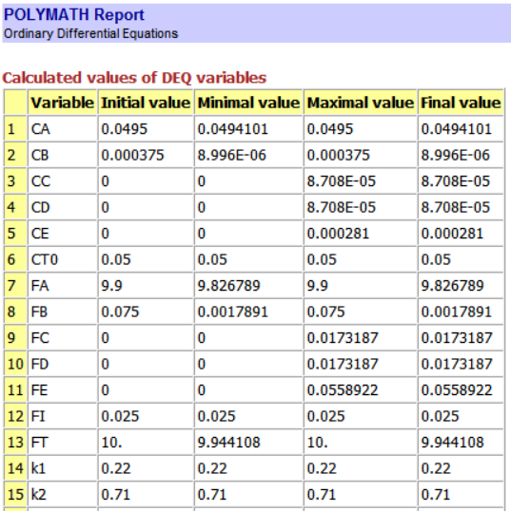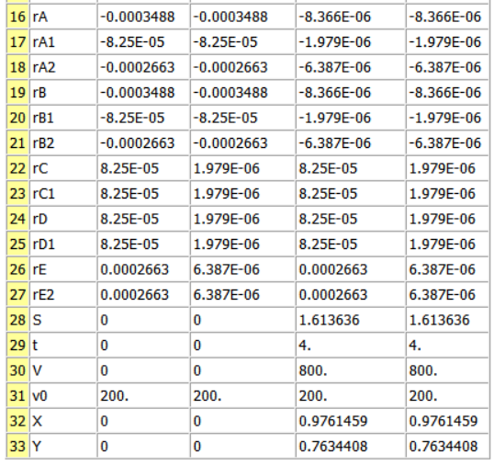

Figure 9. Polymath report

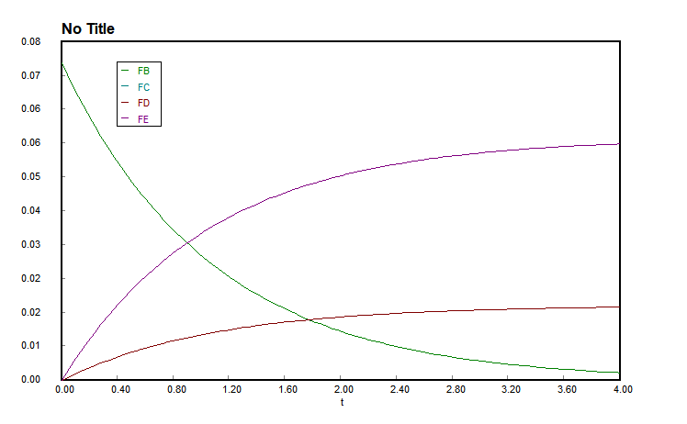

Figure 10. Graph of space time & molar flow rate

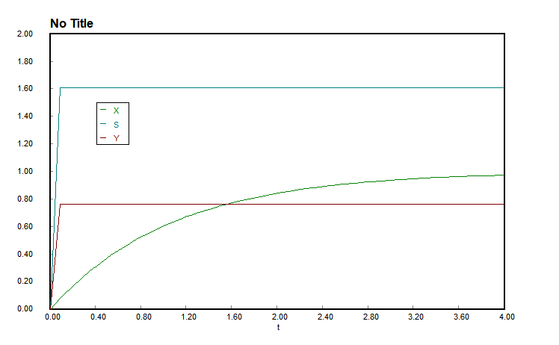

Figure 11. Graph of space time & conversion, overall selectivity, overall yield

(b)

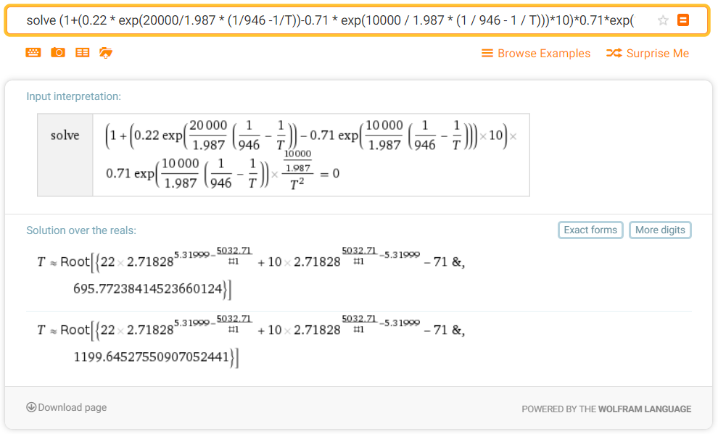

Figure 12. Solution of dCE/dT=0