**HW#7**

**P8-7**

**(a)**

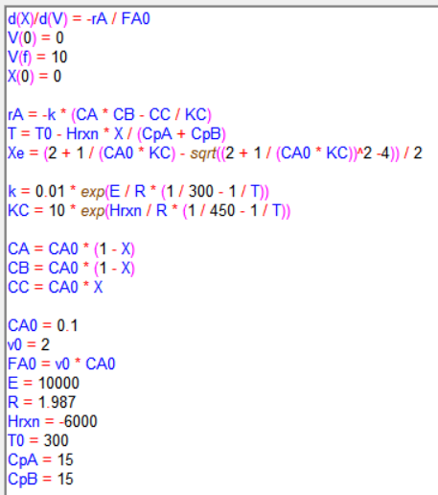

Figure 1. Polymath coding

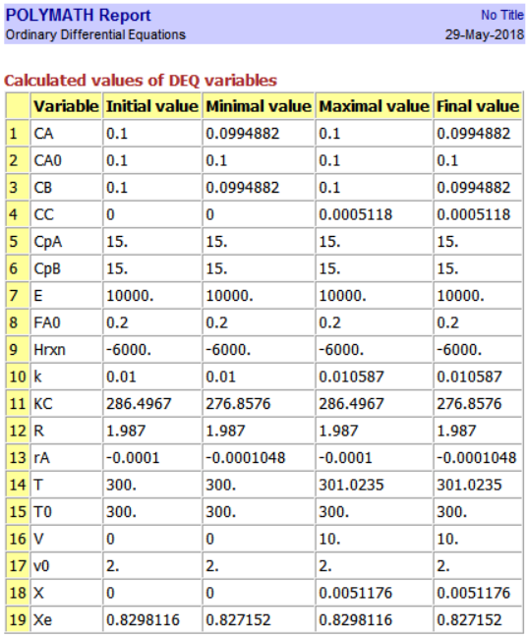

Figure 2. Polymath report

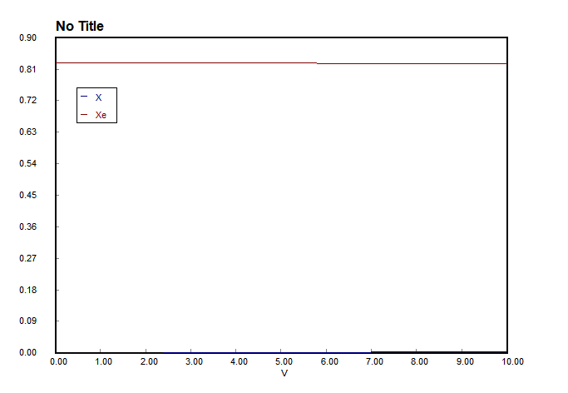

Figure 3. Graph for V and X, Xe (V up to 10 L)

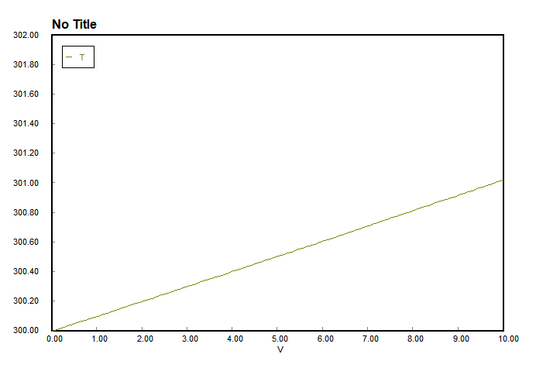

Figure 4. Graph for V and T (V up to 10 L)

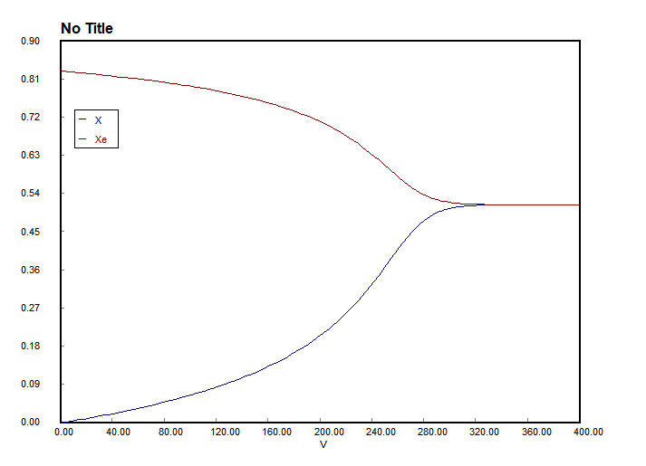

Figure 5. Graph for V and X, Xe (V up to 400 L)

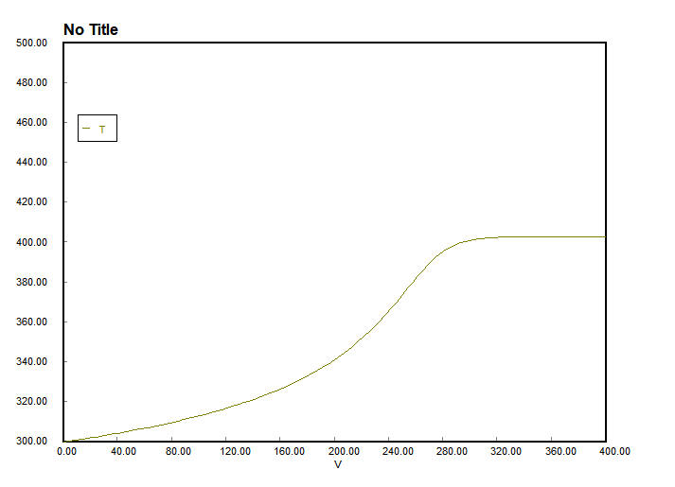

Figure 6. Graph for V and T (V up to 400 L)

**(b)**

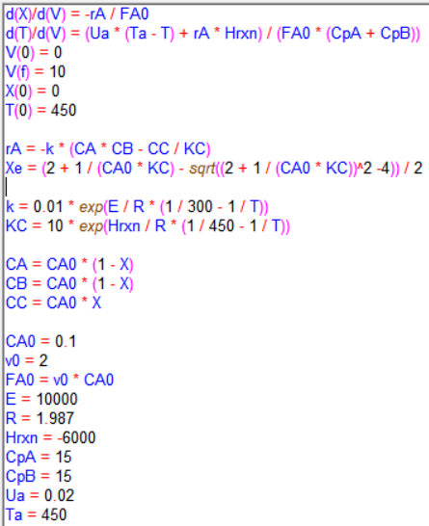

Figure 7. Polymath coding

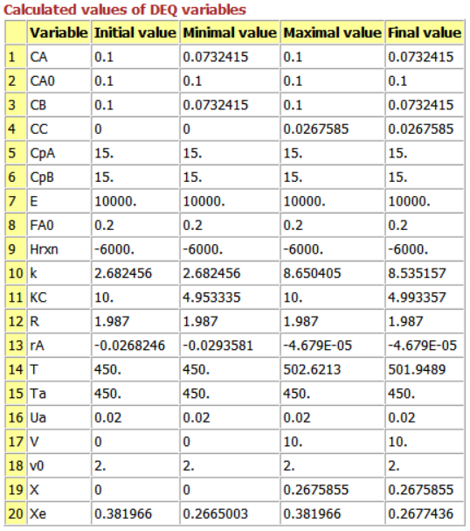

Figure 8. Polymath report

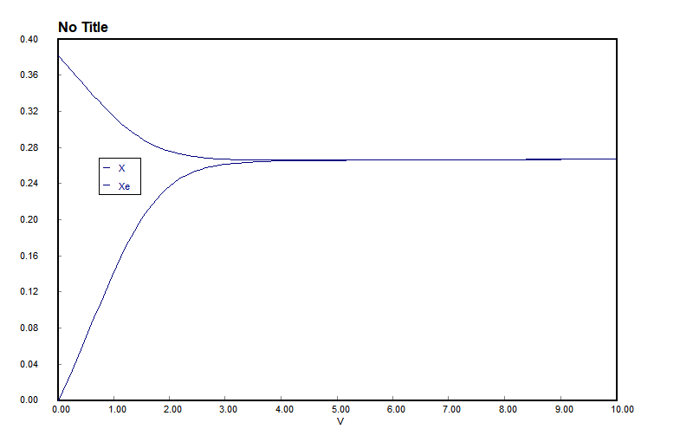

Figure 9. Graph for V and X(lower line), Xe(upper line) (V up to 10 L)

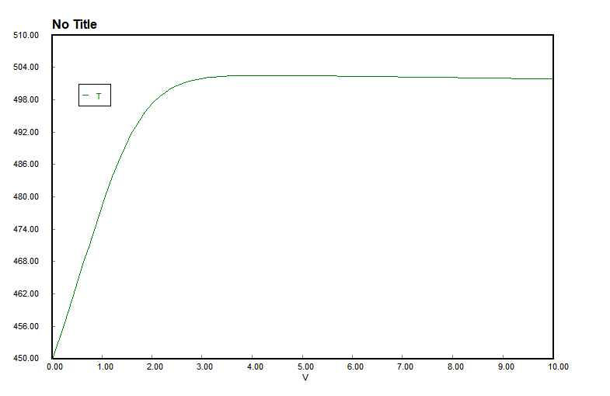

Figure 10. Graph for V and T (V up to 10 L)

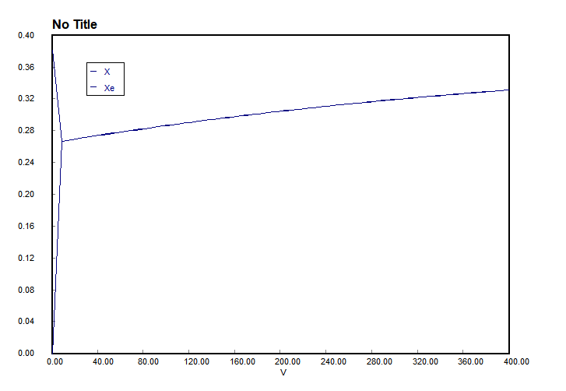

Figure 11. Graph for V and X(lower line), Xe(upper line) (V up to 400 L)

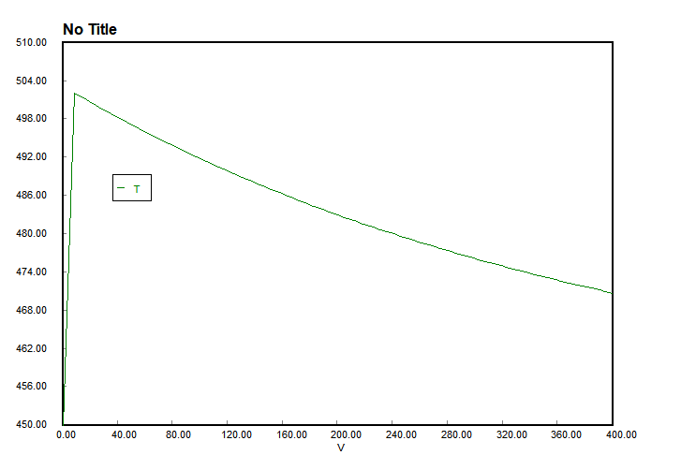

Figure 12. Graph for V and T (V up to 400 L)

**(c)**

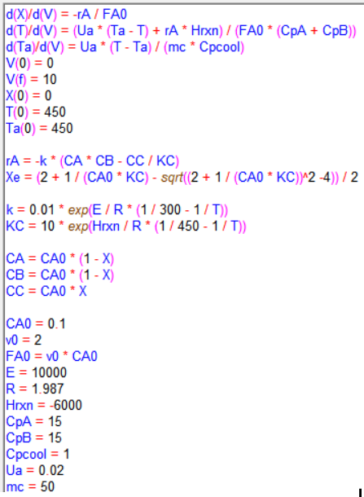

Figure 13. Polymath coding

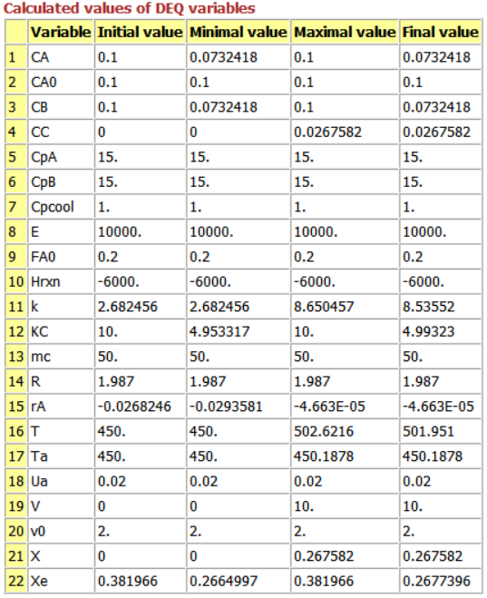

Figure 14. Polymath report

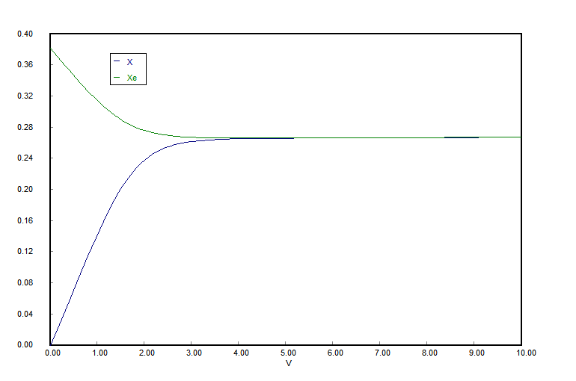

Figure 15. Graph for V and X, Xe (V up to 10 L, mc = 50 g/s)

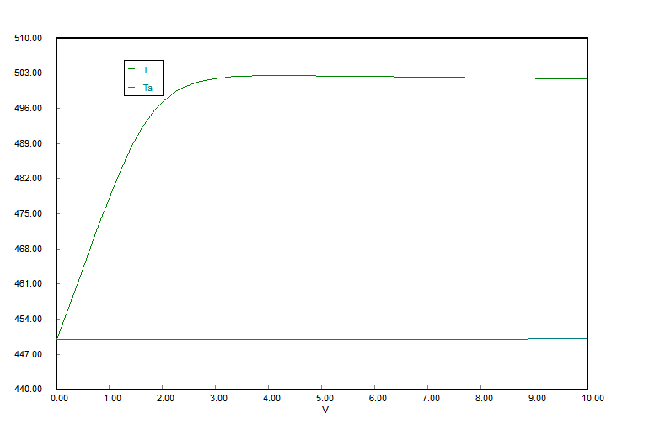

Figure 16. Graph for V and T, Ta (V up to 10 L, mc = 50 g/s)

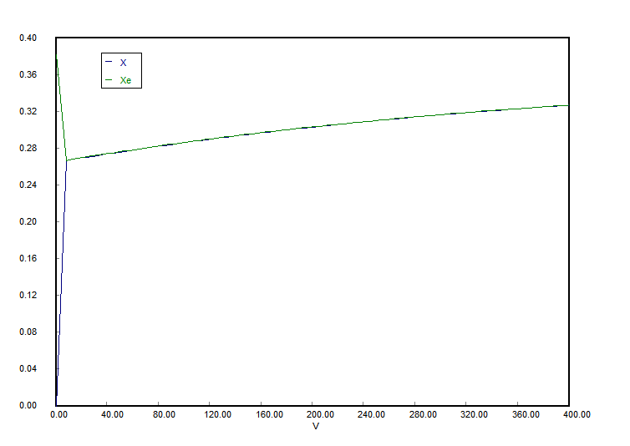

Figure 17. Graph for V and X, Xe (V up to 400 L, mc = 50 g/s)

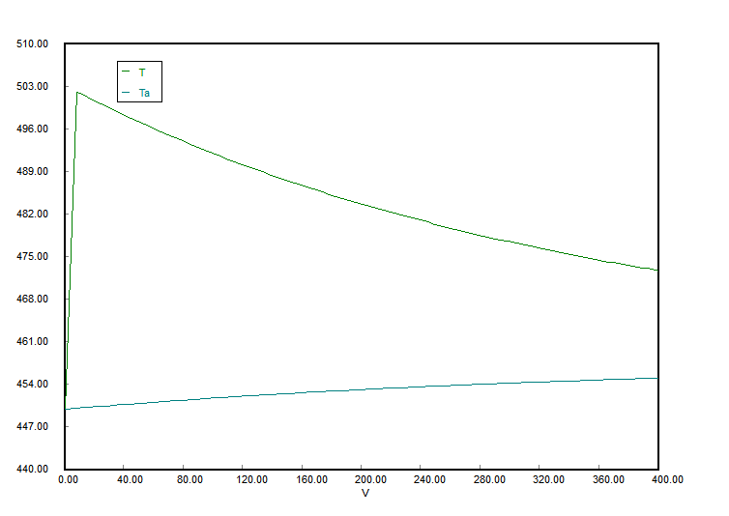

Figure 18. Graph for V and T, Ta (V up to 400 L, mc = 50 g/s)

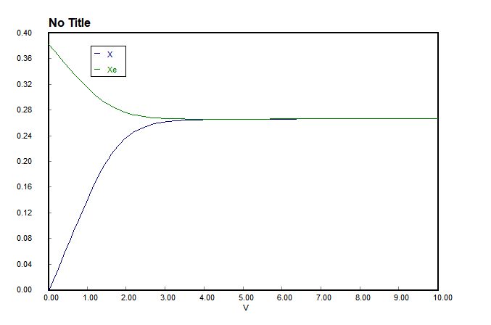

Figure 19. Graph for V and X, Xe (V up to 10 L, mc = 10 g/s)

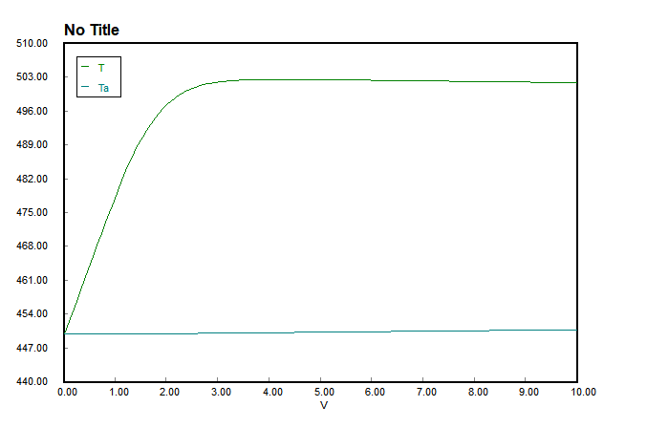

Figure 20. Graph for V and T, Ta (V up to 10 L, mc = 10 g/s)

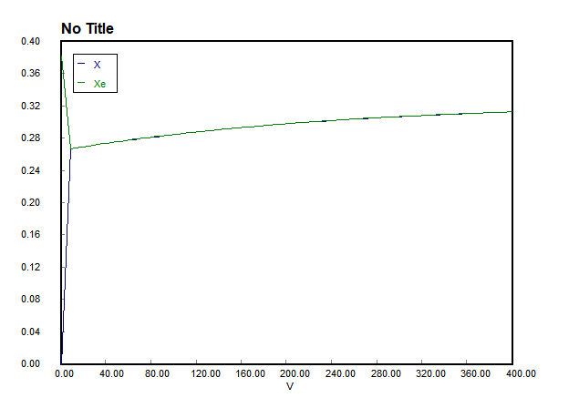

Figure 21. Graph for V and X, Xe (V up to 400 L, mc = 10 g/s)

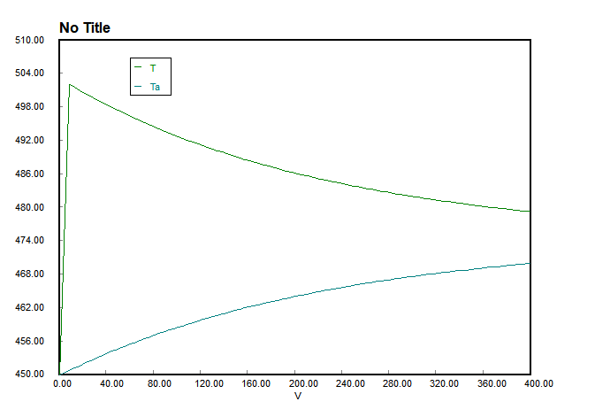

Figure 22. Graph for V and T, Ta (V up to 400 L, mc = 10 g/s)

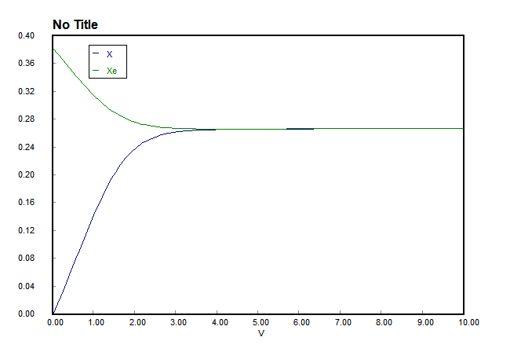

Figure 23. Graph for V and X, Xe (V up to 10 L, mc = 100 g/s)

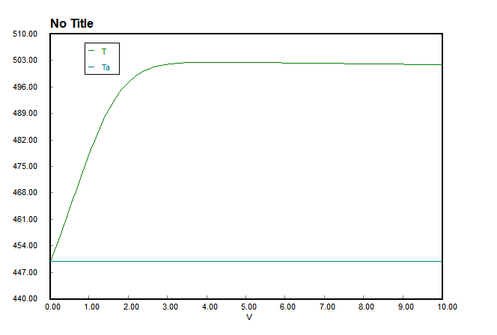

Figure 24. Graph for V and T, Ta (V up to 10 L, mc = 100 g/s)

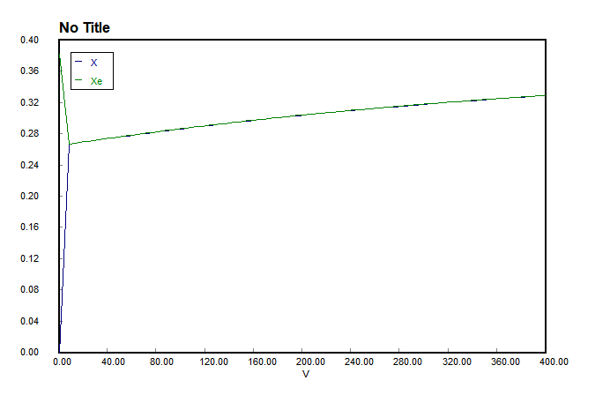

Figure 25. Graph for V and X, Xe (V up to 400 L, mc = 100 g/s)

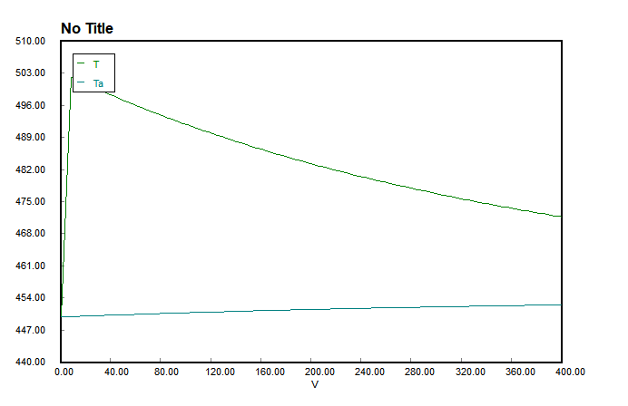

Figure 26. Graph for V and T, Ta (V up to 400 L, mc = 100 g/s)

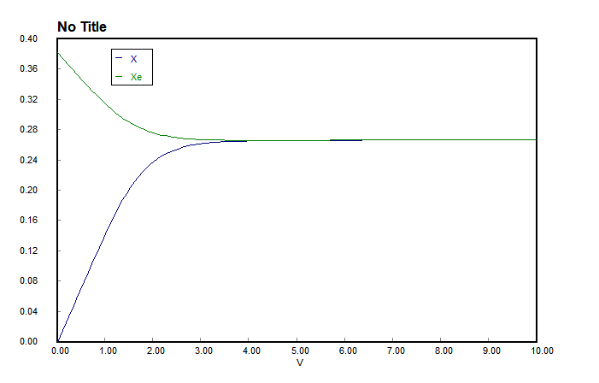

Figure 27. Graph for V and X, Xe (V up to 10 L, mc = 1000 g/s)

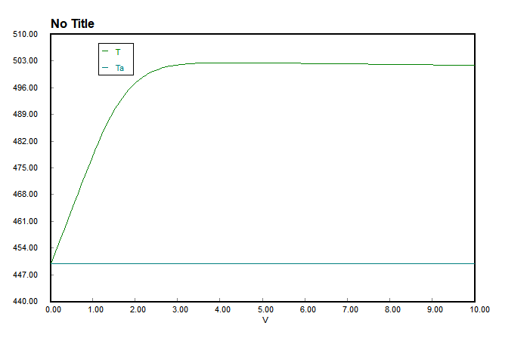

Figure 28. Graph for V and T, Ta (V up to 10 L, mc = 1000 g/s)

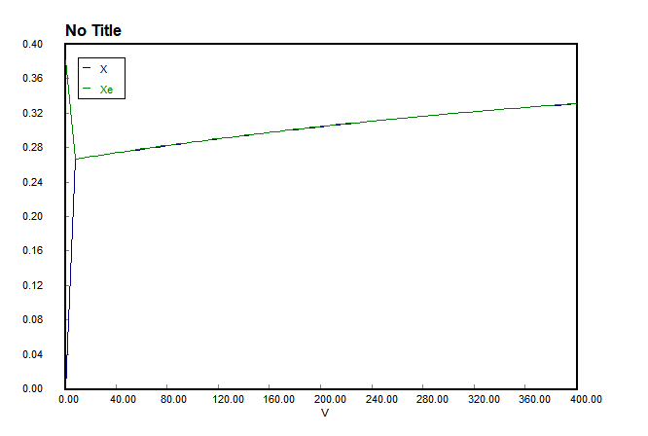

Figure 29. Graph for V and X, Xe (V up to 400 L, mc = 1000 g/s)

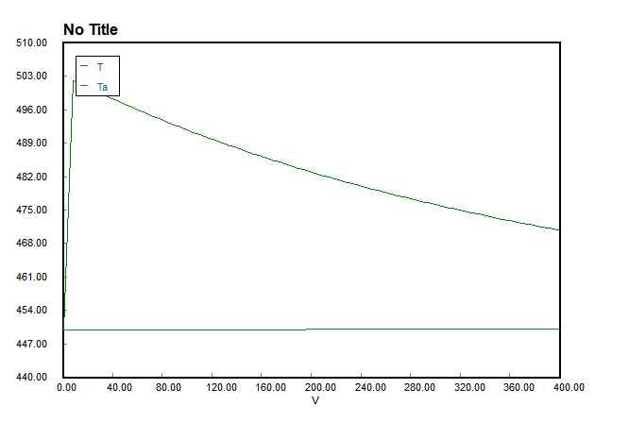

Figure 30. Graph for V and T, Ta (V up to 400 L, mc = 100 g/s)

**(d)**

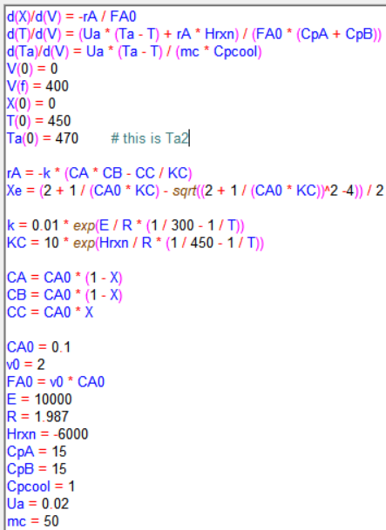

Figure 31. Polymath Coding

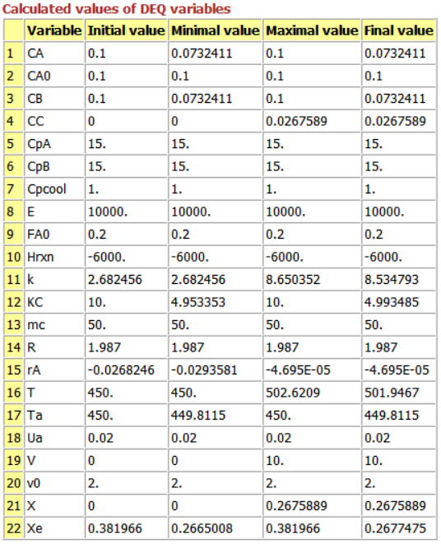

Figure 32. Polymath report

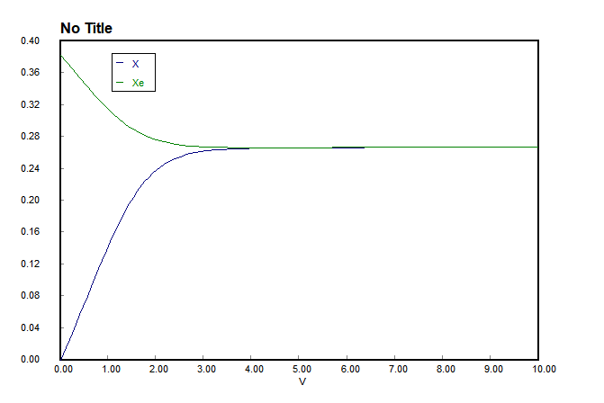

Figure 33. Graph for V and X, Xe (V up to 10 L, mc = 50 g/s)

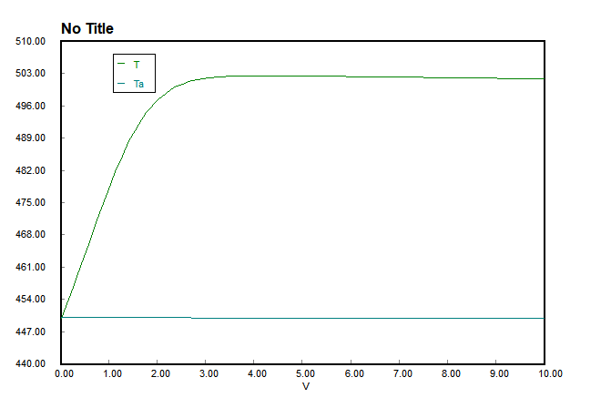

Figure 34. Graph for V and T, Ta (V up to 10 L, mc = 50 g/s)

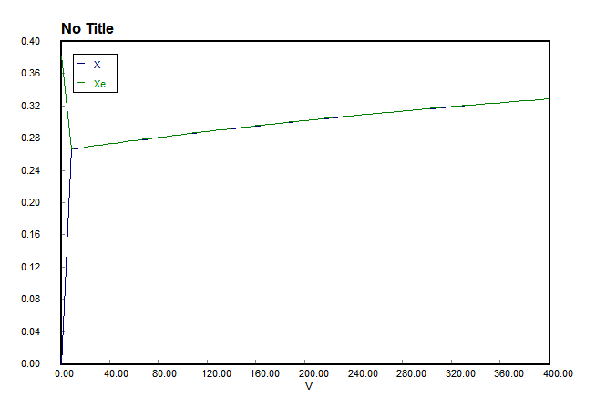

Figure 35. Graph for V and X, Xe (V up to 400 L, mc = 50 g/s)

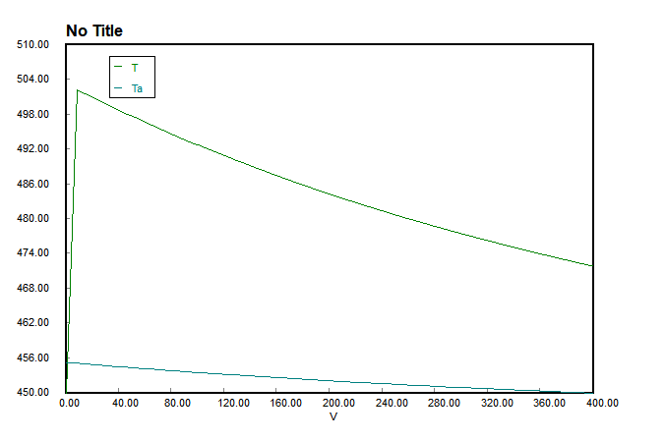

Figure 36. Graph for V and T, Ta (V up to 400 L, mc = 50 g/s)

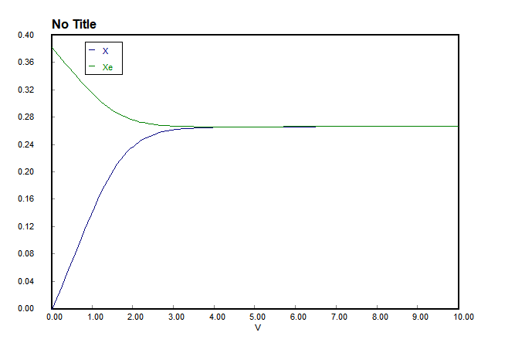

Figure 37. Graph for V and X, Xe (V up to 10 L, mc = 10 g/s)

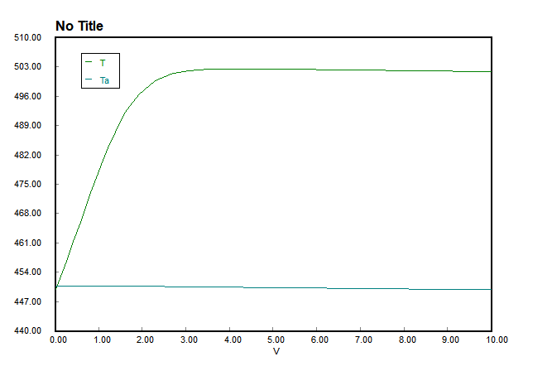

Figure 38. Graph for V and T, Ta (V up to 10 L, mc = 10 g/s)

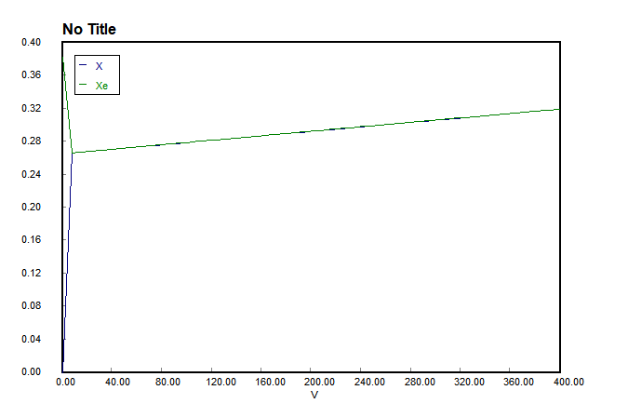

Figure 39. Graph for V and X, Xe (V up to 400 L, mc = 10 g/s)

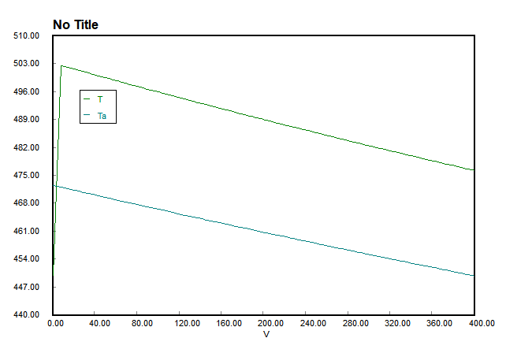

Figure 40. Graph for V and T, Ta (V up to 400 L, mc = 10 g/s)

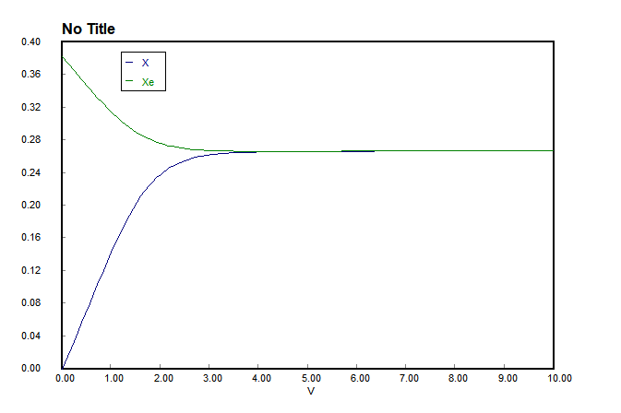

Figure 41. Graph for V and X, Xe (V up to 10 L, mc = 100 g/s)

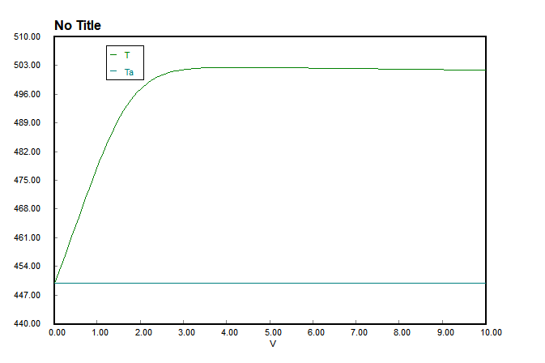

Figure 42. Graph for V and T, Ta (V up to 10 L, mc = 100 g/s)

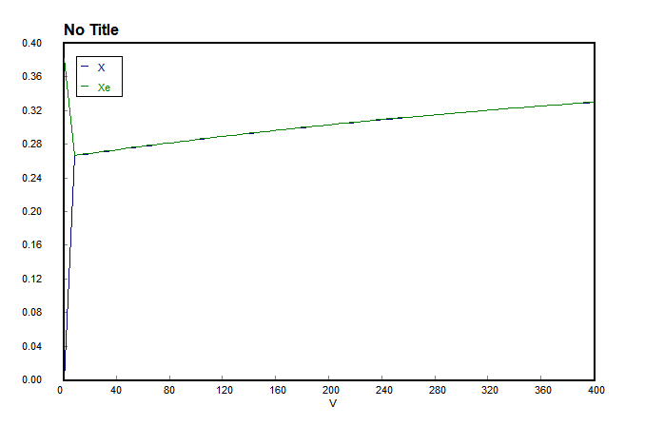

Figure 43. Graph for V and X, Xe (V up to 400 L, mc = 100 g/s)

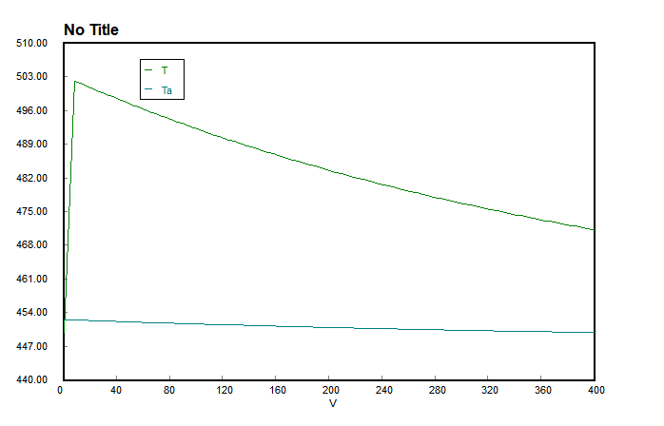

Figure 44. Graph for V and T, Ta (V up to 400 L, mc = 100 g/s)

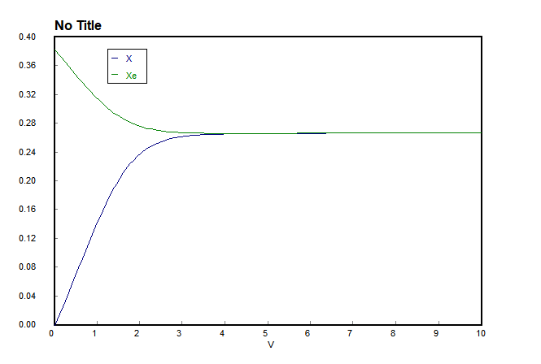

Figure 45. Graph for V and X, Xe (V up to 10 L, mc = 1000 g/s)

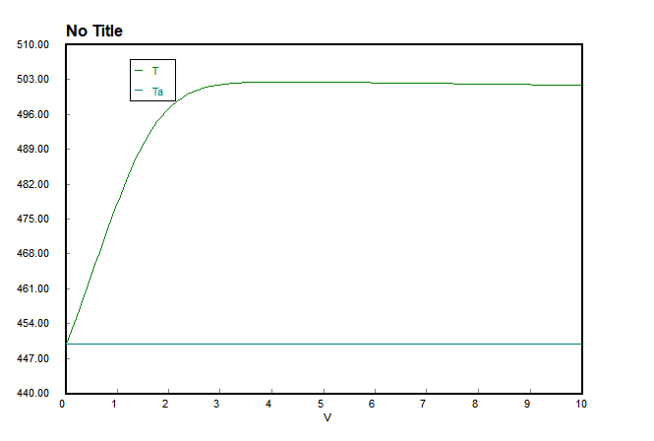

Figure 46. Graph for V and T, Ta (V up to 10 L, mc = 1000 g/s)

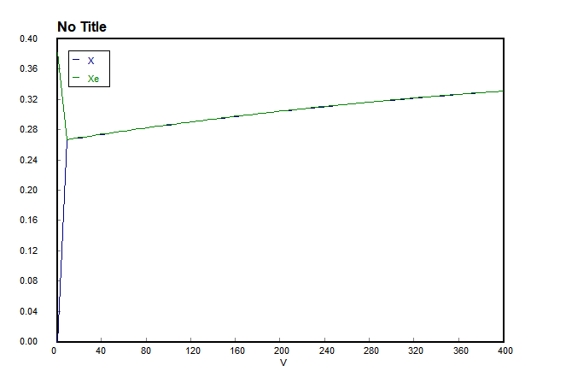

Figure 47. Graph for V and X, Xe (V up to 400 L, mc = 1000 g/s)

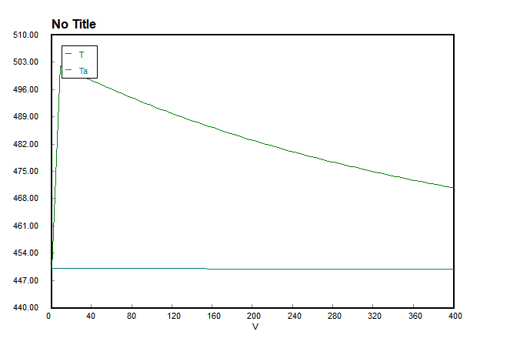

Figure 48. Graph for V and T, Ta (V up to 400 L, mc = 1000 g/s)