CS589 Machine Learning

Homework 5

Submitted by- Ravi Agrawal Due on- Dec 11nd, 2017 Submitted On- Dec 13th , 2017

1 a:

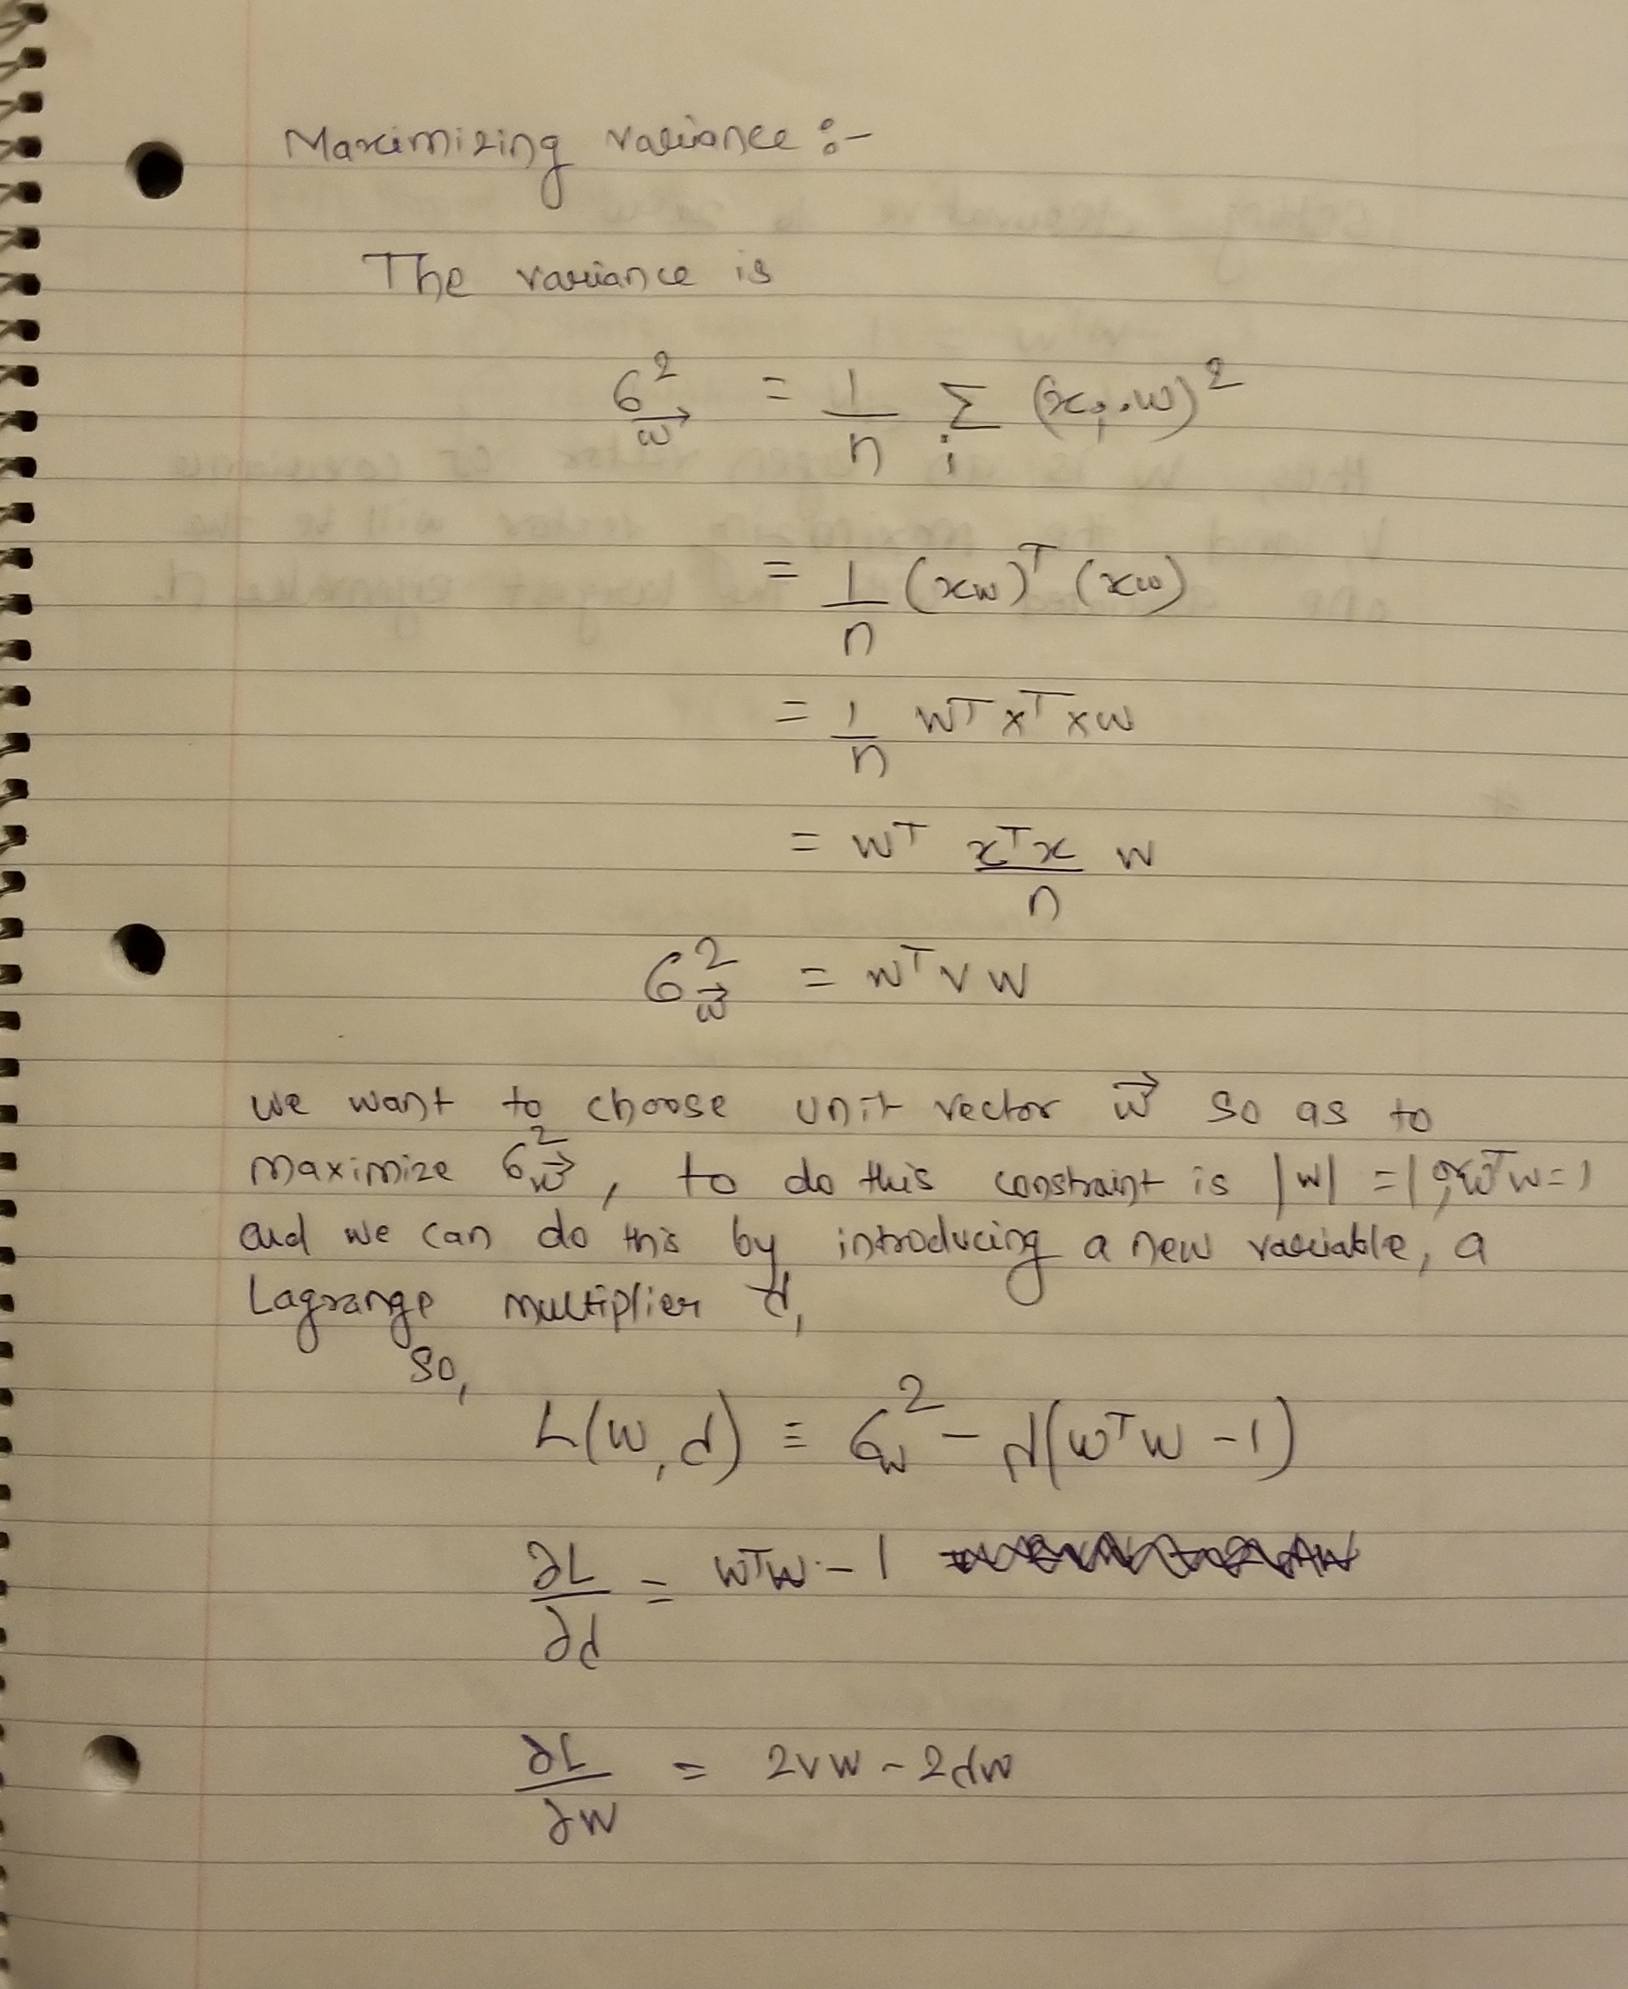

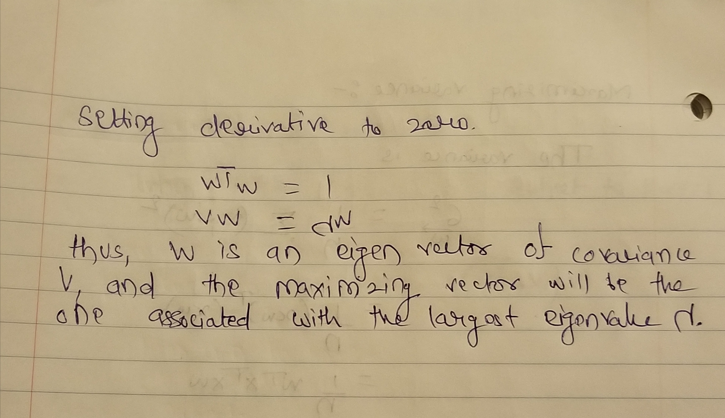

1 b:

As see in the 1a, we get the maximum variance is generated by the k maximum eigen value, it is very simple to proof that subspace of dimension 2 that maximizes the variance is associated with the eigenvalue of the first two maximum eigen value.

We know:- VW = λW gives us maximum variance of the data,

The 1 principle component that covers the maximum variance is represented as VW1 = λ1W1. Using the above equations. The Same rule applies for the two dimension VW2= λ2W2.

1 C: The Xp = ∑ αixi ∀ 1… p -1 solving this equation for p = 2 and p = 3 gives:

X2  = α1x1  Equation 1

X3  = α1x1 + α2x2 Equation 2

Here:

We can update X2  in Equation 2 to Equation 1

X3  = α1x1 + α2α1x1 Equation 3

Same is true for the higher dimension.

Say P = 4:

X4  = α1x1 + α2α1x1  + α3(α1x1 + α2α1x1) Equation 4

So, it gets clear from the above equation that most of the variance is captured by the first Eigen vector of the estimated covariance matrix. The reason this Happens is very clear from the Equation 3 and Equation 4. When we start moving to the higher dimension, the equation follows the linear relation with first Eigen vector.

1 d 1:

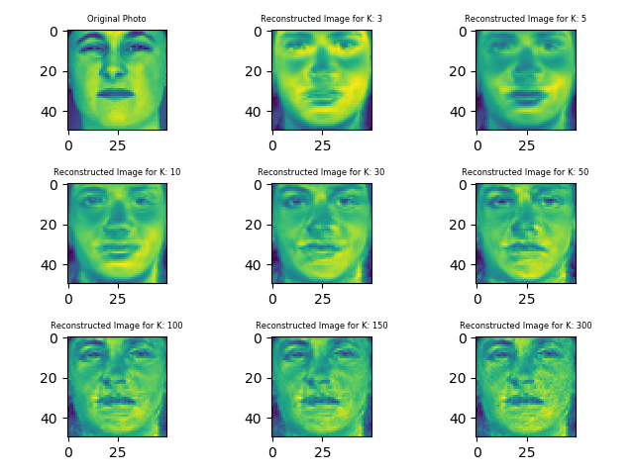

1 d 2 / 4:

|  |  |  |
| --- | --- | --- |
| **c** | **Reconstruction Error** | **Compression Rate** |
| 3 | 44.263 | 0.031 |
| 5 | 40.743 | 0.052 |
| 10 | 35.653 | 0.104 |
| 30 | 22.825 | 0.312 |
| 50 | 18.698 | 0.520 |
| 100 | 14.544 | 1.040 |
| 150 | 14.449 | 1.560 |
| 300 | 14.056 | 3.120 |

The PCA is very efficient method for the image compression, As performing the PCA in the 100 images took fraction of time as compared to the performing the k-means on a single image with the k as low as 2. But the PCA have high reconstruction Error and with the increase in the k, the compression rate also increases and in case of really high k the compression rate becomes 1.5 to 3 time of the original data set.

2 a. The elbow method in the k mean clustering is way to find the optimal number of k for the k-mean clustering. The main idea of the elbow method is to run the k-mean clustering method for the range of values of k and for each value of the k calculate the sum of squared error (SEE). When plotting the SSE for the values of the k, it looks like an arm and the elbow of that arm provide the best value of the k.

2 b: The K-mean++ is an extension to the k-mean clustering algorithm. The approach leads to the constant factor improvement. The typical approach is to choose a data example as the center for cluster, choose another data example which is at least ε distance away from the first example as center for cluster.

2 c 1.

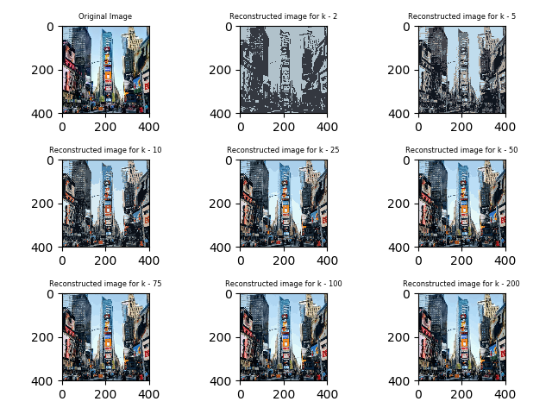

2 c 2/ 3.

|  |  |  |
| --- | --- | --- |
| **K** | **Reconstruction Error** | **Compression Rate** |
| 2 | 0.157 | 0.041 |
| 5 | 0.091 | 0.096 |
| 10 | 0.064 | 0.138 |
| 25 | 0.043 | 0.193 |
| 50 | 0.032 | 0.235 |
| 75 | 0.028 | 0.260 |
| 100 | 0.025 | 0.277 |
| 200 | 0.019 | 0.329 |

2 c 4:

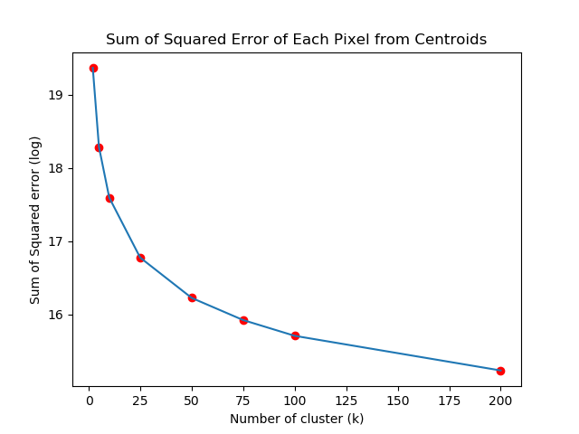

The K-means is very powerful tool for the image compression, but finding the right k can be troublesome. If the K-means is performed with very small k then we may end up with very high Reconstruction error, Sum of Squared error (SSE) or very low compression rate. If we choose k very high then the algorithms will work very well on compression without losing information but will take a long time to compress the image. The elbow graph as shown above is a great technique to found the right k to get the fast compression, without losing information.