CS589 Machine Learning
Homework 4
Submitted by- Ravi Agrawal Due on- Nov 20nd, 2017
A 1:
def p_j_alpha(j, alpha):
X_i = 1.0
if j[0] !=0:
X_i = 1e-80
else:
for i in range(1, len(j)):
X_i = X_i*alpha if j[i] == j[i-1] else X_i*(1.0 - alpha)
return X_i

A 3:
Case 3 : Input : J=(1,1,0,1,0,1) , α=0.2, Output= 1e-80 or 0.0
Case 4 : Input : J=(0,1,0,1,0,0) , α=0.2, Output=0.0819

B 1:
def p_b_j(b, j, dic):
X_i = 1.0
for i in range(len(b)):
X_i *= dic[j[i], b[i]]
return X_i
B 2:
Case 3 : Input : J=(0,1,1,0,0,1), B = (1,0,1,1,1,0), Output = 0.04147
Case 4 : Input : J=(1,1,0,0,1,1), B = (0,1,1,0,1,1), Output = 0.00014

C 1:
def p_alpha(alpha):
if alpha >= 0.0 and alpha <= 1.0:
return 1.0
else:
return 1e-80

D 1:
def p_alpha_j_b(b, j, alpha):
return p_alpha(alpha)*p_b_j(b, j, dic)*p_j_alpha(j, alpha)

D 3:
Case 3 : Input : J=(0,0,0,0,0,1), B = (0,1,1,1,0,1), α=0.63, Output= 0.00011
Case 4 : Input : J=(0,0,1,0,0,1,1), B = (1,1,0,0,1,1,1), α=0.23, Output=5.1191e-06

E :
def random_j(j):
length = len(j)
index = np.random.randint(0, length)
j_new = np.copy(j)
j_new[index] = int(not j_new[index])
return j_new

F 1:
def p_j_alpha_b(b, alpha, iteration):
j = np.array([0 for i in range(len(b))])
j_mean = np.array([0 for i in range(len(b))])
for i in range(iteration):
j_new = np.array(random_j(j))
acceprance_ratio = p_alpha_j_b(b, j_new, alpha)*1.0/p_alpha_j_b(b, j, alpha)*1.0
if random.random() <= acceprance_ratio:
j = j_new
j_mean += j
return j_mean/(1.0*iteration)

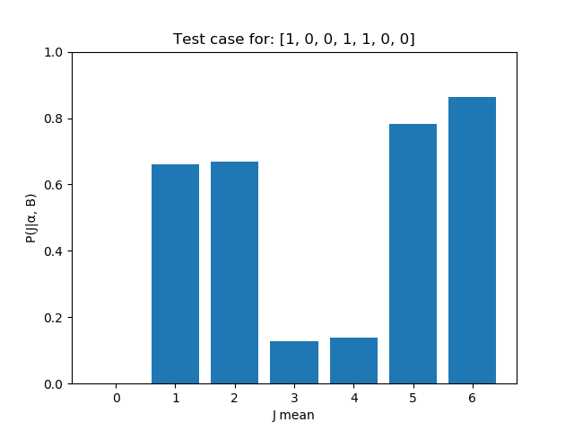
F 3:
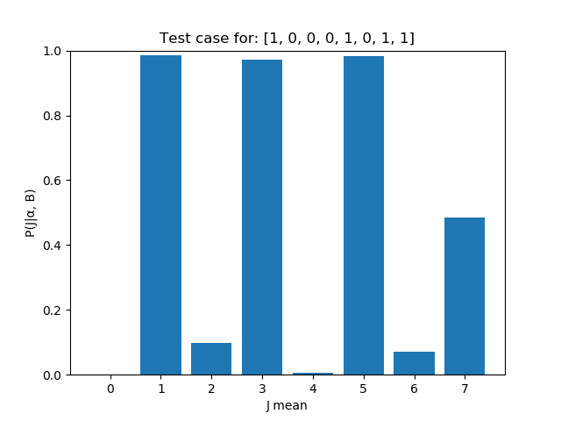

F 4:
Case 2 :
B=(1,0,0,0,1,0,1,1), α=0.11, Output=[ 0.0, 0.9778, 0.09, 0.9747, 0.0038, 0.9862, 0.0628, 0.4821]
Case 3 :
B = (1,0,0,1,1,0,0), α=0.75, Output= [ 0.0, 0.6442, 0.667, 0.1081, 0.1046, 0.7767, 0.8517]

G:
def random_alpha(alpha):
return np.random.rand()

H 1:
def p_alpha_given_j_b(j, b, iteration):
alpha_mean =[]
alpha = random.random()
for i in range(int(iteration)):
alpha_new = random_alpha(alpha)
#print(p_alpha_j_b(b, j, alpha))
acceprance_ratio = p_alpha_j_b(b, j, alpha_new)/p_alpha_j_b(b, j, alpha)
if random.random() <= acceprance_ratio:
alpha = alpha_new
alpha_mean.append(alpha)
return sum(alpha_mean)/(1.0*iteration)

H 3:
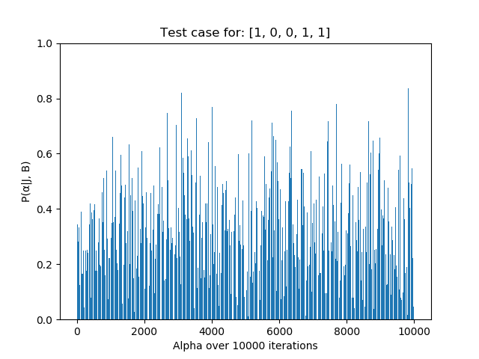

H 4:
Case 4 : Input : J=(0,1,1,1,1,1,1,0), B = (1,0,0,1,1,0,0,1), Output=0.6649
Case 5 : Input : J=(0,1,1,0,1,0), B = (1,0,0,1,1,1), Output=0.2900

I:
def proposal_alpha_j(j, alpha):
return random_j(j), random_alpha(alpha)

J 1:
def p_new_alpha_new_j_b(b, iteration):
alpha_mean = 0.0
alpha = random.random()
j = np.array([0 for i in range(len(b))])
j_mean = np.array([0 for i in range(len(b))])
for i in range(int(iteration)):
alpha_new = random_alpha(alpha)
j_new = np.array(random_j(j))
acceprance_ratio = p_alpha_j_b(b, j_new, alpha_new)/p_alpha_j_b(b, j, alpha)
if random.random() <= acceprance_ratio:
alpha = alpha_new
j = j_new
alpha_mean += alpha
j_mean += j
return j_mean/(1.0*iteration), alpha_mean/(1.0*iteration)

J 2 1:

J 2 2:

J 2 3:

J 3:

K 1:
def p_n_1_given_alpha(j_n, alpha):
if j_n == 0:
return alpha*0.8 + (1 - alpha)*0.1
if j_n == 1:
return alpha*0.1 + (1 – alpha)*0.8

K 2:
Case 3 : Input : α = 0.33456, J n = 0, Output=0.33419
Case 4 : Input : α = 0.5019, J n = 1,Output=0.44867

L 1:
def p_j_alpha_given_b(b, iteration):
j_proposed, alpha_proposed = p_new_alpha_new_j_b(b, iteration)
j = 1*(j_proposed > 0.5)
return p_n_1_given_alpha(j[-1], alpha_proposed)

M 1:
USERNAME - IMRAVIAGRAWAL:

