ENGINEERING MINI PROJECT REPORT
RippleRisk: Systemic Risk Simulation and Financial Contagion Analysis Platform


Submitted to: [COLLEGE NAME PLACEHOLDER]
Department: [DEPARTMENT PLACEHOLDER]
Subject: [SUBJECT NAME PLACEHOLDER]
Submitted by:
1. [STUDENT NAME] - [ROLL NUMBER]
2. [STUDENT NAME] - [ROLL NUMBER]
Project Guide: [GUIDE NAME PLACEHOLDER]
Academic Year: [ACADEMIC YEAR PLACEHOLDER]
Semester: [SEMESTER PLACEHOLDER]

Certificate
This is to certify that the mini project titled 'RippleRisk: Systemic Risk Simulation and Financial Contagion Analysis Platform' is a bonafide work carried out by the students listed on the cover page under the guidance of [GUIDE NAME PLACEHOLDER] in partial fulfillment of the requirements of [SUBJECT NAME PLACEHOLDER].
College: [COLLEGE NAME PLACEHOLDER] Department: [DEPARTMENT PLACEHOLDER] Academic Year: [ACADEMIC YEAR PLACEHOLDER]
Guide Signature: ____________________ HOD Signature: ____________________ Principal Signature: ____________________

Student Declaration
We hereby declare that this report is our original work, prepared using the repository artifacts available in Jinnotgin3/ripple-risk, and has not been submitted previously for any degree or diploma. We acknowledge all referenced sources.
Student Signatures:
1. ____________________
2. ____________________

Acknowledgement
We thank [COLLEGE NAME PLACEHOLDER], [DEPARTMENT PLACEHOLDER], and our guide [GUIDE NAME PLACEHOLDER] for continuous support. We also acknowledge the maintainers of the open-source technologies used in this project, including Spring Boot, React, Vite, and related libraries.

Abstract
RippleRisk is a full-stack prototype for studying systemic financial risk and contagion behavior in interconnected institutions. The repository combines a Java Spring Boot backend and a React TypeScript frontend. The backend exposes REST APIs for authentication, entity management, and exposure management, with persistence through Spring Data JPA and an in-memory H2 database. Security configuration includes stateless session policy, CORS control, and endpoint authorization rules. The frontend provides routed pages for login, network setup, scenario configuration, result visualization, intervention comparison, executive reporting, and audit viewing. Repository analysis shows that core data-management APIs are implemented and can be integrated with UI flows, while several simulation and reporting views currently use static sample datasets for demonstration. This distinction is important for engineering evaluation: existing code demonstrates architecture, componentization, styling consistency, and dashboard interaction design, but does not yet include a backend contagion computation engine or complete production authentication. The project is therefore suitable as an academic mini project for software architecture, API design, and financial risk dashboard prototyping, with clear future scope for algorithmic simulation, persistent storage migration, robust JWT validation, role-based access control, and automated tests.

Preliminary Pages

Table of Contents

If the table of contents does not auto-populate, open the file in Microsoft Word, right-click inside the TOC, and choose 'Update Field' then 'Update entire table'.

List of Figures
1. Figure 1.1: RippleRisk High-Level Architecture
2. Figure 3.1: Use-Case Diagram
3. Figure 4.1: Backend Class Diagram
4. Figure 4.2: Login Sequence
5. Figure 4.3: Current Simulation Activity Flow
6. Figure 4.4: H2/JPA Schema Diagram

List of Tables
1. Table 3.1: Functional Requirements Grounded in Repository
2. Table 3.2: Execution Requirements
3. Table 6.1: Derived Validation Cases

Chapter 1: Introduction

1.1 Background
RippleRisk targets systemic-risk modeling where institutions are connected through directed credit/exposure links. The root README and frontend modules describe lender-borrower style networks and shock-oriented analysis workflows.

1.2 Motivation
Traditional isolated risk views can miss cascade effects across counterparty links. This project motivates a connected-network perspective where distress propagation can be observed over multiple rounds.

1.3 Problem Statement
Design and implement a web-based platform that records financial entities and exposures, supports scenario inputs, and presents contagion-oriented analytical views for learning and experimentation.

1.4 Aim and Objectives
Objectives implemented in code include: (i) secure login endpoint and frontend login flow, (ii) CRUD-style entity/exposure APIs, (iii) routed UI modules for scenarios, results, compare, report, and audit pages, and (iv) reusable formatting and UI component patterns.

1.5 Scope and Significance
Current scope is prototype-level. Backend simulation computation and persistent production storage are outside current implementation but are clear extension points.

1.6 Proposed Solution
The repository adopts a decoupled frontend-backend architecture with API proxying during development. This supports modular growth and staged feature completion.
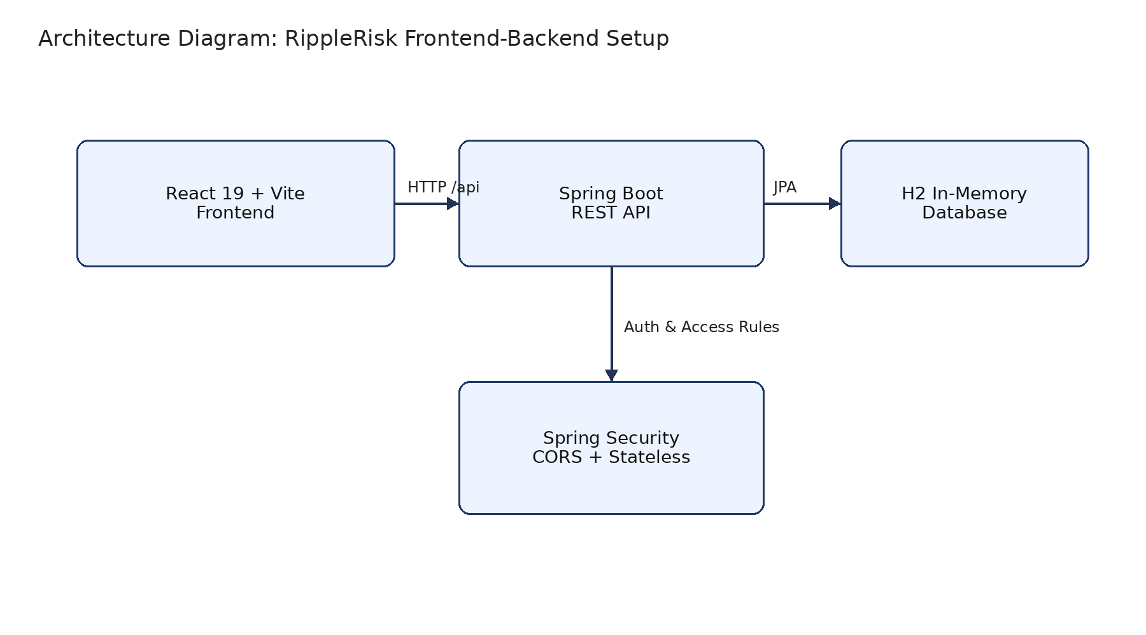
Figure 1.1: RippleRisk High-Level Architecture

Chapter 2: Literature Survey and Existing System

2.1 Relevant Technical Sources
The implementation aligns with established practices in Spring Boot web development [1], Spring Security [2], Spring Data JPA [3], React [4], and Vite development proxying [5].

2.2 Existing System in Repository
Implemented backend controllers expose endpoints for login, entity management, and exposure management. Frontend pages for scenarios, results, compare, report, and audit presently display static/demo content rather than backend-computed simulation outputs.

2.3 Limitations
A complete contagion algorithm service, persistent production database integration, and robust JWT validation filter chain are not currently present in this codebase.

2.4 Proposed System Advantages
Despite prototype gaps, the repository already demonstrates modular code organization, API boundary clarity, and a clean basis for implementing future quantitative models and stronger security hardening.

Chapter 3: Software Requirements and System Analysis

3.1 Functional Requirements
ID | Requirement | Repository Evidence
FR1 | User login request and token response | backend/controller/AuthController.java + frontend/pages/Login.tsx
FR2 | Create/read/update/delete risk entities | backend/controller/EntityController.java
FR3 | Create/read/delete exposures | backend/controller/ExposureController.java
FR4 | Scenario configuration UI | frontend/pages/Scenarios.tsx
FR5 | Results/compare/report/audit views | frontend/pages/Results.tsx, Compare.tsx, Report.tsx, Audit.tsx
Table 3.1: Functional Requirements Grounded in Repository

3.2 Non-Functional Requirements
Development-time usability (Vite), modular maintainability (componentized frontend + layered backend), and secure defaults (stateless policy + protected endpoints) are reflected in current code.

3.3 Hardware and Software Requirements
Category | Requirement
Backend | Java 21, Maven, Spring Boot 3.3.5
Frontend | Node.js/npm, React 19, Vite
Database | H2 in-memory
OS | Any OS with Java + Node runtime support
Table 3.2: Execution Requirements

3.4 Feasibility and Use Cases
Technical feasibility is high for academic deployment because dependencies are standard and setup is straightforward. Use cases include authenticated access, entity/exposure maintenance, and scenario/result exploration.
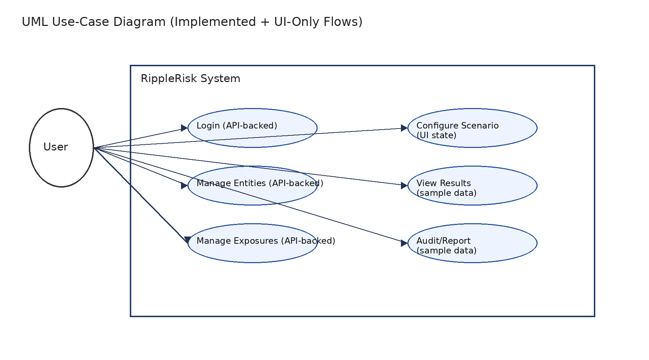
Figure 3.1: Use-Case Diagram

Chapter 4: System Design and Architecture

4.1 Module View
Frontend modules are organized under pages/components/lib/styles, while backend modules are structured as config/controller/entity/repository.

4.2 UML/Class Relationships
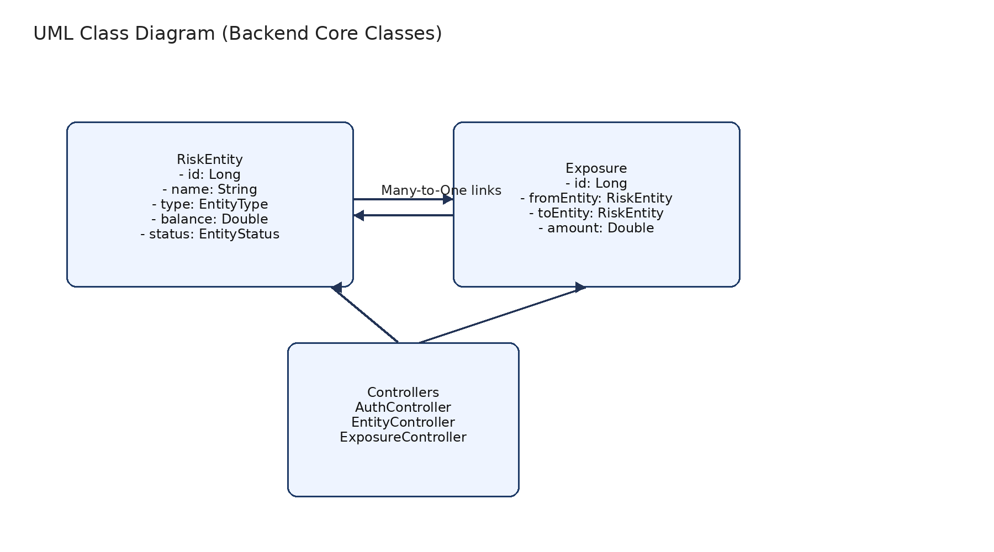
Figure 4.1: Backend Class Diagram

4.3 Sequence Workflow
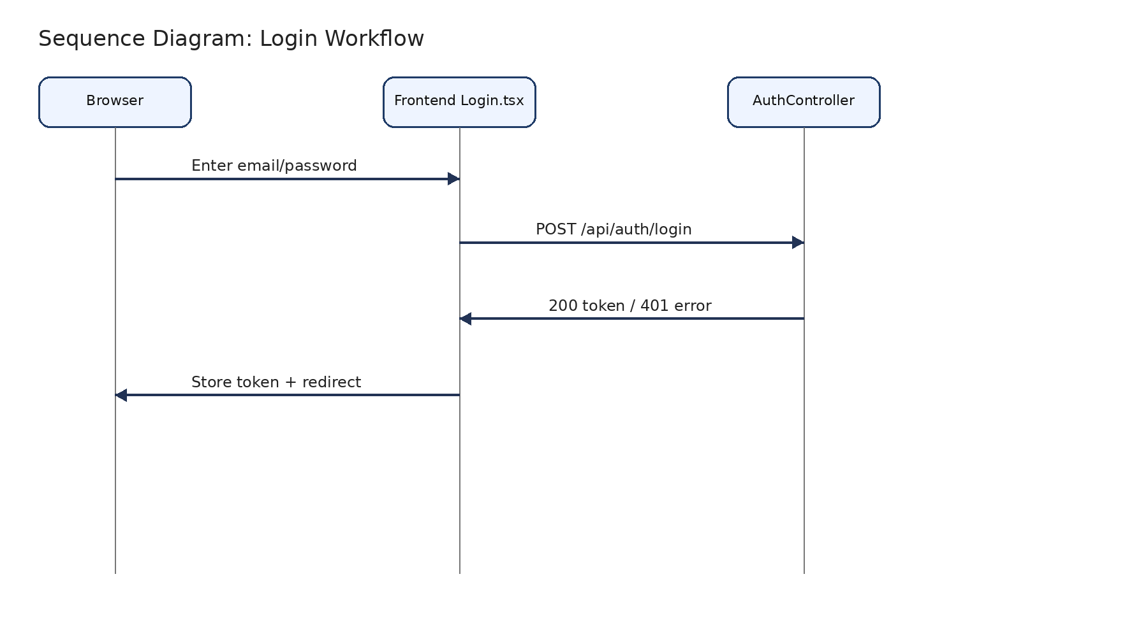
Figure 4.2: Login Sequence

4.4 Activity Flow
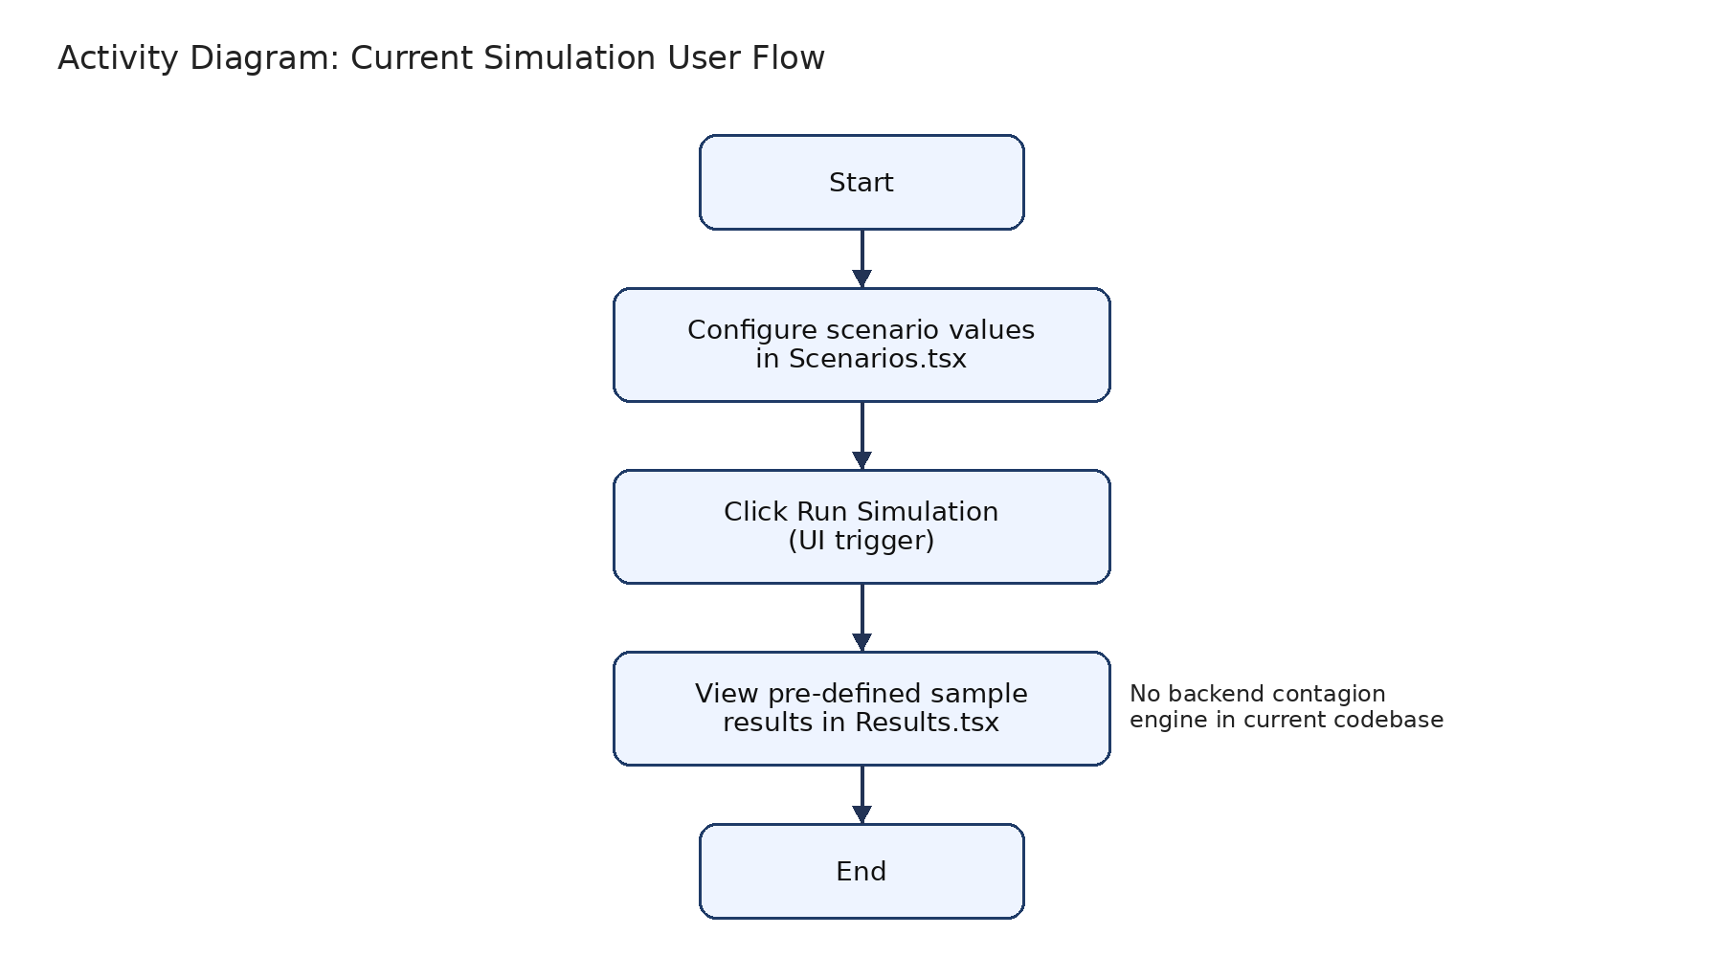
Figure 4.3: Current Simulation Activity Flow

4.5 ER/Schema Design
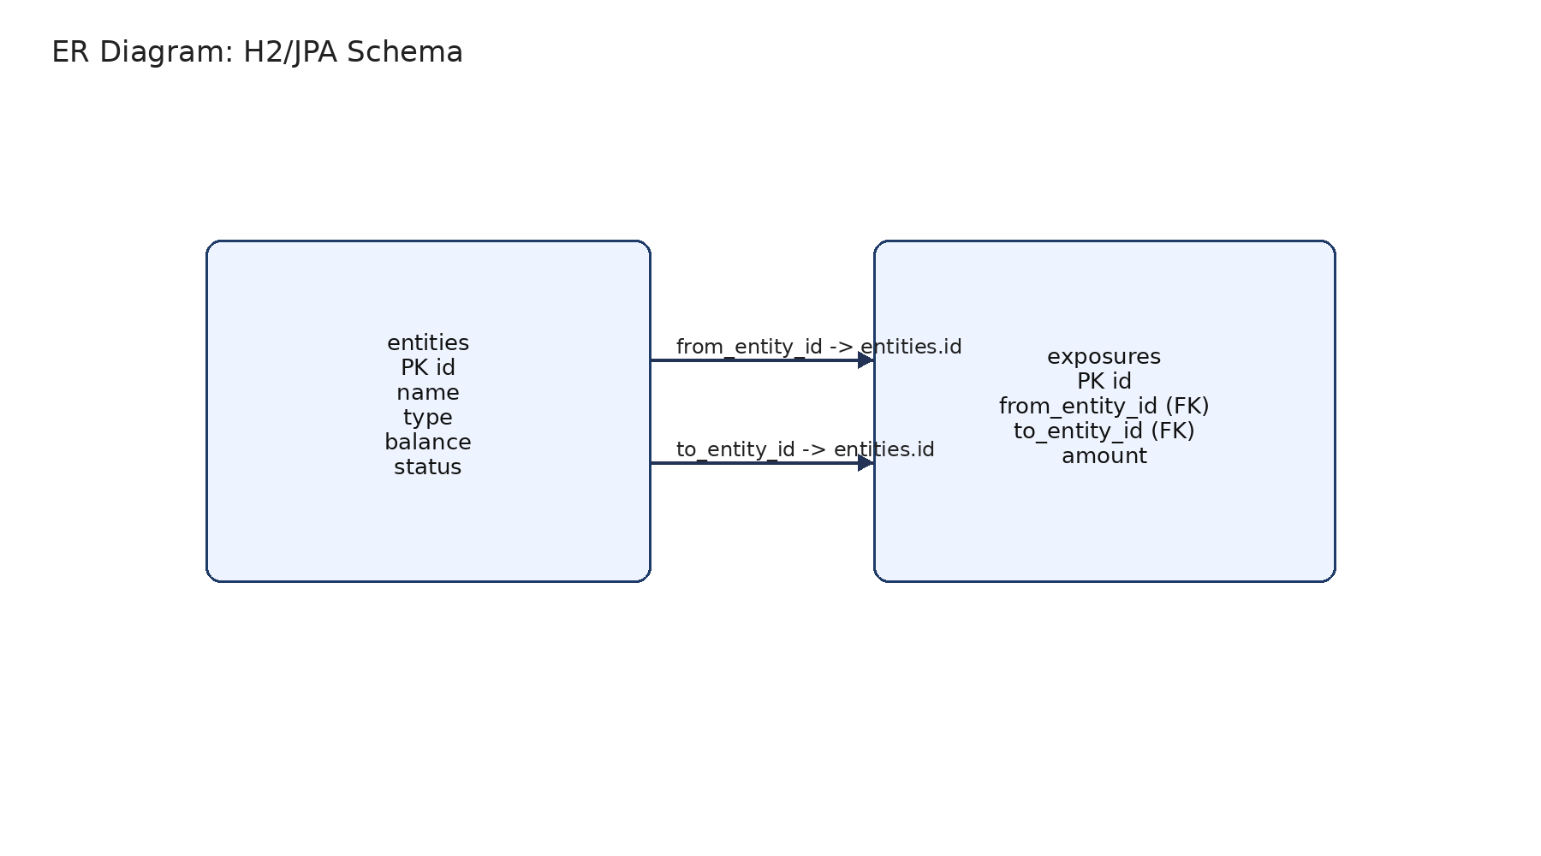
Figure 4.4: H2/JPA Schema Diagram

Chapter 5: Technology Stack and Implementation

5.1 Actual Technology Stack
Backend: Spring Boot Web, Data JPA, Validation, Security, H2. Frontend: React, TypeScript, Vite, Tailwind CSS, Lucide icons. Build tools: Maven and npm.

5.2 Repository Structure
backend/
src/main/java/com/ripplerisk/{config,controller,entity,repository}
src/main/resources/application.properties
frontend/
src/{pages,components,lib,styles}
package.json, vite.config.ts

5.3 Important Implemented Workflows
Login flow posts credentials from Login.tsx to /api/auth/login and stores token client-side. Entity and exposure management are supported by dedicated REST controllers and JPA repositories.

5.4 Setup and Run Steps
cd backend && mvn clean spring-boot:run
cd frontend && npm install && npm run dev

5.5 Sanitized Code Snippets
@PostMapping("/login")
public ResponseEntity<?> login(@RequestBody Map<String,String> body) { ... }
const SHOCK_TYPES = ["CREDIT_DEFAULT","LIQUIDITY_CRUNCH","MARKET_SHOCK","REGULATORY_ACTION"];

Chapter 6: Testing and Results

6.1 Available Test Infrastructure
No dedicated backend or frontend test classes/spec files were found in the repository snapshot inspected for this report. Therefore, validation focused on build/lint execution and report-generation checks.

6.2 Test-Case Table (Derived)
TC ID | Scenario | Expected Behavior | Status Basis
TC1 | POST /api/auth/login with valid demo credentials | Returns token payload | Implemented in AuthController
TC2 | GET /api/entities | Returns entity list | Implemented in EntityController
TC3 | POST /api/exposures | Persists exposure | Implemented in ExposureController
TC4 | Navigate /results page | Shows sample metrics and timeline | Implemented in Results.tsx (static data)
Table 6.1: Derived Validation Cases

6.3 Screenshots
Screenshot placeholders are used in this report because runtime screenshots were not bundled in the repository. Capture guidance: run backend and frontend locally, open each route, and replace placeholders with actual captures.
Placeholder list: Login, Networks, Scenarios, Results, Compare, Report, Audit pages.

6.4 Observed Limitations and Error Handling
Because several frontend pages rely on static arrays, simulation outputs are illustrative. Backend validation annotations exist on entity endpoints, and missing IDs return HTTP 404 responses where implemented.

Chapter 7: Conclusion and Future Scope
RippleRisk demonstrates a clean full-stack baseline for systemic-risk platform development, with concrete API and UI modules already in place. It is suitable for academic demonstration of architecture, REST integration, and financial dashboard design.
Future scope includes: implementing contagion computation service and persistence of scenario runs, replacing static frontend datasets with API-backed data, introducing strong JWT issuance/validation and role-based authorization, adding automated tests, and migrating from in-memory to persistent database for production readiness.

References
[1] Spring Boot Reference Documentation, https://docs.spring.io/spring-boot/docs/current/reference/html/
[2] Spring Security Reference, https://docs.spring.io/spring-security/reference/
[3] Spring Data JPA Reference, https://docs.spring.io/spring-data/jpa/reference/
[4] React Documentation, https://react.dev/
[5] Vite Documentation (Server Proxy), https://vite.dev/config/server-options.html#server-proxy
[6] H2 Database Engine Documentation, https://h2database.com/html/main.html
[7] Apache Maven Documentation, https://maven.apache.org/guides/index.html

Appendix

A. API Samples (Sanitized)
POST /api/entities
{"name":"Apex Bank","type":"LENDER","balance":5000000,"status":"HEALTHY"}
POST /api/exposures
{"fromEntity":{"id":1},"toEntity":{"id":2},"amount":800000}

B. Configuration (Sanitized)
spring.datasource.url=jdbc:h2:mem:rippledb...
ripple.cors.allowed-origins=http://localhost:5173

C. Figure Assets Directory
All generated diagram assets are stored under report_assets/ and can be edited/re-generated by rerunning generate_report.py.

