3-Fold Cross Validation Report

1. Full Bayes:
   1. Confusion Matrix for 3-Folds:

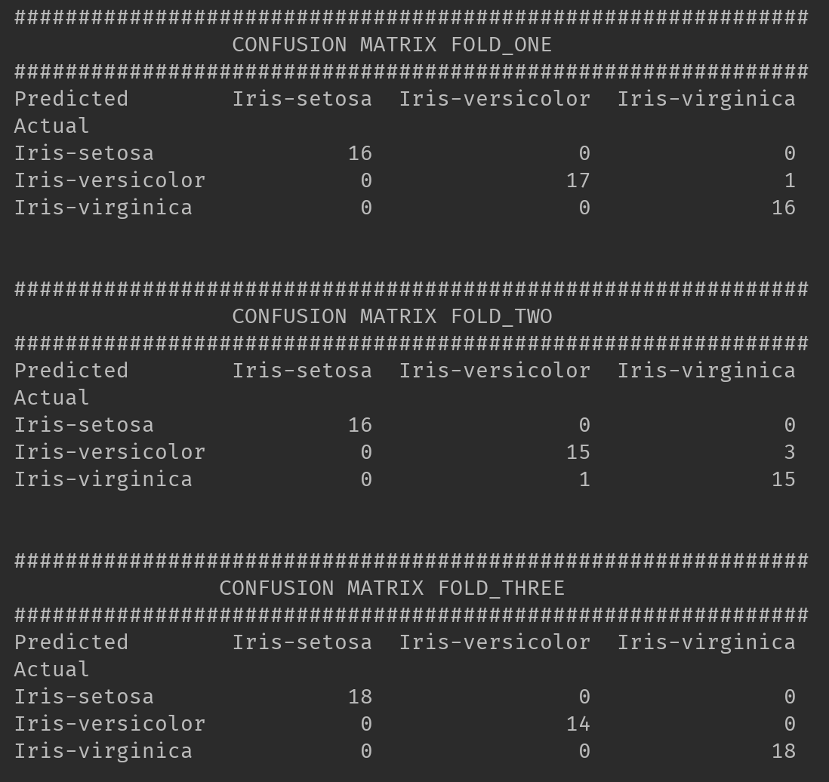

* 1. Assessment for each class:

Output from console:

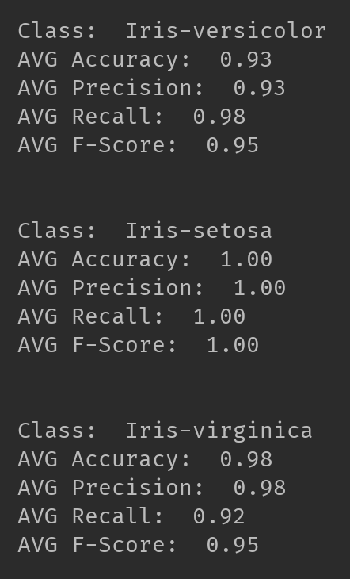

|  |  |  |  |
| --- | --- | --- | --- |
| Class | Iris-versicolor | Iris-setosa | Iris-virginica |
| AVG Accuracy | 0.93 | 1.00 | 0.98 |
| AVG Precision | 0.93 | 1.00 | 0.98 |
| AVG Recall | 0.98 | 1.00 | 0.92 |
| AVG F-Score | 0.95 | 1.00 | 0.95 |

1. Naïve Bayes
   1. Confusion Matrix for 3-Folds:
   2. Assessment for each class:

Output from console:

|  |  |  |  |
| --- | --- | --- | --- |
| Class | Iris-versicolor | Iris-setosa | Iris-virginica |
| AVG Accuracy | 0.91 | 0.98 | 0.94 |
| AVG Precision | 0.91 | 0.98 | 0.94 |
| AVG Recall | 0.92 | 1.00 | 0.90 |
| AVG F-Score | 0.91 | 0.99 | 0.92 |