**159.339 Assignment 2 Report**

1. **File Order**

The chart below shows order of files loading in details.

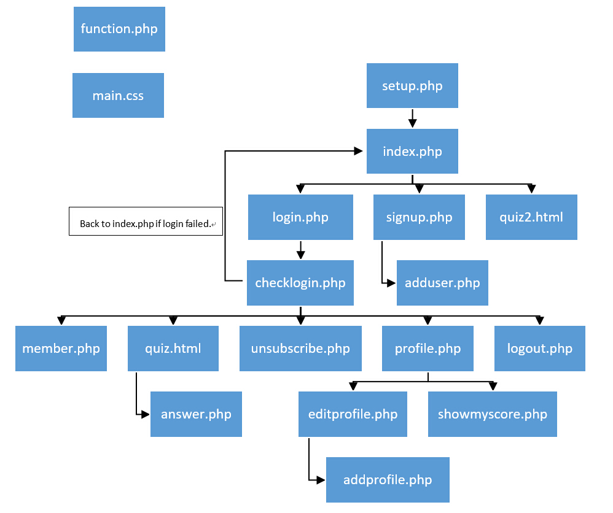

1. **Purpose of files included**

setup.php - let users connect database and create tables.

index.php - A home page file, provides buttons of Login, Quiz, etc.

login.php – A page to let user login account.

signup.php – A page to let user signup account.

quiz.html - provides a quiz page, is loaded when user is logged-in.

quiz2.html - same as quiz.html, but is loaded when user is not logged-in.

checklogin.php – Is used to verify user login info correction.

adduser.php – A page to show successful signup info.

member.php – A page that shows all registered username and scores.

Unsubscribe.php – To delete registered user from database.

profile.php – A page that displays user’s profile and options.

logout.php – Log out from current account.

answer.php – A page to display feedback after quiz.php is submitted.

editprofile.php – A page allows user to update status.

showmyscore.php – A page to display user’s highest score.

addprofile.php – To add profile info into database.

main.css - Used to render buttons and fonts canvas.

1. **Application Screenshots**

Below are four screenshots of homepage, quiz page, login page, member’s profile page.

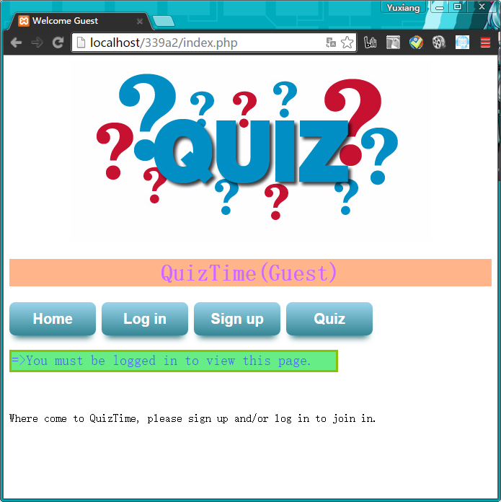

(Home page)

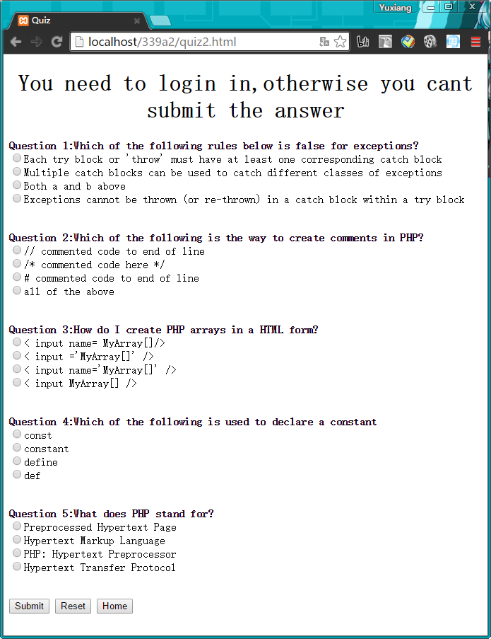

(Quiz page when unlogged-in)

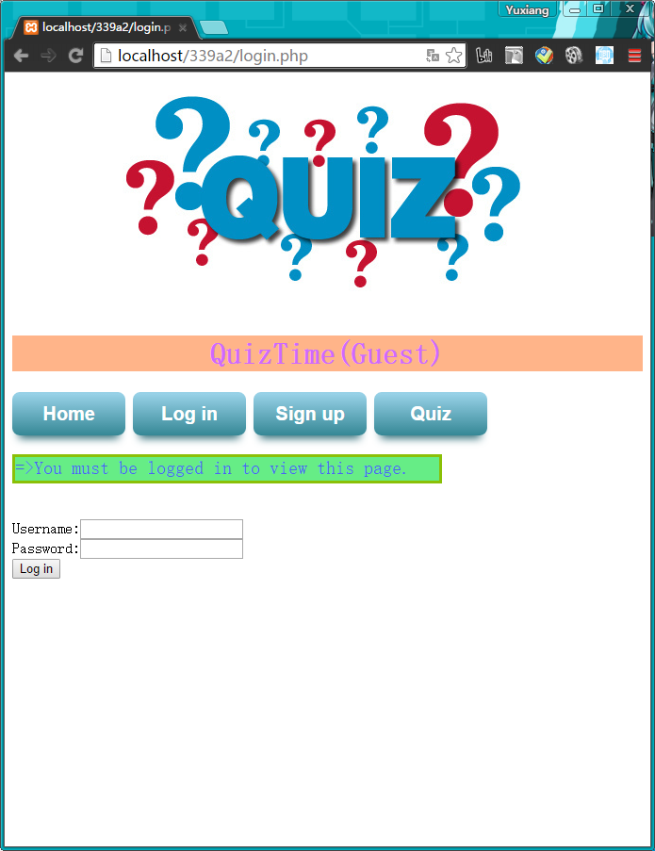

(Log in page)

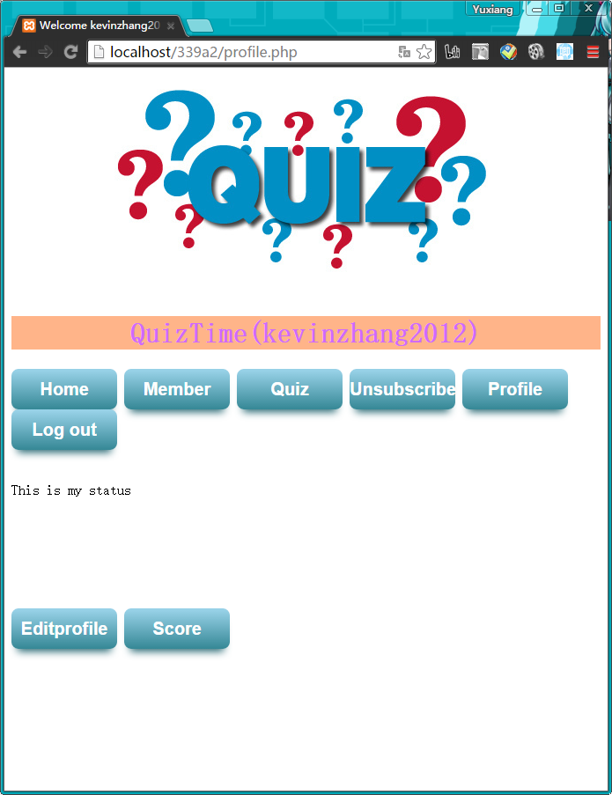

(Member’s profile page)

Part 3 report

a)

When user submit their quiz. The “answer.php” will give a feedback. The total score will be printed and the wrong answer and correct answer will also be printed. Different score will get different feedback.

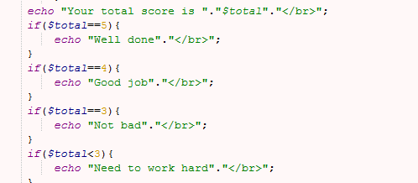

b)

We use JavaScript to randomly take 5 different question for 20 question.(quiz.html)

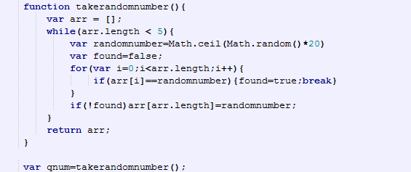

This function will return array and this array has 5 different number which are smaller than 20. We use those number to take questions. And this array will also be stored in hidden tag.





So when user submit their quiz, the “answer.php” will get those number and use them to check answer.

c)

When user submit their quiz. The total score will be printed on screen. The “answer.php” will compare the previous score which was stored in database. If the total score is bigger than previous score, the new will be stored in database. Otherwise the score in database will not be changed.

