Lab#-14 Tasks

Name:

JinsarAhmed

Roll no:

20SW116

Topic:

Develop a dashboard using Power BI tool.

* **Dataset:** <https://www.kaggle.com/datasets/abecklas/fifa-world-cup>
* KPIs
* Which team won the most World Cups, and how many wins was that?
* Which Finals or Semi-final games were decided by penalties?
* Which years had the highest and lowest attendance to the World Cup games?
* What's the average number of goals scored per World Cup?
* How many countries qualified for the World Cup in 1930 compared to 2014?
* Does history show more home-team wins or away-team wins?

TASK 01:

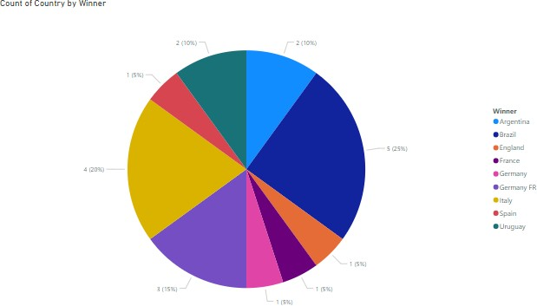

TASK 02:

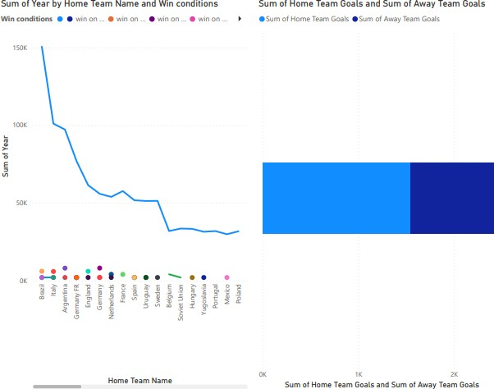

TASK 03:

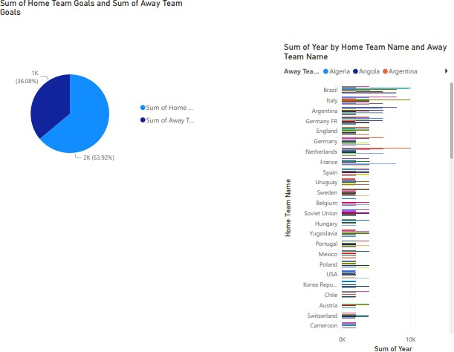

TASK 04:

THE END