MoshiMoshi

by

4AGI

Team: Loh Jinsen, Sim Shi Zhen, Chia Zi Qi, Ng Joey
Problem Statement: Stress & Workload Manager
Video Presentation: [Unlisted Youtube Link]
Presentation Slides: [https://canva.link/evvrrgeeuauiilh]
1. Project Overview 3
1.1 Our Solution 4
1.1.1 Feature Set 4
2.1 Ideas We Considered 5
2.2 Ideation Boards 8
2.3 Mentor Consultation 9
3. Design & Prototype 10
4. What Makes It Different 17
5. Technical Architecture & Feasibility 19
5.1 Tech stack 19
5.2 System architecture diagram 21
5.3 Build Plan & Scope 21

1. Project Overview
University students are the primary stakeholders of this problem. University life requires students to manage far more than lectures and assignments. A typical student may face overlapping deadlines, examinations, group projects, club activities, part-time work, social commitments, insufficient rest and personal errands which all within an irregular schedule that can change at short notice.
These responsibilities are often scattered across learning platforms, assignment documents, calendars, messaging applications and handwritten notes. Because there is no single view of the student’s total load, students may know that they feel overwhelmed without knowing exactly which part of their life is causing the imbalance or what they should change first.
This challenge is particularly relevant to university students for four reasons:
- Their schedules are irregular. Classes, consultations and group meetings do not always follow a consistent daily routine.
- Deadlines frequently overlap. Requirements from different subjects are often planned independently, causing workload peaks.
- They are developing independent habits. Many students are managing their own time, health and responsibilities for the first time.
- Stress affects several areas at once. Academic pressure can lead students to sacrifice sleep, exercise, meals, relationships and essential errands.
The wider stakeholders include lecturers and project teammates whose deadlines and meetings affect the student’s schedule, friends and family who provide social support, and university counsellors or student-support services that assist students experiencing serious or prolonged distress. However, MoshiMoshi is designed primarily around the student’s daily experience.
Several applications already address individual parts of this problem:
- Todoist helps users capture, organize and prioritize tasks. However, it still depends heavily on users entering and managing their responsibilities, and its main focus is task productivity rather than the interaction between workload and well-being.
- Headspace provides meditation, mindfulness, sleep and mental-health resources. However, it does not reorganize the academic deadlines, meetings or errands that may be causing a student’s stress.
- Finch makes self-care engaging through a virtual pet that grows when users complete self-care activities. However, its main focus is user-selected self-care goals rather than interpreting the student’s academic schedule and rebalancing the causes of overload.
These applications are valuable within their own areas, but the student must still recognize the problem, open the appropriate application and decide what to do. The missing element is a continuous connection between workload awareness, well-being, practical rebalancing and recovery. University students therefore need more than another task list or meditation library. They need a low-friction system that brings their academic and personal responsibilities together, identifies which area is becoming overloaded and recommends a realistic next action before pressure develops into burnout.

1.1 Our Solution
MoshiMoshi is a proactive, privacy-conscious AI workload and well-being companion designed specifically for university students. It brings together tasks, timetables, assignment guidelines, meetings, errands and student-provided well-being information to present the student’s load across five dimensions: Mental, Time, Physical, Social and Errands. When an imbalance is detected, MoshiMoshi helps the student decide what must be completed, what should be done and what can safely wait. It then recommends a suitable recovery activity and rewards healthy actions with points, items and character growth.

1.1.1 Feature Set
- Five-Dimensional Load Overview
MoshiMoshi organizes the student’s daily load into five connected dimensions:
  - Mental: Emotional pressure, concentration demands and feelings shared by the student
  - Time: Classes, deadlines, meetings and schedule conflicts
  - Physical: Prolonged work, rest, movement and recovery
  - Social: Group meetings, friendships and opportunities for social support
  - Errands: Laundry, shopping, meals and other personal responsibilities
- The dashboard shows which dimensions are healthy, rising or overloaded instead of reducing the student’s situation to one unexplained stress score.
- AI-Assisted Task Rebalancing
When the student’s workload becomes unbalanced, MoshiMoshi organizes responsibilities into Must Do, Should Do and Can Wait. It then recommends practical changes, such as moving a flexible gym session or recorded lecture to another day. The student can accept or reject each suggestion before the schedule is updated.
- Flexible Task Collection
Students can add responsibilities through manual entry, voice conversation, timetable or assignment upload, calendar synchronization and nearby-location exploration. These options reduce repeated data entry while preserving manual control.
- Calendar and Meeting Integration
The proposed integration with Google Calendar, Microsoft Outlook, Google Meet and Microsoft Teams brings classes, deadlines and group meetings into the same daily plan.
- Talk-to-Moshi Voice Companion
Students can naturally describe their plans or feelings. For example: “I am tired today. I have an assignment tomorrow, a group meeting tonight and I still need to do my laundry.” Moshi can identify the relevant responsibilities, recommend a suitable next step and ask for confirmation before changing the plan.
- Context-Appropriate Recovery Activities
MoshiMoshi offers recovery activities of different lengths, including guided breathing, stretching, power naps, short walks, relaxing audio and sleep preparation. This allows the recommendation to fit the student’s available time rather than requiring a long wellness routine.
- Guided Breathing Mini-Game
The breathing activity guides the student through a 4–2–4 rhythm: breathe in for four seconds, hold for two seconds and breathe out for four seconds. The animation and progress indicator transform a short recovery break into a simple interactive challenge.
- Recovery Reward Loop
Students earn points for completing healthy actions such as a guided breathing session, an appropriate break, stretching, walking, protecting sleep or rebalancing an unrealistic plan. Points can be exchanged for food, books, artwork, games and other supplies for the Moshi character.
- Growing Moshi Companion
Moshi gains progress as the student maintains healthier habits. The central idea is: when the student takes care of themselves, Moshi grows too. This rewards recovery and healthy boundaries rather than only rewarding the completion of more work.
- Location-Aware Activities and Errands
With permission, students can explore nearby services and activities, view estimated travel time and add the selected location to their schedule. This makes the Errands dimension and daily workload more realistic.
- Supportive Student Community
Students can create groups, add friends and participate in shared activities. The community is intended to encourage consistency and mutual support rather than competition over who works the longest.
- Privacy-Conscious Intelligence
MoshiMoshi is designed to prioritize local processing for sensitive contextual information wherever technically suitable. Students should be able to understand which data sources are connected, why information is needed and how access can be paused or removed.

2. Ideation & Process

2.1 Ideas We Considered
Table of every distinct idea generated, with why each was kept or dropped, order it so that chosen ideas are listed first
Idea | Why it was dropped / kept
Five-dimensional workload overview (Chosen) | Stress is not caused by academic tasks alone. The five dimensions provide a clearer and more actionable picture of the student’s situation.
Proactive AI support (Chosen) | Students who are already overloaded may not consistently record every task and emotion. Contextual assistance reduces this burden.
AI companion with natural conversation (Chosen) | A supportive character makes check-ins feel more human and less like completing another form.
AI task rebalancing (Chosen) | A warning alone does not solve overload. Students need help deciding what must be done and what can wait.
Privacy-conscious edge processing (Chosen) | Academic documents, activities and personal conversations may contain sensitive information. Local processing should be prioritized where suitable.
Calendar and meeting integration (Chosen) | Classes and group meetings affect the student’s Time and Social load and should be included automatically where possible.
Timetable and assignment upload (Chosen) | Important academic requirements may be stored in documents rather than calendars. Uploading reduces repeated entry.
Voice-based task and emotion capture (Chosen) | Speaking can be easier than navigating multiple forms when the student is tired or busy.
Context-appropriate recovery suggestions (Chosen) | A short intervention that fits the student’s available time is more practical than a generic recommendation.
Guided breathing mini-game (Chosen) | It turns a short break into a structured and achievable activity with immediate feedback.
Points, item shop and character growth (Chosen) | The reward loop gives emotional meaning to healthy habits and supports continued engagement.
Location-aware activity and errand planning (Chosen) | Travel and completion time affect whether an activity is realistic and should be reflected in the student’s load.
Student community (Chosen) | Friends and groups can provide motivation and support, especially during demanding academic periods.
Fully manual task and mood logging (Dropped) | It repeats the reactive pattern of existing tools and creates the most friction when students are already overloaded. Manual entry remains available as a fallback.
Fixed timetable-based reminders (Dropped) | A reminder based only on time may appear during an unsuitable activity and become easy to ignore.
Single overall stress score (Dropped) | One score identifies a problem but does not explain its cause or show what the student should change.
Long meditation sessions as the main recovery method (Dropped) | Long sessions may be unrealistic during classes and deadline periods. Short recovery activities are more accessible.
Going out as the default recovery action (Dropped) | It may require too much time or energy. It remains an option when the student’s context allows it.
Rewards based only on task completion (Dropped) | This could encourage overwork. MoshiMoshi also rewards recovery, sleep, balance and appropriate help-seeking.

2.2 Ideation Boards
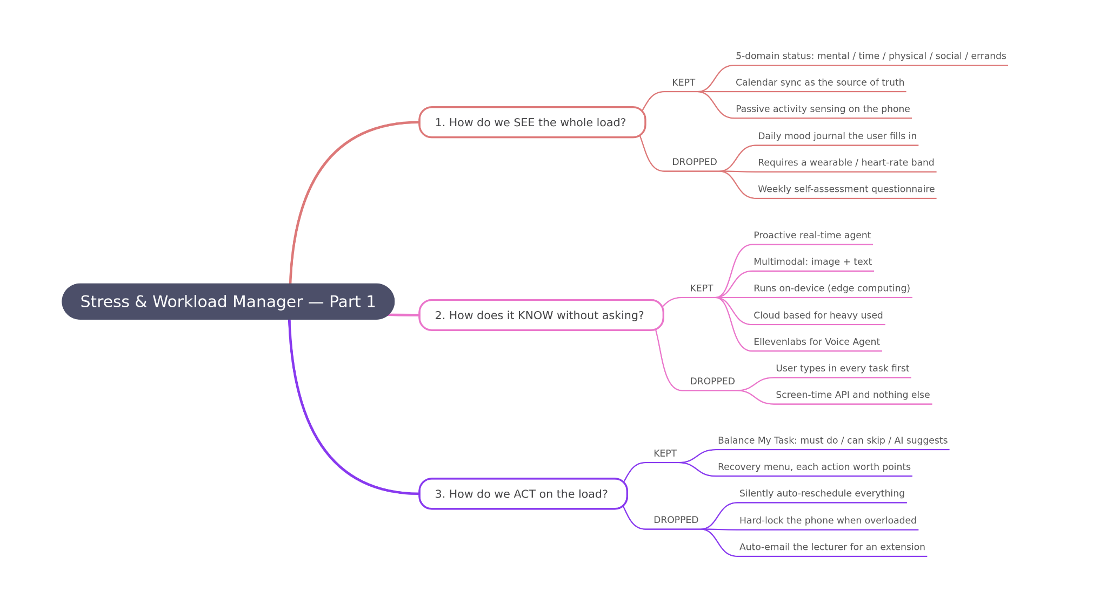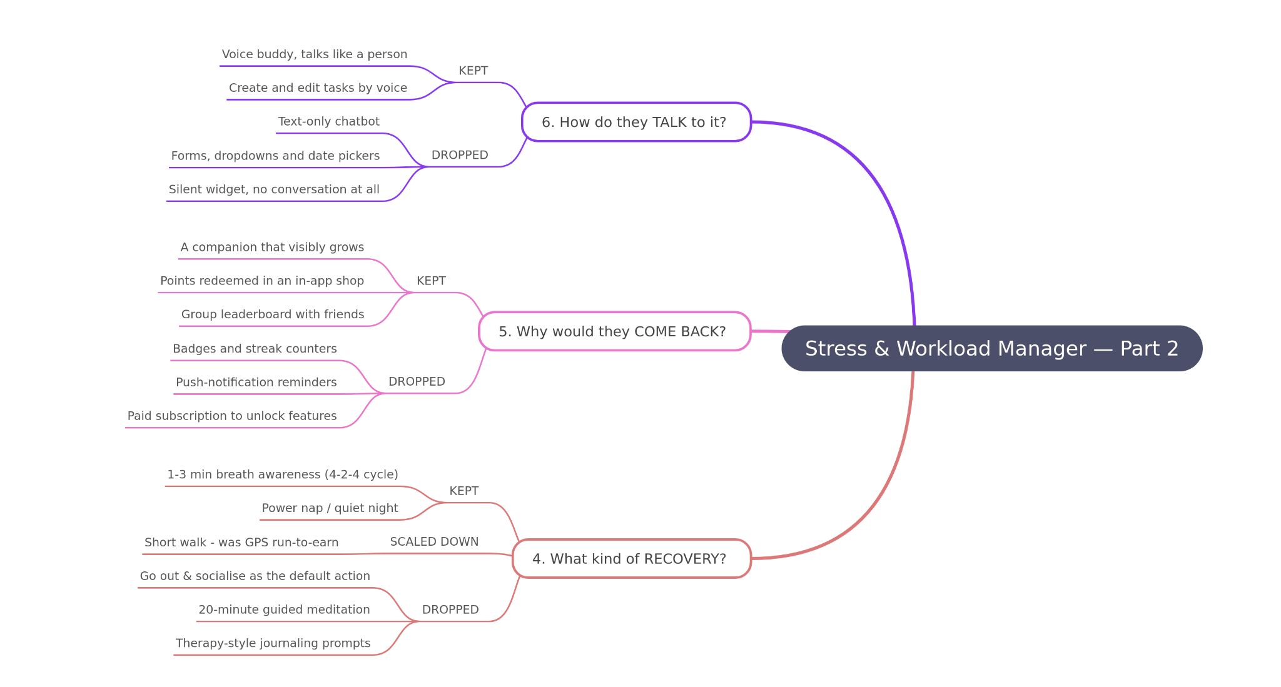

2.3 Mentor Consultation
Date | Mentor | Feedback Received | What Was Changed
10 September 2026 | Kueh Pang Teng | Mentor pointed out a privacy concern with our screen tracking approach. To detect what the student is working on, we planned to capture screenshots of the computer screen and run an AI model over each image to do checking. However, if checking is done in the cloud, every screenshot has to be sent to the data centre. This will expose the student’s privacy to possible data leakage, such as assignments, personal files, messages, and others. | We rearchitected the intelligence to run on the edge device (the user’s phone) instead of the cloud. We will train a small AI model and deploy it on device, so the screenshots are analysed locally and the user’s data never leaves their own devices. Only non-sensitive derived results will be sent to the cloud. This removed the central data center stored entirely and turned privacy into a built-in prperty of the architecture rather than a policy promise.

3. Design & Prototype
UI Prototype: [ MoshiMoshi - Figma ]
Home Page
The Home Page provides quick access to the main features of the app, including Task, Voice, Recovery, and Community. The character changes its expression based on the daily status and shows its thoughts. Clicking the character opens the profile and shop, while clicking Today’s Status shows the current daily status.
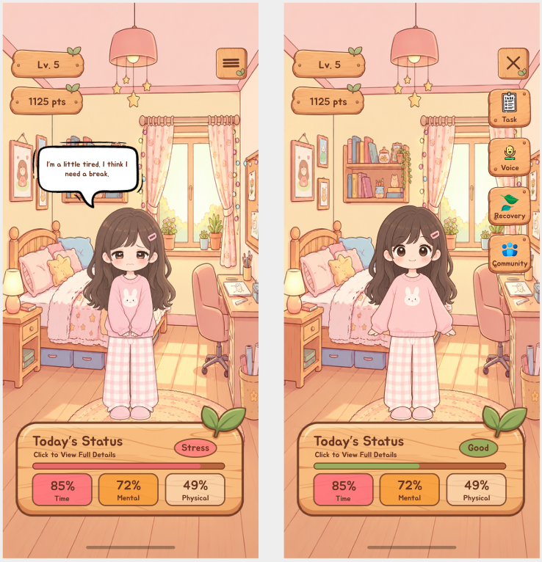
Profile Page
The Profile Page shows the character’s level, points, and progress. The shop allows points to be exchanged for different food and activity items, which can help the character grow.
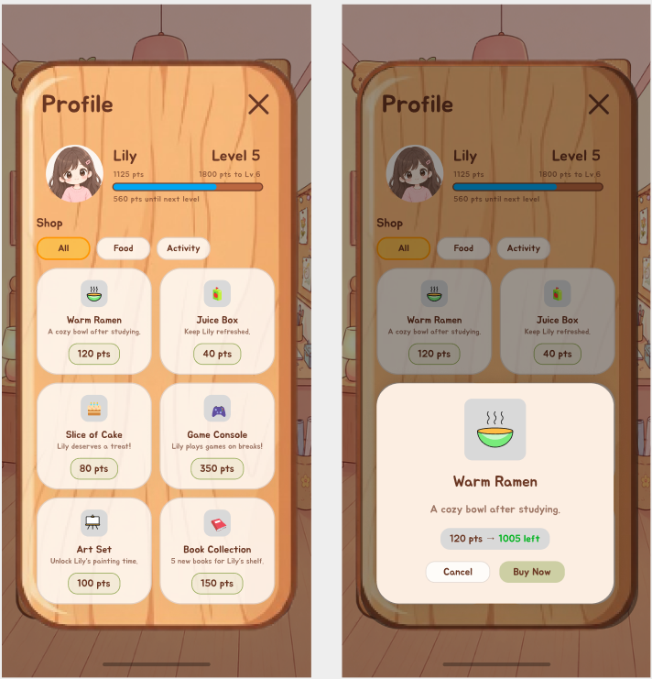

Today’s Status
The Today’s Status Page shows the overall condition of the day and the status of different areas, such as Mental, Time, Physical, Social, and Errands. If the overall status becomes Overload, Balance My Task can be used to reorganize tasks and reduce the workload.
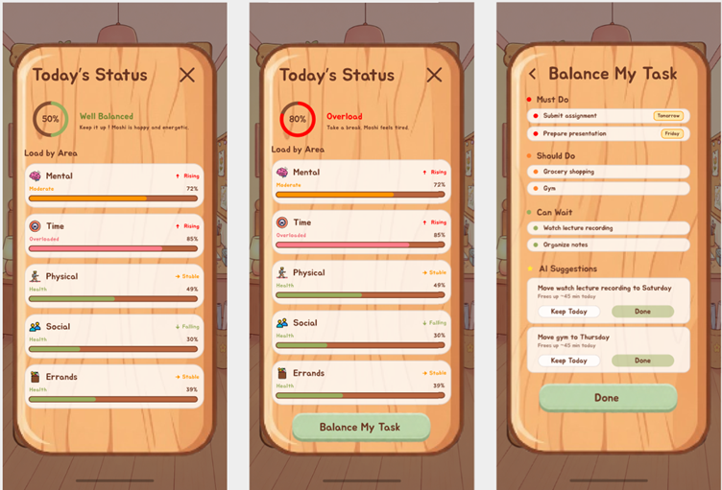

Task Page
The Task Page shows the daily schedule, upcoming deadlines, and tasks with point rewards. Tasks can be added manually or through other options such as uploading, calendar syncing, and exploring recommendations. Existing tasks can also be edited to update their details and schedule.
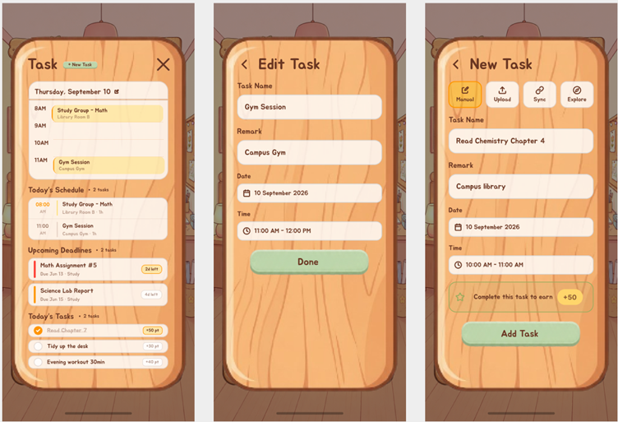

Voice Page
The Voice Page provides a space to interact with MoshiMoshi, the AI companion, through voice and quick prompts. MoshiMoshi can suggest actions or directly perform tasks, such as adding a new task.
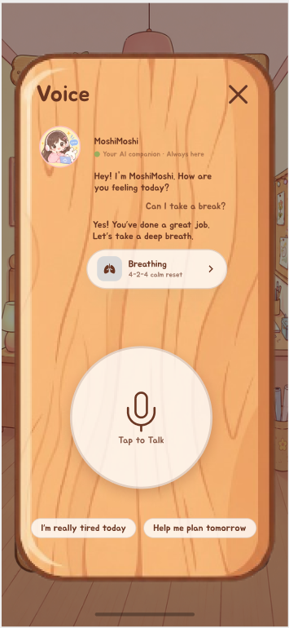

Recovery Page
The Recovery Page provides different recovery activities to help with rest and relaxation. AI recommendations suggest suitable breaks, while each activity shows its duration and point reward, with guidance on how to complete it.
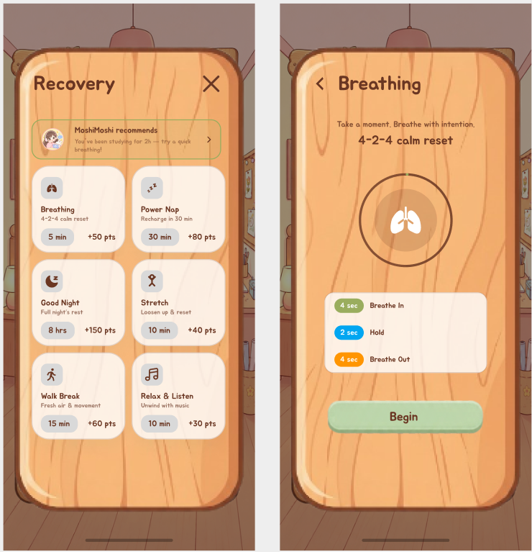

Community Page
The Community Page allows people to join or create groups, add friends, and find nearby friends. It also provide a space to support and keep each other accountable.
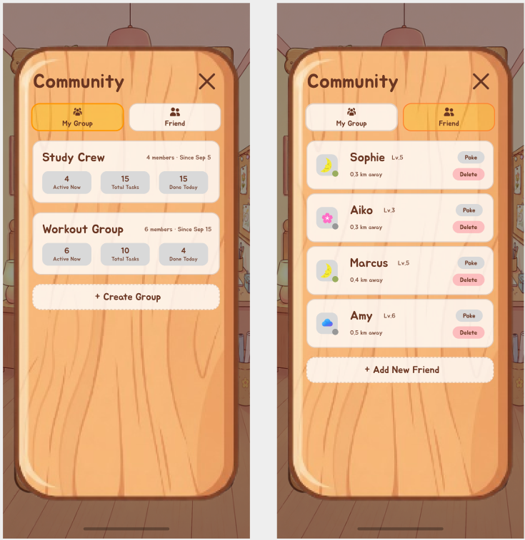

4. What Makes It Different
Most stress and workload apps are reactive, the student need to manually log tasks, mood, or schedule before any help arrives. This is exactly what an overloaded student never has the time or energy to do, which will make the app fail precisely when it’s needed most.
However, Moshi Moshi is not a task manager with wellness features bolted on, nor a wellness app with a to-do list attached. It is an AI companion that supervises a student’s health while managing their workload. Nowadays, mostly students are under intense academic pressure and often lose track of time and neglect their health, sometimes with serious consequences. Its core idea is to walk with the student through each day, sensing rising stress, rebalancing what they're carrying, and gently pushing them toward rest, a walk outside, or their friends, not just nudging them to finish more tasks.

Capability | Todoist | Headspace | Finch | MoshiMoshi
Task and deadline organization | ✓ | ✘ | ✓ | ✓
Meditation or recovery activities | ✘ | ✓ | ✓ | ✓
Virtual companion | ✘ | ✘ | ✓ | ✓
Calendar-based schedule awareness | ✓ | ✘ | ✘ | ✓
Five-dimensional student-load overview | ✘ | ✘ | ✘ | ✓
Academic timetable and guideline input | ✘ | ✘ | ✘ | ✓
AI-assisted Must Do / Should Do / Can Wait rebalancing | ✘ | ✘ | ✘ | ✓
Voice-based planning and emotional check-in | ✘ | ✘ | ✘ | ✓
Location-aware activity and errand planning | ✘ | ✘ | ✘ | ✓
Recovery-linked points and companion growth | ✘ | ✘ | ✓ | ✓
Rewards healthy balance as part of workload management | ✘ | ✘ | ✘ | ✓
Task and deadline organization | ✓ | ✘ | ✓ | ✓

4.1 Novel Features
- Edge Computing for Instant, Private Reaction
To understand what a student is working on and how heavy their load is, the agents need to observe their screen activity. This is actually an inherently sensitive signal, since a screen may expose assignments, personal files, private messages, and confidential work. Therefore, Moshi Moshi performs this sensing and inference locally on the user's device rather than in the cloud. Besides, Edge processing eliminate the network round trip, which allow the agent to respond the moment stress is detected rather than waiting on server latency.
- Live Screen-aware Break Detection Instead of Timetable-based Reminders
Every existing app that reminds you to rest does so from a timetable. Regardless of whether the user typed in or the app generated, the app will still strictly follow the timetable to send notifications. However, people rarely follow their own timetable minute to minute. When a “time to rest” alerts pops up while the student is actually doing something else entirely, it will feels jarring and disconnected. A reminder that this is just an app blindly following a preset plan, not something that understands what they are really doing. That mismatch erodes trust and trains the user to ignore the notifications.
- Gamified Rewards Built Around a Companion that Grows
Instead of a plain badge or a text notification, which is a kind of reward that feels transactional and easy to ignore, Moshi Moshi is a companion the student grows genuinely attached to. It is the student's academic soul companion, always standing alongside them and offering a timely reminder and a word of encouragement whenever they have pushed themselves too hard. In the end, the whole reward economy is built so that looking after yourself is exactly what makes Moshi flourish, and so that no student feels they are carrying the load alone.
- Talk-to-Moshi voice companion
Beyond taps and forms, MoshiMoshi lets the student simply talk to Moshi. User can just simply talk about the plan and the workload they need to do. Most stress and workload apps treat data entry and emotional support as two different things. Usually is a checkbox for the task, a meditation clip for the stress. MoshiMoshi collapses them into a single spoken exchange, which is both the lowest-friction way to log something and the most human way to feel heard. For a user who is too drained to type or tap through menus, speaking a sentence is effortless, and being greeted by name. The Moshi Moshi asked how they make the app feel like a companion that genuinely cares rather than a tool waiting for input.

5. Technical Architecture & Feasibility

5.1 Tech stack
Moshi Moshi is built as a privacy-first Android app. We are Android-first on purpose, not as a shortcut: iOS does not expose app-usage signals without a special Apple entitlement, so our core loop literally cannot run there today. We would rather name that than promise both platforms and ship neither properly.
Layer | Choice | Why this | Constraint we expect
Frontend | React Native (Android only) | Our team already knows React Native well, so we can turn our Figma screens into a working app quickly | Android only is a deliberate call, not a shortcut. iPhones do not let apps see this kind of usage information without special approval from Apple, so our core idea cannot exist there today
Sensing layer | Native Android module (Kotlin), bridged into the React Native app | It reads what the phone already knows: which apps have been open and for how long, when the screen has been on, and what is in the calendar. That is what lets us skip asking the student to type anything | Android makes the student grant this in settings rather than a simple popup, so some will say no. The app still works on the calendar alone, just with less accuracy
On-device reasoning | Python service (FastAPI) in Termux | We run a Python service (FastAPI) in Termux to serve the AI model directly on the device. We use Gemma 3 1B for this. Termux provides a ready-made environment that lets us deploy inference without building a native system. | Termux is not distributed through the Play Store, so reaching a wider public later means porting this into the app itself. We are naming that now as scoped post-finals work rather than discovering it after the finals
Load scoring | Rule-based scoring engine (Python, on-device) | We can tell a student exactly why the app thinks they are overloaded, and it costs nothing to run. Nothing leaves the phone for this step | The weightings need tuning against real behaviour, so we plan a small pilot rather than quoting an accuracy figure we have not measured
Heavy reasoning | DeepSeek API, called only at the moment of a check-in | Much cheaper per call than the bigger providers, which matters for a student team with no budget | This is the one moment anything leaves the phone. We send a one-line summary, never the history behind it, and the buddy falls back to prepared lines when there is no connection
Voice | ElevenLabs | A companion that sounds mechanical does not get used twice. The voice is the retention feature | It costs per minute and needs a connection. We cap check-ins at 90 seconds partly for this, and the breathing timer runs on the phone so a dropped connection never cuts a session short
Database | MongoDB Atlas (free tier), leaderboard data only | Free, managed, and flexible enough for groups and scores | The app cannot talk to the database directly without putting the login details on the student's phone, which would be a security hole. So we need a small service sitting in front of it
API layer | Node.js + Express, hosted on Render free tier | Keeps the database login off the phone, and gives us one place to control what is allowed to leave | Free hosting goes to sleep when idle, so the first leaderboard load can be slow. We will keep it awake during judging
Local storage | SQLite on the device | Every sensed signal, score and task lives here and never syncs | Moving your history to a new phone is not solved in v1, and we would rather say that than fake a sync feature

5.2 System architecture diagram
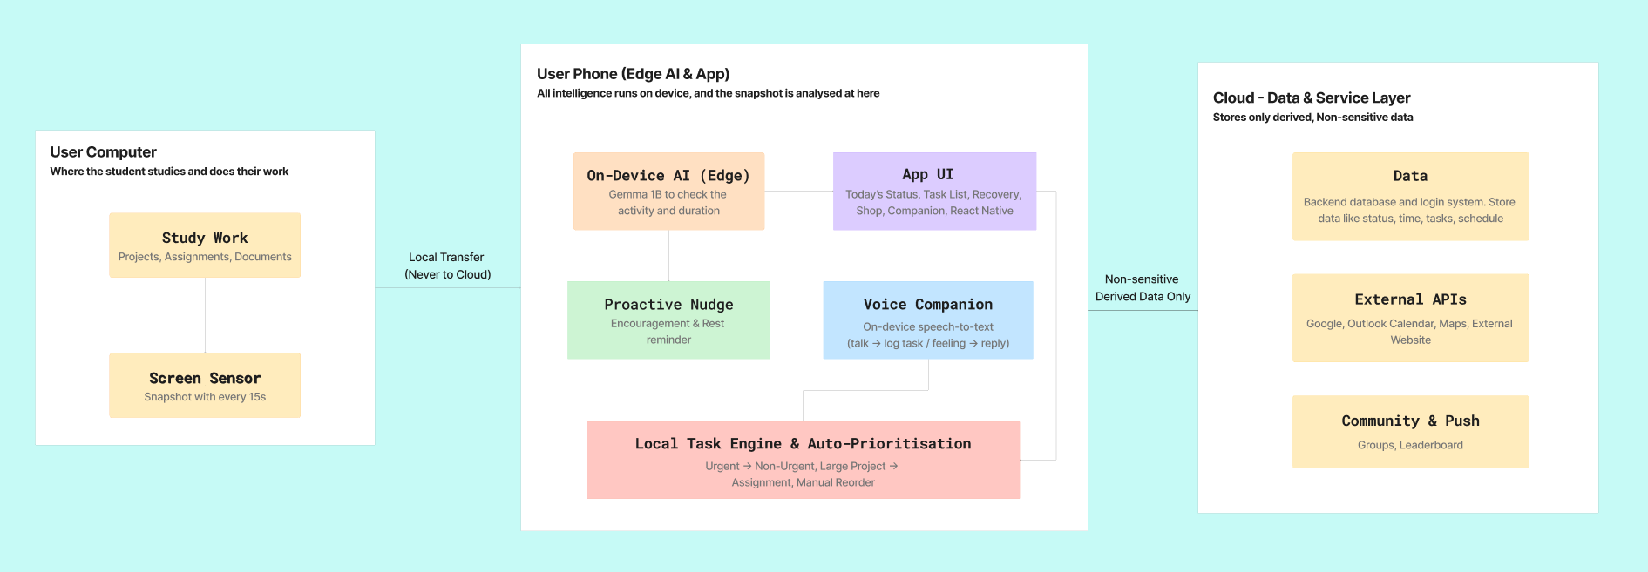

5.3 Build Plan & Scope
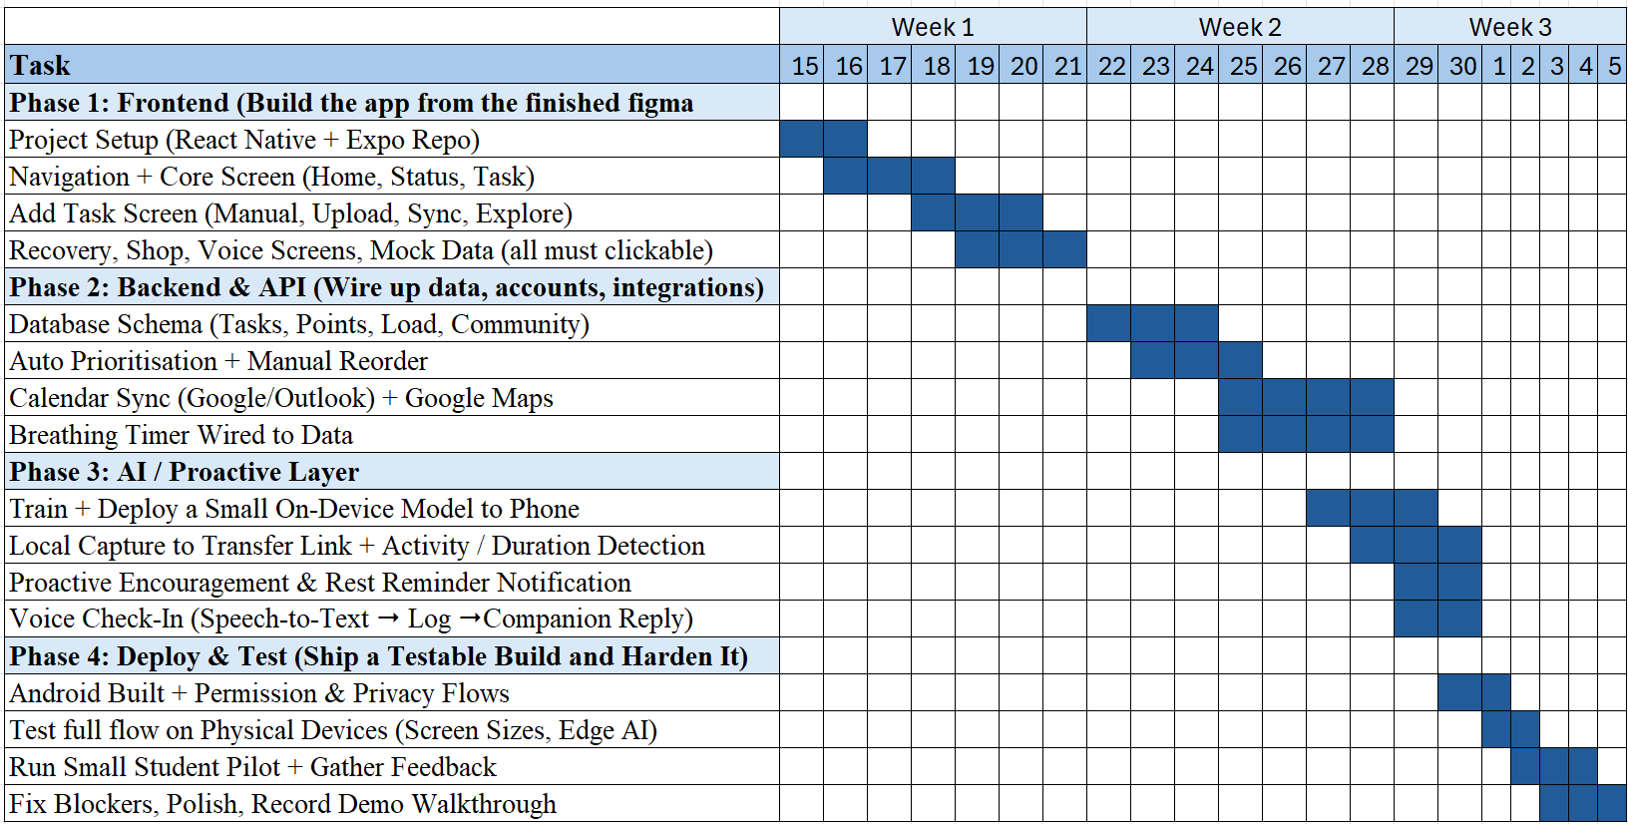
We will prepare the test cases and recruit students for the pilot, then build the load overview, task rebalancing, breathing activities and companion rewards. Once these features work together, we’ll test the app on physical devices and gather feedback from students. The final few days are reserved for fixing problems and preparing the demo. The checkpoints help us confirm that each stage is ready before moving on.

