**Infinite War**

High Concept 2

Game Flow 2

Game Controls 2

Keyboard 2

Mouse 2

Game Contents 2

Enemy 2

Weapon 3

Random System 3

Score 5

# High Concept

* 2D Topdown Shooting Game. I jumped into a battlefield alone to defeat the enemy. I will survive this battlefield and become a hero!

# Game Flow

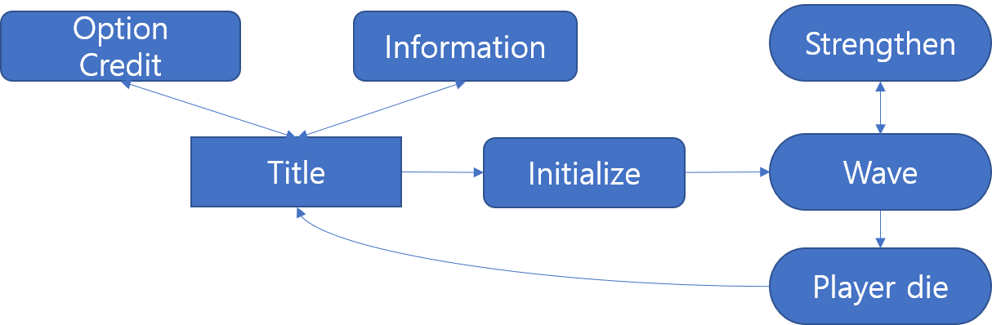

# Game Controls

## Keyboard

* + W: Move Up
  + S: Move Down
  + A: Move Left
  + D: Move Right
  + Space bar: Next Weapon

## Mouse

* + Position – player rotation
  + Left Click - Attack

# Game Contents

## **Enemy**

* + Each wave, increase health.
    - Normal Type
      * slowly approach with knife.
    - Speed Type
      * quickly approach with knife.
    - Long range Type
      * Shoot from far.
    - Shield Type
      * Have the shield.

## **Weapon**

* + Dagger Throw
    - Short range
    - Average damage
  + Gun
    - long range
    - small bullet
    - Weak Damage
  + C4
    - Mounted Bomb
    - Large range (Attach)
    - long cool-time
  + Long sword
    - Short range
    - Knockback System
    - Backward attack possible (Round)

## **Random System**

* + When every wave or kill enemies, get a chance of random reinforcement.
    - High Probability
      * damage up
      * Reinforcement by weapon type
      * Other probability ups
    - Middle Probability
      * recover HP
      * Reinforcement by weapon type+
      * damage up+
      * Movement Up
    - Low Probability
      * Movement Up+
      * damage up++
      * Reinforcement by weapon type++
      * HP max+
      * Attack speed
    - Rare Probability (once)
      * Dagger reinforcement
        + long range
        + double throw
      * Gun reinforcement
        + double machine gun
      * C4 reinforcement
        + immediate explosion
        + range up
      * Long sword reinforcement
        + Charging available
        + range up & damage up

## **Score**

* + One point for each kill.
  + New record System.