1. Main page (‘/’)

- shows list of hot topics

- Tab shows ‘debate’, ‘yes or no’, ‘ranking’ and ‘my page’. Each tab connects corresponding page. ‘Debate’ tabs navigate to debate main list page. ‘Yes or No’ navigate to Yes or No main list page. ‘Ranking’ navigate to rank page. ‘My Page’ navigate to My Page.

- ‘Banner’ shows Notice and hot topics of the week. If the user clicks ‘Banner’, navigate to the corresponding topic detail page.

- ‘Preparing Debate List’ shows list of debates that will open soon. Clicking one of the debates on the list navigates to the debate detail page.

- ‘Current Debate List’ shows list of ongoing debates. Clicking one of the debates on the list navigates to the debate detail page.

- ‘Current Yes or No list’ shows list of ongoing Yes or No. Clicking one of the Yes or No leads to Yes or No Main Page.

- ‘Brief Ranking’ shows list of top rankers. It also shows my current rank at the top of the list.

- ‘Home’ button remains on all pages, navigating to main page.

2. Sign in (‘/sign_in’)

- Pop up when you press ‘Sign In’ button in the main page.

- Login an established user

- Get ‘id’, ‘password’ as input

3. Sign up (‘/sign_up’)

- Sign up a new user

- Get ‘id’, ‘email’, ‘nickname’, ‘password’ as input

4. My page (‘/mypage’)

- Show the My Page which contains list of Profile, My Yes or No and My Debate.

- Profile list shows my information. ‘Rank’, ‘Number of Participation : Vote’, ‘Number of Participation : Write’, ‘My total point’ changes according to participation on the website.

- ‘My Yes or No’ and ‘My Debate’ shows titles of list of articles that I wrote. Clicking a title navigates to the detail page of the article.

5. Rank page (‘/rank’)

- Show ‘Total Rank’, ‘Hot Ranker of the week’, ‘My Rank Overview’

- ‘Total Rank’ shows the rank list of top rankers in descending order.

- ‘Hot Ranker of the Week’ shows the list of rankers who have received most likes in the week

- ‘My Rank Overview’ shows the overview of my rank, how many likes of I have received in the week.

6. Write a page for Debate (‘/debate/create’)

- Create a post for Debate

- Gets ‘title’, ‘main topic’, ‘summary’, ‘time limit’, ‘total time limit’, ‘text description for A side’, ‘short text description for B side’ as text input. ‘Word Limit’ is set as NULL value. These are mandatory

- Gets ‘Category Selection’ as list selection. This selection is mandatory

- Gets ‘Picture 1 for A side’, ‘Picture 2 for B side’. These are optional.

- Needs to click ‘Yes I agree’ to the Agreement term. This is mandatory

- If the user clicks ‘Post’, create and post the new debate detail page on the Debate main list page. Add the page to ‘My Debate List’ and increment the Number of Write Participation

- When the user clicks ‘Post’, and if the user did not fill any of the mandatory blank, a pop up pages turns up, showing the user needs to fill all mandatory blank.

- If the user clicks ‘Cancel’, navigate to Debate Main list page.

- If the user clicks ‘Find Pic’, navigate to find pic page.

7. Write a page for Yes or No (‘/yesorno/create’)

- Create a post for Yes or No

- Gets ‘title’, ‘main topic’, ‘summary’, ‘Word Limit’, ‘text description for A side’, ‘short text description for B side’ as text input. ‘Time limit’, ‘total time limit’, is set as NULL value. These are mandatory

- Gets ‘Category Selection’ as list selection. This selection is mandatory

- Gets ‘Picture 1 for A side’, ‘Picture 2 for B side’. These are optional.

- Needs to click ‘Yes I agree’ to the Agreement term. This is mandatory

- If the user clicks ‘Post’, create and post the new Yes or No detail page on the Yes or No main list page. Add the page to ‘My Yes or No List’ and increment the Number of Write Participation

- When the user clicks ‘Post’, and if the user did not fill any of the mandatory blank, a pop up pages turns up, showing the user needs to fill all mandatory blank.

- If the user clicks ‘Cancel’, navigate to Yes or No Main list page.

- If the user clicks ‘Find Pic’, navigate to find pic page

8. Find picture (Pop up)

- Shows my computer local directory

- If the user selects a file and clicks ‘Confirm‘, upload the file the ‘Picture’ blank.

- If the user clicks ‘Cancel’, close the Find Picture page.

Controller

Refer to the Github

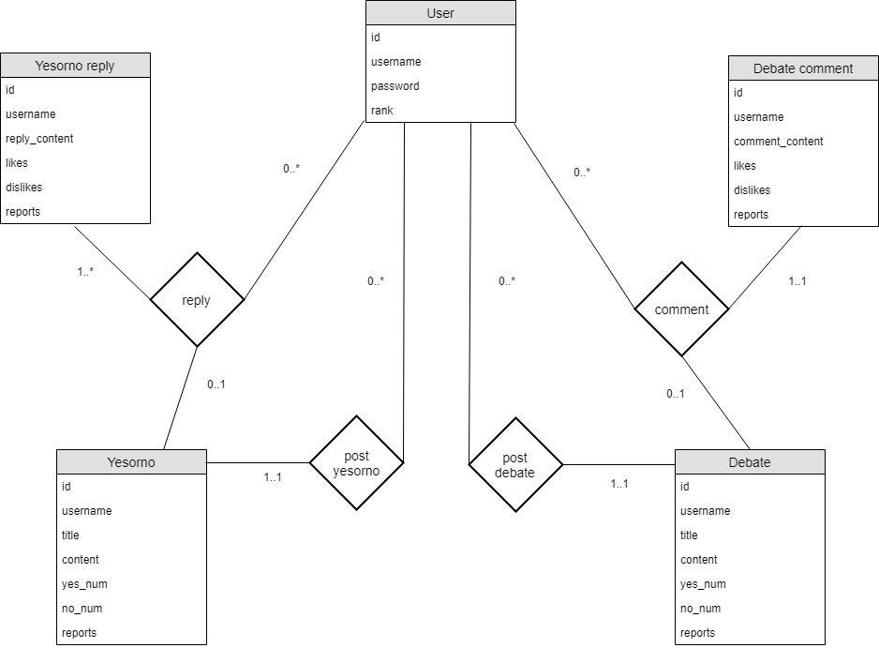

Front End design

Front end Algorithm

Components

1. ngOnInit

-check the user is logged in by calling backend api, and redirect to main page if user is not signed in.

2. Main Page

-onClickDebate(post : debate) : redirect to corresponding debate detail page

-onClickYesOrNO(post : yesorno) : redirect to corresponding yes or no detail page

3. Sign In

-onClickSignInButton(id : string, password : string) Call backend signin api. If sign-in is accepted, redirect to the main page. If sign-in is rejected, alert the user.

-onClickCancelButton() : redirect to main page

4. Sign Up

-onClickConfirmButton(id : string, email : string, nickname : string, password : string): Make a new user. If username is already used, alert the user to use another username. If sign up is successful, redirect to the main page.

-onClickCancelButton() : redirect to main page

5. My Page

-onClickDebate(post : debate): redirect to one of debate detail page I have composed.

-onClickYesOrNo(post : yesorno): redirect to one of yesorno detail page I have composed.

6. Rank Page

-onClickPageNumber(page number : int) : redirect to the corresponding page number

7. Write Page / Debate

-onClickFindPictureButton() : redirect to the find picture page

-onClickCategory() : select one of the category in the list

-onClickAgreeCheckBox(confirm : Boolean): make confirm to agreement true

-onClickPostButton(title, category_selection, main_topic, brief_summary, time_limit, total_time_limit, word_limit, short_text. Picture, check_box): Make a new debate. Add it to the top of the debate list. If any of the mandatory feature is not filled in, alert the user. If post is successful, redirect to debate main page.

8. Write Page / Yes or No

-onClickFindPictureButton() : Picture page pops up without closing the write page.

-onClickCategory() : select one of the category in the list

-onClickAgreeCheckBox(confirm : Boolean): make confirm to agreement true

-onClickPostButton(title, category_selection, main_topic, brief_summary, time_limit, total_time_limit, word_limit, short_text. Picture, check_box): Make a new yes or no. Add it to the top of the yesorno list. If any of mandatory feature is not filled in, alert the user. If post is successful, redirect to yes or no main page.

9. Find Picture

-onClickConfirmButton(picture file) : select the file that the user wants to insert. After clicking the button, user post the file to the write page. If post is successful, find picture page closes.

-onClickCancelButton() : close the find picture page.

Subcomponents

1. Tabs

-onClickHomeButton : Redirect to main page.

-onClickDebateButton : Redirect to debate main page (list page).

-onClickYesOrNoButton : Redirect to yes or no main page.

-onClickRankingBUtton : Redirect to Rank page.

-onClickSignInButton : Redirect to Sign In page.

-onClickSignUpButton : Redirect to Sign Up Page

-onClickMyPageButton : Redirect to My Page.

**Services**

1. UserService

-signUp(username: string, password: string) -> Promise<{status: boolean, reason: enum}>: Call Backend signUp API, and return the result.

-signIn(username: string, password: string) -> Promise<boolean>: Call backend signin api, and return the result.

-signOut(): Call signout api.

- getUserById(userId: number) -> Promise<User>: Call backend api, and return the user

2. DebateService

-makeNewDebate(content: debate, tags: string[]) -> Promise<{status: boolean, reason: enum}>: Call backend api to make new debate, and return the result.

-getDebateById(debateId: number) -> Promise<Debate>: Call backend api to get a specific debate.

3. YesOrNoService

-makeNewYesOrNo(content: yesorno, tags: string[]) -> Promise<{status: boolean, reason: enum}>: Call backend api to make new yesorno, and return the result.

-getYesOrNoById(yesornoId: number) -> Promise<YesOrNo>: Call backend api to get a specific yesorno.

4. PhotoService

-uploadNewPhoto() -> Promise<{status: boolean, reason: enum, photoId: number}>: Call backend api to upload new photo, and return the result.