苏州大学实验报告
院、系 | 计算机学院 |  | 年级专业 |  | 软件工程 |  | 姓名 | 朱金涛 | 学号 | 2327406014
课程名称 |  | 机器学习课程实践 |  |  |  |  |  |  | 成绩
指导教师 |  | 李俊涛 |  | 同组实验者 |  | 无 |  | 实验日期 | 2025年9月24日

实 验 名 称 | 机器学习综合实践实验四：决策树

- 实验目的
本实验旨在通过在泰坦尼克号数据集上构建决策树分类模型，深入理解决策树的基本原理及其参数设置对模型性能的影响。通过对比 CART（基尼指数） 与 ID3（信息增益） 两种划分方式，掌握决策树的生长机制和预测过程。同时，结合 max_depth、min_samples_split、min_samples_leaf 等超参数的实验，直观感受欠拟合与过拟合的表现，并理解剪枝在防止模型过拟合、提高泛化能力中的作用。
- 实验内容
在泰坦尼克数据集上完成：
- 使用ID3和CART的决策树分类器预测乘客生还与否；
- 可视化决策树,打印出决策准则；
- 输出决策树的准确率；
- 实验步骤和结果
- 利用最简单的方法进行实验，划分训练集和测试集（4:1）。直接调用CART的“gini”模型进行决策树的构建。ID3用的是“entropy”。此时并未考虑任何优化，也没有设置树的最大深度。任由其自行学习。
最终决策树级决策准则如下：
CART方法：
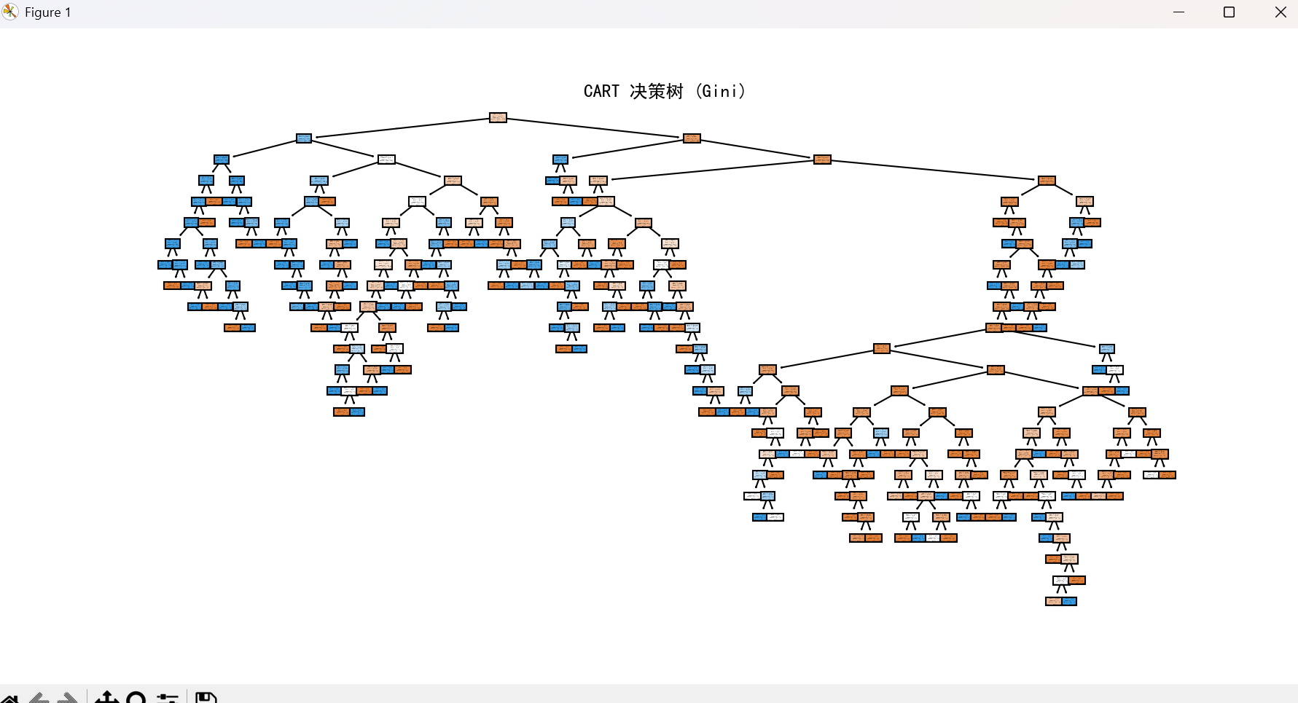

CART 决策规则:
|--- Sex <= 0.50
| |--- Pclass <= 2.50
| | |--- Fare <= 28.86
| | | |--- Age <= 56.00
| | | | |--- Fare <= 28.23
| | | | | |--- SibSp <= 0.50
| | | | | | |--- Age <= 37.00
| | | | | | | |--- class: 1
| | | | | | |--- Age > 37.00
| | | | | | | |--- Age <= 39.00
| | | | | | | | |--- class: 0
| | | | | | | |--- Age > 39.00
| | | | | | | | |--- class: 1
| | | | | |--- SibSp > 0.50
| | | | | | |--- Age <= 25.00
| | | | | | | |--- class: 1
| | | | | | |--- Age > 25.00
| | | | | | | |--- Age <= 27.50
| | | | | | | | |--- Fare <= 17.43
| | | | | | | | | |--- class: 1
| | | | | | | | |--- Fare > 17.43
| | | | | | | | | |--- class: 0
| | | | | | | |--- Age > 27.50
| | | | | | | | |--- Age <= 43.00
| | | | | | | | | |--- class: 1
| | | | | | | | |--- Age > 43.00
| | | | | | | | | |--- Age <= 44.50
| | | | | | | | | | |--- class: 0
| | | | | | | | | |--- Age > 44.50
| | | | | | | | | | |--- class: 1
| | | | |--- Fare > 28.23
| | | | | |--- class: 0
| | | |--- Age > 56.00
| | | | |--- class: 0
| | |--- Fare > 28.86
| | | |--- Parch <= 1.50
| | | | |--- class: 1
| | | |--- Parch > 1.50
| | | | |--- Fare <= 135.78
| | | | | |--- class: 1
| | | | |--- Fare > 135.78
| | | | | |--- Fare <= 158.21
| | | | | | |--- class: 0
| | | | | |--- Fare > 158.21
| | | | | | |--- class: 1
| |--- Pclass > 2.50
| | |--- Embarked <= 1.50
| | | |--- Age <= 29.75
| | | | |--- Fare <= 8.08
| | | | | |--- Fare <= 6.99
| | | | | | |--- class: 0
| | | | | |--- Fare > 6.99
| | | | | | |--- Age <= 25.00
| | | | | | | |--- class: 1
| | | | | | |--- Age > 25.00
| | | | | | | |--- Fare <= 7.74
| | | | | | | | |--- class: 1
| | | | | | | |--- Fare > 7.74
| | | | | | | | |--- Fare <= 7.79
| | | | | | | | | |--- class: 1
| | | | | | | | |--- Fare > 7.79
| | | | | | | | | |--- class: 1
| | | | |--- Fare > 8.08
| | | | | |--- Fare <= 15.37
| | | | | | |--- Age <= 6.50
| | | | | | | |--- class: 1
| | | | | | |--- Age > 6.50
| | | | | | | |--- Age <= 28.50
| | | | | | | | |--- Age <= 16.00
| | | | | | | | | |--- Age <= 14.75
| | | | | | | | | | |--- class: 0
| | | | | | | | | |--- Age > 14.75
| | | | | | | | | | |--- class: 1
| | | | | | | | |--- Age > 16.00
| | | | | | | | | |--- class: 0
| | | | | | | |--- Age > 28.50
| | | | | | | | |--- class: 1
| | | | | |--- Fare > 15.37
| | | | | | |--- class: 1
| | | |--- Age > 29.75
| | | | |--- class: 0
| | |--- Embarked > 1.50
| | | |--- Fare <= 17.25
| | | | |--- Fare <= 10.82
| | | | | |--- Fare <= 7.52
| | | | | | |--- class: 1
| | | | | |--- Fare > 7.52
| | | | | | |--- Fare <= 9.71
| | | | | | | |--- Parch <= 0.50
| | | | | | | | |--- Age <= 54.00
| | | | | | | | | |--- Age <= 27.00
| | | | | | | | | | |--- Age <= 18.50
| | | | | | | | | | | |--- class: 0
| | | | | | | | | | |--- Age > 18.50
| | | | | | | | | | | |--- truncated branch of depth 4
| | | | | | | | | |--- Age > 27.00
| | | | | | | | | | |--- Fare <= 8.67
| | | | | | | | | | | |--- class: 0
| | | | | | | | | | |--- Fare > 8.67
| | | | | | | | | | | |--- truncated branch of depth 2
| | | | | | | | |--- Age > 54.00
| | | | | | | | | |--- class: 1
| | | | | | | |--- Parch > 0.50
| | | | | | | | |--- class: 1
| | | | | | |--- Fare > 9.71
| | | | | | | |--- Age <= 19.00
| | | | | | | | |--- Fare <= 10.15
| | | | | | | | | |--- class: 1
| | | | | | | | |--- Fare > 10.15
| | | | | | | | | |--- class: 0
| | | | | | | |--- Age > 19.00
| | | | | | | | |--- class: 0
| | | | |--- Fare > 10.82
| | | | | |--- Age <= 40.00
| | | | | | |--- Fare <= 13.44
| | | | | | | |--- class: 1
| | | | | | |--- Fare > 13.44
| | | | | | | |--- Fare <= 15.12
| | | | | | | | |--- class: 0
| | | | | | | |--- Fare > 15.12
| | | | | | | | |--- Parch <= 0.50
| | | | | | | | | |--- Age <= 27.00
| | | | | | | | | | |--- class: 0
| | | | | | | | | |--- Age > 27.00
| | | | | | | | | | |--- class: 1
| | | | | | | | |--- Parch > 0.50
| | | | | | | | | |--- class: 1
| | | | | |--- Age > 40.00
| | | | | | |--- class: 0
| | | |--- Fare > 17.25
| | | | |--- Age <= 5.50
| | | | | |--- Age <= 3.50
| | | | | | |--- class: 0
| | | | | |--- Age > 3.50
| | | | | | |--- class: 1
| | | | |--- Age > 5.50
| | | | | |--- Age <= 30.00
| | | | | | |--- class: 0
| | | | | |--- Age > 30.00
| | | | | | |--- Age <= 38.50
| | | | | | | |--- Parch <= 0.50
| | | | | | | | |--- class: 0
| | | | | | | |--- Parch > 0.50
| | | | | | | | |--- class: 1
| | | | | | |--- Age > 38.50
| | | | | | | |--- class: 0
|--- Sex > 0.50
| |--- Age <= 3.50
| | |--- SibSp <= 2.50
| | | |--- class: 1
| | |--- SibSp > 2.50
| | | |--- Parch <= 1.50
| | | | |--- class: 0
| | | |--- Parch > 1.50
| | | | |--- class: 1
| |--- Age > 3.50
| | |--- Pclass <= 1.50
| | | |--- Fare <= 26.14
| | | | |--- class: 0
| | | |--- Fare > 26.14
| | | | |--- Fare <= 30.60
| | | | | |--- Age <= 54.00
| | | | | | |--- Fare <= 27.14
| | | | | | | |--- Age <= 31.50
| | | | | | | | |--- class: 1
| | | | | | | |--- Age > 31.50
| | | | | | | | |--- class: 1
| | | | | | |--- Fare > 27.14
| | | | | | | |--- Fare <= 29.10
| | | | | | | | |--- class: 0
| | | | | | | |--- Fare > 29.10
| | | | | | | | |--- Parch <= 0.50
| | | | | | | | | |--- Age <= 28.50
| | | | | | | | | | |--- class: 1
| | | | | | | | | |--- Age > 28.50
| | | | | | | | | | |--- Fare <= 30.25
| | | | | | | | | | | |--- class: 0
| | | | | | | | | | |--- Fare > 30.25
| | | | | | | | | | | |--- class: 1
| | | | | | | | |--- Parch > 0.50
| | | | | | | | | |--- class: 0
| | | | | |--- Age > 54.00
| | | | | | |--- Age <= 72.50
| | | | | | | |--- class: 0
| | | | | | |--- Age > 72.50
| | | | | | | |--- class: 1
| | | | |--- Fare > 30.60
| | | | | |--- Fare <= 52.28
| | | | | | |--- Embarked <= 1.00
| | | | | | | |--- Age <= 38.00
| | | | | | | | |--- class: 0
| | | | | | | |--- Age > 38.00
| | | | | | | | |--- Age <= 63.50
| | | | | | | | | |--- Fare <= 30.85
| | | | | | | | | | |--- class: 0
| | | | | | | | | |--- Fare > 30.85
| | | | | | | | | | |--- class: 1
| | | | | | | | |--- Age > 63.50
| | | | | | | | | |--- class: 0
| | | | | | |--- Embarked > 1.00
| | | | | | | |--- class: 0
| | | | | |--- Fare > 52.28
| | | | | | |--- Age <= 50.50
| | | | | | | |--- Fare <= 77.01
| | | | | | | | |--- Age <= 21.00
| | | | | | | | | |--- class: 0
| | | | | | | | |--- Age > 21.00
| | | | | | | | | |--- Age <= 49.50
| | | | | | | | | | |--- class: 1
| | | | | | | | | |--- Age > 49.50
| | | | | | | | | | |--- class: 0
| | | | | | | |--- Fare > 77.01
| | | | | | | | |--- Age <= 17.50
| | | | | | | | | |--- class: 1
| | | | | | | | |--- Age > 17.50
| | | | | | | | | |--- Age <= 31.50
| | | | | | | | | | |--- class: 0
| | | | | | | | | |--- Age > 31.50
| | | | | | | | | | |--- Fare <= 84.15
| | | | | | | | | | | |--- class: 0
| | | | | | | | | | |--- Fare > 84.15
| | | | | | | | | | | |--- truncated branch of depth 4
| | | | | | |--- Age > 50.50
| | | | | | | |--- class: 0
| | |--- Pclass > 1.50
| | | |--- Fare <= 51.70
| | | | |--- Fare <= 7.13
| | | | | |--- class: 0
| | | | |--- Fare > 7.13
| | | | | |--- Fare <= 7.18
| | | | | | |--- class: 1
| | | | | |--- Fare > 7.18
| | | | | | |--- Fare <= 23.35
| | | | | | | |--- Age <= 13.50
| | | | | | | | |--- class: 1
| | | | | | | |--- Age > 13.50
| | | | | | | | |--- Fare <= 22.89
| | | | | | | | | |--- Age <= 45.25
| | | | | | | | | | |--- Age <= 43.50
| | | | | | | | | | | |--- truncated branch of depth 13
| | | | | | | | | | |--- Age > 43.50
| | | | | | | | | | | |--- truncated branch of depth 3
| | | | | | | | | |--- Age > 45.25
| | | | | | | | | | |--- class: 0
| | | | | | | | |--- Fare > 22.89
| | | | | | | | | |--- class: 1
| | | | | | |--- Fare > 23.35
| | | | | | | |--- Parch <= 0.50
| | | | | | | | |--- Age <= 32.25
| | | | | | | | | |--- Age <= 31.00
| | | | | | | | | | |--- class: 0
| | | | | | | | | |--- Age > 31.00
| | | | | | | | | | |--- class: 1
| | | | | | | | |--- Age > 32.25
| | | | | | | | | |--- class: 0
| | | | | | | |--- Parch > 0.50
| | | | | | | | |--- class: 0
| | | |--- Fare > 51.70
| | | | |--- Fare <= 63.02
| | | | | |--- Age <= 30.00
| | | | | | |--- Age <= 27.00
| | | | | | | |--- class: 1
| | | | | | |--- Age > 27.00
| | | | | | | |--- class: 1
| | | | | |--- Age > 30.00
| | | | | | |--- class: 1
| | | | |--- Fare > 63.02
| | | | | |--- class: 0
结果：

ID3决策树：
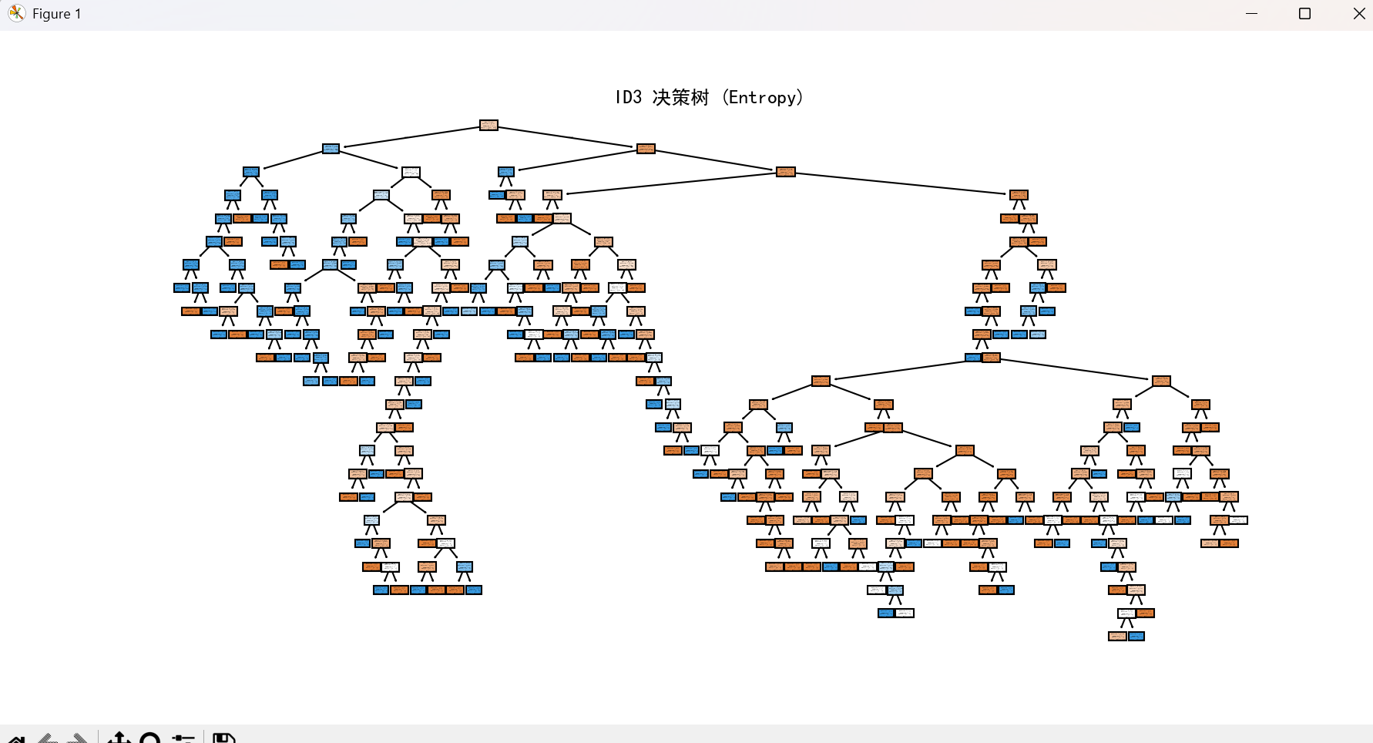
ID3 决策规则:
|--- Sex <= 0.50
| |--- Pclass <= 2.50
| | |--- Fare <= 28.86
| | | |--- Age <= 56.00
| | | | |--- Fare <= 28.23
| | | | | |--- SibSp <= 0.50
| | | | | | |--- Age <= 37.00
| | | | | | | |--- class: 1
| | | | | | |--- Age > 37.00
| | | | | | | |--- Age <= 39.00
| | | | | | | | |--- class: 0
| | | | | | | |--- Age > 39.00
| | | | | | | | |--- class: 1
| | | | | |--- SibSp > 0.50
| | | | | | |--- Age <= 25.00
| | | | | | | |--- class: 1
| | | | | | |--- Age > 25.00
| | | | | | | |--- Age <= 27.50
| | | | | | | | |--- Fare <= 17.43
| | | | | | | | | |--- class: 1
| | | | | | | | |--- Fare > 17.43
| | | | | | | | | |--- class: 0
| | | | | | | |--- Age > 27.50
| | | | | | | | |--- Age <= 43.00
| | | | | | | | | |--- class: 1
| | | | | | | | |--- Age > 43.00
| | | | | | | | | |--- Age <= 44.50
| | | | | | | | | | |--- class: 0
| | | | | | | | | |--- Age > 44.50
| | | | | | | | | | |--- class: 1
| | | | |--- Fare > 28.23
| | | | | |--- class: 0
| | | |--- Age > 56.00
| | | | |--- class: 0
| | |--- Fare > 28.86
| | | |--- Parch <= 1.50
| | | | |--- class: 1
| | | |--- Parch > 1.50
| | | | |--- Fare <= 135.78
| | | | | |--- class: 1
| | | | |--- Fare > 135.78
| | | | | |--- Fare <= 158.21
| | | | | | |--- class: 0
| | | | | |--- Fare > 158.21
| | | | | | |--- class: 1
| |--- Pclass > 2.50
| | |--- Fare <= 24.81
| | | |--- Embarked <= 1.50
| | | | |--- Age <= 29.75
| | | | | |--- Fare <= 15.37
| | | | | | |--- Fare <= 8.08
| | | | | | | |--- Fare <= 6.99
| | | | | | | | |--- class: 0
| | | | | | | |--- Fare > 6.99
| | | | | | | | |--- Age <= 25.00
| | | | | | | | | |--- class: 1
| | | | | | | | |--- Age > 25.00
| | | | | | | | | |--- Fare <= 7.74
| | | | | | | | | | |--- class: 1
| | | | | | | | | |--- Fare > 7.74
| | | | | | | | | | |--- Fare <= 7.79
| | | | | | | | | | | |--- class: 1
| | | | | | | | | | |--- Fare > 7.79
| | | | | | | | | | | |--- class: 1
| | | | | | |--- Fare > 8.08
| | | | | | | |--- Age <= 6.50
| | | | | | | | |--- class: 1
| | | | | | | |--- Age > 6.50
| | | | | | | | |--- Age <= 28.50
| | | | | | | | | |--- Age <= 16.00
| | | | | | | | | | |--- Age <= 14.75
| | | | | | | | | | | |--- class: 0
| | | | | | | | | | |--- Age > 14.75
| | | | | | | | | | | |--- class: 1
| | | | | | | | | |--- Age > 16.00
| | | | | | | | | | |--- class: 0
| | | | | | | | |--- Age > 28.50
| | | | | | | | | |--- class: 1
| | | | | |--- Fare > 15.37
| | | | | | |--- class: 1
| | | | |--- Age > 29.75
| | | | | |--- class: 0
| | | |--- Embarked > 1.50
| | | | |--- Fare <= 7.52
| | | | | |--- class: 1
| | | | |--- Fare > 7.52
| | | | | |--- Age <= 6.50
| | | | | | |--- Fare <= 10.80
| | | | | | | |--- class: 0
| | | | | | |--- Fare > 10.80
| | | | | | | |--- SibSp <= 2.00
| | | | | | | | |--- class: 1
| | | | | | | |--- SibSp > 2.00
| | | | | | | | |--- class: 0
| | | | | |--- Age > 6.50
| | | | | | |--- Fare <= 20.80
| | | | | | | |--- SibSp <= 2.00
| | | | | | | | |--- Age <= 55.00
| | | | | | | | | |--- Age <= 34.00
| | | | | | | | | | |--- Parch <= 1.50
| | | | | | | | | | | |--- truncated branch of depth 10
| | | | | | | | | | |--- Parch > 1.50
| | | | | | | | | | | |--- class: 1
| | | | | | | | | |--- Age > 34.00
| | | | | | | | | | |--- class: 0
| | | | | | | | |--- Age > 55.00
| | | | | | | | | |--- class: 1
| | | | | | | |--- SibSp > 2.00
| | | | | | | | |--- class: 1
| | | | | | |--- Fare > 20.80
| | | | | | | |--- class: 0
| | |--- Fare > 24.81
| | | |--- Fare <= 31.33
| | | | |--- class: 0
| | | |--- Fare > 31.33
| | | | |--- Fare <= 32.88
| | | | | |--- class: 1
| | | | |--- Fare > 32.88
| | | | | |--- class: 0
|--- Sex > 0.50
| |--- Age <= 3.50
| | |--- SibSp <= 2.50
| | | |--- class: 1
| | |--- SibSp > 2.50
| | | |--- Parch <= 1.50
| | | | |--- class: 0
| | | |--- Parch > 1.50
| | | | |--- class: 1
| |--- Age > 3.50
| | |--- Pclass <= 1.50
| | | |--- Fare <= 26.14
| | | | |--- class: 0
| | | |--- Fare > 26.14
| | | | |--- Fare <= 30.60
| | | | | |--- Age <= 54.00
| | | | | | |--- Fare <= 27.14
| | | | | | | |--- Age <= 31.50
| | | | | | | | |--- class: 1
| | | | | | | |--- Age > 31.50
| | | | | | | | |--- class: 1
| | | | | | |--- Fare > 27.14
| | | | | | | |--- Fare <= 29.10
| | | | | | | | |--- class: 0
| | | | | | | |--- Fare > 29.10
| | | | | | | | |--- Age <= 28.50
| | | | | | | | | |--- class: 1
| | | | | | | | |--- Age > 28.50
| | | | | | | | | |--- Fare <= 30.25
| | | | | | | | | | |--- class: 0
| | | | | | | | | |--- Fare > 30.25
| | | | | | | | | | |--- class: 1
| | | | | |--- Age > 54.00
| | | | | | |--- Age <= 72.50
| | | | | | | |--- class: 0
| | | | | | |--- Age > 72.50
| | | | | | | |--- class: 1
| | | | |--- Fare > 30.60
| | | | | |--- Fare <= 52.28
| | | | | | |--- Fare <= 37.00
| | | | | | | |--- Embarked <= 1.00
| | | | | | | | |--- Fare <= 30.85
| | | | | | | | | |--- class: 0
| | | | | | | | |--- Fare > 30.85
| | | | | | | | | |--- Age <= 63.50
| | | | | | | | | | |--- class: 1
| | | | | | | | | |--- Age > 63.50
| | | | | | | | | | |--- class: 0
| | | | | | | |--- Embarked > 1.00
| | | | | | | | |--- class: 0
| | | | | | |--- Fare > 37.00
| | | | | | | |--- class: 0
| | | | | |--- Fare > 52.28
| | | | | | |--- Age <= 50.50
| | | | | | | |--- Fare <= 77.01
| | | | | | | | |--- Age <= 21.00
| | | | | | | | | |--- class: 0
| | | | | | | | |--- Age > 21.00
| | | | | | | | | |--- Age <= 49.50
| | | | | | | | | | |--- class: 1
| | | | | | | | | |--- Age > 49.50
| | | | | | | | | | |--- class: 0
| | | | | | | |--- Fare > 77.01
| | | | | | | | |--- Age <= 17.50
| | | | | | | | | |--- class: 1
| | | | | | | | |--- Age > 17.50
| | | | | | | | | |--- Age <= 31.50
| | | | | | | | | | |--- class: 0
| | | | | | | | | |--- Age > 31.50
| | | | | | | | | | |--- Fare <= 84.15
| | | | | | | | | | | |--- class: 0
| | | | | | | | | | |--- Fare > 84.15
| | | | | | | | | | | |--- truncated branch of depth 4
| | | | | | |--- Age > 50.50
| | | | | | | |--- class: 0
| | |--- Pclass > 1.50
| | | |--- Fare <= 7.13
| | | | |--- class: 0
| | | |--- Fare > 7.13
| | | | |--- Age <= 45.25
| | | | | |--- Fare <= 51.70
| | | | | | |--- Fare <= 26.12
| | | | | | | |--- Age <= 13.50
| | | | | | | | |--- class: 1
| | | | | | | |--- Age > 13.50
| | | | | | | | |--- Age <= 44.50
| | | | | | | | | |--- Fare <= 7.18
| | | | | | | | | | |--- class: 1
| | | | | | | | | |--- Fare > 7.18
| | | | | | | | | | |--- Age <= 28.75
| | | | | | | | | | | |--- truncated branch of depth 11
| | | | | | | | | | |--- Age > 28.75
| | | | | | | | | | | |--- truncated branch of depth 12
| | | | | | | | |--- Age > 44.50
| | | | | | | | | |--- class: 1
| | | | | | |--- Fare > 26.12
| | | | | | | |--- class: 0
| | | | | |--- Fare > 51.70
| | | | | | |--- Fare <= 63.02
| | | | | | | |--- Age <= 30.00
| | | | | | | | |--- Age <= 27.00
| | | | | | | | | |--- class: 1
| | | | | | | | |--- Age > 27.00
| | | | | | | | | |--- class: 1
| | | | | | | |--- Age > 30.00
| | | | | | | | |--- class: 1
| | | | | | |--- Fare > 63.02
| | | | | | | |--- class: 0
| | | | |--- Age > 45.25
| | | | | |--- class: 0
结果：
ID3 准确率: 0.8100558659217877
【自我分析】
虽然不做任何约束和剪枝时模型的准确率很高，但是我认为这并不是800多条数据该有的准确度，或者说这样简单的划分数据集训练出来的结果还是有偶然性的。用这些数据检测出来的准确率可能很高，但是如果换其他数据可能效果就会比较差，这也就是“过拟合”现象。
于是学习了一种能够一定程度上能改善这种现象的数据集划分方法——交叉验证。原理是将整体数据集划分为五块（其他块数也行），然后循环用其中的一块作为测试集，其余作为训练集。这样一来，所有块都会有机会作为训练集和测试集。这种方法能大大减小偶然性。
结果如下：（由于决策准则太长，此处就不加上了）
CART:
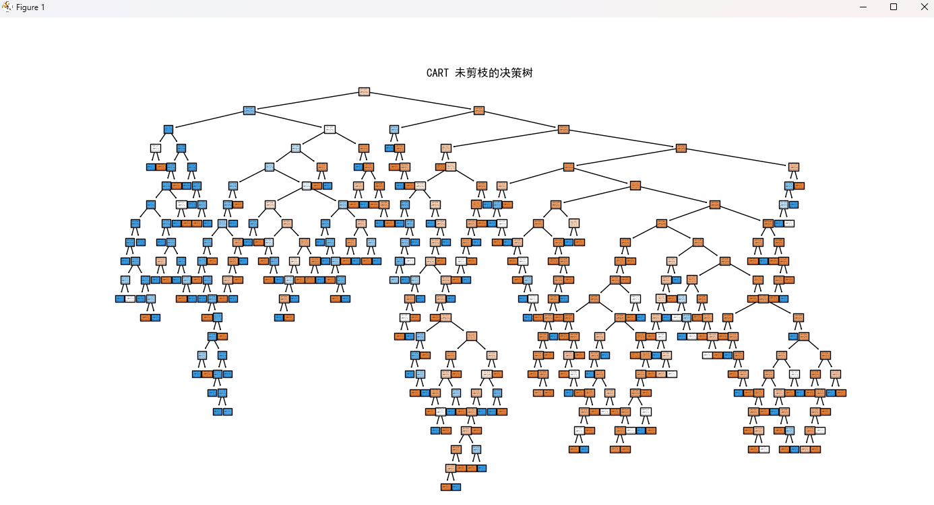
CART 交叉验证准确率 (未剪枝): 0.7801 (±0.0320)
ID3：
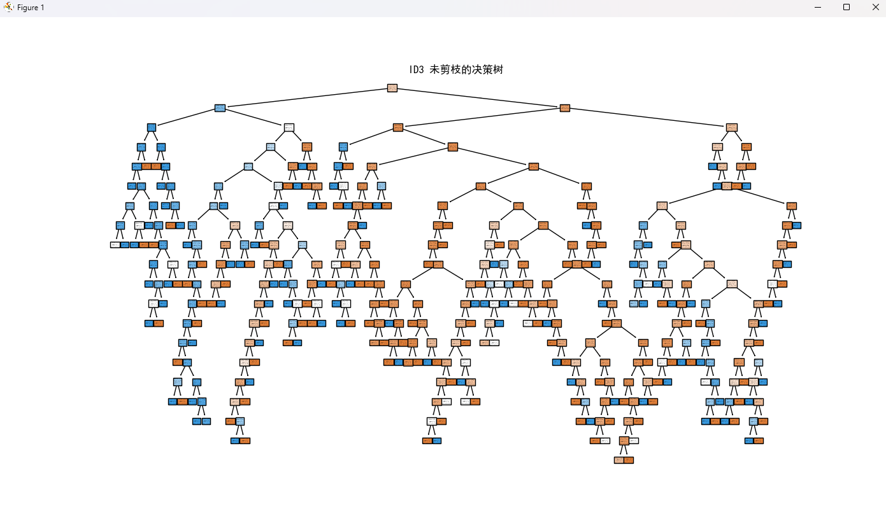
ID3 交叉验证准确率 (未剪枝): 0.7789 (±0.0238)
发现此时的精确度确实略有下降，恰好印证了我之前的想法。接下来进一步尝试通过剪枝来进行优化。
综合考虑下决定采用“后剪枝”的方法。因为如果预剪枝的话只是提前限制了它的深度，很难掌控一个好的度。于是采用代价复杂度剪枝（Cost Complexity Pruning）方法，通过调节 ccp_alpha 参数去除对预测贡献较小的分支。实验结果显示，剪枝前后模型在准确率上差异不大，但树的深度和叶子数明显减少，结构更加简洁，解释性和泛化能力得到提升。
结果如下：
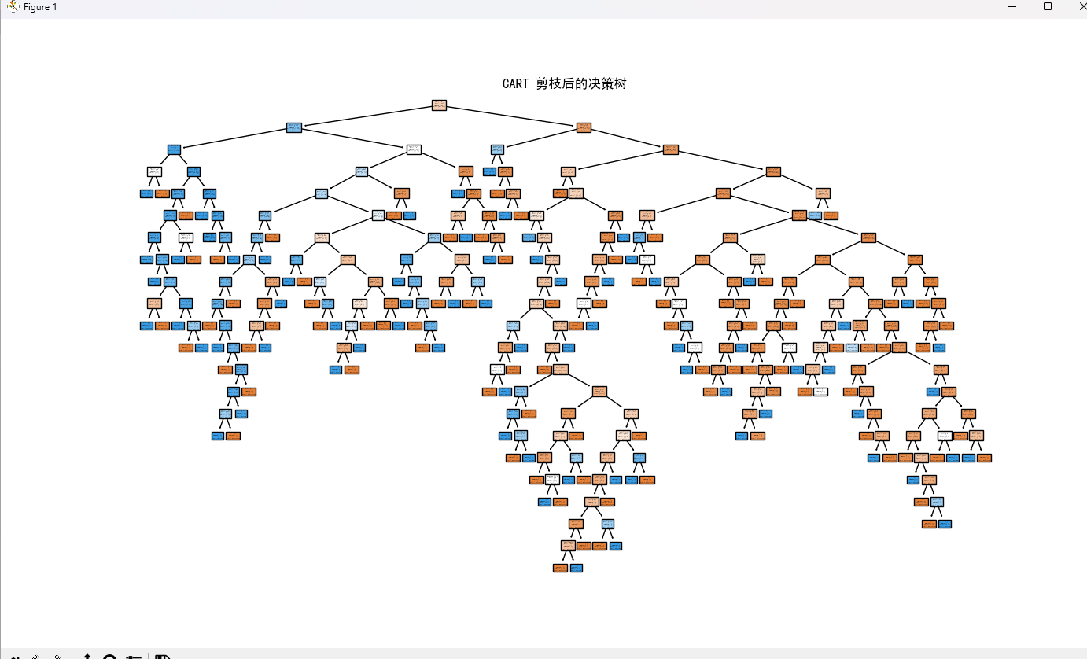

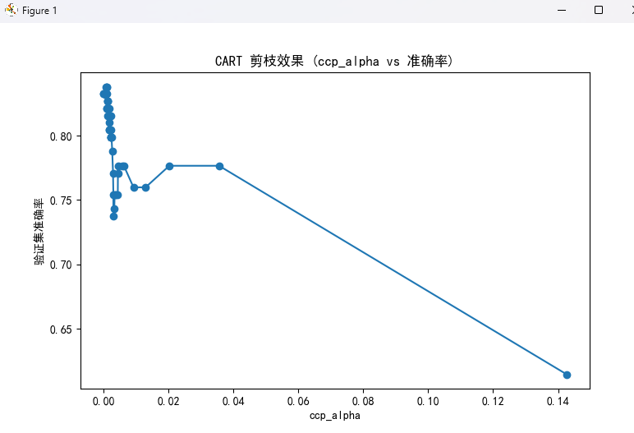

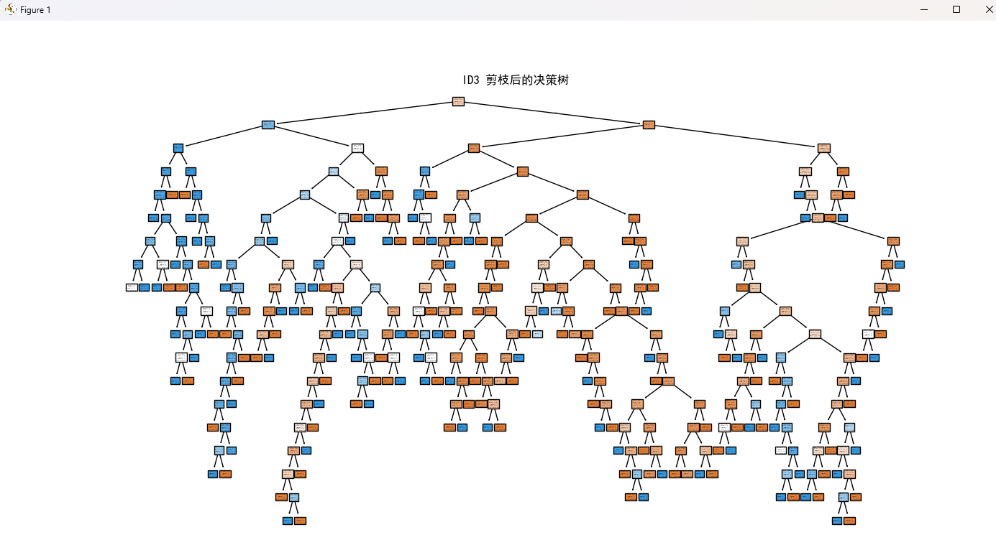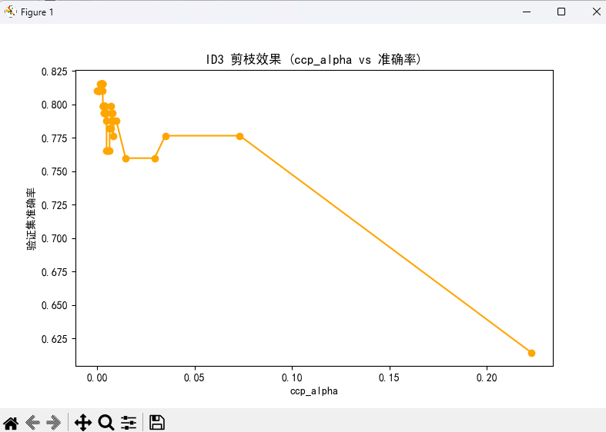
精准度也有了提高：
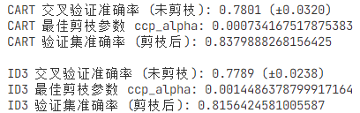
在 Titanic 数据集上，CART 与 ID3 在未剪枝时都能获得较高的准确率，但存在树结构过深、节点过多的问题。经过后剪枝处理后，两种算法的测试集准确率与未剪枝基本持平，而决策树的深度和叶子数有所减少。其中，CART 在剪枝后依然保持较优的预测性能，结构更为简洁；ID3 剪枝后准确率略有下降，但模型复杂度显著降低。整体来看，剪枝能够在保持性能稳定的同时提升模型的可解释性与泛化能力。
- 实验总结
本实验基于 Titanic 数据集，分别构建了 CART（基尼指数）和 ID3（信息增益）两种决策树分类器，并结合交叉验证和后剪枝方法对模型性能进行了评估与优化。实验结果显示，未剪枝的决策树能够较好地拟合训练数据，在测试集上也取得了较高的准确率，但树的深度较大、叶子节点较多，存在一定的过拟合风险。
在采用代价复杂度剪枝（ccp_alpha）后，两类决策树在测试集上的准确率与未剪枝时基本持平，但模型结构显著简化，深度和叶子数均有所下降，规则更清晰，解释性和泛化能力得到提升。从对比结果看，CART 在准确率和稳定性上整体优于 ID3，而 ID3 剪枝后虽然准确率略有下降，但模型复杂度明显降低，更有助于理解模型的决策逻辑。
综上，本实验验证了决策树在分类任务中的有效性，同时说明了剪枝在防止过拟合、提升泛化能力和模型可解释性方面的重要作用。CART 更适合在注重性能的场景中应用，而 ID3 在教学演示和模型可解释性方面具有一定优势，为后续的模型选择和改进提供了参考。

