Central Bank (fee amount to be separated to match debit)
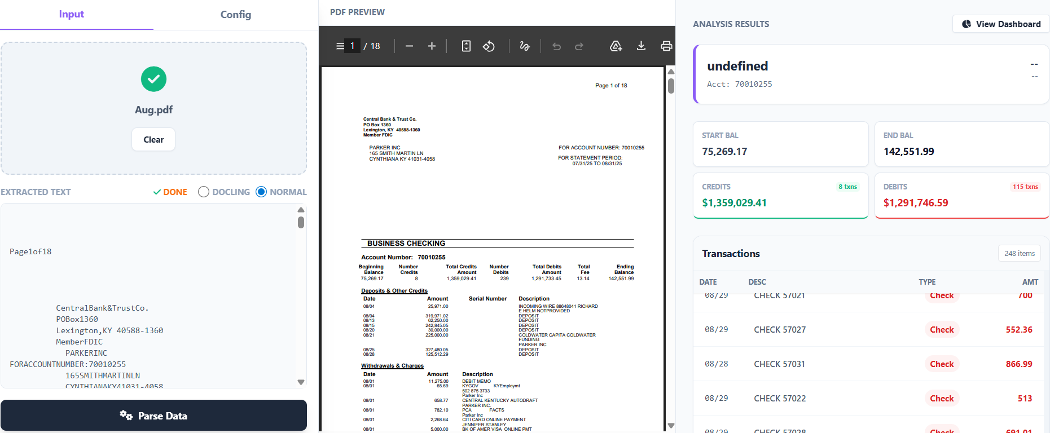

Trustco(sometimes mismatch in debit and interest amount to be seperated)
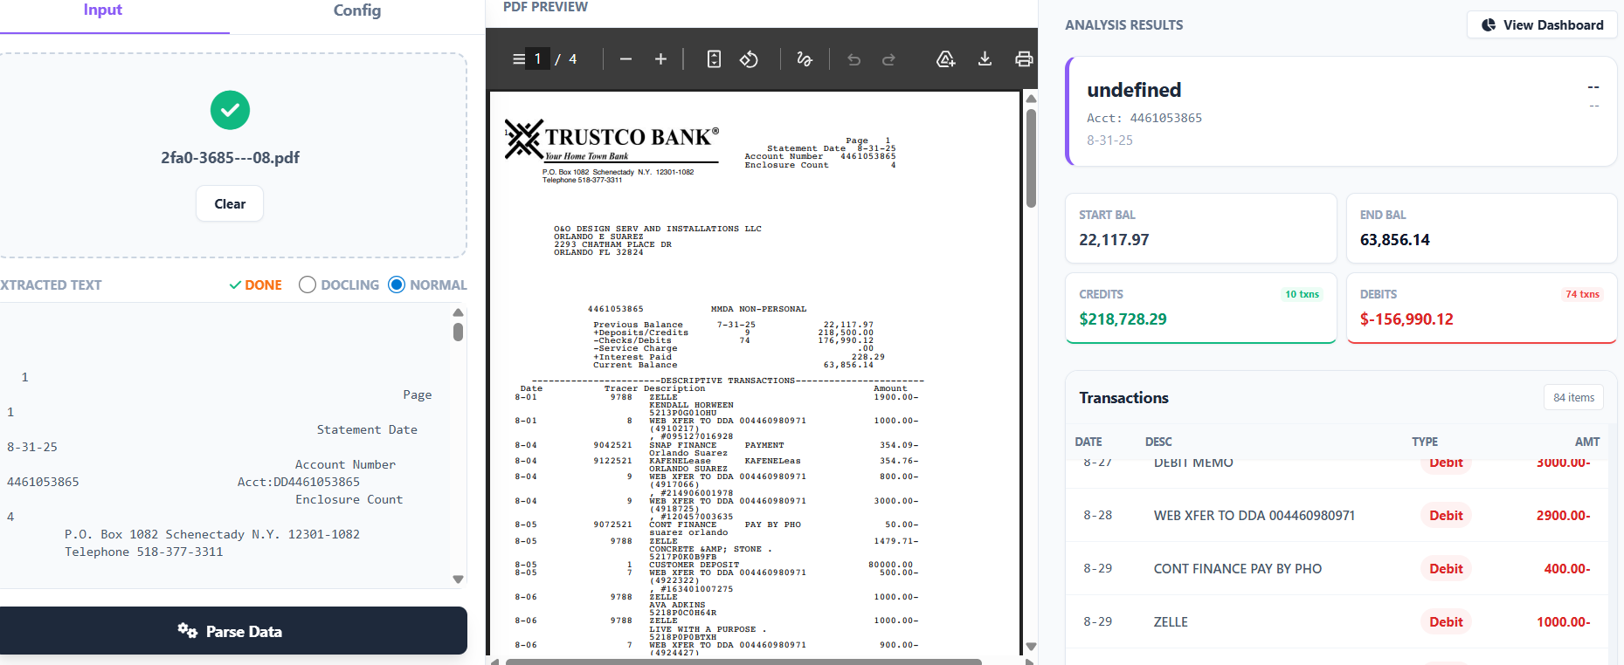

Sun Coast (single account working , multi account to be fixed).
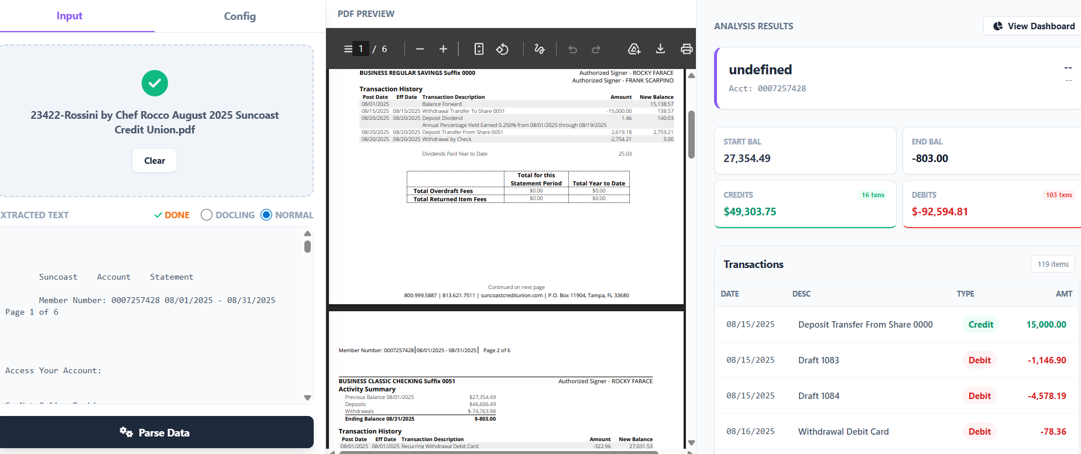

Numerica (single account working, multi account to be checked)
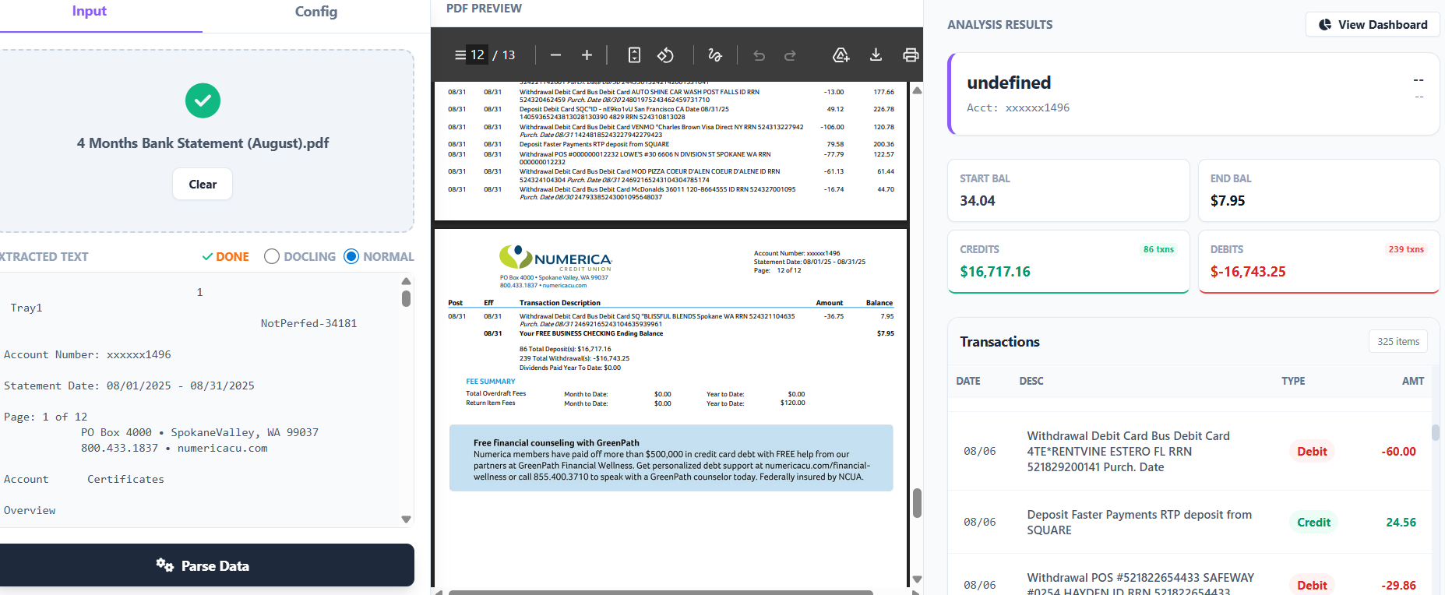

Home Bank (Mismatch due to some long description failing to add to transactions, need fix)
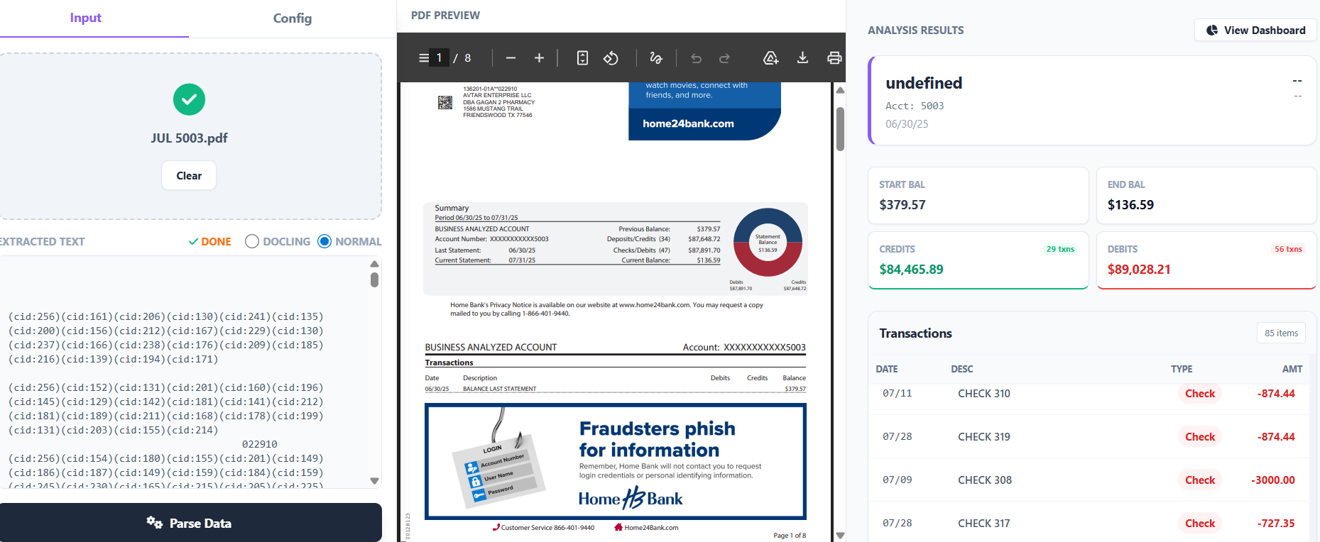

F & M (debit mismatch due to check to be verified)
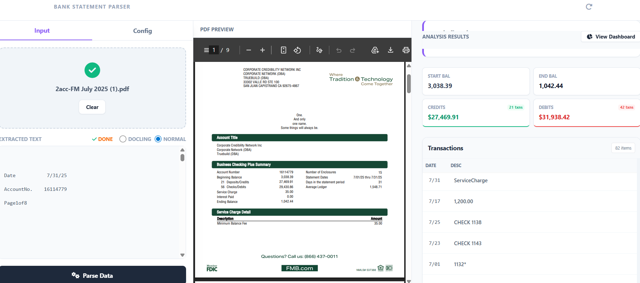

German American
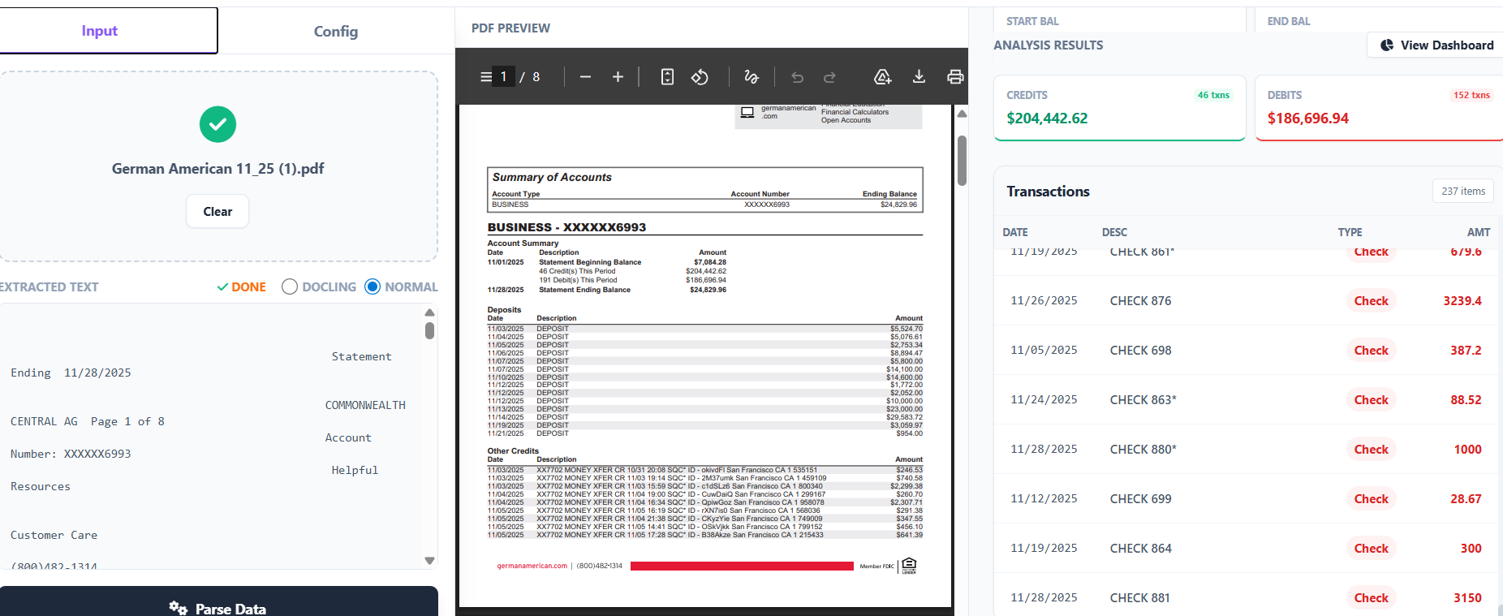

Safe Credit Union
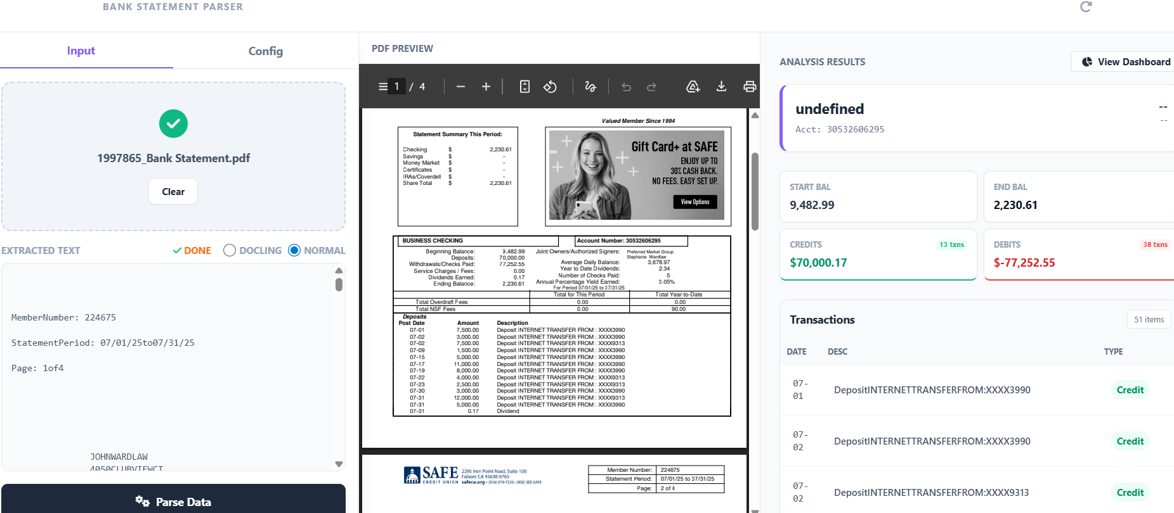

Americu (debit credit mismatch to be checked)
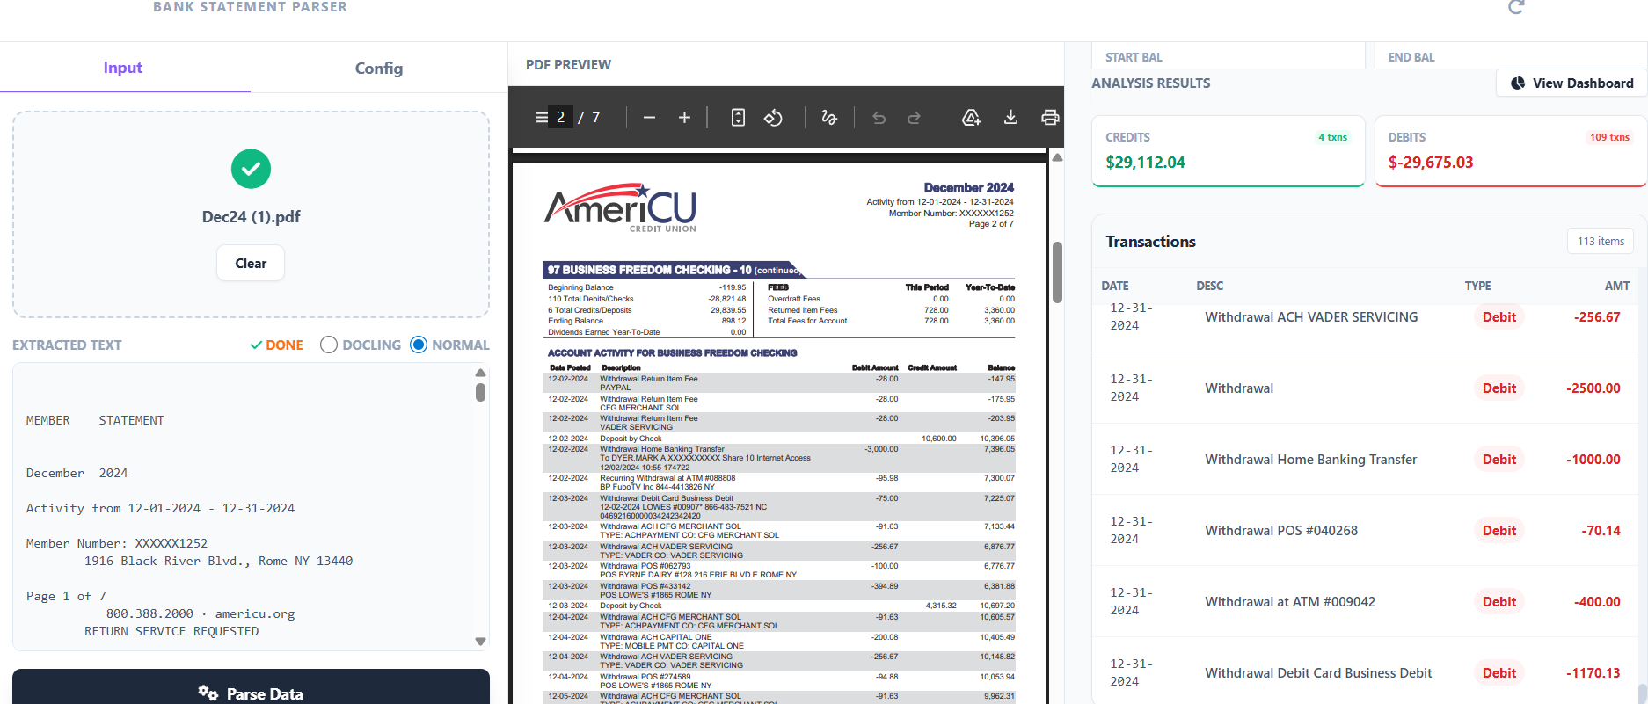

Middle Town Valley(Debit credit mismatch due to long description)
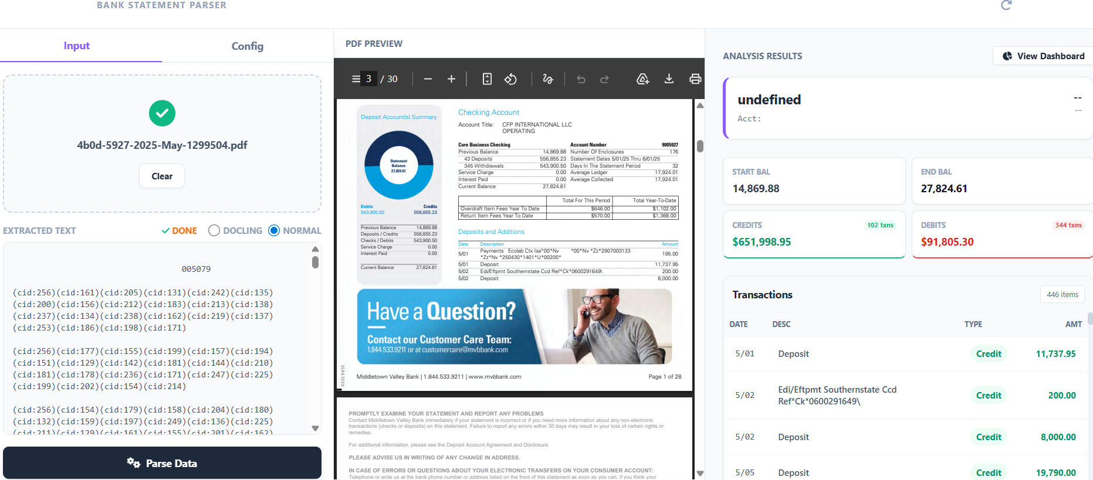

Atlantic FCU (multi account to be fixed)
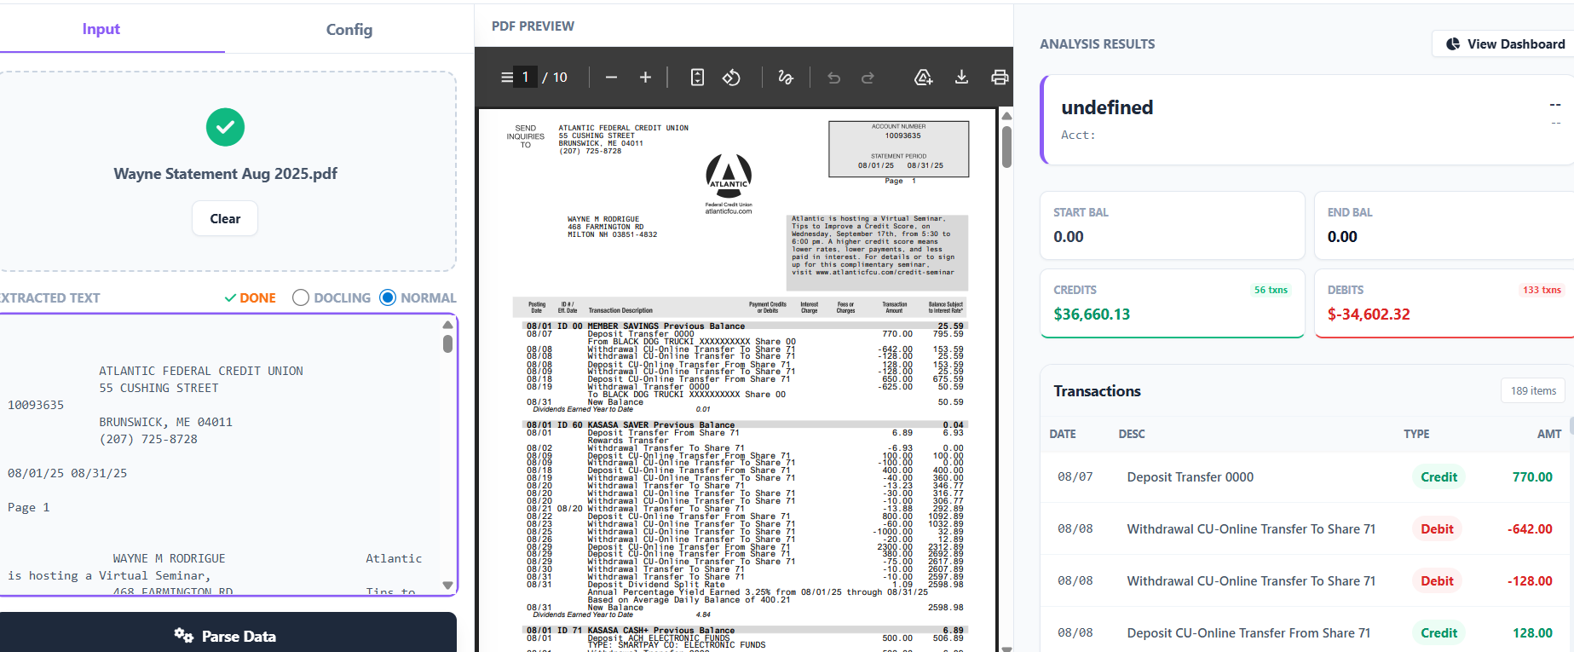

DCU : (multi account to be fixed)
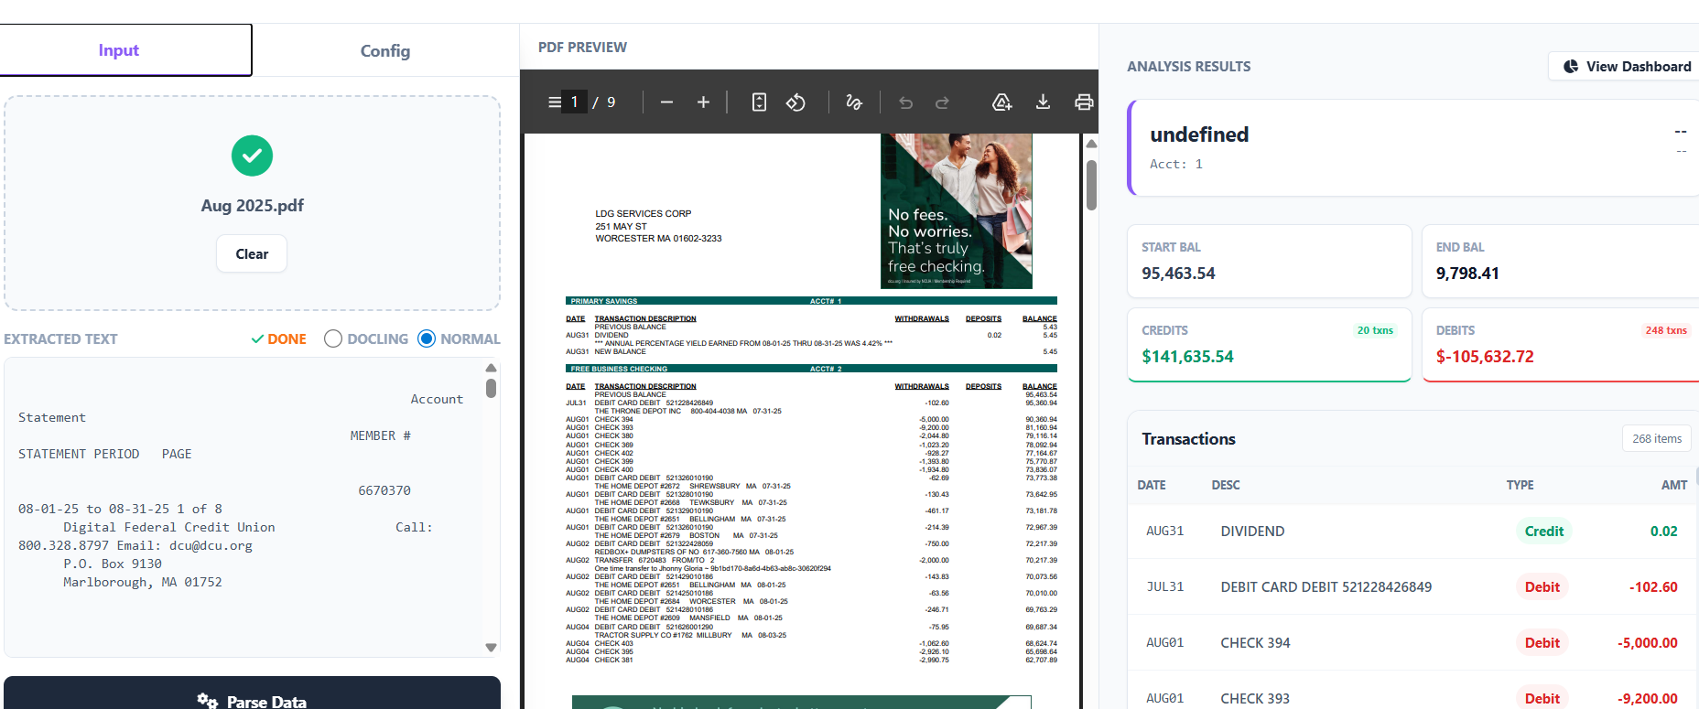

Lili Bank: (fee to be seperated)
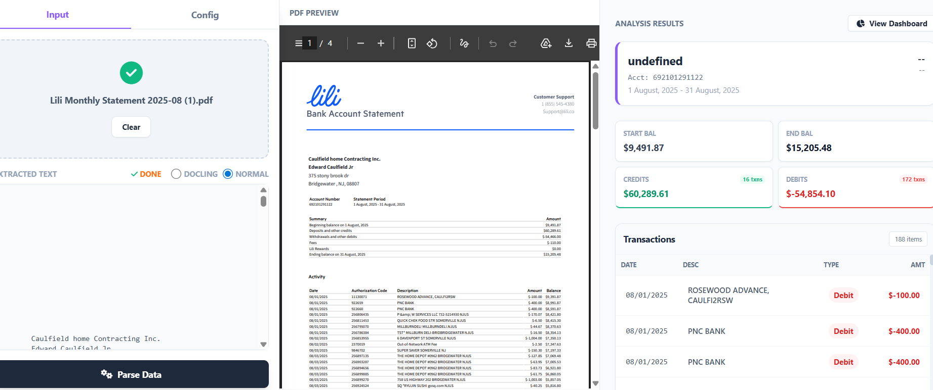

Code

