**CS4623 Advanced Web-based App Development**

**Homework 02**

**(There are two web app exercises in this homework and you have to complete both of them)**

Name: ________________________

Prepared: 2/16, Due: 2/27 by 11:59pm

DIY - Exercise01 Develop a photo selection web app [20 points]

The app will display a photo’s description and a photo(image) based the photo description selected from a dropdown list.

**Requirements:**

1. Create a dropdown list that will show the descriptions of the photos from **the Photos table in the HalloweenSE.mdf database**. Make sure you put the database in the designed directory by asp.net. Otherwise, the web app will crash when I test you app on my machine. [7%]
2. Display the description “**A Student Union at SE**” and its **corresponding photo** (see Fig.-1 below) when the app is requested the first time. [2%]
3. **Center** the whole webpage (or webform) [1%]
4. Adding the required code so that when a use selects a photo description from **the dropdown list**, your app will display the description on **a label server control** and its corresponding photo on **an image server control** on the webpage. (see the screen shot below) [9%]
5. Make sure you test your web app before submission. [1%]

|  |  |
| --- | --- |
|  |  |
| Fig.-1 | Fig.-2 |

Remarks:

1. The HalloweenSE.zip database is in a zip form so remember to unzip it.
2. The Images_SE.zip file has all the image files so remember to unzip it.
3. Refer to the video below to see the completed web app.
   * <https://www.youtube.com/watch?v=1dzBPLUIKhA&hd=1>

Extra 4-1 Enhance the Quotation application [20 points]

The application for this exercise is an enhanced version of the one for exercise 3-1. First, the Quotation has a confirm button to the right of the Calculate button. Second, the Confirm button redirects to a Confirmation page.

The Quotation page (Default.aspx)

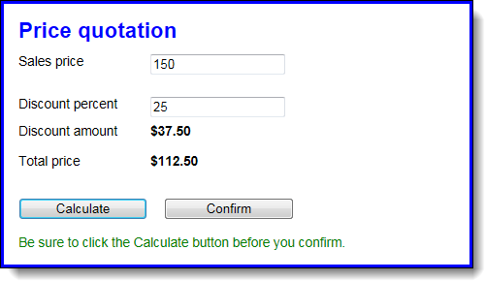

The Confirmation page (Confirm.aspx)

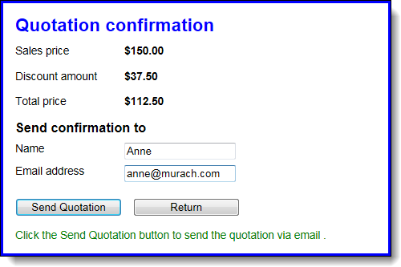

Open the web site for this exercise and start enhancing its pages

1. Open the web site named XEx04Quotation in your exercises_extra folder. It includes the aspx and code behind files for the pages shown above, **but the first page doesn’t have the code for the Confirm button and the second page doesn’t have the code for either of the buttons that are shown**. And neither page has the code for the label for the message that’s displayed below the buttons.
2. Add the Confirm button to the Quotation page right after the Calculate button, and set its CssClass attribute to the button class.
3. Add the Send Quotation and Return buttons to the Confirmation page, and set the appropriate CssClass attributes. Also, set the attributes for the Return button so it goes back to the Quotation page and doesn’t cause validation.
4. On each page, add a label control below the buttons. The ID for each control should be lblMessage, and the starting messages should be as shown above.
5. Test the application to see how it’s going, and make any adjustments.

Add the C# code that makes the application work

1. Create a Click event handler for the Confirm button of the Quotation page. This button **should redirect to the Confirmation page**, which will display the quotation that is being confirmed by getting the data from session state.
2. To make this work, the Click event handler for the Calculate button of the Quotation page **should save the sales price, discount amount, and total price in session state**. Now, add that code to that event handler. Note in the Confirmation page above that you only have to add the values for sales price, discount amount, and total price to session state because those are the only values displayed on the form.
3. When the user clicks the Confirm button on the Quotation page to go to the Confirmation page, the Load event handler for the Confirmation page should get the data from session state and display it as shown above. Now, add that code to the Load event handler.
4. Add an event handler for the Click event of the Send Quotation button. If the entries for this form are valid, this handler should display a message below the buttons that says: “**This function hasn’t been implemented yet.**” It should **also set the values in session state to null**.

Test and refine the operation of the application.

1. Code and test what you have so far. At this point, all four buttons should work. although you may be able to find errors by trying different sequences of button clicks. If, for example, the user clicks on the Confirm button on the Quotation page before clicking on the Calculate button, the application may blow up because there isn’t any data in session state.
2. To fix errors like that, **add code** to the Click event handler for the Confirm button on the Quotation page that **tests whether the value for the sales price in session state is null**: If it is, this message should be displayed in the label below the buttons: “**Click the Calculate button before you confirm**.” If it isn’t, the handler should redirect to the Confirmation page.
3. Do the same test in the Load event handler for the Confirmation page. If the sales price in session state is null, don’t display the values on the page. If it isn’t, get the values from session state and display them.

Make any final adjustments

1. Take a final look at the application, and make any adjustments for improving the look of the application, the operation of the application, or the clarity and logic of the code.

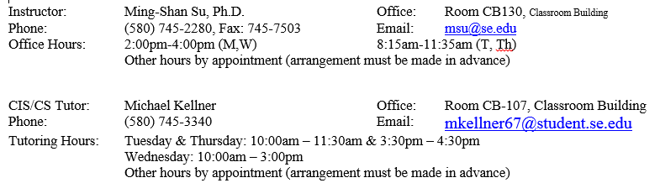

Remarks:

1. Please zip each project into a zipped file and submit it to your blackboard account **(**
2. [**http://blackboard.se.edu**](http://blackboard.se.edu)**).**
3. Please visit the website <http://homepages.se.edu/blackboard/student-support/tutorials/> and then click the “Submitting an Assignment” link to view the tutorial video (2m:43s) about how to submit your homework file(s) if necessary.
4. Please use any computer in the computer labs to do the homework if you don’t own a computer or your computer is crashed.
5. This is not a group project so please complete the homework by yourself.