DRCPROP Tutorial

Carsten Schwarz, February 2012

This tutorial describes how the drcprop classes can be used to setup a simple optical systems for ray tracing.

Part 1

Let's start with the most simple example test_simple_bar2.cc

it is only a brick with the constructor

PndDrcOptBrick bar(17,17.5/2,100);

Dimensions 34x17.5x200 mm, the arguments are the half-lengths. Its center is positioned at 0,0,0. These are no physical units it could be mm,cm,m,km.

When you run doxygen to generate some class documentation, then you see there the picture of such a brick PndDrcOptBrick and the names of the surfaces.

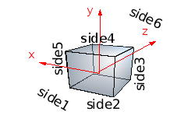

Therefore the two surfaces side6 and side1 are the surfaces at z=+-100 and get now special functionality:

bar.Surface("side6")->SetReflectivity(PndDrcOptReflSilver());
bar.Surface("side1")->SetPixel();

side6 is now reflecting (reflection probability as function of wavelength defined in PndDrcOptReflSilver) and side1 is a pixel, if a photon hits this side the propagation is stopped.

Now a optical system is generated which in principle could contain many volumes which are connected (future step)

PndDrcOptDevSys opt_system;
opt_system.AddDevice(bar);

The manager holds all information about objects, one can add several optical systems. The idea was that if a detectors consists of many optical systems which are all the same, but different in position like the bars with lenses and mirrors in a barrel, they are all added to the manager

PndDrcOptDevManager* manager = new PndDrcOptDevManager();
manager->AddDeviceSystem(opt_system);

Now a filestream is created an connected to the manager

fstream geo;
geo.open("Geo.C",std::ios::out);
geo<<"{"<<endl;
geo<<" TCanvas *c1 = new TCanvas(\"c1\"); "<<endl;
if ( ((TROOT*)gROOT)->GetVersionInt() < 51600)
{
geo<<" TView *view = new TView(1);"<<endl;
}
else
{
geo<<" TView *view = TView::CreateView(1);"<<endl;
}
geo<<" view->SetRange(-50,-50,-50,50,50,50);"<<endl;
geo<<" Int_t i;"<<endl;
geo<<" view->SetView(0,90,90,i);"<<endl;
// the following command sets a flag within the manager and all photons from
// now on will be traced and can be plotted by calling within root
// .x Geo.C
// .x Screen.C
//
manager->Print(geo);
//
// the intention is to play around with routines.

if this

manager->Print(geo)

is not commented out each photons path element is written to a file together with the geometry of all objects. That is done in a stupid space consuming way (look to Geo.C which then is generated) that it is better for long photon lists to comment it out.

now create a particle with 0.69c 10mm under the bar and shoot in towards (0,1,1) through the bar

// create a list of photons in bar

XYZPoint pos(0,-10,0);
XYZVector dir(0,1,1);
double beta = 0.69;
bool photons_exist = manager->Cerenkov(pos,dir,beta); // generate photons
if (photons_exist) manager->Propagate(); // propagate photons
list<PndDrcPhoton> list_photon = manager->PhotonList(); // get list

if photons are generated by manager->Cerenkov(pos,dir,beta); then they are propagated by manager->Propagate(); and you can access the propagated photons by accessing a list

for(iph=list_photon.begin(); iph != list_photon.end(); ++iph)
{
if ((*iph).Fate()==Drc::kPhotMeasured) icnt_measured++;
else if ((*iph).Fate()==Drc::kPhotFlying) icnt_flying++;
// should never happen.
else if ((*iph).Fate()==Drc::kPhotAbsorbed) icnt_absorbed++;
else icnt_lost++;
}

here it is simply the fate, but you could for example print out the coordinates, eg. (*iph).Position().X() and so on...

if you run the file you get the output

generated photons: 48
measured photons: 18
absorbed photons: 14
lost photons: 16

Here, only 48 photons were generated since the speed of the particle just above the Cherenkov threshold. Absorbed in the quartz were 14 photons due to the photon attenuation lenghth of the quartz material or due to the reflectivity of the mirror. 16 photons were lost because they have not been internally reflected. The remainin 18 photons hit the surface “side1”.

A file Geo.C is generated which can be viewed with root:

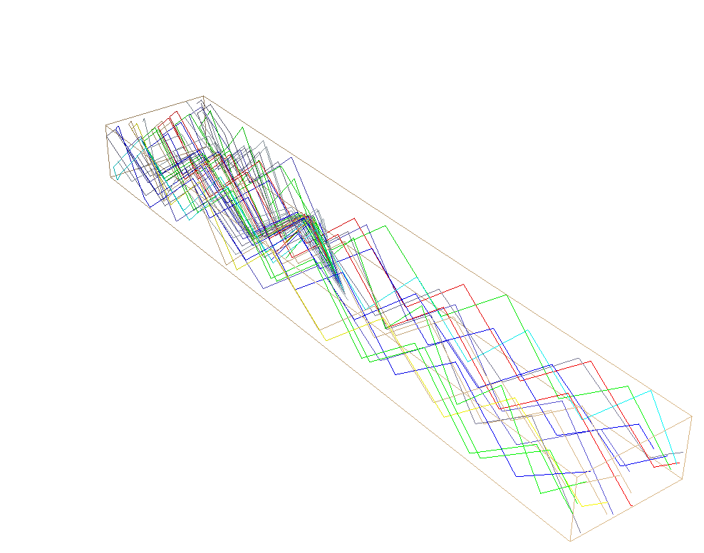

One sees the generated Cherenkov photons reflectin in the +z direction beeing reflected and hitting “side1”. The color of the photons represent their wavelength: red is red, blue is blue, the color code one finds in
//----------------------------------------------------------------------
int PndDrcPhoton::ColorNumber(double lambda) const
{
// the colors were taken from wikipedia entry about colors.
if (lambda< 0.1) return 17; // grey
if (lambda> 740) return 50; // dark red
else if (lambda> 625) return 2; // red
else if (lambda> 590) return 42; // orange
else if (lambda> 565) return 5; // yellow
else if (lambda> 520) return 3; // green
else if (lambda> 500) return 7; // cyan
else if (lambda> 450) return 4; // blue
else if (lambda> 430) return 9; // indigo
else if (lambda> 380) return 39; // violet
return 33; // blue grey
}

Part 2
In the next example we define a surface reflection probability for the quartz bars. Look to test_simple_bar2a.cc.
Including

#include "PndDrcOptReflGray.h"

the constructor

PndDrcOptReflGray refl;
refl.SetReflProb(0.99);

is available, the reflextivity is 99% and the outside surfaces of both bars get this quantity with eg.

bar1.Surface("side2")->SetReflectivity(refl);

It is important that all devices get names. With these names one can acess the objects. Internally within the classes all objects are cloned and have different pointers. Therefore, the names are needed to find these objects.

Instead of writing
PndDrcOptBrick bar2(17,17.5/2,100);
bar2.SetOptMaterial(PndDrcOptMatLithotecQ0());
bar2.SetName("bar2");
bar2.Surface("side1")->SetPixel();
bar2.Surface("side2")->SetReflectivity(refl);
bar2.Surface("side3")->SetReflectivity(refl);
bar2.Surface("side4")->SetReflectivity(refl);
bar2.Surface("side5")->SetReflectivity(refl);

the following is the same
PndDrcOptBrick bar2(bar1);
bar2.SetName("bar2");
bar2.Surface("side1")->SetPixel();
bar2.Surface("side6")->SetReflectivity(PndDrcOptReflNone());
// (one needs the definition #include PndDrcOptReflNone.h)

Now we shift the bars in the right position that “side1” of “bar1” faces “side6” of “bar2”.

bar1.AddTransform(Transform3D(XYZVector(0,0, 100))); // shift by half length
bar2.AddTransform(Transform3D(XYZVector(0,0,-100)));

and after adding the to the optical system, we connect the corresponding surfaces (again using names):

// couple surface 1 of device 1 with surface 2 of device 2
// dev1 dev2 surf1 surf2
opt_system.CoupleDevice("bar1","bar2","side1","side6");

One can now play with the reflection probability and see how the number of measured photons change.

For a 50% reflection probability the photons do not reach the pixel side anymore.

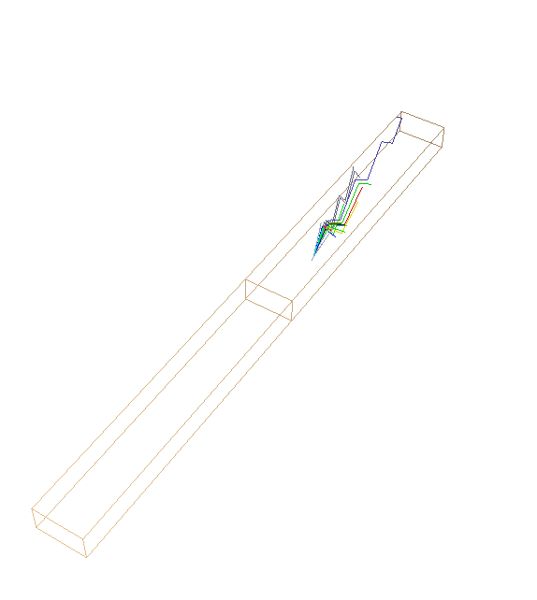

Part 3

The optical active volumes are not restricted to boxes, they can consist of surfaces delimited by polygons. The surfaces within these polygons need not to be flat, they can even bend like eg. Lenses. The PndDrcOptBrick is internally a combination of 6 rectangular surfaces. One can do this also by hand. We will exercise this by constructing a prism shaped expansion box. This is the example in file test_simple_bar2b.cc.

// define an expansion volume with limitin points in z-y:
//
// p3a
// / |
// / |
// / | y
// p2a | ^
// | | |
// p1a------p4a z <--0
//
// the left side will be connected to the quartz bar the right side will be the pixel.
//
//
// seen from -z it looks like
//
// p3a----p3b Y
// | | ^
// | | |
// | | x <--0
// | |
// | |
// p4a----p4b

The coordinates of the points are given and 6 surfaces defined.

PndDrcSurfPolyFlat a1,a2,a3,a4,a5,a6;

a1.SetName("side+z");
a1.AddPoint(p4a);
a1.AddPoint(p4b);
a1.AddPoint(p3b);
a1.AddPoint(p3a);
a1.SetPrintColor(2); // paint it in red
a1.SetPixel(); // pixel

The names are needed for later access of the object. It is important, that the sequence of added points goes either clock wise or counter clock wise around the surface. Otherwise:

a1.AddPoint(p4a);
a1.AddPoint(p3b); // swapped
a1.AddPoint(p4b); // swapped
a1.AddPoint(p3a);
would create a hour glass shaped surface (not wanted).

From the surfaces one constructs the volume. It is up to the programmer, that all sides are closed and the volume has no holes.

PndDrcOptVol ex_box;
PndDrcOptMatLithotecQ0 quartz;
ex_box.SetOptMaterial(quartz);
ex_box.AddSurface(a1);
ex_box.AddSurface(a2);
ex_box.AddSurface(a3);
ex_box.AddSurface(a4);
ex_box.AddSurface(a5);
ex_box.AddSurface(a6);
ex_box.SetName("expansion_box");

ex_box.Surface("side-z")->SetPixel();

The pixel is now the last surface in -z direction. The box is added to the optical system and the connection of the surfaces are

// couple surface 1 of device 1 with surface 2 of device 2
// dev1 dev2 surf1 surf2
opt_system.CoupleDevice("bar1","bar2", "side1","side6");
opt_system.CoupleDevice("bar2","expansion_box","side1","side+z");

Running the code and “root Geo.C” shows
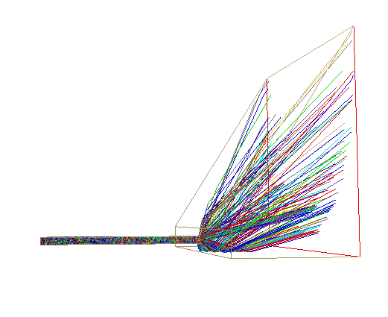

The example contains also a code section how to produce the coordinates of the photons which hit the backplane with colors representing the wavelength of the photons.

Run root Screen.C (Again the implemenatation is not very smart, but it works)

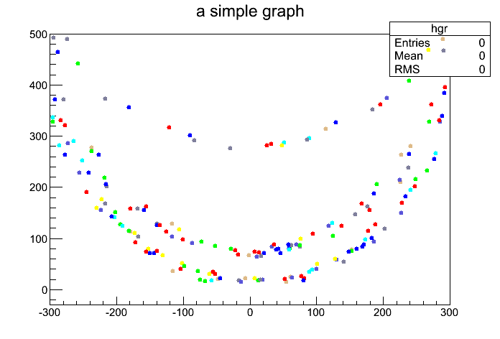
Part 4

In file test_simple_bar2c.cc it is shown how to construct non flat surfaces. In this example a focussing mirror is attached to the downstream side of the quartz bar. For the implementation the spherical surface of a lens is taken. The lens surface gets a reflectivity.

PndDrcOptLens mirror(17,17.5/2,40,9999,4600);

mirror.SetOptMaterial(PndDrcOptMatLithotecQ0());

//
//
// p16---------p26
// /| side6 /|
// / | / |
// / p46-------/-p36 Y
// p1-----------p2 / ^ Z side46
// / | / /| / | / side56 side36
// / |/ / |/ |/ side26
// / p4-------/--p3 X <---0
// p11---------p21 /
// | /side1 | / side41
// |/ |/ side51 side31
// p41---------p31 side21
mirror.SetName("mirror");
mirror.Surface("side6")->SetReflectivity(PndDrcOptReflSilver()); // the mirror
mirror.AddTransform(Transform3D(XYZVector(0,0, 1000+40))); // shift by half length + 1000mm bar length
mirror.Surface("side21")->SetReflectivity(refl);
mirror.Surface("side26")->SetReflectivity(refl);
mirror.Surface("side31")->SetReflectivity(refl);
mirror.Surface("side36")->SetReflectivity(refl);
mirror.Surface("side41")->SetReflectivity(refl);
mirror.Surface("side46")->SetReflectivity(refl);
mirror.Surface("side51")->SetReflectivity(refl);
mirror.Surface("side56")->SetReflectivity(refl);

However the image does not get sharper:

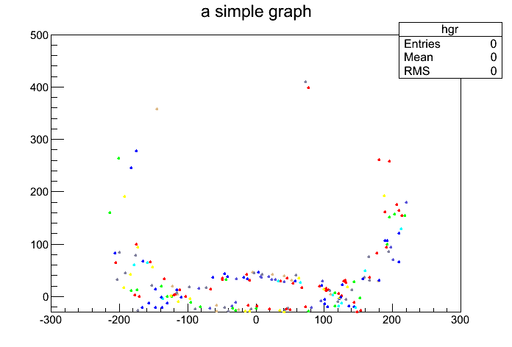

To see why, limit the wavelength range and increase the number of photons:

bool photons_exist = manager->Cerenkov(pos,dir,beta,10000,1e16,400,405);

Focussing can be switched on and off by

PndDrcOptLens mirror(17,17.5/2,40,9999,4600); // focussing
PndDrcOptLens mirror(17,17.5/2,40,9999,9999); // non focussing

Now the images are (left focussed right unfocussed)

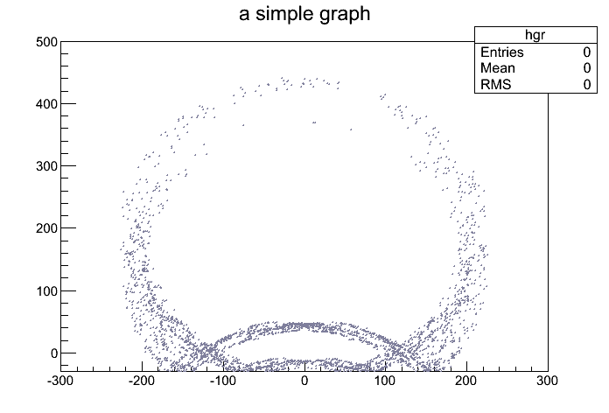
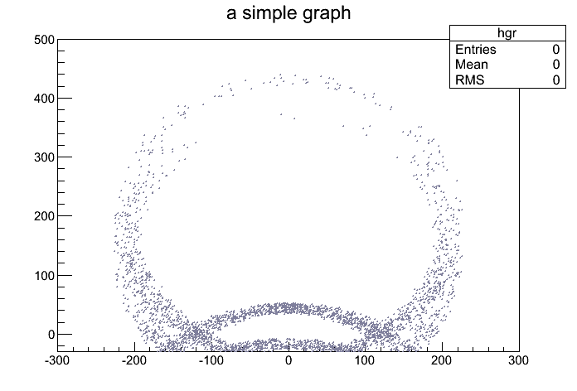

The photons which hit the top part of the screen have a longer path and are therefore unfocused.

If on uses only a few photons one can turn on the geometry for a look towards the mirror.
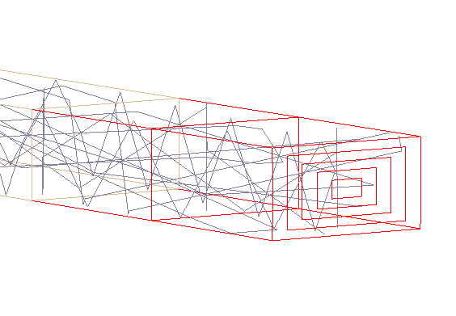
Photons can also manually set. If one set the option

OPTION opt;

opt = Point;

the photons are set individually and are later propagated:

bool photons_exist = false;
list<PndDrcPhoton> list_photon;

PndDrcPhoton ph;
for (double xx=-15; xx<=+15; xx+=2)
{
for (double yy=-7; yy<=7; yy+=2)
{
ph.SetPosition(XYZPoint(xx,yy,10));
ph.SetDirection(XYZVector(0,0,+1));
ph.SetWavelength(650);
list_photon.push_back(ph);
}
}
photons_exist = true;
manager->SetPhotonList(list_photon,"bar1");
if (photons_exist) manager->Propagate(); // propagate photons
list_photon = manager->PhotonList(); // get list

It is necessary for the propagation to tell the photons, in which volume they are. Therefore, the above parameter “bar1”.
The resulting figure is:
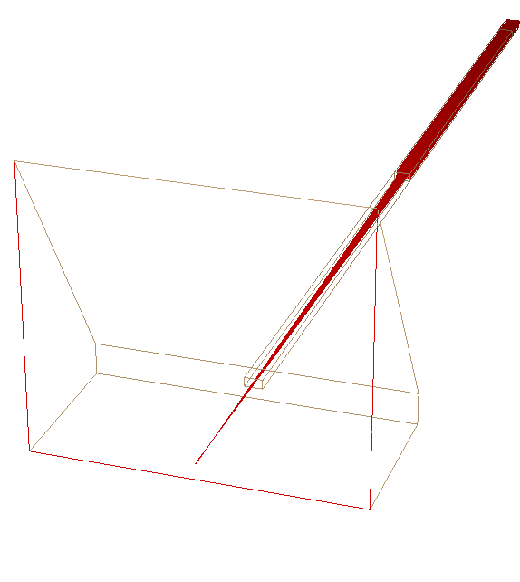

One observes photons sent downstream towards the focussing mirror and reflected back, focussed on a single point.

Next we create geometric figures on the screen, eg. squares, to see how the different angles are focussed. This is done by setting the option to

opt = Squares1;

Squares with half angle 0.1,0.2,0.3, and 0.4 degrees are produced. They are red, yellow, cyan, and blue (wavelength), respectively. The red photons suffer no side reflection on their way towards the mirror and back towards the photon detector. The yellow photons suffer a reflection at the bootom and top sides, but no reflection at the left or right side.

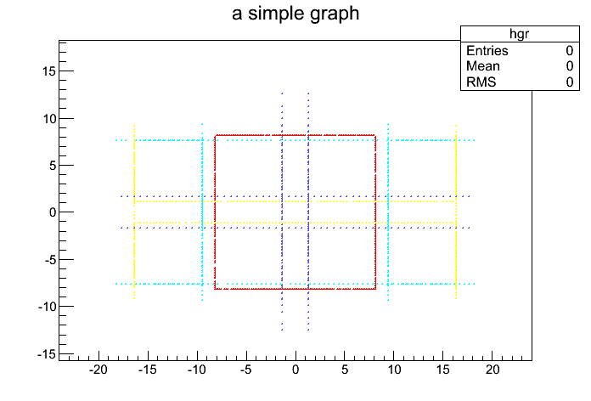

With opt=Squares2 we test the position dependency: The colors code now if the origin for above red square is shifted by 5 mm in 4 different directions. There is a dependency, which disapears when on corrects the mirror radius from 4600mm to 4700mm in a pragmatic approach. It is a focussing effect. Now the squares are all the same:

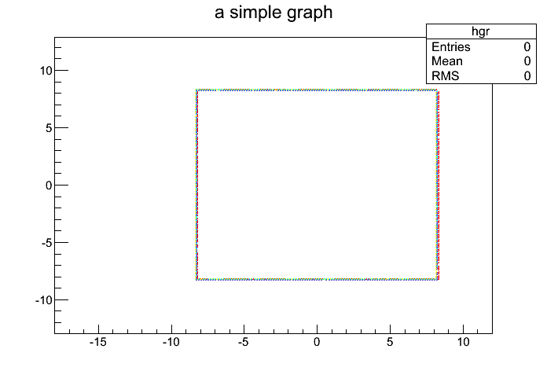

No let's increase the emission angle to 0.2 degree, where on gets a reflection on the way towards the photon detector at the top and bottom side:

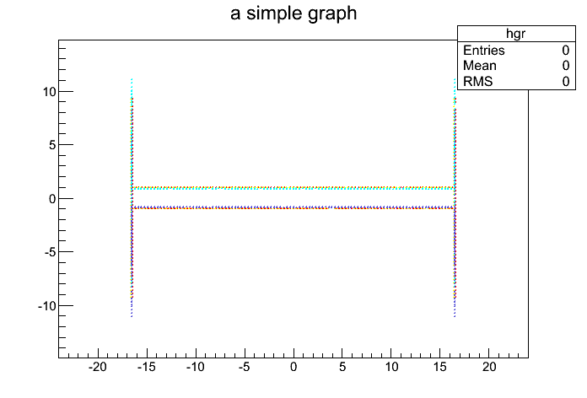

the reflection on the way from the mirror at the top and bottom side leads to different positions on the detector plane for photons emitted 5mm lower or higher. Therefore, one has these sharp structure in the focussed Cherenov images which do not fall on each other.

