
Continuous Assessment Cover Sheet
Student Name: Jinyan Yang | Student Number:D00264564
Programme: | Stage: | Complete Student Checklist:  Re-read brief  References and Bibliography  Proofread
Module: Power System Engineering
Due Date: 2023.10. 4 | No. Pages: 12
Lecturer’s Name: Tim Daly
Assignment No. and/or Description/Topic: Power World |  | Mode of Submission:  Softcopy Hardcopy
DECLARATION: I declare that:
- This work is entirely my own, and no part of it has been copied from any other person’s words or ideas, except as specifically acknowledged through the use of inverted commas and in-text references;
- No part of this assignment has been written for me by any other person except where such collaboration has been authorised by the lecturer concerned;
- I understand that I am bound by DkIT Academic Integrity Policy. I understand that I may be penalised if I have violated the policy in any way;
- This assignment has not been submitted for any other module at DkIT or any other institution, unless authorised by the relevant Lecturer(s);
- I have read and abided by all of the requirements set down for this assignment.

Signature……………………………………………………..…………………………………………………… Date………………..…………

Lecturer’s Comments

Provisional Mark : Lecturers Signature : _________ Date: _________
Work submitted late will be subject to penalties in accordance with the DkIT Continuous Assessment Policy
Power System Engineering Assignment 1

TOC

1. Introduction to Power World 3
2. Setting up Power World 4
2.1 File-New case 4
2.2 Draw some example 4
2.3 Start to study Power world 5
2.3.1 function 5
2.3.2 Zoom method 7
2.4 Power World Simulator—Edit Mode: 7
2.4.1 Edit mode 7
3. Review of previous studies 10
4.Transmission lines (part 1) – wk 2 13

List of Figures
Pic. 1 Build a new case 4
Pic. 2 Draw example1 4
Pic. 3 Draw example2 5
Pic. 4 Draw example3 5
Pic. 5 function1 6
Pic. 6 function2 6
Pic. 7 function3 7
Pic. 8 function4 7
Pic. 9 Edit mode 8
Pic. 10 Bus3-1 8
Pic. 11 Bus3-2 9
Pic. 12 Bus3-3 9
Pic. 13 Bus3-4 10
Pic. 14 Bus3-5 10
Pic. 15 Bus3-6 11
Pic. 16 Bus3-7 11
Pic. 17 example 2.3 12
Pic. 18 example 2.32 13
Pic. 19 example 5_4 14

- Introduction to Power World

Function:
Power World provides convenient tool for simulating power system timing, allowing the user to simulate a power system with color-animated single line diagram.
Alternative:
Easypower, skm, EDSA

- Setting up Power World

2.1 File-New case

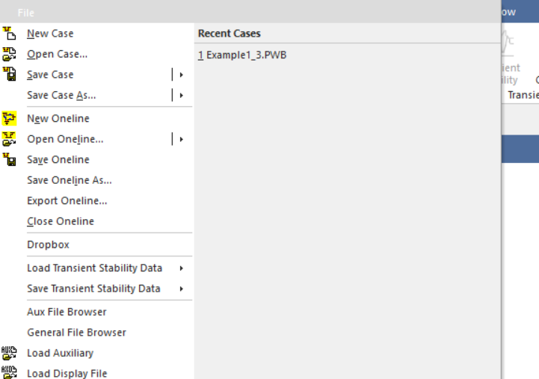
Pic. 1 Build a new case

2.2 Draw some examples

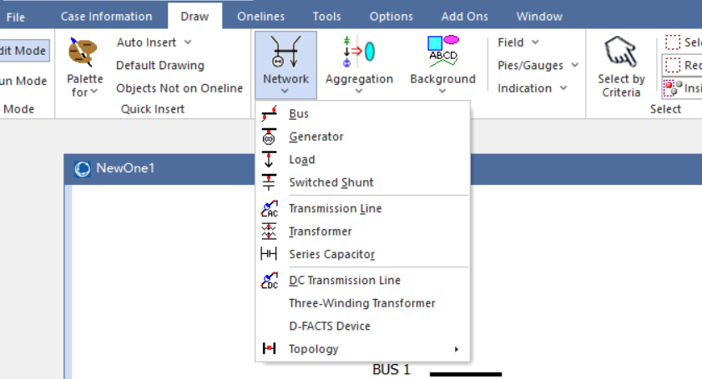
Pic. 2 Draw example1

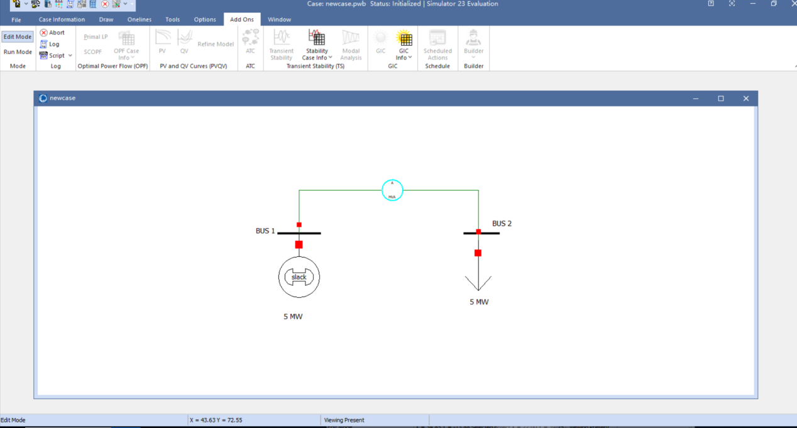
Pic. 3 Draw example2

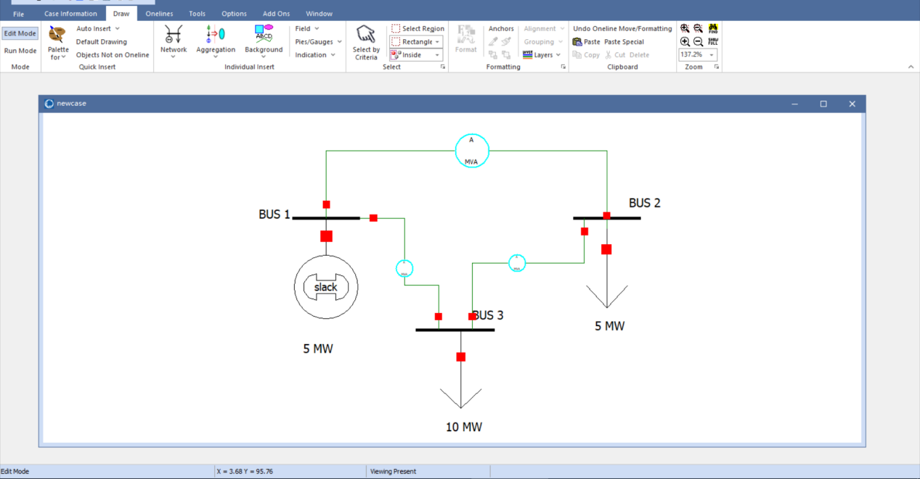
Pic. 4 Draw example3

2.3 Start to study Power world

2.3.1 function

Select the Tools tab on the Ribbon and then click on the green and black arrow button above Solve (i.e.,the ‘‘Play’’ button).

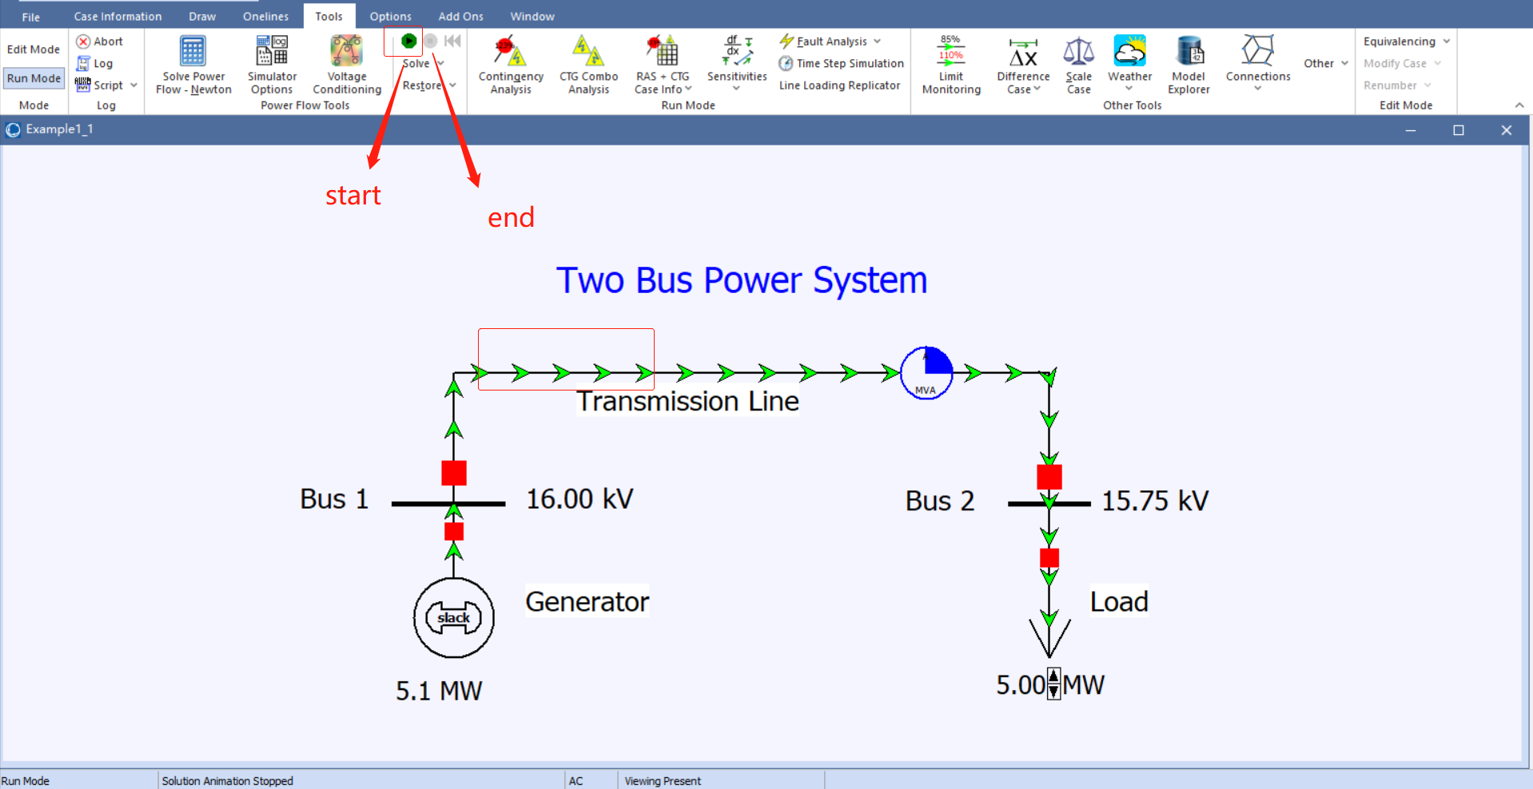
Pic. 5 function1

Clicking on any of the circuit breakers isolates the load from the generator resulting in a blackout.

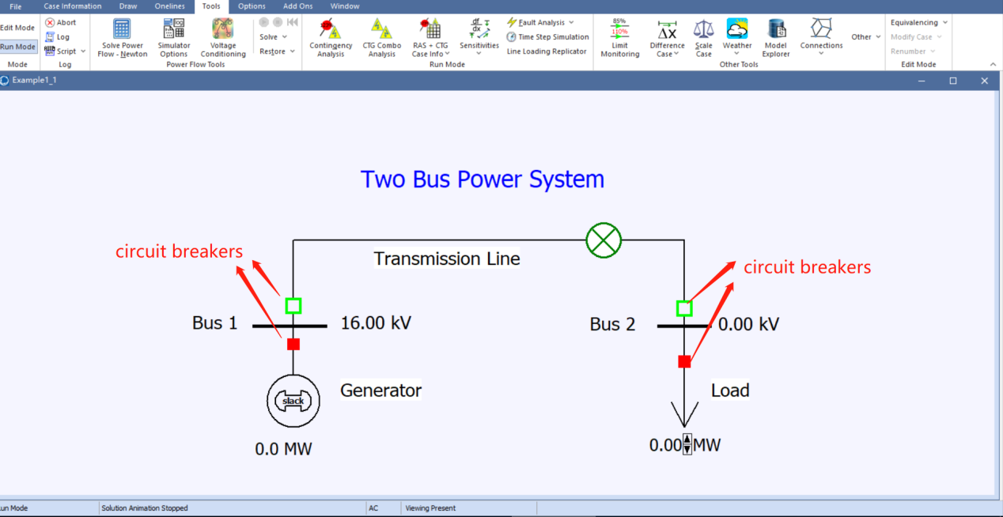
Pic. 6 function2

Note that because of the impedance of the line, the load’s voltage drops as its value is increased
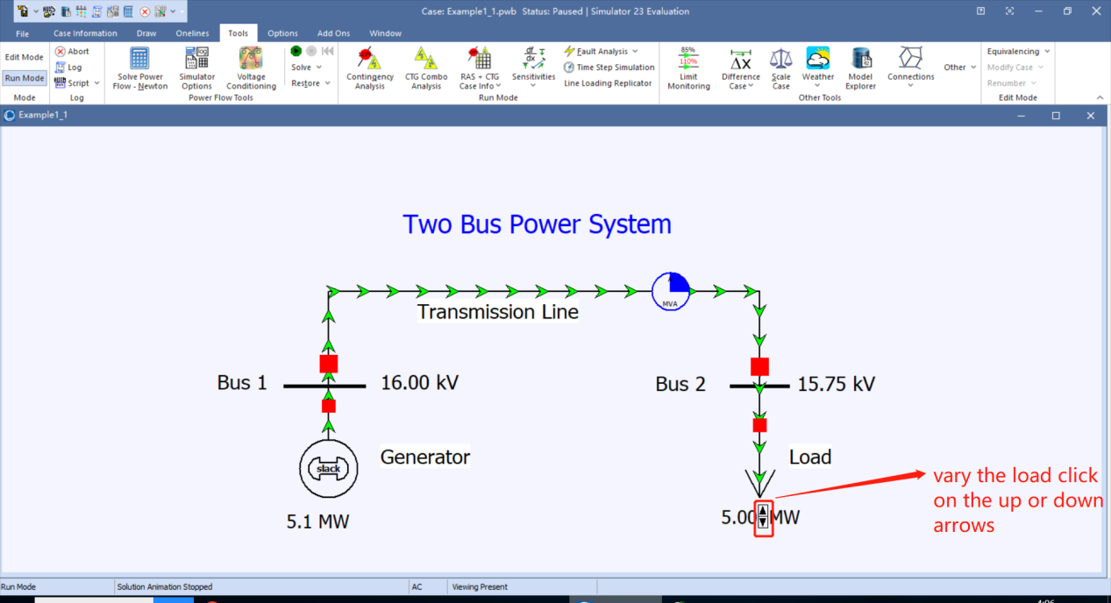
Pic. 7 function3

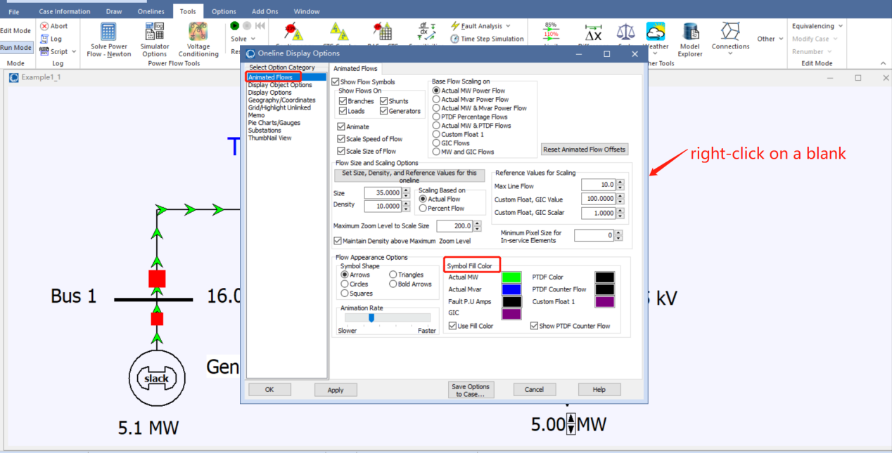
Pic. 8 function4

2.3.2 Zoom method
click in an empty portion, the keyboard arrow keys in the direction, so on

The power system model is stored in *.pwb files (Power World binary file) while the one-line display information is stored in *.pwd files (Power World display file).

2.4 Power World Simulator—Edit Mode:

Power World has simulations and performing analysis

2.4.1 Edit mode

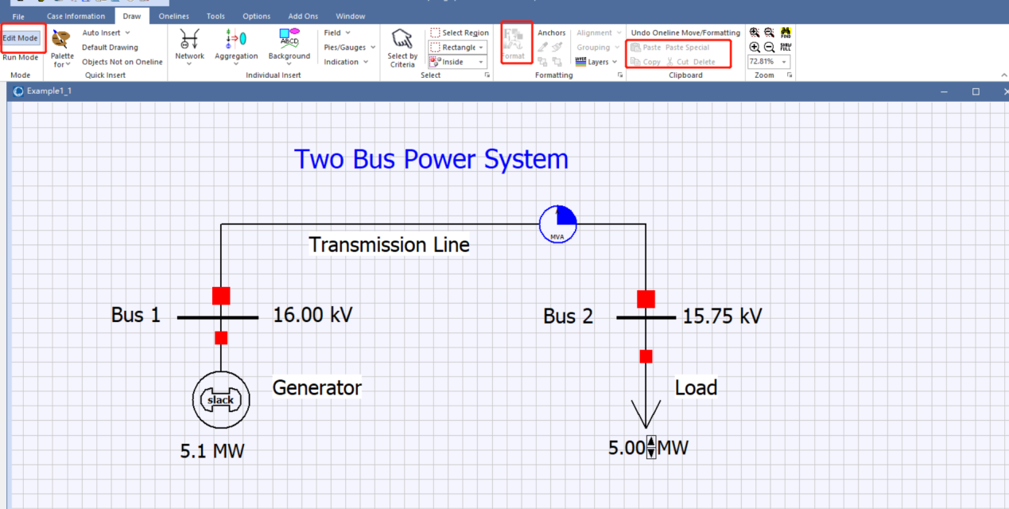
Pic. 9 Edit mode

BUS 3
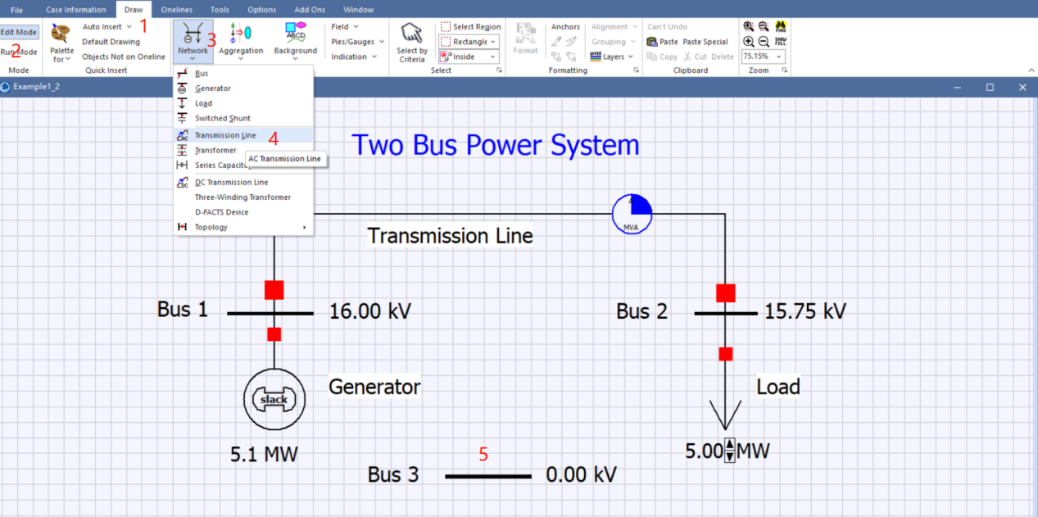
Pic. 10 Bus3-1

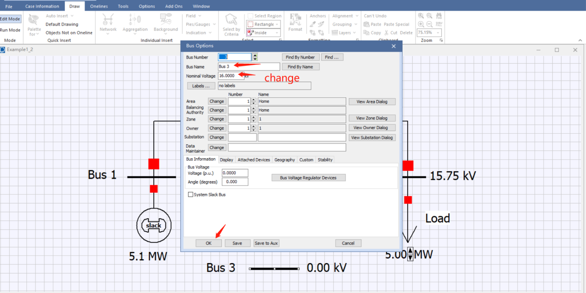
Pic. 11 Bus3-2

BUS- change the font’s size
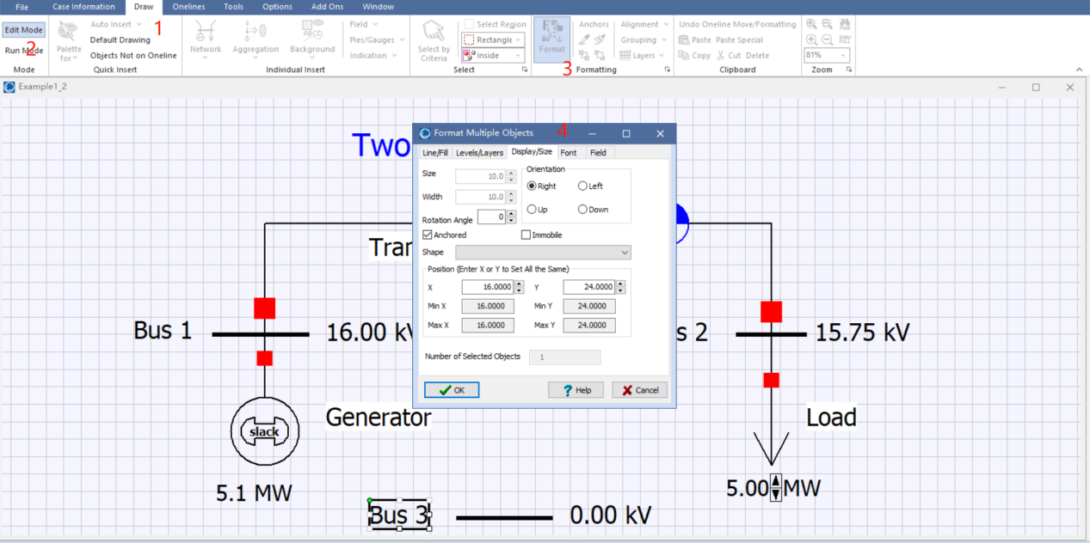
Pic. 12 Bus3-3

BUS3 load-set parameter
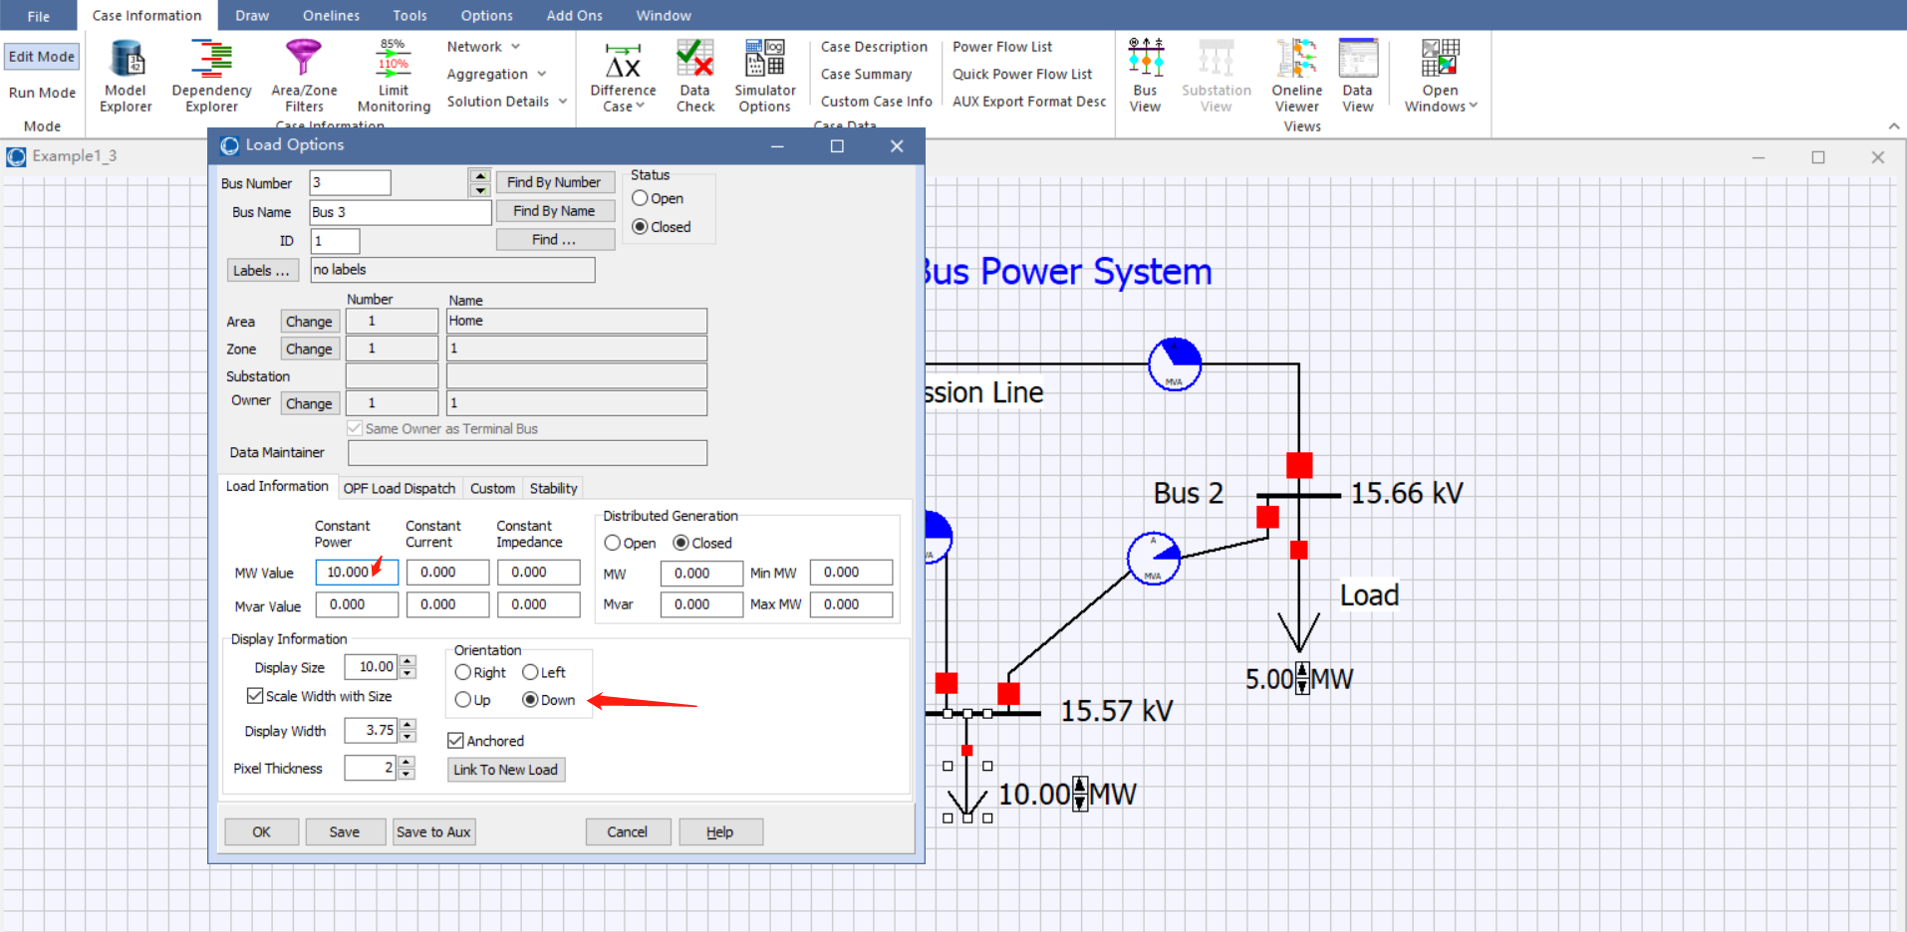
Pic. 13 Bus3-4

change the option dialog size
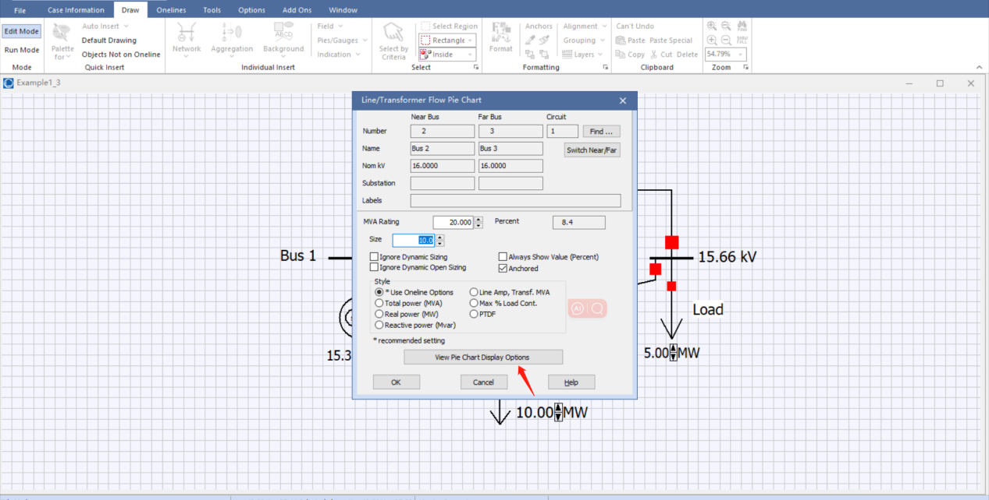
Pic. 14 Bus3-5

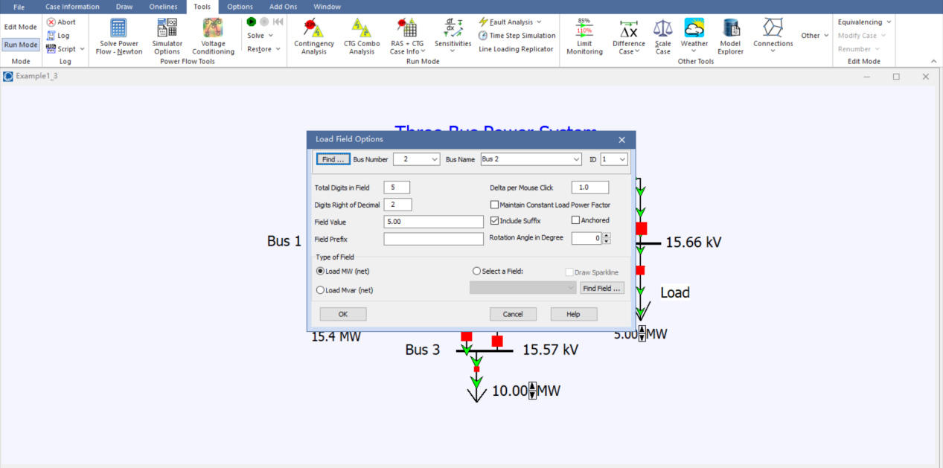
Pic. 15 Bus3-6

P： real power provided to the load bus Q: reactive power
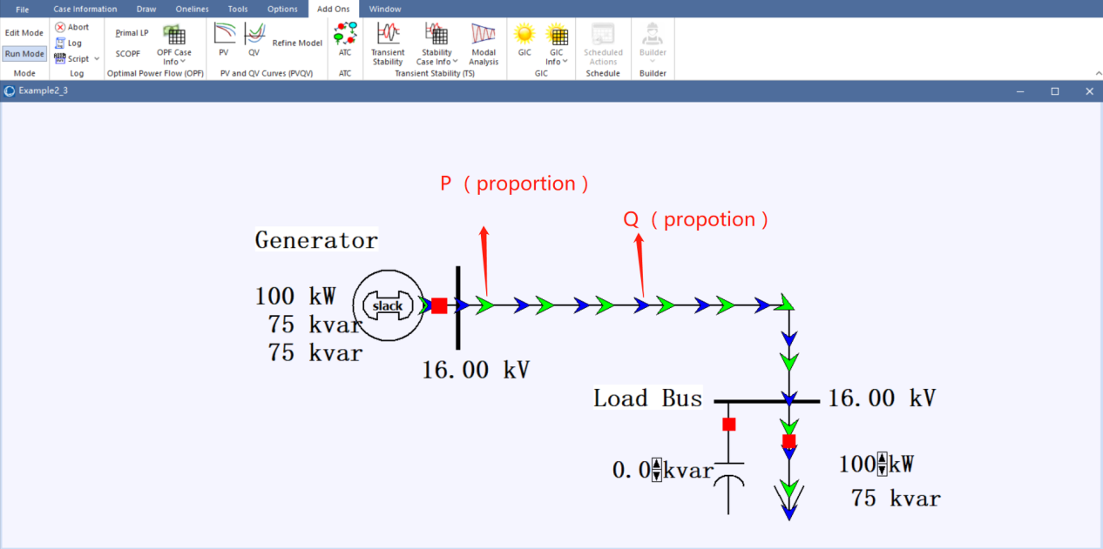
Pic. 16 Bus3-7

3. Review of previous studies

Real power flow is unchanged
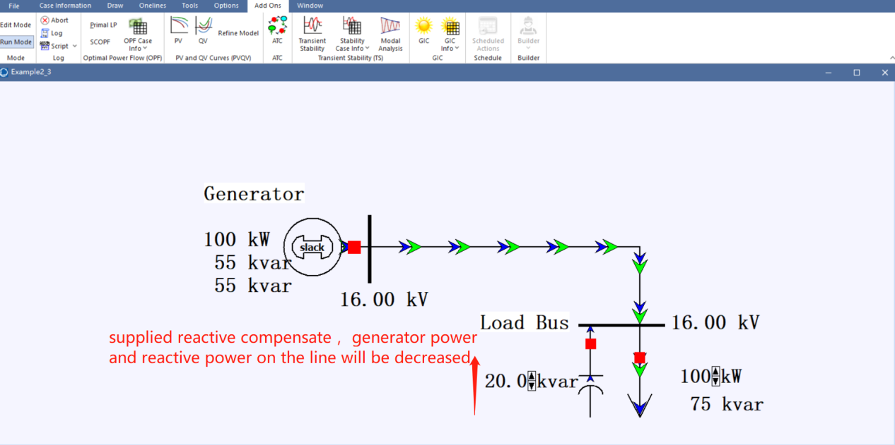
Pic. 17 example 2.3

The effect of the capacitor is to increase power factor of the generator power to the load. Also,
Qc increases to 20kvar, Qs will decrease to 35kvar.
Qs = $\sqrt{Ss^{2}−{Ps}^{2}}$( Qs is decreasing, Ps is unchanging, Ss is decreasing)
Ss= Ps/ pf (Ss is decreasing, pf is increasing )
Is= Ss/V (Ss is decreasing, Is is decreasing )

Note:
Ps is generator real power;
Ss is generator power;
pf is power factor;
Qc is reactive compensation;
Qs is reactive power;

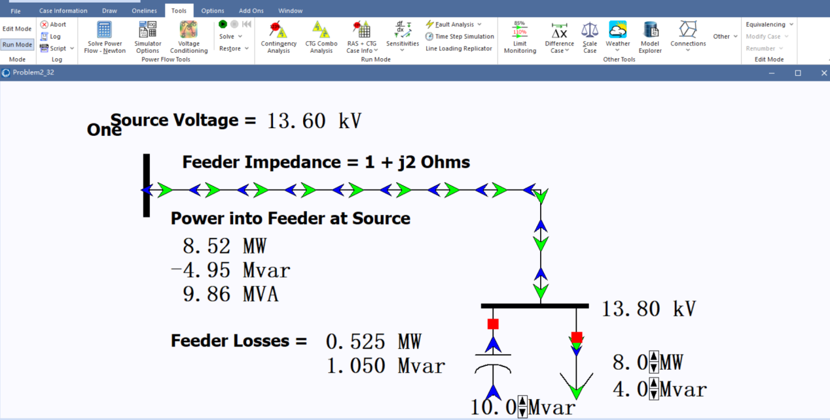
Pic. 18 example 2.32

Qcap(Mvar) | Real power line loss(MW) | Power flow(Mvar) | Power factor
0.5 | 0.400 | 0.801 | 0.895
1.0 | 0.383 | 0.766 | 0.856
1.5 | 0.369 | 0.738 | 0.825
2.0 | 0.357 | 0.714 | 0.798
2.5 | 0.348 | 0.696 | 0.778
3.0 | 0.341 | 0.682 | 0.762
3.5 | 0.337 | 0.675 | 0.754
4.0 | 0.336 | 0.670 | 0.750
4.5 | 0.337 | 0.675 | 0.754
5.0 | 0.341 | 0.682 | 0.762
5.5 | 0.348 | 0.696 | 0.778
6.0 | 0.357 | 0.714 | 0.798
6.5 | 0.369 | 0.738 | 0.825
7.0 | 0.383 | 0.766 | 0.856
7.5 | 0.400 | 0.801 | 0.895
8.0 | 0.420 | 0.840 | 0.939
8.5 | 0.442 | 0.885 | 0.989
9.0 | 0.460 | 0.934 | 1.041
9.5 | 0.495 | 0.990 | 1.107
10.0 | 0.525 | 1.050 | 1.174

Char.3.1-example 2.32

Qcap between 0.5 and 4.0, source voltage is decreasing, so the feeder loss is decreasing;
Qcap between 4.5 and 10.0, source voltage is decreasing, so the feeder loss is increasing;
Qcap = 4.0; minimize Real power line loss and Real power line loss and minimize power MVA flow;

- Transmission lines (part 1) – wk 2
Transmission lines are used to transmit radio-frequency alternating currents, which are of a high enough frequency that their wave nature must be taken into account. Transmission lines are generally used for connecting transmitter and receiver antennas, transmitting cable television signals, relaying routed calls between telecommunication exchanges, computer network connections, and high-speed computer data buses.

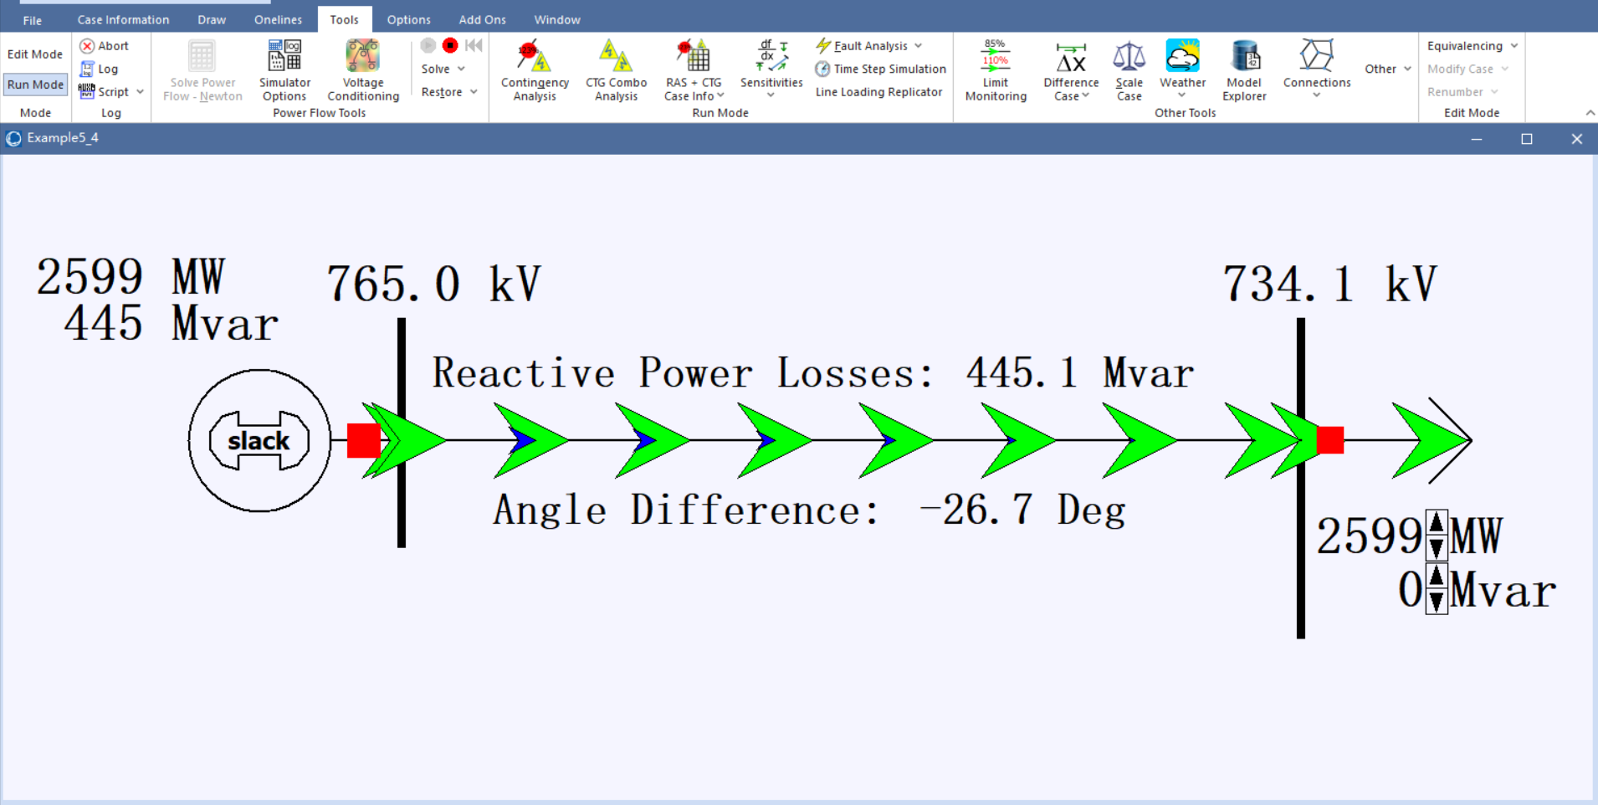
Pic. 19 example 5_4

5.43

If 0.9 per unit,
Pmax = $\frac{0.9∗0.9∗2199}{sin(\frac{2π∗300}{5000})}$=2.2*2199=4840 MW

5.44
Pmax = $\frac{0.9∗0.9∗1000}{sin(\frac{2π∗300}{5000})}$=2.2*1000=2200 MW
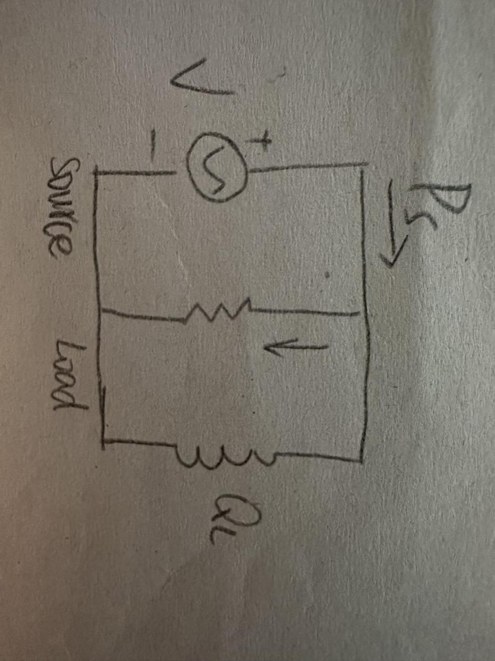

When load on the line = SIL Reactive power = 0
When load on the line > SIL Load voltage < send ending value
When load on the line < SIL Load voltage > send ending value

