Interspecies Interactions Drive Community-Level Selection in Microbial Coalescence
Jinyeop Song1, Jiliang Hu1, and Jeff Gore1
1Department of Physics, Massachusetts Institute of Technology, Cambridge, MA, USA

Abstract
It has long been debated in ecology whether communities behave as cohesive units or as loose collections of independent species. Here, we study this question in the context of community coalescence, the mixing of previously isolated communities, using bacterial microcosm experiments combined with ecological modeling. Our results demonstrate that effective interaction intensity and environmental feedbacks determine whether communities or species are the units of selection during coalescence. When effective interactions are moderate to strong, one parental community consistently outcompetes the other, indicating community-level selection. In contrast, under weak interactions, species fates are uncorrelated and the two communities contribute equally to the coalesced outcome, indicating the absence of community-level selection. A similar nutrient-dependent shift toward Dominance also appears in taxonomically richer communities derived from natural environmental samples. Furthermore, we identify two distinct regimes underlying community-level selection in experiments with different media conditions: an emergent regime in which collective dynamics shape outcomes that cannot be predicted from species traits alone, and a top-down regime where dominant species determine the winning community. Together, these results reconcile conflicting observations on community-level selection during community coalescence by demonstrating that communities behave as cohesive units only when effective interactions and feedbacks are sufficiently strong.

1 Introduction
In nature, species coexist and interact within complex communities, yet whether these assemblages function as cohesive, integrated units or merely as loose collections of independently acting species remains a fundamental question in ecology. Historically, this tension has been framed through two influential paradigms. Clements’ “superorganism” view treats communities as discrete biological entities with emergent properties arising from species interdependencies, potentially as a result of coevolution1,2,3,4,5. In contrast, Gleason’s individualistic hypothesis posits that species independently occupy niches, with community composition emerging from the coincidental overlap of species ranges6,7,8,9. Despite decades of research, the conditions that determine when communities behave as cohesive units versus loose species assemblages remain unclear.
These contrasting frameworks make distinct predictions in the context of community coalescence, the mixing of previously isolated communities10,11. Coalescence occurs across diverse contexts and scales: environmental disturbances trigger microbial community mixing in soils12,13, flooding events promote coalescence in aquatic and estuarine habitats14, skin microbiomes undergo exchange through daily social contact15, and gut microbiomes are subject to wholesale community transfer through fecal microbiota transplantation16,17. Coalescence brings species with distinct interaction histories into contact, creating novel cross-community interactions that can reshape the resulting assemblage10. Thus, it provides a natural test for the individualistic versus holistic paradigms: The holistic view predicts that species within a community have correlated persistence, making the community the primary unit of selection, termed community-level selection. The individualistic view predicts species-level selection, yielding outcomes shaped by individual fitness regardless of community origin, with no systematic correlation in species persistence within parental communities.
Substantial theoretical and empirical evidence supports the holistic prediction that communities act as cohesive units during coalescence. Early theoretical work by Gilpin18 suggested that pre-assembled communities, having already undergone internal competitive exclusion, possess structured interaction patterns that differ fundamentally from randomly assembled communities. Because species within such communities have been filtered to coexist, their survival outcomes become coupled, producing asymmetric post-coalescence communities dominated by one parental community19. Notably, this structured interaction can arise due to ecological exclusion alone, even in the absence of long-term coevolution, as demonstrated in synthetic microbial communities20,21. Building on this foundation, resource-consumer models formalized the mechanism by which such selection occurs, demonstrating that communities with superior collective fitness through resource consumption outcompete others in ways not predictable from individual species performance alone11,22,23,24. Empirically, correlated selection between dominant and subdominant taxa has been observed across 100 coalescence experiments, confirming that species retention within communities is indeed correlated25.
However, opposing evidence supports the individualistic prediction that species respond independently to coalescence events, with outcomes primarily determined by environmental sorting rather than collective community dynamics. Empirical work reports that coexistence between species from different source communities is common through niche partitioning rather than competitive exclusion during macro-scale biogeographic interchange in marine and terrestrial biomes26; similar patterns have been observed in microbial systems where closely related species coexist via resource partitioning27. Paleontological evidence further indicates that species responded individually to past climatic shifts, relocating to favorable habitats rather than persisting as fixed assemblages, consistent with the view that ecological communities are largely chance associations of species28. In microbial systems, local environmental factors explain more variation than the presence of constantly interchanging neighboring communities29. Strain-resolved metagenomic analyses of in vitro gut microbial communities showed species-level dynamics rather than community-level selection, with surviving species originating from both parental communities30,31. These findings suggest that selection during coalescence acts on species-level traits rather than on emergent community properties.
Together, these contrasting lines of evidence indicate that communities behave as units of selection in some coalescence events but not others; however, the governing factors of these transitions remain poorly understood. Here, we combine empirical and theoretical approaches to investigate how effective interaction intensity and environmental feedbacks drive these contrasting outcomes. Using randomly assembled synthetic microbial communities across different interaction regimes, we classify post-coalescence outcomes into three types: Dominance (one community wins), Mixture (both persist), and Restructuring (a novel state emerges). Under weak interactions, Mixture prevails and species persistence is uncorrelated, consistent with individualistic dynamics. As effective interaction intensity increases, the system shifts toward Dominance, where species persistence becomes correlated, indicating community-level selection. A phenomenological generalized Lotka–Volterra (gLV) model with randomly sampled pairwise competitive interactions recapitulates the observed Dominance/Mixture transition, and a similar nutrient-dependent shift toward Dominance also appears in taxonomically richer communities derived from natural environmental samples. Further analysis reveals two mechanistic regimes underlying community-level selection: one where a few dominant taxa largely determine the winner, and another where collective multi-species dynamics shape the outcome. These results reconcile conflicting observations by identifying effective interaction intensity, environmental feedbacks, and assembly-generated interaction structure as key determinants of community-level selection.

2 Results

2.1 Community-level selection is prevalent in microbial coalescence
Our central question is whether selection acts primarily on whole communities as cohesive units during community coalescence. To address this, we asked how often coalescence outcomes are represented primarily by one parental community versus blending of both or forming a novel community. Consider a coalescence event where communities A and B merge to produce community C (Fig. 1A). We represent each community by a community composition vector and compute the cosine similarity between the coalesced community C and each parental community (Fig. 1B):
(1)
where , , and denote community composition vectors for the two parental communities and the coalesced community, and denotes the Euclidean norm. These two similarity scores yield a two-dimensional similarity map in which the location of C reflects how strongly it resembles each parental community. We partition this map into three coalescence outcome classes (see Methods): Dominance, where C closely resembles one parental community but not the other; Mixture, where C similarly resembles both parental communities; and Restructuring, where C diverges from both parental communities into a novel configuration. Restructuring denotes low parental retention: the coalesced community is not well explained by the parental communities or their combination, and may reflect a new stable composition produced by previously unseen cross-community species interactions. Crucially, Dominance provides outcome-level evidence for community-level selection: one parental community largely displaces the other while preserving its compositional structure.
To quantify the occurrence of outcome types experimentally, we assembled random in vitro communities and subjected them to pairwise coalescence (Fig. 1C). We first curated a strain library of 54 bacterial isolates collected from diverse environments (soil, tree surface, and flower stamen). The library is phylogenetically broad, spanning 29 families across three phyla: Proteobacteria, Firmicutes, and Bacteroidota (Extended Data Fig. 1; Supplementary Fig. 1). From this library, we assembled 30 parental communities with varying initial richness (6, 12, or 24 species; see Methods) and stabilized them for 7 days under daily growth–dilution cycles (30 every 24 h) (Fig. 1C). Our initial experiments were done in Base medium (1 g L yeast extract, 1 g L soytone, 10 mM sodium phosphate, 0.1 mM CaCl, 2 mM MgCl, 4 mg L NiSO, 50 mg L MnCl, 5 g L glucose and 4 g L urea; pH 6.5), a buffered complex medium that we have previously determined has moderate interaction strength and supports high species coexistence (Supplementary Information, mean species survival ratio = %). We then performed 83 pairwise coalescence events by mixing stabilized parental communities in equal volumes and restabilizing for an additional 7 days. Community compositions of parental and coalesced communities were measured at the end of stabilization by 16S rRNA amplicon sequencing (Amplicon Sequence Variants, ASVs), and we also recorded the optical density (OD) and pH of the communities to contextualize assembly and post-coalescence dynamics.
Representative time series illustrate the spectrum of post-coalescence dynamics (Fig. 1D). In outcomes classified as Dominance, one parental lineage rapidly displaces the other after mixing and the coalesced community converges to a composition closely matching that parental community, while largely preserving its internal relative-abundance structure over serial dilution cycles. In the Restructuring case, the merged community converges toward a novel state distinct from both parental communities. Among three representative time-series trajectories, we did not observe Mixture cases in which both parental communities remained comparably represented after coalescence (see Supplementary Fig. 2).
Projecting all outcomes into the similarity space based on stabilized compositions (Fig. 1E) revealed that Dominance is the most frequent empirical outcome. Of the 83 coalescence events, 54 were classified as Dominance, 26 as Restructuring, and 3 as Mixture (Fig. 1E). Alternative metric analysis revealed that Dominance remained the most frequent outcome under abundance-weighted compositional metrics, including Euclidean distance and Bray–Curtis dissimilarity, but not under Jaccard index or Jensen–Shannon divergence, which emphasize species-identity retention and full-distribution divergence, respectively (Extended Data Fig. 2). To test whether Base-medium Dominance could arise from a compositional artifact of parental abundance structure, we compared observed outcomes with matched additive-null expectations constructed from the same parental-community pairs. Observed outcomes were more strongly biased toward one parental community than their matched additive-null expectations (one-sided paired Wilcoxon test, ; Extended Data Fig. 3), and additional abundance-skew null models also produced weaker parental bias than the data (Supplementary Note 1). Together, these null-model controls support a community-level selection interpretation.

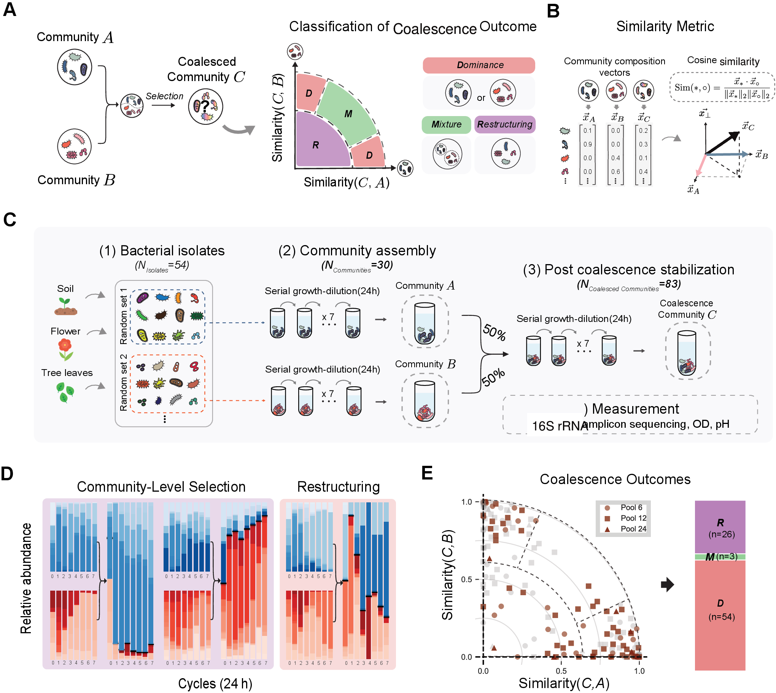

Figure 1: Fig. 1. Coalescence of synthetic microbial communities frequently yields Dominance. a, Schematic of coalescence: parental communities A and B are mixed to produce C. Outcomes are classified as Dominance (one parental community wins), Mixture (both persist), or Restructuring (novel state). b, We use similarity to quantify compositional resemblance between communities and define a two-dimensional similarity map for classifying outcomes. c, Experimental workflow: 30 parental communities (initial richness 6, 12, or 24) were assembled from 54 bacterial isolates, stabilized, mixed pairwise (), and restabilized. d, Representative time courses showing Dominance (left, center) and Restructuring (right). e, Dominance is the most frequent outcome in Base medium. Of 83 coalescence events, 54 (65%) were classified as Dominance, 26 (31%) as Restructuring, and 3 (4%) as Mixture. Different symbols indicate initial richness (circles: 6; squares: 12; triangles: 24 species). Gray points represent the symmetric counterpart of each coalescence event (community B versus A).

2.2 Theoretical model with random interactions reproduces community-level selection
To gain insight into why Dominance is the prevalent outcome, we introduced a generalized Lotka–Volterra (gLV) model32,33 that mirrors the experimental protocol (Fig. 2A). In this classic model, species grow logistically and compete pairwise:
(2)
where is abundance, is growth rate, and is the competition coefficient between species and (with self-interaction ). We fixed and drew off-diagonal competition coefficients from a uniform distribution , so increasing expands the sampled coefficient range and increases both the mean and spread of competitive effects34,35. From a pool of 54 species, we generated two parental communities of 12 species each with no shared species, allowed each to reach equilibrium, then mixed them equally to simulate coalescence (Fig. 2A; see Methods for details). Post-coalescence compositions were analyzed using the same similarity metrics as in the experiments. The gLV model serves as a phenomenological framework to explore how the statistical properties of interaction coefficients shape coalescence outcomes, rather than as a mechanistic model of the specific biochemical interactions (e.g., pH modification, metabolic cross-feeding) underlying our experimental observations.
We simulated 1,200 random coalescence events at an interaction-strength parameter value of and analyzed the similarity of each coalescence outcome to the two parental communities. At this parameter value, the random-interaction model quantitatively reproduces the high frequency of Dominance observed in the experiments. Outcomes concentrate near the axes rather than the diagonal, indicating asymmetric dominance by one parental community (Fig. 2B). Quantitatively, Dominance accounts for 61% of all outcomes, far more frequent than Restructuring (26%) or Mixture (13%; Fig. 2B, right). This observation suggests that, within this competitive gLV framework, interspecies competitive interactions are sufficient to reproduce the high frequency of Dominance observed in coalescence.
To understand how Dominance emerges in the model and whether it reflects community-level selection, we examined the role of the assembly process. During assembly, competitive exclusion filters out species with strong competitive interactions, leaving communities with reduced interaction strength compared to the initial pool (paired -test, ; Fig. 2C; Supplementary Fig. 3). Because surviving species compete weakly with each other but face stronger competition from outsiders, their fates become coupled during coalescence: they tend to persist or go extinct together. We quantified this effect using pairwise selection correlation, which tests across coalescence events whether species pairs from the same parental community share survival outcomes (both persist or both go extinct) more strongly than species pairs from different parental communities (Supplementary Information; Fig. 2D). Species from the same parental community showed strongly positive correlations, while cross-community pairs showed negative correlations, a pattern observed in both simulations and experiments (Fig. 2D). This supports the interpretation that species within an assembled parental community have coupled fates during coalescence. Together, the prevalence of Dominance combined with positive within-community selection correlation provides evidence for community-level selection in this system.

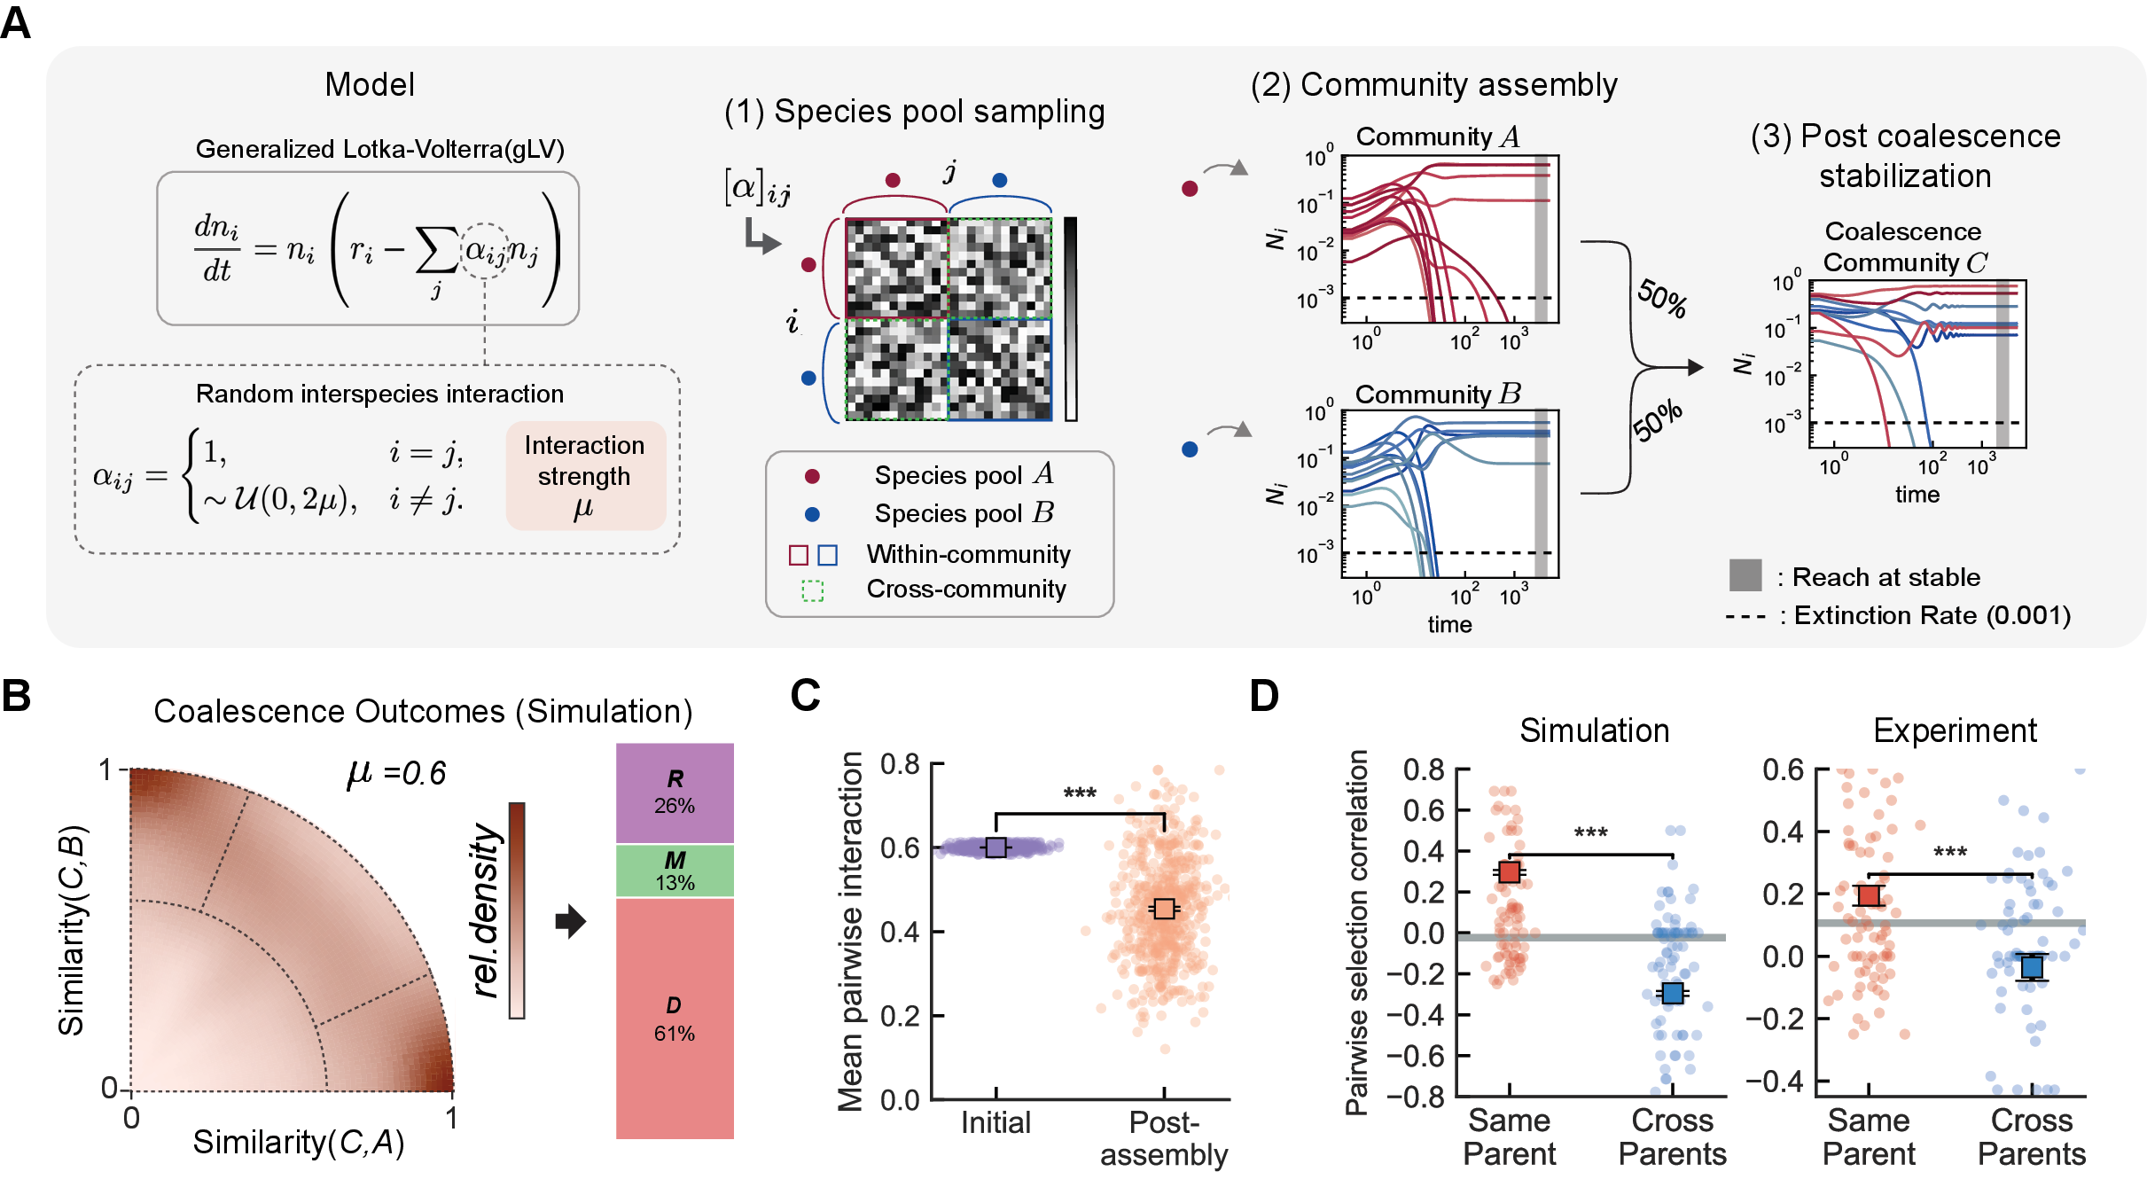

Figure 2: Fig. 2. Generalized Lotka–Volterra model of community coalescence. a, Simulation workflow: species grow according to the generalized Lotka–Volterra (gLV) equations, where interaction coefficients are drawn from a uniform distribution . The interaction-strength parameter sets the sampled coefficient range, increasing both mean and spread. Two equilibrated parental communities are mixed and simulated to steady state. b, Outcome density map (, simulations). The model reproduces the high frequency of Dominance (61%) observed experimentally. c, Community assembly significantly reduces interaction strength among surviving species (paired -test, ). d, Pairwise selection correlation. Individual dots show per-event pairwise selection correlations; in the simulation panel, 100 stratified events per group are displayed for legibility. Squares with error bars show mean s.e.m. across all coalescence events ( per group in simulations and all valid experimental events in the experimental panel). Gray horizontal lines indicate the random selection baseline from a null model in which parental-affiliation labels are shuffled (see Supplementary Information). Within-community pairs (species pairs from the same parental community; red) show positive correlation (co-survival), while cross-community pairs (blue) show negative correlation, indicating community-level selection. This pattern holds for both simulations (left) and experiments (right).

2.3 Interaction strength controls coalescence outcome type and degree of community-level selection
Having established that random interspecies interactions can recapitulate Dominance with correlated pairwise selection, we next investigated how the interaction-strength parameter alters coalescence outcomes. We simulated 1,200 coalescence events at each of three representative values of the interaction-strength parameter () and mapped outcomes into the similarity space (Fig. 3A). At weak interactions (), outcomes clustered in the interior of the map, indicating Mixture; as increased, outcomes shifted toward the axes, indicating Dominance. We quantified this shift using the Parental Dominance Index (PDI), which captures the relative contribution of each parental community (0: parental community B, 0.5: equal, 1: parental community A; see Methods). PDI distributions shifted from unimodal near 0.5 at to bimodal at higher (Fig. 3A), reflecting a transition in which Dominance becomes increasingly frequent, indicating community-level selection.
Across interaction-strength parameter values from to , we observed a systematic shift in coalescence outcomes (Fig. 3B), with Mixture predominating at weak interactions and Dominance at strong interactions. Restructuring emerged at moderate to high interaction strengths. These patterns were robust to variation in growth rates, carrying capacities, interaction-coefficient distributions, parental-community species richness, and model extensions allowing beneficial interactions or varying reciprocal pair-coupling structure (Supplementary Figs. 4–6 and 39–41; Extended Data Fig. 4). Further analysis separating the mean and variance of the interaction-coefficient distribution showed that both average inhibitory effect and coefficient heterogeneity contribute to the Dominance regime (Supplementary Fig. 42). Notably, the frequency of Dominance remained relatively stable across parental communities ranging from 4 to 48 species, spanning our experimental species pool range. To determine whether this transition from Mixture to Dominance corresponds to the degree of co-selection, we examined pairwise selection correlation across interaction-strength parameter values. Notably, within-community pairwise selection correlation emerged only at high interaction strengths, indicating that species fates become coupled only when interactions are sufficiently strong (Extended Data Fig. 5). These findings indicate that interaction strength simultaneously determines both coalescence outcome type and the level at which selection operates.

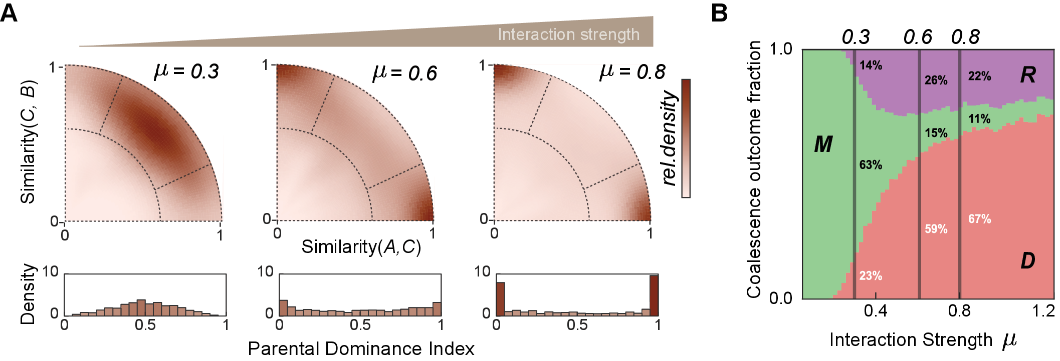

Figure 3: Fig. 3. Interaction strength controls the transition between coalescence outcome types in simulation. a, Simulated coalescence outcome maps at three representative values of the interaction-strength parameter: , , ; simulations per condition. Outcomes shift from central Mixtures at weak interactions () to axis-aligned Dominance at strong interactions (). Histograms show the Parental Dominance Index (PDI) transitioning from unimodal to bimodal. b, Outcome fractions across interaction-strength parameter values (– ). Mixture predominates at low , while Dominance becomes prevalent as increases. Restructuring peaks at intermediate strengths. Error bars, s.e.m.

2.4 Nutrient-dependent invasion resistance and environmental feedbacks shift coalescence outcomes
Following prior work showing that nutrient concentration can alter microbial competition and that pH-mediated environmental feedbacks can drive bacterial interactions34,35,36,37, we conducted additional coalescence experiments by removing glucose and urea from the Base medium or increasing their concentrations (Methods). This yielded two additional media conditions (Fig. 4A): Nutr (no added glucose/urea) and Nutr (high supplementation). To approximate how net interaction effects change across nutrient conditions, we measured invasion resistance using pairwise invasion assays among the 12 most abundant isolates (95:5 initial frequency; Methods, Supplementary Figs. 7–9). The fraction of failed invasions increased monotonically with nutrient supply (Nutr: ; Base: ; Nutr: ; mean s.e.m.; Fig. 4B), indicating that invasion resistance increases across the nutrient gradient.
We then performed coalescence experiments in Nutr and Nutr media using the same parental-community assembly scheme to examine whether this nutrient-dependent change in invasion resistance is accompanied by the predicted shift in coalescence outcomes. The distribution of outcomes in similarity space shifted systematically with nutrient concentration (Fig. 4C), which we quantified by the fraction of each outcome type (Fig. 4D). In Nutr (), where interactions are weakest, Mixture was the most frequent outcome (53%), and Dominance was substantially reduced to 39% compared to the Base medium (Dominance: 65%, Mixture: 4%). In Nutr (), Dominance further increased to 76%. The distributions of PDI, asymmetry, and retention magnitude show the same nutrient-dependent shift before applying category labels (Supplementary Figs. 10–12). Pairwise selection correlation analysis confirmed that this shift corresponds to a transition in the level of selection (Extended Data Fig. 6). In Base and Nutr media, within-community species pairs showed significantly higher selection correlation than cross-community pairs (), consistent with community-level selection. In Nutr, no such correlation was observed, consistent with weaker origin-correlated persistence and more species-level dynamics. We next tested whether nutrient-dependent changes in parental-community properties, including parental-community biomass heterogeneity and initial richness effects, could explain this trend; however, Dominance outcomes were not biased toward the higher-biomass parental community, and these factors did not account for the nutrient-dependent increase in Dominance or correlated species fates (Supplementary Note 5 and Supplementary Figs. 13–15, 45). These results are consistent with the qualitative theoretical prediction: lower invasion resistance and weaker effective interactions yield Mixture with uncorrelated species fates, while higher invasion resistance and stronger effective interactions yield Dominance with community-level selection.

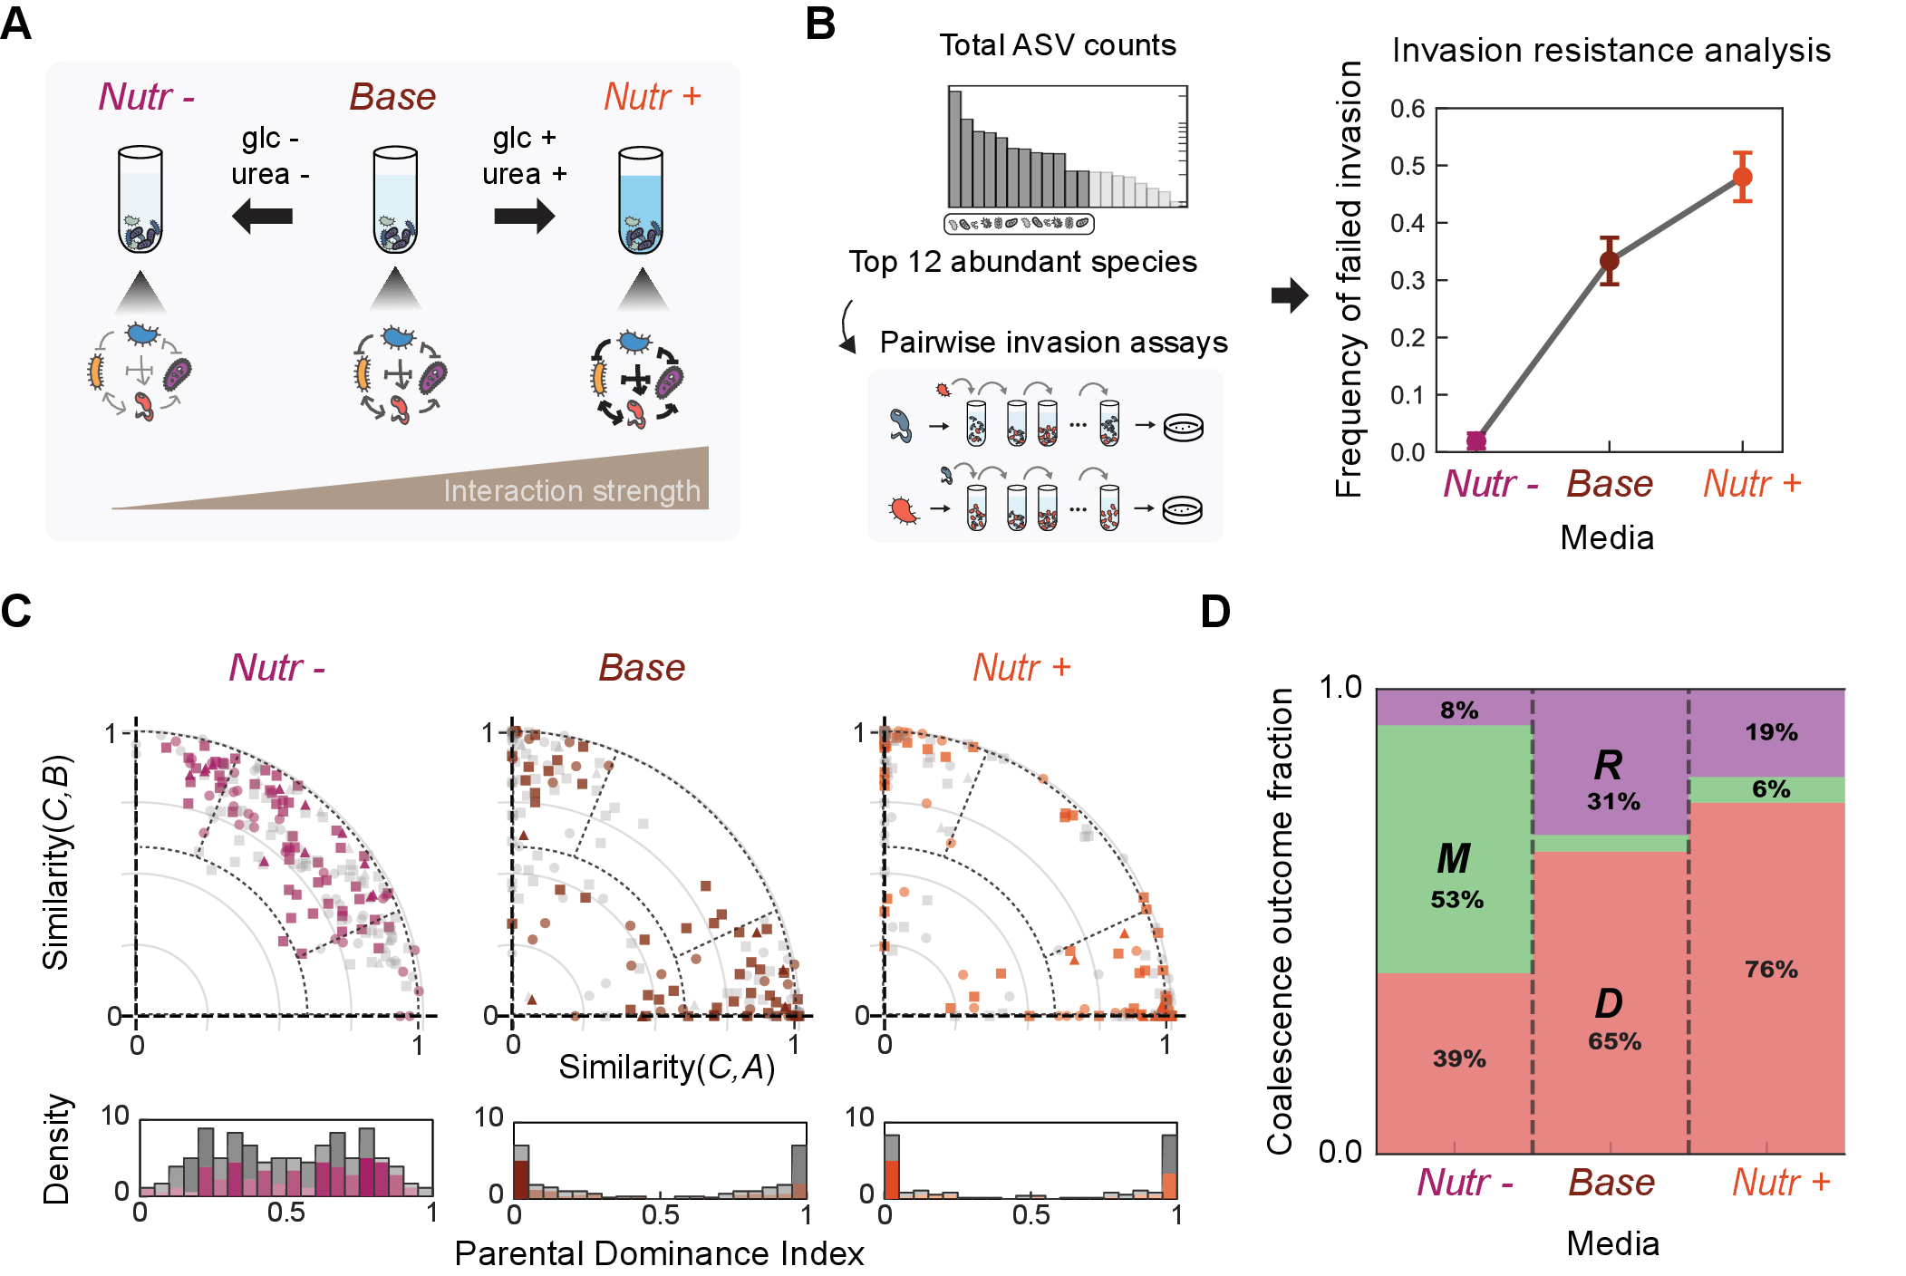

Figure 4: Fig. 4. Nutrient concentration modulates invasion resistance and coalescence outcomes. Experimental manipulation of nutrient concentration tests whether increased invasion resistance is associated with a shift in coalescence outcomes from Mixture toward Dominance. a, Schematic of nutrient manipulation: we varied glucose and urea concentrations to create three media conditions with increasing invasion resistance (Nutr, Base, Nutr). b, Pairwise invasion assays show that failed invasion frequency among the 12 most abundant isolates (95:5 initial frequency, assays per medium) increases monotonically with nutrient concentration (Nutr: , Base: , Nutr: ; mean s.e.m.). c, Coalescence outcome distributions shift systematically with nutrient concentration. Scatter plots show outcomes in similarity space for each medium (Nutr: , magenta; Base: , brown; Nutr: , orange); different symbols indicate initial richness. Gray points represent the symmetric counterpart of each coalescence event (community B versus A). Histograms show PDI distributions. d, The fraction of Dominance increases with nutrient concentration (39% in Nutr, 65% in Base, 76% in Nutr) while Mixture declines from 53% to 4% to 6% (chi-square test for trend, ), consistent with model predictions. Error bars, s.e.m.

2.5 Dominant community predictability reveals two mechanistic regimes
We observed Dominance in both Base and Nutr media, consistent with community-level selection as confirmed by pairwise selection correlation (Extended Data Fig. 6). We next asked whether we can predict which parental community will win during coalescence. Prior work has suggested that species-level competitive outcomes may correlate with Dominance direction10,38. Inspired by these observations, we tested whether pairwise competition between dominant species34,37 predicts which community wins (Fig. 5A).
The relative abundance of dominant species in stabilized parental communities increased with nutrient concentration ( in Nutr, in Base, in Nutr; mean s.e.m., Fig. 5B), suggesting that dominant species exert greater influence under higher nutrient concentration. We therefore tested whether pairwise competition between dominant species predicts the coalescence outcome by analyzing the linear relationship between dominant-species competitive success (from invasion assays) and the PDI of coalescence outcomes (Fig. 5C). Predictive power varied markedly across media: in Nutr, where Mixture predominates and pairwise selection correlation is weak, pairwise competition showed no predictive power (); in Base medium, predictive power was weak (), consistent with collective multi-species dynamics shaping outcomes; in Nutr, pairwise competition was more predictive (), indicating that dominant species contribute substantially to determining which community wins. These results suggest that community-level selection spans a mechanistic continuum: at one end, an emergent regime (Base medium) where multi-species dynamics collectively shape the outcome and no single species trait is predictive, and at the other, a top-down regime (Nutr medium) where a few dominant taxa determine the winner. The Nutr predictability trend remained significant after recalculating PDI with dominant species excluded (Spearman rank-correlation tests: after removing the coalesced-community dominant species and after removing the two parental-community dominant species; Supplementary Fig. 16), indicating that it is not solely a dominant-species artifact in the PDI calculation.
We next asked whether environmental modification through pH could contribute to the top-down regime. In our system, dominant species are often strong pH modifiers that either acidify or alkalinize the medium (Supplementary Fig. 17). In both Base and Nutr media, when these pH-modifying species become dominant within a community, their identities predict the community’s overall pH. Communities dominated by acidifiers become acidic, while those dominated by alkalizers become alkaline (Supplementary Fig. 18). In coalescence events between acidic (pH 6.5) and alkaline (pH 7.5) parental communities, the acidic community dominated in only 56% of cases in Base medium () and in 91% of cases in Nutr medium () (Extended Data Fig. 7). The difference between Base and Nutr proportions was significant (two-sided Fisher exact test, ), consistent with the hypothesis that high nutrients amplify metabolic activity, thereby intensifying pH modification and excluding pH-sensitive species36,37. Together, the dominant-species and strict pH-contrast analyses suggest that Nutr Dominance may reflect a top-down regime, in which dominant taxa and associated environmental feedbacks help determine winner identity. However, this pH-based analysis addresses winner direction in high-contrast acidic–alkaline pairings and does not by itself account for the full Dominance pattern across all coalescence events. Dominance in Base is less directly explained by the measured dominant-species and pH effects tested here.

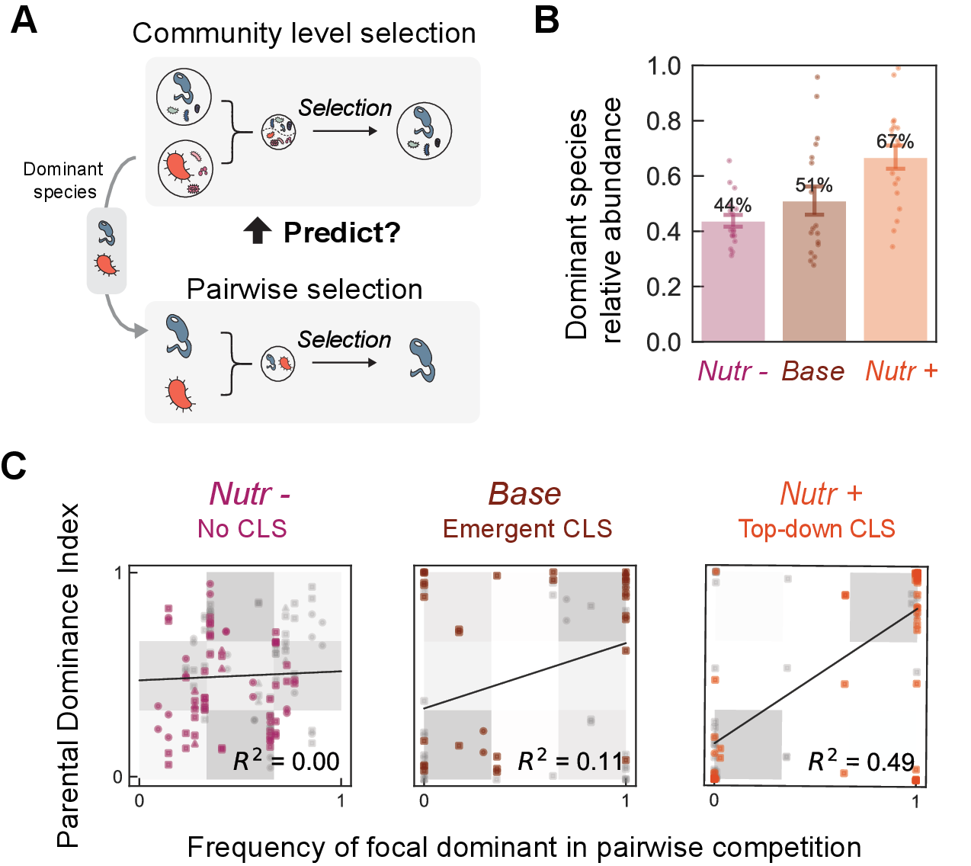

Figure 5: Fig. 5. Predictability of Dominance direction reveals two mechanistic regimes. The direction of Dominance (which parental community wins) becomes increasingly predictable from dominant species competition across media conditions, distinguishing an emergent regime (Base) from a top-down regime (Nutr). a, Schematic: can pairwise competition between dominant species predict which community wins? b, Relative abundance of dominant species increases with nutrient concentration (Nutr: ; Base: ; Nutr: ; mean s.e.m.). c, Dominant species competitive success versus PDI of coalescence outcomes; gray shading indicates Dominance. Predictive power: in Nutr, () in Base (emergent regime), and () in Nutr (top-down regime). Gray points represent the symmetric counterpart of each coalescence event (community B versus A). Linear regression with 95% confidence intervals shown.

2.6 Nutrient-dependent coalescence outcomes in natural sample-derived communities
The synthetic communities described above were assembled from individually isolated bacterial strains, allowing precise control over initial composition but raising the question of whether these patterns also appear in taxonomically richer communities derived from natural environmental samples. To address this, we performed coalescence experiments using natural sample-derived communities established through laboratory stabilization from environmental samples.
We collected six environmental samples from diverse microhabitats (soil, compost, and decomposing organic matter) and established bacterial communities through seven rounds of serial growth-dilution in laboratory media across all three nutrient conditions (Nutr, Base, and Nutr; Fig. 6A). After stabilization, these natural sample-derived communities exhibited higher ASV richness than synthetic communities (mean of ASVs above 0.1% threshold, compared to in synthetic communities; Supplementary Figs. 19–21) and retained source-specific taxonomic structure at both ASV and genus levels (Supplementary Fig. 22).
We performed 15 pairwise coalescence events with two biological replicates each ( per condition) across all three nutrient conditions after stabilization and analyzed outcomes using the same similarity framework applied to synthetic communities. Natural sample-derived communities showed similar patterns to synthetic communities: outcomes clustered along the axes in similarity space (Fig. 6B,C). The fraction of Dominance outcomes increased with nutrient concentration (37% in Nutr, 70% in Base, 77% in Nutr), mirroring the nutrient-dependent trend observed in synthetic communities. These communities showed higher Restructuring fractions, possibly reflecting greater taxonomic diversity and more complex interaction networks. Because these communities were laboratory-stabilized before coalescence, pre-selection in defined media could have contributed to their similarity to synthetic-community outcomes. However, their higher richness and retained source-specific taxonomic structure indicate that stabilization did not produce complete ASV- or genus-level taxonomic collapse (Supplementary Figs. 19–22 and Supplementary Note 6). Overall, these results suggest that the nutrient-dependent increase in Dominance observed in synthetic consortia is also present in taxonomically richer natural sample-derived communities.

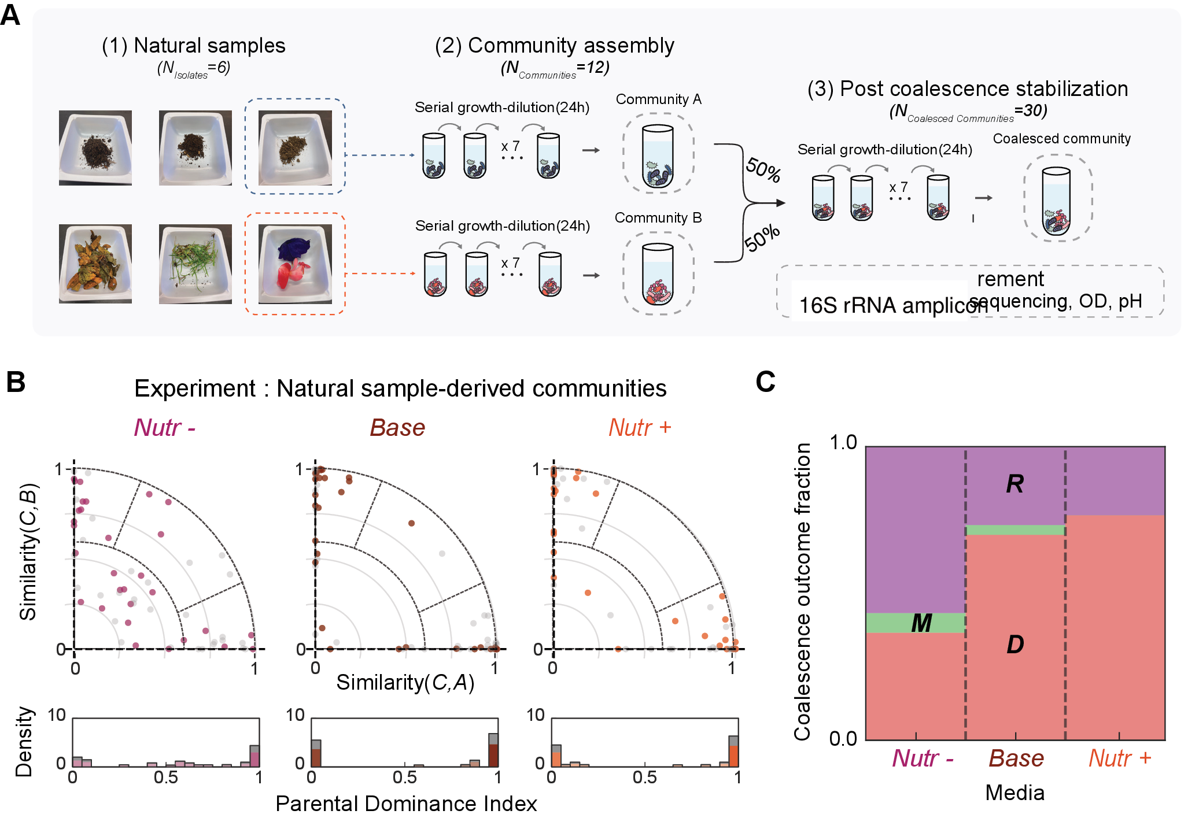

Figure 6: Fig. 6. Dominance patterns in natural sample-derived communities. Natural sample-derived communities show qualitatively similar coalescence patterns to synthetic communities, with Dominance frequency increasing under higher nutrient concentration. a, Experimental workflow follows Fig. 1c, but uses natural sample-derived communities from six environmental samples including soil, compost, and decomposing organic matter. b, Coalescence outcome distributions in similarity space for natural sample-derived communities across three media conditions ( coalescence events per condition, 15 unique pairs 2 replicates). Similar to synthetic communities, outcomes are more centered in Nutr and shift toward the axes in Base and Nutr. Gray points represent the symmetric counterpart of each coalescence event (community B versus A). Histograms below show PDI distributions. c, The fraction of Dominance outcomes increases with nutrient concentration in these communities (37% in Nutr, 70% in Base, 77% in Nutr), consistent with patterns observed in synthetic communities. Error bars, s.e.m.

3 Discussion
Our work demonstrates that effective interaction intensity, environmental feedbacks, and assembly-generated interaction structure govern community coalescence outcomes, determining both the dominant outcome type and the level at which selection operates. In both experiments and modeling, when effective interactions are strong, Dominance prevails and species persistence is correlated within parental communities, indicating community-level selection; when interactions are weak, Mixture predominates and species respond independently. Furthermore, predictability analyses suggest two regimes within Dominance. In the top-down regime, dominant taxa and environmental feedbacks, including pH modification, may bias winner identity. In the emergent regime, collective multi-species dynamics appear to govern outcomes, and dominant-species-based prediction is insufficient. These findings reconcile the Clements–Gleason debate: effective interaction intensity determines whether communities behave as cohesive units or loose species assemblages.
Our work provides the first experimental demonstration of alternative regimes in community coalescence, reconciling previously contrasting observations of community-level versus species-level selection. Prior studies have reported both outcomes: some found communities behaving as cohesive units22,25, while others observed species responding independently26,29. Our results suggest that these conflicting observations may reflect differences in interaction strength across experimental systems. For instance, the absence of community-level selection in in vitro gut microbiome coalescence experiments30,31 is consistent with our framework. Rich media such as Brain Heart Infusion (BHI) are analogous to our Nutr condition, providing complex and diverse resources while lacking high concentrations of readily metabolizable carbon sources. This resource structure reduces both direct resource competition and pH-mediated interactions, thereby weakening interspecies interactions37 and favoring species-level rather than community-level dynamics. Likewise, interaction strength may vary systematically across ecosystems: microbial biofilms experience strong metabolic interactions due to high cell densities and shared resources39, whereas mobile macroscopic organisms interact more transiently across larger spatial scales. These differences may explain why community-level selection is more frequently observed in microbial coalescence studies. This framework provides a unified perspective: rather than asking whether communities are cohesive units, we should ask under what conditions they become so, with interaction strength emerging as a key determinant.
A growing body of work has identified interaction strength as a key control parameter governing diverse aspects of microbial community dynamics, including diversity34,40, stability37,41, coexistence33, and invasion outcomes35,42. Our results extend this claim to include coalescence, providing further evidence that interaction strength determines when communities exhibit collective behavior. Importantly, interaction strength is used here as a coarse-grained descriptor that can reflect the combined effects of multiple ecological processes, rather than as a claim about one specific mechanism. The parallel with priority effects is particularly instructive; recent work showed that assembly order shapes final composition only under strong interactions, whereas weak interactions lead to convergent outcomes regardless of assembly history35,43. Our coalescence results mirror this pattern: strong interactions allow parental-community identity to shape the outcome, while weak interactions yield convergent Mixtures. Together, these findings reinforce interaction strength as a useful predictor of history-dependent community dynamics across multiple ecological contexts.
Notably, and perhaps counterintuitively, our model shows that community-level selection-like patterns can emerge without explicitly cooperative interactions between species, consistent with predictions from Tikhonov’s resource-competition models22 and random Lotka–Volterra theory32,33. Community-level selection is often attributed to cooperative mechanisms such as cross-feeding or division of labor. By contrast, the model suggests that assembly history and competitive interactions can be sufficient to generate correlated species fates during coalescence. Thus, cooperative and competitive mechanisms may represent distinct routes to community-level selection, and understanding how these routes interact remains an important direction for future work.
Accordingly, we use community-level selection as an outcome-level description of origin-correlated persistence during coalescence. This operational definition does not by itself identify the causal ecological or biochemical mechanisms, which may vary across systems. In nature, coalescence occurs in richer settings that may shift regimes and outcomes. Environmental heterogeneity (temperature, pH buffering, and other physicochemical factors) covaries with interaction strength and can reshape coalescence across habitats10,38,44,45. In host-associated microbiomes, host filtering, priority effects, and spatial structure further influence successful colonization, making coalescence a useful framework for predicting and steering microbiome transfer14,46,47. Our experiments focus on steady-state outcomes and thus do not capture temporal dynamics such as fluctuating resources, migration pulses, or host responses. Accounting for this broader ecological complexity will help build a more comprehensive picture of community-level selection across habitats and scales.

4 Methods

Microbial Strain Library and Culture Conditions
We used a library of 54 bacterial isolates from environmental samples (soil, tree surface, and flower stamen) collected in Cambridge, MA, USA, spanning 29 families across three phyla (Proteobacteria, Firmicutes, and Bacteroidota; Extended Data Fig. 1; Supplementary Fig. 1). Isolates were purified by serial streaking and stored as glycerol stocks at °C. Experiments were conducted in culture medium containing 1 g L yeast extract, 1 g L soytone, 10 mM sodium phosphate, 0.1 mM CaCl, 2 mM MgCl, 4 mg L NiSO, 50 mg L MnCl (pH 6.5), supplemented at three nutrient levels—Nutr (no added glucose/urea), Base (5 g L glucose, 4 g L urea), and Nutr (20 g L glucose, 16 g L urea)—which perturb net interaction intensity, invasion resistance, and environmental feedbacks. Communities were grown in 300 L volumes in 96-well deep-well plates at 25 °C with shaking at 800 rpm. Full media composition and culture conditions are provided in Supplementary Methods.

Community Assembly and Coalescence Experiments
Parental communities () were assembled at three richness levels (6, 12, or 24 species) by sequential assignment of isolates from the strain library, each with two biological replicates. For 6-species and 12-species parental communities, non-overlapping sets were assembled (e.g., community 1: strains 1–6, community 2: strains 7–12). Communities were stabilized through seven daily 30-fold serial dilutions before coalescence. Coalescence experiments mixed two pre-stabilized parental communities at a 1:1 volume ratio, followed by seven additional serial transfers to reach new steady states (Fig. 1C). In total, 83 pairwise coalescence events were performed in Base medium, and additional experiments were conducted across all three nutrient conditions. Full experimental details are provided in Supplementary Methods.

16S rRNA Sequencing
Community composition was measured by 16S rRNA amplicon sequencing (V4 region). DNA was extracted using QIAGEN DNeasy PowerSoil kit, and sequencing was performed at Argonne National Laboratory. Amplicon sequence variants (ASVs) were identified using DADA248 with SILVA 13849 as reference. In experimental analyses, the community composition vector was the ASV relative-abundance vector derived from these 16S profiles. Species richness was defined as ASVs with 0.1% relative abundance, corresponding to the extinction threshold used in simulations. Raw sequencing reads are available via Dryad; see Data Availability. Full sequencing and data processing details are provided in Supplementary Methods.

Optical Density and pH Measurements
Optical density (OD) was measured after each 24-hour growth cycle using a plate reader (BioTek Synergy H1). Community pH was measured using a benchtop pH meter (Apera Instruments PH5500). These measurements were used to monitor community growth dynamics and to assess environmental modification by dominant species. Full measurement protocols are provided in Supplementary Methods.

Classification of Coalescence Outcomes
Coalescence outcomes were classified based on similarity between the coalesced community and each parental community. Similarity was computed as cosine similarity between community composition vectors (see Supplementary Note 1 for full normalization details). These two similarity scores place each outcome in a two-dimensional similarity space. From the similarity scores, we derived: (1) retention magnitude , quantifying how much of the coalesced composition is explained by the parental communities; and (2) parental dominance index (PDI), quantifying directional parental contribution (0: parental community B dominance, 0.5: equal contributions, 1: parental community A dominance). The Restructuring boundary is defined by , equivalently by a retention radius in the similarity map. Outcomes were categorized as Restructuring (low retention; substantial ecological reorganization), Mixture (high retention with PDI near 0.5; balanced parental contributions), or Dominance (high retention with PDI near 0 or 1; one parental community overwhelms the other). To assess whether Dominance reflects community-level selection, we computed pairwise selection correlations measuring whether species from the same parental community share selection outcomes during coalescence. Full mathematical framework is provided in Supplementary Notes 1–2.

Lotka–Volterra Simulations
Community dynamics were modeled using generalized Lotka–Volterra (gLV) equations (Eq. 2). We fixed growth rates to 1 and self-interaction coefficients , and drew off-diagonal competition coefficients from a uniform distribution , so sets the sampled coefficient range and therefore controls both the mean and heterogeneity of competitive effects within this phenomenological model. From a pool of 54 species, we assembled four non-overlapping parental communities of 12 species each (no shared species per pair). Communities were equilibrated numerically (species below 0.1% relative abundance threshold set to zero), then all pairwise combinations mixed at equal proportions to simulate coalescence, with independently sampled interaction matrices per replicate. Full simulation parameters and robustness analyses are provided in Supplementary Methods.

Pairwise Invasion Assays
To operationally estimate invasion resistance across nutrient conditions, we performed pairwise invasion assays among the 12 most abundant isolates. Each pair was tested in both directions (resident:invader = 95:5) and propagated through seven daily dilution cycles across all three nutrient conditions. Final compositions were determined by colony counting. An invasion was scored as failed if the invader remained below 1% relative abundance. Pairwise outcomes were then classified as coexistence (both isolates above 10% in both directions), exclusion (the same isolate drove its competitor below 1% in both directions), or bistability (each isolate excluded the other when resident). The fraction of failed invasions served as an empirical proxy for net interaction intensity and invasion resistance (Fig. 4B). Full experimental details are provided in Supplementary Methods.

Natural Sample-Derived Communities
We performed coalescence experiments using communities derived from six natural environmental samples (soil, compost, decomposing organic matter) collected in Cambridge, MA. Unlike synthetic communities assembled from isolated strains, these communities were derived from complex environmental assemblages. Samples were enriched through seven serial dilution cycles to establish stable communities, then 15 pairwise coalescence events (each with two biological replicates, per condition) were conducted across all three nutrient conditions. Full experimental details are provided in Supplementary Methods.

Statistical Analyses
Statistical significance was defined at . All tests were two-sided unless explicitly stated otherwise. Paired -tests compared interaction strength values before and after assembly. Permutation tests (1,000 permutations) assessed pairwise selection correlations. Mann-Whitney U tests compared experimental values against null distributions. Chi-square tests for trend assessed outcome fraction shifts across nutrient conditions. Fisher’s exact test compared categorical outcomes between conditions. Linear regression quantified predictability of coalescence outcomes from dominant-species competition ( reported). For figures requiring error bars, the mean and s.e.m. are presented, with specific test details provided in each legend. Full statistical methods are provided in Supplementary Methods.

Data Availability
Isolates and communities are available upon request. All data are available in the Supplementary Information and via Dryad: DOI: 10.5061/dryad.2z34tmq0z.

Code Availability
All code used for simulation and analysis is available via GitHub at https://github.com/Jinyeop3110/interspecies-interaction-derive-Community-Level-Selection.

Acknowledgements
J.G. acknowledges funding support from the Schmidt Polymath Award and the Sloan Foundation.

Author Contributions
J.Y.S., J.H. and J.G. conceived the study. J.Y.S. and J.H. performed the experiments and the theoretical modeling. J.Y.S. analyzed the data. All authors wrote and edited the manuscript.

Competing Interests
The authors declare no competing interests.

Additional Information
Supplementary Information is available for this paper.
Correspondence to Jeff Gore (gore@mit.edu).

References

[1] Clements, F. E. Plant Succession: An Analysis of the Development of Vegetation. No. 242 in Carnegie Institution of Washington Publication (Carnegie Institution of Washington, Washington, DC, 1916).
[2] Clements, F. E. Nature and structure of the climax. Journal of Ecology 24, 252–284 (1936).
[3] Odum, E. P. The strategy of ecosystem development. Science 164, 262–270 (1969).
[4] Lovelock, J. E. Gaia: A New Look at Life on Earth (Oxford University Press, Oxford, 1979).
[5] Wilson, D. S. & Sober, E. Reviving the superorganism. Journal of Theoretical Biology 136, 337–356 (1989).
[6] Gleason, H. A. The individualistic concept of the plant association. The American Midland Naturalist 21, 92–110 (1939).
[7] Cain, S. A. Characteristics of natural areas and factors in their development. Ecological Monographs 17, 185–200 (1947).
[8] Mason, H. L. Evolution of certain floristic associations in Western North America. Ecological Monographs 17, 201–210 (1947).
[9] Whittaker, R. H. Gradient analysis of vegetation. Biological Reviews 42, 207–264 (1967).
[10] Rillig, M. C. et al. Interchange of entire communities: Microbial community coalescence. Trends in Ecology & Evolution 30, 470–476 (2015).
[11] Lechón-Alonso, P., Clegg, T., Cook, J., Smith, T. P. & Pawar, S. The role of competition versus cooperation in microbial community coalescence. PLoS Computational Biology 17, e1009584 (2021).
[12] Huet, S. et al. Experimental community coalescence sheds light on microbial interactions in soil and restores impaired functions. Microbiome 11, 42 (2023).
[13] Bresciani, L., Custer, G. F., Koslicki, D. & Dini-Andreote, F. Interplay of ecological processes modulates microbial community reassembly following coalescence. The ISME Journal 19, wraf041 (2025).
[14] Liu, X. & Salles, J. F. Drivers and consequences of microbial community coalescence. The ISME Journal 18, wrae179 (2024).
[15] Sarkar, A. et al. Microbial transmission in the social microbiome and host health and disease. Cell 187, 17–43 (2024).
[16] Xiao, Y., Angulo, M. T., Lao, S., Weiss, S. T. & Liu, Y.-Y. An ecological framework to understand the efficacy of fecal microbiota transplantation. Nature Communications 11, 3329 (2020).
[17] Gupta, S., Allen-Vercoe, E. & Petrof, E. O. Fecal microbiota transplantation: in perspective. Therapeutic Advances in Gastroenterology 9, 229–239 (2016).
[18] Gilpin, M. Community-level competition: Asymmetrical dominance. Proceedings of the National Academy of Sciences 91, 3252–3254 (1994).
[19] Debray, R. et al. Priority effects in microbiome assembly. Nature Reviews Microbiology 20, 109–121 (2022).
[20] Venturelli, O. S. et al. Deciphering microbial interactions in synthetic human gut microbiome communities. Molecular Systems Biology 14, e8157 (2018).
[21] Maynard, D. S., Miller, Z. R. & Allesina, S. Predicting coexistence in experimental ecological communities. Nature Ecology & Evolution 4, 91–100 (2020).
[22] Tikhonov, M. Community-level cohesion without cooperation. eLife 5, e15747 (2016).
[23] Xie, L., Yuan, A. E. & Shou, W. Simulations reveal challenges to artificial community selection and possible strategies for success. PLOS Biology 17, e3000295 (2019).
[24] Xie, L. & Shou, W. Steering ecological-evolutionary dynamics to improve artificial selection of microbial communities. Nature Communications 12, 6799 (2021).
[25] Diaz-Colunga, J. et al. Top-down and bottom-up cohesiveness in microbial community coalescence. Proceedings of the National Academy of Sciences 119, e2111261119 (2022).
[26] Vermeij, G. J. When biotas meet: Understanding biotic interchange. Science 253, 1099–1104 (1991).
[27] Brochet, S. et al. Niche partitioning facilitates coexistence of closely related honey bee gut bacteria. eLife 10, e68583 (2021).
[28] Benton, M. J. & Emerson, B. C. How did life become so diverse? the dynamics of diversification according to the fossil record and molecular phylogenetics. Palaeontology 50, 23–40 (2007).
[29] Van der Gucht, K. et al. The power of species sorting: Local factors drive bacterial community composition over a wide range of spatial scales. Proceedings of the National Academy of Sciences 104, 20404–20409 (2007).
[30] Goldman, D. A. et al. Competition for shared resources increases dependence on initial population size during coalescence of gut microbial communities. Proceedings of the National Academy of Sciences 122, e2322440122 (2025).
[31] Walton, S. J. et al. Community coalescence reveals strong selection and coexistence within species in complex microbial communities. bioRxiv (2025).
[32] May, R. M. Will a large complex system be stable? Nature 238, 413–414 (1972).
[33] Grilli, J. et al. Feasibility and coexistence of large ecological communities. Nature Communications 8, 14389 (2017).
[34] Hu, J., Amor, D. R., Barbier, M., Bunin, G. & Gore, J. Emergent phases of ecological diversity and dynamics mapped in microcosms. Science 378, 85–89 (2022).
[35] Hu, J., Barbier, M., Bunin, G. & Gore, J. Collective dynamical regimes predict invasion success and impacts in microbial communities. Nature Ecology & Evolution 9, 406–416 (2025).
[36] Ratzke, C. & Gore, J. Modifying and reacting to the environmental pH can drive bacterial interactions. PLOS Biology 16, e2004248 (2018).
[37] Ratzke, C., Barrere, J. & Gore, J. Strength of species interactions determines biodiversity and stability in microbial communities. Nature Ecology & Evolution 4, 376–383 (2020).
[38] Castledine, M., Sierocinski, P., Padfield, D. & Buckling, A. Community coalescence: An eco-evolutionary perspective. Philosophical Transactions of the Royal Society B: Biological Sciences 375, 20190252 (2020).
[39] Nadell, C. D., Drescher, K. & Foster, K. R. Spatial structure, cooperation and competition in biofilms. Nature Reviews Microbiology 14, 589–600 (2016).
[40] Marsland, R., III et al. Available energy fluxes drive a transition in the diversity, stability, and functional structure of microbial communities. PLoS Computational Biology 15, e1006793 (2019).
[41] Allesina, S. & Tang, S. Stability criteria for complex ecosystems. Nature 483, 205–208 (2012).
[42] Kurkjian, H. M., Akbari, M. J. & Momeni, B. The impact of interactions on invasion and colonization resistance in microbial communities. PLOS Computational Biology 17, e1008643 (2021).
[43] Fukami, T. Historical contingency in community assembly: Integrating niches, species pools, and priority effects. Annual Review of Ecology, Evolution, and Systematics 46, 1–23 (2015).
[44] Rillig, M. C. & Mansour, I. Microbial ecology: Community coalescence stirs things up. Current Biology 27, R1280–R1282 (2017).
[45] Tropini, C., Earle, K. A., Huang, K. C. & Sonnenburg, J. L. The gut microbiome: Connecting spatial organization to function. Cell Host & Microbe 21, 433–442 (2017).
[46] Smillie, C. S. et al. Strain tracking reveals the determinants of bacterial engraftment in the human gut following fecal microbiota transplantation. Cell Host & Microbe 23, 229–240.e5 (2018).
[47] Rocca, J. D., Muscarella, M. E., Peralta, A. L., Izabel-Shen, D. & Simonin, M. Guided by microbes: Applying community coalescence principles for predictive microbiome engineering. mSystems 6, e00538–21 (2021).
[48] Callahan, B. J. et al. DADA2: High-resolution sample inference from Illumina amplicon data. Nature Methods 13, 581–583 (2016).
[49] Quast, C. et al. The SILVA ribosomal RNA gene database project: improved data processing and web-based tools. Nucleic Acids Research 41, D590–D596 (2013).

