**Supplementary for**

Simulating large-scale urban land-use patterns and dynamics using the U-Net deep learning architecture

Supplementary-1: The historical urban land-use map in North China Plain

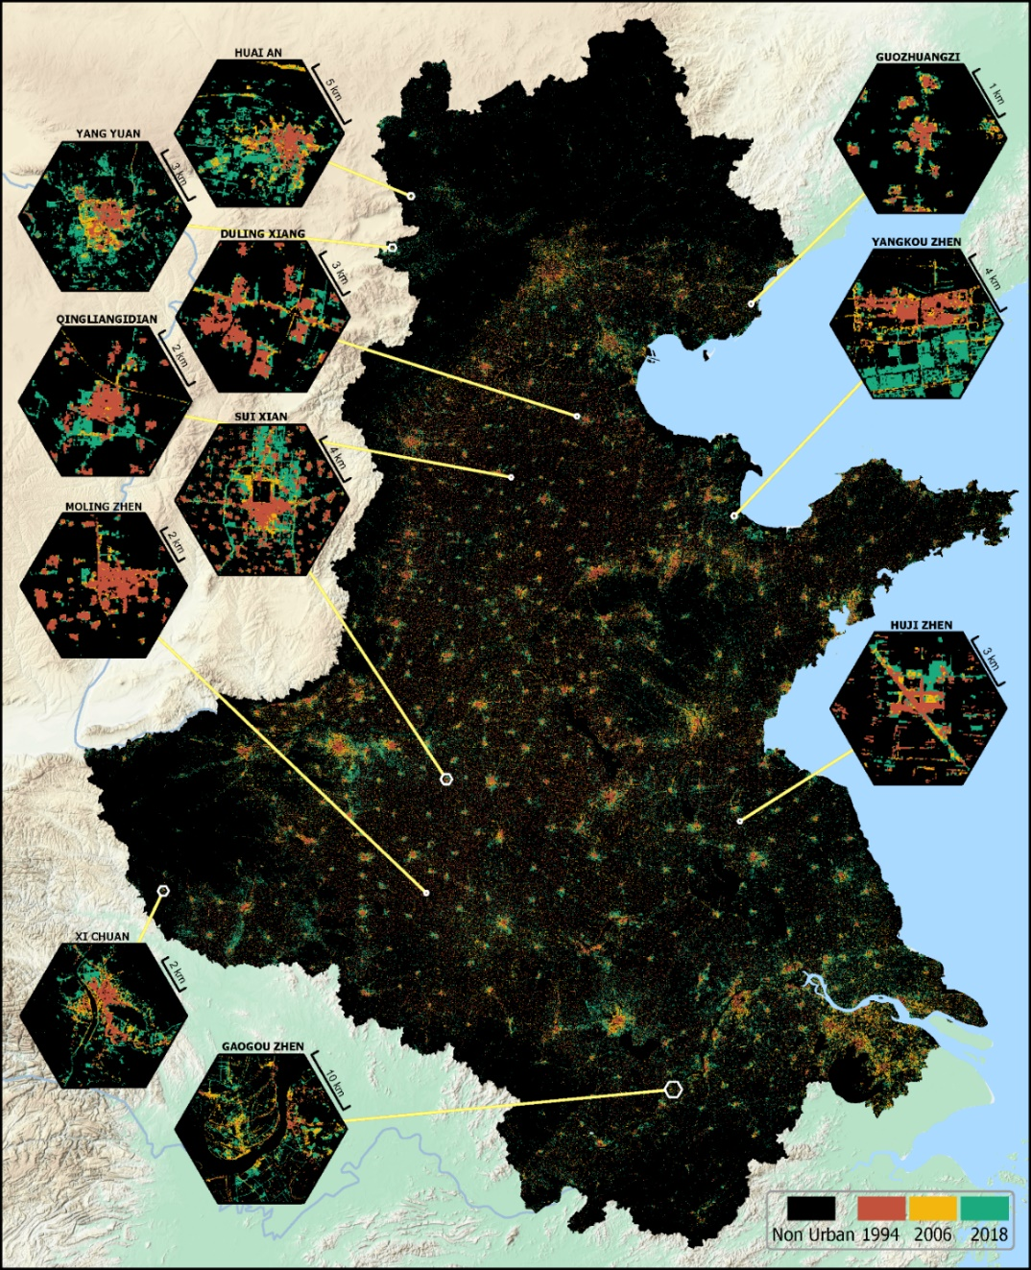

Supplementary-2: A separate experiment to support the claim of “distance factors provide little additional useful information” in the manuscript.

We collected historical road data (vector) from *OpenStreetMap*, computed the distance to roads in raster format, and appended this data as additional drivers to train the U-Net. The evaluation (MSE of 5k 256*256 tiled images against their corresponding reference 256*256 tiled images) shows that introducing road distance information makes the U-Net harder to train (longer training time and slightly higher MSE).

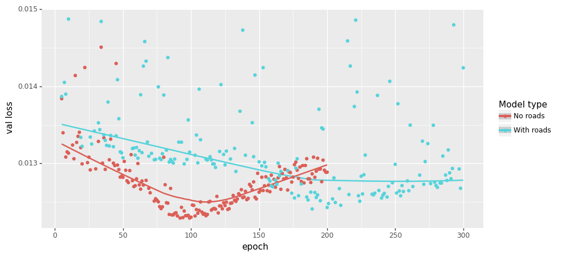

One possible explanation is that U-Net is sensitive to “visual signals (i.e., spatial features)” but distance hardly provides any robust spatial features. Below is a conceptual illustration of urban land-use (a) and distance-based driver (b) being processed by U-Net. The distance-based driver exhibits a monotonical increasing pattern perpendicular to the road, and this pattern remains unchanged in the U-Net. However, the overall urban land-use change patterns were captured in the down-sampling process and the finer patterns were reconstructed in the up-sampling process. Therefore, the monotonicity of distance-based drivers may prevent U-Net to learn additional patterns from roads/town centers, etc.

