Manuscript Number: CEUS-D-21-00877

Simulating large-scale urban land-use patterns and dynamics using the U-Net deep learning architecture

Dear Mr. Wang,

Thank you for submitting your manuscript to Computers, Environment and Urban Systems.

I have completed my evaluation of your manuscript. The reviewers recommend reconsideration of your manuscript following major revision. I invite you to resubmit your manuscript after addressing the comments below. Please resubmit your revised manuscript by Jul 06, 2022.

When revising your manuscript, please consider all issues mentioned in the reviewers' comments carefully: please outline every change made in response to their comments and provide suitable rebuttals for any comments not addressed. Please note that your revised submission may need to be re-reviewed.

To submit your revised manuscript, please log in as an author at https://www.editorialmanager.com/ceus/, and navigate to the "Submissions Needing Revision" folder.

Computers, Environment and Urban Systems values your contribution and I look forward to receiving your revised manuscript.

Kind regards,      
Alison Heppenstall     
Associate Editor

Computers, Environment and Urban Systems

**Reviewer #1:**

The paper reports the result of a study using deep learning to model urban land development by applying the U-Net architecture to a study area of the North China Plain. The subject addressed in this article is worthy of investigation and appropriate to the journal.

Thanks for confirming the value of this study.

However, the methodology is not clearly descried w.r.t the data used for the development of the two U-Net models and the novel methodological contributions.

To clarify the data used to train the U-Net models, we added a table in the “Data processing” section.

Table 3. The data used to train U-Net models. (This table is inserted in the “2.4. Data preprocessing”)

|  |  |  |  |
| --- | --- | --- | --- |
| Data | Time | Source | Resolution |
| Urban land use | 1994, 2006, 2018 | Wang et al. (2021b) | 30 m |
| Elevation | 2000* | Shuttle Radar Topography Mission | 30 m |
| Slope | 2000* | Derived from elevation | 30 m |

* Note, the elevation and slope data were used in both U-Net-A and U-Net-B despite their being acquired in 2000.

The novel methodological contributions, comparing to CA models, of deep learning architecture (U-Net) in simulating urban development mainly lies on 1) reducing subjectivity upon tweaking model weights/parameters, and 2) introducing computer vision technologies to “see” urban growth (i.e., sensitive to spatial features) rather than regression in a neighborhood scop to compose driving factors into transition rules.

That been said, the U-Net itself is not an innovative architecture (cutting-edge perspective) in deep learning field. So, we focus the innovation of U-Net on how it could add up to the current CA-mainstreamed urban simulation study: 1) automated to extract the optimum transition rules and 2) extract large scale (256 * 256 pixels window comparing to ~ 10*10 window of CA models) spatial features into simulation. However, it is not appropriate to discussion novel methodological contributions in the methods section. Instead, we discussed how the U-Net could contribute to urban simulation studies in the discussion section (4.1. Mimicking real-world urban patterns and dynamics, and 4.2. Reducing subjectivity by automatically constructing transition rules).

Somehow, the conclusions are not well supported by the study results, e.g., "The U-Net model successfully captured neighborhood effects, gravity effects, and linear expansion along transportation routes in the urban dynamics", where "linear expansion along transportation routes" seems to be concluded based on visual inspections of 11 smaller areas.

We agree that the “neighborhood effects, gravity effects, and linear expansion effects” could be abstracted by more appropriate metrics in theory, but current landscape indexes have limited power to reflect these characteristics (Uuemaa et al. 2009; Frazier and Kedron 2017; Pontius et al. 2008). Indeed, assess the quality of output features remains a significant challenge even in the deep learning community because of the versatile traits in spatial signals that beyond the mathematical description of simple shape indexes (Wang et al. 2020; Ghosh et al. 2020): it is common to evaluate the performances of deep learning models by observe the resulted images (Gonog and Zhou 2019; Xu et al. 2018). However, we still computed the landscape shape index for readers so that they comprehend the performance of U-Net simulation with a basic estimation.

In this study, we deliberately illustrated 11 small-scale (1km – 10km) regions to present that U-Net has learned some inherent patterns (i.e., the neighborhood, gravity, and linear effects) of urban development. The reason for choosing small-scale regions is that urban expansion simulation usually performs less accurate in small areas than in larger regions (Pontius et al. 2008). If small area looks sensible, readers are more likely to be convinced that the deep learning architecture could simulate the urban development well in the overall scale.

To explain to readers of our visual inspection-based pattern evaluating, we added the description of “The accuracy metrics and spatial pattern metrics have limited power to fully abstract the spatial patterns in urban land use simulation (Uuemaa et al. 2009; Frazier and Kedron 2017; Pontius et al. 2008). To assess the U-Net’s ability in simulating urban land use, we randomly selected 11 evenly distributed regions in the research area and visually inspect the resulted maps focus on if U-Net had captured the important urban development characteristics such as gravity, neighborhood, and linear effects.” in the “2.7 validation and accuracy assessment” section. Meanwhile, we also added a discussion explaining the cause of choosing visual inspection over shape metrics to evaluate learned patterns (sophistication in spatial pattern abstraction), the potential bias (cherry picking), and the measures in this study to reduce such biases (11 small-areas that is random and evenly distributed) in the “4. discussion” section.

The highlight states "U-Net achieves similar accuracies with CA models with lengthen calibration". What do you mean about "lengthen calibration"? How does your study result support "similar accuracies"? What makes the U-Net models better than CA models? Perhaps, the highlight needs to be revised and corresponding quantitative comparison and discussion are needed in the discussion section.

There are challenges to compare model performances across studies. According to Pontius et al. (2008), two factors have profound influences on the prediction accuracies: 1) The urban expansion net area and 2) the spatial resolution. Positive relationship exists between the figure of merit (FoM, i.e., the prediction accuracy) versus observed net change. Prediction errors vanished when the simulation maps been resampled into coarser resolution. Therefore, a same/close historical urbanization magnitude and spatial resolution is the premise to compare U-Net with other CA models.

In this study, we selected two other CA-based studies for comparison because they were conducted in China (similar historical urbanization magnitude) and have the same 30m spatial resolution with our study. Wang et al. (2021c) used particle swarm optimization algorithm, iterated a range of parameters settings such as self-recognition component, social component, inertial weights, and number of particles to finally get the best model with a FoM of 0.193 in Zhuji, China. Wang et al. (2021a) incorporated four periods of historical urban land use as momentums, adopted five models on top of each historical period to develop 17 sub-models, and tested eight different neighborhood sizes (5*5 to 41*41) for each sub-model to finally determined the best simulation that achieved a FoM of 0.219 in Beijing, China.

The FoM in this study, computed from 76 prefectures, ranging from 0.12 to 0.27 with the median value of 0.19. This median value is close to 0.193 reported by Wang et al. (2021c), but lower than 0.219 found by Wang et al. (2021a). This lower FoM is because Beijing is one of the most rapidly urbanized regions in China and fast urbanization region is more likely to get a higher FoM in urban land use simulation than other less urbanized regions (Pontius et al. 2008). Therefore, it can be concluded that U-Net achieves the similar accuracy with those CA-based models underthought a length calibration process.

We rewrite the “4.3. Accurate prediction and robustness in capturing spatial patterns” in the discussion section emphasizing 1) the difficulty in cross study comparison (effects of urbanization rate and spatial resolution), 2) how we selected the studies to be compared, and 3) the close FoM value between our study and other length calibrated studies.

One of my main concerns is the description of the data used in the study, which are not clear and consistent considering the following listed example lines. You actually used land use maps of 1994, 2006 and 2018 only, plus elevation/slope data (not sure if also of these three years), but the way the data are described is confusing.

We added a table 3 in the “Data processing” section to make it clear to readers that only land use maps (1994, 2006 and 2018) and elevation/slope data were used in this study.

Line 97-98: "used high-accuracy maps of urban land-use between 1993 and 2012 to train the model" and tested the model by the projected spatial distribution of urbanization for 2018

We change “between 1993 and 2012” to “between 1994 and 2006.” To avoid confusion of how the U-Net were validated using a reference map, we modified the description to “We then projected the spatial distribution of urbanization for 2018 use this model and thoroughly tested its ability to accurately capture the high-level spatial features, shapes, and patterns of urban development against the reference urban land use of 2018.”

Line 100-101: THIS trained model was then used to project patterns in 2030

To avoid confusion between the two models trained in this study, we modified the description to “Finally, we trained another U-Net model on land use maps of 2006 and 2018 to project patterns in 2030 based on historical urbanization rates.”

Line 108-109: "We used Landsat data to map urban development in the study area for the years 1994, 2006, and 2018" - I think you are talking about "map land use"

The terms used throughout the manuscript need to be clearly-defined or understood and consistent, e.g., urban dynamic map, urban map, urban land-use map, urban land use map, urban pixel number, urban pixels, urban images

We have changed “urban dynamic map, urban map, urban land-use map” to “urban land use map” through the manuscript.

Line 111-113: here you start talk about using different years of data for two different U-net models.

In our first submission, we denoted the different historical periods with different names (1994–2006 and 2006–2018 are referred to as “base,” 2018 and 2030 are called “target,” and the true 2018 urban map is called “reference”) and described the U-Net as “U-Net trained on base/target years.” Such notation could confuse the readers because they need to roll back to the method section to discern the differences between “U-Nets trained on base/target years.”

To emphasize the differences of the two U-Net models, we added a table in the introduction section and append a suffix to them. We deleted the description on training phases (i.e., 1994–2006 and 2006–2018 are referred to as “base,” etc.), and used the “U-Net-A/B”, rather than “U-Net trained on base/target years”, to identify the deep learning model through the manuscript.

Table 1. The U-Net developed in this study. (This table is inserted above the workflow chart)

|  |  |  |
| --- | --- | --- |
| Model name | Training years | Project year |
| U-Net-A | 1994, 2006 | 2018 |
| U-Net-B | 2006, 2018 | 2030 |

Line 196-199: what are the spatial resolutions of land use, elevation, and slope data, assuming they are rasters?

We added a table 3 in the “Data processing” section to make it clear to readers that all data used were raster with a spatial resolution of 30m.

Line 213-215: what's urban map here? Here, what data were used to train which model?

We change “urban map for 1994” to “urban land use map for 1994.”

To clarify the data used to train U-Net, we added more information in the parenesis for explanation: “The samples included three-layer input data (e.g., urban land use map for 1994, elevation and slope for U-Net-A) and a single-layer future urban land use map (e.g., urban land use map for 2006 for U-Net-A).”

Line 226: what are the input images here? Land use maps?

The input images refer to the combination of land use map and the elevation/slope data. To clarify this concept, we added more information in the parenthesis for explanation: “The input image (e.g., a three-layer image of urban land use for 1994 and the elevation/slope data for U-Net-A) was split into tiles, supplied to the trained U-Net model to produce separate outputs, and then the outputs were mosaicked into a single transition potential map.”

Line 204-205: any previous studies that prove "little additional useful information" provided by distance factors?

We had conducted a separate experiment showed that “distance to road provided little additional useful information.” We collected historical road data (vector) from *OpenSteetMap*, computed the distance to roads (meter records in raster format), and append these distances data as additional drivers to U-Net. The evaluation (MSE of 5k 256*256 tiled images against their corresponded reference 256*256 tiled images) shows that introducing road distance information makes the U-Net harder to train (longer training time and slightly worse MSE).

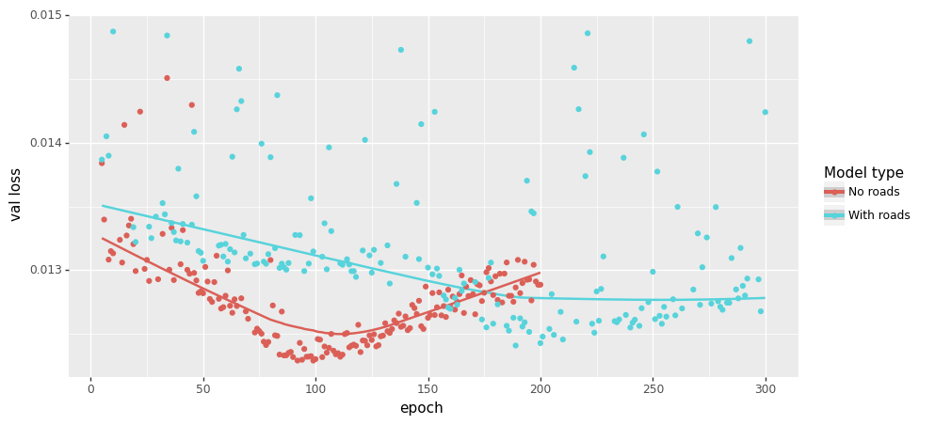

One possible explanation is that U-Net is sensitive to “visual signals (i.e., spatial features)” but distance hardly provide any robust spatial features. Below is the transition potential comparison of three sites given distance to road. Three contradictory conclusions can be concluded by the U-Net with the road information appended. So, we determined not to add distance information into the U-Net model.

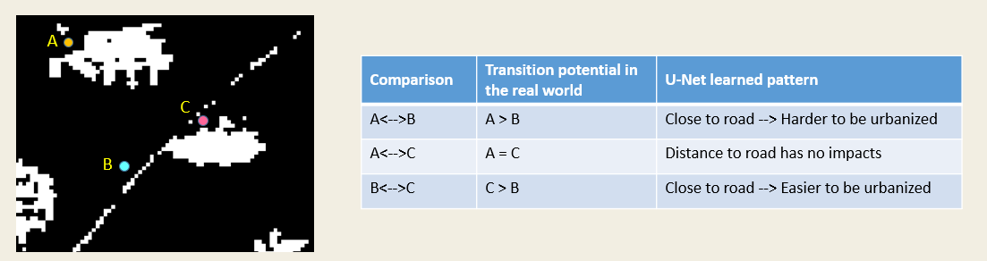

Another distance information commonly used is the distance to existing urban center. We also determined not to use such data because it also against the setting of deep learning for urban simulation: use visual signals to “see” the urban development. Whereas the distance information falls in a different principle of “use regressions to capture the first law of geography.” To the end, “to see urban development” is the most exciting part that can be added to the CA-mainstreamed land use simulation studies, so we had not used any distances data in this study.

Line 285-286: "to historical urban land-use maps for the period 1994-2006" - the expression implies maps of more than two years

We had changed the description to “to historical urban land use maps of 1994 and 2006”

What message does Fig. 5 convey? How does it show dynamics of urban land use? What do you mean about "urban dynamic map"? Do you really need this large map while showing the details as small snapshots?

The purpose of Fig. 5 is to introduce the historical urban land use to reader. This message connives less connections to the main topic of this study “deep learning to simulation urban land use,” so we deleted this figure.

Line 310-312: Is SuiXian a large town? What are those smaller villages which have the same phenomena - high transition potential?

There are several small towns, including SuiXian, been zoomed into as snapshot of transition potential maps. The visually high transition potential effects are because of a “standard deviation” stretch method been applied to the map. Otherwise, there will be only a very thin peripheral areas been indicated as high transition potential.

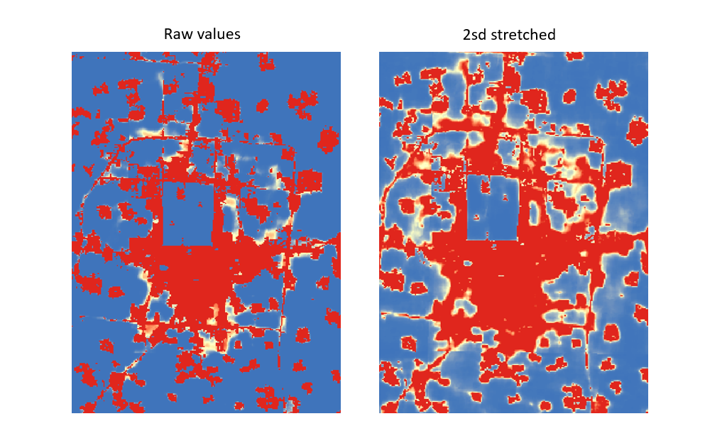

To clarify the visual effects of transition potential map, we added the stretch method and parameter in to figure note: “The transition potential values were stretched by two standard deviations to better show the learned patterns of U-Net.”

Figure 10 - do you really need this large map while showing the details as small snapshots?

Figure 11 - do you really need this large map while showing the details as small snapshots?

Fig. 10, 11 and 13 show 11 smaller urban areas, no large urban centers. How will you generalize the observations from the patterns around these areas to more general urban development?

What's the purpose of including projection of 2030 urban land use? Is it just to demonstrate the use of the trained U-Net models?

**Reviewer #2:**

I have reviewed this article carefully; I agree that it is a promising new idea to apply U-Net to urban growth simulation and prediction.

However, this method focuses on the characteristics of images (i.e., urban land use landscape), rather than understanding the process of urban growth from the driving factors (i.e., the combined effects of nature and society, etc.) that drive landscape evolution. Therefore, this method cannot understand the mechanism of urban evolution.

On the other hand, the author does not strongly prove that the simulation accuracy of this method is better than the results of traditional CA-based result.

I noticed that the author mentioned in the article that U-NET achieved higher accuracy than CA in some cities. But this does not mean that U-NET performs better in a large area, such as the study area of this paper.

Publication bibliography

Frazier, Amy E.; Kedron, Peter (2017): Landscape Metrics: Past Progress and Future Directions. In *Curr Landscape Ecol Rep* 2 (3), pp. 63–72. DOI: 10.1007/s40823-017-0026-0.

Ghosh, Bhaskar; Dutta, Indira Kalyan; Totaro, Michael; Bayoumi, Magdy (2020): A Survey on the Progression and Performance of Generative Adversarial Networks, pp. 1–8. DOI: 10.1109/ICCCNT49239.2020.9225510.

Gonog, Liang; Zhou, Yimin (2019): A Review: Generative Adversarial Networks, pp. 505–510. DOI: 10.1109/ICIEA.2019.8833686.

Pontius, Robert Gilmore; Boersma, Wideke; Castella, Jean-Christophe; Clarke, Keith; Nijs, Ton de; Dietzel, Charles et al. (2008): Comparing the input, output, and validation maps for several models of land change. In *Ann Reg Sci* 42 (1), pp. 11–37. DOI: 10.1007/s00168-007-0138-2.

Uuemaa, Evelin; Antrop, Marc; Roosaare, Jüri; Marja, Riho; Mander, Ülo (2009): Landscape metrics and indices : an overview of their use in landscape research. In *LIVING REVIEWS IN LANDSCAPE RESEARCH* 3 (1), pp. 1–28. Available online at http://biblio.ugent.be/publication/695518.

Wang, Haijun; Guo, Jiaqi; Zhang, Bin; Zeng, Haoran (2021a): Simulating urban land growth by incorporating historical information into a cellular automata model. In *Landscape and Urban Planning* 214, p. 104168. DOI: 10.1016/j.landurbplan.2021.104168.

Wang, Jinzhu; Hadjikakou, Michalis; Bryan, Brett A. (2021b): Consistent, accurate, high resolution, long time-series mapping of built-up land in the North China Plain. In *GIScience & Remote Sensing*, pp. 1–17. DOI: 10.1080/15481603.2021.1948275.

Wang, Rong; Feng, Yongjiu; Wei, Yongliang; Tong, Xiaohua; Zhai, Shuting; Zhou, Yilun; Wu, Peiqi (2021c): A comparison of proximity and accessibility drivers in simulating dynamic urban growth. In *Transactions in GIS* 25 (2), pp. 923–947. DOI: 10.1111/tgis.12707.

Wang, Zhengwei; Healy, Graham; Smeaton, Alan F.; Ward, Tomás E. (2020): Use of Neural Signals to Evaluate the Quality of Generative Adversarial Network Performance in Facial Image Generation. In *Cogn Comput* 12 (1), pp. 13–24. DOI: 10.1007/s12559-019-09670-y.

Xu, Qiantong; Huang, Gao; Yuan, Yang; Guo, Chuan; Sun, Yu; Wu, Felix; Weinberger, Kilian (2018): An empirical study on evaluation metrics of generative adversarial networks. DOI: 10.48550/arXiv.1806.07755.