Manuscript Number: CEUS-D-21-00877

Simulating large-scale urban land-use patterns and dynamics using the U-Net deep learning architecture

Dear Mr. Wang,

Thank you for submitting your manuscript to Computers, Environment and Urban Systems.

I have completed my evaluation of your manuscript. The reviewers recommend reconsideration of your manuscript following major revision. I invite you to resubmit your manuscript after addressing the comments below. Please resubmit your revised manuscript by Jul 06, 2022.

When revising your manuscript, please consider all issues mentioned in the reviewers' comments carefully: please outline every change made in response to their comments and provide suitable rebuttals for any comments not addressed. Please note that your revised submission may need to be re-reviewed.

To submit your revised manuscript, please log in as an author at https://www.editorialmanager.com/ceus/, and navigate to the "Submissions Needing Revision" folder.

Computers, Environment and Urban Systems values your contribution and I look forward to receiving your revised manuscript.

Kind regards,      
Alison Heppenstall     
Associate Editor

Computers, Environment and Urban Systems

**Reviewer #1:**

The paper reports the result of a study using deep learning to model urban land development by applying the U-Net architecture to a study area of the North China Plain. The subject addressed in this article is worthy of investigation and appropriate to the journal.

Thanks for your positive evaluation of the value of this study.

However, the methodology is not clearly described w.r.t the data used for the development of the two U-Net models and the novel methodological contributions.

To clarify the data used to train the U-Net models, we added a table in the “Data processing” section.

*Table 3. The data used to train U-Net models. (This table is inserted in the “2.4. Data preprocessing”)*

|  |  |  |  |
| --- | --- | --- | --- |
| *Data* | *Time* | *Source* | *Resolution* |
| *Urban land use* | *1994, 2006, 2018* | *Wang et al. (2021b)* | *30 m* |
| *Elevation* | *2000\** | *Shuttle Radar Topography Mission* | *30 m* |
| *Slope* | *2000\** | *Derived from elevation* | *30 m* |

*\* Note, the elevation and slope data were used in 1994, 2006, and 2018 despite their being acquired in 2000.*

The novel methodological contributions, compared to CA models, of the deep learning architecture (U-Net) in simulating urban land-use mainly lie in 1) reducing subjectivity upon tweaking model weights/parameters, and 2) introducing computer vision technologies to learn urban growth patterns (i.e., sensitive to spatial features) rather than applying regression in a neighborhood to translate driving factors into transition rules.

The U-Net itself is a new architecture in the deep learning field and while it has been applied across several fields, it is still an emerging technology. We focus the innovation on the application of U-Net to the mainstream urban simulation field which is currently dominated by CA-based methods, with its advantages being: 1) automated extraction of the optimum transition rules and 2) learning complex spatial features and processes of urban development. We discuss how the U-Net could contribute to urban simulation studies in the discussion section (4.1. Mimicking real-world urban patterns and dynamics, and 4.2. Reducing subjectivity by automatically constructing transition rules).

Somehow, the conclusions are not well supported by the study results, e.g., "The U-Net model successfully captured neighborhood effects, gravity effects, and linear expansion along transportation routes in the urban dynamics", where "linear expansion along transportation routes" seems to be concluded based on visual inspections of 11 smaller areas.

We computed the patch number and landscape shape index to quantitatively assess the performance of the U-Net simulation. However, “neighborhood effects, gravity effects, and linear expansion effects” could not be quantified by current landscape shape indexes which have limited power to capture these high-level characteristics (Uuemaa et al. 2009; Frazier and Kedron 2017; Pontius et al. 2008). Indeed, assessing the quality of output features remains a significant challenge even in the deep learning community because of the heterogeneity in spatial features that are beyond the ability of simple shape indexes to describe mathematically (Wang et al. 2020; Ghosh et al. 2020). Instead, it is common to evaluate the performances of deep learning models by observing the resulting images (Gonog and Zhou 2019; Xu et al. 2018) and qualitatively assessing and categorizing the results via human interpretation to complement the quantitative metrics as we have done.

Our conclusions are not based on the 11 inset areas presented but rather they are based on detailed visual interpretation and query of the entire map outputs at a range of scales as we describe in the Methods section. We selected 11 small-scale (1km – 10km) regions to illustrate the urban patterns learned by U-Net (i.e., the neighborhood, gravity, and linear effects) to the reader. The illustrative inset areas were selected to cover the full gradient of city size and span the entire study area. The reason for choosing small-scale regions is that urban expansion simulation usually performs less accurately in small areas than in larger regions (Pontius et al. 2008). If the simulation in a small area looks sensible, readers are more likely to be convinced that the deep learning architecture could simulate the urban development well on the overall scale. The full dataset is available online if the reader wishes to make a more detailed inspection or inspect other areas.

To explain to readers about our visual inspection-based pattern evaluation, we added the description in the “2.7 validation and accuracy assessment” as below:

*we selected 11 cities of varying sizes from across the study area for visual inspection to qualitatively evaluate the ability of U-Net to simulate realistic spatial urban land-use patterns and development characteristics.*

We also discussed the reasons for using visual inspection to evaluate the performance of U-Net and call for better tools too quantitatively assess the complex spatial shapes in the urban land-use change process in the “4.5. Limitations and prospects” section:

*Spatial patterns of urban development are complex. . The shape index employed in this study revealed a high level of agreement between the U-Net projection of urban areas and the reference land-use map. However, our assessment of the ability of the U-Net to mimic patterns was largely based on visual inspection. No quantitative metrics currently exist which are able to objectively assess whether projected urban patterns and shapes look plausible. Expert human interpretation such as the visual inspection method used in this study can effectively assess the realism of projection urban patterns but it is a qualitative and imprecise process. Better tools and metrics are required to quantitatively assess these complex spatial shapes and patterns to complement qualitative assessment based on human interpretation*

The highlight states "U-Net achieves similar accuracies with CA models with lengthen calibration". What do you mean about "lengthen calibration"? How does your study result support "similar accuracies"? What makes the U-Net models better than CA models? Perhaps, the highlight needs to be revised and a corresponding quantitative comparison and discussion are needed in the discussion section.

‘Lengthen calibration’ was an error, thanks for picking this up. With regard to ‘similar accuracies’ we have completely rewritten this section (4.3. Accurate prediction and robustness in capturing spatial patterns) to improve the clarity of the comparison…

*There are challenges to comparing model performance across studies. Pontius et al. (2008) reported two factors that profoundly influence urban land-use simulation accuracy: 1) the area of urban expansion, and; 2) the spatial resolution. A positive relationship exists between the FoM and observed land-use change. Prediction errors vanished when the simulation maps were resampled into coarser resolution (Pontius et al. 2008). Given these sensitivities, to enable a fair comparison of the accuracy of our U-Net model outputs with CA model outputs, we selected two CA-based studies with similar historical urbanization area and the same 30m spatial resolution as our study. Wang et al. (2021c) used a particle swarm optimization algorithm, iterated a range of parameter settings such as a self-recognition component, a social component, inertia weights, and the number of particles, to finally arrive at the best model with an FoM of 0.193 for Zhuji, China. Wang et al. (2021a) developed 17 sub-models incorporating four periods of historical urban land-use and tested eight different neighborhood sizes (5*5 to 41*41) for each sub-model to ultimately identify the best simulation which achieved a FoM of 0.219 for Beijing, China. The FoM (computed from 76 prefectures) in our study ranges from 0.177 - 0.215 (interquartile range) which covers the 0.193 reported by Wang et al. (2021c) but is slightly lower than the 0.219 found by Wang et al. (2021a). This higher FoM reported by Wang et al. (2021a) may be explained by the very large amount of urbanization in their study area (i.e., Beijing) (Pontius et al. 2008).* ***This comparison demonstrates that U-Net achieved similar predictive accuracies to comparable CA-based urban land-use models.***

One of my main concerns is the description of the data used in the study, which is not clear and consistent considering the following listed example lines. You actually used land use maps of 1994, 2006, and 2018 only, plus elevation/slope data (not sure if also of these three years), but the way the data are described is confusing.

We added table 3 in the “Data processing” section to make it clear to readers that only land-use maps (1994, 2006, and 2018) and elevation/slope data were used in this study.

*Table 3. The data used to train U-Net models. (This table is inserted in the “2.4. Data preprocessing”)*

|  |  |  |  |
| --- | --- | --- | --- |
| *Data* | *Time* | *Source* | *Resolution* |
| *Urban land-use* | *1994, 2006, 2018* | *Wang et al. (2021b)* | *30 m* |
| *Elevation* | *2000\** | *Shuttle Radar Topography Mission* | *30 m* |
| *Slope* | *2000\** | *Derived from elevation* | *30 m* |

*\* Note, the elevation and slope data were used in 1994, 2006, and 2018 despite their being acquired in 2000.*

Line 97-98: "used high-accuracy maps of urban land-use between 1993 and 2012 to train the model" and tested the model by the projected spatial distribution of urbanization for 2018

We apologise for this error. We changed “between 1993 and 2012” to “between 1994 and 2006.”

To avoid confusion about how the U-Net was validated using a reference map, we modified the description to:

*We then projected the spatial distribution of urbanization for 2018 using this model and thoroughly tested its ability to accurately capture the high-level spatial features, shapes, and patterns of urban development against the reference urban land-use of 2018.*

Line 100-101: THIS trained model was then used to project patterns in 2030

Thanks, We now completely rewrote this sentence, which now reads:

*The trained models were then applied to produce a transition potential layer used to create an urban land-use map for the prediction year.*

Line 111-113: here you start talking about using different years of data for two different U-net models.

In our initial submission, we denoted the different historical periods with different names (1994–2006 and 2006–2018 are referred to as “base,” 2018 and 2030 are called “target,” and the true 2018 urban map is called “reference”) and described the U-Net as “U-Net trained on base/target years.” We now see that this notation could confuse the reader because they need to roll back to the method section to discern the differences between “U-Nets trained on base/target years.”

To avoid confusion between the two models trained in this study, we modified the description when introducing the two U-Net models in the “2.1. Method overview” section:

*We created two U-Net models (Table 1). U-Net-A was trained for the validation purpose by comparing its projected land-use map with the reference map using a range of accuracy and pattern-based metrics. U-Net-B was trained to predict future urban land-use for 2030.*

|  |  |  |
| --- | --- | --- |
| *Model name* | *Training years* | *Prediction year* |
| *U-Net-A* | *1994, 2006* | *2018* |
| *U-Net-B* | *2006, 2018* | *2030* |

Table 1. Brief description of the U-Net models trained in this study.

Line 108-109: "We used Landsat data to map urban development in the study area for the years 1994, 2006, and 2018" - I think you are talking about "map land use"

The terms used throughout the manuscript need to be clearly defined or understood and consistent, e.g., urban dynamic map, urban map, urban land-use map, urban land use map, urban pixel number, urban pixels, urban images

Yes, this assumption is correct. We have now changed “urban dynamic map, urban map, etc.” to “urban land-use map” throughout the manuscript.

Line 196-199: what are the spatial resolutions of land-use, elevation, and slope data, assuming they are rasters?

We added a table 3 in the “Data processing” section to make it clear to readers that all data used were in raster format with a spatial resolution of 30m.

Line 213-215: what's urban map here? Here, what data were used to train which model?

We changed “urban map for 1994” to “urban land-use map for 1994.” To clarify the data used to train U-Net, we added more information in parentheses for explanation:

*The samples included three-layer input data (e.g., urban land-use map for 1994, elevation and slope for U-Net-A) and a single-layer future urban land-use map (e.g., urban land-use map for 2006 for U-Net-A).”*

Line 226: what are the input images here? Land use maps?

The input images refer to the combination of the land-use map and the elevation/slope data. To clarify this concept, we added more information in the parenthesis for explanation:

*The input image (e.g., a three-layer image of urban land-use for 1994 and the elevation/slope data for U-Net-A) was split into tiles, supplied to the trained U-Net model to produce separate outputs, and then the outputs were mosaicked into a single transition potential map.*

Line 204-205: any previous studies that prove "little additional useful information" provided by distance factors?

The U-net approach is rather new, and we are not aware of any other published studies that support this finding. However, to inform this decision, we conducted a separate experiment.We collected historical road data (vector) from *OpenStreetMap*, computed the distance to roads in raster format, and included this data as additional drivers to train the U-Net. The evaluation (MSE of 5k 256*256 tiled images against their corresponding reference 256*256 tiled images) shows that introducing road distance information makes the U-Net harder to train (longer training time and slightly higher MSE).

Line 285-286: "to historical urban land-use maps for the period 1994-2006" - the expression implies maps of more than two years

We changed this to “historical urban land-use maps of 1994 and 2006”.

What message does Fig. 5 convey? How does it show the dynamics of urban land use? What do you mean about "urban dynamic map"? Do you really need this large map while showing the details as small snapshots?

The purpose of Fig. 5 was to introduce the historical urban land-use in the study area to the reader. We agree that this figure is probably extraneous and have moved it to supplementary documents.

Line 310-312: Is SuiXian a large town? What are those smaller villages which have the same phenomena - high transition potential?

There are several small towns, including Suixian, which have been selected to illustrate transition potential calculated by U-Net. The high transition potential effects are because of a “standard deviation” stretch method being applied to the map. We have now realized that applying a stretch method would exaggerate the transition potentials surrounding initial urban area and changed canceled the stretching method.

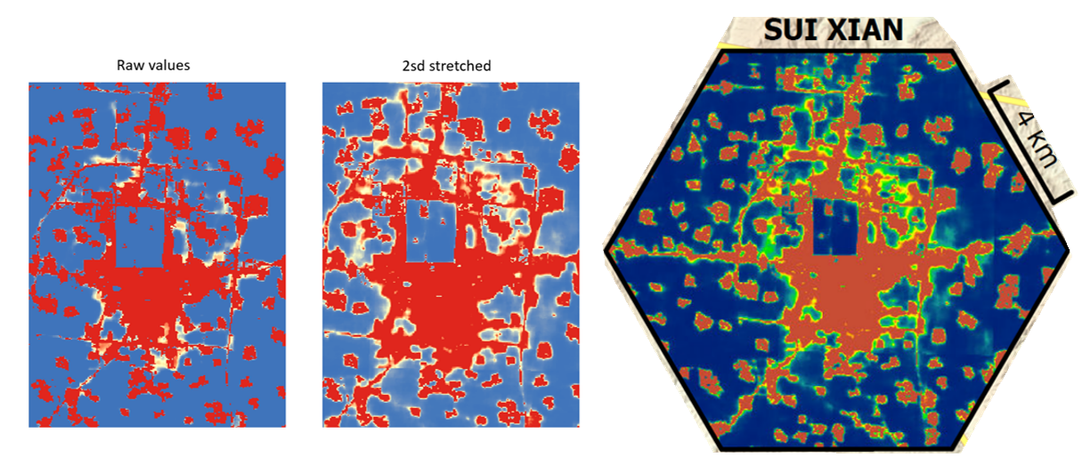

Figure 10 - do you really need this large map while showing the details as small snapshots?

Figure 11 - do you really need this large map while showing the details as small snapshots?

We do need these two figures to demonstrate that U-Net had learned the “gravity, neighborhood, and linear effects” in urban development via visual inspection. We chose to keep the large map as well as show the detailed inset maps to give readers the overall view of the whole study area on how U-Net performed and the degree of urban expansion. Also, we found that eliminating the large map won’t necessarily reduce much page space (see below our alternative design) and readers will wonder where these localities are within the region.

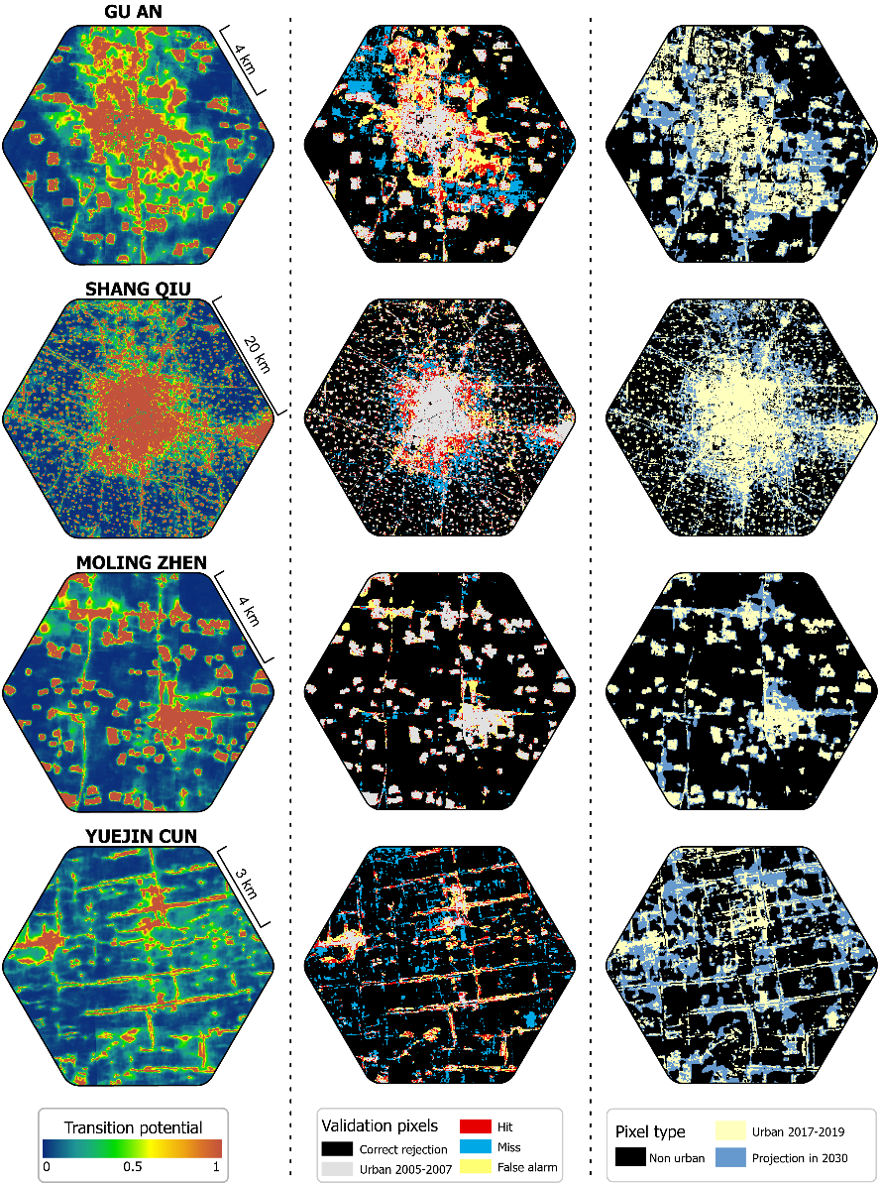

Fig. 10, 11, and 13 show 11 smaller urban areas, no large urban centers. How will you generalize the observations from the patterns around these areas to more general urban development?

Readers can zoom into the large cities to see the generalized simulation of urban land-use with our high-resolution figure. The data will also be made available freely online. We have tried to include large cities as inset maps, but the visual effects are less clear than in the small towns because the subtle details are obscured by large-scale transition potential patterns (see below figure).

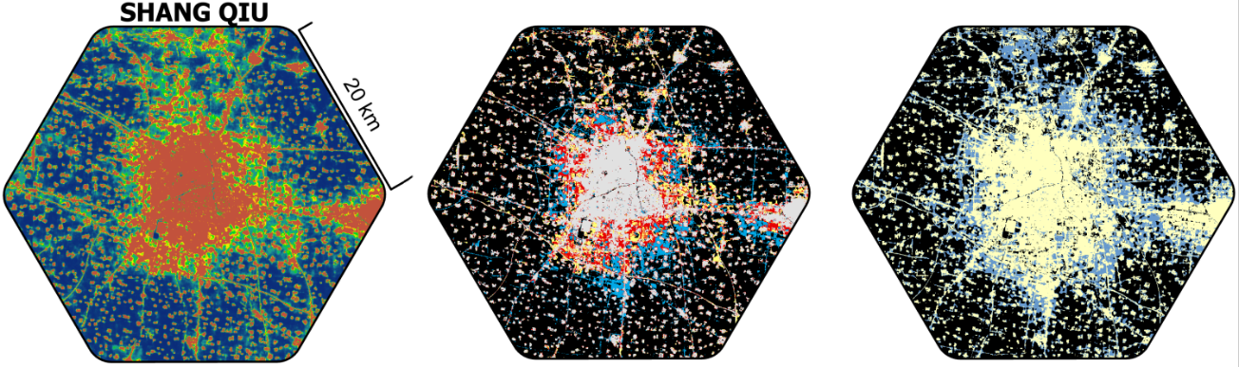

What's the purpose of including the projection of 2030 urban land use? Is it just to demonstrate the use of the trained U-Net models?

The complete flow of urban land-use simulation in this study is: 1) develop the U-Net architecture, 2) validate the trained U-Net against historical reference urban land-use map, and 3) apply the U-Net to project urban land-use to a future date. As the reviewer rightly recognizes, the primary purpose of including the projection to 2030 is to demonstrate the use of the trained U-Net. However, as one of the fastest urbanized regions in the world as well as the food bowl of China, knowing the accurate future urban land-use in the future provides significant practical value to support the regulation of urban development and evaluation of the impacts on sustainability. Urban land-use is a key proxy for socioeconomic assessment and environmental protection. Studies focusing on sustainable development and climate change can benefit from our accurate future land-use predictions.

**Reviewer #2:**

I have reviewed this article carefully; I agree that it is a promising new idea to apply U-Net to urban growth simulation and prediction.

Thanks for your supportive comments about our work.

However, this method focuses on the characteristics of images (i.e., urban land use landscape), rather than understanding the process of urban growth from the driving factors (i.e., the combined effects of nature and society, etc.) that drive landscape evolution. Therefore, this method cannot understand the mechanism of urban evolution.

Thanks for this insightful comment. Indeed the inability to elucidate underlying mechanisms of change is a limitation of machine learning approaches to simulation of urban form in general. But to understand the mechanism of urban evolution was not our goal in this paper, which was rather to accurately replicate spatial patterns (lines 135-8)

“This ability to learn spatial patterns suggests that U-Net has the potential to identify and assimilate the spatial processes that drive urban development and accurately capture the resulting patterns of cities.”

Our research continues, and aims to improve on, a long line of investigation that strongly suggests that machine learning approaches can successfully replicate urban land patterns without “knowing” (in a human sense) what the causal factors are. In this sense they are certainly useful for land use planning. We agree that other approaches might be more appropriate for understanding the causal mechanisms derived from the interaction between nature and society.

There are two types of CA-based urban land-use simulation models: the one is called the regressive model which focuses on increasing the simulation accuracy and finding the optimum functions to compose drivers (e.g., suitability, proximity, stochastic factors, etc.) into transition rules (Gantumur et al. 2020; Shafizadeh-Moghadam et al. 2017). The other one, often called the participatory model, emphasizes balancing the interests of stakeholders in the urbanization process to reveal the mechanisms/drivers behind urban land-use change (Clarke and Johnson 2020; Mansour et al. 2020).

The U-Net shares the same goal the regressive model of increasing prediction accuracies but does so using a deep learning approach rather than building a regression between driving factors and urban land-use. It possesses several significant advantages: 1) it automatically extracts transition rules without the requirement of manually setting parameters such as neighborhood size and decay rates (Feng and Tong 2020; Roodposhti et al. 2020; Peng et al. 2020), and 2) it uses computer vision technologies to learn the spatial patterns of urban development. Therefore, introducing deep learning architectures bring about the significant potential to complement CA-based models with comparable simulation performances and the automatic recognition of complex spatial patterns.

The U-Net model revealed, via visual inspection, three significant urban development processes such as neighborhood effects, gravity effects, and linear expansion effects. However, these learned patterns are hidden in the ~30 million weights within the U-Net. However, there are several potential ways to transform the trained U-Net into human recognizable rules, i.e., revealing the mechanism of urban evolution. The explainable machine learning techniques enable the abstracting of knowledge from deep learning architectures (Gunning et al. 2019; Dosilovic et al.). However, there are uncertainties if these measures can be successfully applied to U-Net and they also exceeded the topic of this study. To make readers clear about the limited capability of U-Net models as well as the potential ways to extract human-recognizable rules from them, we described the advancement in the deep learning technology as a potential solution to help understand the urban land-use change mechanism in the discussion section:

*Emerging developments in extracting human-recognizable knowledge from deep learning architectures (Gunning et al. 2019; Dosilovic et al.) could be applied to U-Net models for a better understanding of the mechanisms behind urban land-use dynamics.*

On the other hand, the author does not strongly prove that the simulation accuracy of this method is better than the results of traditional CA-based results. I noticed that the author mentioned in the article that U-NET achieved higher accuracy than CA in some cities. But this does not mean that U-NET performs better in a large area, such as the study area of this paper.

The primary goal of introducing deep learning to urban land-use simulation is to compare the pros and cons and explore how deep learning could complement CA-based land-use modeling, rather than to demonstrate that deep learning is superior. The comparison between U-Net and other studies showed that these two methods, from an accuracy metrics perspective, are very close.

The accuracy of the simulated urban land-use is profoundly impacted by 1) the net urbanized area and 2) the spatial resolution of the raster data (Pontius et al. 2008). We compared our result with two CA-based studies that iterated multiple parameters (window sizes, inertia weights, iteration number, etc.) or developed 17 sub-models to get the best simulation outcome (Wang et al. 2021a; Wang et al. 2021c). The comparison showed that the FoM in this study, computed from 76 prefectures, with the 1st quantile value of 0.177, the 3rd quantile of 0.215, and the median of 0.197, was close to 0.193 reported by Wang et al. (2021c), and 0.219 found by Wang et al. (2021a).

U-NET achieved higher accuracy than CA in some cities because the FoM is positively related to the urbanization rate (Pontius et al. 2008): some cities had more net urbanized areas and are more likely to have higher FoM. However, the interquartile value of FoM from U-Net simulation is very close to the selected CA-based studies. Therefore, U-Net achieves similar accuracies to those CA-based models underthought a length calibration process.

Publication bibliography

Clarke, Keith C.; Johnson, J. Michael (2020): Calibrating SLEUTH with big data: Projecting California's land use to 2100. In *Computers, Environment and Urban Systems* 83, p. 101525. DOI: 10.1016/j.compenvurbsys.2020.101525.

Dosilovic, Filip Karlo; Brcic, Mario; Hlupic, Nikica: Explainable artificial intelligence: A survey, pp. 210–215. DOI: 10.23919/MIPRO.2018.8400040.

Feng, Yongjiu; Tong, Xiaohua (2020): A new cellular automata framework of urban growth modeling by incorporating statistical and heuristic methods. In *International Journal of Geographical Information Science* 34 (1), pp. 74–97. DOI: 10.1080/13658816.2019.1648813.

Frazier, Amy E.; Kedron, Peter (2017): Landscape Metrics: Past Progress and Future Directions. In *Curr Landscape Ecol Rep* 2 (3), pp. 63–72. DOI: 10.1007/s40823-017-0026-0.

Gantumur, Byambakhuu; Wu, Falin; Vandansambuu, Battsengel; Tsegmid, Bazarkhand; Dalaibaatar, Enkhjargal; Zhao, Yan (2020): Spatiotemporal dynamics of urban expansion and its simulation using CA-ANN model in Ulaanbaatar, Mongolia. In *Geocarto International*, pp. 1–16. DOI: 10.1080/10106049.2020.1723714.

Ghosh, Bhaskar; Dutta, Indira Kalyan; Totaro, Michael; Bayoumi, Magdy (2020): A Survey on the Progression and Performance of Generative Adversarial Networks, pp. 1–8. DOI: 10.1109/ICCCNT49239.2020.9225510.

Gonog, Liang; Zhou, Yimin (2019): A Review: Generative Adversarial Networks, pp. 505–510. DOI: 10.1109/ICIEA.2019.8833686.

Gunning, David; Stefik, Mark; Choi, Jaesik; Miller, Timothy; Stumpf, Simone; Yang, Guang-Zhong (2019): XAI-Explainable artificial intelligence. In *Science robotics* 4 (37). DOI: 10.1126/scirobotics.aay7120.

Mansour, Shawky; Al-Belushi, Mohammed; Al-Awadhi, Talal (2020): Monitoring land use and land cover changes in the mountainous cities of Oman using GIS and CA-Markov modelling techniques. In *Land use policy* 91, p. 104414. DOI: 10.1016/j.landusepol.2019.104414.

Peng, Kaifeng; Jiang, Weiguo; Deng, Yue; Liu, Yinghui; Wu, Zhifeng; Chen, Zheng (2020): Simulating wetland changes under different scenarios based on integrating the random forest and CLUE-S models: A case study of Wuhan Urban Agglomeration. In *Ecological Indicators* 117, p. 106671. DOI: 10.1016/j.ecolind.2020.106671.

Pontius, Robert Gilmore; Boersma, Wideke; Castella, Jean-Christophe; Clarke, Keith; Nijs, Ton de; Dietzel, Charles et al. (2008): Comparing the input, output, and validation maps for several models of land change. In *Ann Reg Sci* 42 (1), pp. 11–37. DOI: 10.1007/s00168-007-0138-2.

Roodposhti, Majid Shadman; Hewitt, Richard J.; Bryan, Brett A. (2020): Towards automatic calibration of neighbourhood influence in cellular automata land-use models. In *Computers, Environment and Urban Systems* 79, p. 101416. DOI: 10.1016/j.compenvurbsys.2019.101416.

Shafizadeh-Moghadam, Hossein; Asghari, Ali; Tayyebi, Amin; Taleai, Mohammad (2017): Coupling machine learning, tree-based and statistical models with cellular automata to simulate urban growth. In *Computers, Environment and Urban Systems* 64, pp. 297–308. DOI: 10.1016/j.compenvurbsys.2017.04.002.

Uuemaa, Evelin; Antrop, Marc; Roosaare, Jüri; Marja, Riho; Mander, Ülo (2009): Landscape metrics and indices : an overview of their use in landscape research. In *LIVING REVIEWS IN LANDSCAPE RESEARCH* 3 (1), pp. 1–28. Available online at http://biblio.ugent.be/publication/695518.

Wang, Haijun; Guo, Jiaqi; Zhang, Bin; Zeng, Haoran (2021a): Simulating urban land growth by incorporating historical information into a cellular automata model. In *Landscape and Urban Planning* 214, p. 104168. DOI: 10.1016/j.landurbplan.2021.104168.

Wang, Jinzhu; Hadjikakou, Michalis; Bryan, Brett A. (2021b): Consistent, accurate, high resolution, long time-series mapping of built-up land in the North China Plain. In *GIScience & Remote Sensing*, pp. 1–17. DOI: 10.1080/15481603.2021.1948275.

Wang, Rong; Feng, Yongjiu; Wei, Yongliang; Tong, Xiaohua; Zhai, Shuting; Zhou, Yilun; Wu, Peiqi (2021c): A comparison of proximity and accessibility drivers in simulating dynamic urban growth. In *Transactions in GIS* 25 (2), pp. 923–947. DOI: 10.1111/tgis.12707.

Wang, Zhengwei; Healy, Graham; Smeaton, Alan F.; Ward, Tomás E. (2020): Use of Neural Signals to Evaluate the Quality of Generative Adversarial Network Performance in Facial Image Generation. In *Cogn Comput* 12 (1), pp. 13–24. DOI: 10.1007/s12559-019-09670-y.

Xu, Qiantong; Huang, Gao; Yuan, Yang; Guo, Chuan; Sun, Yu; Wu, Felix; Weinberger, Kilian (2018): An empirical study on evaluation metrics of generative adversarial networks. DOI: 10.48550/arXiv.1806.07755.