**Supplementary for**

Simulating large-scale urban land-use patterns and dynamics using the U-Net deep learning architecture

In the manuscript, we described “distance factors provide little additional useful information” to train the U-Net model. Below is the separate experiment to support such claim.

We collected historical road data (vector) from *OpenStreetMap*, computed the distance to roads (meter records in raster format), and append these distances data as additional drivers to train U-Net. The evaluation (MSE of 5k 256*256 tiled images against their corresponded reference 256*256 tiled images) shows that introducing road distance information makes the U-Net harder to train (longer training time and slightly worse MSE).

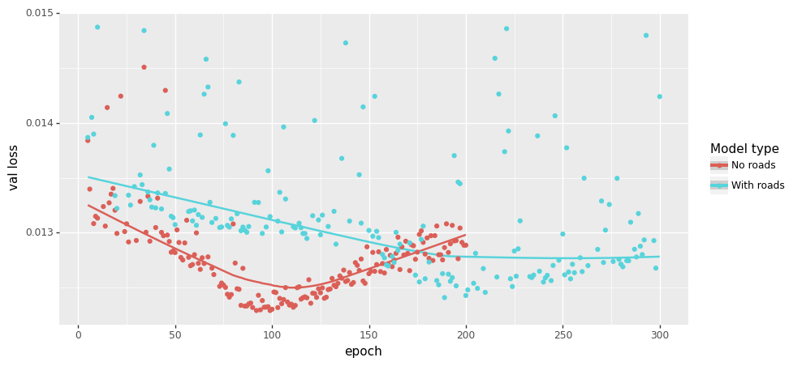

One possible explanation is that U-Net is sensitive to “visual signals (i.e., spatial features)” but distance hardly provides any robust spatial features. Below is the transition potential comparison of three sites given distance to road. Three contradictory conclusions can be concluded by the U-Net with the road information appended. So, we determined not to add distance information into the U-Net model.

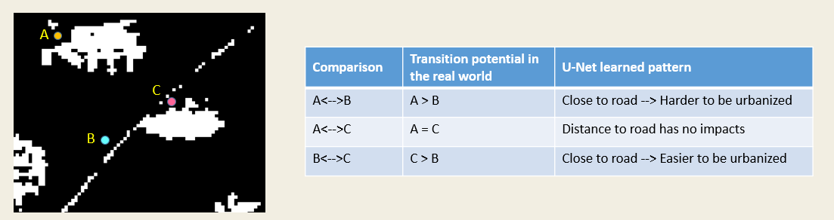

Another commonly used distance information is the distance to the existing urban centers. We also determined not to use such data because it is also against the setting of deep learning for urban simulation: use visual signals to “see” the urban development. Whereas distance information falls under a different principle of “use regressions to capture the first law of geography.” In the end, “to see urban development” is the most exciting part that can be added to the CA-mainstreamed land-use simulation studies, so we had not used any distances data in this study.