# 2. Data and Method

The research workflow is summarized in Fig. The Landsat archive was used to mapping the urban development from 1990 to 2019 with a 3-year interval (paper-1). Road networks, Digital Elevation Model (DEM), the derived distance to road, and slope were used as auxiliary data to improve the projection performance. All data were resampled to 30m resolution and then concatenated to a multiband image as the input image. The training samples were randomly cropped from the input image with a size of 512*512 (i.e., the width and heights of the parcel were 512 pixels). After sample collection, the UNET was used to train on these samples and produce the transition potential map with the input image. Lastly, we derived a threshold that derived from the historical urban area trajectory and determined the pixel with a greater value than this threshold as the urban expansion predictions.

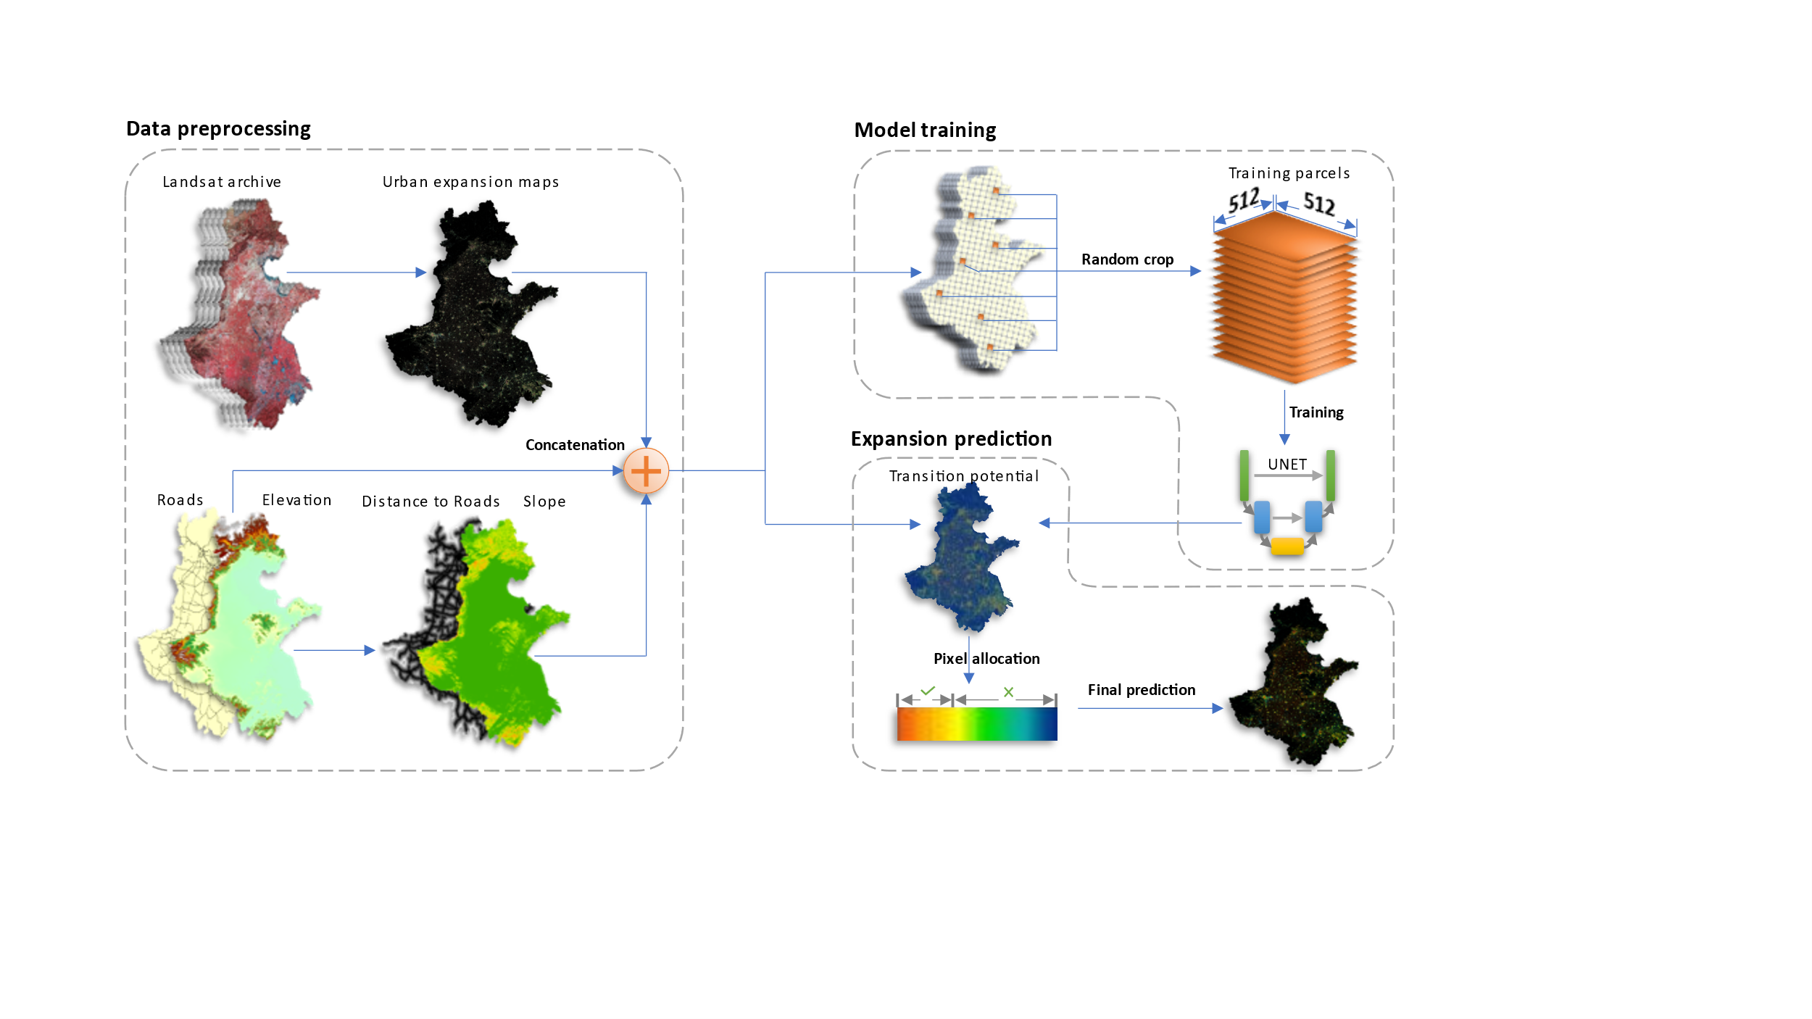

## 2.1 Data preprocessing

### 2.1.1 Urban dynamic mapping

Spectral, temporal, meteorology, and elevation predictors were used to map the urban dynamics of the study area from 1990 to 2019. The spectral predictors were the median value taken from the image collection of each 3-year Landsat archive. The temporal predictors were the coefficients from the Fourier Transformation fitting on the image collection. The meteorology and elevation predictors were used to improve the classification under different climatic and topological conditions. This urban dynamic product has the highest overall accuracy comparing to other products in the study area because the temporal predictors removed the errors classifications from fallow farmland, and a mapping correction algorithm further improved the mapping consistency.

|  |  |  |
| --- | --- | --- |
| **Data Type** | **Source** | **Time Span** |
| Road network | Open Street Map | 2014-now |
| DEM | NASA | 2000 |
| Slope | Derived from DEM | 2000 |
| Urban dynamic map | Wang et. al. | 1990-2019 |

### 2.1.2 Auxiliary data processing

Road network and DEM were used to improve the urban projection. Because the projection model only accept raster data, the road network was converted to raster data where each pixel indicate the shortest distance to the nearest road. The slope data was derived from the DEM and as included in the auxiliary data.

## 2.2 Train the Deep learning model

### 2.2.1 The UNET model for spatial feature extraction

### 2.2.2 Control sample collection

All data were concatenated into a multiband image to improve the efficiency of control sample collection. Then the *neighborhoodToArray* module of the Google Earth Engine platform was used to turn the neighborhood of each pixel in the multiband image into a two dimensional matrix (i.e., an image parcel). We set the neighborhood size to 512 following the data science practices and thus the height and width of control samples were 512 pixels. A total of 25,000 sample parcels were randomly collected with 20,000 for training and 5,000 for evaluating the projection model.