

金融数据智能分析和展示平台二期二阶段升级优化研发项目

接口测试报告

接口测试报告
简介 | 金融数据智能分析和展示平台二期二阶段升级优化研发项目
目的
更新历史 |  |  |  | 客户签收  (如有意见，请在收到此份计划后5日内提出)
编写人 | 日期 | 变更内容 | 版本 | 签收人 | 签收日期
牟家尧 | 2025.10.22 | 接口测试报告编写 | V1.0
审核人 | 审核时间 | 审核意见
审批人 | 审批时间 | 审批意见

目 录
1. 概述 4
1.1 项目背景 4
1.2 编写目的 4
1.3 接口测试简介 4
第2章 测试环境 5
2.1 网络拓扑图 5
2.2 服务器软件环境 5
2.3 服务器硬件环境 5
2.4 服务器网络环境 6
2.5 客户机配置 6
2.6 测试工具 6
第3章 测试方案 7
3.1 测试方法 7
3.2 测试范围 7
3.3 测试用例 7
3.4 测试结论 106
3.5 问题统计与分析 106
3.6 总结 107

概述

项目背景
金融数据智能分析和展示平台二期二阶段升级优化研发，是在一期平台的基础上引入外部大数据，提升数据获取的及时度和准确度，辅助各子公司对客户、渠道、业务、风险、资金、资产等多维度的数据分析、挖掘，并将各项数据做可视化处理。通过可视化呈现方式，多维分析还有管理驾驶舱的结合快速地获取数据，辅助集团和子公司管理层提升运营管理效能，强化风控管理能力。
编写该测试报告主要有以下几个目的：
1.测试单一接口的功能是否正常，能否正常调用。
2.测试多借口混合场景调用功能是否正常。
3.通过对测试结果的分析，得到对软件质量的评价。

编写目的
本文档为 “数据智能分析和展示平台二期二阶段升级优化”软件项目的系统接口测试报告，目的在于检测单个接口的功能符合设计需求，多个接口间相互调用正常。通过分析接口测试结果，得出系统质量评估结果。

接口测试简介
接口是指同一个系统中模块与模块间的数据传递接口、前后端交互、跨系统跨平台跨数据库的对接。而接口测试，则是通过接口的不同情况下的输入，去对比输出，看看是否满足接口规范所规定的功能要求。

测试环境

网络拓扑图
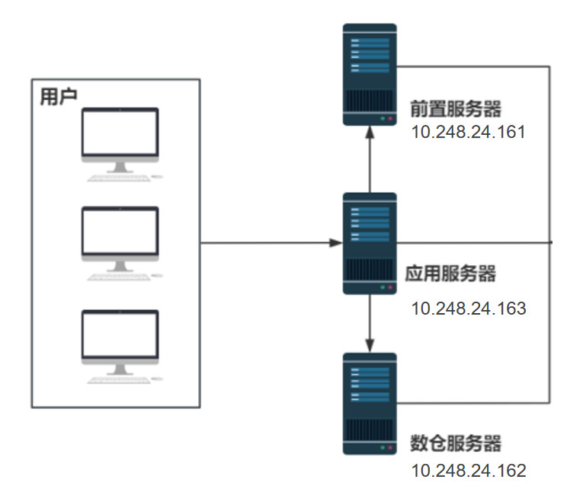

服务器软件环境
资源名称 | 软件环境 | 备注
应用服务器 | 1.操作系统：麒麟  2.报表展示：数据智能分析和展示平台1.0
前置数据服务器 | 1.操作系统：麒麟  2.关系数据库：Mysql 5.7
数仓服务器 | 1.操作系统：麒麟  2.关系数据库：Oracle 11g
测试机 | - 操作系统： Windows 7、Windows 10  - 浏览器：Edge116.0.1938.62、Chrome116.0.5845.140、Firefox 116.0.3

服务器硬件环境
以下为服务器的配置：
资源名称 | CPU | 内存 | 硬盘 | 备注
前置数据库服务器 | 16核 | 16G | 500GB
数仓数据库服务器 | 16核 | 16G | 500GB
应用服务器 | 8核 | 16G | 500GB

服务器网络环境
典型的B/S架构，1000M带宽。

客户机配置
操作系统 | CPU | 内存
Windows 10 | i5-7500 3.40GHz | 16.0 GB

测试工具
工具 | 版本要求 | 备注
禅道 | 8.2.6 | 用于bug缺陷管理
Apifox | 2.7.50 | 接口请求模拟发送工具
Fiddler | 5.0 | 接口请求抓包工具

测试方案

测试方法
根据接口功能说明和需求文档，通过Fiddler抓取接口请求信息，明确接口的输入输出参数。根据边界值、等价类等方法设计测试用例，使用Apifox模拟接口发送请求，记录并对比预期响应结果和实际响应结果的区别。

测试范围
外部接口测试：企业大数据平台接口

测试用例
用例名称 | 企业大数据-首页-模糊查询成功
用例编号 | 43385
接口地址 | /api/yjt/crdb/search
请求方式 | get
前置条件 | 数据查询功能正常
描述 | 正常查询数据信息成功
请求头部 | Content-Type：text/plain;charset=UTF-8
请求参数 | keyword=四川和邦生物科技股份有限公司
状态码 | 200
预期返回结果 | {"state":true,"data":[{"oldStock":[],"alias":"和邦生物","socialCreditCode":"91511100740039656L","itcode":"1010776533","oldName":["四川乐山和邦化工有限公司","四川和邦股份有限公司"],"name":"四川和邦生物科技股份有限公司"},{"oldStock":[],"alias":null,"socialCreditCode":"91511112MA6285FC08","itcode":"1001482997","oldName":[],"name":"四川和邦生物科技股份有限公司营养剂分公司"},{"oldStock":[],"alias":null,"socialCreditCode":"91310115MAE4F3FU7D","itcode":"1147588329","oldName":[],"name":"四川和邦生物科技股份有限公司上海分公司"},{"oldStock":[],"alias":null,"socialCreditCode":null,"itcode":"1012475473","oldName":[],"name":"四川和邦生物科技股份有限公司热动分厂"},{"oldStock":[],"alias":null,"socialCreditCode":"91510105MAD4281H2B","itcode":"1137186528","oldName":[],"name":"四川和邦生物科技股份有限公司成都分公司"}],"traceId":"69201117fe62224e3135a2fe"}
实际结果 | 与预期结果一致  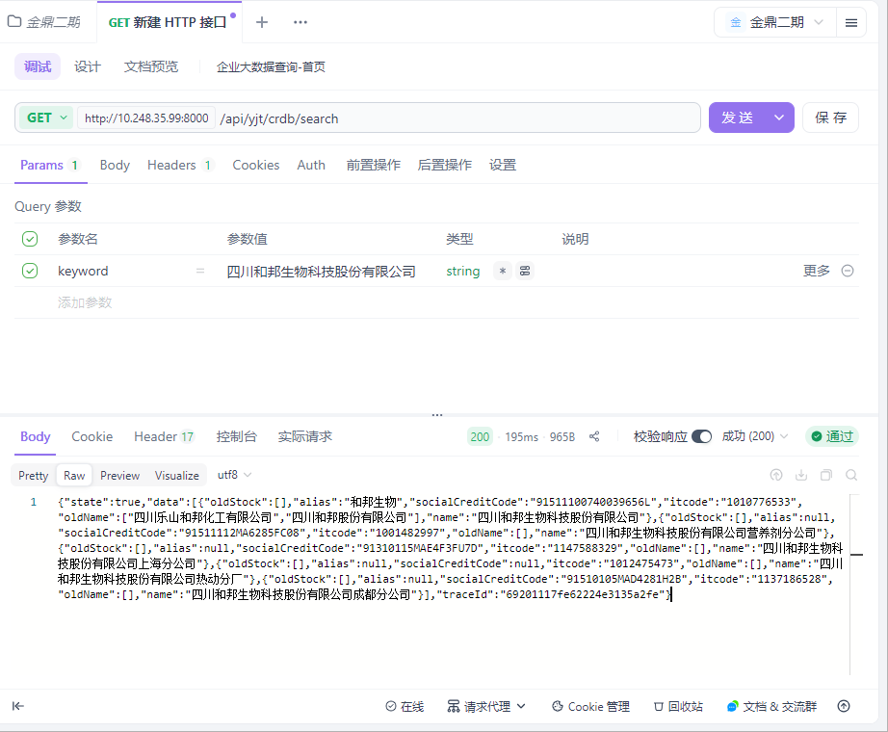

用例名称 | 企业大数据-首页-模糊查询失败
用例编号 | 43386
接口地址 | /api/yjt/crdb/search
请求方式 | get
前置条件 | 数据查询功能正常
描述 | 查询不存在的数据
请求头部 | Content-Type：text/plain;charset=UTF-8
请求参数 | keyword=2222222222222222
状态码 | 200
预期返回结果 | {"state":true,"data":[],"traceId":"69201212e908494d1111f801"}
实际结果 | 与预期结果一致  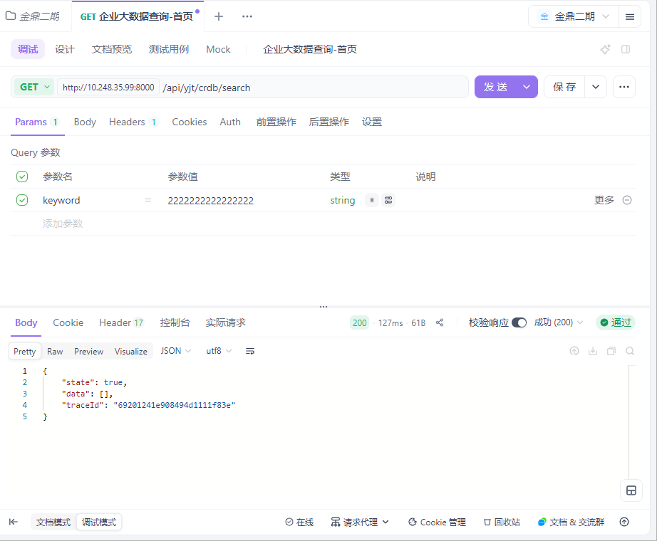

用例名称 | 企业大数据-基本信息-企业速览-企业基本信息
用例编号 | 43387
接口地址 | /api/esb/businessInfo/search
请求方式 | get
前置条件 | 数据查询功能正常
描述 | 正常查询数据信息成功
请求头部 | Content-Type：text/plain;charset=UTF-8
请求参数 | obj=1010776533
状态码 | 200
预期返回结果 | {"state":true,"data":{"RegistCapi":883139.12,"BelongOrg":"四川省乐山市市场监督管理局","CreditCode":"91511100740039656L","Email":"jsy@hebang.cn","CompanyName_s":"和邦生物","Website":"www.hebang.cn","PostalCode":614801,"SocialInsurance":"2417人","LegalRepresentative":"曾小平","StartDate":"2002-08-01","ActualCapi":30000.0,"CompanyName":"四川和邦生物科技股份有限公司","TxIdentificationNumber":null,"Employment":"企业选择不公示","Currency":"CNY","CompanyHistory":" 公司前身为和邦化工,成立于2002年8月1日。2008年2月28日,和邦化工以截至2008年1月31日经君和所审计的净资产值363,449,735.90元为基础,按照1.2115:1的比例折合股本共计30,000万股,整体变更设立为股份有限公司。2008年2月28日,公司在四川省乐山市工商行政管理局完成注册变更登记,并领取了注册号为511100000001732的<企业法人营业执照>。\r\n 2015年7月31日,公司名称由“四川和邦股份有限公司”变更为“四川和邦生物科技股份有限公司”;英文名称由“Sichuan Hebang Corporation Limited”变更为“Sichuan Hebang Biotechnology Co.,Ltd.”。","OrganizationCode":"74003965-6","CheckDate":"2022-04-19","RegistrationNumber":"511100000001732","RevokeDate":null,"Status":"在营","CurrencyUnit":"万元","MailingAddress":"四川省乐山市五通桥区牛华镇沔坝村","OfficeAddress":"四川省乐山市五通桥区牛华镇沔坝村","OriginalName":["四川乐山和邦化工有限公司","四川和邦股份有限公司"],"EndDate":null,"TermStart":"2002-08-01","TermEnd":null,"Scope":"许可项目:农药生产;农药批发;农药零售;肥料生产;第二、三类监控化学品和第四类监控化学品中含磷、硫、氟的特定有机化学品生产;危险化学品生产;危险化学品经营;危险废物经营;食品添加剂生产;饲料添加剂生产;货物进出口;技术进出口;进出口代理(依法须经批准的项目,经相关部门批准后方可开展经营活动,具体经营项目以相关部门批准文件或许可证件为准)一般项目:食品添加剂销售、肥料销售;化肥销售;化工产品生产(不含许可类化工产品);化工产品销售(不含许可类化工产品);技术服务、技术开发、技术咨询、技术交流、技术转让、技术推广;固体废物治理;非食用盐销售;国内贸易代理(除依法须经批准的项目外,凭营业执照依法自主开展经营活动)。","RegisteredAddress":"四川省乐山市五通桥区牛华镇沔坝村","PhoneNumber":"028-62050230","CompanyCode":1010776533,"EnglishName":"SichuanHebang Biotechnology Co.,Ltd.","regionIndustryList":[{"IndustryCode":"C","SmallCategoryCode":"C2612","SubIndustry":"化学原料和化学制品制造业","City":"乐山市","MiddleCategoryCode":"C261","County":"五通桥区","Province":"四川省","Industry":"制造业","CompanyName":"四川和邦生物科技股份有限公司","SubIndustryCode":"C26","MiddleCategory":"基础化学原料制造","SmallCategory":"无机碱制造","AreaCode":"511112","CompanyCode":1010776533}],"changeList":[{"ContentAfter":"2025-05-26新章程","CompanyName":"四川和邦生物科技股份有限公司","ContentBefore":"","ChangeDate":"2025-06-27","ChangeItem":"章程备案","CompanyCode":1010776533},{"ContentAfter":"","CompanyName":"四川和邦生物科技股份有限公司","ContentBefore":"陈静 卢丹 龚嵘鹏","ChangeDate":"2025-06-27","ChangeItem":"高级管理人员备案","CompanyCode":1010776533},{"ContentAfter":"陈天 胡杨 贺正刚 曾小平 袁长华 宋英 秦学玲 李进 王军","CompanyName":"四川和邦生物科技股份有限公司","ContentBefore":"王军 袁长华 宋英 秦学玲 李进 曾小平 贺正刚 胡杨 陈天","ChangeDate":"2025-06-27","ChangeItem":"高级管理人员备案","CompanyCode":1010776533},{"ContentAfter":"漆科江 *** 备案手机：*** （网上办理）","CompanyName":"四川和邦生物科技股份有限公司","ContentBefore":"杨萍 *** 备案手机：***","ChangeDate":"2025-01-23","ChangeItem":"联络人备案","CompanyCode":1010776533},{"ContentAfter":"漆科江 *** 备案手机：*** （网上办理）","CompanyName":"四川和邦生物科技股份有限公司","ContentBefore":"漆科江 *** 备案手机：***","ChangeDate":"2025-01-23","ChangeItem":"联络人备案","CompanyCode":1010776533},{"ContentAfter":"2023-12-29修改章程第三条、第四十四条、第四十六条、第八十五条、第一百零一条、第一百零七条、第一百一十条、第一百一十一条、第一百一十三条、第一百一十四条、第一百一十五条、第一百一十六条、第一百一十七条、第一百一十八条、第一百二十六条、第一百三十九条、第一百四十九条、第一百七十条、第二百零九条","CompanyName":"四川和邦生物科技股份有限公司","ContentBefore":"无","ChangeDate":"2024-01-15","ChangeItem":"章程备案","CompanyCode":1010776533},{"ContentAfter":"卢丹 陈静 龚嵘鹏","CompanyName":"四川和邦生物科技股份有限公司","ContentBefore":"龚嵘鹏 卢丹 缪成云","ChangeDate":"2023-05-31","ChangeItem":"高级管理人员备案","CompanyCode":1010776533},{"ContentAfter":"许可项目:农药生产;农药批发;农药零售;肥料生产;第二、三类监控化学品和第四类监控化学品中含磷、硫、氟的特定有机化学品生产;危险化学品生产;危险化学品经营;危险废物经营;食品添加剂生产;饲料添加剂生产;货物进出口;技术进出口;进出口代理(依法须经批准的项目,经相关部门批准后方可开展经营活动,具体经营项目以相关部门批准文件或许可证件为准)一般项目:肥料销售;化肥销售;化工产品生产(不含许可类化工产品);化工产品销售(不含许可类化工产品);技术服务、技术开发、技术咨询、技术交流、技术转让、技术推广;固体废物治理;非食用盐销售;国内贸易代理;食品添加剂销售(除依法须经批准的项目外,凭营业执照依法自主开展经营活动)。","CompanyName":"四川和邦生物科技股份有限公司","ContentBefore":"许可项目:农药生产;农药批发;农药零售;肥料生产;第二、三类监控化学品和第四类监控化学品中含磷、硫、氟的特定有机化学品生产;危险化学品生产;危险化学品经营;危险废物经营;食品添加剂生产;饲料添加剂生产;货物进出口;技术进出口;进出口代理(依法须经批准的项目,经相关部门批准后方可开展经营活动,具体经营项目以相关部门批准文件或许可证件为准)一般项目:肥料销售;化肥销售;化工产品生产(不含许可类化工产品);化工产品销售(不含许可类化工产品);技术服务、技术开发、技术咨询、技术交流、技术转让、技术推广;固体废物治理;非食用盐销售;国内贸易代理(除依法须经批准的项目外,凭营业执照依法自主开展经营活动)。","ChangeDate":"2022-04-19","ChangeItem":"经营范围变更","CompanyCode":1010776533},{"ContentAfter":"2022-04-06新章程","CompanyName":"四川和邦生物科技股份有限公司","ContentBefore":"无","ChangeDate":"2022-04-19","ChangeItem":"章程备案","CompanyCode":1010776533},{"ContentAfter":"2021-04-16新章程","CompanyName":"四川和邦生物科技股份有限公司","ContentBefore":"无","ChangeDate":"2021-06-11","ChangeItem":"章程备案","CompanyCode":1010776533}],"shareholderInfoList":[{"ShareholdingRatio":"22.2400","CompanyName":"四川和邦生物科技股份有限公司","ContributionTime":null,"ShareholderType":"企业法人","ShareholderName":"四川和邦投资集团有限公司","Unit":"股","ContributionTpe":"实物","ShareholdeCode":1004133733,"CompanyCode":1010776533,"ShouldCapi":1963779103},{"ShareholdingRatio":"5.9400","CompanyName":"四川和邦生物科技股份有限公司","ContributionTime":null,"ShareholderType":"企业法人","ShareholderName":"四川省盐业集团有限责任公司","Unit":"股","ContributionTpe":null,"ShareholdeCode":1001643730,"CompanyCode":1010776533,"ShouldCapi":524359246},{"ShareholdingRatio":"4.6700","CompanyName":"四川和邦生物科技股份有限公司","ContributionTime":null,"ShareholderType":"自然人股东","ShareholderName":"贺正刚","Unit":"股","ContributionTpe":null,"ShareholdeCode":null,"CompanyCode":1010776533,"ShouldCapi":4.12632E8},{"ShareholdingRatio":"1.0500","CompanyName":"四川和邦生物科技股份有限公司","ContributionTime":null,"ShareholderType":"证券投资基金","ShareholderName":"华泰证券股份有限公司-鹏华中证细分化工产业主题交易型开放式指数证券投资基金","Unit":"股","ContributionTpe":null,"ShareholdeCode":null,"CompanyCode":1010776533,"ShouldCapi":92787762},{"ShareholdingRatio":"1.0200","CompanyName":"四川和邦生物科技股份有限公司","ContributionTime":null,"ShareholderType":"证券投资基金","ShareholderName":"中国农业银行股份有限公司-中证500交易型开放式指数证券投资基金","Unit":"股","ContributionTpe":null,"ShareholdeCode":null,"CompanyCode":1010776533,"ShouldCapi":90089916},{"ShareholdingRatio":"1.0100","CompanyName":"四川和邦生物科技股份有限公司","ContributionTime":null,"ShareholderType":"企业法人","ShareholderName":"香港中央结算有限公司","Unit":"股","ContributionTpe":null,"ShareholdeCode":1012809068,"CompanyCode":1010776533,"ShouldCapi":89282624},{"ShareholdingRatio":"0.7700","CompanyName":"四川和邦生物科技股份有限公司","ContributionTime":null,"ShareholderType":"自然人股东","ShareholderName":"高序磊","Unit":"股","ContributionTpe":null,"ShareholdeCode":null,"CompanyCode":1010776533,"ShouldCapi":67730096},{"ShareholdingRatio":"0.4400","CompanyName":"四川和邦生物科技股份有限公司","ContributionTime":null,"ShareholderType":"自然人股东","ShareholderName":"赵勇","Unit":"股","ContributionTpe":null,"ShareholdeCode":null,"CompanyCode":1010776533,"ShouldCapi":39035034},{"ShareholdingRatio":"0.3700","CompanyName":"四川和邦生物科技股份有限公司","ContributionTime":null,"ShareholderType":"证券投资基金","ShareholderName":"中国民生银行股份有限公司-光大保德信信用添益债券型证券投资基金","Unit":"股","ContributionTpe":null,"ShareholdeCode":null,"CompanyCode":1010776533,"ShouldCapi":3.30096E7},{"ShareholdingRatio":"0.2800","CompanyName":"四川和邦生物科技股份有限公司","ContributionTime":null,"ShareholderType":"证券投资基金","ShareholderName":"招商银行股份有限公司-中欧红利优享灵活配置混合型证券投资基金","Unit":"股","ContributionTpe":null,"ShareholdeCode":null,"CompanyCode":1010776533,"ShouldCapi":24599917}],"subsidiaryList":[{"Investee":"四川和邦盐矿有限公司","CompanyName":"四川和邦生物科技股份有限公司","ContributionTime":"2010-10-26","InvesteeCode":"1008989495","Unit":"万元","ShareholdeCode":"100.0000","ContributionTpe":"货币","CompanyCode":1010776533,"ShouldCapi":6000.0},{"Investee":"四川和邦新材料有限公司","CompanyName":"四川和邦生物科技股份有限公司","ContributionTime":"2030-03-09","InvesteeCode":"1011828593","Unit":"万元","ShareholdeCode":"100.0000","ContributionTpe":"货币","CompanyCode":1010776533,"ShouldCapi":30000.0},{"Investee":"四川和邦磷矿有限公司","CompanyName":"四川和邦生物科技股份有限公司","ContributionTime":"2012-09-05","InvesteeCode":"1010429057","Unit":"万元","ShareholdeCode":"100.0000","ContributionTpe":"货币","CompanyCode":1010776533,"ShouldCapi":28600.0},{"Investee":"四川和邦电子商务有限公司","CompanyName":"四川和邦生物科技股份有限公司","ContributionTime":null,"InvesteeCode":"1006043634","Unit":"万元","ShareholdeCode":"100.0000","ContributionTpe":null,"CompanyCode":1010776533,"ShouldCapi":20000.0},{"Investee":"乐山和邦新材料科技有限公司","CompanyName":"四川和邦生物科技股份有限公司","ContributionTime":"2020-05-31","InvesteeCode":"1011490445","Unit":"万元","ShareholdeCode":"100.0000","ContributionTpe":"货币","CompanyCode":1010776533,"ShouldCapi":50000.0},{"Investee":"四川武骏光能股份有限公司","CompanyName":"四川和邦生物科技股份有限公司","ContributionTime":"2010-07-20","InvesteeCode":"1010699173","Unit":"万元","ShareholdeCode":"88.3763","ContributionTpe":"货币","CompanyCode":1010776533,"ShouldCapi":40000.0},{"Investee":"四川和邦生物视高有限公司","CompanyName":"四川和邦生物科技股份有限公司","ContributionTime":"2030-03-09","InvesteeCode":"1012354062","Unit":"万元","ShareholdeCode":"100.0000","ContributionTpe":"货币","CompanyCode":1010776533,"ShouldCapi":10000.0},{"Investee":"乐山和邦农业科技有限公司","CompanyName":"四川和邦生物科技股份有限公司","ContributionTime":"2015-06-04","InvesteeCode":"1011887874","Unit":"万元","ShareholdeCode":"100.0000","ContributionTpe":"货币","CompanyCode":1010776533,"ShouldCapi":49200.0},{"Investee":"乐山涌江实业有限公司","CompanyName":"四川和邦生物科技股份有限公司","ContributionTime":"2016-10-27","InvesteeCode":"1076870574","Unit":"万元","ShareholdeCode":"100.0000","ContributionTpe":"货币","CompanyCode":1010776533,"ShouldCapi":16010.0},{"Investee":"四川合江和邦化学有限公司","CompanyName":"四川和邦生物科技股份有限公司","ContributionTime":null,"InvesteeCode":"1008618021","Unit":"万元","ShareholdeCode":"100.0000","ContributionTpe":null,"CompanyCode":1010776533,"ShouldCapi":2000.0}],"managementList":[{"CompanyName":"四川和邦生物科技股份有限公司","position":"审计委员会委员","CompanyCode":1010776533,"Name":"宋英"},{"CompanyName":"四川和邦生物科技股份有限公司","position":"审计委员会主任","CompanyCode":1010776533,"Name":"宋英"},{"CompanyName":"四川和邦生物科技股份有限公司","position":"董事长","CompanyCode":1010776533,"Name":"曾小平"},{"CompanyName":"四川和邦生物科技股份有限公司","position":"非独立董事","CompanyCode":1010776533,"Name":"曾小平"},{"CompanyName":"四川和邦生物科技股份有限公司","position":"总经理","CompanyCode":1010776533,"Name":"曾小平"},{"CompanyName":"四川和邦生物科技股份有限公司","position":"战略委员会主任","CompanyCode":1010776533,"Name":"贺正刚"},{"CompanyName":"四川和邦生物科技股份有限公司","position":"战略委员会委员","CompanyCode":1010776533,"Name":"贺正刚"},{"CompanyName":"四川和邦生物科技股份有限公司","position":"战略委员会委员","CompanyCode":1010776533,"Name":"曾小平"},{"CompanyName":"四川和邦生物科技股份有限公司","position":"审计委员会委员","CompanyCode":1010776533,"Name":"胡杨"},{"CompanyName":"四川和邦生物科技股份有限公司","position":"非独立董事","CompanyCode":1010776533,"Name":"贺正刚"}],"branchList":[{"CompanyName":"四川和邦生物科技股份有限公司","Relationship":"企业总分关系","BranchName":"四川和邦生物科技股份有限公司上海分公司","BranchCode":"1147588329","CompanyCode":1010776533},{"CompanyName":"四川和邦生物科技股份有限公司","Relationship":"企业总分关系","BranchName":"四川和邦生物科技股份有限公司成都分公司","BranchCode":"1137186528","CompanyCode":1010776533},{"CompanyName":"四川和邦生物科技股份有限公司","Relationship":"企业总分关系","BranchName":"四川和邦生物科技股份有限公司营养剂分公司","BranchCode":"1001482997","CompanyCode":1010776533}],"enterpriseNatureList":[{"id":"102128777","itcode":"80189718","itcode2":"1010776533","companyName":"四川和邦生物科技股份有限公司","companyTypecode":9,"companyType":"私人相对控股","orgTypeCode":4,"organType":"股份有限公司","updateTime":"2023-08-04T13:05:27.330Z","natureCode":570,"natureName":"私有企业(民营企业)"}],"suspectedList":[{"RegistCapi":500.0,"Status":"在营","CurrencyUnit":"万元","RelatedpartyCode":"1059323642","LegalRepresentative":"杨红武","CommonPhoneNumber":null,"CommonEmail":null,"StartDate":"2018-12-20","CompanyName":"四川和邦生物科技股份有限公司","CommonRegisteredAddress":"四川省乐山市五通桥区牛华镇沔坝村","RelatedpartyName":"乐山时代房地产开发有限公司","Relationshiptype":"共同注册地","CompanyCode":"1010776533"},{"RegistCapi":500.0,"Status":"在营","CurrencyUnit":"万元","RelatedpartyCode":"1059293366","LegalRepresentative":"杨红武","CommonPhoneNumber":null,"CommonEmail":null,"StartDate":"2018-12-19","CompanyName":"四川和邦生物科技股份有限公司","CommonRegisteredAddress":"四川省乐山市五通桥区牛华镇沔坝村","RelatedpartyName":"乐山弘元房地产开发有限公司","Relationshiptype":"共同注册地","CompanyCode":"1010776533"},{"RegistCapi":500.0,"Status":"在营","CurrencyUnit":"万元","RelatedpartyCode":"1059323634","LegalRepresentative":"杨红武","CommonPhoneNumber":null,"CommonEmail":null,"StartDate":"2018-12-19","CompanyName":"四川和邦生物科技股份有限公司","CommonRegisteredAddress":"四川省乐山市五通桥区牛华镇沔坝村","RelatedpartyName":"乐山和裕房地产开发有限公司","Relationshiptype":"共同注册地","CompanyCode":"1010776533"},{"RegistCapi":1000.0,"Status":"注销","CurrencyUnit":"万元","RelatedpartyCode":"1012125986","LegalRepresentative":"杨爱平","CommonPhoneNumber":null,"CommonEmail":null,"StartDate":"2014-01-15","CompanyName":"四川和邦生物科技股份有限公司","CommonRegisteredAddress":"四川省乐山市五通桥区牛华镇沔坝村","RelatedpartyName":"乐山和邦设备有限公司","Relationshiptype":"共同注册地","CompanyCode":"1010776533"},{"RegistCapi":0.0,"Status":"在营","CurrencyUnit":"万元","RelatedpartyCode":"1085378802","LegalRepresentative":"王晶","CommonPhoneNumber":null,"CommonEmail":null,"StartDate":"2010-05-28","CompanyName":"四川和邦生物科技股份有限公司","CommonRegisteredAddress":"四川省乐山市五通桥区牛华镇沔坝村","RelatedpartyName":"中国石化销售股份有限公司四川乐山石油分公司乐天加油站","Relationshiptype":"共同注册地","CompanyCode":"1010776533"},{"RegistCapi":0.0,"Status":"在营","CurrencyUnit":"万元","RelatedpartyCode":"1085361984","LegalRepresentative":"王晶","CommonPhoneNumber":null,"CommonEmail":null,"StartDate":"2004-09-24","CompanyName":"四川和邦生物科技股份有限公司","CommonRegisteredAddress":"四川省乐山市五通桥区牛华镇沔坝村","RelatedpartyName":"中国石化销售股份有限公司四川乐山石油分公司昭乐加油站","Relationshiptype":"共同注册地","CompanyCode":"1010776533"},{"RegistCapi":"","Status":"注销","CurrencyUnit":null,"RelatedpartyCode":"1030360603","LegalRepresentative":"古全胜","CommonPhoneNumber":null,"CommonEmail":null,"StartDate":"2000-11-09","CompanyName":"四川和邦生物科技股份有限公司","CommonRegisteredAddress":"四川省乐山市五通桥区牛华镇沔坝村","RelatedpartyName":"乐山市五通桥牛华镇沔坝屠宰点","Relationshiptype":"共同注册地","CompanyCode":"1010776533"},{"RegistCapi":225.0,"Status":"注销","CurrencyUnit":"万美元","RelatedpartyCode":"1027805502","LegalRepresentative":"吴绍林","CommonPhoneNumber":null,"CommonEmail":null,"StartDate":"1995-05-05","CompanyName":"四川和邦生物科技股份有限公司","CommonRegisteredAddress":"四川省乐山市五通桥区牛华镇沔坝村","RelatedpartyName":"乐山凌云陶瓷有限公司","Relationshiptype":"共同注册地","CompanyCode":"1010776533"}],"companyScaleList":[{"CompanyName":"四川和邦生物科技股份有限公司","CR0102_002":"大型企业","CR0102_001":"1","CompanyCode":1010776533}],"actualControlList":[{"id":161252583,"itcode":"80189718","itcode2":"1010776533","companyName":"四川和邦生物科技股份有限公司","investorName":"贺正刚","investorcode":"30176716","investorcode2":null,"influenceRatio":26.91,"influenceType":31}],"controllerInfoList":[{"companyCode":"1010776533","companyName":"四川和邦生物科技股份有限公司","creditCode":"91511100740039656L","suspectControllerCode1":null,"suspectControllerName1":null,"suspectControllerTotalWeight1":null,"influenceRatio1":null,"suspectControllerPathCount1":null,"suspectControllerPathMaxDepth1":null,"suspectControllerPathMinDepth1":null,"suspectControllerPath1":[],"suspectControllerCode2":"P001431703","suspectControllerName2":"贺正刚","suspectControllerTotalWeight2":26.6876,"influenceRatio2":22.24,"suspectControllerPathCount2":2,"suspectControllerPathMaxDepth2":2,"suspectControllerPathMinDepth2":1,"suspectControllerPath2":[{"path_1":[{"sourceName":"贺正刚","sourceCode":"P001431703","weight":4.67,"targetName":"四川和邦生物科技股份有限公司","targetCode":"1010776533"}]},{"path_2":[{"sourceName":"贺正刚","sourceCode":"P001431703","weight":99,"targetName":"四川和邦投资集团有限公司","targetCode":"1004133733"},{"sourceName":"四川和邦投资集团有限公司","sourceCode":"1004133733","weight":22.24,"targetName":"四川和邦生物科技股份有限公司","targetCode":"1010776533"}]}],"discloseControllerCode":"P001431703","discloseControllerName":"贺正刚","discloseControllerPath":"贺正刚--->4.67%四川和邦生物科技股份有限公司\n贺正刚--->99%四川和邦投资集团有限公司--->22.24%四川和邦生物科技股份有限公司"}],"controlledCompanyInfoList":[]},"traceId":"69201295fe62224e3135a56a"}
实际结果 | 与预期结果一致  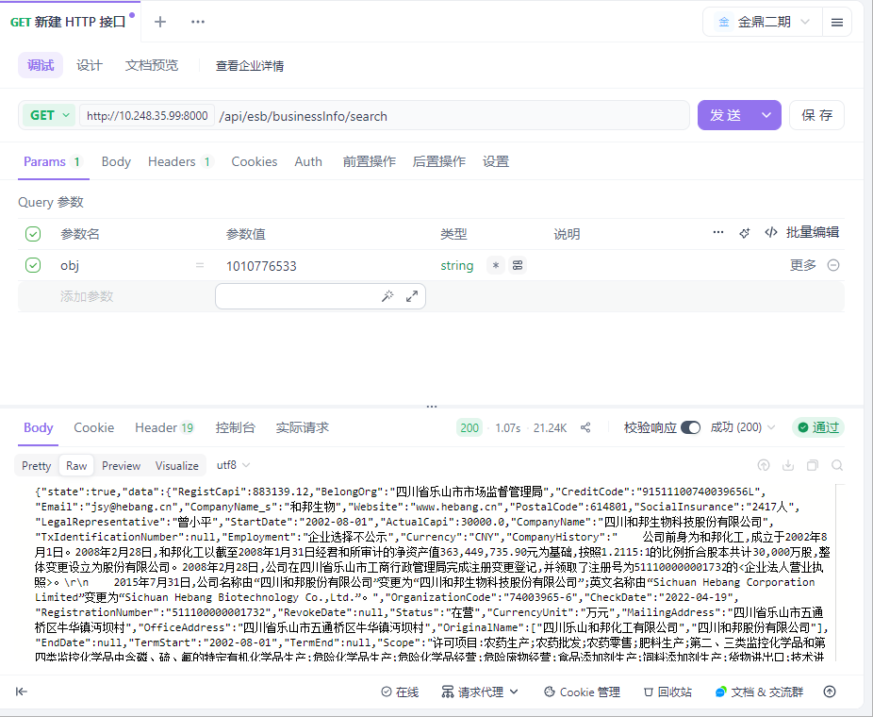

用例名称 | 企业大数据-基本信息-企业速览-新闻
用例编号 | 43388
接口地址 | /api/yjt/crdb_v2/news/newscontent
请求方式 | get
前置条件 | 数据查询功能正常
描述 | 正常查询数据信息成功
请求头部 | Content-Type：text/plain;charset=UTF-8
请求参数 | objs=1010776533&bdate=2015-11-21&edate=2025-11-21
状态码 | 200
预期返回结果 | {"state":true,"data":[{"SimilarityType":"否","NewsCode":784988003,"NewsLink":"http://sns.sseinfo.com/","NewsDate":"2025-11-14 16:42:00","RelatedOrg":[{"Mamiorg":"主机构","AlertImportanceABS":0,"QuotaCode":8749,"AlertImportance":"0","Itcode2":1010776533,"NpProperty":"非负","CompanyCode":80189718},{"Mamiorg":"主机构","AlertImportanceABS":0,"QuotaCode":8759,"AlertImportance":"0","Itcode2":1010776533,"NpProperty":"非负","CompanyCode":80189718}],"Title":"(上互动)和邦生物：Wonarah磷矿预计2026年开始开采和销售","NewsCode_Main":null,"CRNW0023_005":null,"Source":"上证e互动"},{"SimilarityType":"否","NewsCode":784986475,"NewsLink":"http://sns.sseinfo.com/","NewsDate":"2025-11-14 16:32:00","RelatedOrg":[{"Mamiorg":"主机构","AlertImportanceABS":0,"QuotaCode":8408,"AlertImportance":"0","Itcode2":1010776533,"NpProperty":"非负","CompanyCode":80189718},{"Mamiorg":"主机构","AlertImportanceABS":0,"QuotaCode":8759,"AlertImportance":"0","Itcode2":1010776533,"NpProperty":"非负","CompanyCode":80189718}],"Title":"(上互动)和邦生物：烟峰磷矿及刘家山磷矿设计产能公布, Wonarah磷矿预计2026年开始销售","NewsCode_Main":null,"CRNW0023_005":null,"Source":"上证e互动"},{"SimilarityType":"否","NewsCode":784986472,"NewsLink":"http://sns.sseinfo.com/","NewsDate":"2025-11-14 16:32:00","RelatedOrg":[{"Mamiorg":"主机构","AlertImportanceABS":0,"QuotaCode":8408,"AlertImportance":"0","Itcode2":1010776533,"NpProperty":"非负","CompanyCode":80189718},{"Mamiorg":"主机构","AlertImportanceABS":0,"QuotaCode":8759,"AlertImportance":"0","Itcode2":1010776533,"NpProperty":"非负","CompanyCode":80189718}],"Title":"(上互动)和邦生物：布尔津野马主营业务为硅石矿开采，设计产能96万吨/年","NewsCode_Main":null,"CRNW0023_005":null,"Source":"上证e互动"},{"SimilarityType":"否","NewsCode":784986465,"NewsLink":"http://sns.sseinfo.com/","NewsDate":"2025-11-14 16:32:00","RelatedOrg":[{"Mamiorg":"主机构","AlertImportanceABS":0,"QuotaCode":8759,"AlertImportance":"0","Itcode2":1010776533,"NpProperty":"非负","CompanyCode":80189718},{"Mamiorg":"主机构","AlertImportanceABS":0,"QuotaCode":8406,"AlertImportance":"0","Itcode2":1010776533,"NpProperty":"非负","CompanyCode":80189718}],"Title":"(上互动)和邦生物：公司未有投资建设2万吨/年六氟磷酸锂项目","NewsCode_Main":null,"CRNW0023_005":null,"Source":"上证e互动"},{"SimilarityType":"否","NewsCode":784986167,"NewsLink":"http://sns.sseinfo.com/","NewsDate":"2025-11-14 16:31:00","RelatedOrg":[{"Mamiorg":"主机构","AlertImportanceABS":0,"QuotaCode":8408,"AlertImportance":"0","Itcode2":1010776533,"NpProperty":"非负","CompanyCode":80189718},{"Mamiorg":"主机构","AlertImportanceABS":0,"QuotaCode":8749,"AlertImportance":"0","Itcode2":1010776533,"NpProperty":"非负","CompanyCode":80189718},{"Mamiorg":"主机构","AlertImportanceABS":0,"QuotaCode":8759,"AlertImportance":"0","Itcode2":1010776533,"NpProperty":"非负","CompanyCode":80189718}],"Title":"(上互动)和邦生物：公司已启动了Wonarah磷矿一期70万吨/年产能的建设规划","NewsCode_Main":null,"CRNW0023_005":null,"Source":"上证e互动"},{"SimilarityType":"否","NewsCode":782890522,"NewsLink":"http://sns.sseinfo.com/","NewsDate":"2025-11-07 17:00:00","RelatedOrg":[{"Mamiorg":"主机构","AlertImportanceABS":0,"QuotaCode":8747,"AlertImportance":"0","Itcode2":1010776533,"NpProperty":"非负","CompanyCode":80189718},{"Mamiorg":"主机构","AlertImportanceABS":0,"QuotaCode":8759,"AlertImportance":"0","Itcode2":1010776533,"NpProperty":"非负","CompanyCode":80189718}],"Title":"(上互动)和邦生物：布尔津硅石矿可用于晶硅制造","NewsCode_Main":null,"CRNW0023_005":null,"Source":"上证e互动"},{"SimilarityType":"否","NewsCode":782890528,"NewsLink":"http://sns.sseinfo.com/","NewsDate":"2025-11-07 17:00:00","RelatedOrg":[{"Mamiorg":"主机构","AlertImportanceABS":0,"QuotaCode":8747,"AlertImportance":"0","Itcode2":1010776533,"NpProperty":"非负","CompanyCode":80189718},{"Mamiorg":"主机构","AlertImportanceABS":0,"QuotaCode":8759,"AlertImportance":"0","Itcode2":1010776533,"NpProperty":"非负","CompanyCode":80189718}],"Title":"(上互动)和邦生物：公司为广安项目和印尼项目顺利推进进行了一系列的创新技术研发，创新工艺带来成本和资源的节约","NewsCode_Main":null,"CRNW0023_005":null,"Source":"上证e互动"},{"SimilarityType":"否","NewsCode":782890251,"NewsLink":"http://sns.sseinfo.com/","NewsDate":"2025-11-07 16:59:00","RelatedOrg":[{"Mamiorg":"主机构","AlertImportanceABS":0,"QuotaCode":8759,"AlertImportance":"0","Itcode2":1010776533,"NpProperty":"非负","CompanyCode":80189718},{"Mamiorg":"主机构","AlertImportanceABS":0,"QuotaCode":8408,"AlertImportance":"0","Itcode2":1010776533,"NpProperty":"非负","CompanyCode":80189718},{"Mamiorg":"主机构","AlertImportanceABS":0,"QuotaCode":8749,"AlertImportance":"0","Itcode2":1010776533,"NpProperty":"非负","CompanyCode":80189718}],"Title":"(上互动)和邦生物：公司对广安和印尼项目具有坚定的信心","NewsCode_Main":null,"CRNW0023_005":null,"Source":"上证e互动"},{"SimilarityType":"否","NewsCode":782890247,"NewsLink":"http://sns.sseinfo.com/","NewsDate":"2025-11-07 16:59:00","RelatedOrg":[{"Mamiorg":"主机构","AlertImportanceABS":0,"QuotaCode":8748,"AlertImportance":"0","Itcode2":1010776533,"NpProperty":"非负","CompanyCode":80189718},{"Mamiorg":"主机构","AlertImportanceABS":0,"QuotaCode":8759,"AlertImportance":"0","Itcode2":1010776533,"NpProperty":"非负","CompanyCode":80189718}],"Title":"(上互动)和邦生物：公司草甘膦产品采用IDA工艺，具有高纯度和良好质量竞争优势","NewsCode_Main":null,"CRNW0023_005":null,"Source":"上证e互动"},{"SimilarityType":"否","NewsCode":782890532,"NewsLink":"http://sns.sseinfo.com/","NewsDate":"2025-11-07 16:59:00","RelatedOrg":[{"Mamiorg":"主机构","AlertImportanceABS":0,"QuotaCode":8749,"AlertImportance":"0","Itcode2":1010776533,"NpProperty":"非负","CompanyCode":80189718},{"Mamiorg":"主机构","AlertImportanceABS":0,"QuotaCode":8759,"AlertImportance":"0","Itcode2":1010776533,"NpProperty":"非负","CompanyCode":80189718}],"Title":"(上互动)和邦生物：Jundee金矿项目进展请以公司公告为准","NewsCode_Main":null,"CRNW0023_005":null,"Source":"上证e互动"}],"traceId":"692014e4fe62224e3135aa5f"}
实际结果 | 与预期结果一致  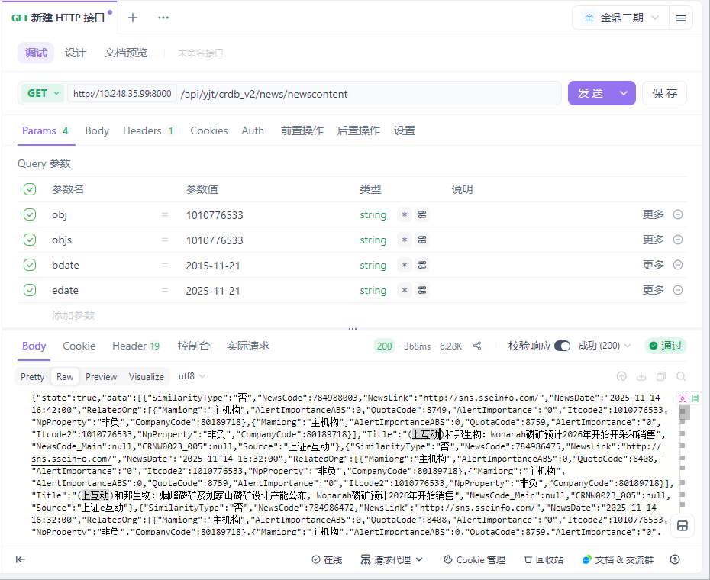

用例名称 | 企业大数据-基本信息-企业速览-高管
用例编号 | 43389
接口地址 | /api/yjt/crdb_v2/business_info/management
请求方式 | get
前置条件 | 数据查询功能正常
描述 | 正常查询数据信息成功
请求头部 | Content-Type：text/plain;charset=UTF-8
请求参数 | objs=1010776533
状态码 | 200
预期返回结果 | {"state":true,"data":[{"CompanyName":"四川和邦生物科技股份有限公司","position":"审计委员会委员","CompanyCode":1010776533,"Name":"宋英"},{"CompanyName":"四川和邦生物科技股份有限公司","position":"审计委员会主任","CompanyCode":1010776533,"Name":"宋英"},{"CompanyName":"四川和邦生物科技股份有限公司","position":"董事长","CompanyCode":1010776533,"Name":"曾小平"},{"CompanyName":"四川和邦生物科技股份有限公司","position":"非独立董事","CompanyCode":1010776533,"Name":"曾小平"},{"CompanyName":"四川和邦生物科技股份有限公司","position":"总经理","CompanyCode":1010776533,"Name":"曾小平"},{"CompanyName":"四川和邦生物科技股份有限公司","position":"战略委员会主任","CompanyCode":1010776533,"Name":"贺正刚"},{"CompanyName":"四川和邦生物科技股份有限公司","position":"战略委员会委员","CompanyCode":1010776533,"Name":"贺正刚"},{"CompanyName":"四川和邦生物科技股份有限公司","position":"战略委员会委员","CompanyCode":1010776533,"Name":"曾小平"},{"CompanyName":"四川和邦生物科技股份有限公司","position":"审计委员会委员","CompanyCode":1010776533,"Name":"胡杨"},{"CompanyName":"四川和邦生物科技股份有限公司","position":"非独立董事","CompanyCode":1010776533,"Name":"贺正刚"}],"traceId":"692015a8e908494d1111ff41"}
实际结果 | 与预期结果一致  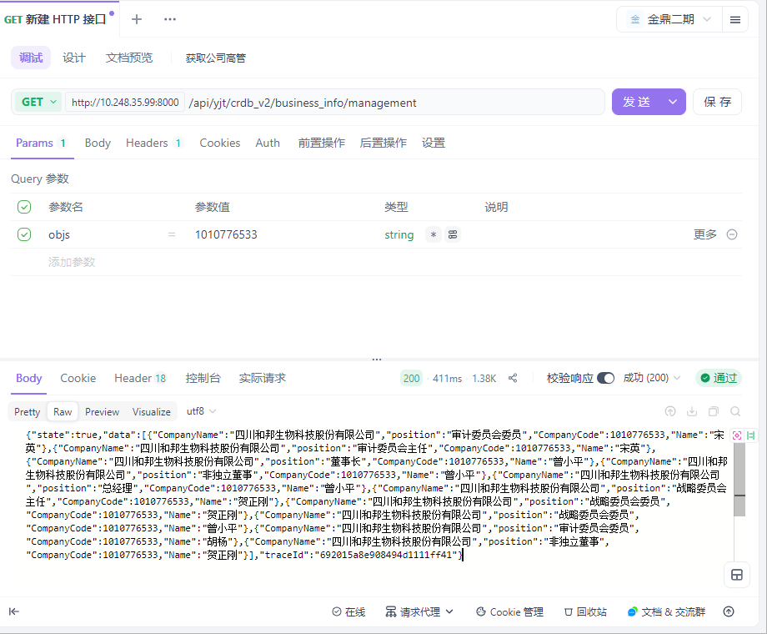

用例名称 | 企业大数据-基本信息-企业速览-主体评级
用例编号 | 43390
接口地址 | /api/yjt/crdb_v2/credit/mainrating
请求方式 | get
前置条件 | 数据查询功能正常
描述 | 正常查询数据信息成功
请求头部 | Content-Type：text/plain;charset=UTF-8
请求参数 | objs=1010776533
状态码 | 200
预期返回结果 | {"state":true,"data":[{"declaredate":"2025-09-24","rantingDate":"2025-09-23","entityCode":80189718,"entityName":"四川和邦生物科技股份有限公司","thisRaiting":"AA","raitingOutlook":"稳定","raitingOrgName":"中证鹏元资信评估股份有限公司","raitingOrgCode":80002099,"raitingType":"长期债务评级"},{"declaredate":"2025-07-29","rantingDate":"2025-07-28","entityCode":80189718,"entityName":"四川和邦生物科技股份有限公司","thisRaiting":"AA","raitingOutlook":"稳定","raitingOrgName":"中证鹏元资信评估股份有限公司","raitingOrgCode":80002099,"raitingType":"长期债务评级"},{"declaredate":"2025-02-05","rantingDate":"2025-01-26","entityCode":80189718,"entityName":"四川和邦生物科技股份有限公司","thisRaiting":"AA","raitingOutlook":"稳定","raitingOrgName":"中证鹏元资信评估股份有限公司","raitingOrgCode":80002099,"raitingType":"长期债务评级"},{"declaredate":"2024-10-24","rantingDate":"2024-06-28","entityCode":80189718,"entityName":"四川和邦生物科技股份有限公司","thisRaiting":"AA","raitingOutlook":"稳定","raitingOrgName":"中证鹏元资信评估股份有限公司","raitingOrgCode":80002099,"raitingType":"长期债务评级"},{"declaredate":"2019-05-25","rantingDate":"2019-05-23","entityCode":80189718,"entityName":"四川和邦生物科技股份有限公司","thisRaiting":"AA","raitingOutlook":"稳定","raitingOrgName":"中证鹏元资信评估股份有限公司","raitingOrgCode":80002099,"raitingType":"长期债务评级"},{"declaredate":"2018-03-13","rantingDate":"2018-03-09","entityCode":80189718,"entityName":"四川和邦生物科技股份有限公司","thisRaiting":"AA","raitingOutlook":"稳定","raitingOrgName":"中证鹏元资信评估股份有限公司","raitingOrgCode":80002099,"raitingType":"长期债务评级"},{"declaredate":"2017-05-27","rantingDate":"2017-05-22","entityCode":80189718,"entityName":"四川和邦生物科技股份有限公司","thisRaiting":"AA","raitingOutlook":"稳定","raitingOrgName":"中证鹏元资信评估股份有限公司","raitingOrgCode":80002099,"raitingType":"长期债务评级"},{"declaredate":"2016-05-30","rantingDate":"2016-05-23","entityCode":80189718,"entityName":"四川和邦生物科技股份有限公司","thisRaiting":"AA","raitingOutlook":"稳定","raitingOrgName":"中证鹏元资信评估股份有限公司","raitingOrgCode":80002099,"raitingType":"长期债务评级"},{"declaredate":"2015-04-20","rantingDate":"2015-04-16","entityCode":80189718,"entityName":"四川和邦生物科技股份有限公司","thisRaiting":"AA","raitingOutlook":"稳定","raitingOrgName":"中证鹏元资信评估股份有限公司","raitingOrgCode":80002099,"raitingType":"长期债务评级"},{"declaredate":"2014-11-21","rantingDate":"2014-06-27","entityCode":80189718,"entityName":"四川和邦生物科技股份有限公司","thisRaiting":"AA","raitingOutlook":"稳定","raitingOrgName":"中证鹏元资信评估股份有限公司","raitingOrgCode":80002099,"raitingType":"长期债务评级"}],"traceId":"692019e1fe62224e3135b196"}
实际结果 | 与预期结果一致  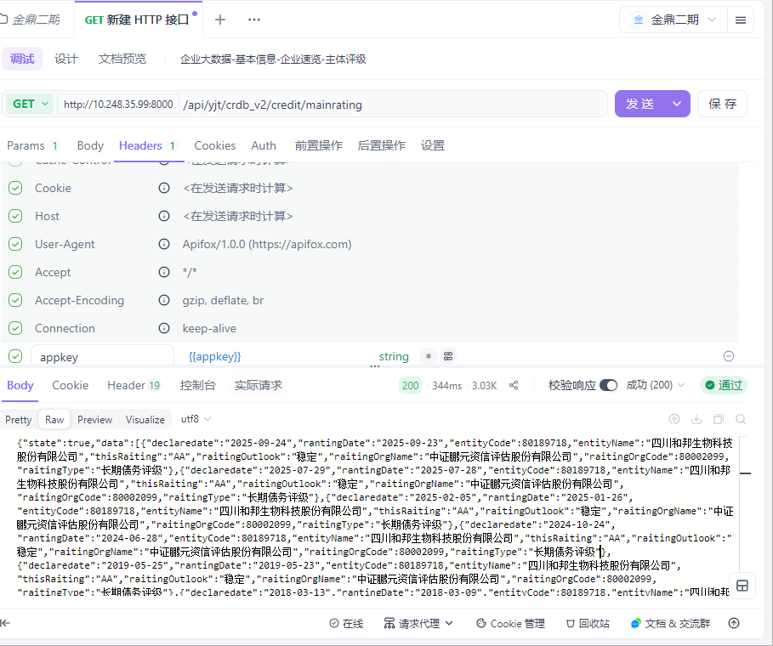

用例名称 | 企业大数据-企业详情-基本信息-工商信息
用例编号 | 43391
接口地址 | /api/yjt/crdb_v2/business_info/shareholder_info
请求方式 | get
前置条件 | 数据查询功能正常
描述 | 正常查询数据信息成功
请求头部 | Content-Type：text/plain;charset=UTF-8
请求参数 | objs=1010776533&from=0&size=20
状态码 | 200
预期返回结果 | {"state":true,"data":{"RegistCapi":883139.12,"BelongOrg":"四川省乐山市市场监督管理局","CreditCode":"91511100740039656L","Email":"jsy@hebang.cn","CompanyName_s":"和邦生物","Website":"www.hebang.cn","PostalCode":614801,"SocialInsurance":"2417人","LegalRepresentative":"曾小平","StartDate":"2002-08-01","ActualCapi":30000.0,"CompanyName":"四川和邦生物科技股份有限公司","TxIdentificationNumber":null,"Employment":"企业选择不公示","Currency":"CNY","CompanyHistory":" 公司前身为和邦化工,成立于2002年8月1日。2008年2月28日,和邦化工以截至2008年1月31日经君和所审计的净资产值363,449,735.90元为基础,按照1.2115:1的比例折合股本共计30,000万股,整体变更设立为股份有限公司。2008年2月28日,公司在四川省乐山市工商行政管理局完成注册变更登记,并领取了注册号为511100000001732的<企业法人营业执照>。\r\n 2015年7月31日,公司名称由“四川和邦股份有限公司”变更为“四川和邦生物科技股份有限公司”;英文名称由“Sichuan Hebang Corporation Limited”变更为“Sichuan Hebang Biotechnology Co.,Ltd.”。","OrganizationCode":"74003965-6","CheckDate":"2022-04-19","RegistrationNumber":"511100000001732","RevokeDate":null,"Status":"在营","CurrencyUnit":"万元","MailingAddress":"四川省乐山市五通桥区牛华镇沔坝村","OfficeAddress":"四川省乐山市五通桥区牛华镇沔坝村","OriginalName":["四川乐山和邦化工有限公司","四川和邦股份有限公司"],"EndDate":null,"TermStart":"2002-08-01","TermEnd":null,"Scope":"许可项目:农药生产;农药批发;农药零售;肥料生产;第二、三类监控化学品和第四类监控化学品中含磷、硫、氟的特定有机化学品生产;危险化学品生产;危险化学品经营;危险废物经营;食品添加剂生产;饲料添加剂生产;货物进出口;技术进出口;进出口代理(依法须经批准的项目,经相关部门批准后方可开展经营活动,具体经营项目以相关部门批准文件或许可证件为准)一般项目:食品添加剂销售、肥料销售;化肥销售;化工产品生产(不含许可类化工产品);化工产品销售(不含许可类化工产品);技术服务、技术开发、技术咨询、技术交流、技术转让、技术推广;固体废物治理;非食用盐销售;国内贸易代理(除依法须经批准的项目外,凭营业执照依法自主开展经营活动)。","RegisteredAddress":"四川省乐山市五通桥区牛华镇沔坝村","PhoneNumber":"028-62050230","CompanyCode":1010776533,"EnglishName":"SichuanHebang Biotechnology Co.,Ltd.","regionIndustryList":[{"IndustryCode":"C","SmallCategoryCode":"C2612","SubIndustry":"化学原料和化学制品制造业","City":"乐山市","MiddleCategoryCode":"C261","County":"五通桥区","Province":"四川省","Industry":"制造业","CompanyName":"四川和邦生物科技股份有限公司","SubIndustryCode":"C26","MiddleCategory":"基础化学原料制造","SmallCategory":"无机碱制造","AreaCode":"511112","CompanyCode":1010776533}],"changeList":[{"ContentAfter":"2025-05-26新章程","CompanyName":"四川和邦生物科技股份有限公司","ContentBefore":"","ChangeDate":"2025-06-27","ChangeItem":"章程备案","CompanyCode":1010776533},{"ContentAfter":"","CompanyName":"四川和邦生物科技股份有限公司","ContentBefore":"陈静 卢丹 龚嵘鹏","ChangeDate":"2025-06-27","ChangeItem":"高级管理人员备案","CompanyCode":1010776533},{"ContentAfter":"陈天 胡杨 贺正刚 曾小平 袁长华 宋英 秦学玲 李进 王军","CompanyName":"四川和邦生物科技股份有限公司","ContentBefore":"王军 袁长华 宋英 秦学玲 李进 曾小平 贺正刚 胡杨 陈天","ChangeDate":"2025-06-27","ChangeItem":"高级管理人员备案","CompanyCode":1010776533},{"ContentAfter":"漆科江 *** 备案手机：*** （网上办理）","CompanyName":"四川和邦生物科技股份有限公司","ContentBefore":"杨萍 *** 备案手机：***","ChangeDate":"2025-01-23","ChangeItem":"联络人备案","CompanyCode":1010776533},{"ContentAfter":"漆科江 *** 备案手机：*** （网上办理）","CompanyName":"四川和邦生物科技股份有限公司","ContentBefore":"漆科江 *** 备案手机：***","ChangeDate":"2025-01-23","ChangeItem":"联络人备案","CompanyCode":1010776533},{"ContentAfter":"2023-12-29修改章程第三条、第四十四条、第四十六条、第八十五条、第一百零一条、第一百零七条、第一百一十条、第一百一十一条、第一百一十三条、第一百一十四条、第一百一十五条、第一百一十六条、第一百一十七条、第一百一十八条、第一百二十六条、第一百三十九条、第一百四十九条、第一百七十条、第二百零九条","CompanyName":"四川和邦生物科技股份有限公司","ContentBefore":"无","ChangeDate":"2024-01-15","ChangeItem":"章程备案","CompanyCode":1010776533},{"ContentAfter":"卢丹 陈静 龚嵘鹏","CompanyName":"四川和邦生物科技股份有限公司","ContentBefore":"龚嵘鹏 卢丹 缪成云","ChangeDate":"2023-05-31","ChangeItem":"高级管理人员备案","CompanyCode":1010776533},{"ContentAfter":"许可项目:农药生产;农药批发;农药零售;肥料生产;第二、三类监控化学品和第四类监控化学品中含磷、硫、氟的特定有机化学品生产;危险化学品生产;危险化学品经营;危险废物经营;食品添加剂生产;饲料添加剂生产;货物进出口;技术进出口;进出口代理(依法须经批准的项目,经相关部门批准后方可开展经营活动,具体经营项目以相关部门批准文件或许可证件为准)一般项目:肥料销售;化肥销售;化工产品生产(不含许可类化工产品);化工产品销售(不含许可类化工产品);技术服务、技术开发、技术咨询、技术交流、技术转让、技术推广;固体废物治理;非食用盐销售;国内贸易代理;食品添加剂销售(除依法须经批准的项目外,凭营业执照依法自主开展经营活动)。","CompanyName":"四川和邦生物科技股份有限公司","ContentBefore":"许可项目:农药生产;农药批发;农药零售;肥料生产;第二、三类监控化学品和第四类监控化学品中含磷、硫、氟的特定有机化学品生产;危险化学品生产;危险化学品经营;危险废物经营;食品添加剂生产;饲料添加剂生产;货物进出口;技术进出口;进出口代理(依法须经批准的项目,经相关部门批准后方可开展经营活动,具体经营项目以相关部门批准文件或许可证件为准)一般项目:肥料销售;化肥销售;化工产品生产(不含许可类化工产品);化工产品销售(不含许可类化工产品);技术服务、技术开发、技术咨询、技术交流、技术转让、技术推广;固体废物治理;非食用盐销售;国内贸易代理(除依法须经批准的项目外,凭营业执照依法自主开展经营活动)。","ChangeDate":"2022-04-19","ChangeItem":"经营范围变更","CompanyCode":1010776533},{"ContentAfter":"2022-04-06新章程","CompanyName":"四川和邦生物科技股份有限公司","ContentBefore":"无","ChangeDate":"2022-04-19","ChangeItem":"章程备案","CompanyCode":1010776533},{"ContentAfter":"2021-04-16新章程","CompanyName":"四川和邦生物科技股份有限公司","ContentBefore":"无","ChangeDate":"2021-06-11","ChangeItem":"章程备案","CompanyCode":1010776533}],"shareholderInfoList":[{"ShareholdingRatio":"22.2400","CompanyName":"四川和邦生物科技股份有限公司","ContributionTime":null,"ShareholderType":"企业法人","ShareholderName":"四川和邦投资集团有限公司","Unit":"股","ContributionTpe":"实物","ShareholdeCode":1004133733,"CompanyCode":1010776533,"ShouldCapi":1963779103},{"ShareholdingRatio":"5.9400","CompanyName":"四川和邦生物科技股份有限公司","ContributionTime":null,"ShareholderType":"企业法人","ShareholderName":"四川省盐业集团有限责任公司","Unit":"股","ContributionTpe":null,"ShareholdeCode":1001643730,"CompanyCode":1010776533,"ShouldCapi":524359246},{"ShareholdingRatio":"4.6700","CompanyName":"四川和邦生物科技股份有限公司","ContributionTime":null,"ShareholderType":"自然人股东","ShareholderName":"贺正刚","Unit":"股","ContributionTpe":null,"ShareholdeCode":null,"CompanyCode":1010776533,"ShouldCapi":4.12632E8},{"ShareholdingRatio":"1.0500","CompanyName":"四川和邦生物科技股份有限公司","ContributionTime":null,"ShareholderType":"证券投资基金","ShareholderName":"华泰证券股份有限公司-鹏华中证细分化工产业主题交易型开放式指数证券投资基金","Unit":"股","ContributionTpe":null,"ShareholdeCode":null,"CompanyCode":1010776533,"ShouldCapi":92787762},{"ShareholdingRatio":"1.0200","CompanyName":"四川和邦生物科技股份有限公司","ContributionTime":null,"ShareholderType":"证券投资基金","ShareholderName":"中国农业银行股份有限公司-中证500交易型开放式指数证券投资基金","Unit":"股","ContributionTpe":null,"ShareholdeCode":null,"CompanyCode":1010776533,"ShouldCapi":90089916},{"ShareholdingRatio":"1.0100","CompanyName":"四川和邦生物科技股份有限公司","ContributionTime":null,"ShareholderType":"企业法人","ShareholderName":"香港中央结算有限公司","Unit":"股","ContributionTpe":null,"ShareholdeCode":1012809068,"CompanyCode":1010776533,"ShouldCapi":89282624},{"ShareholdingRatio":"0.7700","CompanyName":"四川和邦生物科技股份有限公司","ContributionTime":null,"ShareholderType":"自然人股东","ShareholderName":"高序磊","Unit":"股","ContributionTpe":null,"ShareholdeCode":null,"CompanyCode":1010776533,"ShouldCapi":67730096},{"ShareholdingRatio":"0.4400","CompanyName":"四川和邦生物科技股份有限公司","ContributionTime":null,"ShareholderType":"自然人股东","ShareholderName":"赵勇","Unit":"股","ContributionTpe":null,"ShareholdeCode":null,"CompanyCode":1010776533,"ShouldCapi":39035034},{"ShareholdingRatio":"0.3700","CompanyName":"四川和邦生物科技股份有限公司","ContributionTime":null,"ShareholderType":"证券投资基金","ShareholderName":"中国民生银行股份有限公司-光大保德信信用添益债券型证券投资基金","Unit":"股","ContributionTpe":null,"ShareholdeCode":null,"CompanyCode":1010776533,"ShouldCapi":3.30096E7},{"ShareholdingRatio":"0.2800","CompanyName":"四川和邦生物科技股份有限公司","ContributionTime":null,"ShareholderType":"证券投资基金","ShareholderName":"招商银行股份有限公司-中欧红利优享灵活配置混合型证券投资基金","Unit":"股","ContributionTpe":null,"ShareholdeCode":null,"CompanyCode":1010776533,"ShouldCapi":24599917}],"subsidiaryList":[{"Investee":"四川和邦盐矿有限公司","CompanyName":"四川和邦生物科技股份有限公司","ContributionTime":"2010-10-26","InvesteeCode":"1008989495","Unit":"万元","ShareholdeCode":"100.0000","ContributionTpe":"货币","CompanyCode":1010776533,"ShouldCapi":6000.0},{"Investee":"四川和邦新材料有限公司","CompanyName":"四川和邦生物科技股份有限公司","ContributionTime":"2030-03-09","InvesteeCode":"1011828593","Unit":"万元","ShareholdeCode":"100.0000","ContributionTpe":"货币","CompanyCode":1010776533,"ShouldCapi":30000.0},{"Investee":"四川和邦磷矿有限公司","CompanyName":"四川和邦生物科技股份有限公司","ContributionTime":"2012-09-05","InvesteeCode":"1010429057","Unit":"万元","ShareholdeCode":"100.0000","ContributionTpe":"货币","CompanyCode":1010776533,"ShouldCapi":28600.0},{"Investee":"四川和邦电子商务有限公司","CompanyName":"四川和邦生物科技股份有限公司","ContributionTime":null,"InvesteeCode":"1006043634","Unit":"万元","ShareholdeCode":"100.0000","ContributionTpe":null,"CompanyCode":1010776533,"ShouldCapi":20000.0},{"Investee":"乐山和邦新材料科技有限公司","CompanyName":"四川和邦生物科技股份有限公司","ContributionTime":"2020-05-31","InvesteeCode":"1011490445","Unit":"万元","ShareholdeCode":"100.0000","ContributionTpe":"货币","CompanyCode":1010776533,"ShouldCapi":50000.0},{"Investee":"四川武骏光能股份有限公司","CompanyName":"四川和邦生物科技股份有限公司","ContributionTime":"2010-07-20","InvesteeCode":"1010699173","Unit":"万元","ShareholdeCode":"88.3763","ContributionTpe":"货币","CompanyCode":1010776533,"ShouldCapi":40000.0},{"Investee":"四川和邦生物视高有限公司","CompanyName":"四川和邦生物科技股份有限公司","ContributionTime":"2030-03-09","InvesteeCode":"1012354062","Unit":"万元","ShareholdeCode":"100.0000","ContributionTpe":"货币","CompanyCode":1010776533,"ShouldCapi":10000.0},{"Investee":"乐山和邦农业科技有限公司","CompanyName":"四川和邦生物科技股份有限公司","ContributionTime":"2015-06-04","InvesteeCode":"1011887874","Unit":"万元","ShareholdeCode":"100.0000","ContributionTpe":"货币","CompanyCode":1010776533,"ShouldCapi":49200.0},{"Investee":"乐山涌江实业有限公司","CompanyName":"四川和邦生物科技股份有限公司","ContributionTime":"2016-10-27","InvesteeCode":"1076870574","Unit":"万元","ShareholdeCode":"100.0000","ContributionTpe":"货币","CompanyCode":1010776533,"ShouldCapi":16010.0},{"Investee":"四川合江和邦化学有限公司","CompanyName":"四川和邦生物科技股份有限公司","ContributionTime":null,"InvesteeCode":"1008618021","Unit":"万元","ShareholdeCode":"100.0000","ContributionTpe":null,"CompanyCode":1010776533,"ShouldCapi":2000.0}],"managementList":[{"CompanyName":"四川和邦生物科技股份有限公司","position":"审计委员会委员","CompanyCode":1010776533,"Name":"宋英"},{"CompanyName":"四川和邦生物科技股份有限公司","position":"审计委员会主任","CompanyCode":1010776533,"Name":"宋英"},{"CompanyName":"四川和邦生物科技股份有限公司","position":"董事长","CompanyCode":1010776533,"Name":"曾小平"},{"CompanyName":"四川和邦生物科技股份有限公司","position":"非独立董事","CompanyCode":1010776533,"Name":"曾小平"},{"CompanyName":"四川和邦生物科技股份有限公司","position":"总经理","CompanyCode":1010776533,"Name":"曾小平"},{"CompanyName":"四川和邦生物科技股份有限公司","position":"战略委员会主任","CompanyCode":1010776533,"Name":"贺正刚"},{"CompanyName":"四川和邦生物科技股份有限公司","position":"战略委员会委员","CompanyCode":1010776533,"Name":"贺正刚"},{"CompanyName":"四川和邦生物科技股份有限公司","position":"战略委员会委员","CompanyCode":1010776533,"Name":"曾小平"},{"CompanyName":"四川和邦生物科技股份有限公司","position":"审计委员会委员","CompanyCode":1010776533,"Name":"胡杨"},{"CompanyName":"四川和邦生物科技股份有限公司","position":"非独立董事","CompanyCode":1010776533,"Name":"贺正刚"}],"branchList":[{"CompanyName":"四川和邦生物科技股份有限公司","Relationship":"企业总分关系","BranchName":"四川和邦生物科技股份有限公司上海分公司","BranchCode":"1147588329","CompanyCode":1010776533},{"CompanyName":"四川和邦生物科技股份有限公司","Relationship":"企业总分关系","BranchName":"四川和邦生物科技股份有限公司成都分公司","BranchCode":"1137186528","CompanyCode":1010776533},{"CompanyName":"四川和邦生物科技股份有限公司","Relationship":"企业总分关系","BranchName":"四川和邦生物科技股份有限公司营养剂分公司","BranchCode":"1001482997","CompanyCode":1010776533}],"enterpriseNatureList":[{"id":"102128777","itcode":"80189718","itcode2":"1010776533","companyName":"四川和邦生物科技股份有限公司","companyTypecode":9,"companyType":"私人相对控股","orgTypeCode":4,"organType":"股份有限公司","updateTime":"2023-08-04T13:05:27.330Z","natureCode":570,"natureName":"私有企业(民营企业)"}],"suspectedList":[{"RegistCapi":500.0,"Status":"在营","CurrencyUnit":"万元","RelatedpartyCode":"1059323642","LegalRepresentative":"杨红武","CommonPhoneNumber":null,"CommonEmail":null,"StartDate":"2018-12-20","CompanyName":"四川和邦生物科技股份有限公司","CommonRegisteredAddress":"四川省乐山市五通桥区牛华镇沔坝村","RelatedpartyName":"乐山时代房地产开发有限公司","Relationshiptype":"共同注册地","CompanyCode":"1010776533"},{"RegistCapi":500.0,"Status":"在营","CurrencyUnit":"万元","RelatedpartyCode":"1059293366","LegalRepresentative":"杨红武","CommonPhoneNumber":null,"CommonEmail":null,"StartDate":"2018-12-19","CompanyName":"四川和邦生物科技股份有限公司","CommonRegisteredAddress":"四川省乐山市五通桥区牛华镇沔坝村","RelatedpartyName":"乐山弘元房地产开发有限公司","Relationshiptype":"共同注册地","CompanyCode":"1010776533"},{"RegistCapi":500.0,"Status":"在营","CurrencyUnit":"万元","RelatedpartyCode":"1059323634","LegalRepresentative":"杨红武","CommonPhoneNumber":null,"CommonEmail":null,"StartDate":"2018-12-19","CompanyName":"四川和邦生物科技股份有限公司","CommonRegisteredAddress":"四川省乐山市五通桥区牛华镇沔坝村","RelatedpartyName":"乐山和裕房地产开发有限公司","Relationshiptype":"共同注册地","CompanyCode":"1010776533"},{"RegistCapi":1000.0,"Status":"注销","CurrencyUnit":"万元","RelatedpartyCode":"1012125986","LegalRepresentative":"杨爱平","CommonPhoneNumber":null,"CommonEmail":null,"StartDate":"2014-01-15","CompanyName":"四川和邦生物科技股份有限公司","CommonRegisteredAddress":"四川省乐山市五通桥区牛华镇沔坝村","RelatedpartyName":"乐山和邦设备有限公司","Relationshiptype":"共同注册地","CompanyCode":"1010776533"},{"RegistCapi":0.0,"Status":"在营","CurrencyUnit":"万元","RelatedpartyCode":"1085378802","LegalRepresentative":"王晶","CommonPhoneNumber":null,"CommonEmail":null,"StartDate":"2010-05-28","CompanyName":"四川和邦生物科技股份有限公司","CommonRegisteredAddress":"四川省乐山市五通桥区牛华镇沔坝村","RelatedpartyName":"中国石化销售股份有限公司四川乐山石油分公司乐天加油站","Relationshiptype":"共同注册地","CompanyCode":"1010776533"},{"RegistCapi":0.0,"Status":"在营","CurrencyUnit":"万元","RelatedpartyCode":"1085361984","LegalRepresentative":"王晶","CommonPhoneNumber":null,"CommonEmail":null,"StartDate":"2004-09-24","CompanyName":"四川和邦生物科技股份有限公司","CommonRegisteredAddress":"四川省乐山市五通桥区牛华镇沔坝村","RelatedpartyName":"中国石化销售股份有限公司四川乐山石油分公司昭乐加油站","Relationshiptype":"共同注册地","CompanyCode":"1010776533"},{"RegistCapi":"","Status":"注销","CurrencyUnit":null,"RelatedpartyCode":"1030360603","LegalRepresentative":"古全胜","CommonPhoneNumber":null,"CommonEmail":null,"StartDate":"2000-11-09","CompanyName":"四川和邦生物科技股份有限公司","CommonRegisteredAddress":"四川省乐山市五通桥区牛华镇沔坝村","RelatedpartyName":"乐山市五通桥牛华镇沔坝屠宰点","Relationshiptype":"共同注册地","CompanyCode":"1010776533"},{"RegistCapi":225.0,"Status":"注销","CurrencyUnit":"万美元","RelatedpartyCode":"1027805502","LegalRepresentative":"吴绍林","CommonPhoneNumber":null,"CommonEmail":null,"StartDate":"1995-05-05","CompanyName":"四川和邦生物科技股份有限公司","CommonRegisteredAddress":"四川省乐山市五通桥区牛华镇沔坝村","RelatedpartyName":"乐山凌云陶瓷有限公司","Relationshiptype":"共同注册地","CompanyCode":"1010776533"}],"companyScaleList":[{"CompanyName":"四川和邦生物科技股份有限公司","CR0102_002":"大型企业","CR0102_001":"1","CompanyCode":1010776533}],"actualControlList":[{"id":161252583,"itcode":"80189718","itcode2":"1010776533","companyName":"四川和邦生物科技股份有限公司","investorName":"贺正刚","investorcode":"30176716","investorcode2":null,"influenceRatio":26.91,"influenceType":31}],"controllerInfoList":[{"companyCode":"1010776533","companyName":"四川和邦生物科技股份有限公司","creditCode":"91511100740039656L","suspectControllerCode1":null,"suspectControllerName1":null,"suspectControllerTotalWeight1":null,"influenceRatio1":null,"suspectControllerPathCount1":null,"suspectControllerPathMaxDepth1":null,"suspectControllerPathMinDepth1":null,"suspectControllerPath1":[],"suspectControllerCode2":"P001431703","suspectControllerName2":"贺正刚","suspectControllerTotalWeight2":26.6876,"influenceRatio2":22.24,"suspectControllerPathCount2":2,"suspectControllerPathMaxDepth2":2,"suspectControllerPathMinDepth2":1,"suspectControllerPath2":[{"path_1":[{"sourceName":"贺正刚","sourceCode":"P001431703","weight":4.67,"targetName":"四川和邦生物科技股份有限公司","targetCode":"1010776533"}]},{"path_2":[{"sourceName":"贺正刚","sourceCode":"P001431703","weight":99,"targetName":"四川和邦投资集团有限公司","targetCode":"1004133733"},{"sourceName":"四川和邦投资集团有限公司","sourceCode":"1004133733","weight":22.24,"targetName":"四川和邦生物科技股份有限公司","targetCode":"1010776533"}]}],"discloseControllerCode":"P001431703","discloseControllerName":"贺正刚","discloseControllerPath":"贺正刚--->4.67%四川和邦生物科技股份有限公司\n贺正刚--->99%四川和邦投资集团有限公司--->22.24%四川和邦生物科技股份有限公司"}],"controlledCompanyInfoList":[]},"traceId":"69201a61e908494d11120773"}
实际结果 | 与预期结果一致  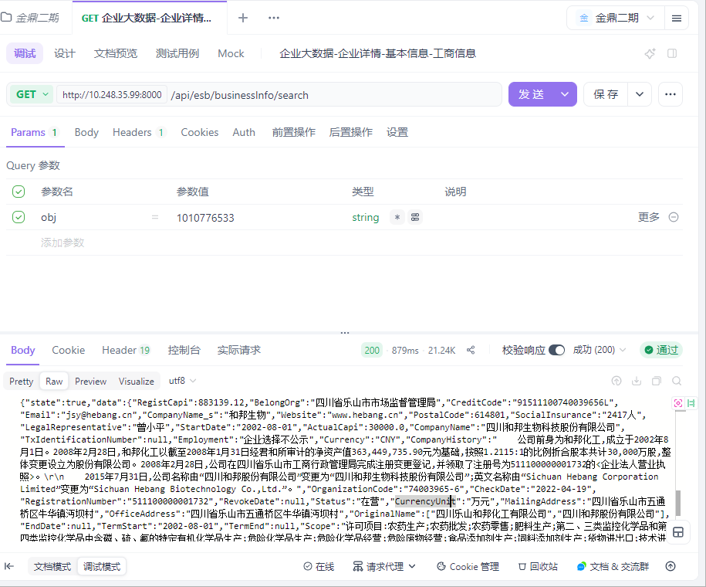

用例名称 | 企业大数据-企业详情-基本信息-工商变更
用例编号 | 43392
接口地址 | /api/yjt/crdb_v2/business_info/change
请求方式 | get
前置条件 | 数据查询功能正常
描述 | 正常查询数据信息成功
请求头部 | Content-Type：text/plain;charset=UTF-8
请求参数 | objs=1010776533&from=0&size=20
状态码 | 200
预期返回结果 | {"state":true,"data":[{"ContentAfter":"曾小平 王军 贺正刚 李正先 梅淑先 莫融 王锡岭 宋克利 杨红武","CompanyName":"四川和邦生物科技股份有限公司","ContentBefore":"李正先 曾小平 莫融 张丽华 刘滔 贺正刚 王锡岭 宋克利 王军","ChangeDate":"2017-06-28","ChangeItem":"高级管理人员备案","CompanyCode":1010776533},{"ContentAfter":"注册资本(金):401420.4649万元","CompanyName":"四川和邦生物科技股份有限公司","ContentBefore":"注册资本(金):331223.8578万元","ChangeDate":"2016-11-28","ChangeItem":"注册资本变更","CompanyCode":1010776533},{"ContentAfter":"姓名:曾小平,职务:副董事长,证件号码:***","CompanyName":"四川和邦生物科技股份有限公司","ContentBefore":"姓名:王亚西,职务:董事,证件号码:****3","ChangeDate":"2016-06-30","ChangeItem":"其他变更","CompanyCode":1010776533},{"ContentAfter":"姓名:李景林,职务:监事,证件号码:***","CompanyName":"四川和邦生物科技股份有限公司","ContentBefore":"姓名:刘安平,职务:监事,证件号码:***","ChangeDate":"2016-06-30","ChangeItem":"其他变更","CompanyCode":1010776533},{"ContentAfter":"姓名:王军;证件类型:中华人民共和国居民身份证;证件号码:***;移动电话:***;联系电话:3207820;电子邮件:wj@hebang.cn;","CompanyName":"四川和邦生物科技股份有限公司","ContentBefore":"姓名:王军;证件类型:中华人民共和国居民身份证;证件号码:***;移动电话:;联系电话:3207820;电子邮件:8539903722@QQ.COM;","ChangeDate":"2016-06-30","ChangeItem":"财务负责人备案","CompanyCode":1010776533},{"ContentAfter":"姓名:王军;证件类型:中华人民共和国居民身份证;证件号码:***;移动电话:;移动电话:3207820;电子邮件:8539903722@QQ.COM;","CompanyName":"四川和邦生物科技股份有限公司","ContentBefore":"姓名:;证件类型:;证件号码:;移动电话:;移动电话:;电子邮件:;","ChangeDate":"2015-10-13","ChangeItem":"财务负责人备案","CompanyCode":1010776533},{"ContentAfter":"经营范围及方式:经营范围:制造、销售草甘膦、蛋氨酸、农药、工业碳酸钠、食用碳酸钠、氯化铵、化肥(农用氯化铵)、液氨、碳酸钙;化工新产品开发;生产工艺中的废气、废渣、废水治理;对外投资;化工技术咨询;自营和代理各类商品和技术的进出口(国家限定或禁止公司经营的商品和技术除外)。※","CompanyName":"四川和邦生物科技股份有限公司","ContentBefore":"经营范围及方式:经营范围:制造、销售草甘膦、纯碱、氯化铵(化肥)、液氨、碳酸钙;化工新产品开发;生产工艺中的废气、废渣、废水治理;对外投资;化工技术咨询。※","ChangeDate":"2015-10-13","ChangeItem":"经营范围变更","CompanyCode":1010776533},{"ContentAfter":"一般经营项目:制造、销售草甘膦、蛋氨酸、农药、工业碳酸钠、食用碳酸钠、氯化铵、化肥(农用氯化铵)、液氨、碳酸钙;化工新产品开发;生产工艺中的废气、废渣、废水治理;对外投资;化工技术咨询;自营和代理各类商品和技术的进出口(国家限定或禁止公司经营的商品和技术除外)。※","CompanyName":"四川和邦生物科技股份有限公司","ContentBefore":"一般经营项目:制造、销售草甘膦、纯碱、氯化铵(化肥)、液氨、碳酸钙;化工新产品开发;生产工艺中的废气、废渣、废水治理;对外投资;化工技术咨询。※","ChangeDate":"2015-10-13","ChangeItem":"其他变更","CompanyCode":1010776533},{"ContentAfter":"姓名:杨萍;证件类型:中华人民共和国居民身份证;证件号码:***;联络人住所:;联络人联系电话:***;联络人移动电话:***;联络人电子邮件:341334708@QQ.COM;邮政编码:;","CompanyName":"四川和邦生物科技股份有限公司","ContentBefore":"姓名:杨萍;证件类型:;证件号码:***;联络人住所:;联络人联系电话:***;联络人移动电话:***;联络人电子邮件:;邮政编码:;","ChangeDate":"2015-10-13","ChangeItem":"联络人备案","CompanyCode":1010776533},{"ContentAfter":"注册资本(金):331223.8578万元","CompanyName":"四川和邦生物科技股份有限公司","ContentBefore":"注册资本(金):110407.9526万元","ChangeDate":"2015-09-14","ChangeItem":"注册资本变更","CompanyCode":1010776533},{"ContentAfter":"企业(机构)名称:四川和邦生物科技股份有限公司","CompanyName":"四川和邦生物科技股份有限公司","ContentBefore":"企业(机构)名称:四川和邦股份有限公司","ChangeDate":"2015-07-31","ChangeItem":"企业名称变更","CompanyCode":1010776533},{"ContentAfter":"注册资本(金):110407.9526万元","CompanyName":"四川和邦生物科技股份有限公司","ContentBefore":"注册资本(金):101109.485万元","ChangeDate":"2015-06-09","ChangeItem":"注册资本变更","CompanyCode":1010776533},{"ContentAfter":"经营范围及方式:制造、销售草甘膦、农药乳化剂、纯碱、氯化铵(化肥)、液氨、碳酸钙;化工新产品开发;生产工艺中的废气、废渣、废水治理;对外投资;化工技术咨询。※","CompanyName":"四川和邦生物科技股份有限公司","ContentBefore":"经营范围及方式:制造、销售纯碱、氯化铵(化肥)、液氨、碳酸钙;化工新产品开发;生产工艺中的废气、废渣、废水治理;对外投资;化工技术咨询。※","ChangeDate":"2014-09-09","ChangeItem":"经营范围变更","CompanyCode":1010776533},{"ContentAfter":"注册资本(金):101109.485","CompanyName":"四川和邦生物科技股份有限公司","ContentBefore":"注册资本(金):50554.7425","ChangeDate":"2014-09-09","ChangeItem":"注册资本变更","CompanyCode":1010776533},{"ContentAfter":"姓名:刘安平,职务:监事,证件号码:***","CompanyName":"四川和邦生物科技股份有限公司","ContentBefore":"姓名:杨爱平,职务:监事,证件号码:***","ChangeDate":"2014-09-09","ChangeItem":"其他变更","CompanyCode":1010776533},{"ContentAfter":"一般经营项目:制造、销售草甘膦、农药乳化剂、纯碱、氯化铵(化肥)、液氨、碳酸钙;化工新产品开发;生产工艺中的废气、废渣、废水治理;对外投资;化工技术咨询。※","CompanyName":"四川和邦生物科技股份有限公司","ContentBefore":"一般经营项目:制造、销售纯碱、氯化铵(化肥)、液氨、碳酸钙;化工新产品开发;生产工艺中的废气、废渣、废水治理;对外投资;化工技术咨询。※","ChangeDate":"2014-09-09","ChangeItem":"其他变更","CompanyCode":1010776533},{"ContentAfter":"实收资本:50554.7425","CompanyName":"四川和邦生物科技股份有限公司","ContentBefore":"实收资本:45000","ChangeDate":"2014-04-29","ChangeItem":"实收资本备案","CompanyCode":1010776533},{"ContentAfter":"企业(机构)类型:其他股份有限公司(上市)","CompanyName":"四川和邦生物科技股份有限公司","ContentBefore":"企业(机构)类型:有限责任公司(自然人投资或控股)","ChangeDate":"2014-04-29","ChangeItem":"企业类型变更","CompanyCode":1010776533},{"ContentAfter":"投资方名称:张丽华;出资日期:2002-08-11","CompanyName":"四川和邦生物科技股份有限公司","ContentBefore":"投资方名称:张丽华;出资日期:2010-12-15","ChangeDate":"2012-09-05","ChangeItem":"股东（发起人）名称变更","CompanyCode":1010776533},{"ContentAfter":"注册资本(金):45000","CompanyName":"四川和邦生物科技股份有限公司","ContentBefore":"注册资本(金):35000","ChangeDate":"2012-09-05","ChangeItem":"注册资本变更","CompanyCode":1010776533}],"traceId":"69201b3fe908494d111208e3"}
实际结果 | 与预期结果一致  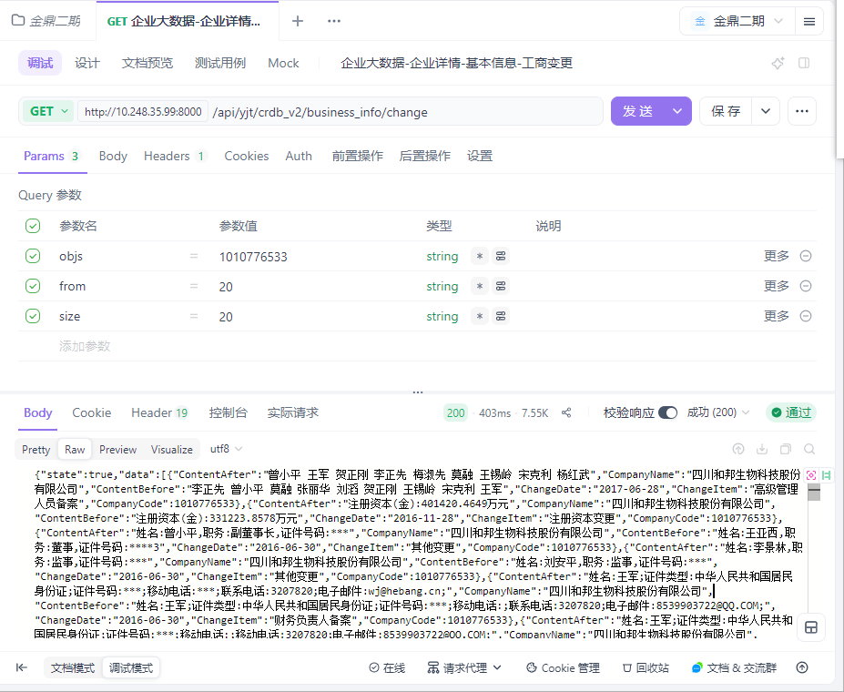

用例名称 | 企业大数据-企业详情-基本信息-高管信息
用例编号 | 43393
接口地址 | /api/yjt/crdb_v2/business_info/management
请求方式 | get
前置条件 | 数据查询功能正常
描述 | 正常查询数据信息成功
请求头部 | Content-Type：text/plain;charset=UTF-8
请求参数 | objs=1010776533
状态码 | 200
预期返回结果 | {"state":true,"data":[{"CompanyName":"四川和邦生物科技股份有限公司","position":"审计委员会委员","CompanyCode":1010776533,"Name":"宋英"},{"CompanyName":"四川和邦生物科技股份有限公司","position":"审计委员会主任","CompanyCode":1010776533,"Name":"宋英"},{"CompanyName":"四川和邦生物科技股份有限公司","position":"董事长","CompanyCode":1010776533,"Name":"曾小平"},{"CompanyName":"四川和邦生物科技股份有限公司","position":"非独立董事","CompanyCode":1010776533,"Name":"曾小平"},{"CompanyName":"四川和邦生物科技股份有限公司","position":"总经理","CompanyCode":1010776533,"Name":"曾小平"},{"CompanyName":"四川和邦生物科技股份有限公司","position":"战略委员会主任","CompanyCode":1010776533,"Name":"贺正刚"},{"CompanyName":"四川和邦生物科技股份有限公司","position":"战略委员会委员","CompanyCode":1010776533,"Name":"贺正刚"},{"CompanyName":"四川和邦生物科技股份有限公司","position":"战略委员会委员","CompanyCode":1010776533,"Name":"曾小平"},{"CompanyName":"四川和邦生物科技股份有限公司","position":"审计委员会委员","CompanyCode":1010776533,"Name":"胡杨"},{"CompanyName":"四川和邦生物科技股份有限公司","position":"非独立董事","CompanyCode":1010776533,"Name":"贺正刚"}],"traceId":"69201d9cfe62224e3135b855"}
实际结果 | 与预期结果一致  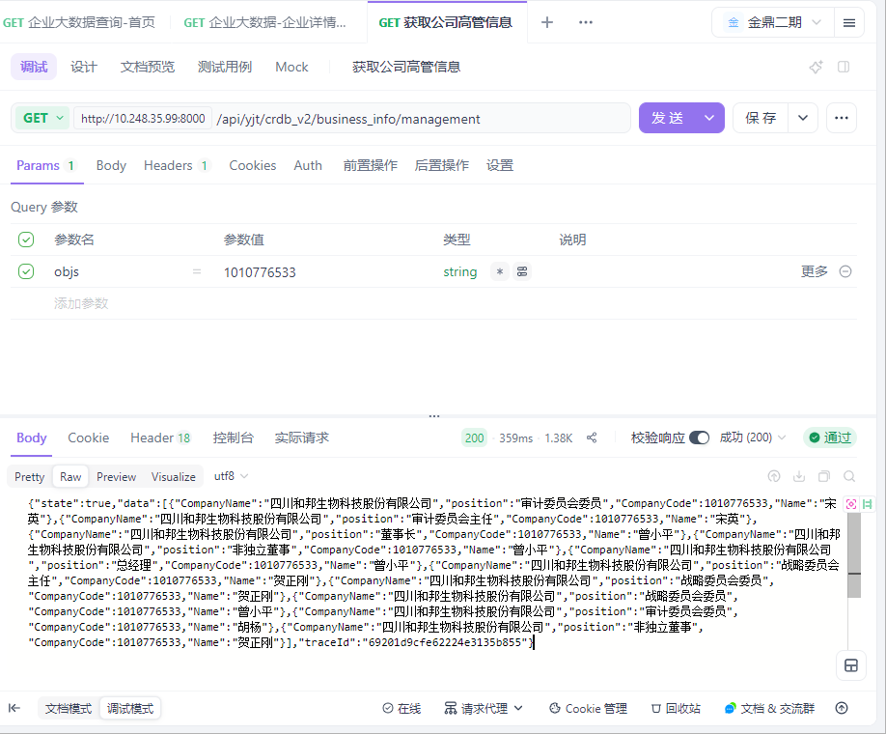

用例名称 | 企业大数据-企业详情-基本信息-股东信息
用例编号 | 43394
接口地址 | /api/yjt/crdb_v2/business_info/management
请求方式 | get
前置条件 | 数据查询功能正常
描述 | 正常查询数据信息成功
请求头部 | Content-Type：text/plain;charset=UTF-8
请求参数 | objs=1010776533&from=0&size=20
状态码 | 200
预期返回结果 | {"state":true,"data":[{"ShareholdingRatio":"22.2400","CompanyName":"四川和邦生物科技股份有限公司","ContributionTime":null,"ShareholderType":"企业法人","ShareholderName":"四川和邦投资集团有限公司","Unit":"股","ContributionTpe":"实物","ShareholdeCode":1004133733,"CompanyCode":1010776533,"ShouldCapi":1.963779103E9},{"ShareholdingRatio":"5.9400","CompanyName":"四川和邦生物科技股份有限公司","ContributionTime":null,"ShareholderType":"企业法人","ShareholderName":"四川省盐业集团有限责任公司","Unit":"股","ContributionTpe":null,"ShareholdeCode":1001643730,"CompanyCode":1010776533,"ShouldCapi":5.24359246E8},{"ShareholdingRatio":"4.6700","CompanyName":"四川和邦生物科技股份有限公司","ContributionTime":null,"ShareholderType":"自然人股东","ShareholderName":"贺正刚","Unit":"股","ContributionTpe":null,"ShareholdeCode":null,"CompanyCode":1010776533,"ShouldCapi":4.12632E8},{"ShareholdingRatio":"1.0500","CompanyName":"四川和邦生物科技股份有限公司","ContributionTime":null,"ShareholderType":"证券投资基金","ShareholderName":"华泰证券股份有限公司-鹏华中证细分化工产业主题交易型开放式指数证券投资基金","Unit":"股","ContributionTpe":null,"ShareholdeCode":null,"CompanyCode":1010776533,"ShouldCapi":9.2787762E7},{"ShareholdingRatio":"1.0200","CompanyName":"四川和邦生物科技股份有限公司","ContributionTime":null,"ShareholderType":"证券投资基金","ShareholderName":"中国农业银行股份有限公司-中证500交易型开放式指数证券投资基金","Unit":"股","ContributionTpe":null,"ShareholdeCode":null,"CompanyCode":1010776533,"ShouldCapi":9.0089916E7},{"ShareholdingRatio":"1.0100","CompanyName":"四川和邦生物科技股份有限公司","ContributionTime":null,"ShareholderType":"企业法人","ShareholderName":"香港中央结算有限公司","Unit":"股","ContributionTpe":null,"ShareholdeCode":1012809068,"CompanyCode":1010776533,"ShouldCapi":8.9282624E7},{"ShareholdingRatio":"0.7700","CompanyName":"四川和邦生物科技股份有限公司","ContributionTime":null,"ShareholderType":"自然人股东","ShareholderName":"高序磊","Unit":"股","ContributionTpe":null,"ShareholdeCode":null,"CompanyCode":1010776533,"ShouldCapi":6.7730096E7},{"ShareholdingRatio":"0.4400","CompanyName":"四川和邦生物科技股份有限公司","ContributionTime":null,"ShareholderType":"自然人股东","ShareholderName":"赵勇","Unit":"股","ContributionTpe":null,"ShareholdeCode":null,"CompanyCode":1010776533,"ShouldCapi":3.9035034E7},{"ShareholdingRatio":"0.3700","CompanyName":"四川和邦生物科技股份有限公司","ContributionTime":null,"ShareholderType":"证券投资基金","ShareholderName":"中国民生银行股份有限公司-光大保德信信用添益债券型证券投资基金","Unit":"股","ContributionTpe":null,"ShareholdeCode":null,"CompanyCode":1010776533,"ShouldCapi":3.30096E7},{"ShareholdingRatio":"0.2800","CompanyName":"四川和邦生物科技股份有限公司","ContributionTime":null,"ShareholderType":"证券投资基金","ShareholderName":"招商银行股份有限公司-中欧红利优享灵活配置混合型证券投资基金","Unit":"股","ContributionTpe":null,"ShareholdeCode":null,"CompanyCode":1010776533,"ShouldCapi":2.4599917E7}],"traceId":"69201debfe62224e3135b8c4"}
实际结果 | 与预期结果一致  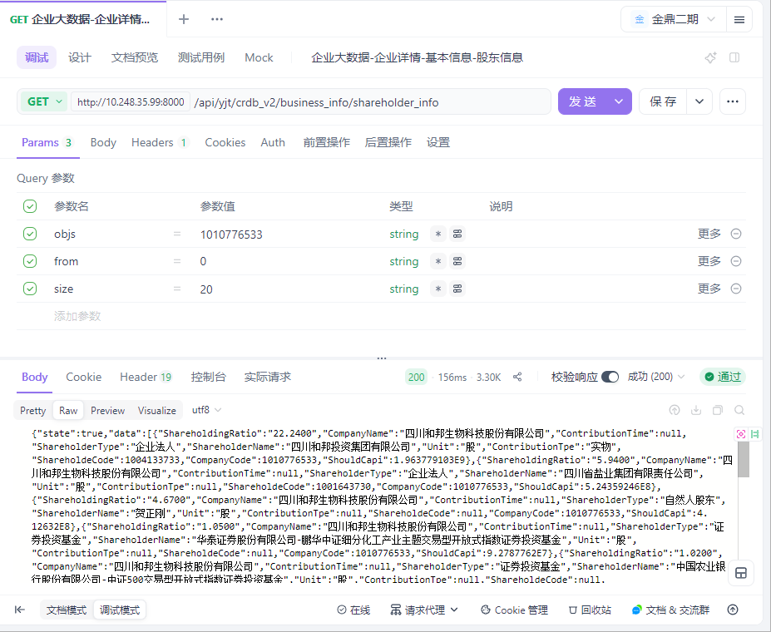

用例名称 | 企业大数据-企业详情-基本信息-对外投资企业
用例编号 | 43395
接口地址 | /api/yjt/crdb_v2/business_info/management
请求方式 | get
前置条件 | 数据查询功能正常
描述 | 正常查询数据信息成功
请求头部 | Content-Type：text/plain;charset=UTF-8
请求参数 | objs=1010776533&from=0&size=20
状态码 | 200
预期返回结果 | {"state":true,"data":[{"Investee":"四川和邦盐矿有限公司","CompanyName":"四川和邦生物科技股份有限公司","ContributionTime":"2010-10-26","InvesteeCode":"1008989495","Unit":"万元","ShareholdeCode":"100.0000","ContributionTpe":"货币","CompanyCode":1010776533,"ShouldCapi":6000.0},{"Investee":"四川和邦新材料有限公司","CompanyName":"四川和邦生物科技股份有限公司","ContributionTime":"2030-03-09","InvesteeCode":"1011828593","Unit":"万元","ShareholdeCode":"100.0000","ContributionTpe":"货币","CompanyCode":1010776533,"ShouldCapi":30000.0},{"Investee":"四川和邦磷矿有限公司","CompanyName":"四川和邦生物科技股份有限公司","ContributionTime":"2012-09-05","InvesteeCode":"1010429057","Unit":"万元","ShareholdeCode":"100.0000","ContributionTpe":"货币","CompanyCode":1010776533,"ShouldCapi":28600.0},{"Investee":"四川和邦电子商务有限公司","CompanyName":"四川和邦生物科技股份有限公司","ContributionTime":null,"InvesteeCode":"1006043634","Unit":"万元","ShareholdeCode":"100.0000","ContributionTpe":null,"CompanyCode":1010776533,"ShouldCapi":20000.0},{"Investee":"乐山和邦新材料科技有限公司","CompanyName":"四川和邦生物科技股份有限公司","ContributionTime":"2020-05-31","InvesteeCode":"1011490445","Unit":"万元","ShareholdeCode":"100.0000","ContributionTpe":"货币","CompanyCode":1010776533,"ShouldCapi":50000.0},{"Investee":"四川武骏光能股份有限公司","CompanyName":"四川和邦生物科技股份有限公司","ContributionTime":"2010-07-20","InvesteeCode":"1010699173","Unit":"万元","ShareholdeCode":"88.3763","ContributionTpe":"货币","CompanyCode":1010776533,"ShouldCapi":40000.0},{"Investee":"四川和邦生物视高有限公司","CompanyName":"四川和邦生物科技股份有限公司","ContributionTime":"2030-03-09","InvesteeCode":"1012354062","Unit":"万元","ShareholdeCode":"100.0000","ContributionTpe":"货币","CompanyCode":1010776533,"ShouldCapi":10000.0},{"Investee":"乐山和邦农业科技有限公司","CompanyName":"四川和邦生物科技股份有限公司","ContributionTime":"2015-06-04","InvesteeCode":"1011887874","Unit":"万元","ShareholdeCode":"100.0000","ContributionTpe":"货币","CompanyCode":1010776533,"ShouldCapi":49200.0},{"Investee":"乐山涌江实业有限公司","CompanyName":"四川和邦生物科技股份有限公司","ContributionTime":"2016-10-27","InvesteeCode":"1076870574","Unit":"万元","ShareholdeCode":"100.0000","ContributionTpe":"货币","CompanyCode":1010776533,"ShouldCapi":16010.0},{"Investee":"四川合江和邦化学有限公司","CompanyName":"四川和邦生物科技股份有限公司","ContributionTime":null,"InvesteeCode":"1008618021","Unit":"万元","ShareholdeCode":"100.0000","ContributionTpe":null,"CompanyCode":1010776533,"ShouldCapi":2000.0},{"Investee":"成都新朝阳作物科学股份有限公司","CompanyName":"四川和邦生物科技股份有限公司","ContributionTime":"2019-12-26","InvesteeCode":"1090838058","Unit":"万元","ShareholdeCode":"5.0500","ContributionTpe":"其他","CompanyCode":1010776533,"ShouldCapi":270.0},{"Investee":"四川省中明环境治理有限公司","CompanyName":"四川和邦生物科技股份有限公司","ContributionTime":"2016-09-30","InvesteeCode":"1003458332","Unit":"万元","ShareholdeCode":"4.0000","ContributionTpe":"货币","CompanyCode":1010776533,"ShouldCapi":57.7368},{"Investee":"四川和邦刘家山磷矿业有限公司","CompanyName":"四川和邦生物科技股份有限公司","ContributionTime":"2051-10-27","InvesteeCode":"1116380416","Unit":"万元","ShareholdeCode":"100.0000","ContributionTpe":"货币","CompanyCode":1010776533,"ShouldCapi":50000.0},{"Investee":"四川桥联商贸有限责任公司","CompanyName":"四川和邦生物科技股份有限公司","ContributionTime":"2013-01-24","InvesteeCode":"1011042855","Unit":"万元","ShareholdeCode":"100.0000","ContributionTpe":null,"CompanyCode":1010776533,"ShouldCapi":1000.0},{"Investee":"四川乐山和友化工有限公司","CompanyName":"四川和邦生物科技股份有限公司","ContributionTime":null,"InvesteeCode":"1001824081","Unit":"万元","ShareholdeCode":"100.0000","ContributionTpe":null,"CompanyCode":1010776533,"ShouldCapi":2000.0},{"Investee":"乐山市新维自动化工程有限公司","CompanyName":"四川和邦生物科技股份有限公司","ContributionTime":null,"InvesteeCode":"1011488886","Unit":"万元","ShareholdeCode":"100.0000","ContributionTpe":"货币","CompanyCode":1010776533,"ShouldCapi":300.0},{"Investee":"乐山和邦设备有限公司","CompanyName":"四川和邦生物科技股份有限公司","ContributionTime":null,"InvesteeCode":"1012125986","Unit":"万元","ShareholdeCode":"100.0000","ContributionTpe":"货币","CompanyCode":1010776533,"ShouldCapi":1000.0},{"Investee":"犍为和邦顺城盐业有限公司","CompanyName":"四川和邦生物科技股份有限公司","ContributionTime":"2008-03-07","InvesteeCode":"1012082836","Unit":"万元","ShareholdeCode":"100.0000","ContributionTpe":"货币","CompanyCode":1010776533,"ShouldCapi":7000.0},{"Investee":"自贡和邦化工有限公司","CompanyName":"四川和邦生物科技股份有限公司","ContributionTime":"2043-11-27","InvesteeCode":"1137946720","Unit":"万元","ShareholdeCode":"100.0000","ContributionTpe":"货币","CompanyCode":1010776533,"ShouldCapi":10000.0},{"Investee":"乐山市商业银行股份有限公司","CompanyName":"四川和邦生物科技股份有限公司","ContributionTime":null,"InvesteeCode":"1011475628","Unit":"股","ShareholdeCode":"2.7400","ContributionTpe":null,"CompanyCode":1010776533,"ShouldCapi":1.32389542E8}],"traceId":"69201ebde908494d11120f66"}
实际结果 | 与预期结果一致  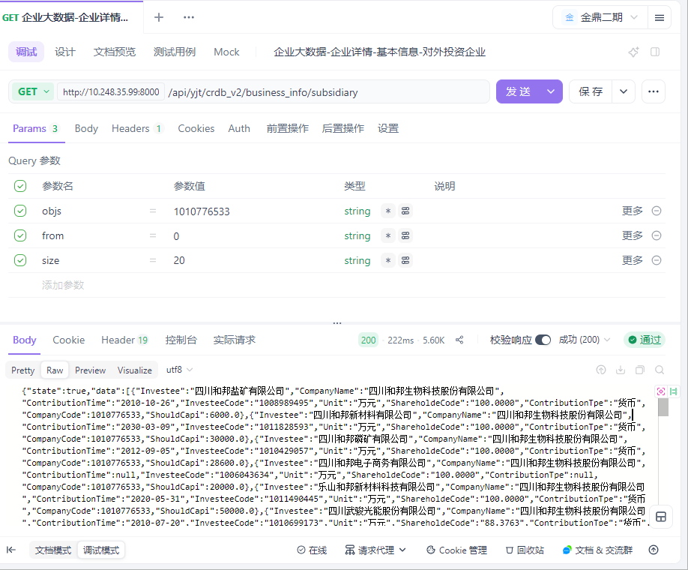

用例名称 | 企业大数据-企业详情-新闻公告-新闻舆情
用例编号 | 43396
接口地址 | /api/yjt/crdb_v2/news/newscontent
请求方式 | get
前置条件 | 数据查询功能正常
描述 | 正常查询数据信息成功
请求头部 | Content-Type：text/plain;charset=UTF-8
请求参数 | objs=1010776533&from=0&size=20&bdate=2015-11-21&edate=2025-11-21
状态码 | 200
预期返回结果 | {"state":true,"data":[{"SimilarityType":"否","NewsCode":785532165,"NewsLink":"https://mp.weixin.qq.com/s?__biz=MzAxOTAwMDczNQ==&mid=2650299150&idx=1&sn=cb3d545f2a93e0073ac586e680dcfa9c&chksm=82d1789e879cccea288cb4fbc9d994df6fe4ae47d089a832318d9a608773ee9b302e10372914&scene=0&xt","NewsDate":"2025-11-20 23:51:00","RelatedOrg":[{"Mamiorg":"主机构","AlertImportanceABS":0,"QuotaCode":8749,"AlertImportance":"0","Itcode2":1010776533,"NpProperty":"非负","CompanyCode":80189718}],"Title":"五通桥区人民政府与四川和邦生物科技股份有限公司举行年产60万吨蛋氨酸项目签约仪式","NewsCode_Main":null,"CRNW0023_005":null,"Source":"乐山发布"},{"SimilarityType":"否","NewsCode":784988003,"NewsLink":"http://sns.sseinfo.com/","NewsDate":"2025-11-14 16:42:00","RelatedOrg":[{"Mamiorg":"主机构","AlertImportanceABS":0,"QuotaCode":8749,"AlertImportance":"0","Itcode2":1010776533,"NpProperty":"非负","CompanyCode":80189718},{"Mamiorg":"主机构","AlertImportanceABS":0,"QuotaCode":8759,"AlertImportance":"0","Itcode2":1010776533,"NpProperty":"非负","CompanyCode":80189718}],"Title":"(上互动)和邦生物：Wonarah磷矿预计2026年开始开采和销售","NewsCode_Main":null,"CRNW0023_005":null,"Source":"上证e互动"},{"SimilarityType":"否","NewsCode":784986472,"NewsLink":"http://sns.sseinfo.com/","NewsDate":"2025-11-14 16:32:00","RelatedOrg":[{"Mamiorg":"主机构","AlertImportanceABS":0,"QuotaCode":8408,"AlertImportance":"0","Itcode2":1010776533,"NpProperty":"非负","CompanyCode":80189718},{"Mamiorg":"主机构","AlertImportanceABS":0,"QuotaCode":8759,"AlertImportance":"0","Itcode2":1010776533,"NpProperty":"非负","CompanyCode":80189718}],"Title":"(上互动)和邦生物：布尔津野马主营业务为硅石矿开采，设计产能96万吨/年","NewsCode_Main":null,"CRNW0023_005":null,"Source":"上证e互动"},{"SimilarityType":"否","NewsCode":784986465,"NewsLink":"http://sns.sseinfo.com/","NewsDate":"2025-11-14 16:32:00","RelatedOrg":[{"Mamiorg":"主机构","AlertImportanceABS":0,"QuotaCode":8759,"AlertImportance":"0","Itcode2":1010776533,"NpProperty":"非负","CompanyCode":80189718},{"Mamiorg":"主机构","AlertImportanceABS":0,"QuotaCode":8406,"AlertImportance":"0","Itcode2":1010776533,"NpProperty":"非负","CompanyCode":80189718}],"Title":"(上互动)和邦生物：公司未有投资建设2万吨/年六氟磷酸锂项目","NewsCode_Main":null,"CRNW0023_005":null,"Source":"上证e互动"},{"SimilarityType":"否","NewsCode":784986475,"NewsLink":"http://sns.sseinfo.com/","NewsDate":"2025-11-14 16:32:00","RelatedOrg":[{"Mamiorg":"主机构","AlertImportanceABS":0,"QuotaCode":8408,"AlertImportance":"0","Itcode2":1010776533,"NpProperty":"非负","CompanyCode":80189718},{"Mamiorg":"主机构","AlertImportanceABS":0,"QuotaCode":8759,"AlertImportance":"0","Itcode2":1010776533,"NpProperty":"非负","CompanyCode":80189718}],"Title":"(上互动)和邦生物：烟峰磷矿及刘家山磷矿设计产能公布, Wonarah磷矿预计2026年开始销售","NewsCode_Main":null,"CRNW0023_005":null,"Source":"上证e互动"},{"SimilarityType":"否","NewsCode":784986167,"NewsLink":"http://sns.sseinfo.com/","NewsDate":"2025-11-14 16:31:00","RelatedOrg":[{"Mamiorg":"主机构","AlertImportanceABS":0,"QuotaCode":8408,"AlertImportance":"0","Itcode2":1010776533,"NpProperty":"非负","CompanyCode":80189718},{"Mamiorg":"主机构","AlertImportanceABS":0,"QuotaCode":8749,"AlertImportance":"0","Itcode2":1010776533,"NpProperty":"非负","CompanyCode":80189718},{"Mamiorg":"主机构","AlertImportanceABS":0,"QuotaCode":8759,"AlertImportance":"0","Itcode2":1010776533,"NpProperty":"非负","CompanyCode":80189718}],"Title":"(上互动)和邦生物：公司已启动了Wonarah磷矿一期70万吨/年产能的建设规划","NewsCode_Main":null,"CRNW0023_005":null,"Source":"上证e互动"},{"SimilarityType":"否","NewsCode":782890528,"NewsLink":"http://sns.sseinfo.com/","NewsDate":"2025-11-07 17:00:00","RelatedOrg":[{"Mamiorg":"主机构","AlertImportanceABS":0,"QuotaCode":8747,"AlertImportance":"0","Itcode2":1010776533,"NpProperty":"非负","CompanyCode":80189718},{"Mamiorg":"主机构","AlertImportanceABS":0,"QuotaCode":8759,"AlertImportance":"0","Itcode2":1010776533,"NpProperty":"非负","CompanyCode":80189718}],"Title":"(上互动)和邦生物：公司为广安项目和印尼项目顺利推进进行了一系列的创新技术研发，创新工艺带来成本和资源的节约","NewsCode_Main":null,"CRNW0023_005":null,"Source":"上证e互动"},{"SimilarityType":"否","NewsCode":782890522,"NewsLink":"http://sns.sseinfo.com/","NewsDate":"2025-11-07 17:00:00","RelatedOrg":[{"Mamiorg":"主机构","AlertImportanceABS":0,"QuotaCode":8747,"AlertImportance":"0","Itcode2":1010776533,"NpProperty":"非负","CompanyCode":80189718},{"Mamiorg":"主机构","AlertImportanceABS":0,"QuotaCode":8759,"AlertImportance":"0","Itcode2":1010776533,"NpProperty":"非负","CompanyCode":80189718}],"Title":"(上互动)和邦生物：布尔津硅石矿可用于晶硅制造","NewsCode_Main":null,"CRNW0023_005":null,"Source":"上证e互动"},{"SimilarityType":"否","NewsCode":782890247,"NewsLink":"http://sns.sseinfo.com/","NewsDate":"2025-11-07 16:59:00","RelatedOrg":[{"Mamiorg":"主机构","AlertImportanceABS":0,"QuotaCode":8748,"AlertImportance":"0","Itcode2":1010776533,"NpProperty":"非负","CompanyCode":80189718},{"Mamiorg":"主机构","AlertImportanceABS":0,"QuotaCode":8759,"AlertImportance":"0","Itcode2":1010776533,"NpProperty":"非负","CompanyCode":80189718}],"Title":"(上互动)和邦生物：公司草甘膦产品采用IDA工艺，具有高纯度和良好质量竞争优势","NewsCode_Main":null,"CRNW0023_005":null,"Source":"上证e互动"},{"SimilarityType":"否","NewsCode":782890251,"NewsLink":"http://sns.sseinfo.com/","NewsDate":"2025-11-07 16:59:00","RelatedOrg":[{"Mamiorg":"主机构","AlertImportanceABS":0,"QuotaCode":8759,"AlertImportance":"0","Itcode2":1010776533,"NpProperty":"非负","CompanyCode":80189718},{"Mamiorg":"主机构","AlertImportanceABS":0,"QuotaCode":8408,"AlertImportance":"0","Itcode2":1010776533,"NpProperty":"非负","CompanyCode":80189718},{"Mamiorg":"主机构","AlertImportanceABS":0,"QuotaCode":8749,"AlertImportance":"0","Itcode2":1010776533,"NpProperty":"非负","CompanyCode":80189718}],"Title":"(上互动)和邦生物：公司对广安和印尼项目具有坚定的信心","NewsCode_Main":null,"CRNW0023_005":null,"Source":"上证e互动"},{"SimilarityType":"否","NewsCode":782890532,"NewsLink":"http://sns.sseinfo.com/","NewsDate":"2025-11-07 16:59:00","RelatedOrg":[{"Mamiorg":"主机构","AlertImportanceABS":0,"QuotaCode":8749,"AlertImportance":"0","Itcode2":1010776533,"NpProperty":"非负","CompanyCode":80189718},{"Mamiorg":"主机构","AlertImportanceABS":0,"QuotaCode":8759,"AlertImportance":"0","Itcode2":1010776533,"NpProperty":"非负","CompanyCode":80189718}],"Title":"(上互动)和邦生物：Jundee金矿项目进展请以公司公告为准","NewsCode_Main":null,"CRNW0023_005":null,"Source":"上证e互动"},{"SimilarityType":"否","NewsCode":782890240,"NewsLink":"http://sns.sseinfo.com/","NewsDate":"2025-11-07 16:59:00","RelatedOrg":[{"Mamiorg":"主机构","AlertImportanceABS":0,"QuotaCode":8749,"AlertImportance":"0","Itcode2":1010776533,"NpProperty":"非负","CompanyCode":80189718},{"Mamiorg":"主机构","AlertImportanceABS":0,"QuotaCode":8759,"AlertImportance":"0","Itcode2":1010776533,"NpProperty":"非负","CompanyCode":80189718}],"Title":"(上互动)和邦生物：面对外部经营环境的变化与行业周期挑战，公司确立了“资源端+高新技术端”的两极发展战略","NewsCode_Main":null,"CRNW0023_005":null,"Source":"上证e互动"},{"SimilarityType":"否","NewsCode":782890269,"NewsLink":"http://sns.sseinfo.com/","NewsDate":"2025-11-07 16:58:00","RelatedOrg":[{"Mamiorg":"主机构","AlertImportanceABS":0,"QuotaCode":8759,"AlertImportance":"0","Itcode2":1010776533,"NpProperty":"非负","CompanyCode":80189718},{"Mamiorg":"主机构","AlertImportanceABS":0,"QuotaCode":8415,"AlertImportance":"0","Itcode2":1010776533,"NpProperty":"非负","CompanyCode":80189718}],"Title":"(上互动)和邦生物：公司将根据相关规定和业绩情况考虑是否进行业绩预告","NewsCode_Main":null,"CRNW0023_005":null,"Source":"上证e互动"},{"SimilarityType":"否","NewsCode":782888933,"NewsLink":"http://sns.sseinfo.com/","NewsDate":"2025-11-07 16:51:00","RelatedOrg":[{"Mamiorg":"主机构","AlertImportanceABS":0,"QuotaCode":8406,"AlertImportance":"0","Itcode2":1010776533,"NpProperty":"非负","CompanyCode":80189718},{"Mamiorg":"主机构","AlertImportanceABS":0,"QuotaCode":8759,"AlertImportance":"0","Itcode2":1010776533,"NpProperty":"非负","CompanyCode":80189718}],"Title":"(上互动)和邦生物：公司暂停对阜兴科技的后期投资是基于当前光伏行业市场情况及阶段性产能错配的审慎考虑","NewsCode_Main":null,"CRNW0023_005":null,"Source":"上证e互动"},{"SimilarityType":"否","NewsCode":782888944,"NewsLink":"http://sns.sseinfo.com/","NewsDate":"2025-11-07 16:50:00","RelatedOrg":[{"Mamiorg":"主机构","AlertImportanceABS":0,"QuotaCode":8759,"AlertImportance":"0","Itcode2":1010776533,"NpProperty":"非负","CompanyCode":80189718},{"Mamiorg":"主机构","AlertImportanceABS":0,"QuotaCode":8747,"AlertImportance":"0","Itcode2":1010776533,"NpProperty":"非负","CompanyCode":80189718}],"Title":"(上互动)和邦生物：公司关于磷方面的业务包括磷矿石、双甘膦、草甘膦等","NewsCode_Main":null,"CRNW0023_005":null,"Source":"上证e互动"},{"SimilarityType":"否","NewsCode":782372325,"NewsLink":"https://www.toutiao.com/article/7567983464796996150/","NewsDate":"2025-11-02 12:41:00","RelatedOrg":[{"Mamiorg":"主机构","AlertImportanceABS":0,"QuotaCode":90101,"AlertImportance":"0","Itcode2":1010776533,"NpProperty":"非负","CompanyCode":80189718}],"Title":"极米科技押注AI、成都路桥囤矿，11月A股将延续怎样格局？丨周观川股","NewsCode_Main":null,"CRNW0023_005":null,"Source":"新浪财经"},{"SimilarityType":"否","NewsCode":782345943,"NewsLink":"http://www.creb.com.cn/td/213419.jhtml","NewsDate":"2025-11-01 16:10:00","RelatedOrg":[{"Mamiorg":"副机构","AlertImportanceABS":0,"QuotaCode":8950,"AlertImportance":"0","Itcode2":1010776533,"NpProperty":"非负","CompanyCode":80189718}],"Title":"重金拿下22宗地：起底“大黑马”邦泰集团","NewsCode_Main":null,"CRNW0023_005":null,"Source":"中国房地产网"},{"SimilarityType":"否","NewsCode":782272132,"NewsLink":"http://sns.sseinfo.com/","NewsDate":"2025-10-31 16:40:00","RelatedOrg":[{"Mamiorg":"主机构","AlertImportanceABS":0,"QuotaCode":8759,"AlertImportance":"0","Itcode2":1010776533,"NpProperty":"非负","CompanyCode":80189718},{"Mamiorg":"主机构","AlertImportanceABS":0,"QuotaCode":8770,"AlertImportance":"0","Itcode2":1010776533,"NpProperty":"非负","CompanyCode":80189718}],"Title":"(上互动)和邦生物：公司已获得的探矿权需要探矿有结果后向相关部门申请并获得其批准才能办理采矿权","NewsCode_Main":null,"CRNW0023_005":null,"Source":"上证e互动"},{"SimilarityType":"否","NewsCode":782272127,"NewsLink":"http://sns.sseinfo.com/","NewsDate":"2025-10-31 16:40:00","RelatedOrg":[{"Mamiorg":"主机构","AlertImportanceABS":0,"QuotaCode":8748,"AlertImportance":"0","Itcode2":1010776533,"NpProperty":"非负","CompanyCode":80189718},{"Mamiorg":"主机构","AlertImportanceABS":0,"QuotaCode":8759,"AlertImportance":"0","Itcode2":1010776533,"NpProperty":"非负","CompanyCode":80189718},{"Mamiorg":"主机构","AlertImportanceABS":0,"QuotaCode":8747,"AlertImportance":"0","Itcode2":1010776533,"NpProperty":"非负","CompanyCode":80189718}],"Title":"(上互动)和邦生物：公司不生产或销售医用药品，包括仿制药","NewsCode_Main":null,"CRNW0023_005":null,"Source":"上证e互动"},{"SimilarityType":"否","NewsCode":782272144,"NewsLink":"http://sns.sseinfo.com/","NewsDate":"2025-10-31 16:40:00","RelatedOrg":[{"Mamiorg":"主机构","AlertImportanceABS":0,"QuotaCode":8747,"AlertImportance":"0","Itcode2":1010776533,"NpProperty":"非负","CompanyCode":80189718},{"Mamiorg":"主机构","AlertImportanceABS":0,"QuotaCode":8759,"AlertImportance":"0","Itcode2":1010776533,"NpProperty":"非负","CompanyCode":80189718}],"Title":"(上互动)和邦生物：公司暂无国有化改革规划","NewsCode_Main":null,"CRNW0023_005":null,"Source":"上证e互动"}],"traceId":"69201f49e908494d1112102b"}
实际结果 | 与预期结果一致  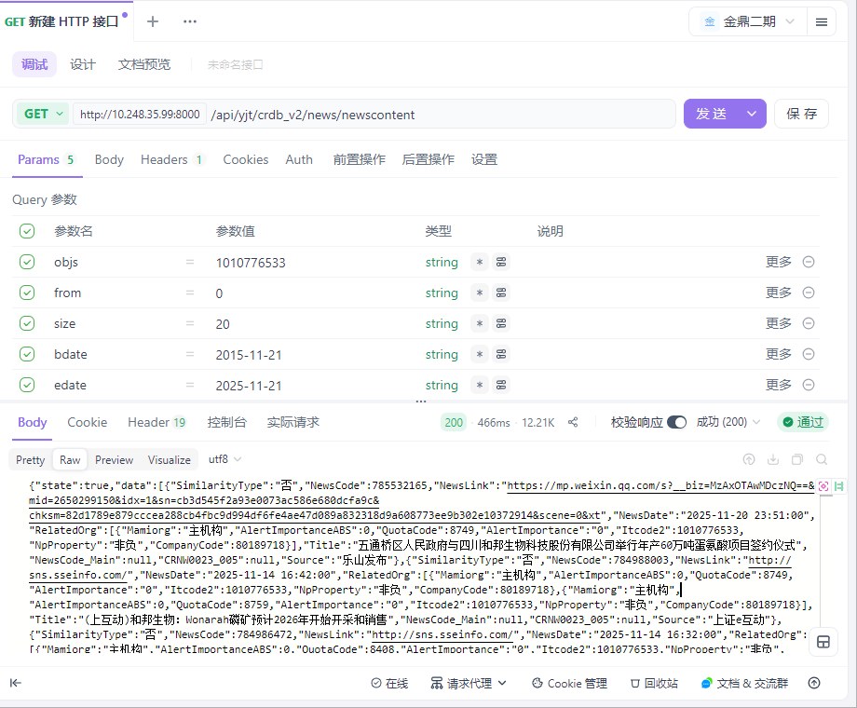

用例名称 | 企业大数据-企业详情-信用评级-主体评级
用例编号 | 43397
接口地址 | /api/yjt/crdb_v2/credit/mainrating
请求方式 | get
前置条件 | 数据查询功能正常
描述 | 正常查询数据信息成功
请求头部 | Content-Type：text/plain;charset=UTF-8
请求参数 | objs=1010776533&from=0&size=20
状态码 | 200
预期返回结果 | {"state":true,"data":[{"declaredate":"2025-09-24","rantingDate":"2025-09-23","entityCode":80189718,"entityName":"四川和邦生物科技股份有限公司","thisRaiting":"AA","raitingOutlook":"稳定","raitingOrgName":"中证鹏元资信评估股份有限公司","raitingOrgCode":80002099,"raitingType":"长期债务评级"},{"declaredate":"2025-07-29","rantingDate":"2025-07-28","entityCode":80189718,"entityName":"四川和邦生物科技股份有限公司","thisRaiting":"AA","raitingOutlook":"稳定","raitingOrgName":"中证鹏元资信评估股份有限公司","raitingOrgCode":80002099,"raitingType":"长期债务评级"},{"declaredate":"2025-02-05","rantingDate":"2025-01-26","entityCode":80189718,"entityName":"四川和邦生物科技股份有限公司","thisRaiting":"AA","raitingOutlook":"稳定","raitingOrgName":"中证鹏元资信评估股份有限公司","raitingOrgCode":80002099,"raitingType":"长期债务评级"},{"declaredate":"2024-10-24","rantingDate":"2024-06-28","entityCode":80189718,"entityName":"四川和邦生物科技股份有限公司","thisRaiting":"AA","raitingOutlook":"稳定","raitingOrgName":"中证鹏元资信评估股份有限公司","raitingOrgCode":80002099,"raitingType":"长期债务评级"},{"declaredate":"2019-05-25","rantingDate":"2019-05-23","entityCode":80189718,"entityName":"四川和邦生物科技股份有限公司","thisRaiting":"AA","raitingOutlook":"稳定","raitingOrgName":"中证鹏元资信评估股份有限公司","raitingOrgCode":80002099,"raitingType":"长期债务评级"},{"declaredate":"2018-03-13","rantingDate":"2018-03-09","entityCode":80189718,"entityName":"四川和邦生物科技股份有限公司","thisRaiting":"AA","raitingOutlook":"稳定","raitingOrgName":"中证鹏元资信评估股份有限公司","raitingOrgCode":80002099,"raitingType":"长期债务评级"},{"declaredate":"2017-05-27","rantingDate":"2017-05-22","entityCode":80189718,"entityName":"四川和邦生物科技股份有限公司","thisRaiting":"AA","raitingOutlook":"稳定","raitingOrgName":"中证鹏元资信评估股份有限公司","raitingOrgCode":80002099,"raitingType":"长期债务评级"},{"declaredate":"2016-05-30","rantingDate":"2016-05-23","entityCode":80189718,"entityName":"四川和邦生物科技股份有限公司","thisRaiting":"AA","raitingOutlook":"稳定","raitingOrgName":"中证鹏元资信评估股份有限公司","raitingOrgCode":80002099,"raitingType":"长期债务评级"},{"declaredate":"2015-04-20","rantingDate":"2015-04-16","entityCode":80189718,"entityName":"四川和邦生物科技股份有限公司","thisRaiting":"AA","raitingOutlook":"稳定","raitingOrgName":"中证鹏元资信评估股份有限公司","raitingOrgCode":80002099,"raitingType":"长期债务评级"},{"declaredate":"2014-11-21","rantingDate":"2014-06-27","entityCode":80189718,"entityName":"四川和邦生物科技股份有限公司","thisRaiting":"AA","raitingOutlook":"稳定","raitingOrgName":"中证鹏元资信评估股份有限公司","raitingOrgCode":80002099,"raitingType":"长期债务评级"},{"declaredate":"2014-05-23","rantingDate":"2014-05-22","entityCode":80189718,"entityName":"四川和邦生物科技股份有限公司","thisRaiting":"AA","raitingOutlook":"稳定","raitingOrgName":"中证鹏元资信评估股份有限公司","raitingOrgCode":80002099,"raitingType":"长期债务评级"},{"declaredate":"2013-04-18","rantingDate":"2013-02-05","entityCode":80189718,"entityName":"四川和邦生物科技股份有限公司","thisRaiting":"AA","raitingOutlook":"稳定","raitingOrgName":"中证鹏元资信评估股份有限公司","raitingOrgCode":80002099,"raitingType":"长期债务评级"}],"traceId":"692020c3e908494d11121200"}
实际结果 | 与预期结果一致  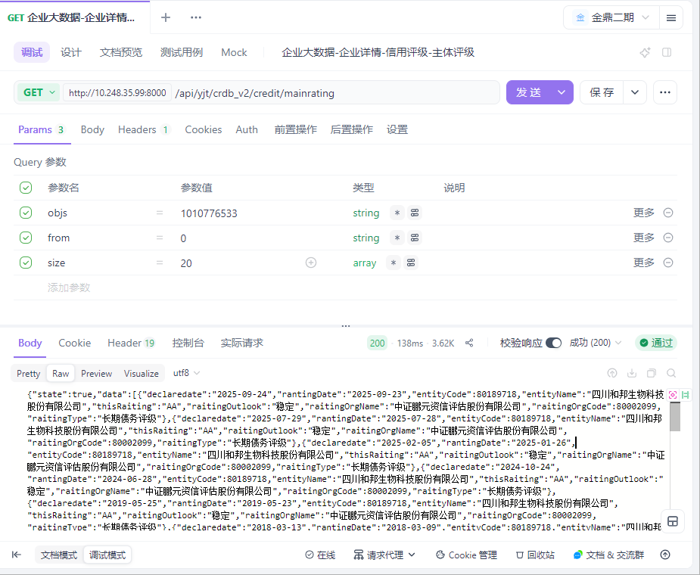

用例名称 | 企业大数据-企业详情-信用评级-纳税信用等级
用例编号 | 43398
接口地址 | /api/yjt/crdb_v2/credit/Tax_rating
请求方式 | get
前置条件 | 数据查询功能正常
描述 | 正常查询数据信息成功
请求头部 | Content-Type：text/plain;charset=UTF-8
请求参数 | objs=1010776533&from=0&size=20
状态码 | 200
预期返回结果 | {"state":true,"data":[{"Itname":null,"Rating_Year":"2017","Rating_Level":"A","Itcode2":null,"Rating_Agencies":"国家税务总局乐山市税务局"},{"Itname":null,"Rating_Year":"2020","Rating_Level":"A","Itcode2":null,"Rating_Agencies":"国家税务总局四川省税务局"},{"Itname":null,"Rating_Year":"2022","Rating_Level":"A","Itcode2":null,"Rating_Agencies":"国家税务总局四川省税务局"},{"Itname":null,"Rating_Year":"2021","Rating_Level":"A","Itcode2":null,"Rating_Agencies":"国家税务总局四川省税务局"},{"Itname":null,"Rating_Year":"2023","Rating_Level":"A","Itcode2":null,"Rating_Agencies":"国家税务总局乐山市税务局"},{"Itname":null,"Rating_Year":"2024","Rating_Level":"A","Itcode2":null,"Rating_Agencies":"国家税务总局四川省税务局"}],"traceId":"6920214ce908494d111212b2"}
实际结果 | 与预期结果一致  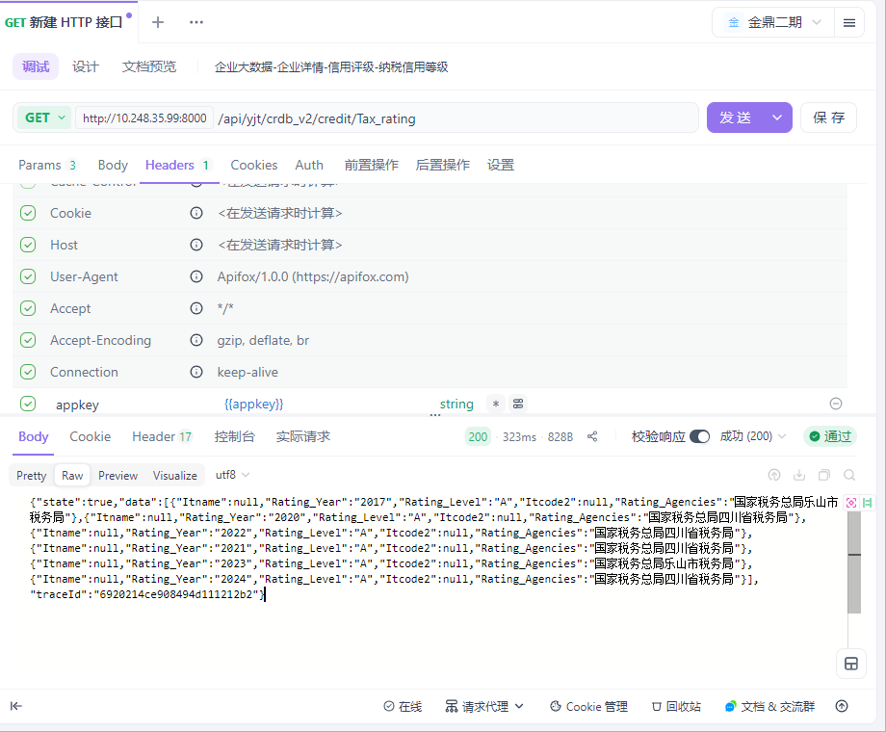

用例名称 | 企业大数据-企业详情-信用评级-监管等级
用例编号 | 43399
接口地址 | /api/yjt/crdb_v2/credit/Tax_rating
请求方式 | get
前置条件 | 数据查询功能正常
描述 | 正常查询数据信息成功
请求头部 | Content-Type：text/plain;charset=UTF-8
请求参数 | objs=1010776533&from=0&size=20
状态码 | 200
预期返回结果 | {"state":true,"data":[],"traceId":"692021bffe62224e3135bd07"}
实际结果 | 与预期结果一致  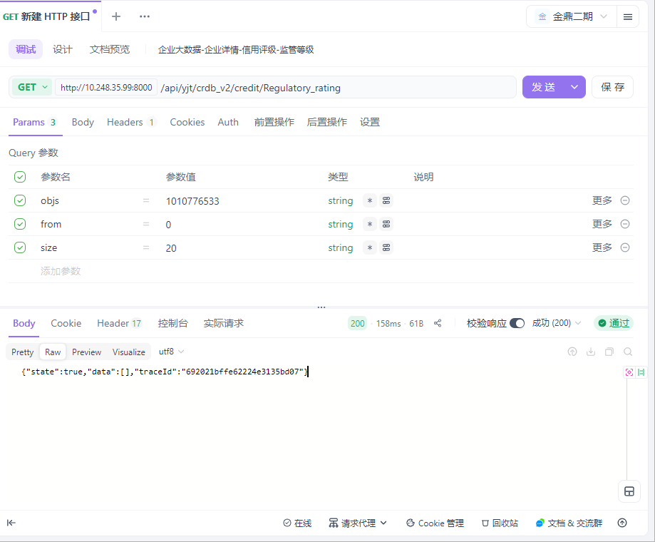

用例名称 | 企业大数据-企业详情-信用评级-环保类评级
用例编号 | 43400
接口地址 | /api/yjt/crdb_v2/credit/Environmental_rating
请求方式 | get
前置条件 | 数据查询功能正常
描述 | 正常查询数据信息成功
请求头部 | Content-Type：text/plain;charset=UTF-8
请求参数 | objs=1010776533&from=0&size=20
状态码 | 200
预期返回结果 | {"state":true,"data":[{"Itname":"四川和邦生物科技股份有限公司","Rating_Type_Code":11001,"Rating_Level":"诚信","Rating_Year":"2023","Declaredate":"2025-03-08","Attachment":"CDE73FD8-9F01-3749-A658-4795767373A5","Rating_Type":"企业环保信评","Itcode2":"1010776533","Rating_Agencies":"四川省生态环境厅"},{"Itname":"四川和邦生物科技股份有限公司","Rating_Type_Code":11001,"Rating_Level":"诚信","Rating_Year":"2022","Declaredate":"2024-06-11","Attachment":"9E4FA0CB-1011-3259-AF09-867373A40813","Rating_Type":"企业环保信评","Itcode2":"1010776533","Rating_Agencies":"四川省生态环境厅"},{"Itname":"四川和邦生物科技股份有限公司","Rating_Type_Code":11001,"Rating_Level":"良好","Rating_Year":"2021","Declaredate":"2023-09-27","Attachment":"2B0FF789-6F2C-30BF-9636-7A88D5C0C755","Rating_Type":"企业环保信评","Itcode2":"1010776533","Rating_Agencies":"四川省生态环境厅"},{"Itname":"四川和邦生物科技股份有限公司","Rating_Type_Code":11001,"Rating_Level":"诚信","Rating_Year":"2022","Declaredate":"2023-07-12","Attachment":"128b140e-c5a1-4fec-afd8-e6beec1af092","Rating_Type":"企业环保信评","Itcode2":"1010776533","Rating_Agencies":"四川省生态环境厅"},{"Itname":"四川和邦生物科技股份有限公司","Rating_Type_Code":11001,"Rating_Level":"良好","Rating_Year":"2021","Declaredate":"2022-07-29","Attachment":"30ab32ad-28f0-45cd-9d29-2ae44d9d03a2","Rating_Type":"企业环保信评","Itcode2":"1010776533","Rating_Agencies":"四川省生态环境厅"},{"Itname":"四川和邦生物科技股份有限公司","Rating_Type_Code":11001,"Rating_Level":"诚信","Rating_Year":"2019","Declaredate":"2021-10-21","Attachment":"5A3A8912-9548-3ADF-8459-6DA533402A21","Rating_Type":"企业环保信评","Itcode2":"1010776533","Rating_Agencies":"四川省生态环境厅"},{"Itname":"四川和邦生物科技股份有限公司","Rating_Type_Code":11001,"Rating_Level":"良好","Rating_Year":"2016","Declaredate":"2021-10-21","Attachment":"94CFE86B-DC5B-316C-953F-1B8AE9A5DBD5","Rating_Type":"企业环保信评","Itcode2":"1010776533","Rating_Agencies":"四川省生态环境厅"},{"Itname":"四川和邦生物科技股份有限公司","Rating_Type_Code":11001,"Rating_Level":"良好","Rating_Year":"2017","Declaredate":"2021-10-21","Attachment":"61055375-B3B8-36CD-A77E-5654D6AC767B","Rating_Type":"企业环保信评","Itcode2":"1010776533","Rating_Agencies":"四川省生态环境厅"},{"Itname":"四川和邦生物科技股份有限公司","Rating_Type_Code":11001,"Rating_Level":"良好","Rating_Year":"2018","Declaredate":"2021-10-21","Attachment":"57AC83CF-02C0-3784-A420-9527F95562FE","Rating_Type":"企业环保信评","Itcode2":"1010776533","Rating_Agencies":"四川省生态环境厅"},{"Itname":"四川和邦生物科技股份有限公司","Rating_Type_Code":11001,"Rating_Level":"良好","Rating_Year":"2020","Declaredate":"2021-07-27","Attachment":"ab5dd827-6e49-4593-a785-49180e4e9202","Rating_Type":"企业环保信评","Itcode2":"1010776533","Rating_Agencies":"四川省生态环境厅"},{"Itname":"四川和邦生物科技股份有限公司","Rating_Type_Code":11001,"Rating_Level":"诚信","Rating_Year":"2019","Declaredate":"2020-09-28","Attachment":"67738bea-85b7-4a44-9926-60d532cb0f62","Rating_Type":"企业环保信评","Itcode2":"1010776533","Rating_Agencies":"四川省生态环境厅"},{"Itname":"四川和邦生物科技股份有限公司","Rating_Type_Code":11001,"Rating_Level":"良好","Rating_Year":"2017","Declaredate":"2018-08-14","Attachment":"9e954276-50f7-4c47-a915-1f2ea600b6d2","Rating_Type":"企业环保信评","Itcode2":"1010776533","Rating_Agencies":"乐山市环境保护局"},{"Itname":"四川和邦生物科技股份有限公司","Rating_Type_Code":11001,"Rating_Level":"良好","Rating_Year":"2017","Declaredate":"2018-06-14","Attachment":"e124ddb9-9f7c-47d9-bb40-df0abbdd6832","Rating_Type":"企业环保信评","Itcode2":"1010776533","Rating_Agencies":"四川省生态环境厅"},{"Itname":"四川和邦生物科技股份有限公司","Rating_Type_Code":11001,"Rating_Level":"良好","Rating_Year":"2016","Declaredate":"2017-06-19","Attachment":"2c4ceede-f9f4-437f-8cb4-bdbd7a872d92","Rating_Type":"企业环保信评","Itcode2":"1010776533","Rating_Agencies":"四川省环境保护厅"},{"Itname":"四川和邦生物科技股份有限公司","Rating_Type_Code":11001,"Rating_Level":"良好","Rating_Year":"2024","Declaredate":"1900-01-01","Attachment":"73C918D7-7658-3590-B94B-5557E4B886E4","Rating_Type":"企业环保信评","Itcode2":"1010776533","Rating_Agencies":"四川省生态环境厅"}],"traceId":"69202299e908494d1112154a"}
实际结果 | 与预期结果一致  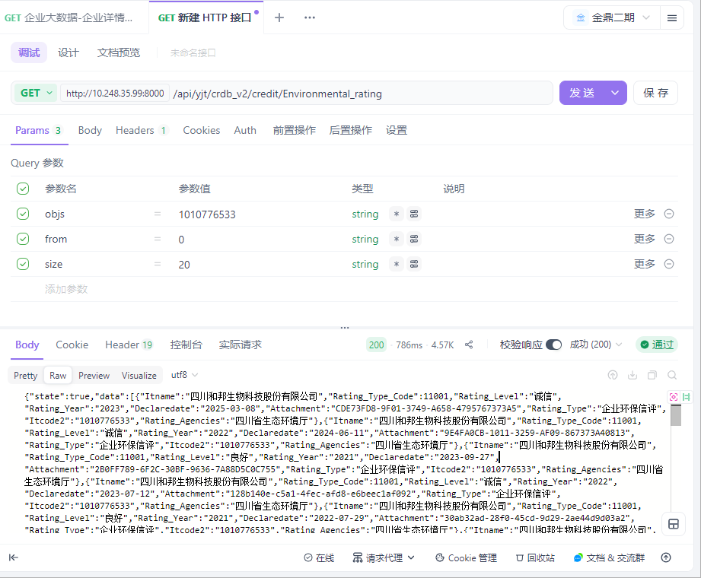

用例名称 | 企业大数据-企业详情-信用评级-其他领域评级
用例编号 | 43401
接口地址 | /api/yjt/crdb_v2/credit/other_fields_credit_rating
请求方式 | get
前置条件 | 数据查询功能正常
描述 | 正常查询数据信息成功
请求头部 | Content-Type：text/plain;charset=UTF-8
请求参数 | objs=1010776533&from=0&size=20
状态码 | 200
预期返回结果 | {"state":true,"data":[{"Itname":"四川和邦生物科技股份有限公司","Rating_Level":"二级","Rating_Year":"2025","Rating_Type2_Code":23005,"Rating_Type2":"危险化学品生产信评","Declaredate":"2025-07-09","Rating_Type1":"安全生产类","Attachment":"3848effe-dbb9-427a-99a5-1538391d5522","Itcode2":"1010776533","Rating_Agencies":"四川省应急管理厅","Rating_Type1_Code":23}],"traceId":"692022f8e908494d111215bf"}
实际结果 | 与预期结果一致  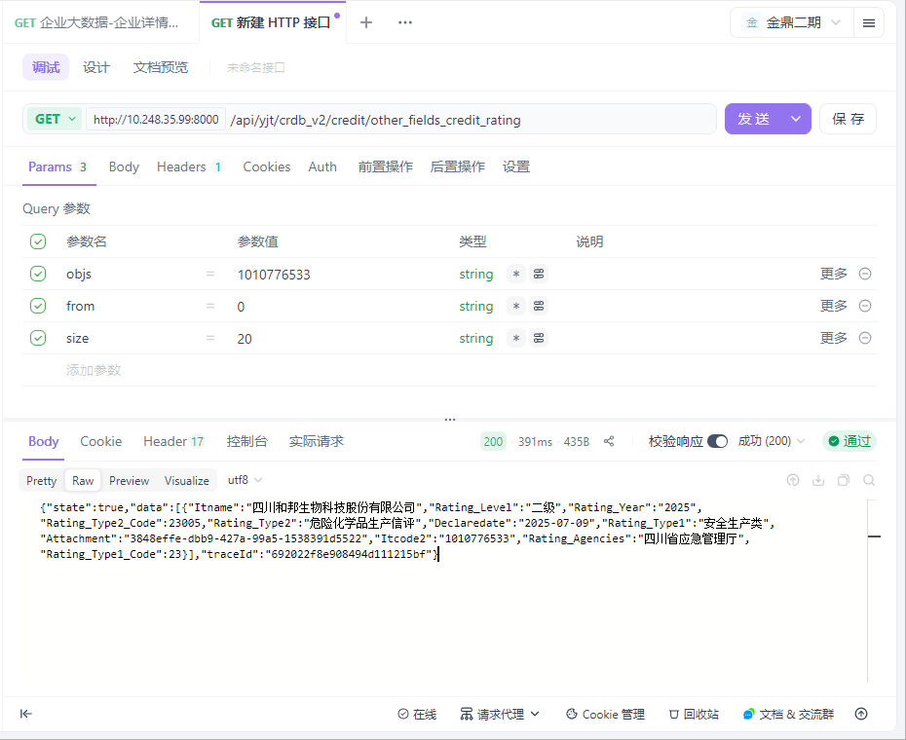

用例名称 | 企业大数据-企业详情-企业经营-客户
用例编号 | 43402
接口地址 | /api/yjt/crdb_v2/business_info/Customer
请求方式 | get
前置条件 | 数据查询功能正常
描述 | 正常查询数据信息成功
请求头部 | Content-Type：text/plain;charset=UTF-8
请求参数 | objs=1010776533&from=0&size=20
状态码 | 200
预期返回结果 | {"state":true,"data":[{"IndustryCode":"F","CustomerCode":1011712874,"SmallCategoryCode":"F5165","AnnounmtDate":"2025-06-03","SubIndustry":"批发业","ReportDate":"2025年","MiddleCategoryCode":"F516","ContracAmount":"","Unit":"","Source":"招投标公告","Industry":"批发和零售业","CompanyName":"四川和邦生物科技股份有限公司","SubIndustryCode":"F51","MiddleCategory":"矿产品、建材及化工产品批发","SmallCategory":"建材批发","Region":"四川省","CustomerName":"攀钢集团物资贸易有限公司","CompanyCode":1010776533},{"IndustryCode":"F","CustomerCode":1011712874,"SmallCategoryCode":"F5165","AnnounmtDate":"2025-04-30","SubIndustry":"批发业","ReportDate":"2025年","MiddleCategoryCode":"F516","ContracAmount":"","Unit":"","Source":"招投标公告","Industry":"批发和零售业","CompanyName":"四川和邦生物科技股份有限公司","SubIndustryCode":"F51","MiddleCategory":"矿产品、建材及化工产品批发","SmallCategory":"建材批发","Region":"四川省","CustomerName":"攀钢集团物资贸易有限公司","CompanyCode":1010776533},{"IndustryCode":"F","CustomerCode":1011712874,"SmallCategoryCode":"F5165","AnnounmtDate":"2025-03-05","SubIndustry":"批发业","ReportDate":"2025年","MiddleCategoryCode":"F516","ContracAmount":"","Unit":"","Source":"招投标公告","Industry":"批发和零售业","CompanyName":"四川和邦生物科技股份有限公司","SubIndustryCode":"F51","MiddleCategory":"矿产品、建材及化工产品批发","SmallCategory":"建材批发","Region":"四川省","CustomerName":"攀钢集团物资贸易有限公司","CompanyCode":1010776533},{"IndustryCode":"F","CustomerCode":1011712874,"SmallCategoryCode":"F5165","AnnounmtDate":"2025-01-21","SubIndustry":"批发业","ReportDate":"2025年","MiddleCategoryCode":"F516","ContracAmount":"","Unit":"","Source":"招投标公告","Industry":"批发和零售业","CompanyName":"四川和邦生物科技股份有限公司","SubIndustryCode":"F51","MiddleCategory":"矿产品、建材及化工产品批发","SmallCategory":"建材批发","Region":"四川省","CustomerName":"攀钢集团物资贸易有限公司","CompanyCode":1010776533},{"IndustryCode":"F","CustomerCode":1011712874,"SmallCategoryCode":"F5165","AnnounmtDate":"2024-12-27","SubIndustry":"批发业","ReportDate":"2024年","MiddleCategoryCode":"F516","ContracAmount":"","Unit":"","Source":"招投标公告","Industry":"批发和零售业","CompanyName":"四川和邦生物科技股份有限公司","SubIndustryCode":"F51","MiddleCategory":"矿产品、建材及化工产品批发","SmallCategory":"建材批发","Region":"四川省","CustomerName":"攀钢集团物资贸易有限公司","CompanyCode":1010776533},{"IndustryCode":"F","CustomerCode":1011712874,"SmallCategoryCode":"F5165","AnnounmtDate":"2024-12-17","SubIndustry":"批发业","ReportDate":"2024年","MiddleCategoryCode":"F516","ContracAmount":"","Unit":"","Source":"招投标公告","Industry":"批发和零售业","CompanyName":"四川和邦生物科技股份有限公司","SubIndustryCode":"F51","MiddleCategory":"矿产品、建材及化工产品批发","SmallCategory":"建材批发","Region":"四川省","CustomerName":"攀钢集团物资贸易有限公司","CompanyCode":1010776533},{"IndustryCode":"F","CustomerCode":1011712874,"SmallCategoryCode":"F5165","AnnounmtDate":"2024-11-29","SubIndustry":"批发业","ReportDate":"2024年","MiddleCategoryCode":"F516","ContracAmount":"","Unit":"","Source":"招投标公告","Industry":"批发和零售业","CompanyName":"四川和邦生物科技股份有限公司","SubIndustryCode":"F51","MiddleCategory":"矿产品、建材及化工产品批发","SmallCategory":"建材批发","Region":"四川省","CustomerName":"攀钢集团物资贸易有限公司","CompanyCode":1010776533},{"IndustryCode":"F","CustomerCode":1011712874,"SmallCategoryCode":"F5165","AnnounmtDate":"2024-11-18","SubIndustry":"批发业","ReportDate":"2024年","MiddleCategoryCode":"F516","ContracAmount":"","Unit":"","Source":"招投标公告","Industry":"批发和零售业","CompanyName":"四川和邦生物科技股份有限公司","SubIndustryCode":"F51","MiddleCategory":"矿产品、建材及化工产品批发","SmallCategory":"建材批发","Region":"四川省","CustomerName":"攀钢集团物资贸易有限公司","CompanyCode":1010776533},{"IndustryCode":"F","CustomerCode":1011712874,"SmallCategoryCode":"F5165","AnnounmtDate":"2024-11-15","SubIndustry":"批发业","ReportDate":"2024年","MiddleCategoryCode":"F516","ContracAmount":"","Unit":"","Source":"招投标公告","Industry":"批发和零售业","CompanyName":"四川和邦生物科技股份有限公司","SubIndustryCode":"F51","MiddleCategory":"矿产品、建材及化工产品批发","SmallCategory":"建材批发","Region":"四川省","CustomerName":"攀钢集团物资贸易有限公司","CompanyCode":1010776533},{"IndustryCode":"F","CustomerCode":1011712874,"SmallCategoryCode":"F5165","AnnounmtDate":"2024-09-23","SubIndustry":"批发业","ReportDate":"2024年","MiddleCategoryCode":"F516","ContracAmount":"","Unit":"","Source":"招投标公告","Industry":"批发和零售业","CompanyName":"四川和邦生物科技股份有限公司","SubIndustryCode":"F51","MiddleCategory":"矿产品、建材及化工产品批发","SmallCategory":"建材批发","Region":"四川省","CustomerName":"攀钢集团物资贸易有限公司","CompanyCode":1010776533},{"IndustryCode":"F","CustomerCode":1011712874,"SmallCategoryCode":"F5165","AnnounmtDate":"2024-04-02","SubIndustry":"批发业","ReportDate":"2024年","MiddleCategoryCode":"F516","ContracAmount":"","Unit":"","Source":"招投标公告","Industry":"批发和零售业","CompanyName":"四川和邦生物科技股份有限公司","SubIndustryCode":"F51","MiddleCategory":"矿产品、建材及化工产品批发","SmallCategory":"建材批发","Region":"四川省","CustomerName":"攀钢集团物资贸易有限公司","CompanyCode":1010776533},{"IndustryCode":"F","CustomerCode":1011712874,"SmallCategoryCode":"F5165","AnnounmtDate":"2023-10-31","SubIndustry":"批发业","ReportDate":"2023年","MiddleCategoryCode":"F516","ContracAmount":"","Unit":"","Source":"招投标公告","Industry":"批发和零售业","CompanyName":"四川和邦生物科技股份有限公司","SubIndustryCode":"F51","MiddleCategory":"矿产品、建材及化工产品批发","SmallCategory":"建材批发","Region":"四川省","CustomerName":"攀钢集团物资贸易有限公司","CompanyCode":1010776533},{"IndustryCode":"F","CustomerCode":1001971594,"SmallCategoryCode":"F5179","AnnounmtDate":"2023-08-28","SubIndustry":"批发业","ReportDate":"2023年","MiddleCategoryCode":"F517","ContracAmount":"","Unit":"","Source":"招投标公告","Industry":"批发和零售业","CompanyName":"四川和邦生物科技股份有限公司","SubIndustryCode":"F51","MiddleCategory":"机械设备、五金产品及电子产品批发","SmallCategory":"其他机械设备及电子产品批发","Region":"四川省","CustomerName":"四川省宜宾环球华欣商业发展有限公司","CompanyCode":1010776533},{"IndustryCode":"C","CustomerCode":1004167031,"SmallCategoryCode":"C3055","AnnounmtDate":"2023-08-02","SubIndustry":"非金属矿物制品业","ReportDate":"2023年","MiddleCategoryCode":"C305","ContracAmount":"","Unit":"","Source":"招投标公告","Industry":"制造业","CompanyName":"四川和邦生物科技股份有限公司","SubIndustryCode":"C30","MiddleCategory":"玻璃制品制造","SmallCategory":"玻璃包装容器制造","Region":"四川省","CustomerName":"四川天马玻璃有限公司","CompanyCode":1010776533},{"IndustryCode":"F","CustomerCode":1011712874,"SmallCategoryCode":"F5165","AnnounmtDate":"2023-07-10","SubIndustry":"批发业","ReportDate":"2023年","MiddleCategoryCode":"F516","ContracAmount":"","Unit":"","Source":"招投标公告","Industry":"批发和零售业","CompanyName":"四川和邦生物科技股份有限公司","SubIndustryCode":"F51","MiddleCategory":"矿产品、建材及化工产品批发","SmallCategory":"建材批发","Region":"四川省","CustomerName":"攀钢集团物资贸易有限公司","CompanyCode":1010776533},{"IndustryCode":"F","CustomerCode":1011712874,"SmallCategoryCode":"F5165","AnnounmtDate":"2023-06-14","SubIndustry":"批发业","ReportDate":"2023年","MiddleCategoryCode":"F516","ContracAmount":"","Unit":"","Source":"招投标公告","Industry":"批发和零售业","CompanyName":"四川和邦生物科技股份有限公司","SubIndustryCode":"F51","MiddleCategory":"矿产品、建材及化工产品批发","SmallCategory":"建材批发","Region":"四川省","CustomerName":"攀钢集团物资贸易有限公司","CompanyCode":1010776533},{"IndustryCode":"F","CustomerCode":1011712874,"SmallCategoryCode":"F5165","AnnounmtDate":"2023-05-29","SubIndustry":"批发业","ReportDate":"2023年","MiddleCategoryCode":"F516","ContracAmount":"","Unit":"","Source":"招投标公告","Industry":"批发和零售业","CompanyName":"四川和邦生物科技股份有限公司","SubIndustryCode":"F51","MiddleCategory":"矿产品、建材及化工产品批发","SmallCategory":"建材批发","Region":"四川省","CustomerName":"攀钢集团物资贸易有限公司","CompanyCode":1010776533},{"IndustryCode":"F","CustomerCode":1011712874,"SmallCategoryCode":"F5165","AnnounmtDate":"2023-03-30","SubIndustry":"批发业","ReportDate":"2023年","MiddleCategoryCode":"F516","ContracAmount":"","Unit":"","Source":"招投标公告","Industry":"批发和零售业","CompanyName":"四川和邦生物科技股份有限公司","SubIndustryCode":"F51","MiddleCategory":"矿产品、建材及化工产品批发","SmallCategory":"建材批发","Region":"四川省","CustomerName":"攀钢集团物资贸易有限公司","CompanyCode":1010776533},{"IndustryCode":"F","CustomerCode":1011712874,"SmallCategoryCode":"F5165","AnnounmtDate":"2023-01-11","SubIndustry":"批发业","ReportDate":"2023年","MiddleCategoryCode":"F516","ContracAmount":"","Unit":"","Source":"招投标公告","Industry":"批发和零售业","CompanyName":"四川和邦生物科技股份有限公司","SubIndustryCode":"F51","MiddleCategory":"矿产品、建材及化工产品批发","SmallCategory":"建材批发","Region":"四川省","CustomerName":"攀钢集团物资贸易有限公司","CompanyCode":1010776533},{"IndustryCode":"F","CustomerCode":1011712874,"SmallCategoryCode":"F5165","AnnounmtDate":"2022-10-25","SubIndustry":"批发业","ReportDate":"2022年","MiddleCategoryCode":"F516","ContracAmount":"","Unit":"","Source":"招投标公告","Industry":"批发和零售业","CompanyName":"四川和邦生物科技股份有限公司","SubIndustryCode":"F51","MiddleCategory":"矿产品、建材及化工产品批发","SmallCategory":"建材批发","Region":"四川省","CustomerName":"攀钢集团物资贸易有限公司","CompanyCode":1010776533}],"traceId":"692023fcfe62224e3135c072"}
实际结果 | 与预期结果一致  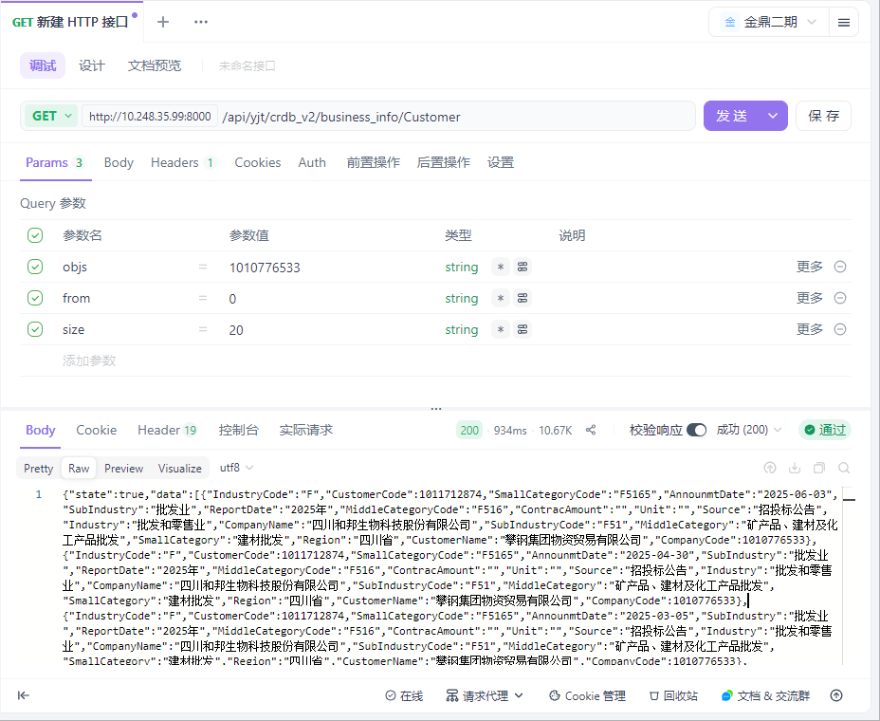

用例名称 | 企业大数据-企业详情-企业经营-供应商
用例编号 | 43403
接口地址 | /api/yjt/crdb_v2/business_info/Supplier
请求方式 | get
前置条件 | 数据查询功能正常
描述 | 正常查询数据信息成功
请求头部 | Content-Type：text/plain;charset=UTF-8
请求参数 | objs=1010776533&from=0&size=20
状态码 | 200
预期返回结果 | {"state":true,"data":[{"SupplierCode":1012282123,"IndustryCode":"C","SmallCategoryCode":"C1494","AnnounmtDate":"2023-03-30","SubIndustry":"食品制造业","ReportDate":"2022年","ContracAmount":9108690.0,"MiddleCategoryCode":"C149","Unit":"元","Source":"供应商公告：财务附注—按欠款方归集的年末余额前五名应收账款情况","Industry":"制造业","CompanyName":"四川和邦生物科技股份有限公司","SubIndustryCode":"C14","SupplierName":"云南能源投资股份有限公司","MiddleCategory":"其他食品制造","SmallCategory":"盐加工","Region":"云南省","CompanyCode":1010776533},{"SupplierCode":1012622118,"IndustryCode":"C","SmallCategoryCode":"C2614","AnnounmtDate":"2021-04-27","SubIndustry":"化学原料和化学制品制造业","ReportDate":"2020年","ContracAmount":5.911818055E7,"MiddleCategoryCode":"C261","Unit":"元","Source":"公司公告：财务附注-按预付对象归集的年末余额前五名预付款情况","Industry":"制造业","CompanyName":"四川和邦生物科技股份有限公司","SubIndustryCode":"C26","SupplierName":"新疆紫光永利精细化工有限公司","MiddleCategory":"基础化学原料制造","SmallCategory":"有机化学原料制造","Region":"新疆维吾尔自治区","CompanyCode":1010776533},{"SupplierCode":1011765366,"IndustryCode":"C","SmallCategoryCode":"C3012","AnnounmtDate":"2021-04-27","SubIndustry":"非金属矿物制品业","ReportDate":"2020年","ContracAmount":1.0E7,"MiddleCategoryCode":"C301","Unit":"元","Source":"公司公告：财务附注-按预付对象归集的年末余额前五名预付款情况","Industry":"制造业","CompanyName":"四川和邦生物科技股份有限公司","SubIndustryCode":"C30","SupplierName":"青海发投碱业有限公司","MiddleCategory":"水泥、石灰和石膏制造","SmallCategory":"石灰和石膏制造","Region":"青海省","CompanyCode":1010776533},{"SupplierCode":1012764982,"IndustryCode":"C","SmallCategoryCode":"C3521","AnnounmtDate":"2021-04-27","SubIndustry":"专用设备制造业","ReportDate":"2020年","ContracAmount":6842100.0,"MiddleCategoryCode":"C352","Unit":"元","Source":"公司公告：财务附注-按预付对象归集的年末余额前五名预付款情况","Industry":"制造业","CompanyName":"四川和邦生物科技股份有限公司","SubIndustryCode":"C35","SupplierName":"江苏安凯特科技股份有限公司","MiddleCategory":"化工、木材、非金属加工专用设备制造","SmallCategory":"炼油、化工生产专用设备制造","Region":"江苏省","CompanyCode":1010776533},{"SupplierCode":1011336381,"IndustryCode":"N","SmallCategoryCode":"N7722","AnnounmtDate":"2021-04-27","SubIndustry":"生态保护和环境治理业","ReportDate":"2020年","ContracAmount":1.119693675E7,"MiddleCategoryCode":"N772","Unit":"元","Source":"公司公告：财务附注-账龄超过1年的重要应付账款","Industry":"水利、环境和公共设施管理业","CompanyName":"四川和邦生物科技股份有限公司","SubIndustryCode":"N77","SupplierName":"福建龙净脱硫脱硝工程有限公司","MiddleCategory":"环境治理业","SmallCategory":"大气污染治理","Region":"福建省","CompanyCode":1010776533},{"SupplierCode":1077414996,"IndustryCode":"F","SmallCategoryCode":"F5199","AnnounmtDate":"2021-04-27","SubIndustry":"批发业","ReportDate":"2020年","ContracAmount":1.794380365E7,"MiddleCategoryCode":"F519","Unit":"元","Source":"公司公告：财务附注-按预付对象归集的年末余额前五名预付款情况","Industry":"批发和零售业","CompanyName":"四川和邦生物科技股份有限公司","SubIndustryCode":"F51","SupplierName":"中国石油天然气股份有限公司天然气销售川渝分公司成都销售部","MiddleCategory":"其他批发业","SmallCategory":"其他未列明批发业","Region":"四川省","CompanyCode":1010776533},{"SupplierCode":1012382572,"IndustryCode":"C","SmallCategoryCode":null,"AnnounmtDate":"2021-04-27","SubIndustry":"专用设备制造业","ReportDate":"2020年","ContracAmount":1.650395757E7,"MiddleCategoryCode":null,"Unit":"元","Source":"公司公告：财务附注-账龄超过1年的重要应付账款","Industry":"制造业","CompanyName":"四川和邦生物科技股份有限公司","SubIndustryCode":"C35","SupplierName":"西安核设备有限公司","MiddleCategory":null,"SmallCategory":null,"Region":"陕西省","CompanyCode":1010776533},{"SupplierCode":1012012117,"IndustryCode":"C","SmallCategoryCode":"C3443","AnnounmtDate":"2021-04-27","SubIndustry":"通用设备制造业","ReportDate":"2020年","ContracAmount":2.797660971E7,"MiddleCategoryCode":"C344","Unit":"元","Source":"公司公告：财务附注-账龄超过1年的重要应付账款","Industry":"制造业","CompanyName":"四川和邦生物科技股份有限公司","SubIndustryCode":"C34","SupplierName":"中核苏阀科技实业股份有限公司","MiddleCategory":"泵、阀门、压缩机及类似机械制造","SmallCategory":"阀门和旋塞制造","Region":"江苏省","CompanyCode":1010776533},{"SupplierCode":1012376904,"IndustryCode":"C","SmallCategoryCode":null,"AnnounmtDate":"2021-04-27","SubIndustry":"通用设备制造业","ReportDate":"2020年","ContracAmount":1.607340777E7,"MiddleCategoryCode":null,"Unit":"元","Source":"公司公告：财务附注-账龄超过1年的重要应付账款","Industry":"制造业","CompanyName":"四川和邦生物科技股份有限公司","SubIndustryCode":"C34","SupplierName":"吴江变压器有限公司","MiddleCategory":null,"SmallCategory":null,"Region":"江苏省","CompanyCode":1010776533},{"SupplierCode":1012463874,"IndustryCode":"C","SmallCategoryCode":"C3859","AnnounmtDate":"2020-04-22","SubIndustry":"电气机械和器材制造业","ReportDate":"2019年","ContracAmount":5784059.83,"MiddleCategoryCode":"C385","Unit":"元","Source":"公司公告：财务附注-账龄超过1年的重要应付账款","Industry":"制造业","CompanyName":"四川和邦生物科技股份有限公司","SubIndustryCode":"C38","SupplierName":"温州市东瓯微孔过滤有限公司","MiddleCategory":"家用电力器具制造","SmallCategory":"其他家用电力器具制造","Region":"浙江省","CompanyCode":1010776533},{"SupplierCode":1040253193,"IndustryCode":"C","SmallCategoryCode":"C3529","AnnounmtDate":"2020-04-22","SubIndustry":"专用设备制造业","ReportDate":"2019年","ContracAmount":5281955.52,"MiddleCategoryCode":"C352","Unit":"元","Source":"公司公告：财务附注-账龄超过1年的重要应付账款","Industry":"制造业","CompanyName":"四川和邦生物科技股份有限公司","SubIndustryCode":"C35","SupplierName":"河北诺达化工设备有限公司","MiddleCategory":"化工、木材、非金属加工专用设备制造","SmallCategory":"其他非金属加工专用设备制造","Region":"河北省","CompanyCode":1010776533},{"SupplierCode":1007549261,"IndustryCode":"D","SmallCategoryCode":"D4420","AnnounmtDate":"2020-04-22","SubIndustry":"电力、热力生产和供应业","ReportDate":"2019年","ContracAmount":3123695.72,"MiddleCategoryCode":"D442","Unit":"元","Source":"公司公告：财务附注-按预付对象归集的年末余额前五名预付款情况","Industry":"电力、热力、燃气及水生产和供应业","CompanyName":"四川和邦生物科技股份有限公司","SubIndustryCode":"D44","SupplierName":"国网四川省电力公司泸州供电公司","MiddleCategory":"电力供应","SmallCategory":"电力供应","Region":"四川省","CompanyCode":1010776533},{"SupplierCode":1012622118,"IndustryCode":"C","SmallCategoryCode":"C2614","AnnounmtDate":"2020-04-22","SubIndustry":"化学原料和化学制品制造业","ReportDate":"2019年","ContracAmount":7.2587304E7,"MiddleCategoryCode":"C261","Unit":"元","Source":"公司公告：财务附注-按预付对象归集的年末余额前五名预付款情况","Industry":"制造业","CompanyName":"四川和邦生物科技股份有限公司","SubIndustryCode":"C26","SupplierName":"新疆紫光永利精细化工有限公司","MiddleCategory":"基础化学原料制造","SmallCategory":"有机化学原料制造","Region":"新疆维吾尔自治区","CompanyCode":1010776533},{"SupplierCode":1012594304,"IndustryCode":"C","SmallCategoryCode":"C3899","AnnounmtDate":"2020-04-22","SubIndustry":"电气机械和器材制造业","ReportDate":"2019年","ContracAmount":5266371.68,"MiddleCategoryCode":"C389","Unit":"元","Source":"公司公告：财务附注-按预付对象归集的年末余额前五名预付款情况","Industry":"制造业","CompanyName":"四川和邦生物科技股份有限公司","SubIndustryCode":"C38","SupplierName":"安瑞科(蚌埠)压缩机有限公司","MiddleCategory":"其他电气机械及器材制造","SmallCategory":"其他未列明电气机械及器材制造","Region":"安徽省","CompanyCode":1010776533},{"SupplierCode":1077414996,"IndustryCode":"F","SmallCategoryCode":"F5199","AnnounmtDate":"2020-04-22","SubIndustry":"批发业","ReportDate":"2019年","ContracAmount":3.148012692E7,"MiddleCategoryCode":"F519","Unit":"元","Source":"公司公告：财务附注-按预付对象归集的年末余额前五名预付款情况","Industry":"批发和零售业","CompanyName":"四川和邦生物科技股份有限公司","SubIndustryCode":"F51","SupplierName":"中国石油天然气股份有限公司天然气销售川渝分公司成都销售部","MiddleCategory":"其他批发业","SmallCategory":"其他未列明批发业","Region":"四川省","CompanyCode":1010776533},{"SupplierCode":1011405796,"IndustryCode":"M","SmallCategoryCode":null,"AnnounmtDate":"2020-04-22","SubIndustry":"专业技术服务业","ReportDate":"2019年","ContracAmount":7630000.0,"MiddleCategoryCode":"M748","Unit":"元","Source":"公司公告：财务附注-账龄超过1年的重要应付账款","Industry":"科学研究和技术服务业","CompanyName":"四川和邦生物科技股份有限公司","SubIndustryCode":"M74","SupplierName":"中蓝连海设计研究院","MiddleCategory":"工程技术与设计服务","SmallCategory":null,"Region":"江苏省","CompanyCode":1010776533},{"SupplierCode":1011336381,"IndustryCode":"N","SmallCategoryCode":"N7722","AnnounmtDate":"2020-04-22","SubIndustry":"生态保护和环境治理业","ReportDate":"2019年","ContracAmount":6888706.9,"MiddleCategoryCode":"N772","Unit":"元","Source":"公司公告：财务附注-账龄超过1年的重要应付账款","Industry":"水利、环境和公共设施管理业","CompanyName":"四川和邦生物科技股份有限公司","SubIndustryCode":"N77","SupplierName":"福建龙净脱硫脱硝工程有限公司","MiddleCategory":"环境治理业","SmallCategory":"大气污染治理","Region":"福建省","CompanyCode":1010776533},{"SupplierCode":1011053012,"IndustryCode":"C","SmallCategoryCode":"C1494","AnnounmtDate":"2018-02-13","SubIndustry":"食品制造业","ReportDate":"2017年","ContracAmount":8015.93,"MiddleCategoryCode":"C149","Unit":"万元","Source":"公司公告：财务附注—主要供应商","Industry":"制造业","CompanyName":"四川和邦生物科技股份有限公司","SubIndustryCode":"C14","SupplierName":"四川顺城盐品股份有限公司","MiddleCategory":"其他食品制造","SmallCategory":"盐加工","Region":"四川省","CompanyCode":1010776533},{"SupplierCode":1011053012,"IndustryCode":"C","SmallCategoryCode":"C1494","AnnounmtDate":"2017-04-29","SubIndustry":"食品制造业","ReportDate":"2016年","ContracAmount":6120.12,"MiddleCategoryCode":"C149","Unit":"万元","Source":"公司公告：财务附注—主要供应商","Industry":"制造业","CompanyName":"四川和邦生物科技股份有限公司","SubIndustryCode":"C14","SupplierName":"四川顺城盐品股份有限公司","MiddleCategory":"其他食品制造","SmallCategory":"盐加工","Region":"四川省","CompanyCode":1010776533},{"SupplierCode":1009992507,"IndustryCode":null,"SmallCategoryCode":null,"AnnounmtDate":"2015-04-25","SubIndustry":null,"ReportDate":"2014年","ContracAmount":1.124102071E7,"MiddleCategoryCode":null,"Unit":"元","Source":"供应商公告：财务附注—主要销售客户","Industry":null,"CompanyName":"四川和邦股份有限公司","SubIndustryCode":null,"SupplierName":"长城国际动漫游戏股份有限公司","MiddleCategory":null,"SmallCategory":null,"Region":"四川省","CompanyCode":1010776533}],"traceId":"69202470fe62224e3135c0f7"}
实际结果 | 与预期结果一致  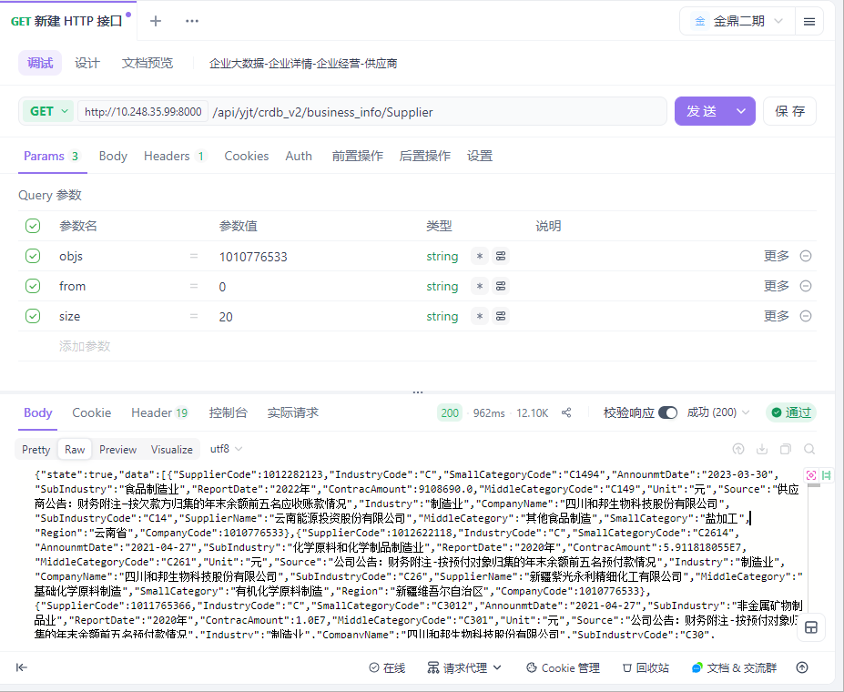

用例名称 | 企业大数据-企业详情-司法诉讼-司法案件
用例编号 | 43404
接口地址 | /api/yjt/crdb_v2/judicial_proceedings/judicial_lawsuit
请求方式 | get
前置条件 | 数据查询功能正常
描述 | 正常查询数据信息成功
请求头部 | Content-Type：text/plain;charset=UTF-8
请求参数 | objs=1010776533&from=0&size=20
状态码 | 200
预期返回结果 | {"state":true,"data":[{"Case identity":"民事一审-被告","Title":"某***、某***等合同纠纷的案件","CaseID":"398933852","CaseClosedOrNot":null,"LatestProgress":"民事一审","CaseReasonCode":"B0401","CaseType":"民事案件,管辖案件","LatestProcessDateType":"开庭日期","LatestProcessDate":"2025-07-18","CaseReason":"合同纠纷","TrialProcedureInfo":[{"CaseNo":"（2025）苏0281民初3077号","RelatedLitigationInfo":[{"sourceID":"70218877","DateType":"立案日期","LitigationInfoType":"立案信息","Date":"2025-02-11","CancelOrNot":0},{"sourceID":"124460517","DateType":"开庭日期","LitigationInfoType":"开庭公告","Date":"2025-03-20","CancelOrNot":0},{"sourceID":"127436613","DateType":"开庭日期","LitigationInfoType":"开庭公告","Date":"2025-06-10","CancelOrNot":0},{"sourceID":"129604401","DateType":"开庭日期","LitigationInfoType":"开庭公告","Date":"2025-07-18","CancelOrNot":0}],"TrialProcedure":"民事一审","PartyInfo":[{"LitigationStatus":"原告","CompanyID":"1012764982","Lname":"江苏安凯特科技股份有限公司","JudgmentResult":"","LitigationStatusCode":1},{"LitigationStatus":"被告","CompanyID":"1011887874","Lname":"乐山和邦农业科技有限公司","JudgmentResult":"","LitigationStatusCode":2},{"LitigationStatus":"被告","CompanyID":"1010776533","Lname":"四川和邦生物科技股份有限公司","JudgmentResult":"","LitigationStatusCode":2}],"CaseNoBasis":null,"Court":"江阴市人民法院"},{"CaseNo":"（2025）苏02民辖终189号","RelatedLitigationInfo":[{"sourceID":"160954196","DateType":"裁判日期","LitigationInfoType":"民事裁定书","Date":"2025-04-22","CancelOrNot":0}],"TrialProcedure":"民事管辖上诉","PartyInfo":[{"LitigationStatus":"上诉人（原审被告）","CompanyID":null,"Lname":"某***","JudgmentResult":"5","LitigationStatusCode":5},{"LitigationStatus":"被上诉人（原审原告）","CompanyID":null,"Lname":"某***","JudgmentResult":"102","LitigationStatusCode":6},{"LitigationStatus":"当事人","CompanyID":null,"Lname":"某***","JudgmentResult":null,"LitigationStatusCode":10},{"LitigationStatus":"当事人","CompanyID":null,"Lname":"某***","JudgmentResult":null,"LitigationStatusCode":10},{"LitigationStatus":"当事人","CompanyID":null,"Lname":"某***","JudgmentResult":null,"LitigationStatusCode":10}],"CaseNoBasis":null,"Court":"江苏省无锡市中级人民法院"}],"AmountInvolved":null,"LatestProgressCode":1},{"Case identity":"财产保全执行-当事人","Title":"江苏安凯特科技股份有限公司等财产保全执行案件","CaseID":"401019165","CaseClosedOrNot":null,"LatestProgress":"财产保全执行","CaseReasonCode":"Z3002","CaseType":"执行案件","LatestProcessDateType":"立案日期","LatestProcessDate":"2024-12-04","CaseReason":"财产保全执行案件","TrialProcedureInfo":[{"CaseNo":"（2024）苏0281执保10932号","RelatedLitigationInfo":[{"sourceID":"70218875","DateType":"立案日期","LitigationInfoType":"立案信息","Date":"2024-12-04","CancelOrNot":0}],"TrialProcedure":"财产保全执行","PartyInfo":[{"LitigationStatus":"当事人","CompanyID":"1011887874","Lname":"乐山和邦农业科技有限公司","JudgmentResult":"","LitigationStatusCode":10},{"LitigationStatus":"当事人","CompanyID":"1012764982","Lname":"江苏安凯特科技股份有限公司","JudgmentResult":"","LitigationStatusCode":10},{"LitigationStatus":"当事人","CompanyID":"1010776533","Lname":"四川和邦生物科技股份有限公司","JudgmentResult":"","LitigationStatusCode":10}],"CaseNoBasis":null,"Court":"江阴市人民法院"}],"AmountInvolved":null,"LatestProgressCode":12},{"Case identity":"其他审判程序-被告","Title":"江苏安凯特科技股份有限公司与乐山和邦农业科技有限公司等其他类型纠纷","CaseID":"401019164","CaseClosedOrNot":null,"LatestProgress":"其他审判程序","CaseReasonCode":null,"CaseType":"其他案件","LatestProcessDateType":"立案日期","LatestProcessDate":"2024-11-29","CaseReason":"其他类型纠纷","TrialProcedureInfo":[{"CaseNo":"（2024）苏0281诉前调18493号","RelatedLitigationInfo":[{"sourceID":"70218874","DateType":"立案日期","LitigationInfoType":"立案信息","Date":"2024-11-29","CancelOrNot":0}],"TrialProcedure":"其他审判程序","PartyInfo":[{"LitigationStatus":"原告","CompanyID":"1012764982","Lname":"江苏安凯特科技股份有限公司","JudgmentResult":"","LitigationStatusCode":1},{"LitigationStatus":"被告","CompanyID":"1011887874","Lname":"乐山和邦农业科技有限公司","JudgmentResult":"","LitigationStatusCode":2},{"LitigationStatus":"被告","CompanyID":"1010776533","Lname":"四川和邦生物科技股份有限公司","JudgmentResult":"","LitigationStatusCode":2}],"CaseNoBasis":null,"Court":"江阴市人民法院"}],"AmountInvolved":null,"LatestProgressCode":200},{"Case identity":"民事二审-当事人","Title":"毕节明钧玻璃股份有限公司等买卖合同纠纷的案件","CaseID":"382490014","CaseClosedOrNot":null,"LatestProgress":"民事二审","CaseReasonCode":"B040109","CaseType":"民事案件","LatestProcessDateType":"开庭日期","LatestProcessDate":"2024-09-13","CaseReason":"买卖合同纠纷","TrialProcedureInfo":[{"CaseNo":"（2024）川11民终1442号","RelatedLitigationInfo":[{"sourceID":"69139438","DateType":"立案日期","LitigationInfoType":"立案信息","Date":"2024-08-27","CancelOrNot":0},{"sourceID":"119729856","DateType":"开庭日期","LitigationInfoType":"开庭公告","Date":"2024-09-13","CancelOrNot":0}],"TrialProcedure":"民事二审","PartyInfo":[{"LitigationStatus":"当事人","CompanyID":"1010971172","Lname":"毕节明钧玻璃股份有限公司","JudgmentResult":"","LitigationStatusCode":10},{"LitigationStatus":"当事人","CompanyID":"1010776533","Lname":"四川和邦生物科技股份有限公司","JudgmentResult":"","LitigationStatusCode":10}],"CaseNoBasis":null,"Court":"四川省乐山市中级人民法院"}],"AmountInvolved":null,"LatestProgressCode":2},{"Case identity":"民事一审-当事人","Title":"四川和邦生物科技股份有限公司等劳动争议的案件","CaseID":"375835035","CaseClosedOrNot":null,"LatestProgress":"民事一审","CaseReasonCode":"B0601","CaseType":"民事案件","LatestProcessDateType":"开庭日期","LatestProcessDate":"2024-07-18","CaseReason":"劳动争议","TrialProcedureInfo":[{"CaseNo":"（2024）川1112民初854号","RelatedLitigationInfo":[{"sourceID":"67714829","DateType":"立案日期","LitigationInfoType":"立案信息","Date":"2024-06-21","CancelOrNot":0},{"sourceID":"119339918","DateType":"开庭日期","LitigationInfoType":"开庭公告","Date":"2024-07-18","CancelOrNot":0}],"TrialProcedure":"民事一审","PartyInfo":[{"LitigationStatus":"当事人","CompanyID":null,"Lname":"周**","JudgmentResult":"","LitigationStatusCode":10},{"LitigationStatus":"当事人","CompanyID":"1010776533","Lname":"四川和邦生物科技股份有限公司","JudgmentResult":"","LitigationStatusCode":10}],"CaseNoBasis":null,"Court":"乐山市五通桥区人民法院"}],"AmountInvolved":null,"LatestProgressCode":1},{"Case identity":"民事一审-原告","Title":"四川和邦生物科技股份有限公司与毕***买卖合同纠纷","CaseID":"366576162","CaseClosedOrNot":null,"LatestProgress":"民事一审","CaseReasonCode":"B040109","CaseType":"民事案件","LatestProcessDateType":"开庭日期","LatestProcessDate":"2024-07-10","CaseReason":"买卖合同纠纷","TrialProcedureInfo":[{"CaseNo":"（2024）川1112民初41号","RelatedLitigationInfo":[{"sourceID":"66128794","DateType":"立案日期","LitigationInfoType":"立案信息","Date":"2024-01-04","CancelOrNot":0},{"sourceID":"114850066","DateType":"开庭日期","LitigationInfoType":"开庭公告","Date":"2024-05-28","CancelOrNot":0},{"sourceID":"119281040","DateType":"开庭日期","LitigationInfoType":"开庭公告","Date":"2024-07-10","CancelOrNot":0}],"TrialProcedure":"民事一审","PartyInfo":[{"LitigationStatus":"原告","CompanyID":"1010776533","Lname":"四川和邦生物科技股份有限公司","JudgmentResult":"","LitigationStatusCode":1},{"LitigationStatus":"被告","CompanyID":null,"Lname":"毕***","JudgmentResult":"","LitigationStatusCode":2},{"LitigationStatus":"当事人","CompanyID":"1010971172","Lname":"毕节明钧玻璃股份有限公司","JudgmentResult":"","LitigationStatusCode":10}],"CaseNoBasis":null,"Court":"乐山市五通桥区人民法院"}],"AmountInvolved":null,"LatestProgressCode":1},{"Case identity":"民事一审-当事人","Title":"四川三洲川化机核能压力容器制造有限公司等买卖合同纠纷的案件","CaseID":"374099103","CaseClosedOrNot":null,"LatestProgress":"民事一审","CaseReasonCode":"B040109","CaseType":"民事案件","LatestProcessDateType":"开庭日期","LatestProcessDate":"2024-07-09","CaseReason":"买卖合同纠纷","TrialProcedureInfo":[{"CaseNo":"（2024）川1112民初808号","RelatedLitigationInfo":[{"sourceID":"67083845","DateType":"立案日期","LitigationInfoType":"立案信息","Date":"2024-06-11","CancelOrNot":0},{"sourceID":"119273655","DateType":"开庭日期","LitigationInfoType":"开庭公告","Date":"2024-07-09","CancelOrNot":0}],"TrialProcedure":"民事一审","PartyInfo":[{"LitigationStatus":"当事人","CompanyID":"1010776533","Lname":"四川和邦生物科技股份有限公司","JudgmentResult":"","LitigationStatusCode":10},{"LitigationStatus":"当事人","CompanyID":"1011444566","Lname":"四川三洲川化机核能压力容器制造有限公司","JudgmentResult":"","LitigationStatusCode":10}],"CaseNoBasis":null,"Court":"乐山市五通桥区人民法院"}],"AmountInvolved":null,"LatestProgressCode":1},{"Case identity":"民事一审-当事人","Title":"豪发建设有限公司等劳务合同纠纷","CaseID":"373907917","CaseClosedOrNot":null,"LatestProgress":"民事一审","CaseReasonCode":"B040157","CaseType":"民事案件","LatestProcessDateType":"立案日期","LatestProcessDate":"2024-07-02","CaseReason":"劳务合同纠纷","TrialProcedureInfo":[{"CaseNo":"（2024）川1112民初920号","RelatedLitigationInfo":[{"sourceID":"66983564","DateType":"立案日期","LitigationInfoType":"立案信息","Date":"2024-07-02","CancelOrNot":0}],"TrialProcedure":"民事一审","PartyInfo":[{"LitigationStatus":"当事人","CompanyID":null,"Lname":"董**","JudgmentResult":"","LitigationStatusCode":10},{"LitigationStatus":"当事人","CompanyID":"1010776533","Lname":"四川和邦生物科技股份有限公司","JudgmentResult":"","LitigationStatusCode":10},{"LitigationStatus":"当事人","CompanyID":"1047007721","Lname":"豪发建设有限公司","JudgmentResult":"","LitigationStatusCode":10}],"CaseNoBasis":null,"Court":"乐山市五通桥区人民法院"}],"AmountInvolved":null,"LatestProgressCode":1},{"Case identity":"民事二审-当事人","Title":"四川和邦生物科技股份有限公司等买卖合同纠纷","CaseID":"369449963","CaseClosedOrNot":null,"LatestProgress":"民事二审","CaseReasonCode":"B040109","CaseType":"民事案件","LatestProcessDateType":"立案日期","LatestProcessDate":"2024-04-30","CaseReason":"买卖合同纠纷","TrialProcedureInfo":[{"CaseNo":"（2024）川11民终689号","RelatedLitigationInfo":[{"sourceID":"65936723","DateType":"立案日期","LitigationInfoType":"立案信息","Date":"2024-04-30","CancelOrNot":0}],"TrialProcedure":"民事二审","PartyInfo":[{"LitigationStatus":"当事人","CompanyID":null,"Lname":"张**","JudgmentResult":"","LitigationStatusCode":10},{"LitigationStatus":"当事人","CompanyID":"1010776533","Lname":"四川和邦生物科技股份有限公司","JudgmentResult":"","LitigationStatusCode":10}],"CaseNoBasis":null,"Court":"四川省乐山市中级人民法院"}],"AmountInvolved":null,"LatestProgressCode":2},{"Case identity":"民事一审-原告","Title":"乐山和邦农业科技有限公司等与乐山一拉得电网自动化有限公司产品责任纠纷","CaseID":"334821590","CaseClosedOrNot":null,"LatestProgress":"民事一审","CaseReasonCode":"B090109","CaseType":"民事案件","LatestProcessDateType":"开庭日期","LatestProcessDate":"2024-04-18","CaseReason":"产品责任纠纷","TrialProcedureInfo":[{"CaseNo":"（2023）川1112民初805号","RelatedLitigationInfo":[{"sourceID":"62440203","DateType":"立案日期","LitigationInfoType":"立案信息","Date":"2023-06-07","CancelOrNot":0},{"sourceID":"111983548","DateType":"开庭日期","LitigationInfoType":"开庭公告","Date":"2024-04-18","CancelOrNot":0}],"TrialProcedure":"民事一审","PartyInfo":[{"LitigationStatus":"原告","CompanyID":"1011887874","Lname":"乐山和邦农业科技有限公司","JudgmentResult":"","LitigationStatusCode":1},{"LitigationStatus":"原告","CompanyID":"1010776533","Lname":"四川和邦生物科技股份有限公司","JudgmentResult":"","LitigationStatusCode":1},{"LitigationStatus":"被告","CompanyID":"1011528603","Lname":"乐山一拉得电网自动化有限公司","JudgmentResult":"","LitigationStatusCode":2}],"CaseNoBasis":null,"Court":"乐山市五通桥区人民法院"}],"AmountInvolved":null,"LatestProgressCode":1},{"Case identity":"民事一审-原告","Title":"四川和邦生物科技股份有限公司与乐山一拉得电网自动化有限公司产品责任纠纷","CaseID":"335681025","CaseClosedOrNot":null,"LatestProgress":"民事一审","CaseReasonCode":"B090109","CaseType":"民事案件","LatestProcessDateType":"开庭日期","LatestProcessDate":"2023-12-20","CaseReason":"产品责任纠纷","TrialProcedureInfo":[{"CaseNo":"（2023）川1112民初804号","RelatedLitigationInfo":[{"sourceID":"63239235","DateType":"立案日期","LitigationInfoType":"立案信息","Date":"2023-06-07","CancelOrNot":0},{"sourceID":"107141321","DateType":"开庭日期","LitigationInfoType":"开庭公告","Date":"2023-12-20","CancelOrNot":0}],"TrialProcedure":"民事一审","PartyInfo":[{"LitigationStatus":"原告","CompanyID":"1010776533","Lname":"四川和邦生物科技股份有限公司","JudgmentResult":"","LitigationStatusCode":1},{"LitigationStatus":"被告","CompanyID":"1011528603","Lname":"乐山一拉得电网自动化有限公司","JudgmentResult":"","LitigationStatusCode":2}],"CaseNoBasis":null,"Court":"乐山市五通桥区人民法院"}],"AmountInvolved":null,"LatestProgressCode":1},{"Case identity":"民事一审-被告","Title":"江苏双达泵阀集团有限公司与四川和邦生物科技股份有限公司买卖合同纠纷","CaseID":"333687286","CaseClosedOrNot":null,"LatestProgress":"民事一审","CaseReasonCode":"B040109","CaseType":"民事案件","LatestProcessDateType":"开庭日期","LatestProcessDate":"2023-08-04","CaseReason":"买卖合同纠纷","TrialProcedureInfo":[{"CaseNo":"（2023）苏1282民初4734号","RelatedLitigationInfo":[{"sourceID":"102344938","DateType":"开庭日期","LitigationInfoType":"开庭公告","Date":"2023-08-04","CancelOrNot":0}],"TrialProcedure":"民事一审","PartyInfo":[{"LitigationStatus":"原告","CompanyID":"1013060859","Lname":"江苏双达泵阀集团有限公司","JudgmentResult":"","LitigationStatusCode":1},{"LitigationStatus":"被告","CompanyID":"1010776533","Lname":"四川和邦生物科技股份有限公司","JudgmentResult":"","LitigationStatusCode":2}],"CaseNoBasis":null,"Court":"靖江市人民法院"}],"AmountInvolved":null,"LatestProgressCode":1},{"Case identity":"民事一审-被告","Title":"成都嘉恒烨机电设备有限公司与四川和邦生物科技股份有限公司等买卖合同纠纷","CaseID":"334438176","CaseClosedOrNot":null,"LatestProgress":"民事一审","CaseReasonCode":"B040109","CaseType":"民事案件","LatestProcessDateType":"立案日期","LatestProcessDate":"2023-06-29","CaseReason":"买卖合同纠纷","TrialProcedureInfo":[{"CaseNo":"（2023）川1112民初872号","RelatedLitigationInfo":[{"sourceID":"62080749","DateType":"立案日期","LitigationInfoType":"立案信息","Date":"2023-06-29","CancelOrNot":0}],"TrialProcedure":"民事一审","PartyInfo":[{"LitigationStatus":"原告","CompanyID":"1027836837","Lname":"成都嘉恒烨机电设备有限公司","JudgmentResult":"","LitigationStatusCode":1},{"LitigationStatus":"被告","CompanyID":"1001482997","Lname":"四川和邦生物科技股份有限公司营养剂分公司","JudgmentResult":"","LitigationStatusCode":2},{"LitigationStatus":"被告","CompanyID":"1010776533","Lname":"四川和邦生物科技股份有限公司","JudgmentResult":"","LitigationStatusCode":2}],"CaseNoBasis":null,"Court":"乐山市五通桥区人民法院"}],"AmountInvolved":null,"LatestProgressCode":1},{"Case identity":"民事一审-被告","Title":"东方电气启能(深圳)科技有限公司与四川和邦生物科技股份有限公司买卖合同纠纷","CaseID":"311703931","CaseClosedOrNot":"已结案","LatestProgress":"民事一审","CaseReasonCode":"B040109","CaseType":"民事案件","LatestProcessDateType":"立案日期","LatestProcessDate":"2023-05-25","CaseReason":"买卖合同纠纷","TrialProcedureInfo":[{"CaseNo":"（2023）川1112民初175号","RelatedLitigationInfo":[{"sourceID":"63492648","DateType":"立案日期","LitigationInfoType":"立案信息","Date":"2023-02-03","CancelOrNot":0},{"sourceID":"92923821","DateType":"开庭日期","LitigationInfoType":"开庭公告","Date":"2023-02-21","CancelOrNot":0},{"sourceID":"27619141","DateType":"立案日期","LitigationInfoType":"被执行人","Date":"2023-05-25","CancelOrNot":1}],"TrialProcedure":"民事一审","PartyInfo":[{"LitigationStatus":"原告","CompanyID":"1009869703","Lname":"深圳东方锅炉控制有限公司","JudgmentResult":"","LitigationStatusCode":1},{"LitigationStatus":"被告","CompanyID":"1010776533","Lname":"四川和邦生物科技股份有限公司","JudgmentResult":"","LitigationStatusCode":2}],"CaseNoBasis":null,"Court":"乐山市五通桥区人民法院"}],"AmountInvolved":null,"LatestProgressCode":1},{"Case identity":"民事一审-被告","Title":"成都中大化工有限责任公司与四川和邦生物科技股份有限公司等买卖合同纠纷","CaseID":"325239290","CaseClosedOrNot":"已结案","LatestProgress":"民事一审","CaseReasonCode":"B040109","CaseType":"民事案件","LatestProcessDateType":"开庭日期","LatestProcessDate":"2023-04-06","CaseReason":"买卖合同纠纷","TrialProcedureInfo":[{"CaseNo":"（2023）川1112民初425号","RelatedLitigationInfo":[{"sourceID":"64001520","DateType":"立案日期","LitigationInfoType":"立案信息","Date":"2023-03-15","CancelOrNot":0},{"sourceID":"99896677","DateType":"开庭日期","LitigationInfoType":"开庭公告","Date":"2023-04-06","CancelOrNot":0}],"TrialProcedure":"民事一审","PartyInfo":[{"LitigationStatus":"原告","CompanyID":"1030186353","Lname":"成都中大化工有限责任公司","JudgmentResult":"","LitigationStatusCode":1},{"LitigationStatus":"被告","CompanyID":"1001482997","Lname":"四川和邦生物科技股份有限公司营养剂分公司","JudgmentResult":"","LitigationStatusCode":2},{"LitigationStatus":"被告","CompanyID":"1010776533","Lname":"四川和邦生物科技股份有限公司","JudgmentResult":"","LitigationStatusCode":2}],"CaseNoBasis":null,"Court":"乐山市五通桥区人民法院"}],"AmountInvolved":null,"LatestProgressCode":1},{"Case identity":"民事一审-被告","Title":"重庆市通信产业服务有限公司与四川和邦生物科技股份有限公司等承揽合同纠纷","CaseID":"325758069","CaseClosedOrNot":"已结案","LatestProgress":"民事一审","CaseReasonCode":"B040134","CaseType":"民事案件","LatestProcessDateType":"立案日期","LatestProcessDate":"2023-03-29","CaseReason":"承揽合同纠纷","TrialProcedureInfo":[{"CaseNo":"（2022）川1112民初1073号","RelatedLitigationInfo":[{"sourceID":"62951838","DateType":"立案日期","LitigationInfoType":"立案信息","Date":"2022-10-19","CancelOrNot":0},{"sourceID":"100112424","DateType":"开庭日期","LitigationInfoType":"开庭公告","Date":"2022-12-14","CancelOrNot":0},{"sourceID":"27010909","DateType":"立案日期","LitigationInfoType":"被执行人","Date":"2023-03-29","CancelOrNot":1},{"sourceID":"27010784","DateType":"立案日期","LitigationInfoType":"被执行人","Date":"2023-03-29","CancelOrNot":1}],"TrialProcedure":"民事一审","PartyInfo":[{"LitigationStatus":"原告","CompanyID":"1010739308","Lname":"重庆市通信产业服务有限公司","JudgmentResult":"","LitigationStatusCode":1},{"LitigationStatus":"被告","CompanyID":"1001482997","Lname":"四川和邦生物科技股份有限公司营养剂分公司","JudgmentResult":"","LitigationStatusCode":2},{"LitigationStatus":"被告","CompanyID":"1010776533","Lname":"四川和邦生物科技股份有限公司","JudgmentResult":"","LitigationStatusCode":2}],"CaseNoBasis":null,"Court":"乐山市五通桥区人民法院"}],"AmountInvolved":null,"LatestProgressCode":1},{"Case identity":"民事一审-被告","Title":"大连深蓝泵业有限公司与四川和邦生物科技股份有限公司等买卖合同纠纷","CaseID":"335349660","CaseClosedOrNot":"已结案","LatestProgress":"民事一审","CaseReasonCode":"B040109","CaseType":"民事案件","LatestProcessDateType":"立案日期","LatestProcessDate":"2023-03-27","CaseReason":"买卖合同纠纷","TrialProcedureInfo":[{"CaseNo":"（2023）川1112民初489号","RelatedLitigationInfo":[{"sourceID":"62902941","DateType":"立案日期","LitigationInfoType":"立案信息","Date":"2023-03-27","CancelOrNot":0}],"TrialProcedure":"民事一审","PartyInfo":[{"LitigationStatus":"原告","CompanyID":"1011523261","Lname":"大连深蓝泵业有限公司","JudgmentResult":"","LitigationStatusCode":1},{"LitigationStatus":"被告","CompanyID":"1001482997","Lname":"四川和邦生物科技股份有限公司营养剂分公司","JudgmentResult":"","LitigationStatusCode":2},{"LitigationStatus":"被告","CompanyID":"1010776533","Lname":"四川和邦生物科技股份有限公司","JudgmentResult":"","LitigationStatusCode":2}],"CaseNoBasis":null,"Court":"乐山市五通桥区人民法院"}],"AmountInvolved":null,"LatestProgressCode":1},{"Case identity":"民事一审-被告","Title":"大连深蓝泵业有限公司与四川和邦生物科技股份有限公司买卖合同纠纷","CaseID":"325067641","CaseClosedOrNot":"已结案","LatestProgress":"民事一审","CaseReasonCode":"B040109","CaseType":"民事案件","LatestProcessDateType":"开庭日期","LatestProcessDate":"2023-03-24","CaseReason":"买卖合同纠纷","TrialProcedureInfo":[{"CaseNo":"（2023）川1112民初211号","RelatedLitigationInfo":[{"sourceID":"62154083","DateType":"立案日期","LitigationInfoType":"立案信息","Date":"2023-02-07","CancelOrNot":0},{"sourceID":"99765817","DateType":"开庭日期","LitigationInfoType":"开庭公告","Date":"2023-03-24","CancelOrNot":0}],"TrialProcedure":"民事一审","PartyInfo":[{"LitigationStatus":"原告","CompanyID":"1011523261","Lname":"大连深蓝泵业有限公司","JudgmentResult":"","LitigationStatusCode":1},{"LitigationStatus":"被告","CompanyID":"1010776533","Lname":"四川和邦生物科技股份有限公司","JudgmentResult":"","LitigationStatusCode":2}],"CaseNoBasis":null,"Court":"乐山市五通桥区人民法院"}],"AmountInvolved":null,"LatestProgressCode":1},{"Case identity":"民事一审-被告","Title":"杨*与四川和邦生物科技股份有限公司劳动争议","CaseID":"335496289","CaseClosedOrNot":"已结案","LatestProgress":"民事一审","CaseReasonCode":"B0601","CaseType":"民事案件","LatestProcessDateType":"立案日期","LatestProcessDate":"2023-03-22","CaseReason":"劳动争议","TrialProcedureInfo":[{"CaseNo":"（2023）川1112民初485号","RelatedLitigationInfo":[{"sourceID":"63046370","DateType":"立案日期","LitigationInfoType":"立案信息","Date":"2023-03-22","CancelOrNot":0}],"TrialProcedure":"民事一审","PartyInfo":[{"LitigationStatus":"原告","CompanyID":null,"Lname":"杨*","JudgmentResult":"","LitigationStatusCode":1},{"LitigationStatus":"被告","CompanyID":"1010776533","Lname":"四川和邦生物科技股份有限公司","JudgmentResult":"","LitigationStatusCode":2}],"CaseNoBasis":null,"Court":"乐山市五通桥区人民法院"}],"AmountInvolved":null,"LatestProgressCode":1},{"Case identity":"民事二审-被上诉人","Title":"章**与四川和邦生物科技股份有限公司劳动争议","CaseID":"336535998","CaseClosedOrNot":"已结案","LatestProgress":"民事二审","CaseReasonCode":"B0601","CaseType":"民事案件","LatestProcessDateType":"立案日期","LatestProcessDate":"2023-02-06","CaseReason":"劳动争议","TrialProcedureInfo":[{"CaseNo":"（2023）川11民终220号","RelatedLitigationInfo":[{"sourceID":"64039937","DateType":"立案日期","LitigationInfoType":"立案信息","Date":"2023-02-06","CancelOrNot":0}],"TrialProcedure":"民事二审","PartyInfo":[{"LitigationStatus":"上诉人","CompanyID":null,"Lname":"章**","JudgmentResult":"","LitigationStatusCode":5},{"LitigationStatus":"被上诉人","CompanyID":"1010776533","Lname":"四川和邦生物科技股份有限公司","JudgmentResult":"","LitigationStatusCode":6}],"CaseNoBasis":null,"Court":"四川省乐山市中级人民法院"}],"AmountInvolved":null,"LatestProgressCode":2}],"traceId":"692024e4fe62224e3135c165"}
实际结果 | 与预期结果一致  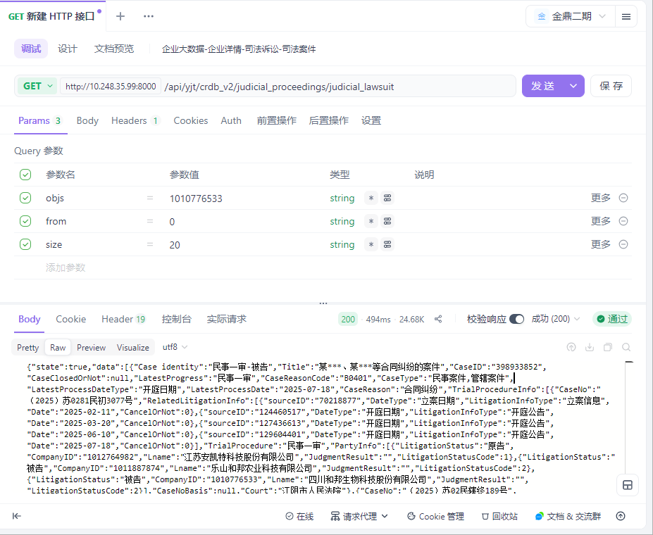

用例名称 | 企业大数据-企业详情-司法诉讼-裁判文书
用例编号 | 43405
接口地址 | /api/yjt/crdb_v2/judicial_proceedings/judicial_lawsuit
请求方式 | get
前置条件 | 数据查询功能正常
描述 | 正常查询数据信息成功
请求头部 | Content-Type：text/plain;charset=UTF-8
请求参数 | objs=1010776533&from=0&size=20
状态码 | 200
预期返回结果 | {"state":true,"data":[{"PublishDate":"2025-04-16","CourtClerk":"杜永琰","TrialProcedureCode":1,"PrimaryCaseReason":"劳动争议、人事争议","CaseID":396447466,"CaseAmount":null,"Court":"乐山市五通桥区人民法院","CaseNo":"（2025）川1112民初31号","CaseTypeCode":"B","PrimaryCaseNo":null,"CaseReasonCode":"B0601","JudgeDate":"2025-02-28","PrimaryCaseReasonCode":"B06","JudgeDocInfo":"D1DD04BA-AD5C-4186-93BD-4103313F43EE","ID":159703107,"OpenOrNot":"公开文书","DocType":"判决书","Title":"鄢某;四川某某有限公司劳动争议一审民事判决书","PartyInfo":[{"CompanyID":"1010776533","LitigationStatus":"被告","Lname":"四川和邦生物科技股份有限公司","LnameAmountInvolved":null,"JudgmentResult":null,"LitigationStatusCode":2},{"CompanyID":null,"LitigationStatus":"原告","Lname":"鄢*","LnameAmountInvolved":null,"JudgmentResult":"获得部分支持","LitigationStatusCode":1}],"DocTypeCode":"101","CaseClosedOrNot":null,"SecondCaseNo":null,"TrialProcedure":"民事一审","CaseType":"民事案件","CaseReason":"劳动争议","ChiefJudge":null},{"PublishDate":"2024-08-30","CourtClerk":"叶玉平","TrialProcedureCode":1,"PrimaryCaseReason":"合同、准合同纠纷","CaseID":251726975,"CaseAmount":"72,000.00","Court":"乐山市五通桥区人民法院","CaseNo":"（2021）川1112民初1222号","CaseTypeCode":"B","PrimaryCaseNo":null,"CaseReasonCode":"B040109","JudgeDate":"2022-01-17","PrimaryCaseReasonCode":"B04","JudgeDocInfo":"0027D47A-1DE7-4316-9E78-C96A44EF6CE9","ID":154901949,"OpenOrNot":"公开文书","DocType":"判决书","Title":"潍坊某公司、四川某公司买卖合同纠纷民事一审民事判决书","PartyInfo":[{"CompanyID":"1010776533","LitigationStatus":"被告（反诉原告）","Lname":"四川和邦生物科技股份有限公司","LnameAmountInvolved":"45,846.16","JudgmentResult":"获得部分支持","LitigationStatusCode":2},{"CompanyID":"1039456171","LitigationStatus":"原告（反诉被告）","Lname":"潍坊恒基磁电机械有限公司","LnameAmountInvolved":null,"JudgmentResult":"获得部分支持","LitigationStatusCode":1}],"DocTypeCode":"101","CaseClosedOrNot":"已结案","SecondCaseNo":null,"TrialProcedure":"民事一审","CaseType":"民事案件","CaseReason":"买卖合同纠纷","ChiefJudge":null},{"PublishDate":"2022-08-29","CourtClerk":"潘志琴","TrialProcedureCode":2,"PrimaryCaseReason":"合同、准合同纠纷","CaseID":251726975,"CaseAmount":null,"Court":"四川省乐山市中级人民法院","CaseNo":"（2022）川11民终825号","CaseTypeCode":"B","PrimaryCaseNo":"（2021）川1112民初1222号","CaseReasonCode":"B040109","JudgeDate":"2022-04-29","PrimaryCaseReasonCode":"B04","JudgeDocInfo":"72D7FF0C-85C6-4E4C-98CB-3F8EB2D2B629","ID":140807255,"OpenOrNot":"公开文书","DocType":"裁定书","Title":"潍坊恒基磁电机械有限公司、四川和邦生物科技股份有限公司买卖合同纠纷民事二审民事裁定书","PartyInfo":[{"CompanyID":"1010776533","LitigationStatus":"被上诉人（原审被告、原审反诉原告）","Lname":"四川和邦生物科技股份有限公司","LnameAmountInvolved":null,"JudgmentResult":"对方撤诉","LitigationStatusCode":6},{"CompanyID":"1039456171","LitigationStatus":"上诉人（原审原告、原审反诉被告）","Lname":"潍坊恒基磁电机械有限公司","LnameAmountInvolved":null,"JudgmentResult":"撤诉","LitigationStatusCode":5}],"DocTypeCode":"102","CaseClosedOrNot":"已结案","SecondCaseNo":null,"TrialProcedure":"民事二审","CaseType":"民事案件","CaseReason":"买卖合同纠纷","ChiefJudge":"周文勤"},{"PublishDate":"2022-01-01","CourtClerk":"胡寒瑜","TrialProcedureCode":1,"PrimaryCaseReason":"合同、准合同纠纷","CaseID":145008048,"CaseAmount":"554,000.00","Court":"乐山市五通桥区人民法院","CaseNo":"（2021）川1112民初137号","CaseTypeCode":"B","PrimaryCaseNo":null,"CaseReasonCode":"B040109","JudgeDate":"2021-04-06","PrimaryCaseReasonCode":"B04","JudgeDocInfo":"9C3E8E3B-57A6-470C-A9E0-0BC422E19C7E","ID":133530096,"OpenOrNot":"公开文书","DocType":"判决书","Title":"上海苏尔寿工程机械制造有限公司与四川和邦生物科技股份有限公司营养剂分公司、四川和邦生物科技股份有限公司买卖合同纠纷一审民事判决书","PartyInfo":[{"CompanyID":"1010776533","LitigationStatus":"被告","Lname":"四川和邦生物科技股份有限公司","LnameAmountInvolved":null,"JudgmentResult":"不被支持","LitigationStatusCode":2},{"CompanyID":"1001048127","LitigationStatus":"原告","Lname":"上海苏尔寿工程机械制造有限公司","LnameAmountInvolved":null,"JudgmentResult":"获得支持","LitigationStatusCode":1},{"CompanyID":"1001482997","LitigationStatus":"被告","Lname":"四川和邦生物科技股份有限公司营养剂分公司","LnameAmountInvolved":null,"JudgmentResult":"不被支持","LitigationStatusCode":2}],"DocTypeCode":"101","CaseClosedOrNot":"已结案","SecondCaseNo":null,"TrialProcedure":"民事一审","CaseType":"民事案件","CaseReason":"买卖合同纠纷","ChiefJudge":null},{"PublishDate":"2021-12-29","CourtClerk":"章凤","TrialProcedureCode":18,"PrimaryCaseReason":"合同、准合同纠纷","CaseID":147623885,"CaseAmount":null,"Court":"乐山市五通桥区人民法院","CaseNo":"（2021）川1112执679号","CaseTypeCode":"E","PrimaryCaseNo":null,"CaseReasonCode":"B040109","JudgeDate":"2021-12-13","PrimaryCaseReasonCode":"B04","JudgeDocInfo":"44BC2637-ACFC-4BE6-9C0B-36F947D218F0","ID":133022184,"OpenOrNot":"公开文书","DocType":"裁定书","Title":"梅特勒-托利多国际贸易（上海）有限公司、四川和邦生物科技股份有限公司营养剂分公司等买卖合同纠纷首次执行执行裁定书","PartyInfo":[{"CompanyID":"1010776533","LitigationStatus":"被执行人","Lname":"四川和邦生物科技股份有限公司","LnameAmountInvolved":null,"JudgmentResult":"被终结执行","LitigationStatusCode":8},{"CompanyID":"1001482997","LitigationStatus":"被执行人","Lname":"四川和邦生物科技股份有限公司营养剂分公司","LnameAmountInvolved":null,"JudgmentResult":"被终结执行","LitigationStatusCode":8},{"CompanyID":"1020155624","LitigationStatus":"申请执行人","Lname":"梅特勒-托利多国际贸易（上海）有限公司","LnameAmountInvolved":null,"JudgmentResult":null,"LitigationStatusCode":7}],"DocTypeCode":"102","CaseClosedOrNot":"已结案","SecondCaseNo":null,"TrialProcedure":"首次执行","CaseType":"执行案件","CaseReason":"买卖合同纠纷","ChiefJudge":null},{"PublishDate":"2021-12-09","CourtClerk":"蒋玮","TrialProcedureCode":1,"PrimaryCaseReason":"合同、准合同纠纷","CaseID":148811378,"CaseAmount":null,"Court":"泰州市姜堰区人民法院","CaseNo":"（2021）苏1204民初1627号","CaseTypeCode":"B","PrimaryCaseNo":null,"CaseReasonCode":"B040109","JudgeDate":"2021-06-25","PrimaryCaseReasonCode":"B04","JudgeDocInfo":"52969FF5-B7E2-4897-9E3F-B56D278B95AB","ID":131124180,"OpenOrNot":"公开文书","DocType":"裁定书","Title":"江苏瑞能防腐设备有限公司、四川和邦生物科技股份有限公司等买卖合同纠纷民事一审民事裁定书","PartyInfo":[{"CompanyID":"1010776533","LitigationStatus":"被告","Lname":"四川和邦生物科技股份有限公司","LnameAmountInvolved":null,"JudgmentResult":"对方撤诉","LitigationStatusCode":2},{"CompanyID":"1000725522","LitigationStatus":"原告","Lname":"江苏瑞能防腐设备有限公司","LnameAmountInvolved":null,"JudgmentResult":"撤诉","LitigationStatusCode":1},{"CompanyID":"1001482997","LitigationStatus":"被告","Lname":"四川和邦生物科技股份有限公司营养剂分公司","LnameAmountInvolved":null,"JudgmentResult":"对方撤诉","LitigationStatusCode":2}],"DocTypeCode":"102","CaseClosedOrNot":"已结案","SecondCaseNo":null,"TrialProcedure":"民事一审","CaseType":"民事案件","CaseReason":"买卖合同纠纷","ChiefJudge":null},{"PublishDate":"2021-12-07","CourtClerk":null,"TrialProcedureCode":18,"PrimaryCaseReason":"合同、准合同纠纷","CaseID":144712690,"CaseAmount":null,"Court":"乐山市五通桥区人民法院","CaseNo":"（2021）川1112执517号","CaseTypeCode":"E","PrimaryCaseNo":null,"CaseReasonCode":"B040109","JudgeDate":"2021-11-24","PrimaryCaseReasonCode":"B04","JudgeDocInfo":"C981872B-C44D-46DB-B3A8-AF8944243E76","ID":130951561,"OpenOrNot":"公开文书","DocType":"通知书","Title":"压缩机有限公司、邦生物科技股份有限公司营养剂分公司等买卖合同纠纷首次执行执行通知书","PartyInfo":[{"CompanyID":"1010776533","LitigationStatus":"被执行人","Lname":"四川和邦生物科技股份有限公司","LnameAmountInvolved":null,"JudgmentResult":null,"LitigationStatusCode":8},{"CompanyID":"1012641729","LitigationStatus":"当事人","Lname":"大连苏尔寿泵及压缩机有限公司","LnameAmountInvolved":null,"JudgmentResult":null,"LitigationStatusCode":10},{"CompanyID":"1001482997","LitigationStatus":"被执行人","Lname":"四川和邦生物科技股份有限公司营养剂分公司","LnameAmountInvolved":null,"JudgmentResult":null,"LitigationStatusCode":8},{"CompanyID":null,"LitigationStatus":"当事人","Lname":"邦生物科技股份有限公司营养剂分公司","LnameAmountInvolved":null,"JudgmentResult":null,"LitigationStatusCode":10},{"CompanyID":null,"LitigationStatus":"当事人","Lname":"邦生物科技股份有限公司","LnameAmountInvolved":null,"JudgmentResult":null,"LitigationStatusCode":10},{"CompanyID":null,"LitigationStatus":"当事人","Lname":"压缩机有限公司","LnameAmountInvolved":null,"JudgmentResult":null,"LitigationStatusCode":10}],"DocTypeCode":"105","CaseClosedOrNot":"已结案","SecondCaseNo":null,"TrialProcedure":"首次执行","CaseType":"执行案件","CaseReason":"买卖合同纠纷","ChiefJudge":null},{"PublishDate":"2021-10-27","CourtClerk":"陆佳怡","TrialProcedureCode":1,"PrimaryCaseReason":"合同、准合同纠纷","CaseID":145922490,"CaseAmount":null,"Court":"上海市浦东新区人民法院","CaseNo":"（2021）沪0115民初66046号之一","CaseTypeCode":"B","PrimaryCaseNo":null,"CaseReasonCode":"B040109","JudgeDate":"2021-09-16","PrimaryCaseReasonCode":"B04","JudgeDocInfo":"41D8FA7B-07F0-4C5A-A198-D51555F00CA2","ID":129050804,"OpenOrNot":"公开文书","DocType":"裁定书","Title":"上海绿珑生物技术有限公司与四川和邦生物科技股份有限公司买卖合同纠纷民事一审案件民事裁定书","PartyInfo":[{"CompanyID":"1010776533","LitigationStatus":"被告","Lname":"四川和邦生物科技股份有限公司","LnameAmountInvolved":null,"JudgmentResult":"对方撤诉","LitigationStatusCode":2},{"CompanyID":"1046348908","LitigationStatus":"原告","Lname":"上海绿珑生物技术有限公司","LnameAmountInvolved":null,"JudgmentResult":"撤诉","LitigationStatusCode":1}],"DocTypeCode":"102","CaseClosedOrNot":"已结案","SecondCaseNo":null,"TrialProcedure":"民事一审","CaseType":"民事案件","CaseReason":"买卖合同纠纷","ChiefJudge":null},{"PublishDate":"2021-10-27","CourtClerk":"沈珺","TrialProcedureCode":1,"PrimaryCaseReason":"合同、准合同纠纷","CaseID":145924596,"CaseAmount":"5,832,000.00","Court":"上海市浦东新区人民法院","CaseNo":"（2021）沪0115民初66046号","CaseTypeCode":"B","PrimaryCaseNo":null,"CaseReasonCode":"B040109","JudgeDate":"2021-07-22","PrimaryCaseReasonCode":"B04","JudgeDocInfo":"26C95D39-AE83-4CC2-A275-EB34CDEAC30F","ID":129053972,"OpenOrNot":"公开文书","DocType":"裁定书","Title":"上海绿珑生物技术有限公司与四川和邦生物科技股份有限公司买卖合同纠纷民事一审案件民事裁定书","PartyInfo":[{"CompanyID":"1010776533","LitigationStatus":"被申请人","Lname":"四川和邦生物科技股份有限公司","LnameAmountInvolved":"5,832,000.00","JudgmentResult":"被冻结","LitigationStatusCode":4},{"CompanyID":"1046348908","LitigationStatus":"申请人","Lname":"上海绿珑生物技术有限公司","LnameAmountInvolved":null,"JudgmentResult":"获得支持","LitigationStatusCode":3}],"DocTypeCode":"102","CaseClosedOrNot":"已结案","SecondCaseNo":null,"TrialProcedure":"民事一审","CaseType":"民事案件","CaseReason":"买卖合同纠纷","ChiefJudge":null},{"PublishDate":"2021-10-11","CourtClerk":"胡寒瑜","TrialProcedureCode":1,"PrimaryCaseReason":"合同、准合同纠纷","CaseID":147622330,"CaseAmount":null,"Court":"乐山市五通桥区人民法院","CaseNo":"（2021）川1112民初966号","CaseTypeCode":"B","PrimaryCaseNo":null,"CaseReasonCode":"B040109","JudgeDate":"2021-09-30","PrimaryCaseReasonCode":"B04","JudgeDocInfo":"933EC9FF-A1AF-4E6E-93C2-24D77EBFF5C8","ID":128560980,"OpenOrNot":"公开文书","DocType":"裁定书","Title":"成都希望森兰电气有限公司、四川和邦生物科技股份有限公司营养剂分公司等买卖合同纠纷民事一审民事裁定书","PartyInfo":[{"CompanyID":"1010776533","LitigationStatus":"被告","Lname":"四川和邦生物科技股份有限公司","LnameAmountInvolved":null,"JudgmentResult":"对方撤诉","LitigationStatusCode":2},{"CompanyID":"1011028262","LitigationStatus":"原告","Lname":"成都希望森兰电气有限公司","LnameAmountInvolved":null,"JudgmentResult":"撤诉","LitigationStatusCode":1},{"CompanyID":"1001482997","LitigationStatus":"被告","Lname":"四川和邦生物科技股份有限公司营养剂分公司","LnameAmountInvolved":null,"JudgmentResult":"对方撤诉","LitigationStatusCode":2}],"DocTypeCode":"102","CaseClosedOrNot":"已结案","SecondCaseNo":null,"TrialProcedure":"民事一审","CaseType":"民事案件","CaseReason":"买卖合同纠纷","ChiefJudge":null},{"PublishDate":"2021-10-11","CourtClerk":"胡寒瑜","TrialProcedureCode":1,"PrimaryCaseReason":"合同、准合同纠纷","CaseID":147621474,"CaseAmount":"163,000.00","Court":"乐山市五通桥区人民法院","CaseNo":"（2021）川1112民初853号","CaseTypeCode":"B","PrimaryCaseNo":null,"CaseReasonCode":"B040109","JudgeDate":"2021-09-06","PrimaryCaseReasonCode":"B04","JudgeDocInfo":"980CF414-D44C-4011-85AF-67C907B9A0D3","ID":128559276,"OpenOrNot":"公开文书","DocType":"判决书","Title":"重庆开山一机节能设备有限公司、四川和邦生物科技股份有限公司买卖合同纠纷民事一审民事判决书","PartyInfo":[{"CompanyID":"1010776533","LitigationStatus":"被告","Lname":"四川和邦生物科技股份有限公司","LnameAmountInvolved":"163,000.00","JudgmentResult":"不被支持","LitigationStatusCode":2},{"CompanyID":"1001998848","LitigationStatus":"原告","Lname":"重庆开山一机节能设备有限公司","LnameAmountInvolved":null,"JudgmentResult":"获得支持","LitigationStatusCode":1}],"DocTypeCode":"101","CaseClosedOrNot":"已结案","SecondCaseNo":null,"TrialProcedure":"民事一审","CaseType":"民事案件","CaseReason":"买卖合同纠纷","ChiefJudge":null},{"PublishDate":"2021-10-11","CourtClerk":"何嘉利","TrialProcedureCode":1,"PrimaryCaseReason":"合同、准合同纠纷","CaseID":147623883,"CaseAmount":"417,592.31","Court":"乐山市五通桥区人民法院","CaseNo":"（2021）川1112民初718号","CaseTypeCode":"B","PrimaryCaseNo":null,"CaseReasonCode":"B040109","JudgeDate":"2021-08-27","PrimaryCaseReasonCode":"B04","JudgeDocInfo":"E7B4E51C-E06D-4365-9B66-67ADB7E1F231","ID":128562281,"OpenOrNot":"公开文书","DocType":"判决书","Title":"梅特勒-托利多国际贸易（上海）有限公司、四川和邦生物科技股份有限公司营养剂分公司等买卖合同纠纷民事一审民事判决书","PartyInfo":[{"CompanyID":"1010776533","LitigationStatus":"被告","Lname":"四川和邦生物科技股份有限公司","LnameAmountInvolved":null,"JudgmentResult":null,"LitigationStatusCode":2},{"CompanyID":"1020155624","LitigationStatus":"原告","Lname":"梅特勒-托利多国际贸易（上海）有限公司","LnameAmountInvolved":null,"JudgmentResult":"获得支持","LitigationStatusCode":1},{"CompanyID":"1001482997","LitigationStatus":"被告","Lname":"四川和邦生物科技股份有限公司营养剂分公司","LnameAmountInvolved":null,"JudgmentResult":"不被支持","LitigationStatusCode":2}],"DocTypeCode":"101","CaseClosedOrNot":"已结案","SecondCaseNo":null,"TrialProcedure":"民事一审","CaseType":"民事案件","CaseReason":"买卖合同纠纷","ChiefJudge":null},{"PublishDate":"2021-10-11","CourtClerk":"何嘉利","TrialProcedureCode":1,"PrimaryCaseReason":"合同、准合同纠纷","CaseID":153574721,"CaseAmount":"155,800.00","Court":"乐山市五通桥区人民法院","CaseNo":"（2021）川1112民初687号","CaseTypeCode":"B","PrimaryCaseNo":null,"CaseReasonCode":"B040109","JudgeDate":"2021-08-27","PrimaryCaseReasonCode":"B04","JudgeDocInfo":"82BCFEA0-FCCC-4201-B347-DAAB961249A0","ID":128561520,"OpenOrNot":"公开文书","DocType":"判决书","Title":"利欧集团湖南泵业有限公司、四川和邦生物科技股份有限公司买卖合同纠纷民事一审民事判决书","PartyInfo":[{"CompanyID":"1010776533","LitigationStatus":"被告","Lname":"四川和邦生物科技股份有限公司","LnameAmountInvolved":"155,800.00","JudgmentResult":"获得部分支持","LitigationStatusCode":2},{"CompanyID":"1011889690","LitigationStatus":"原告","Lname":"利欧集团湖南泵业有限公司","LnameAmountInvolved":null,"JudgmentResult":"获得部分支持","LitigationStatusCode":1}],"DocTypeCode":"101","CaseClosedOrNot":"已结案","SecondCaseNo":null,"TrialProcedure":"民事一审","CaseType":"民事案件","CaseReason":"买卖合同纠纷","ChiefJudge":null},{"PublishDate":"2021-09-27","CourtClerk":"雷越池","TrialProcedureCode":1,"PrimaryCaseReason":"合同、准合同纠纷","CaseID":147262601,"CaseAmount":null,"Court":"乐山市五通桥区人民法院","CaseNo":"（2021）川1112民初779号","CaseTypeCode":"B","PrimaryCaseNo":null,"CaseReasonCode":"B040109","JudgeDate":"2021-09-08","PrimaryCaseReasonCode":"B04","JudgeDocInfo":"9E86FB45-A455-4D9B-848C-41D63EF89427","ID":128120827,"OpenOrNot":"公开文书","DocType":"裁定书","Title":"眉山麦克在线设备股份有限公司、四川和邦生物科技有限公司营养剂分公司等买卖合同纠纷民事一审民事裁定书","PartyInfo":[{"CompanyID":"1010776533","LitigationStatus":"被告","Lname":"四川和邦生物科技股份有限公司","LnameAmountInvolved":null,"JudgmentResult":"对方撤诉","LitigationStatusCode":2},{"CompanyID":"1030823257","LitigationStatus":"原告","Lname":"眉山麦克在线设备股份有限公司","LnameAmountInvolved":null,"JudgmentResult":"撤诉","LitigationStatusCode":1},{"CompanyID":null,"LitigationStatus":"被告","Lname":"四川和邦生物科技有限公司营养剂分公司","LnameAmountInvolved":null,"JudgmentResult":"对方撤诉","LitigationStatusCode":2}],"DocTypeCode":"102","CaseClosedOrNot":"已结案","SecondCaseNo":null,"TrialProcedure":"民事一审","CaseType":"民事案件","CaseReason":"买卖合同纠纷","ChiefJudge":null},{"PublishDate":"2021-09-13","CourtClerk":"刘刈","TrialProcedureCode":1,"PrimaryCaseReason":"合同、准合同纠纷","CaseID":154396775,"CaseAmount":null,"Court":"乐山市五通桥区人民法院","CaseNo":"（2021）川1112民初619号","CaseTypeCode":"B","PrimaryCaseNo":null,"CaseReasonCode":"B040109","JudgeDate":"2021-08-02","PrimaryCaseReasonCode":"B04","JudgeDocInfo":"75432261-1137-4732-BA92-D88E30881446","ID":127525502,"OpenOrNot":"公开文书","DocType":"裁定书","Title":"北京中航化安全阀销售有限公司、四川和邦生物科技股份有限公司买卖合同纠纷民事一审民事裁定书","PartyInfo":[{"CompanyID":"1010776533","LitigationStatus":"被告","Lname":"四川和邦生物科技股份有限公司","LnameAmountInvolved":null,"JudgmentResult":"对方撤诉","LitigationStatusCode":2},{"CompanyID":"1005166280","LitigationStatus":"原告","Lname":"北京中航化安全阀销售有限公司","LnameAmountInvolved":null,"JudgmentResult":"撤诉","LitigationStatusCode":1}],"DocTypeCode":"102","CaseClosedOrNot":"已结案","SecondCaseNo":null,"TrialProcedure":"民事一审","CaseType":"民事案件","CaseReason":"买卖合同纠纷","ChiefJudge":null},{"PublishDate":"2021-08-15","CourtClerk":"耿蜀豫","TrialProcedureCode":28,"PrimaryCaseReason":"合同、准合同纠纷","CaseID":124648304,"CaseAmount":null,"Court":"四川省高级人民法院","CaseNo":"（2021）川民申1085号","CaseTypeCode":"B","PrimaryCaseNo":null,"CaseReasonCode":"B04013503","JudgeDate":"2021-05-17","PrimaryCaseReasonCode":"B04","JudgeDocInfo":"61D0377B-023C-4A84-81A1-BE8638DFB612","ID":126610289,"OpenOrNot":"公开文书","DocType":"裁定书","Title":"四川力百川环境治理有限公司、四川和邦生物科技股份有限公司建设工程施工合同纠纷再审审查与审判监督民事裁定书","PartyInfo":[{"CompanyID":"1010776533","LitigationStatus":"被申请人（一审被告、二审被上诉人）","Lname":"四川和邦生物科技股份有限公司","LnameAmountInvolved":null,"JudgmentResult":"对方被驳回","LitigationStatusCode":4},{"CompanyID":"1032601150","LitigationStatus":"再审申请人（一审原告、二审上诉人）","Lname":"四川力百川环境治理有限公司","LnameAmountInvolved":null,"JudgmentResult":"被驳回","LitigationStatusCode":3}],"DocTypeCode":"102","CaseClosedOrNot":"已结案","SecondCaseNo":"（2020）川11民终997号","TrialProcedure":"民事申请再审审查","CaseType":"民事案件","CaseReason":"建设工程施工合同纠纷","ChiefJudge":"文霁"},{"PublishDate":"2021-07-29","CourtClerk":"颜微","TrialProcedureCode":14,"PrimaryCaseReason":"合同、准合同纠纷","CaseID":23092106,"CaseAmount":null,"Court":"四川省高级人民法院","CaseNo":"（2020）川执监148号","CaseTypeCode":"E","PrimaryCaseNo":null,"CaseReasonCode":"B040109","JudgeDate":"2021-02-05","PrimaryCaseReasonCode":"B04","JudgeDocInfo":"3E0738E3-716A-45B0-BE9C-BA94653ABB8F","ID":126024993,"OpenOrNot":"公开文书","DocType":"裁定书","Title":"云南云内动力集团有限公司、四川和邦生物科技股份有限公司其他案由执行审查类执行裁定书","PartyInfo":[{"CompanyID":"1010776533","LitigationStatus":"申请执行人","Lname":"四川和邦生物科技股份有限公司","LnameAmountInvolved":null,"JudgmentResult":"撤销原判","LitigationStatusCode":7},{"CompanyID":"1011862838","LitigationStatus":"被执行人","Lname":"昆明玻璃股份有限公司","LnameAmountInvolved":null,"JudgmentResult":"撤销原判","LitigationStatusCode":8}],"DocTypeCode":"102","CaseClosedOrNot":"已结案","SecondCaseNo":null,"TrialProcedure":"执行监督","CaseType":"执行案件","CaseReason":"买卖合同纠纷","ChiefJudge":"胡廷俐"},{"PublishDate":"2021-07-27","CourtClerk":null,"TrialProcedureCode":18,"PrimaryCaseReason":"合同、准合同纠纷","CaseID":145568406,"CaseAmount":null,"Court":"乐山市五通桥区人民法院","CaseNo":"（2021）川1112执287号","CaseTypeCode":"E","PrimaryCaseNo":null,"CaseReasonCode":"B040109","JudgeDate":"2021-07-05","PrimaryCaseReasonCode":"B04","JudgeDocInfo":"CB1772A2-99DD-4D17-8376-ADC790AD37E4","ID":125859559,"OpenOrNot":"公开文书","DocType":"通知书","Title":"四川和邦生物科技股份有限公司营养剂分公司,四川和邦生物科技股份有限公司,阿姆斯壮机械（中国）有限公司买卖合同纠纷执行实施类执行通知书","PartyInfo":[{"CompanyID":"1010776533","LitigationStatus":"当事人","Lname":"四川和邦生物科技股份有限公司","LnameAmountInvolved":null,"JudgmentResult":null,"LitigationStatusCode":10},{"CompanyID":"1001482997","LitigationStatus":"当事人","Lname":"四川和邦生物科技股份有限公司营养剂分公司","LnameAmountInvolved":null,"JudgmentResult":null,"LitigationStatusCode":10},{"CompanyID":"1017897842","LitigationStatus":"申请执行人","Lname":"阿姆斯壮机械（中国）有限公司","LnameAmountInvolved":null,"JudgmentResult":"撤销原判","LitigationStatusCode":7}],"DocTypeCode":"105","CaseClosedOrNot":"已结案","SecondCaseNo":null,"TrialProcedure":"首次执行","CaseType":"执行案件","CaseReason":"买卖合同纠纷","ChiefJudge":null},{"PublishDate":"2021-07-22","CourtClerk":"雷越池","TrialProcedureCode":1,"PrimaryCaseReason":"合同、准合同纠纷","CaseID":144756620,"CaseAmount":"304,573.98","Court":"乐山市五通桥区人民法院","CaseNo":"（2021）川1112民初298号","CaseTypeCode":"B","PrimaryCaseNo":null,"CaseReasonCode":"B040109","JudgeDate":"2021-05-27","PrimaryCaseReasonCode":"B04","JudgeDocInfo":"05BF5E91-A9F5-4B2A-A132-31AB622579A8","ID":125749333,"OpenOrNot":"公开文书","DocType":"判决书","Title":"上海思源高压开关有限公司与四川和邦生物科技股份有限公司营养剂分公司、四川和邦生物科技股份有限公司买卖合同纠纷一审民事判决书","PartyInfo":[{"CompanyID":"1010776533","LitigationStatus":"被告","Lname":"四川和邦生物科技股份有限公司","LnameAmountInvolved":null,"JudgmentResult":null,"LitigationStatusCode":2},{"CompanyID":"1001299717","LitigationStatus":"原告（反诉被告）","Lname":"上海思源高压开关有限公司","LnameAmountInvolved":null,"JudgmentResult":"获得部分支持","LitigationStatusCode":1},{"CompanyID":"1001482997","LitigationStatus":"被告（反诉原告）","Lname":"四川和邦生物科技股份有限公司营养剂分公司","LnameAmountInvolved":null,"JudgmentResult":"获得部分支持","LitigationStatusCode":2}],"DocTypeCode":"101","CaseClosedOrNot":"已结案","SecondCaseNo":null,"TrialProcedure":"民事一审","CaseType":"民事案件","CaseReason":"买卖合同纠纷","ChiefJudge":null},{"PublishDate":"2021-07-21","CourtClerk":"何嘉利","TrialProcedureCode":1,"PrimaryCaseReason":"合同、准合同纠纷","CaseID":144712690,"CaseAmount":"597,271.86","Court":"乐山市五通桥区人民法院","CaseNo":"（2021）川1112民初275号","CaseTypeCode":"B","PrimaryCaseNo":null,"CaseReasonCode":"B040109","JudgeDate":"2021-05-18","PrimaryCaseReasonCode":"B04","JudgeDocInfo":"05D33C51-C5CE-48B5-B694-256949700889","ID":125669547,"OpenOrNot":"公开文书","DocType":"判决书","Title":"大连苏尔寿泵及压缩机有限公司与四川和邦生物科技股份有限公司营养剂分公司、四川和邦生物科技股份有限公司买卖合同纠纷一审民事判决书","PartyInfo":[{"CompanyID":"1010776533","LitigationStatus":"被告","Lname":"四川和邦生物科技股份有限公司","LnameAmountInvolved":null,"JudgmentResult":null,"LitigationStatusCode":2},{"CompanyID":"1001482997","LitigationStatus":"被告","Lname":"四川和邦生物科技股份有限公司营养剂分公司","LnameAmountInvolved":null,"JudgmentResult":"获得部分支持","LitigationStatusCode":2},{"CompanyID":"1012641729","LitigationStatus":"原告","Lname":"大连苏尔寿泵及压缩机有限公司","LnameAmountInvolved":null,"JudgmentResult":"获得部分支持","LitigationStatusCode":1}],"DocTypeCode":"101","CaseClosedOrNot":"已结案","SecondCaseNo":null,"TrialProcedure":"民事一审","CaseType":"民事案件","CaseReason":"买卖合同纠纷","ChiefJudge":null}],"traceId":"69202564fe62224e3135c206"}
实际结果 | 与预期结果一致  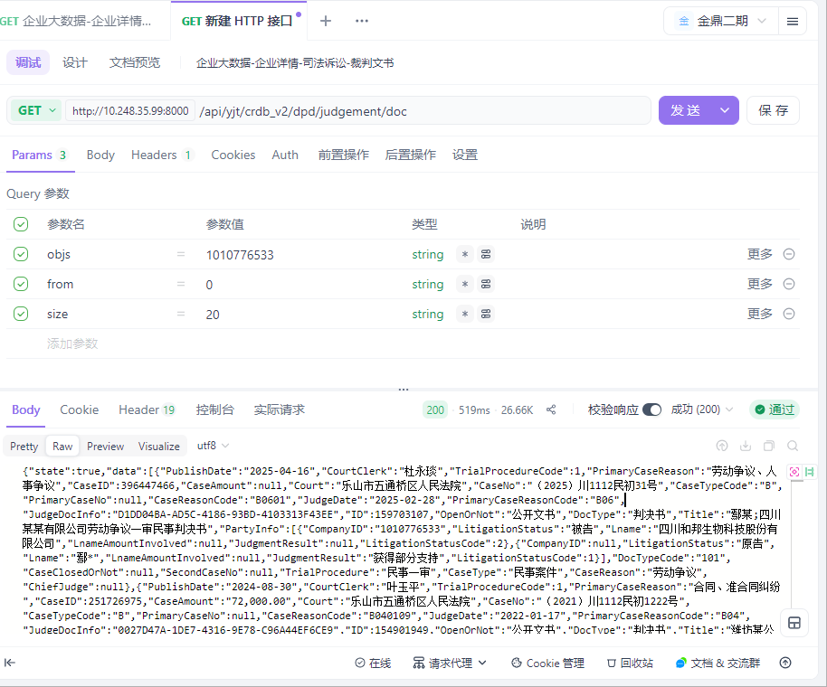

用例名称 | 企业大数据-企业详情-司法诉讼-立案信息
用例编号 | 43406
接口地址 | /api/yjt/crdb_v2/dpd/litigation/case_info_list
请求方式 | get
前置条件 | 数据查询功能正常
描述 | 正常查询数据信息成功
请求头部 | Content-Type：text/plain;charset=UTF-8
请求参数 | objs=1010776533&from=0&size=20
状态码 | 200
预期返回结果 | {"state":true,"data":[{"Filingdate":"2025-02-11","TrialProcedureCode":1,"Sector":null,"Courtdate":null,"CaseID":398933852,"PartyInfo":[{"LitigationStatus":"原告","CompanyID":"1012764982","Lname":"江苏安凯特科技股份有限公司","JudgmentResult":null,"LitigationStatusCode":1},{"LitigationStatus":"被告","CompanyID":"1010776533","Lname":"四川和邦生物科技股份有限公司","JudgmentResult":null,"LitigationStatusCode":2},{"LitigationStatus":"被告","CompanyID":"1011887874","Lname":"乐山和邦农业科技有限公司","JudgmentResult":null,"LitigationStatusCode":2}],"CaseClosedOrNot":"已结案","Court":"江阴市人民法院","CaseNo":"（2025）苏0281民初3077号","Closedate":null,"CaseTypeCode":null,"Area":null,"Casestatus":"审理","TrialProcedure":"民事一审","CaseReasonCode":"Z5501","CaseType":"民事案件","CourtCode":"1012783890","CaseReason":"民事类案件","ID":70218877,"Undertaker":null},{"Filingdate":"2024-12-04","TrialProcedureCode":12,"Sector":null,"Courtdate":null,"CaseID":401019165,"PartyInfo":[{"LitigationStatus":"当事人","CompanyID":"1010776533","Lname":"四川和邦生物科技股份有限公司","JudgmentResult":null,"LitigationStatusCode":10},{"LitigationStatus":"当事人","CompanyID":"1012764982","Lname":"江苏安凯特科技股份有限公司","JudgmentResult":null,"LitigationStatusCode":10},{"LitigationStatus":"当事人","CompanyID":"1011887874","Lname":"乐山和邦农业科技有限公司","JudgmentResult":null,"LitigationStatusCode":10}],"CaseClosedOrNot":"已结案","Court":"江阴市人民法院","CaseNo":"（2024）苏0281执保10932号","Closedate":null,"CaseTypeCode":null,"Area":null,"Casestatus":"审理","TrialProcedure":"财产保全执行","CaseReasonCode":"Z3002","CaseType":"执行案件","CourtCode":"1012783890","CaseReason":"财产保全执行案件","ID":70218875,"Undertaker":null},{"Filingdate":"2024-11-29","TrialProcedureCode":null,"Sector":null,"Courtdate":null,"CaseID":401019164,"PartyInfo":[{"LitigationStatus":"原告","CompanyID":"1012764982","Lname":"江苏安凯特科技股份有限公司","JudgmentResult":null,"LitigationStatusCode":1},{"LitigationStatus":"被告","CompanyID":"1010776533","Lname":"四川和邦生物科技股份有限公司","JudgmentResult":null,"LitigationStatusCode":2},{"LitigationStatus":"被告","CompanyID":"1011887874","Lname":"乐山和邦农业科技有限公司","JudgmentResult":null,"LitigationStatusCode":2}],"CaseClosedOrNot":"已结案","Court":"江阴市人民法院","CaseNo":"（2024）苏0281诉前调18493号","Closedate":null,"CaseTypeCode":null,"Area":null,"Casestatus":"审理","TrialProcedure":null,"CaseReasonCode":null,"CaseType":null,"CourtCode":"1012783890","CaseReason":null,"ID":70218874,"Undertaker":null},{"Filingdate":"2024-08-27","TrialProcedureCode":2,"Sector":null,"Courtdate":null,"CaseID":382490014,"PartyInfo":[{"LitigationStatus":"当事人","CompanyID":"1010776533","Lname":"四川和邦生物科技股份有限公司","JudgmentResult":null,"LitigationStatusCode":10},{"LitigationStatus":"当事人","CompanyID":"1010971172","Lname":"毕节明钧玻璃股份有限公司","JudgmentResult":null,"LitigationStatusCode":10}],"CaseClosedOrNot":"已结案","Court":"四川省乐山市中级人民法院","CaseNo":"（2024）川11民终1442号","Closedate":null,"CaseTypeCode":null,"Area":null,"Casestatus":"审理","TrialProcedure":"民事二审","CaseReasonCode":"B040109","CaseType":"民事案件","CourtCode":"1012483172","CaseReason":"买卖合同纠纷","ID":69139438,"Undertaker":null},{"Filingdate":"2024-07-02","TrialProcedureCode":1,"Sector":null,"Courtdate":null,"CaseID":373907917,"PartyInfo":[{"LitigationStatus":"当事人","CompanyID":"1047007721","Lname":"豪发建设有限公司","JudgmentResult":null,"LitigationStatusCode":10},{"LitigationStatus":"当事人","CompanyID":"1010776533","Lname":"四川和邦生物科技股份有限公司","JudgmentResult":null,"LitigationStatusCode":10},{"LitigationStatus":"当事人","CompanyID":null,"Lname":"董**","JudgmentResult":null,"LitigationStatusCode":10}],"CaseClosedOrNot":"已结案","Court":"乐山市五通桥区人民法院","CaseNo":"（2024）川1112民初920号","Closedate":null,"CaseTypeCode":null,"Area":null,"Casestatus":"审理","TrialProcedure":"民事一审","CaseReasonCode":"B040157","CaseType":"民事案件","CourtCode":"1012574554","CaseReason":"劳务合同纠纷","ID":66983564,"Undertaker":null},{"Filingdate":"2024-06-21","TrialProcedureCode":1,"Sector":null,"Courtdate":null,"CaseID":375835035,"PartyInfo":[{"LitigationStatus":"当事人","CompanyID":"1010776533","Lname":"四川和邦生物科技股份有限公司","JudgmentResult":null,"LitigationStatusCode":10},{"LitigationStatus":"当事人","CompanyID":null,"Lname":"周**","JudgmentResult":null,"LitigationStatusCode":10}],"CaseClosedOrNot":"已结案","Court":"乐山市五通桥区人民法院","CaseNo":"（2024）川1112民初854号","Closedate":null,"CaseTypeCode":null,"Area":null,"Casestatus":"审理","TrialProcedure":"民事一审","CaseReasonCode":"B0601","CaseType":"民事案件","CourtCode":"1012574554","CaseReason":"劳动争议","ID":67714829,"Undertaker":null},{"Filingdate":"2024-06-11","TrialProcedureCode":1,"Sector":null,"Courtdate":null,"CaseID":374099103,"PartyInfo":[{"LitigationStatus":"当事人","CompanyID":"1011444566","Lname":"四川三洲川化机核能压力容器制造有限公司","JudgmentResult":null,"LitigationStatusCode":10},{"LitigationStatus":"当事人","CompanyID":"1010776533","Lname":"四川和邦生物科技股份有限公司","JudgmentResult":null,"LitigationStatusCode":10}],"CaseClosedOrNot":"已结案","Court":"乐山市五通桥区人民法院","CaseNo":"（2024）川1112民初808号","Closedate":null,"CaseTypeCode":null,"Area":null,"Casestatus":"审理","TrialProcedure":"民事一审","CaseReasonCode":"B040109","CaseType":"民事案件","CourtCode":"1012574554","CaseReason":"买卖合同纠纷","ID":67083845,"Undertaker":null},{"Filingdate":"2024-04-30","TrialProcedureCode":2,"Sector":null,"Courtdate":null,"CaseID":369449963,"PartyInfo":[{"LitigationStatus":"当事人","CompanyID":"1010776533","Lname":"四川和邦生物科技股份有限公司","JudgmentResult":null,"LitigationStatusCode":10},{"LitigationStatus":"当事人","CompanyID":null,"Lname":"张**","JudgmentResult":null,"LitigationStatusCode":10}],"CaseClosedOrNot":"已结案","Court":"四川省乐山市中级人民法院","CaseNo":"（2024）川11民终689号","Closedate":null,"CaseTypeCode":null,"Area":null,"Casestatus":"审理","TrialProcedure":"民事二审","CaseReasonCode":"B040109","CaseType":"民事案件","CourtCode":"1012483172","CaseReason":"买卖合同纠纷","ID":65936723,"Undertaker":null},{"Filingdate":"2024-01-04","TrialProcedureCode":1,"Sector":null,"Courtdate":null,"CaseID":366576162,"PartyInfo":[{"LitigationStatus":"当事人","CompanyID":"1010971172","Lname":"毕节明钧玻璃股份有限公司","JudgmentResult":null,"LitigationStatusCode":10},{"LitigationStatus":"当事人","CompanyID":"1010776533","Lname":"四川和邦生物科技股份有限公司","JudgmentResult":null,"LitigationStatusCode":10}],"CaseClosedOrNot":"已结案","Court":"乐山市五通桥区人民法院","CaseNo":"（2024）川1112民初41号","Closedate":null,"CaseTypeCode":null,"Area":null,"Casestatus":"审理","TrialProcedure":"民事一审","CaseReasonCode":"B040109","CaseType":"民事案件","CourtCode":"1012574554","CaseReason":"买卖合同纠纷","ID":66128794,"Undertaker":null},{"Filingdate":"2023-06-29","TrialProcedureCode":1,"Sector":"行政审判庭(繁案团队)","Courtdate":null,"CaseID":334438176,"PartyInfo":[{"LitigationStatus":"原告","CompanyID":"1027836837","Lname":"成都嘉恒烨机电设备有限公司","JudgmentResult":null,"LitigationStatusCode":1},{"LitigationStatus":"被告","CompanyID":"1010776533","Lname":"四川和邦生物科技股份有限公司","JudgmentResult":null,"LitigationStatusCode":2},{"LitigationStatus":"被告","CompanyID":"1001482997","Lname":"四川和邦生物科技股份有限公司营养剂分公司","JudgmentResult":null,"LitigationStatusCode":2}],"CaseClosedOrNot":"已结案","Court":"乐山市五通桥区人民法院","CaseNo":"（2023）川1112民初872号","Closedate":null,"CaseTypeCode":null,"Area":null,"Casestatus":"审理","TrialProcedure":"民事一审","CaseReasonCode":"B040109","CaseType":"民事案件","CourtCode":"1012574554","CaseReason":"买卖合同纠纷","ID":62080749,"Undertaker":"尹*"},{"Filingdate":"2023-06-07","TrialProcedureCode":1,"Sector":"民事审判庭(繁案团队)","Courtdate":null,"CaseID":335681025,"PartyInfo":[{"LitigationStatus":"被告","CompanyID":"1011528603","Lname":"乐山一拉得电网自动化有限公司","JudgmentResult":null,"LitigationStatusCode":2},{"LitigationStatus":"原告","CompanyID":"1010776533","Lname":"四川和邦生物科技股份有限公司","JudgmentResult":null,"LitigationStatusCode":1}],"CaseClosedOrNot":"已结案","Court":"乐山市五通桥区人民法院","CaseNo":"（2023）川1112民初804号","Closedate":null,"CaseTypeCode":null,"Area":null,"Casestatus":"移送","TrialProcedure":"民事一审","CaseReasonCode":"B090109","CaseType":"民事案件","CourtCode":"1012574554","CaseReason":"产品责任纠纷","ID":63239235,"Undertaker":null},{"Filingdate":"2023-06-07","TrialProcedureCode":1,"Sector":"民事审判庭(繁案团队)","Courtdate":null,"CaseID":334821590,"PartyInfo":[{"LitigationStatus":"原告","CompanyID":"1011887874","Lname":"乐山和邦农业科技有限公司","JudgmentResult":null,"LitigationStatusCode":1},{"LitigationStatus":"被告","CompanyID":"1011528603","Lname":"乐山一拉得电网自动化有限公司","JudgmentResult":null,"LitigationStatusCode":2},{"LitigationStatus":"原告","CompanyID":"1010776533","Lname":"四川和邦生物科技股份有限公司","JudgmentResult":null,"LitigationStatusCode":1}],"CaseClosedOrNot":"已结案","Court":"乐山市五通桥区人民法院","CaseNo":"（2023）川1112民初805号","Closedate":null,"CaseTypeCode":null,"Area":null,"Casestatus":"移送","TrialProcedure":"民事一审","CaseReasonCode":"B090109","CaseType":"民事案件","CourtCode":"1012574554","CaseReason":"产品责任纠纷","ID":62440203,"Undertaker":null},{"Filingdate":"2023-03-27","TrialProcedureCode":1,"Sector":"行政审判庭(繁案团队)","Courtdate":null,"CaseID":335349660,"PartyInfo":[{"LitigationStatus":"被告","CompanyID":"1001482997","Lname":"四川和邦生物科技股份有限公司营养剂分公司","JudgmentResult":null,"LitigationStatusCode":2},{"LitigationStatus":"原告","CompanyID":"1011523261","Lname":"大连深蓝泵业有限公司","JudgmentResult":null,"LitigationStatusCode":1},{"LitigationStatus":"被告","CompanyID":"1010776533","Lname":"四川和邦生物科技股份有限公司","JudgmentResult":null,"LitigationStatusCode":2}],"CaseClosedOrNot":"已结案","Court":"乐山市五通桥区人民法院","CaseNo":"（2023）川1112民初489号","Closedate":null,"CaseTypeCode":null,"Area":null,"Casestatus":"归档","TrialProcedure":"民事一审","CaseReasonCode":"B040109","CaseType":"民事案件","CourtCode":"1012574554","CaseReason":"买卖合同纠纷","ID":62902941,"Undertaker":"陈*"},{"Filingdate":"2023-03-22","TrialProcedureCode":1,"Sector":"行政审判庭(繁案团队)","Courtdate":null,"CaseID":335496289,"PartyInfo":[{"LitigationStatus":"被告","CompanyID":"1010776533","Lname":"四川和邦生物科技股份有限公司","JudgmentResult":null,"LitigationStatusCode":2},{"LitigationStatus":"原告","CompanyID":null,"Lname":"杨*","JudgmentResult":null,"LitigationStatusCode":1}],"CaseClosedOrNot":"已结案","Court":"乐山市五通桥区人民法院","CaseNo":"（2023）川1112民初485号","Closedate":null,"CaseTypeCode":null,"Area":null,"Casestatus":"归档","TrialProcedure":"民事一审","CaseReasonCode":"B0601","CaseType":"民事案件","CourtCode":"1012574554","CaseReason":"劳动争议","ID":63046370,"Undertaker":"陈*"},{"Filingdate":"2023-03-15","TrialProcedureCode":1,"Sector":"行政审判庭(繁案团队)","Courtdate":null,"CaseID":325239290,"PartyInfo":[{"LitigationStatus":"被告","CompanyID":"1010776533","Lname":"四川和邦生物科技股份有限公司","JudgmentResult":null,"LitigationStatusCode":2},{"LitigationStatus":"原告","CompanyID":"1030186353","Lname":"成都中大化工有限责任公司","JudgmentResult":null,"LitigationStatusCode":1},{"LitigationStatus":"被告","CompanyID":"1001482997","Lname":"四川和邦生物科技股份有限公司营养剂分公司","JudgmentResult":null,"LitigationStatusCode":2}],"CaseClosedOrNot":"已结案","Court":"乐山市五通桥区人民法院","CaseNo":"（2023）川1112民初425号","Closedate":null,"CaseTypeCode":null,"Area":null,"Casestatus":"归档","TrialProcedure":"民事一审","CaseReasonCode":"B040109","CaseType":"民事案件","CourtCode":"1012574554","CaseReason":"买卖合同纠纷","ID":64001520,"Undertaker":"陈**"},{"Filingdate":"2023-02-07","TrialProcedureCode":1,"Sector":"民事审判庭(繁案团队)","Courtdate":null,"CaseID":325067641,"PartyInfo":[{"LitigationStatus":"原告","CompanyID":"1011523261","Lname":"大连深蓝泵业有限公司","JudgmentResult":null,"LitigationStatusCode":1},{"LitigationStatus":"被告","CompanyID":"1010776533","Lname":"四川和邦生物科技股份有限公司","JudgmentResult":null,"LitigationStatusCode":2}],"CaseClosedOrNot":"已结案","Court":"乐山市五通桥区人民法院","CaseNo":"（2023）川1112民初211号","Closedate":null,"CaseTypeCode":null,"Area":null,"Casestatus":"归档","TrialProcedure":"民事一审","CaseReasonCode":"B040109","CaseType":"民事案件","CourtCode":"1012574554","CaseReason":"买卖合同纠纷","ID":62154083,"Undertaker":"杨**"},{"Filingdate":"2023-02-06","TrialProcedureCode":2,"Sector":"民事第一庭","Courtdate":null,"CaseID":336535998,"PartyInfo":[{"LitigationStatus":"被上诉人","CompanyID":"1010776533","Lname":"四川和邦生物科技股份有限公司","JudgmentResult":null,"LitigationStatusCode":6},{"LitigationStatus":"上诉人","CompanyID":null,"Lname":"章**","JudgmentResult":null,"LitigationStatusCode":5}],"CaseClosedOrNot":"已结案","Court":"四川省乐山市中级人民法院","CaseNo":"（2023）川11民终220号","Closedate":null,"CaseTypeCode":null,"Area":null,"Casestatus":"归档","TrialProcedure":"民事二审","CaseReasonCode":"B0601","CaseType":"民事案件","CourtCode":"1012483172","CaseReason":"劳动争议","ID":64039937,"Undertaker":"李*"},{"Filingdate":"2023-02-03","TrialProcedureCode":1,"Sector":"行政审判庭(繁案团队)","Courtdate":null,"CaseID":311703931,"PartyInfo":[{"LitigationStatus":"被告","CompanyID":"1010776533","Lname":"四川和邦生物科技股份有限公司","JudgmentResult":null,"LitigationStatusCode":2},{"LitigationStatus":"原告","CompanyID":"1009869703","Lname":"深圳东方锅炉控制有限公司","JudgmentResult":null,"LitigationStatusCode":1}],"CaseClosedOrNot":"已结案","Court":"乐山市五通桥区人民法院","CaseNo":"（2023）川1112民初175号","Closedate":null,"CaseTypeCode":null,"Area":null,"Casestatus":"归档","TrialProcedure":"民事一审","CaseReasonCode":"B040109","CaseType":"民事案件","CourtCode":"1012574554","CaseReason":"买卖合同纠纷","ID":63492648,"Undertaker":"陈*"},{"Filingdate":"2023-01-10","TrialProcedureCode":1,"Sector":"行政庭(繁案团队)","Courtdate":null,"CaseID":336263553,"PartyInfo":[{"LitigationStatus":"被告","CompanyID":"1030717738","Lname":"犍为县新店儿煤业有限公司","JudgmentResult":null,"LitigationStatusCode":2},{"LitigationStatus":"被告","CompanyID":"1010776533","Lname":"四川和邦生物科技股份有限公司","JudgmentResult":null,"LitigationStatusCode":2},{"LitigationStatus":"被告","CompanyID":"1008989495","Lname":"四川和邦盐矿有限公司","JudgmentResult":null,"LitigationStatusCode":2},{"LitigationStatus":"原告","CompanyID":null,"Lname":"犍为县东犍果澧家庭农场","JudgmentResult":null,"LitigationStatusCode":1}],"CaseClosedOrNot":"已结案","Court":"犍为县人民法院","CaseNo":"（2023）川1123民初175号","Closedate":null,"CaseTypeCode":null,"Area":null,"Casestatus":"结案","TrialProcedure":"民事一审","CaseReasonCode":"B09011202","CaseType":"民事案件","CourtCode":"1103961796","CaseReason":"水污染责任纠纷","ID":63799499,"Undertaker":"王*"},{"Filingdate":"2022-12-07","TrialProcedureCode":1,"Sector":"行政审判庭(繁案团队)","Courtdate":null,"CaseID":325948851,"PartyInfo":[{"LitigationStatus":"原告","CompanyID":"1010776533","Lname":"四川和邦生物科技股份有限公司","JudgmentResult":null,"LitigationStatusCode":1},{"LitigationStatus":"被告","CompanyID":null,"Lname":"章**","JudgmentResult":null,"LitigationStatusCode":2}],"CaseClosedOrNot":"已结案","Court":"乐山市五通桥区人民法院","CaseNo":"（2022）川1112民初1234号","Closedate":null,"CaseTypeCode":null,"Area":null,"Casestatus":"归档","TrialProcedure":"民事一审","CaseReasonCode":"B0601","CaseType":"民事案件","CourtCode":"1012574554","CaseReason":"劳动争议","ID":63378428,"Undertaker":"陈*"}],"traceId":"69202613fe62224e3135c2ae"}
实际结果 | 与预期结果一致  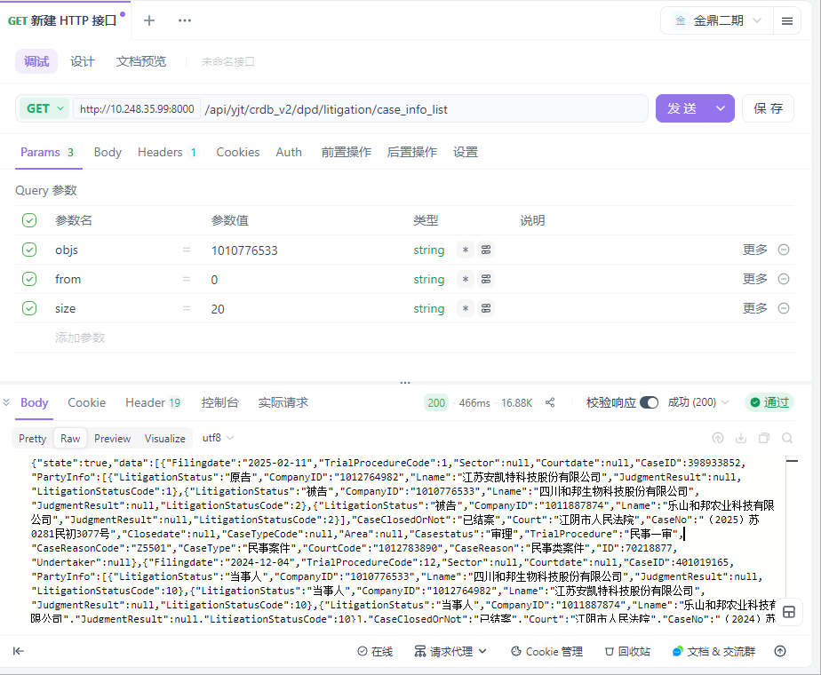

用例名称 | 企业大数据-企业详情-司法诉讼-开庭公告
用例编号 | 43407
接口地址 | /api/yjt/crdb_v2/dpd/litigation/session_annoucement
请求方式 | get
前置条件 | 数据查询功能正常
描述 | 正常查询数据信息成功
请求头部 | Content-Type：text/plain;charset=UTF-8
请求参数 | objs=1010776533&from=0&size=20
状态码 | 200
预期返回结果 | {"state":true,"data":[{"Chiefjudge":null,"Courtdate":"2025-07-18","SourceTable":"地方法院","CaseID":398933852,"PartyInfo":[{"LitigationStatus":"被告","CompanyID":"1010776533","Lname":"四川和邦生物科技股份有限公司","JudgmentResult":null,"LitigationStatusCode":2},{"LitigationStatus":"原告","CompanyID":"1012764982","Lname":"江苏安凯特科技股份有限公司","JudgmentResult":null,"LitigationStatusCode":1},{"LitigationStatus":"被告","CompanyID":"1011887874","Lname":"乐山和邦农业科技有限公司","JudgmentResult":null,"LitigationStatusCode":2}],"CaseClosedOrNot":null,"Court":"江阴市人民法院","CaseNo":"（2025）苏0281民初3077号","Area":"江苏省无锡市江阴市","Yard":"青阳第三审判庭","CaseReasonCode":"B0401","CourtCode":"1012783890","CaseReason":"合同纠纷","ID":129604401,"Courttime":"14:00","Undertaker":"相*"},{"Chiefjudge":null,"Courtdate":"2025-06-10","SourceTable":"地方法院","CaseID":398933852,"PartyInfo":[{"LitigationStatus":"原告","CompanyID":"1012764982","Lname":"江苏安凯特科技股份有限公司","JudgmentResult":null,"LitigationStatusCode":1},{"LitigationStatus":"被告","CompanyID":"1011887874","Lname":"乐山和邦农业科技有限公司","JudgmentResult":null,"LitigationStatusCode":2},{"LitigationStatus":"被告","CompanyID":"1010776533","Lname":"四川和邦生物科技股份有限公司","JudgmentResult":null,"LitigationStatusCode":2}],"CaseClosedOrNot":null,"Court":"江阴市人民法院","CaseNo":"（2025）苏0281民初3077号","Area":"江苏省无锡市江阴市","Yard":"青阳第三审判庭","CaseReasonCode":"B0401","CourtCode":"1012783890","CaseReason":"合同纠纷","ID":127436613,"Courttime":"14:00","Undertaker":"相*"},{"Chiefjudge":null,"Courtdate":"2025-03-20","SourceTable":"地方法院","CaseID":398933852,"PartyInfo":[{"LitigationStatus":"被告","CompanyID":"1011887874","Lname":"乐山和邦农业科技有限公司","JudgmentResult":null,"LitigationStatusCode":2},{"LitigationStatus":"原告","CompanyID":"1012764982","Lname":"江苏安凯特科技股份有限公司","JudgmentResult":null,"LitigationStatusCode":1},{"LitigationStatus":"被告","CompanyID":"1010776533","Lname":"四川和邦生物科技股份有限公司","JudgmentResult":null,"LitigationStatusCode":2}],"CaseClosedOrNot":null,"Court":"江阴市人民法院","CaseNo":"（2025）苏0281民初3077号","Area":"江苏省无锡市江阴市","Yard":"青阳第三审判庭","CaseReasonCode":"B0401","CourtCode":"1012783890","CaseReason":"合同纠纷","ID":124460517,"Courttime":"09:00","Undertaker":"相*"},{"Chiefjudge":null,"Courtdate":"2024-05-28","SourceTable":"中国庭审公开网","CaseID":366576162,"PartyInfo":[{"LitigationStatus":"原告","CompanyID":"1010776533","Lname":"四川和邦生物科技股份有限公司","JudgmentResult":null,"LitigationStatusCode":1},{"LitigationStatus":"被告","CompanyID":null,"Lname":"毕节明均玻璃股份有限公司","JudgmentResult":null,"LitigationStatusCode":2}],"CaseClosedOrNot":null,"Court":"乐山市五通桥区人民法院","CaseNo":"（2024）川1112民初41号","Area":"四川省乐山市五通桥区","Yard":"第二审判庭","CaseReasonCode":"B040109","CourtCode":"1012574554","CaseReason":"买卖合同纠纷","ID":114850066,"Courttime":"14:41","Undertaker":"彭**"},{"Chiefjudge":"彭**","Courtdate":"2024-04-18","SourceTable":"中国庭审公开网","CaseID":334821590,"PartyInfo":[{"LitigationStatus":"原告","CompanyID":"1010776533","Lname":"四川和邦生物科技股份有限公司","JudgmentResult":null,"LitigationStatusCode":1},{"LitigationStatus":"原告","CompanyID":"1011887874","Lname":"乐山和邦农业科技有限公司","JudgmentResult":null,"LitigationStatusCode":1},{"LitigationStatus":"被告","CompanyID":"1011528603","Lname":"乐山一拉得电网自动化有限公司","JudgmentResult":null,"LitigationStatusCode":2}],"CaseClosedOrNot":null,"Court":"乐山市五通桥区人民法院","CaseNo":"（2023）川1112民初805号","Area":"四川省乐山市五通桥区","Yard":"第一审判庭","CaseReasonCode":"B090109","CourtCode":"1012574554","CaseReason":"产品责任纠纷","ID":111983548,"Courttime":"14:55","Undertaker":"彭**"},{"Chiefjudge":"彭**","Courtdate":"2023-12-20","SourceTable":"中国庭审公开网","CaseID":335681025,"PartyInfo":[{"LitigationStatus":"被告","CompanyID":"1011528603","Lname":"乐山一拉得电网自动化有限公司","JudgmentResult":null,"LitigationStatusCode":2},{"LitigationStatus":"原告","CompanyID":"1010776533","Lname":"四川和邦生物科技股份有限公司","JudgmentResult":null,"LitigationStatusCode":1}],"CaseClosedOrNot":null,"Court":"乐山市五通桥区人民法院","CaseNo":"（2023）川1112民初804号","Area":"四川省乐山市五通桥区","Yard":"第三审判庭","CaseReasonCode":"B090109","CourtCode":"1012574554","CaseReason":"产品责任纠纷","ID":107141321,"Courttime":"13:10","Undertaker":"彭**"},{"Chiefjudge":null,"Courtdate":"2023-08-04","SourceTable":"地方法院","CaseID":333687286,"PartyInfo":[{"LitigationStatus":"被告","CompanyID":"1010776533","Lname":"四川和邦生物科技股份有限公司","JudgmentResult":null,"LitigationStatusCode":2},{"LitigationStatus":"原告","CompanyID":"1013060859","Lname":"江苏双达泵阀集团有限公司","JudgmentResult":null,"LitigationStatusCode":1}],"CaseClosedOrNot":null,"Court":"靖江市人民法院","CaseNo":"（2023）苏1282民初4734号","Area":"江苏省泰州市靖江市","Yard":"园区第三法庭","CaseReasonCode":"B040109","CourtCode":"1012463682","CaseReason":"买卖合同纠纷","ID":102344938,"Courttime":"09:10","Undertaker":"朱**"},{"Chiefjudge":null,"Courtdate":"2023-04-06","SourceTable":"地方法院","CaseID":325239290,"PartyInfo":[{"LitigationStatus":"被告","CompanyID":"1001482997","Lname":"四川和邦生物科技股份有限公司营养剂分公司","JudgmentResult":null,"LitigationStatusCode":2},{"LitigationStatus":"被告","CompanyID":"1010776533","Lname":"四川和邦生物科技股份有限公司","JudgmentResult":null,"LitigationStatusCode":2},{"LitigationStatus":"原告","CompanyID":"1030186353","Lname":"成都中大化工有限责任公司","JudgmentResult":null,"LitigationStatusCode":1}],"CaseClosedOrNot":"已结案","Court":"乐山市五通桥区人民法院","CaseNo":"（2023）川1112民初425号","Area":"四川省乐山市五通桥区","Yard":"第二审判庭","CaseReasonCode":"B040109","CourtCode":"1012574554","CaseReason":"买卖合同纠纷","ID":99896677,"Courttime":"14:30","Undertaker":"行***"},{"Chiefjudge":null,"Courtdate":"2023-03-24","SourceTable":"地方法院","CaseID":325067641,"PartyInfo":[{"LitigationStatus":"原告","CompanyID":"1011523261","Lname":"大连深蓝泵业有限公司","JudgmentResult":null,"LitigationStatusCode":1},{"LitigationStatus":"被告","CompanyID":"1010776533","Lname":"四川和邦生物科技股份有限公司","JudgmentResult":null,"LitigationStatusCode":2}],"CaseClosedOrNot":"已结案","Court":"乐山市五通桥区人民法院","CaseNo":"（2023）川1112民初211号","Area":"四川省乐山市五通桥区","Yard":"第三审判庭","CaseReasonCode":"B040109","CourtCode":"1012574554","CaseReason":"买卖合同纠纷","ID":99765817,"Courttime":"14:00","Undertaker":"民***"},{"Chiefjudge":null,"Courtdate":"2023-02-21","SourceTable":"中国庭审公开网","CaseID":311703931,"PartyInfo":[{"LitigationStatus":"原告","CompanyID":"1009869703","Lname":"深圳东方锅炉控制有限公司","JudgmentResult":null,"LitigationStatusCode":1},{"LitigationStatus":"被告","CompanyID":"1010776533","Lname":"四川和邦生物科技股份有限公司","JudgmentResult":null,"LitigationStatusCode":2}],"CaseClosedOrNot":"已结案","Court":"乐山市五通桥区人民法院","CaseNo":"（2023）川1112民初175号","Area":"四川省乐山市五通桥区","Yard":"第一审判庭","CaseReasonCode":"B040109","CourtCode":"1012574554","CaseReason":"买卖合同纠纷","ID":92923821,"Courttime":"14:38","Undertaker":"陈*"},{"Chiefjudge":null,"Courtdate":"2022-12-29","SourceTable":"地方法院","CaseID":325948851,"PartyInfo":[{"LitigationStatus":"原告","CompanyID":"1010776533","Lname":"四川和邦生物科技股份有限公司","JudgmentResult":null,"LitigationStatusCode":1},{"LitigationStatus":"被告","CompanyID":null,"Lname":"章**","JudgmentResult":null,"LitigationStatusCode":2}],"CaseClosedOrNot":"已结案","Court":"乐山市五通桥区人民法院","CaseNo":"（2022）川1112民初1234号","Area":"四川省乐山市五通桥区","Yard":"第一审判庭","CaseReasonCode":"B0601","CourtCode":"1012574554","CaseReason":"劳动争议","ID":100316870,"Courttime":"14:30","Undertaker":"行***"},{"Chiefjudge":null,"Courtdate":"2022-12-14","SourceTable":"地方法院","CaseID":325758069,"PartyInfo":[{"LitigationStatus":"被告","CompanyID":"1001482997","Lname":"四川和邦生物科技股份有限公司营养剂分公司","JudgmentResult":null,"LitigationStatusCode":2},{"LitigationStatus":"原告","CompanyID":"1010739308","Lname":"重庆市通信产业服务有限公司","JudgmentResult":null,"LitigationStatusCode":1},{"LitigationStatus":"被告","CompanyID":"1010776533","Lname":"四川和邦生物科技股份有限公司","JudgmentResult":null,"LitigationStatusCode":2}],"CaseClosedOrNot":"已结案","Court":"乐山市五通桥区人民法院","CaseNo":"（2022）川1112民初1073号","Area":"四川省乐山市五通桥区","Yard":"第二审判庭","CaseReasonCode":"B040134","CourtCode":"1012574554","CaseReason":"承揽合同纠纷","ID":100112424,"Courttime":"15:50","Undertaker":"院***"},{"Chiefjudge":null,"Courtdate":"2022-12-14","SourceTable":"地方法院","CaseID":325724612,"PartyInfo":[{"LitigationStatus":"被告","CompanyID":"1010776533","Lname":"四川和邦生物科技股份有限公司","JudgmentResult":null,"LitigationStatusCode":2},{"LitigationStatus":"原告","CompanyID":"1011028262","Lname":"成都希望森兰电气有限公司","JudgmentResult":null,"LitigationStatusCode":1}],"CaseClosedOrNot":"已结案","Court":"乐山市五通桥区人民法院","CaseNo":"（2022）川1112民初1190号","Area":"四川省乐山市五通桥区","Yard":"第三审判庭","CaseReasonCode":"B040109","CourtCode":"1012574554","CaseReason":"买卖合同纠纷","ID":100112392,"Courttime":"14:30","Undertaker":"行***"},{"Chiefjudge":null,"Courtdate":"2022-12-14","SourceTable":"中国庭审公开网","CaseID":301766671,"PartyInfo":[{"LitigationStatus":"被告","CompanyID":"1010776533","Lname":"四川和邦生物科技股份有限公司","JudgmentResult":null,"LitigationStatusCode":2},{"LitigationStatus":"原告","CompanyID":"1010739308","Lname":"重庆市通信产业服务有限公司","JudgmentResult":null,"LitigationStatusCode":1},{"LitigationStatus":"被告","CompanyID":"1001482997","Lname":"四川和邦生物科技股份有限公司营养剂分公司","JudgmentResult":null,"LitigationStatusCode":2}],"CaseClosedOrNot":null,"Court":"乐山市五通桥区人民法院","CaseNo":"（2022）川1112民初1173号","Area":"四川省乐山市五通桥区","Yard":"第二审判庭","CaseReasonCode":"B040134","CourtCode":"1012574554","CaseReason":"承揽合同纠纷","ID":84681891,"Courttime":"16:00","Undertaker":"舒**"},{"Chiefjudge":null,"Courtdate":"2022-12-14","SourceTable":"中国庭审公开网","CaseID":301021682,"PartyInfo":[{"LitigationStatus":"原告","CompanyID":"1010739308","Lname":"重庆市通信产业服务有限公司","JudgmentResult":null,"LitigationStatusCode":1},{"LitigationStatus":"被告","CompanyID":"1001482997","Lname":"四川和邦生物科技股份有限公司营养剂分公司","JudgmentResult":null,"LitigationStatusCode":2},{"LitigationStatus":"被告","CompanyID":"1010776533","Lname":"四川和邦生物科技股份有限公司","JudgmentResult":null,"LitigationStatusCode":2}],"CaseClosedOrNot":"已结案","Court":"乐山市五通桥区人民法院","CaseNo":"（2022）川1112民初1072号","Area":"四川省乐山市五通桥区","Yard":"第二审判庭","CaseReasonCode":"B040109","CourtCode":"1012574554","CaseReason":"买卖合同纠纷","ID":84669694,"Courttime":"14:41","Undertaker":"余*"},{"Chiefjudge":null,"Courtdate":"2022-10-27","SourceTable":"地方法院","CaseID":296874883,"PartyInfo":[{"LitigationStatus":"被告","CompanyID":"1010776533","Lname":"四川和邦生物科技股份有限公司","JudgmentResult":null,"LitigationStatusCode":2},{"LitigationStatus":"原告","CompanyID":"1027573953","Lname":"成都市创鼎环保设备有限公司","JudgmentResult":null,"LitigationStatusCode":1},{"LitigationStatus":"被告","CompanyID":"1001482997","Lname":"四川和邦生物科技股份有限公司营养剂分公司","JudgmentResult":null,"LitigationStatusCode":2}],"CaseClosedOrNot":"已结案","Court":"乐山市五通桥区人民法院","CaseNo":"（2022）川1112民初843号","Area":"四川省乐山市五通桥区","Yard":"第一审判庭","CaseReasonCode":"B040109","CourtCode":"1012574554","CaseReason":"买卖合同纠纷","ID":99997654,"Courttime":"14:30","Undertaker":"民***"},{"Chiefjudge":null,"Courtdate":"2022-10-27","SourceTable":"中国庭审公开网","CaseID":296874883,"PartyInfo":[{"LitigationStatus":"被告","CompanyID":"1010776533","Lname":"四川和邦生物科技股份有限公司","JudgmentResult":null,"LitigationStatusCode":2},{"LitigationStatus":"被告","CompanyID":"1001482997","Lname":"四川和邦生物科技股份有限公司营养剂分公司","JudgmentResult":null,"LitigationStatusCode":2},{"LitigationStatus":"原告","CompanyID":null,"Lname":"乐山市创鼎环保设备有限公司","JudgmentResult":null,"LitigationStatusCode":1}],"CaseClosedOrNot":"已结案","Court":"乐山市五通桥区人民法院","CaseNo":"（2022）川1112民初843号","Area":"四川省乐山市五通桥区","Yard":"第一审判庭","CaseReasonCode":"B040109","CourtCode":"1012574554","CaseReason":"买卖合同纠纷","ID":81330558,"Courttime":"14:27","Undertaker":"郭**"},{"Chiefjudge":null,"Courtdate":"2022-03-31","SourceTable":"地方法院","CaseID":259479626,"PartyInfo":[{"LitigationStatus":"被告","CompanyID":"1001482997","Lname":"四川和邦生物科技股份有限公司营养剂分公司","JudgmentResult":null,"LitigationStatusCode":2},{"LitigationStatus":"被告","CompanyID":"1010776533","Lname":"四川和邦生物科技股份有限公司","JudgmentResult":null,"LitigationStatusCode":2},{"LitigationStatus":"原告","CompanyID":"1011528603","Lname":"乐山一拉得电网自动化有限公司","JudgmentResult":null,"LitigationStatusCode":1}],"CaseClosedOrNot":"已结案","Court":"乐山市五通桥区人民法院","CaseNo":"（2022）川1112民初206号","Area":"四川省乐山市五通桥区","Yard":"第一审判庭","CaseReasonCode":"B040109","CourtCode":"1012574554","CaseReason":"买卖合同纠纷","ID":99668449,"Courttime":"10:00","Undertaker":"院***"},{"Chiefjudge":null,"Courtdate":"2022-03-22","SourceTable":"地方法院","CaseID":259479626,"PartyInfo":[{"LitigationStatus":"被告","CompanyID":"1010776533","Lname":"四川和邦生物科技股份有限公司","JudgmentResult":null,"LitigationStatusCode":2},{"LitigationStatus":"被告","CompanyID":"1001482997","Lname":"四川和邦生物科技股份有限公司营养剂分公司","JudgmentResult":null,"LitigationStatusCode":2},{"LitigationStatus":"原告","CompanyID":"1011528603","Lname":"乐山一拉得电网自动化有限公司","JudgmentResult":null,"LitigationStatusCode":1}],"CaseClosedOrNot":"已结案","Court":"乐山市五通桥区人民法院","CaseNo":"（2022）川1112民初206号","Area":"四川省乐山市五通桥区","Yard":"第一审判庭","CaseReasonCode":"B040109","CourtCode":"1012574554","CaseReason":"买卖合同纠纷","ID":99561571,"Courttime":"09:30","Undertaker":"院***"},{"Chiefjudge":null,"Courtdate":"2021-12-29","SourceTable":"中国庭审公开网","CaseID":251726975,"PartyInfo":[{"LitigationStatus":"被告","CompanyID":"1010776533","Lname":"四川和邦生物科技股份有限公司","JudgmentResult":"获得部分支持","LitigationStatusCode":2},{"LitigationStatus":"原告","CompanyID":"1039456171","Lname":"潍坊恒基磁电机械有限公司","JudgmentResult":"获得部分支持","LitigationStatusCode":1}],"CaseClosedOrNot":"已结案","Court":"乐山市五通桥区人民法院","CaseNo":"（2021）川1112民初1222号","Area":"四川省乐山市五通桥区","Yard":"第一审判庭","CaseReasonCode":"B040109","CourtCode":"1012574554","CaseReason":"买卖合同纠纷","ID":66824659,"Courttime":"09:40","Undertaker":"许*"}],"traceId":"69202680fe62224e3135c332"}
实际结果 | 与预期结果一致  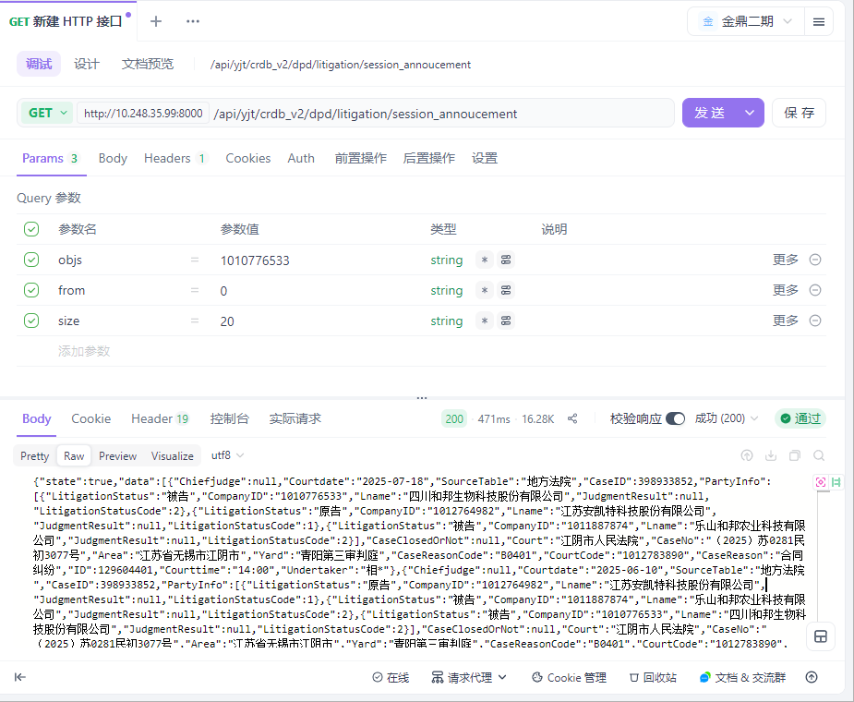

用例名称 | 企业大数据-企业详情-司法诉讼-送达公告
用例编号 | 43408
接口地址 | /api/yjt/crdb_v2/dpd/litigation/delivery_annoucement
请求方式 | get
前置条件 | 数据查询功能正常
描述 | 正常查询数据信息成功
请求头部 | Content-Type：text/plain;charset=UTF-8
请求参数 | objs=1010776533&from=0&size=20
状态码 | 200
预期返回结果 | {"state":true,"data":[],"traceId":"69202736fe62224e3135c3fb"}
实际结果 | 与预期结果一致  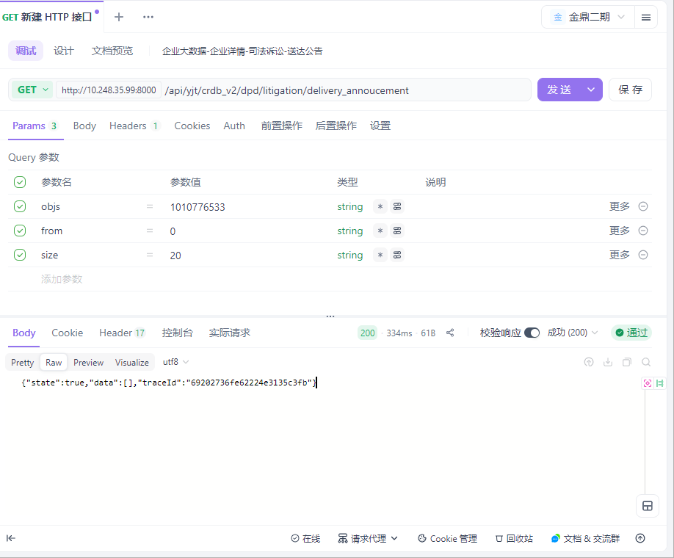

用例名称 | 企业大数据-企业详情-司法诉讼-法院公告
用例编号 | 43409
接口地址 | /api/yjt/crdb_v2/dpd/litigation/court_annoucement
请求方式 | get
前置条件 | 数据查询功能正常
描述 | 正常查询数据信息成功
请求头部 | Content-Type：text/plain;charset=UTF-8
请求参数 | objs=1010776533&from=0&size=20
状态码 | 200
预期返回结果 | {"state":true,"data":[{"AtypeCode":null,"PublishDate":"2021-06-29","PrimaryCaseReason":"与公司、证券、保险、票据等有关的民事纠纷","CaseID":133990459,"ReleaseDate":"2021-06-29","PartyInfo":[{"LitigationStatus":"原告","CompanyID":"1010776533","Lname":"四川和邦生物科技股份有限公司","JudgmentResult":"获得部分支持","LitigationStatusCode":1},{"LitigationStatus":"被告","CompanyID":"1010855115","Lname":"宝塔石化集团财务有限公司","JudgmentResult":"获得部分支持","LitigationStatusCode":2},{"LitigationStatus":"被告","CompanyID":"1012285719","Lname":"云南云天化农资连锁有限公司","JudgmentResult":null,"LitigationStatusCode":2},{"LitigationStatus":"被告","CompanyID":"1012268320","Lname":"宁夏灵武宝塔大古储运有限公司","JudgmentResult":"获得部分支持","LitigationStatusCode":2},{"LitigationStatus":"被告","CompanyID":"1011710104","Lname":"宁夏宝塔能源化工有限公司","JudgmentResult":null,"LitigationStatusCode":2}],"CaseClosedOrNot":"已结案","Court":"宁夏回族自治区银川市中级人民法院","CaseNo":"（2020）宁01民初301号","Atype":null,"CaseReasonCode":"B080902","LayOut":"G31","Content":"DDE10D6B-2231-4EBA-8CA0-C8BF801D4163","CaseReason":"票据追索权纠纷","PrimaryCaseReasonCode":"B08","ID":7335419},{"AtypeCode":null,"PublishDate":"2021-06-10","PrimaryCaseReason":"与公司、证券、保险、票据等有关的民事纠纷","CaseID":133990459,"ReleaseDate":"2021-06-10","PartyInfo":[{"LitigationStatus":"原告","CompanyID":"1010776533","Lname":"四川和邦生物科技股份有限公司","JudgmentResult":"获得部分支持","LitigationStatusCode":1},{"LitigationStatus":"被告","CompanyID":"1011710104","Lname":"宁夏宝塔能源化工有限公司","JudgmentResult":null,"LitigationStatusCode":2},{"LitigationStatus":"被告","CompanyID":"1012268320","Lname":"宁夏灵武宝塔大古储运有限公司","JudgmentResult":"获得部分支持","LitigationStatusCode":2},{"LitigationStatus":"被告","CompanyID":"1010855115","Lname":"宝塔石化集团财务有限公司","JudgmentResult":"获得部分支持","LitigationStatusCode":2},{"LitigationStatus":"被告","CompanyID":"1012285719","Lname":"云南云天化农资连锁有限公司","JudgmentResult":null,"LitigationStatusCode":2}],"CaseClosedOrNot":"已结案","Court":"宁夏回族自治区银川市中级人民法院","CaseNo":"（2020）宁01民初301号","Atype":null,"CaseReasonCode":"B080902","LayOut":"G57","Content":"6BBF23C9-3926-4BC7-943F-3F9EA2A08F13","CaseReason":"票据追索权纠纷","PrimaryCaseReasonCode":"B08","ID":7280405},{"AtypeCode":null,"PublishDate":"2018-10-12","PrimaryCaseReason":null,"CaseID":161315876,"ReleaseDate":null,"PartyInfo":[{"LitigationStatus":"被告","CompanyID":"1010776533","Lname":"四川和邦生物科技股份有限公司","JudgmentResult":null,"LitigationStatusCode":2}],"CaseClosedOrNot":"已结案","Court":"湖北省武汉市江夏区人民法院","CaseNo":"（2018）鄂0115执2272号","Atype":null,"CaseReasonCode":null,"LayOut":null,"Content":"07C90509-B64D-4735-AFCA-A2B6F7FC30FA","CaseReason":null,"PrimaryCaseReasonCode":null,"ID":4390498},{"AtypeCode":null,"PublishDate":"2018-01-12","PrimaryCaseReason":null,"CaseID":46073755,"ReleaseDate":null,"PartyInfo":[{"LitigationStatus":"原告","CompanyID":"1010776533","Lname":"四川和邦生物科技股份有限公司","JudgmentResult":null,"LitigationStatusCode":1},{"LitigationStatus":"被告","CompanyID":"1011472109","Lname":"赤东建设集团有限公司","JudgmentResult":null,"LitigationStatusCode":2}],"CaseClosedOrNot":"已结案","Court":"湖北省武汉市江夏区人民法院","CaseNo":"（2018）鄂0115民初350号","Atype":null,"CaseReasonCode":null,"LayOut":null,"Content":"15775B48-D0B5-4053-89FE-824BA42D9891","CaseReason":null,"PrimaryCaseReasonCode":null,"ID":4191869},{"AtypeCode":null,"PublishDate":"2017-12-14","PrimaryCaseReason":null,"CaseID":46073757,"ReleaseDate":null,"PartyInfo":[{"LitigationStatus":"原告","CompanyID":"1010776533","Lname":"四川和邦生物科技股份有限公司","JudgmentResult":null,"LitigationStatusCode":1},{"LitigationStatus":"原告","CompanyID":"1011472109","Lname":"赤东建设集团有限公司","JudgmentResult":null,"LitigationStatusCode":1}],"CaseClosedOrNot":null,"Court":"湖北省武汉市江夏区人民法院","CaseNo":"（2017）鄂0115执异78号","Atype":null,"CaseReasonCode":null,"LayOut":null,"Content":"47F1A8D5-E2BF-4586-B8CB-06BF0EA74A4A","CaseReason":null,"PrimaryCaseReasonCode":null,"ID":3586937},{"AtypeCode":null,"PublishDate":"2015-05-11","PrimaryCaseReason":null,"CaseID":161575678,"ReleaseDate":null,"PartyInfo":[{"LitigationStatus":"被告","CompanyID":"1010776533","Lname":"四川和邦生物科技股份有限公司","JudgmentResult":null,"LitigationStatusCode":2}],"CaseClosedOrNot":null,"Court":"湖北省武汉市江夏区人民法院","CaseNo":"（2015）鄂江夏民二初字第404号","Atype":null,"CaseReasonCode":null,"LayOut":null,"Content":"538DFE42-42BF-4454-A03D-37DA4BE7D957","CaseReason":null,"PrimaryCaseReasonCode":null,"ID":4109294},{"AtypeCode":null,"PublishDate":"2014-10-29","PrimaryCaseReason":null,"CaseID":161462513,"ReleaseDate":null,"PartyInfo":[{"LitigationStatus":"被告","CompanyID":"1010776533","Lname":"四川和邦生物科技股份有限公司","JudgmentResult":null,"LitigationStatusCode":2}],"CaseClosedOrNot":null,"Court":"湖北省十堰市茅箭区人民法院","CaseNo":"（2014）鄂茅箭民二初字第990号","Atype":null,"CaseReasonCode":null,"LayOut":null,"Content":"64EB2324-ECE4-42A4-9CB4-C1E73A7B19A0","CaseReason":null,"PrimaryCaseReasonCode":null,"ID":3801519}],"traceId":"69202789fe62224e3135c461"}
实际结果 | 与预期结果一致  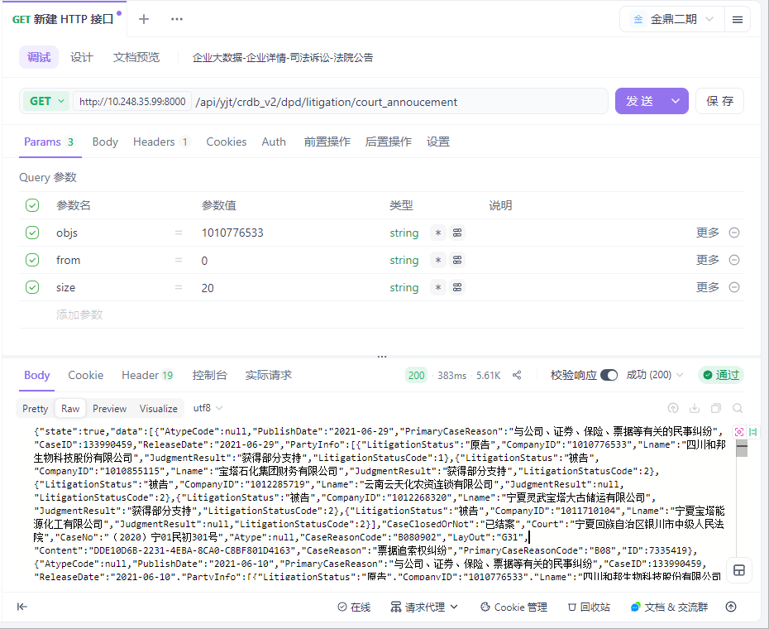

用例名称 | 企业大数据-企业详情-司法诉讼-被执行人
用例编号 | 43410
接口地址 | /api/yjt/crdb_v2/dpd/litigation/enforced
请求方式 | get
前置条件 | 数据查询功能正常
描述 | 正常查询数据信息成功
请求头部 | Content-Type：text/plain;charset=UTF-8
请求参数 | objs=1010776533&from=0&size=20
状态码 | 200
预期返回结果 | {"state":true,"data":[],"traceId":"69202911fe62224e3135c5ff"}
实际结果 | 与预期结果一致  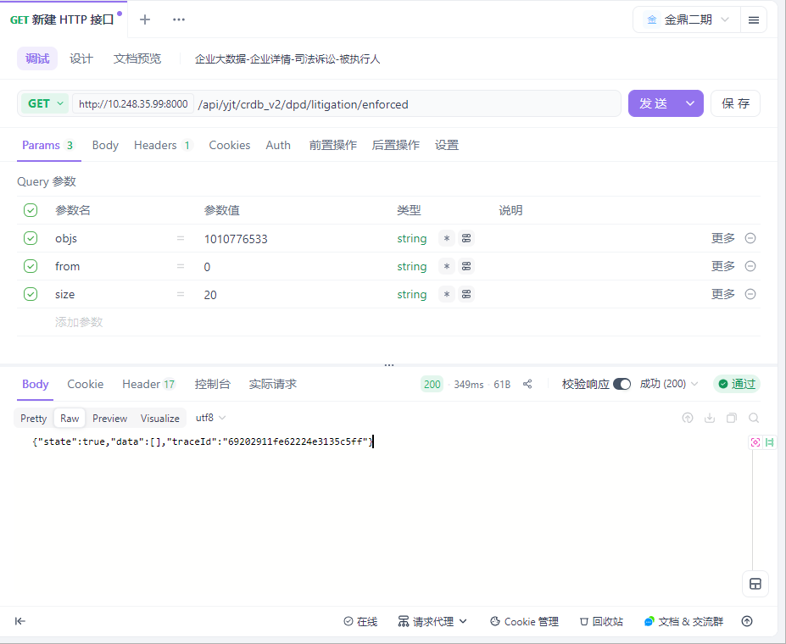

用例名称 | 企业大数据-企业详情-司法诉讼-失信被执行人
用例编号 | 43411
接口地址 | /api/yjt/crdb_v2/dpd/litigation/dishonesty_enforced
请求方式 | get
前置条件 | 数据查询功能正常
描述 | 正常查询数据信息成功
请求头部 | Content-Type：text/plain;charset=UTF-8
请求参数 | objs=1010776533&from=0&size=20
状态码 | 200
预期返回结果 | {"state":true,"data":[],"traceId":"69202972fe62224e3135c670"}
实际结果 | 与预期结果一致  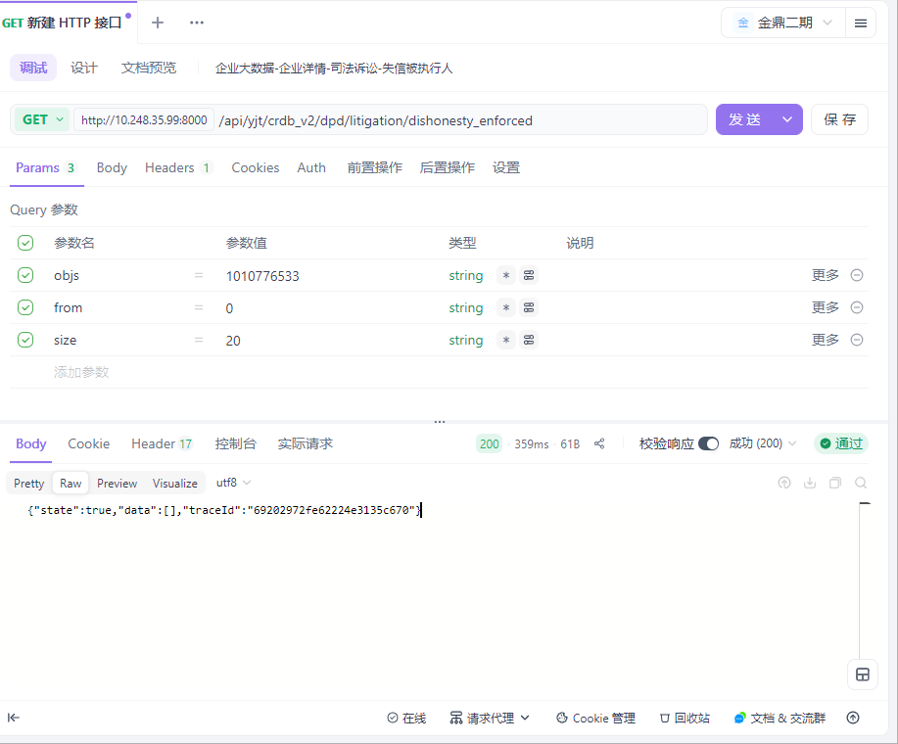

用例名称 | 企业大数据-企业详情-司法诉讼-限制高消费
用例编号 | 43412
接口地址 | /api/yjt/crdb_v2/dpd/litigation/restrict_high_consum
请求方式 | get
前置条件 | 数据查询功能正常
描述 | 正常查询数据信息成功
请求头部 | Content-Type：text/plain;charset=UTF-8
请求参数 | objs=1010776533&from=0&size=20
状态码 | 200
预期返回结果 | {"state":true,"data":[],"traceId":"692029cdfe62224e3135c6d3"}
实际结果 | 与预期结果一致  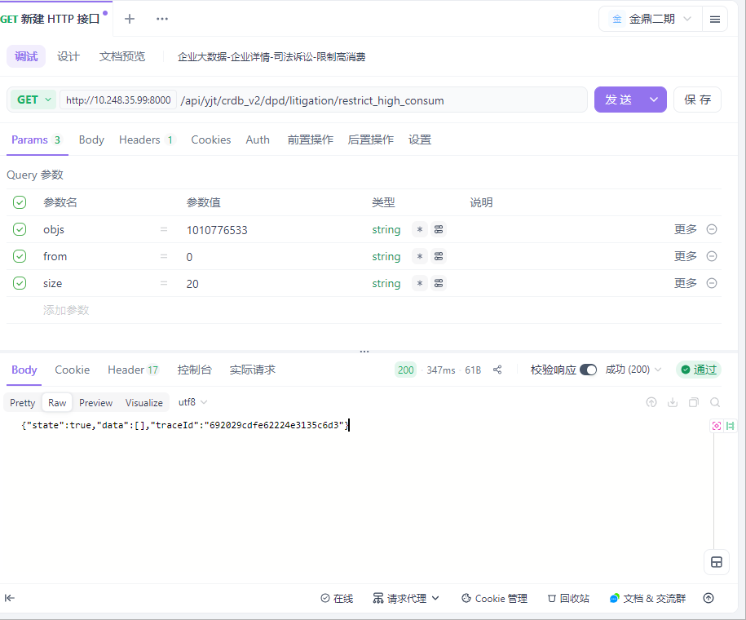

用例名称 | 企业大数据-企业详情-司法诉讼-终本案件
用例编号 | 43413
接口地址 | /api/yjt/crdb_v2/dpd/litigation/final_case
请求方式 | get
前置条件 | 数据查询功能正常
描述 | 正常查询数据信息成功
请求头部 | Content-Type：text/plain;charset=UTF-8
请求参数 | objs=1010776533&from=0&size=20
状态码 | 200
预期返回结果 | {"state":true,"data":[],"traceId":"69202aa2fe62224e3135c7bc"}
实际结果 | 与预期结果一致  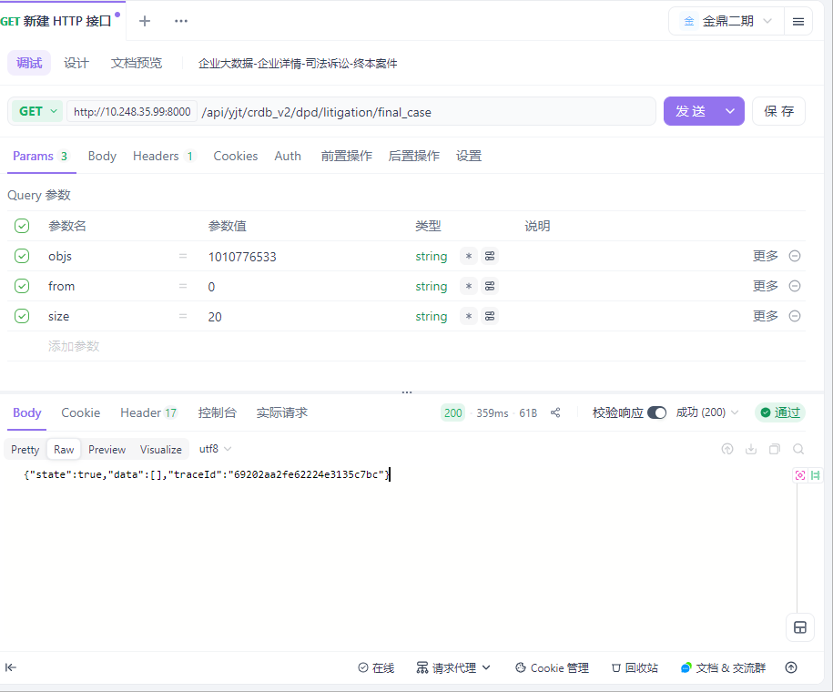

用例名称 | 企业大数据-企业详情-司法诉讼-破产程序
用例编号 | 43414
接口地址 | /api/yjt/crdb_v2/dpd/litigation/insolvency_event
请求方式 | get
前置条件 | 数据查询功能正常
描述 | 正常查询数据信息成功
请求头部 | Content-Type：text/plain;charset=UTF-8
请求参数 | objs=1010776533&from=0&size=20
状态码 | 200
预期返回结果 | {"state":true,"data":[],"traceId":"69202b3efe62224e3135c876"}
实际结果 | 与预期结果一致  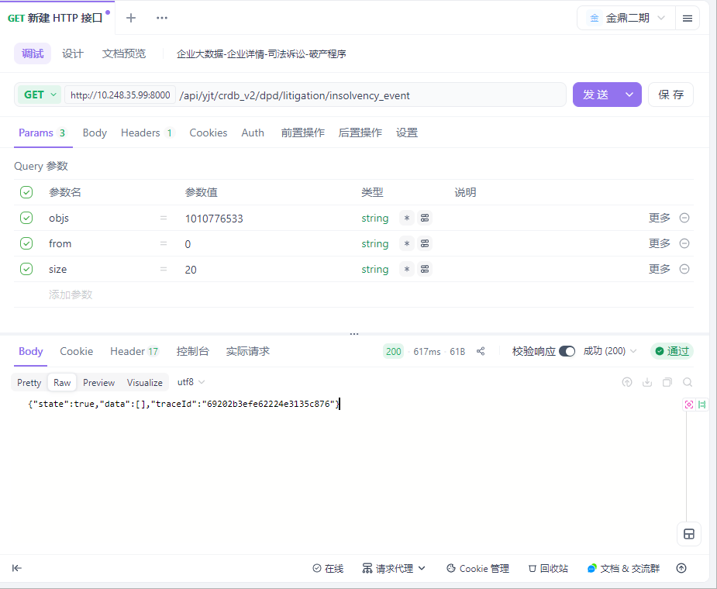

用例名称 | 企业大数据-企业详情-司法诉讼-司法拍卖
用例编号 | 43415
接口地址 | /api/yjt/crdb_v2/judicial_proceedings/judicial_auction
请求方式 | get
前置条件 | 数据查询功能正常
描述 | 正常查询数据信息成功
请求头部 | Content-Type：text/plain;charset=UTF-8
请求参数 | objs=1010776533&from=0&size=20
状态码 | 200
预期返回结果 | {"state":true,"data":[],"traceId":"69202b97fe62224e3135c8da"}
实际结果 | 与预期结果一致  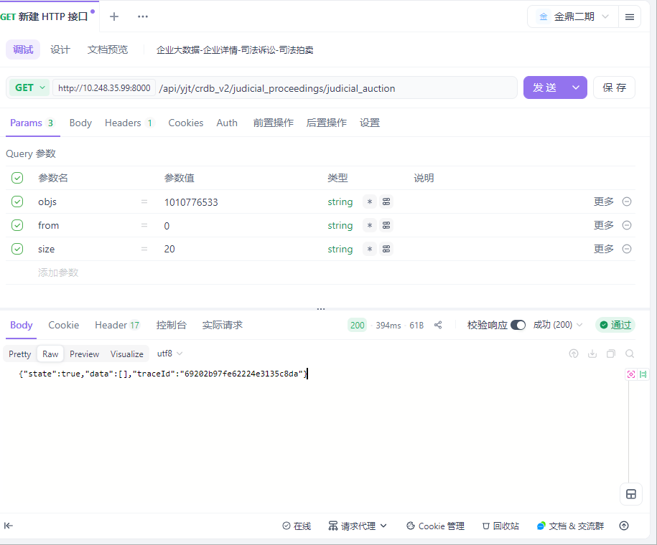

用例名称 | 企业大数据-企业详情-财务数据-主要财务指标
用例编号 | 43416
接口地址 | /api/yjt/crdb_v2/finance/mainIndicatorsF9
请求方式 | get
前置条件 | 数据查询功能正常
描述 | 正常查询数据信息成功
请求头部 | Content-Type：text/plain;charset=UTF-8
请求参数 | objs=1010776533&from=0&size=20
状态码 | 200
预期返回结果 | {"state":true,"data":[{"TOT_SHRHLD_EQTY":1.900651820564E10,"TOT_LIABS":1.064321633424E10,"EBITDA_TO_INT_EXP_CVR":14.83,"EBITDA":9.9349057556E8,"YOY_TOT_CMN_EQTY":-4.85,"INT_CVRG_RT":0.02,"NET_INCM":-7.074460993E7,"TOT_CMN_EQTY":1.862639243187E10,"CompanyName":"四川和邦生物科技股份有限公司","YOY_TOT_ASTS":20.81,"YOY_NET_AST":-5.99,"OrgSubClass":null,"YOY_NET_PRF_ATTR_TO_CMN_SHRHLD":-97.55,"ROE_DIL":0.17,"NoticeDate_New":"2025-04-29","YOY_TOT_INCM_PRFT":-3.13,"NET_PRF_MARG":-0.83,"TOT_PRF":-6.568356206E7,"NON_PFMG_AST_RT_NT":null,"CUCode":"人民币","QK_RT":1.7599,"OrgSupClass":"一般企业","AST_LIAB_RT":35.9,"RTN_ON_THE_TRU":null,"RISK_COV_SPCL":null,"BVPS_LST_ANC":2.067903,"TOT_ASTS":2.964973453988E10,"CUR_RT":2.6055,"ITCode":"1010776533","RTN_ON_CAP":null,"ROE":0.17,"AuditYear":2024,"NET_CFO_PER_SHR":0.052985,"EndDate":"2024-12-31","YOY_NET_INCM":-105.53,"ReportDateType":"年报","TOT_DT_TO_EBITDA":8.11,"TOT_INCM_PRFT":8.54747655013E9,"BAS_EPS":0.0038,"NET_PRF_ATTR_TO_CMN_SHRHLD":3.146468507E7,"NET_CFO":4.6793138717E8,"GRO_PRF_MARG":7.8,"OPEA_PRO_RT_DER":-0.72,"ReportRange":"合并期末","EPS_DIL":0.003562},{"TOT_SHRHLD_EQTY":1.976321827044E10,"TOT_LIABS":4.33940891004E9,"EBITDA_TO_INT_EXP_CVR":106.17,"EBITDA":5.46081140475E9,"YOY_TOT_CMN_EQTY":34.21,"INT_CVRG_RT":88.07,"NET_INCM":3.81023893475E9,"TOT_CMN_EQTY":1.911835670962E10,"CompanyName":"四川和邦生物科技股份有限公司","YOY_TOT_ASTS":34.48,"YOY_NET_AST":35.02,"OrgSubClass":null,"YOY_NET_PRF_ATTR_TO_CMN_SHRHLD":26.12,"ROE_DIL":19.91,"NoticeDate_New":"2023-02-21","YOY_TOT_INCM_PRFT":30.55,"NET_PRF_MARG":29.22,"TOT_PRF":4.47856214358E9,"NON_PFMG_AST_RT_NT":null,"CUCode":"人民币","QK_RT":2.0466,"OrgSupClass":"一般企业","AST_LIAB_RT":18.0,"RTN_ON_THE_TRU":null,"RISK_COV_SPCL":null,"BVPS_LST_ANC":2.164852,"TOT_ASTS":2.410262718048E10,"CUR_RT":2.6026,"ITCode":"1010776533","RTN_ON_CAP":null,"ROE":22.47,"AuditYear":2022,"NET_CFO_PER_SHR":0.299421,"EndDate":"2022-12-31","YOY_NET_INCM":25.9,"ReportDateType":"年报","TOT_DT_TO_EBITDA":0.33,"TOT_INCM_PRFT":1.30389479868E10,"BAS_EPS":0.4377,"NET_PRF_ATTR_TO_CMN_SHRHLD":3.80680886924E9,"NET_CFO":2.64426279195E9,"GRO_PRF_MARG":42.85,"OPEA_PRO_RT_DER":34.37,"ReportRange":"合并期末","EPS_DIL":0.431061},{"TOT_SHRHLD_EQTY":2.021838222129E10,"TOT_LIABS":4.32405190156E9,"EBITDA_TO_INT_EXP_CVR":105.2,"EBITDA":2.56402979064E9,"YOY_TOT_CMN_EQTY":2.39,"INT_CVRG_RT":64.02,"NET_INCM":1.27869926063E9,"TOT_CMN_EQTY":1.957534248528E10,"CompanyName":"四川和邦生物科技股份有限公司","YOY_TOT_ASTS":1.82,"YOY_NET_AST":2.3,"OrgSubClass":null,"YOY_NET_PRF_ATTR_TO_CMN_SHRHLD":-66.29,"ROE_DIL":6.56,"NoticeDate_New":"2024-04-20","YOY_TOT_INCM_PRFT":-32.33,"NET_PRF_MARG":14.49,"TOT_PRF":1.53596552099E9,"NON_PFMG_AST_RT_NT":null,"CUCode":"人民币","QK_RT":1.4854,"OrgSupClass":"一般企业","AST_LIAB_RT":17.62,"RTN_ON_THE_TRU":null,"RISK_COV_SPCL":null,"BVPS_LST_ANC":2.216599,"TOT_ASTS":2.454243412285E10,"CUR_RT":2.6852,"ITCode":"1010776533","RTN_ON_CAP":null,"ROE":6.56,"AuditYear":2023,"NET_CFO_PER_SHR":0.009096,"EndDate":"2023-12-31","YOY_NET_INCM":-66.44,"ReportDateType":"年报","TOT_DT_TO_EBITDA":0.77,"TOT_INCM_PRFT":8.82410781182E9,"BAS_EPS":0.1474,"NET_PRF_ATTR_TO_CMN_SHRHLD":1.28324389334E9,"NET_CFO":8.033178433E7,"GRO_PRF_MARG":23.26,"OPEA_PRO_RT_DER":17.47,"ReportRange":"合并期末","EPS_DIL":0.145307},{"TOT_SHRHLD_EQTY":1.13074540373E10,"TOT_LIABS":3.43256330054E9,"EBITDA_TO_INT_EXP_CVR":9.05,"EBITDA":7.432411807E8,"YOY_TOT_CMN_EQTY":-0.82,"INT_CVRG_RT":1.19,"NET_INCM":2909542.82,"TOT_CMN_EQTY":1.114179492201E10,"CompanyName":"四川和邦生物科技股份有限公司","YOY_TOT_ASTS":1.77,"YOY_NET_AST":-1.27,"OrgSubClass":null,"YOY_NET_PRF_ATTR_TO_CMN_SHRHLD":-92.08,"ROE_DIL":0.37,"NoticeDate_New":"2021-04-27","YOY_TOT_INCM_PRFT":-11.87,"NET_PRF_MARG":0.06,"TOT_PRF":1.580921287E7,"NON_PFMG_AST_RT_NT":null,"CUCode":"人民币","QK_RT":0.8516,"OrgSupClass":"一般企业","AST_LIAB_RT":23.29,"RTN_ON_THE_TRU":null,"RISK_COV_SPCL":null,"BVPS_LST_ANC":1.261632,"TOT_ASTS":1.474001733784E10,"CUR_RT":1.0525,"ITCode":"1010776533","RTN_ON_CAP":null,"ROE":0.37,"AuditYear":2020,"NET_CFO_PER_SHR":0.041766,"EndDate":"2020-12-31","YOY_NET_INCM":-99.43,"ReportDateType":"年报","TOT_DT_TO_EBITDA":2.89,"TOT_INCM_PRFT":5.2607659887E9,"BAS_EPS":0.0048,"NET_PRF_ATTR_TO_CMN_SHRHLD":4.094245237E7,"NET_CFO":3.6885415515E8,"GRO_PRF_MARG":18.8,"OPEA_PRO_RT_DER":8.37,"ReportRange":"合并期末","EPS_DIL":0.004636},{"TOT_SHRHLD_EQTY":1.463727969473E10,"TOT_LIABS":3.28507595702E9,"EBITDA_TO_INT_EXP_CVR":55.34,"EBITDA":4.30619132576E9,"YOY_TOT_CMN_EQTY":27.86,"INT_CVRG_RT":47.05,"NET_INCM":3.03133739549E9,"TOT_CMN_EQTY":1.424543652942E10,"CompanyName":"四川和邦生物科技股份有限公司","YOY_TOT_ASTS":21.59,"YOY_NET_AST":29.45,"OrgSubClass":null,"YOY_NET_PRF_ATTR_TO_CMN_SHRHLD":7284.28,"ROE_DIL":21.22,"NoticeDate_New":"2022-03-15","YOY_TOT_INCM_PRFT":87.56,"NET_PRF_MARG":30.72,"TOT_PRF":3.58321610309E9,"NON_PFMG_AST_RT_NT":null,"CUCode":"人民币","QK_RT":1.1947,"OrgSupClass":"一般企业","AST_LIAB_RT":18.33,"RTN_ON_THE_TRU":null,"RISK_COV_SPCL":null,"BVPS_LST_ANC":1.613071,"TOT_ASTS":1.792235565175E10,"CUR_RT":1.4868,"ITCode":"1010776533","RTN_ON_CAP":null,"ROE":23.79,"AuditYear":2021,"NET_CFO_PER_SHR":0.361977,"EndDate":"2021-12-31","YOY_NET_INCM":104086.04,"ReportDateType":"年报","TOT_DT_TO_EBITDA":0.32,"TOT_INCM_PRFT":9.86710912421E9,"BAS_EPS":0.3578,"NET_PRF_ATTR_TO_CMN_SHRHLD":3.02330624816E9,"NET_CFO":3.19671802305E9,"GRO_PRF_MARG":41.93,"OPEA_PRO_RT_DER":36.44,"ReportRange":"合并期末","EPS_DIL":0.342341}],"traceId":"69202c01fe62224e3135c94e"}
实际结果 | 与预期结果一致  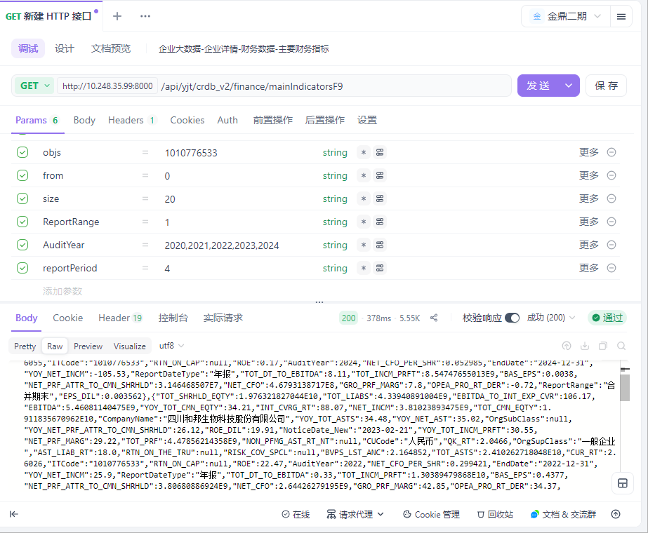

用例名称 | 固定报表-金鼎集团层级表-集团汇总查询成功
用例编号 | 43417
接口地址 | http://10.248.35.99:8090/smartbi/vision/RMIServlet
请求方式 | post
前置条件 | 数据查询功能正常
描述 | 正常查询数据信息成功
请求头部 | Content-Type：text/plain;charset=UTF-8
请求参数 | encode=t(k(Sw-Wp4gRip+-pkaSpdp6kLQ4gRpb*25p+/JV/uuc__'7'7'171mmh~(1h~(1KJ1p71m(7JpN1'Nu7~uh/uu/JT
状态码 | 200
预期返回结果 | :"H~CxOm~"{q,"H~*2KC"{:"H~K~JE'Ch'-O"{'2KK,"~FC~'m~m"{":\H\' \"*dOoA'!x\"{ CH2~,\H\' \"*dOoA'!Em\"{ CH2~,\H\' \"*dOoA'!dO'~\"{ CH2~\H\'}","IH~EC~msEC~"{"yqypg1qgy1 1n{y7{yq","*dOoA'!x"{CH2~,"*dOoA'!Em"{CH2~,"*dOoA'!dO'~"{CH2~,"I2*CO9h9Ev~"{'2KK,"I2*CO96OwcK~h9Ev~"{'2KK,"9OwcK~h9Ev~hm"{'2KK,"m~C~ICxdcKm"{-EK*~,"KE*C6Omc-c~msEC~"{"yqypg11gyq 11{yq{Nr","dcmm~'h'XHOo*~"{-EK*~,"dE*xdcKm"{-EK*~,"EKcE*"{"金鼎集团层级表g子公司确认","E2CdOH"{"Em9c'","I2*CO9h9Ev~3E9~"{'2KK,"I2*CO9h9Ev~D~9ehm"{'2KK,"9OwcK~h9Ev~3E9~"{'2KK,"*dOoMKOECDOOK*"{-EK*~,"~FeOHCs~KE_"{'2KK,"I2*CO9h9Ev~hm"{'2KK,"E2CdOHZ*~Hcm"{"(s6h3","-O'ChIO'"{'2KK,"dcm~COOK*"{-EK*~,"m~*I"{"","OHm~H"{n,"'E9~"{"金鼎集团层级表g子公司确认","cm"{"h--LqLqL1q177mwE1mwE1rp1~q17Eqp~N1LNyqwym","C_e~"{"l!i)(slG))Dfi)!AiD"},"m2HECcO'"{q}
实际结果 | 与预期结果一致  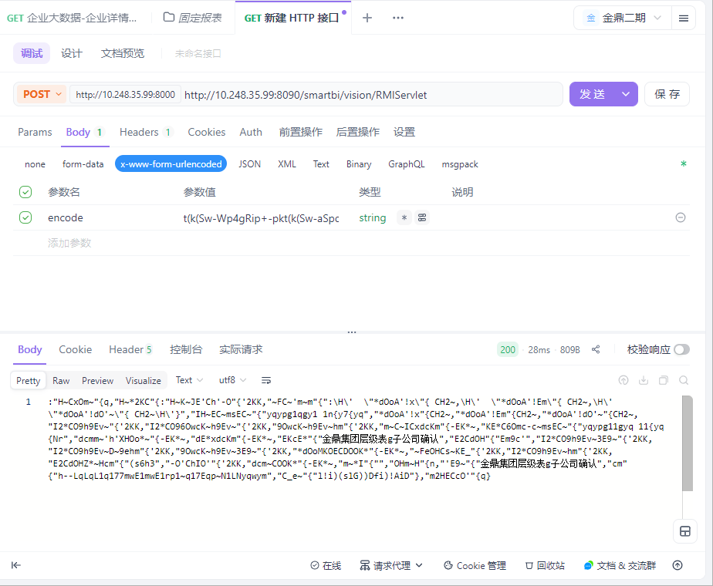

用例名称 | 固定报表-金鼎集团层级表-变动情况查询成功
用例编号 | 43418
接口地址 | http://10.248.35.99:8090/smartbi/vision/RMIServlet
请求方式 | post
前置条件 | 数据查询功能正常
描述 | 正常查询数据信息成功
请求头部 | Content-Type：text/plain;charset=UTF-8
请求参数 | encode=t(k(Sw-Wp4gRip+-pkt(k(Sw-aSpdp6kV2ch+/JV/uuc__'7'7'171mmh~(1h~(1KJ1p71m(7Miu'M~11(M1/uu/JT
状态码 | 200
预期返回结果 | :"H~CxOm~"{q,"H~*2KC"{:"H~K~JE'Ch'-O"{'2KK,"~FC~'m~m"{":\"*dOoA'!x\"{CH2~,\"*dOoA'!Em\"{CH2~,\"*dOoA'!dO'~\"{CH2~,\"dE*xdcKm\"{\"-EK*~\",\"dcmm~'h'XHOo*~\"{\"-EK*~\",\"dcm~COOK*\"{-EK*~,\"*dOoMKOECDOOK*\"{-EK*~}","IH~EC~msEC~"{"yqypg1qgy1 yq{NN{yN","*dOoA'!x"{CH2~,"*dOoA'!Em"{CH2~,"*dOoA'!dO'~"{CH2~,"I2*CO9h9Ev~"{'2KK,"I2*CO96OwcK~h9Ev~"{'2KK,"9OwcK~h9Ev~hm"{'2KK,"m~C~ICxdcKm"{-EK*~,"KE*C6Omc-c~msEC~"{"yqypg11g17 1p{rN{yL","dcmm~'h'XHOo*~"{-EK*~,"dE*xdcKm"{-EK*~,"EKcE*"{"金鼎集团层级表g变动情况","E2CdOH"{"Em9c'","I2*CO9h9Ev~3E9~"{'2KK,"I2*CO9h9Ev~D~9ehm"{'2KK,"9OwcK~h9Ev~3E9~"{'2KK,"*dOoMKOECDOOK*"{-EK*~,"~FeOHCs~KE_"{'2KK,"I2*CO9h9Ev~hm"{'2KK,"E2CdOHZ*~Hcm"{"(s6h3","-O'ChIO'"{'2KK,"dcm~COOK*"{-EK*~,"m~*I"{"","OHm~H"{p,"'E9~"{"金鼎集团层级变动情况表","cm"{"h--LqLqL1q177mwE1mwE1rp1~q17EqnIyLnw11En1","C_e~"{"l!i)(slG))Dfi)!AiD"},"m2HECcO'"{q}
实际结果 | 与预期结果一致  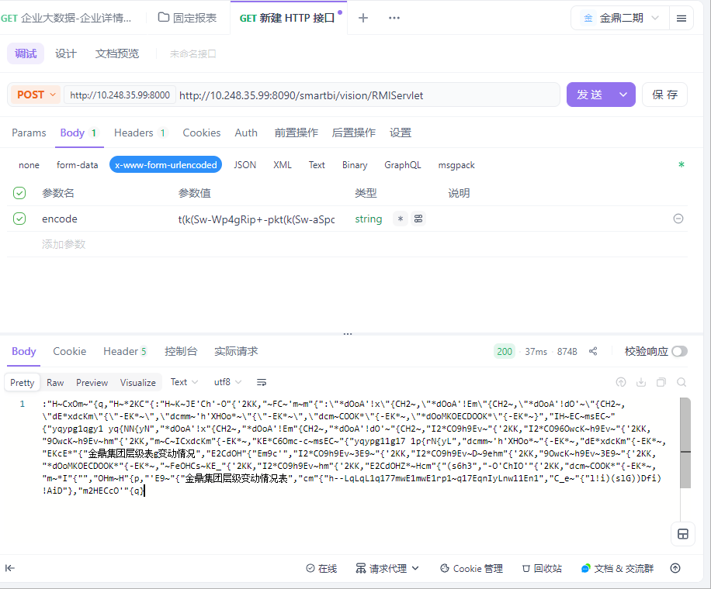

用例名称 | 固定报表-金鼎集团层级表-已注销企业汇总查询成功
用例编号 | 43419
接口地址 | http://10.248.35.99:8090/smartbi/vision/RMIServlet
请求方式 | post
前置条件 | 数据查询功能正常
描述 | 正常查询数据信息成功
请求头部 | Content-Type：text/plain;charset=UTF-8
请求参数 | encode=t(k(Sw-Wp4gRip+-pkt(k(Sw-aSpdp6kV2ch+/JV/uuc__'7'7'171mmh~(1h~(1KJ1p71m(79uh1(u(u1Ji/uu/JT
状态码 | 200
预期返回结果 | :"H~CxOm~"{q,"H~*2KC"{:"H~K~JE'Ch'-O"{'2KK,"~FC~'m~m"{":\H\' \"*dOoA'!x\"{ CH2~,\H\' \"*dOoA'!Em\"{ CH2~,\H\' \"*dOoA'!dO'~\"{ CH2~\H\'}","IH~EC~msEC~"{"yqypg1qgy1 yy{y7{rL","*dOoA'!x"{CH2~,"*dOoA'!Em"{CH2~,"*dOoA'!dO'~"{CH2~,"I2*CO9h9Ev~"{'2KK,"I2*CO96OwcK~h9Ev~"{'2KK,"9OwcK~h9Ev~hm"{'2KK,"m~C~ICxdcKm"{-EK*~,"KE*C6Omc-c~msEC~"{"yqypg11g17 1p{rN{yL","dcmm~'h'XHOo*~"{-EK*~,"dE*xdcKm"{-EK*~,"EKcE*"{"金鼎集团层级表g已注销企业汇总","E2CdOH"{"Em9c'","I2*CO9h9Ev~3E9~"{'2KK,"I2*CO9h9Ev~D~9ehm"{'2KK,"9OwcK~h9Ev~3E9~"{'2KK,"*dOoMKOECDOOK*"{-EK*~,"~FeOHCs~KE_"{'2KK,"I2*CO9h9Ev~hm"{'2KK,"E2CdOHZ*~Hcm"{"(s6h3","-O'ChIO'"{'2KK,"dcm~COOK*"{-EK*~,"m~*I"{"","OHm~H"{r,"'E9~"{"金鼎集团层级表g已注销企业汇总","cm"{"h--LqLqL1q177mwE1mwE1rp1~q17Eq0ym1EyEy1pI","C_e~"{"l!i)(slG))Dfi)!AiD"},"m2HECcO'"{q}
实际结果 | 与预期结果一致  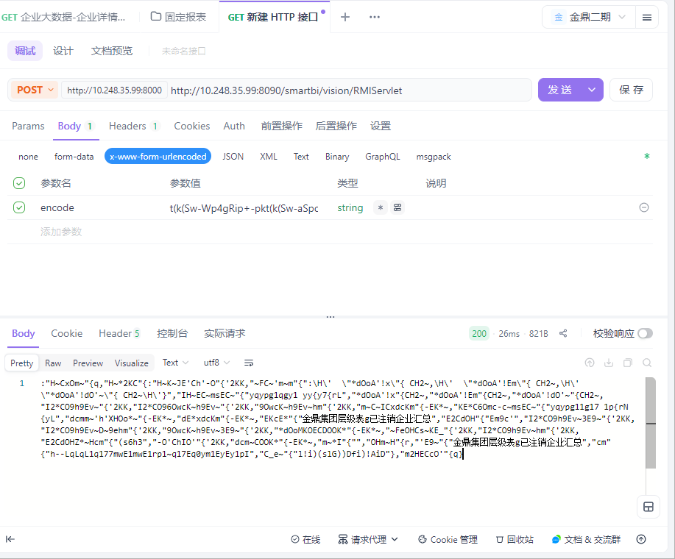

用例名称 | 固定报表-金鼎集团层级表-子公司填报查询成功
用例编号 | 43420
接口地址 | http://10.248.35.99:8090/smartbi/vision/RMIServlet
请求方式 | post
前置条件 | 数据查询功能正常
描述 | 正常查询数据信息成功
请求头部 | Content-Type：text/plain;charset=UTF-8
请求参数 | encode=t(k(Sw-Wp4gRip+-pkaSpdp6kLQ4gRpb*25p+/JV/uuc__'7'7'171mmh~(1h~(1KJ1p71m(7JpN1'Nu7~uh/uu/JT
状态码 | 200
预期返回结果 | :"H~CxOm~"{q,"H~*2KC"{:"ki(3D"{CH2~,"9Om2K~"{:"c*(II~**EwK~"{CH2~,"9Om2K~hm"{"('EK_*c*","9Om2K~"{:"cm"{"('EK_*c*","-2'Ihm*"{"XiASl)"}},"~Fc*C"{CH2~,"IECEKOv"{:"H~K~JE'Ch'-O"{'2KK,"~FC~'m~m"{":\H\' \"*dOoA'!x\"{ CH2~,\H\' \"*dOoA'!Em\"{ CH2~,\H\' \"*dOoA'!dO'~\"{ CH2~\H\'}","IH~EC~msEC~"{"yqypg1qgy1 1n{y7{yq","*dOoA'!x"{CH2~,"*dOoA'!Em"{CH2~,"*dOoA'!dO'~"{CH2~,"I2*CO9h9Ev~"{'2KK,"I2*CO96OwcK~h9Ev~"{'2KK,"9OwcK~h9Ev~hm"{'2KK,"m~C~ICxdcKm"{-EK*~,"KE*C6Omc-c~msEC~"{"yqypg11gyq 11{yq{Nr","dcmm~'h'XHOo*~"{-EK*~,"dE*xdcKm"{-EK*~,"EKcE*"{"金鼎集团层级表g子公司确认","E2CdOH"{"Em9c'","I2*CO9h9Ev~3E9~"{'2KK,"I2*CO9h9Ev~D~9ehm"{'2KK,"9OwcK~h9Ev~3E9~"{'2KK,"*dOoMKOECDOOK*"{-EK*~,"~FeOHCs~KE_"{'2KK,"I2*CO9h9Ev~hm"{'2KK,"E2CdOHZ*~Hcm"{"(s6h3","-O'ChIO'"{'2KK,"dcm~COOK*"{-EK*~,"m~*I"{"","OHm~H"{n,"'E9~"{"金鼎集团层级表g子公司确认","cm"{"h--LqLqL1q177mwE1mwE1rp1~q17Eqp~N1LNyqwym","C_e~"{"l!i)(slG))Dfi)!AiD"},"SihD)"{CH2~,"i)(s"{CH2~,"i)M"{CH2~},"m2HECcO'"{q}
实际结果 | 与预期结果一致  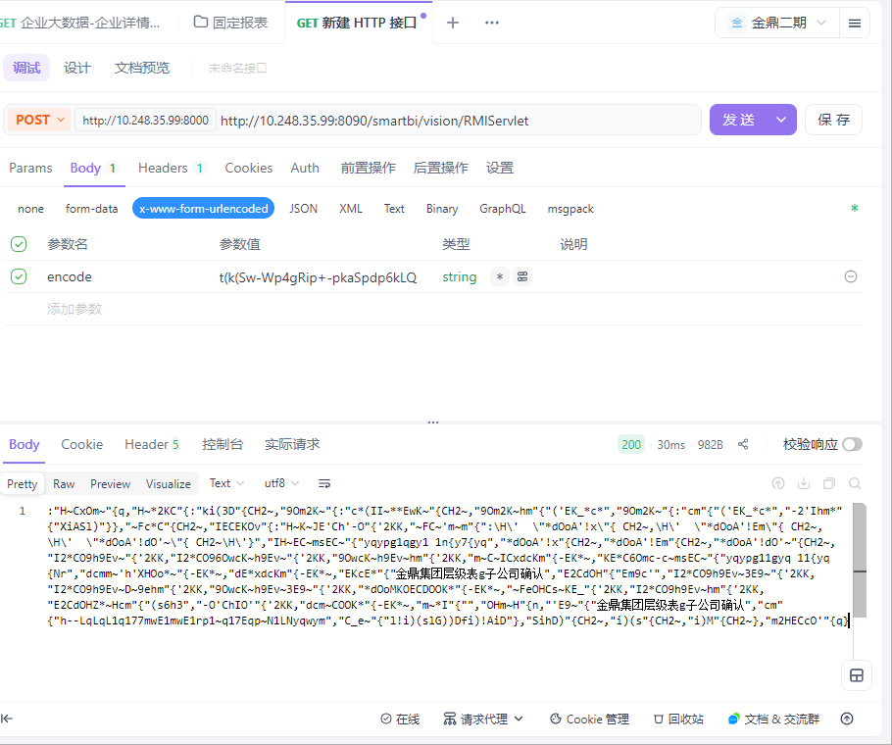

测试结论

问题统计与分析
整个测试过程当中设计了36条测试用例在整个测试过程中发现了3个BUG，目前所有BUG都已全部解决并关闭。
Bug清单：
Bug编号 | Bug标题 | 严重程度 | 优先级 | Bug类型 | Bug状态
6807 | 企业大数据-首页-模糊查询中外文+空格无法查询数据 | 一般 | 2 | 代码错误 | 已关闭
6808 | 企业大数据-首页-模糊查询中文+特殊符号无法查询数据 | 一般 | 2 | 代码错误 | 已关闭
6809 | 企业大数据-基本信息-高管信息无数据返回，其详细信息中应有数据 | 一般 | 2 | 代码错误 | 已关闭

总结
当前对产品进行接口测试，经最后一轮测试，所有接口测试用例执行通过，接口数据返回正确，软件功能正常，符合用户功能需求，产品满足上线条件。

