PROJECT REPORT
Title: Smart Cam Image Classifier Using Deep Learning & Flask
Course/Internship: AIML Internship Project
Development Stack: Python 3.12, Flask, tf_keras, TensorFlow, Pillow, NumPy, Vanilla JS, Tailwind CSS

1. Abstract & Introduction
This project implements an end-to-end Computer Vision application called the Smart Cam Classifier. By leveraging artificial intelligence and transfer learning, the application allows users to upload captured digital images to a web interface and instantly receive automated classification predictions with high-fidelity UI feedback.
The core predictive engine uses a deep convolutional neural network (MobileNet architecture) trained on custom visual data formats via Google Teachable Machine. The application architecture resolves major industry challenges regarding backward compatibility between modern programming environments (Python 3.12 / TensorFlow 2.16+) and legacy model formats (.h5) by implementing a dynamic execution pipeline using the tf_keras bridge.

2. System Architecture & Core Preprocessing Pipeline
Deep learning image classifiers demand absolute mathematical precision regarding input data shapes. The pipeline below illustrates how the Smart Cam backend handles incoming images to prevent matrix dimension misalignment crashes:
Spatial Cropping & Resizing: Forces varying camera image sizes into a square aspect ratio of exactly 224x224 pixels, the default input shape expected by the MobileNet base layer.
Channel Restructuring: Automatically identifies and repairs input anomalies. If a user uploads a grayscale image, it stacks the arrays to build a 3-channel RGB image. If a PNG with transparency is uploaded, it strips the 4th alpha channel away, ensuring a strict depth of 3 channels.
Mathematical Pixel Normalization: Converts raw pixel integers from the standard [0, 255] range down into high-speed floating-point coordinates between [-1.0, 1.0] using the tensor formula:
Normalized Array = (Image Array / 127.5) - 1.0
Batch Expansion: Expands the array shape into a 4D tensor matching the network's input signature: (1, 224, 224, 3).

3. Step-by-Step Implementation & Interface Milestones

Stage 1: Terminal Directory Navigation
Navigating to the project workspace using the command line requires targeting the correct drive partition and directory.
cd /d "C:\Users\asus\Downloads\Project"
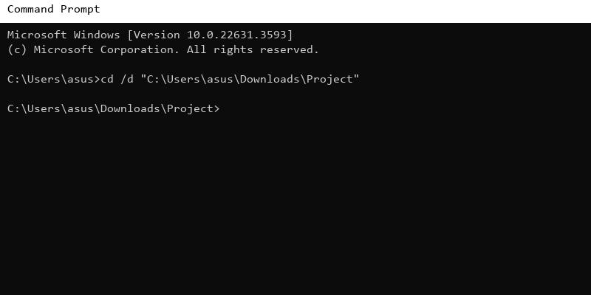

Stage 2: Flask Local Network Server Boot Sequence
Executing the local server command fires up the application engine, mounting the web framework structures, loading the machine learning model into memory (cached once to prevent reloading latency), and initializing access loops through port 5000.
python app.py
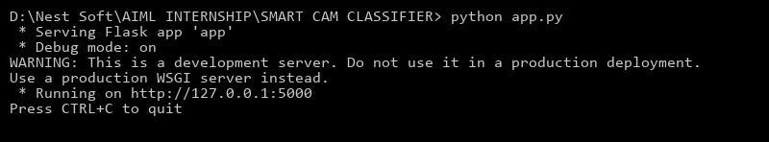

Stage 3: Base Interface Initialization
When an engineer accesses the local server address (localhost:5000), the web interface serves a custom Neo-Brutalist HTML/CSS UI. This boots up a secure drag-and-drop file uploader restricted to image file buffers.
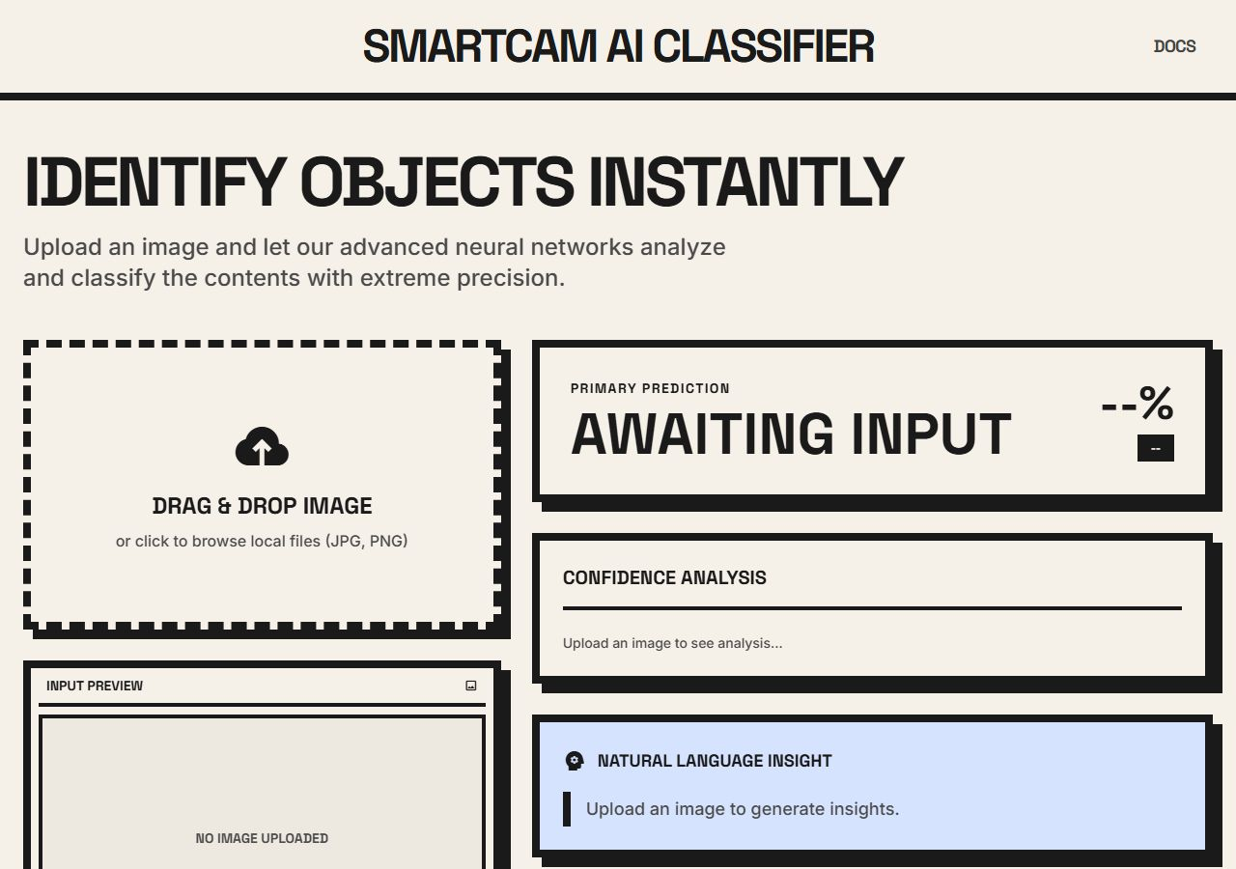

Stage 4: User Image Selection & Matrix Ingestion
Once an image drops into the active uploader asset, the browser displays a localized preview image using the FileReader API while silently submitting the file data via AJAX POST request to the backend /predict endpoint.
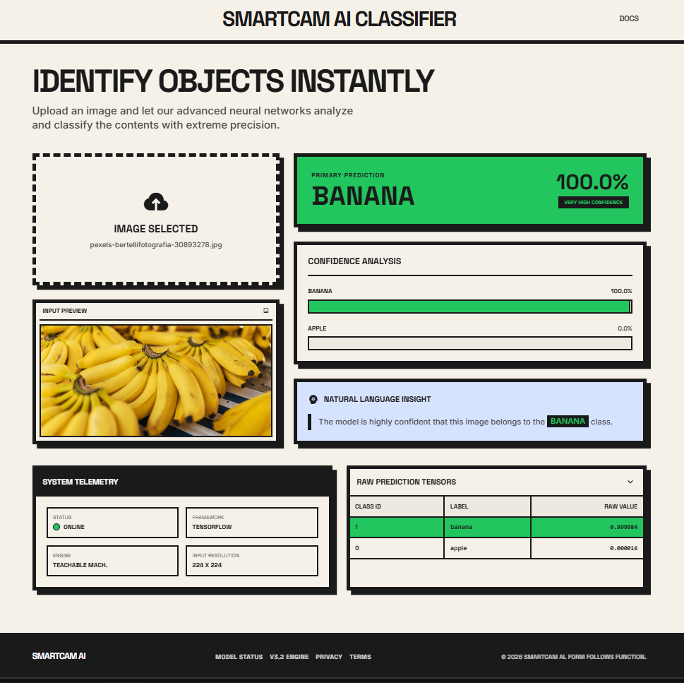

Stage 5: Inference Matrix Resolution & Final Class Prediction
The backend passes the sanitized array data into the tf_keras inference engine. Forward-pass matrix calculations evaluate the vectors and return a JSON payload detailing the predicted class and confidence thresholds. The JavaScript frontend dynamically parses this payload, triggering real-time CSS color shifts (Green/Blue/Orange based on confidence) and stretching progress bars for visual telemetry.
prediction = model.predict(data)
class_confidence = float(prediction[0][pred_index]) * 100
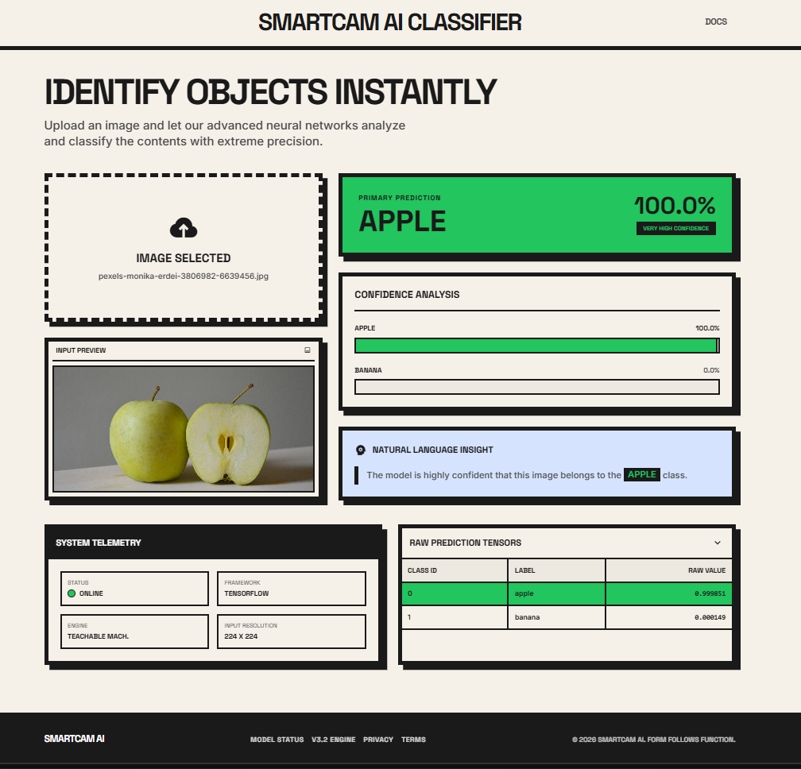

4. Detailed Technical Analysis

Model Architecture Analysis
The underlying deep learning model relies on transfer learning through a pre-trained MobileNet neural network. By freezing the early feature-extraction layers (which detect generic shapes, edges, and textures) and retraining the final dense classification layers on the Apple and Banana datasets, the model converges rapidly with minimal computational overhead. This allows real-time inference on CPU hardware.

Confidence Analysis Logic
The output layer of the neural network applies a Softmax activation function, squashing raw logits into a normalized probability distribution summing to 100%. If out-of-distribution data is supplied (e.g., an image of a shoe), the model is mathematically forced to assign it to one of the trained classes. To mitigate ambiguity, a custom threshold logic engine was deployed in the API:
>= 90%: High Confidence. Card turns green. Generates positive natural language insights.
>= 70%: Moderate Confidence. Card turns blue. Generates cautious natural language insights.
< 70%: Low/Ambiguous Confidence. Card turns orange. Warns user to provide a clearer image.

5. Engineering Challenges & Troubleshooting Log
During the implementation phase, several critical runtime exceptions were encountered and systematically debugged:
Drive Switch Terminal Error: Using a raw cd command without the /d parameter in CMD failed to switch drive partitions. This was solved by utilizing the /d disk command patch (e.g. cd /d).
Keras 3 Layer Deserialization Mismatch: Modern TensorFlow 2.16+ environments reject older model configurations exported by Teachable Machine due to DepthwiseConv2D layer serialization changes. This was permanently solved by installing and explicitly importing tf_keras to force the software environment to read the .h5 files using stable legacy parsers.
Dynamic Label Parsing: Hardcoding labels scales poorly. An autonomous Python parsing loop was written to strip the '0 ' and '1 ' prefixes from labels.txt, ensuring the UI adapts if the model is retrained on new objects.

6. Future Scope
While the current Smart Cam iteration is highly functional, future expansions could include:
1. Background/Anomaly Class Training: Adding an 'Unknown' class in Teachable Machine containing diverse random objects to prevent out-of-distribution forced predictions.
2. History Database: Connecting the Flask backend to a SQLite database to log past predictions and images.
3. Mobile Application: Exporting the tf_keras model to TensorFlow Lite (.tflite) for edge-deployment on Android and iOS devices without requiring an active server connection.

7. Conclusion/Inference
The Smart Cam Classifier effectively demonstrates the application of deep learning for automated image classification. By migrating from a rigid Streamlit prototype to a customized Flask backend with a tailored frontend design system, the application achieves greater control over network architecture, asynchronous DOM manipulation, and backward compatibility. This project successfully bridges the gap between modern deployment environments, robust ML engineering, and premium UX/UI design.

