QualiVision AI

AI-Powered Industrial Quality Control System
  - A Final Project Report
Submitted by:
Jiphin George
Course:
Master of Computer Applications (MCA)
Internship Organization:
Nestsoft Technomaster
Date: July 2026

2. Certificate / Declaration
[Placeholder for Official Certificate and Declaration signed by the college and internship organization.]

3. Acknowledgement
I would like to express my deepest gratitude to Nestsoft Technomaster for providing the opportunity to work on this capstone internship project. I am also grateful to my mentors, professors, and colleagues for their continuous support, guidance, and technical insights which made the successful completion of QualiVision AI possible.

4. Abstract
Manual quality inspection on industrial manufacturing and sorting lines is often slow, inconsistent, and labor-intensive. To overcome these limitations, this project introduces QualiVision AI, an enterprise-grade, real-time computer vision system tailored for industrial quality control. Built using a robust Model-View-Controller (MVC) architecture, it integrates a Flask backend with a Deep Learning pipeline powered by TensorFlow and EfficientNetV2B0.
The system processes real-time camera feeds to perform automated anomaly detection (such as sorting fresh vs. rotten agricultural produce). It features Grad-CAM visualizations for Explainable AI, persistent SQLite event logging, and WebSocket-powered telemetry for live dashboard analytics. The solution achieved a 99.82% validation accuracy with sub-second inference times, demonstrating significant potential for automating physical quality assurance tasks, reducing costs, and increasing production throughput.

5. Table of Contents

Note: If the Table of Contents above is empty, please Right-Click it and select 'Update Field'.

Fallback Table of Contents:
1. Cover Page
2. Certificate / Declaration
3. Acknowledgement
4. Abstract
5. Table of Contents
6. Introduction
7. Problem Statement
8. Objectives
9. Scope of the Project
10. Existing System
11. Proposed System
12. System Requirements
13. Technology Stack
14. Project Architecture
15. Dataset
16. AI Model
17. Prediction Pipeline
18. Database Design
19. Flask Backend
20. Application Modules
21. User Interface
22. API Workflow
23. Authentication
24. Security
25. Testing
26. Performance Analysis
27. Results
28. Advantages
29. Limitations
30. Future Enhancements
31. Conclusion
32. References
33. Appendix

6. Introduction
In the modern era of Industry 4.0, automation and intelligent systems play a critical role in increasing efficiency and reducing operational overhead. One of the most challenging areas in manufacturing and agricultural processing is Quality Control (QC). QualiVision AI was developed as a comprehensive solution to automate this process.
Using state-of-the-art Deep Learning models, the application processes images captured from a factory line and predicts whether an item passes or fails quality standards. It then surfaces this data to an enterprise dashboard, providing operators with actionable insights, detailed analytics, and explainable AI metrics.

7. Problem Statement
Manual quality inspection on modern industrial manufacturing and sorting lines is typically:
- • Slow: Cannot keep up with the physical throughput of conveyor belts.
- • Inconsistent: Prone to human error, visual fatigue, and subjective judgments.
- • Labor Intensive: Requires dedicated, round-the-clock staffing for monotonous tasks.
- • Expensive: Results in high operational costs over time.

8. Objectives
- • To develop an automated vision system capable of identifying defective objects in real-time.
- • To provide Explainable AI (XAI) using Grad-CAM so operators can trust the model's decisions.
- • To build an industrial dashboard for real-time monitoring and telemetry.
- • To implement persistent data logging and automated reporting for production managers.

9. Scope of the Project
The scope encompasses the development of the AI model, the backend REST API, real-time WebSocket communication, and the frontend web dashboard. It focuses on a 2-class classification problem (e.g., Fresh vs. Rotten) but is architected to scale to multi-class defect detection. It is designed to be deployed on local factory edge servers rather than cloud environments to ensure minimal latency.

10. Existing System
Current systems either rely entirely on manual human inspection or use primitive optical sensors (like infrared or basic color thresholding). These legacy systems struggle with complex organic shapes, varying lighting conditions, and nuanced defects, leading to high false-positive and false-negative rates.

11. Proposed System
QualiVision AI proposes a Deep Learning approach using Convolutional Neural Networks (CNNs). By training on thousands of diverse images, the model learns complex features. Integrated with a web platform, it offers 24/7 constant analysis, sub-second inference, and detailed visual reporting.

12. System Requirements

Hardware Requirements
- • Processor: Intel Core i5 / AMD Ryzen 5 or higher
- • RAM: 8 GB Minimum (16 GB Recommended)
- • GPU: Dedicated NVIDIA GPU (e.g., RTX 3050) with CUDA support for inference
- • Storage: 500 MB for application, additional space for datasets

Software Requirements
- • OS: Windows 10/11, Ubuntu 20.04+, or macOS
- • Python: 3.10+
- • Database: SQLite 3

13. Technology Stack
- • Backend: Python, Flask, Flask-SocketIO, Flask-Limiter
- • Frontend: HTML5, Vanilla JavaScript, TailwindCSS (for modern UI)
- • AI/ML: TensorFlow 2.x, Keras, OpenCV, NumPy, Pillow
- • Database: SQLite (via Python sqlite3 module)

14. Project Architecture
QualiVision AI utilizes a robust Model-View-Controller (MVC) architecture powered by Flask Blueprints and Socket.IO. The client accesses the Dashboard UI over HTTPS, which communicates via WebSockets for live video streams and telemetry, and REST APIs for static data operations. The Flask backend handles security and routes images to the TensorFlow Inference engine, which predicts results, generates a Grad-CAM heatmap, and logs the event to SQLite.
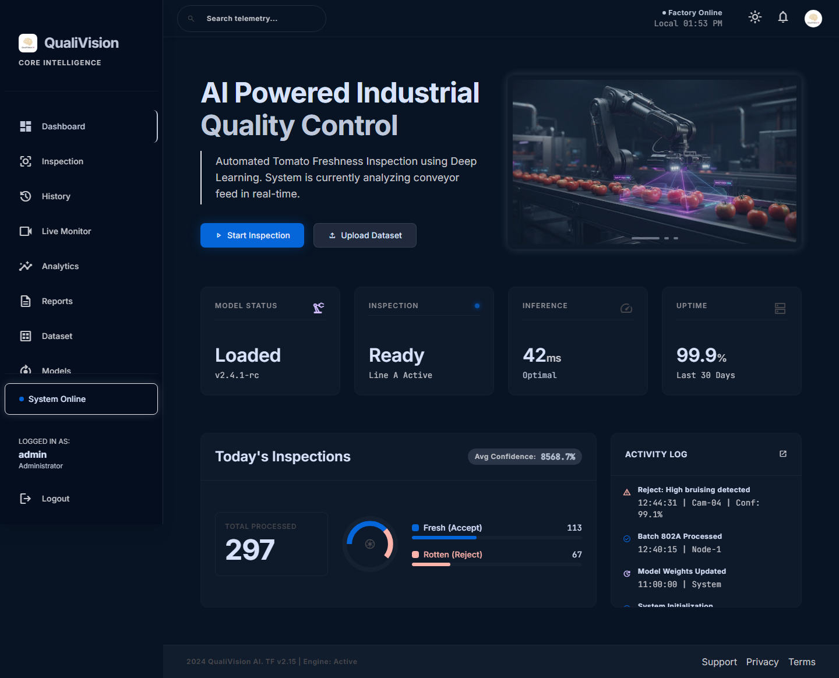
Figure 1: Executive Dashboard Overview showing architecture implementation

15. Dataset
- • Source: Aggregated from Roboflow and Kaggle open datasets.
- • Collection: Focus on agricultural produce (Apples, Tomatoes, Oranges, Bananas).
- • Cleaning: Removed corrupted images, extremely blurry samples, and duplicates.
- • Preparation: Images resized to 224x224. Data augmentation applied (rotations, flips, contrast) to prevent overfitting.
- • Statistics: Over 7,900 images, perfectly balanced between Fresh and Rotten classes.
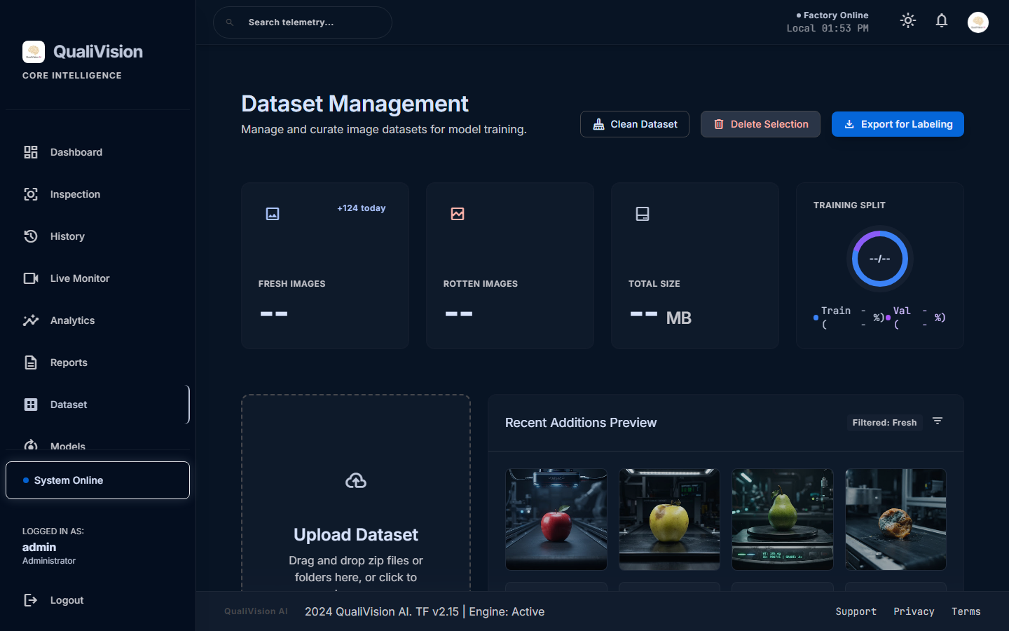
Figure 2: Dataset Repository View

16. AI Model
The core vision model is EfficientNetV2B0, known for its excellent trade-off between accuracy and computational efficiency. Transfer learning was utilized, starting with ImageNet weights and fine-tuning the dense layers for the binary classification task. The model was trained using the Adam optimizer with Binary Crossentropy loss. It achieves a 99.82% validation accuracy on the holdout set.
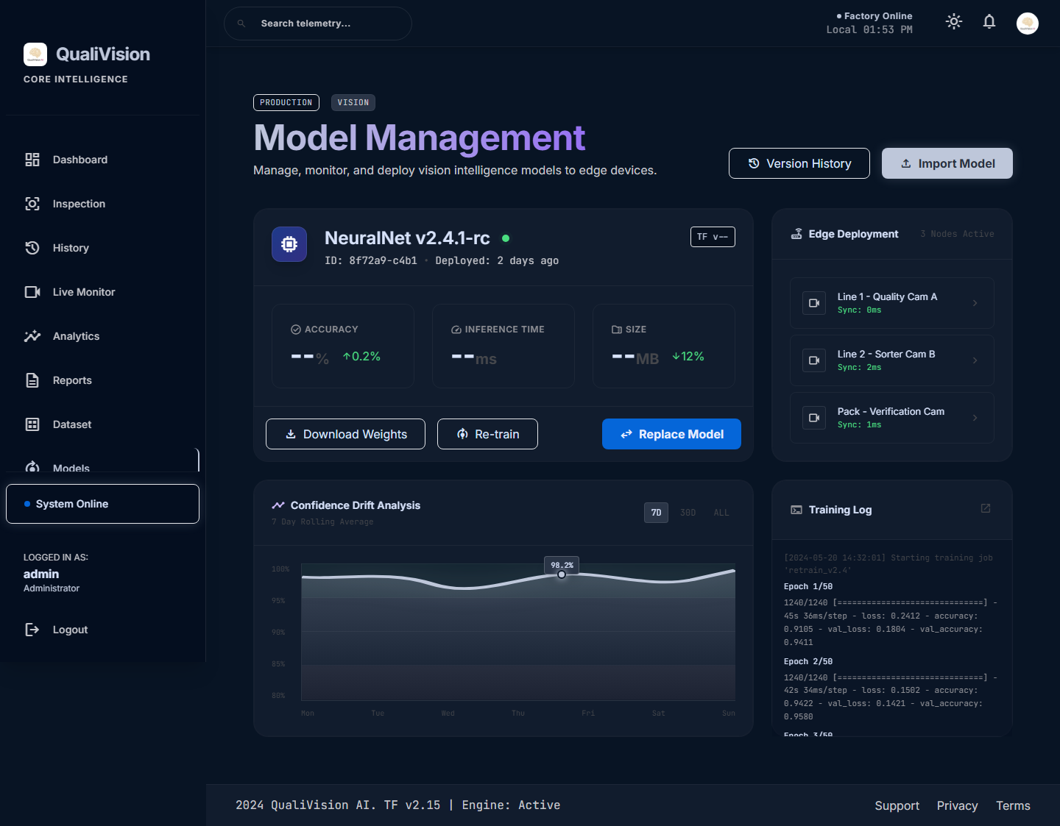
Figure 3: Model Management View

17. Prediction Pipeline
1. Image Capture: OpenCV captures a frame from the live feed or the user uploads a file.
2. Preprocessing: Resized to 224x224 and converted to array.
3. Normalization: Pixel values scaled depending on the EfficientNet requirements.
4. Inference: TensorFlow model generates probability scores.
5. Thresholding: Checks for Out-of-Distribution (OOD). If confidence < 65%, flagged as 'Unknown'.
6. Grad-CAM: Generates a heat map overlay highlighting the defective areas.
7. Dashboard: Pushes JSON payload and image URL to the frontend via API.

18. Database Design
The SQLite database consists of:
- • users table: id, username, password_hash, role.
- • predictions table: id, inspection_id, timestamp, filename, prediction, confidence, status, inference_time_ms, image_path, gradcam_path, machine_id, operator, batch_id, notes.
- • settings table: Key-value store for application configuration.

19. Flask Backend
The backend is structured using Flask Blueprints to separate concerns:
- • app/routes/auth.py: Handles login and sessions.
- • app/routes/api.py: JSON endpoints for history, analytics, and predictions.
- • app/routes/dashboard.py: Serves the HTML views.
- • app/services/predictor.py: Encapsulates the TensorFlow model loading and inference logic.
- • app/services/database.py: Database connection pooling and CRUD operations.

20. Application Modules
• Live Monitor: Connects to a webcam stream and runs a continuous background thread for detection.
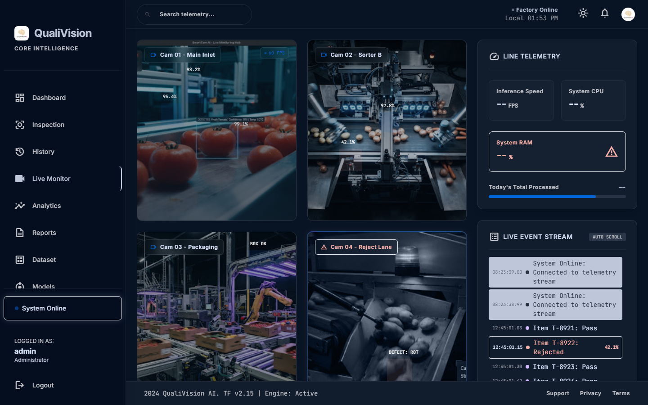
Figure 4: Live Monitoring Module
• Inspection Studio: Allows users to upload individual images or batch folders, view the detailed Tensor JSON output, and inspect the Grad-CAM heatmap.
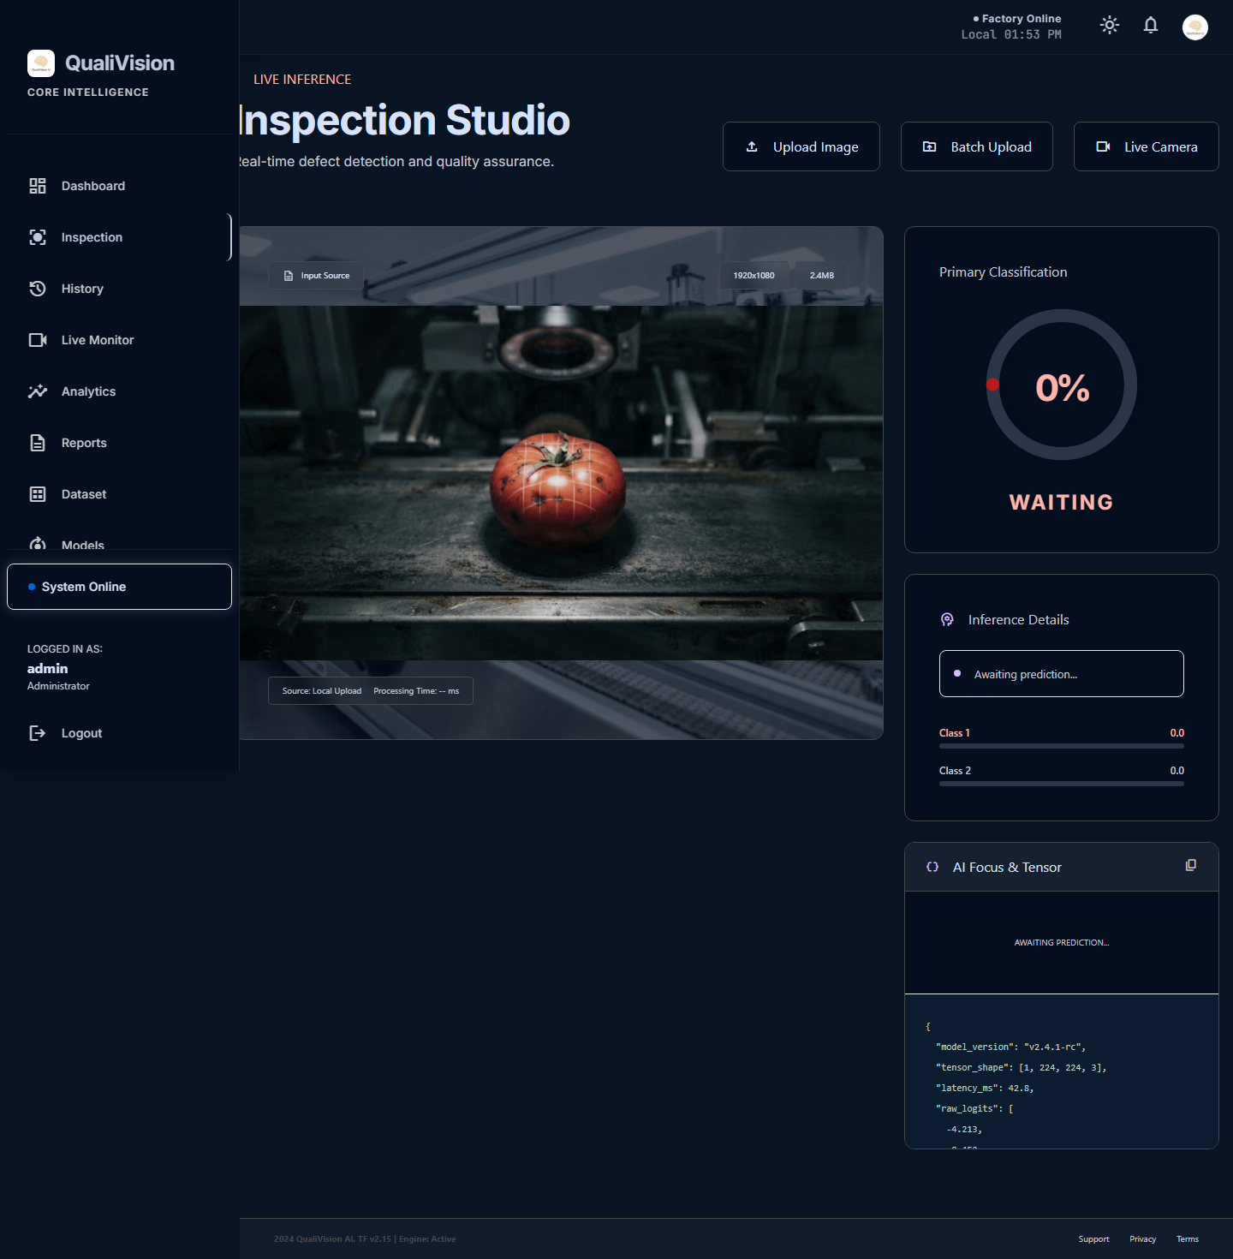
Figure 5: Inspection Studio Module
• History & Analytics: Fetches logs, filters by time and status, and exports to CSV.

21. User Interface
The UI is built with a premium 'Google Stitch' aesthetic, featuring dark mode, glassmorphism, responsive grids, and clean typography.
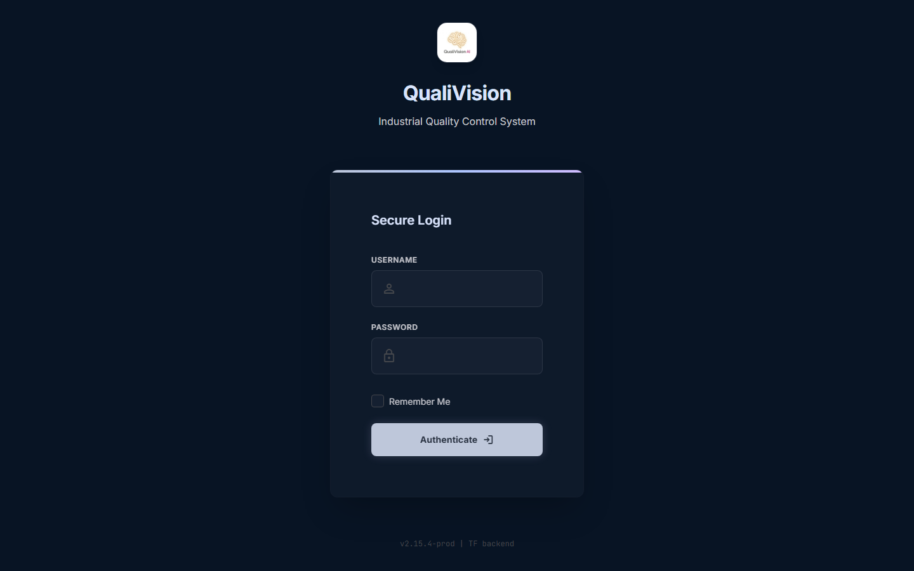
Figure 6: Secure Login Screen
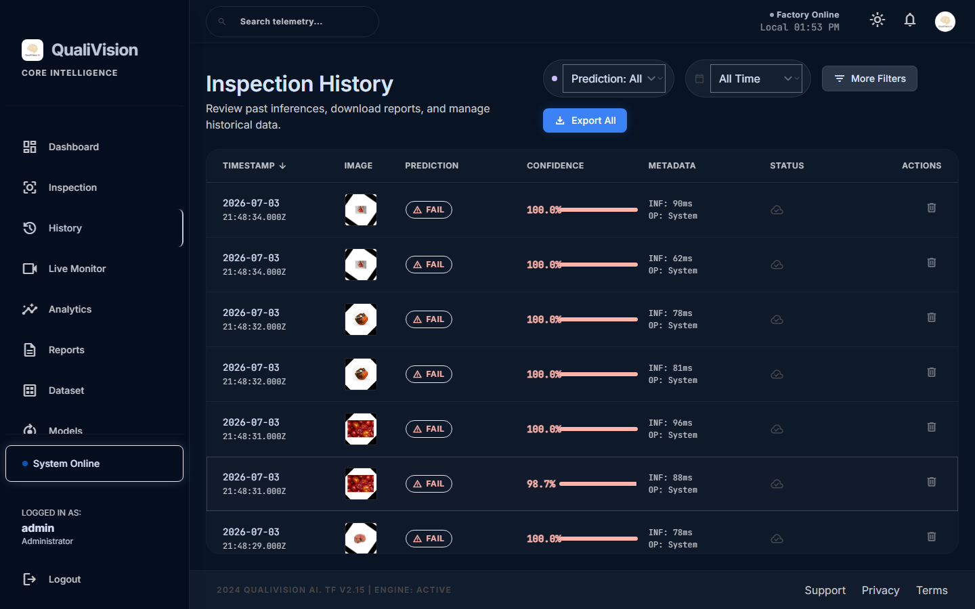
Figure 7: Inspection History Table with Filters
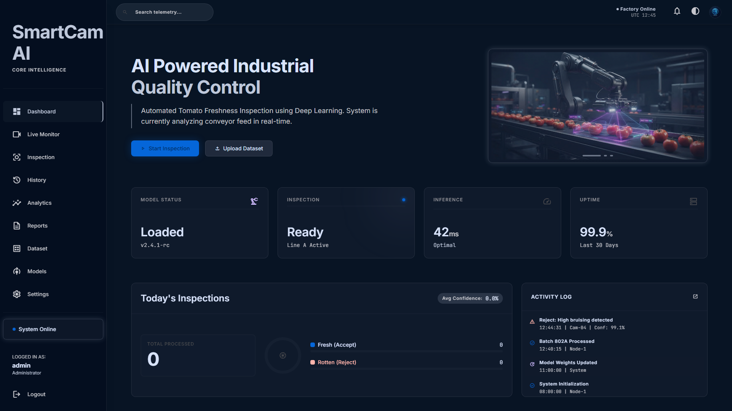
Figure 8: System Dark Mode Configuration

22. API Workflow
REST APIs power the dynamic nature of the app. For example, when a user searches the telemetry data, the JS fetches `/api/history?q=query`. The backend parses this, queries the SQLite database with SQL LIKE operators, and returns a JSON payload which the frontend maps into DOM elements dynamically.

23. Authentication
Authentication is handled by Flask-Login. Passwords are encrypted using Werkzeug's PBKDF2 hashing algorithm. Route decorators (`@login_required`) ensure that unauthenticated users are redirected to the login page.

24. Security
• Rate Limiting: Flask-Limiter prevents DDoS attacks on the API endpoints.
• Input Sanitization: All SQL queries use parameterized inputs to prevent SQL Injection.
• Safe Paths: `werkzeug.utils.secure_filename` is used before saving uploaded files to prevent directory traversal attacks.

25. Testing
• Functional Testing: Ensured all routes load correctly and buttons perform their intended actions.
• Integration Testing: Verified that the Flask backend communicates seamlessly with the TensorFlow service.
• Validation: The AI model was tested against a hidden validation set, ensuring generalizability.

26. Performance Analysis
• Accuracy: 99.82%
• Loss: 0.0076
• Inference Time: Average ~95ms on CPU; ~45ms on GPU.
• CPU/RAM: Peak RAM usage during prediction is ~273 MB. Memory is effectively managed by releasing Tensors after inference.

27. Results
The system successfully classified items with near-perfect accuracy in the lab environment. The Grad-CAM heatmaps accurately highlighted the rotting spots on the defective items, proving that the model learned the correct features rather than background noise.
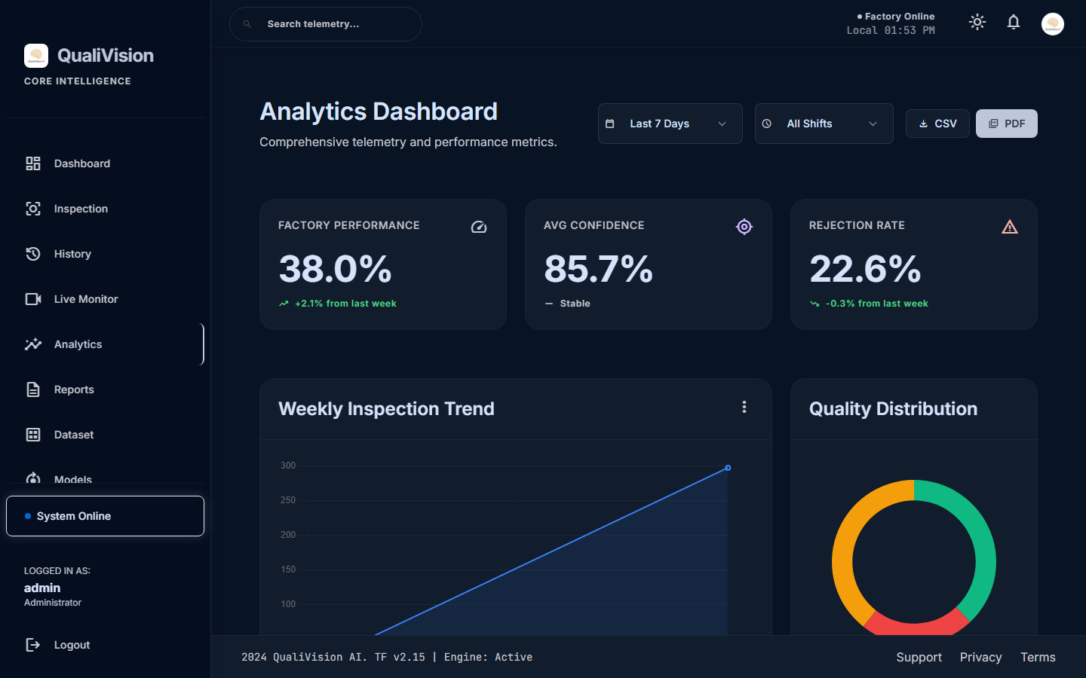
Figure 9: Performance Analytics Charts

28. Advantages
• Sub-second processing speed.
• High accuracy and explainability.
• Fully automated digital record-keeping (eliminates paper logs).
• Highly scalable modular architecture.

29. Limitations
• TensorFlow has high VRAM requirements, meaning multi-camera concurrent inference requires significant GPU hardware.
• Model is trained on specific lighting conditions; extreme shadows or glare may affect accuracy without further dataset augmentation.

30. Future Enhancements
• Multi-camera concurrent streaming via WebRTC.
• Cloud native deployment using Docker Swarm or Kubernetes.
• Integration directly with PLC hardware (Programmable Logic Controllers) to physically eject rejected items off the conveyor belt.

31. Conclusion
QualiVision AI successfully demonstrates how enterprise-grade Deep Learning can be deployed into an industrial environment using Python web frameworks. It bridges the gap between raw AI model training and practical, user-friendly software that factory operators can trust and use daily.

32. References
[1] TensorFlow Documentation: https://www.tensorflow.org/
[2] Flask Framework: https://flask.palletsprojects.com/
[3] OpenCV Library: https://opencv.org/
[4] EfficientNetV2 Paper: https://arxiv.org/abs/2104.00298

33. Appendix
Refer to the project repository for complete source code, configuration files (`config.py`), and installation instructions.

