**Index**

|  |  |
| --- | --- |
|  | **Python code with output** |
| **Ser no.** | **TASKS** |
| **1** | Program CODE for Finding HCF |
| **2** | Program CODE for Finding LCM |
| **3** | Program CODE for Finding |
| **4** | Program CODE for Finding ADDTOREULT |
| **5** | Program CODE for Finding DESC. ORDER LIST |
| **6** | Program CODE for Finding FIRST LETTER |
| **7** | Program CODE for Functioning LIST (PASS) |
| **8** | Program CODE for Functioning LIST |
| **9** | Program CODE for POP Function |
| **10** | Program CODE for EXICUTE (3 no. on 2 digit ) |
| **11** | Program CODE for EXTRECT TO NOTEPAD |
| **12** | Program CODE for LOOPING THE LOOP (DESIGN) |
| **13** | Program CODE for FUNCTION(COUNT) |
| **14** | Program CODE for FUNCTION(LETTER COUNT) |
| **15** | Program CODE for FUNCTION(VOWELS) |
| **16** | Program CODE for CONNECTOR(MYSQL) |
| **17** | Program CODE for REPLACE(TEXT) |
| **18** | Program CODE for Finding all prem. of TRIANGAL |
| **19** |  |
| **20** |  |
|  | **MYSQL COMMAND** |
| **1** | MYSQL command (To show database) |
| **2** | MYSQL command (To select database and create table) |
| **3** | MYSQL command (To show description of table) |
| **4** | MYSQL command (To show tables in database) |
| **5** | MYSQL command (To show all data in table) |
| **6** | MYSQL command (To insert data in table) |
| **7** | MYSQL command (To replace or update data in table) |
| **8** | MYSQL command (To delete a particular data in table) |
| **9** | MYSQL command (To delete table from database) |
| **10** | MYSQL command (To delete database from mysql ) |

1. Program CODE for Finding HCF :-

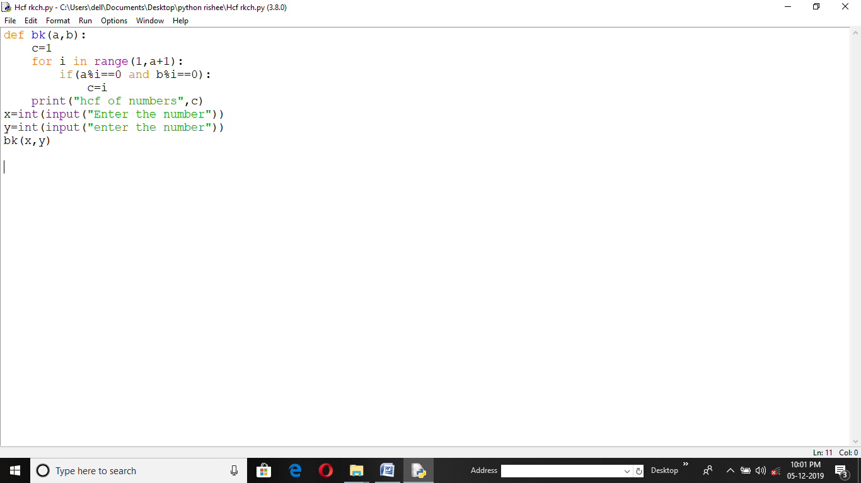

Output :-

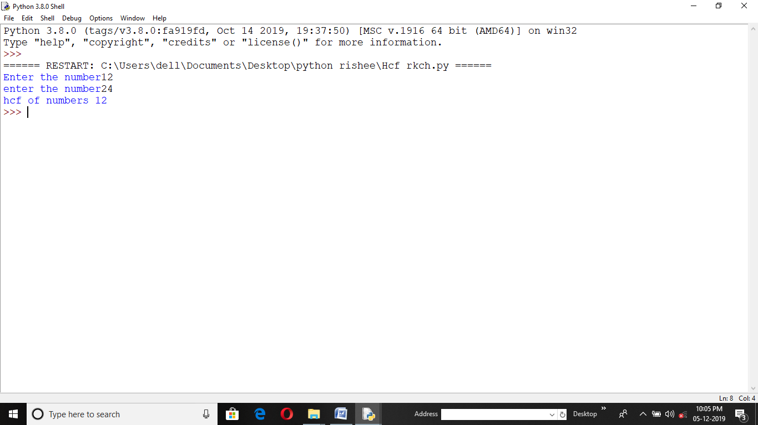

2. Program CODE for Finding LCM :-

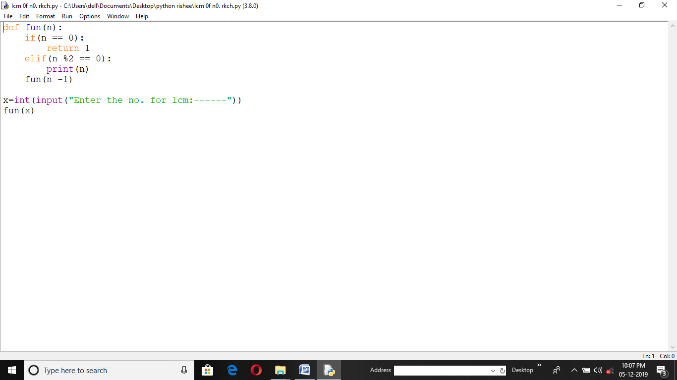

Output :-

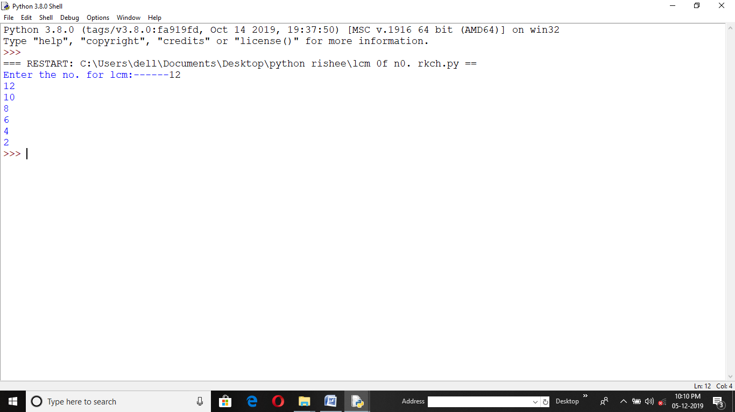

3. Program CODE :-

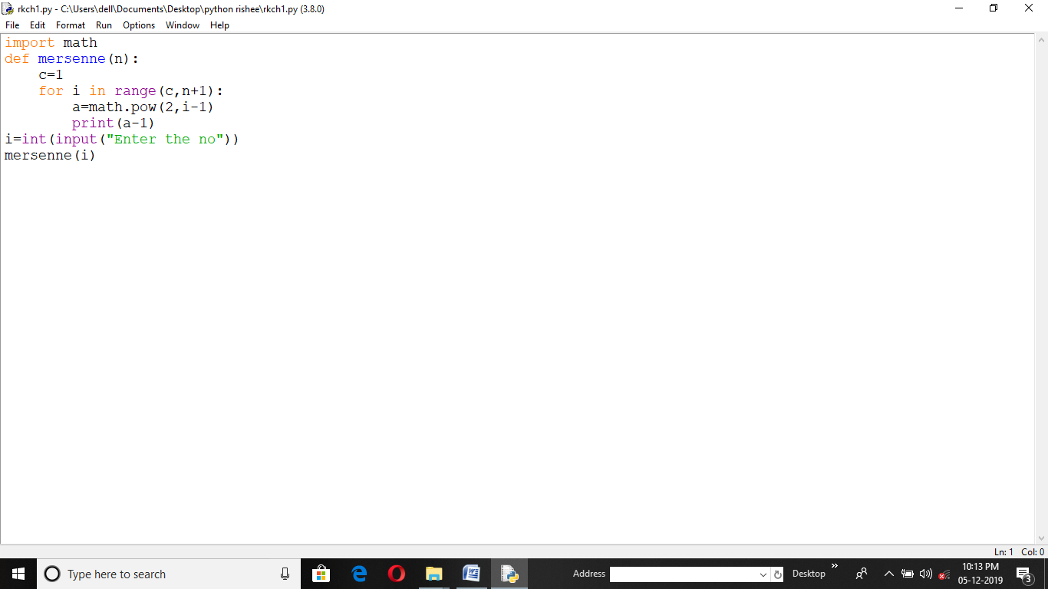

Output :-

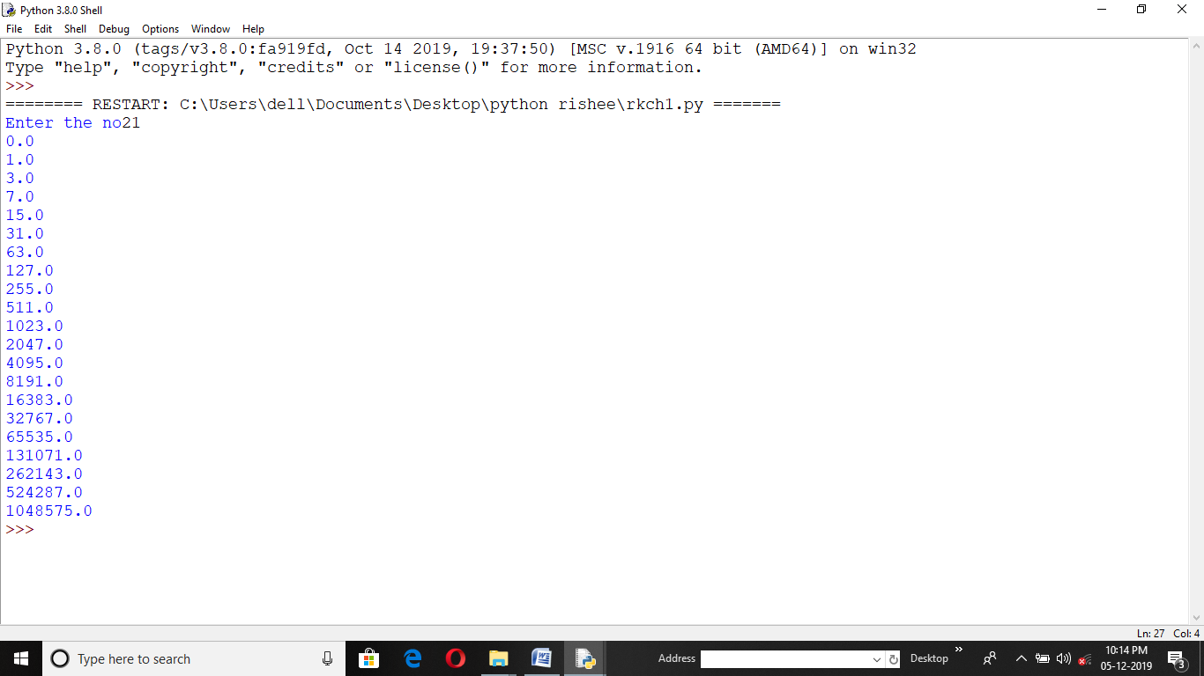

4. Program CODE for Finding ADDTOREULT :-

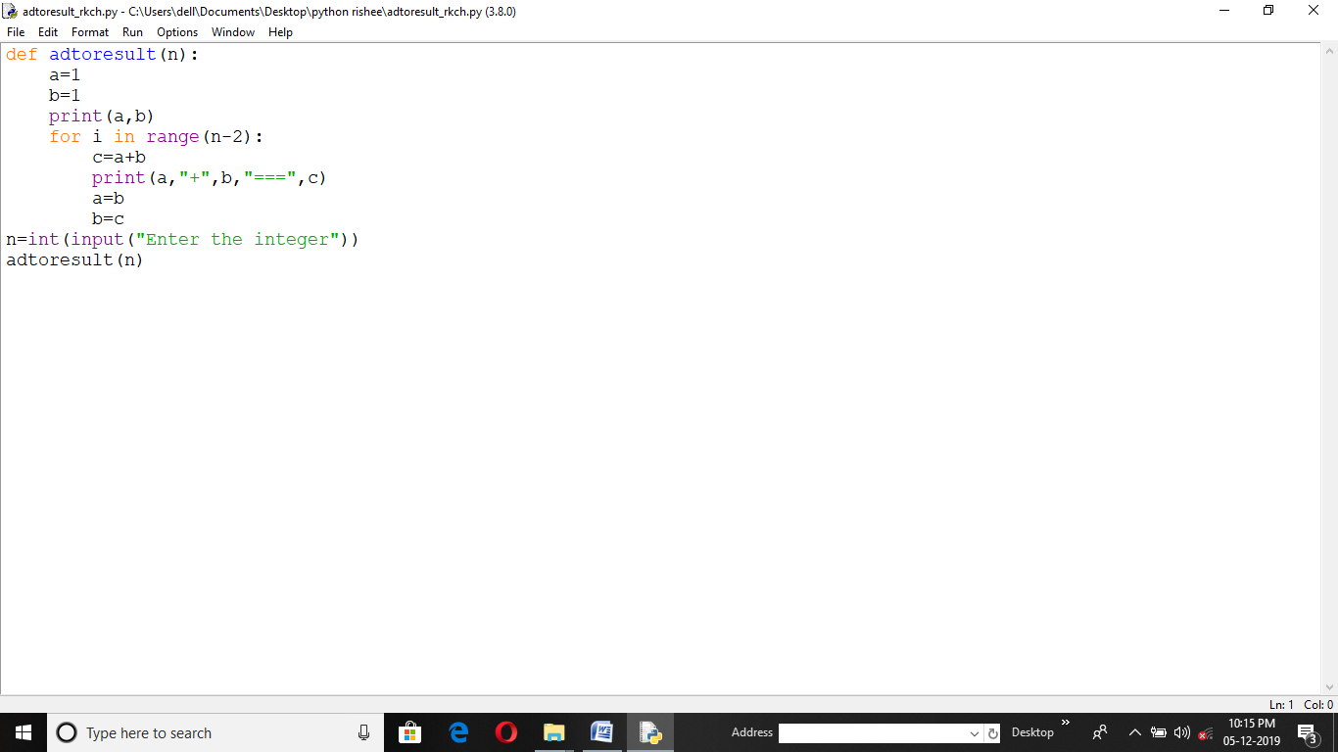

Output :-

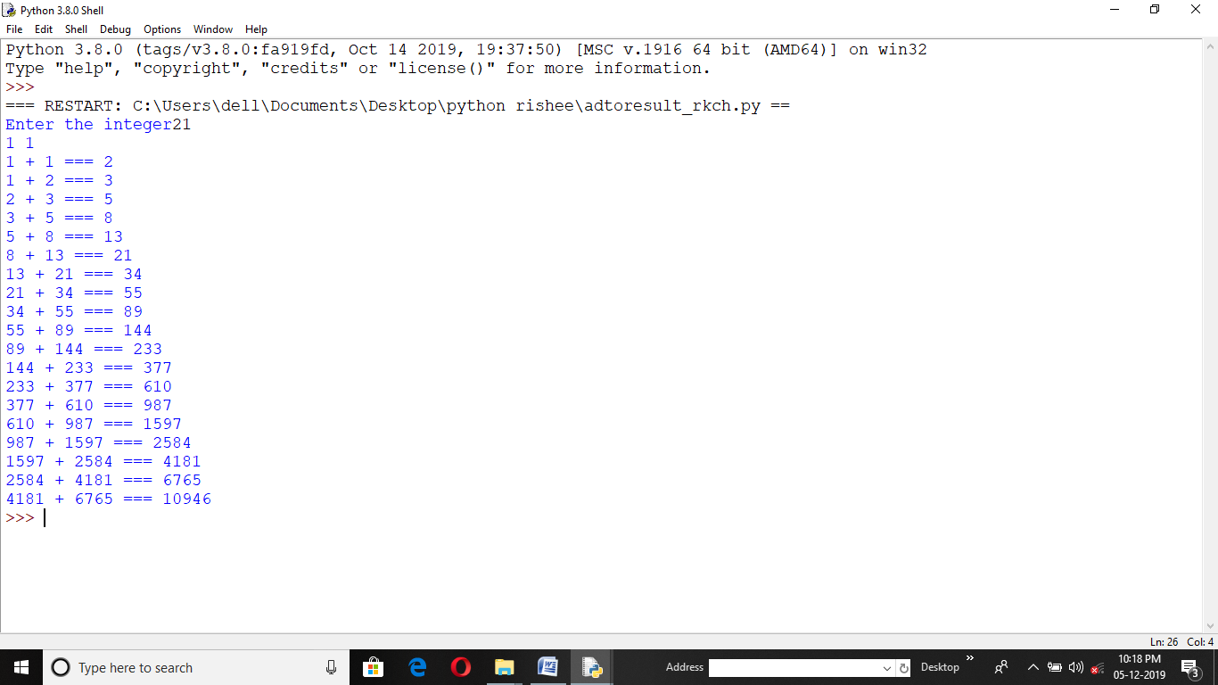

5. Program CODE for Finding DESC. ORDER LIST :-

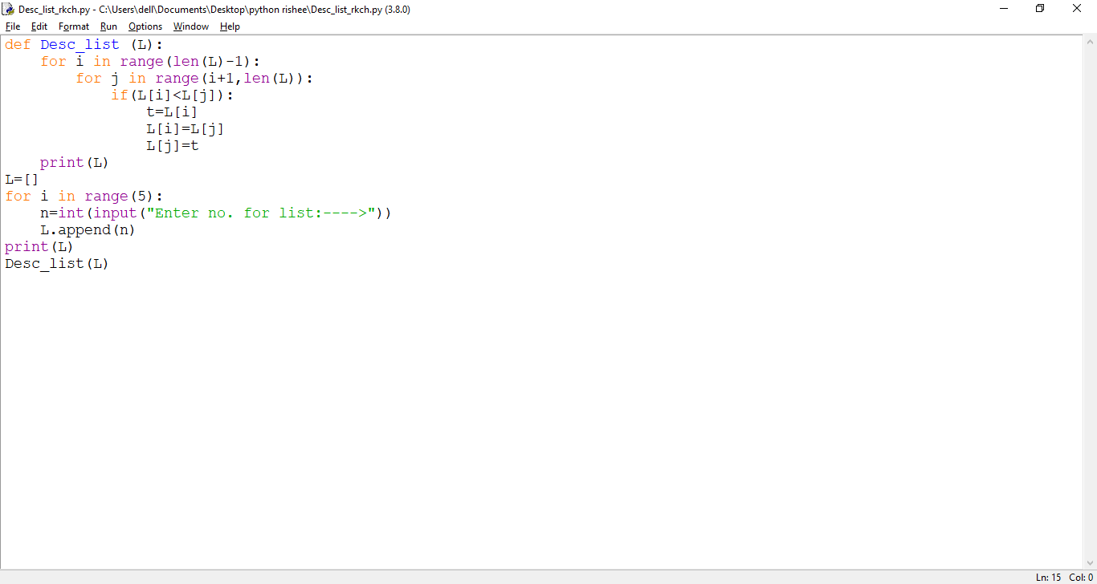

Output :-

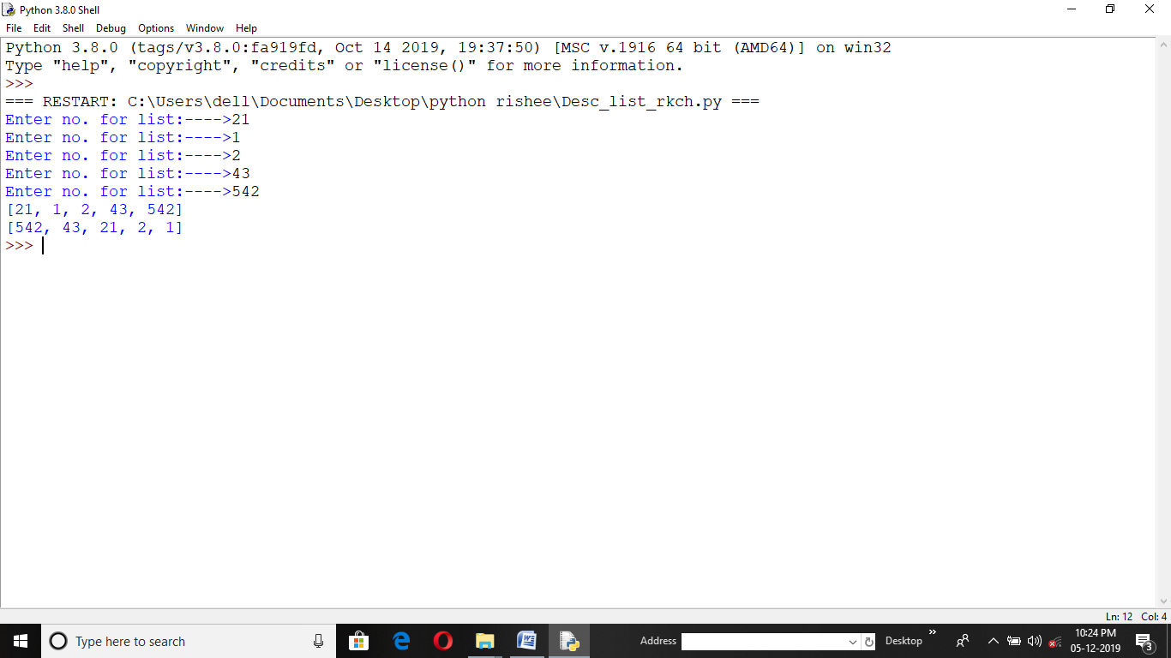

6. Program CODE for Finding FIRST LETTER :-

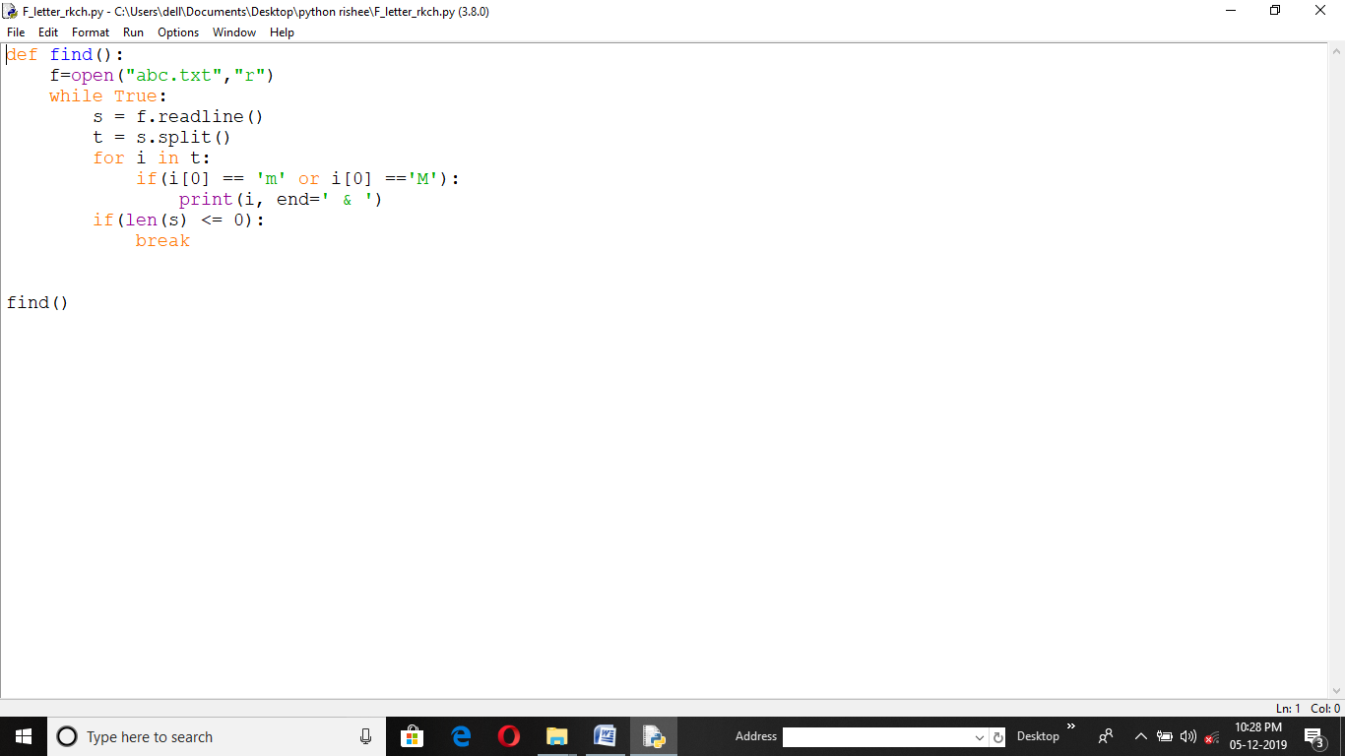

Output :- Notepad :-

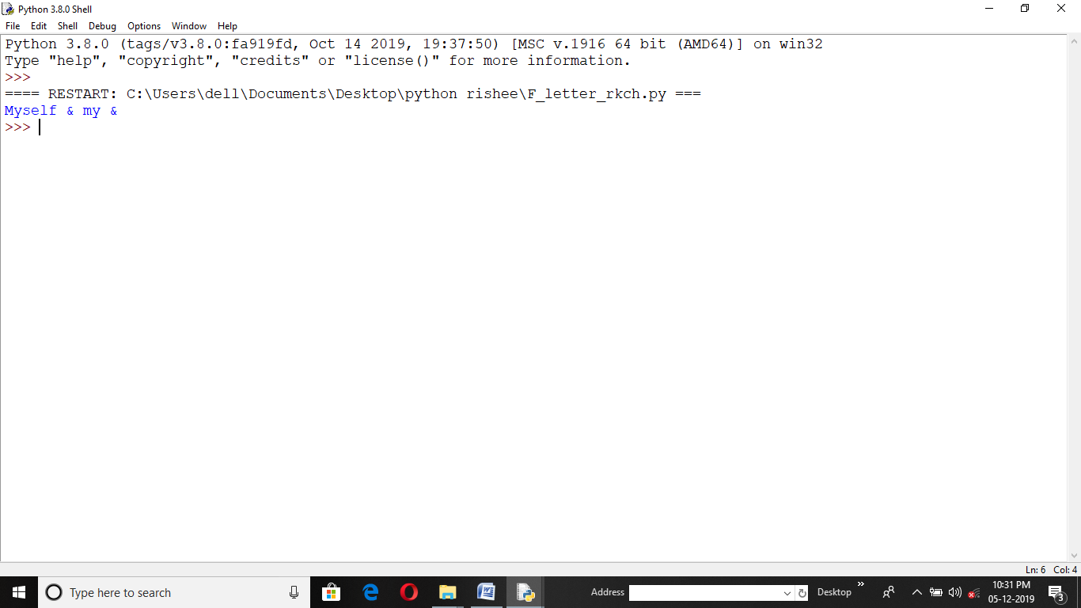 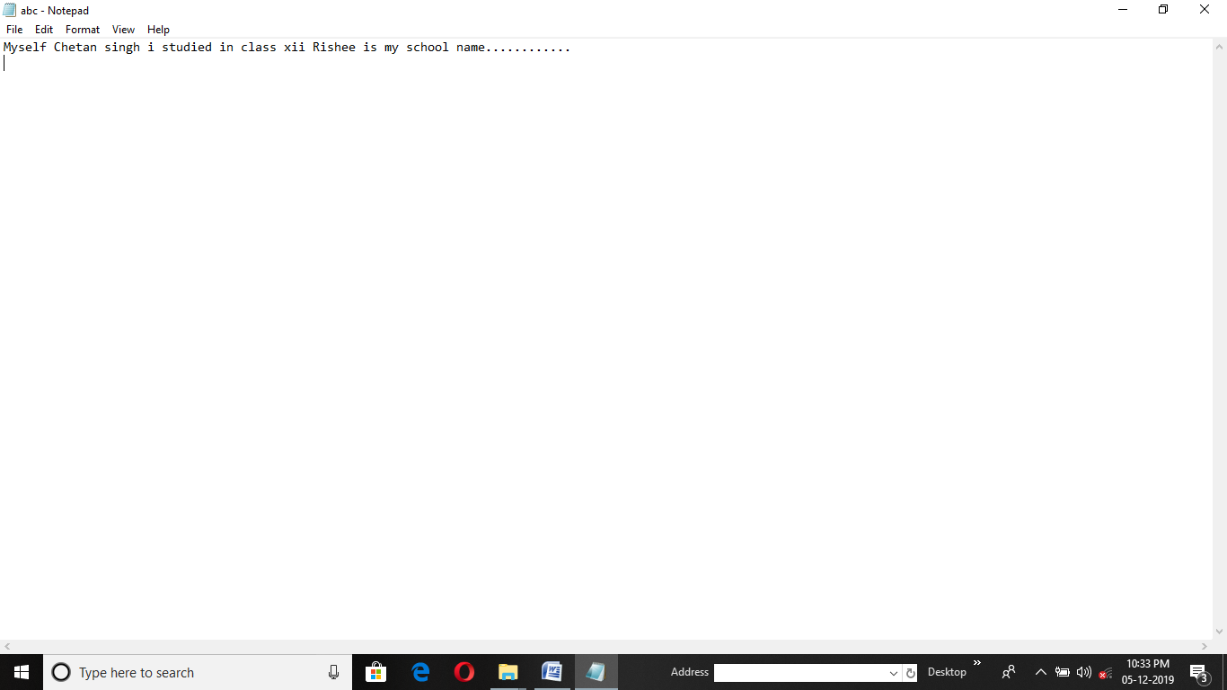

7. Program CODE for Functioning LIST :-

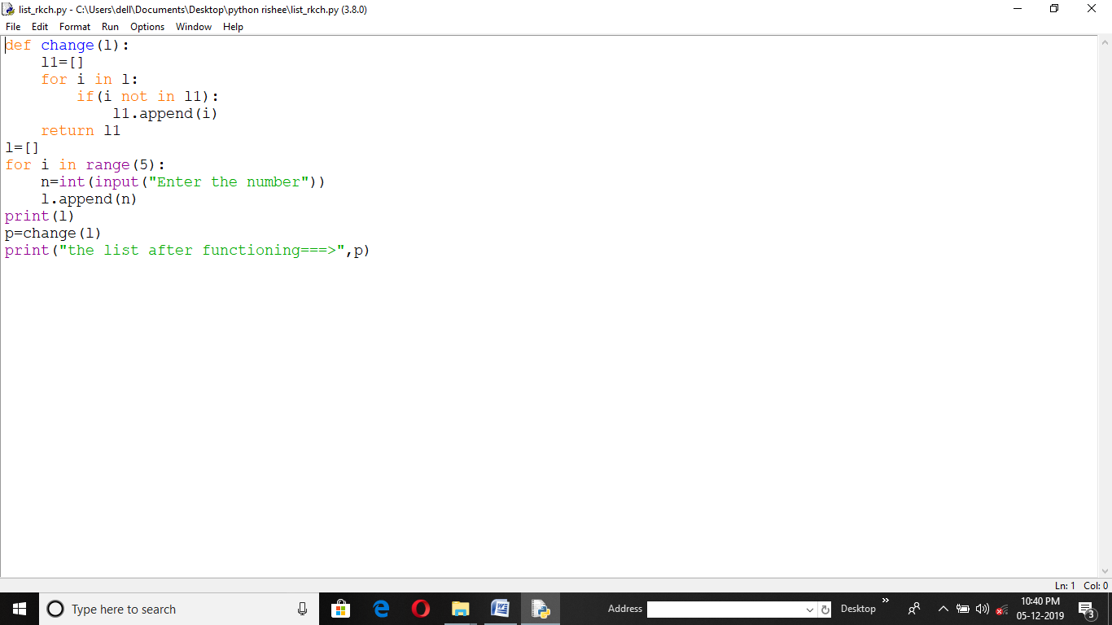

Output :-

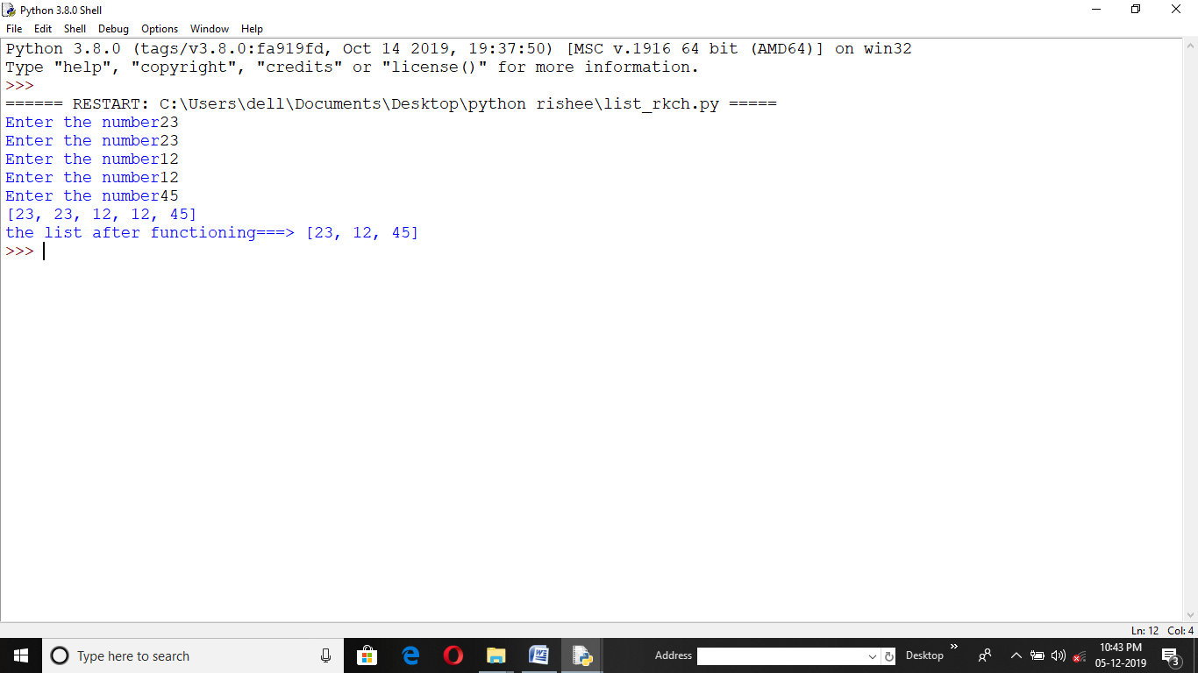

8. Program CODE for Functioning LIST (PASS):-

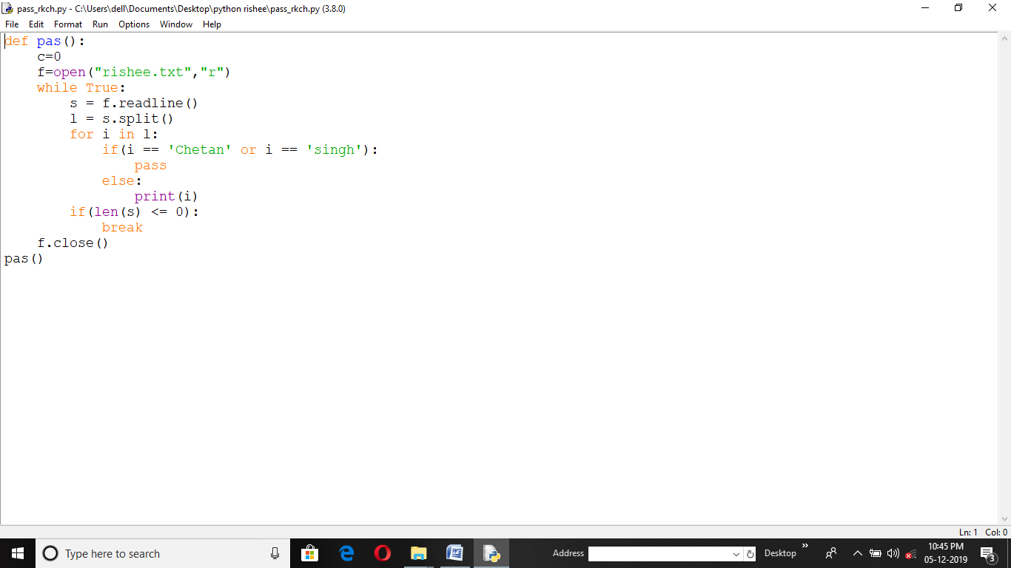

Output :- Notepad :-

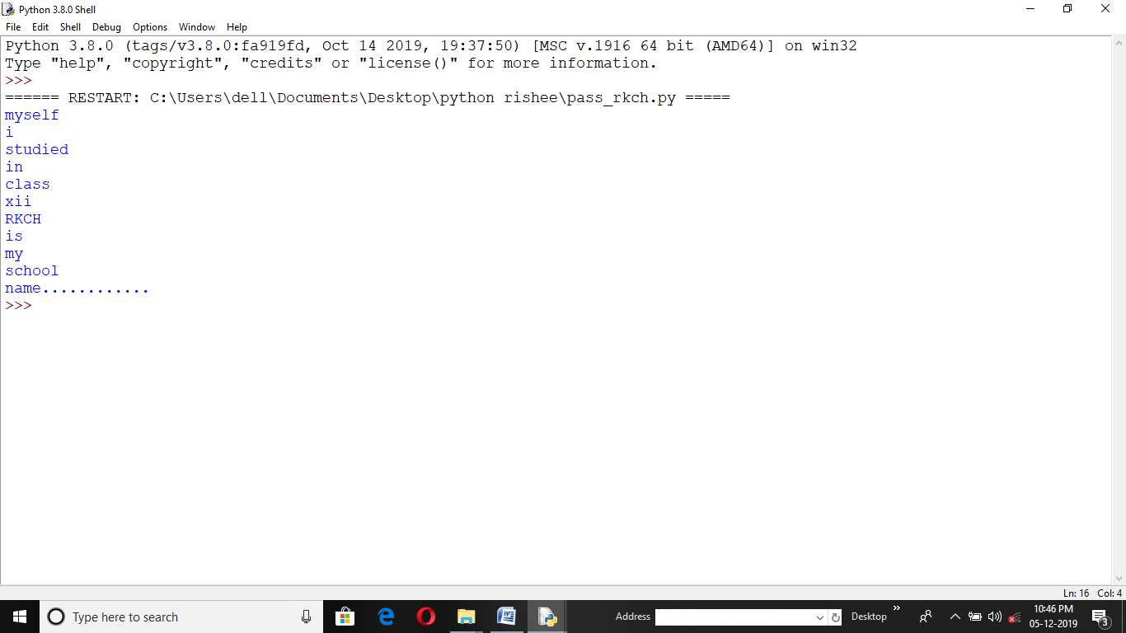 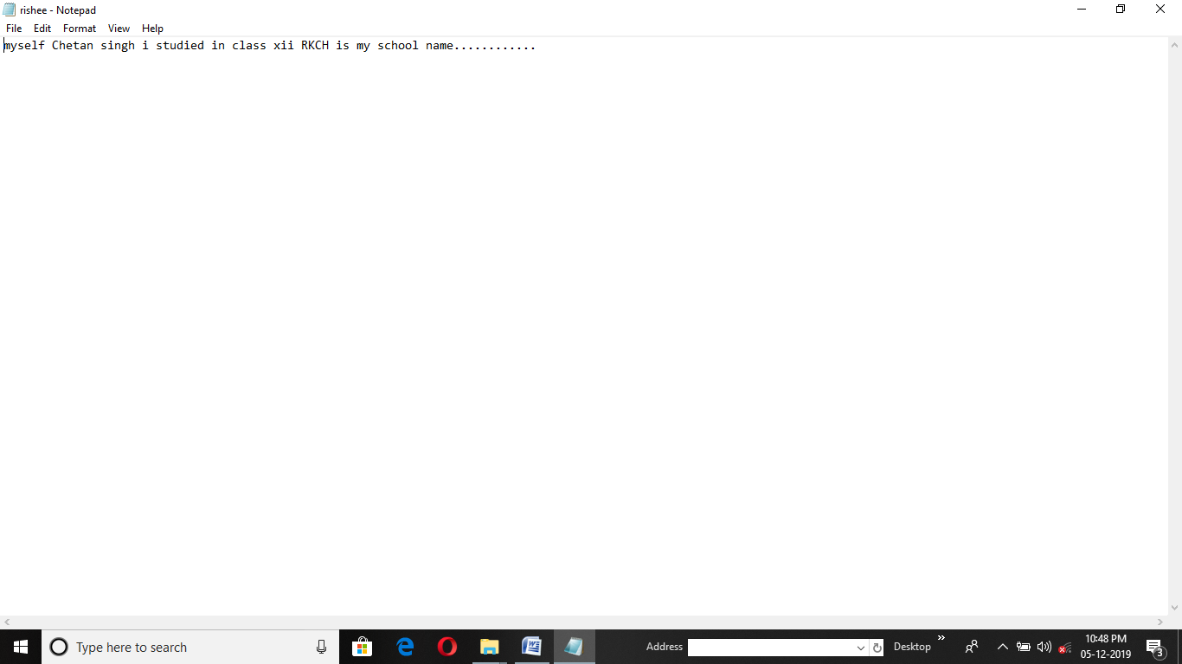

9. Program CODE for POP Function :-

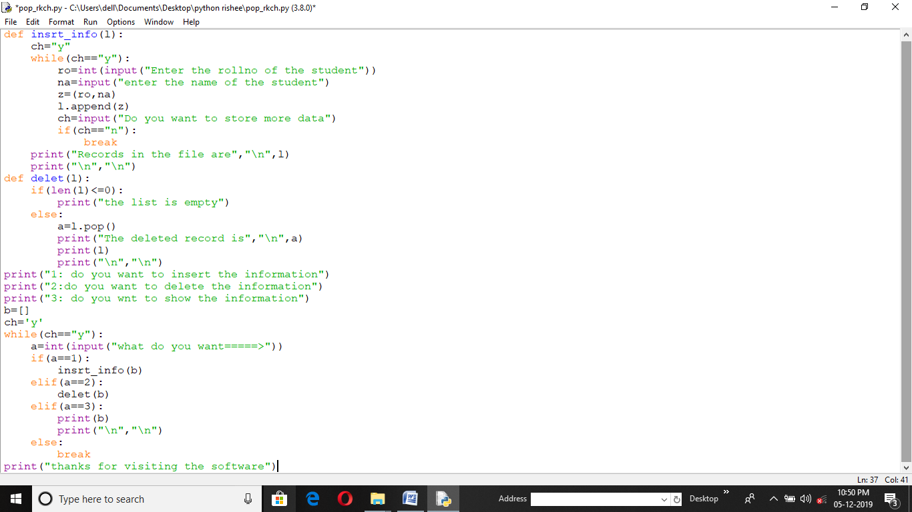

Output :-

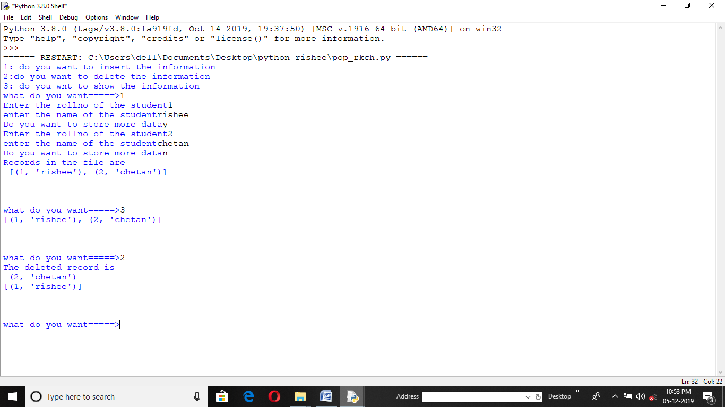

10. Program CODE for EXICUTE (3 no. on 2 digit ) :-

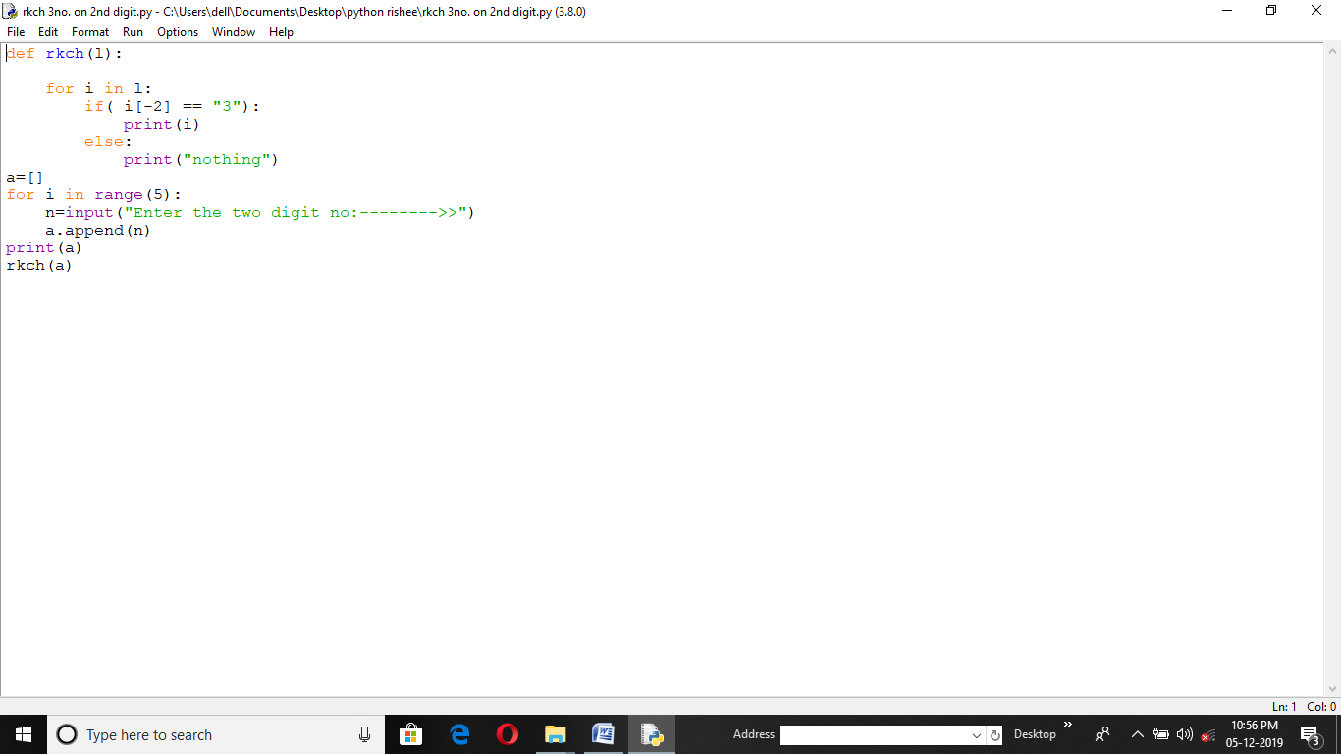

Output :-

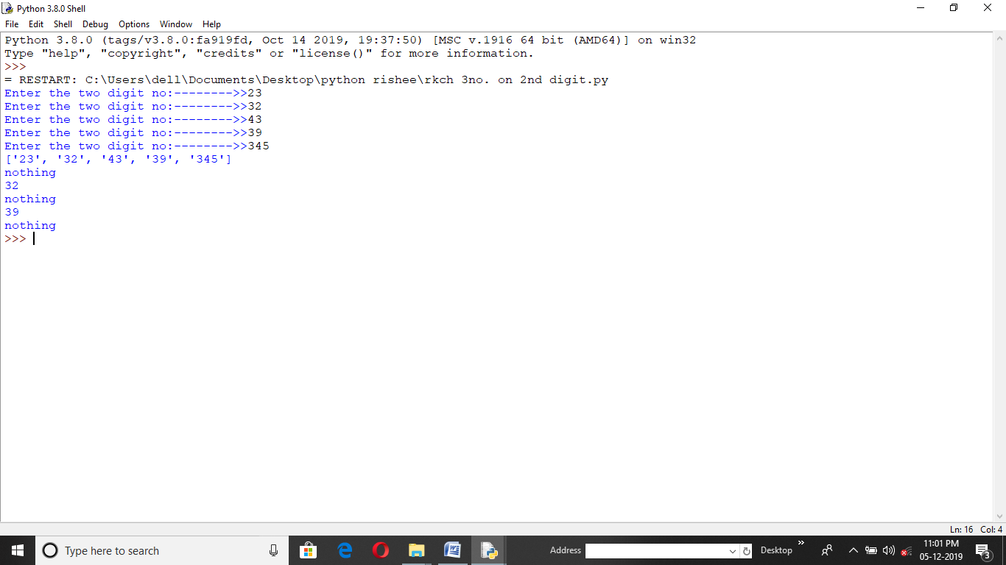

11. Program CODE for EXTRECT TO NOTEPAD :-

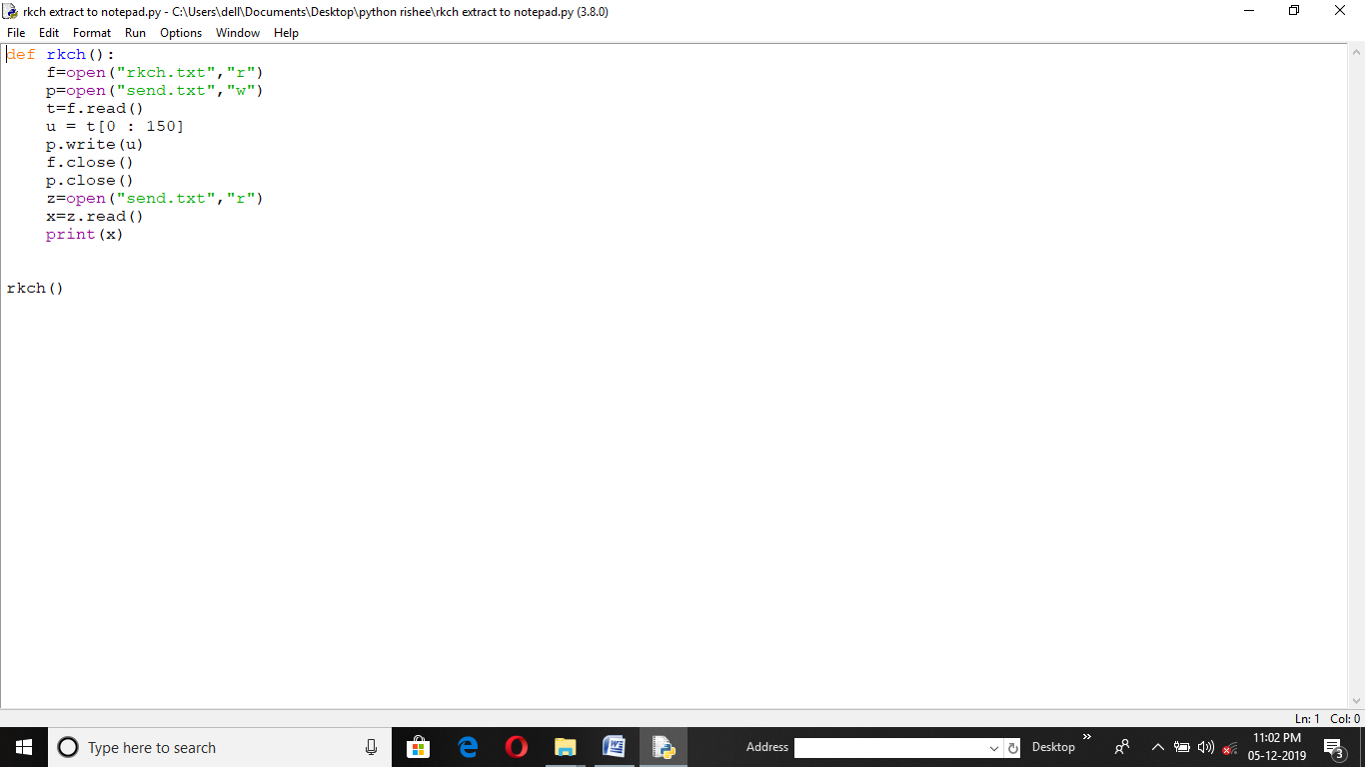

Output :- Notepad :-

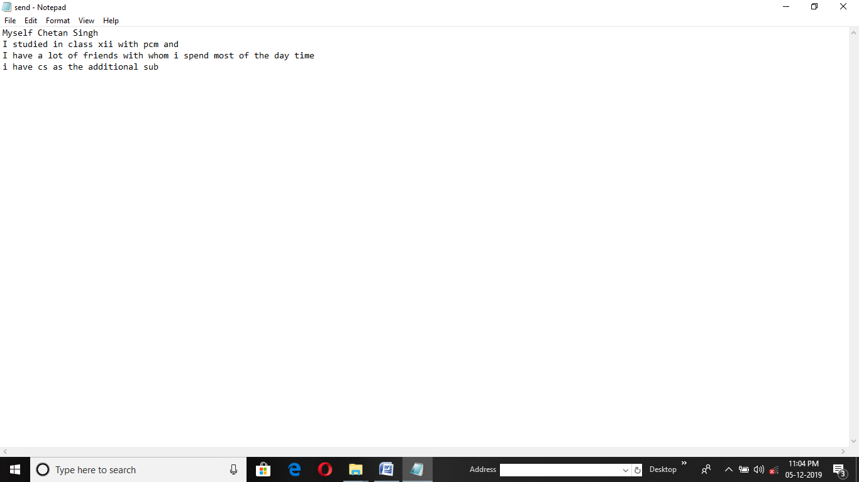 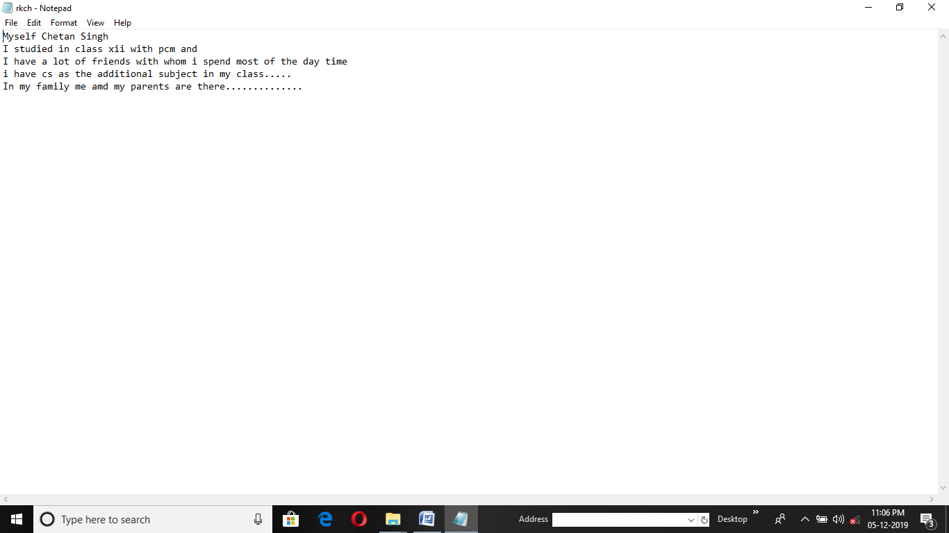

12. Program CODE for LOOPING THE LOOP (DESIGN) :-

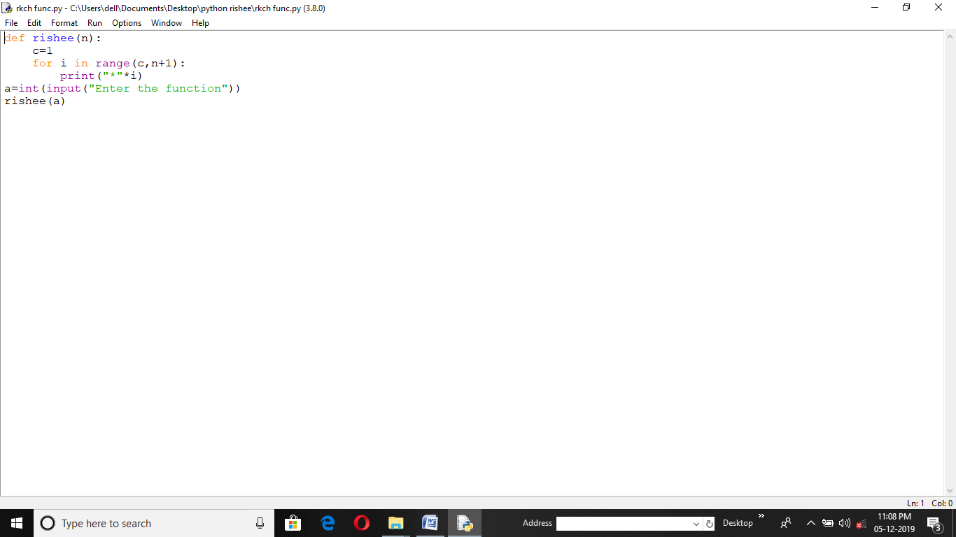

Output :-

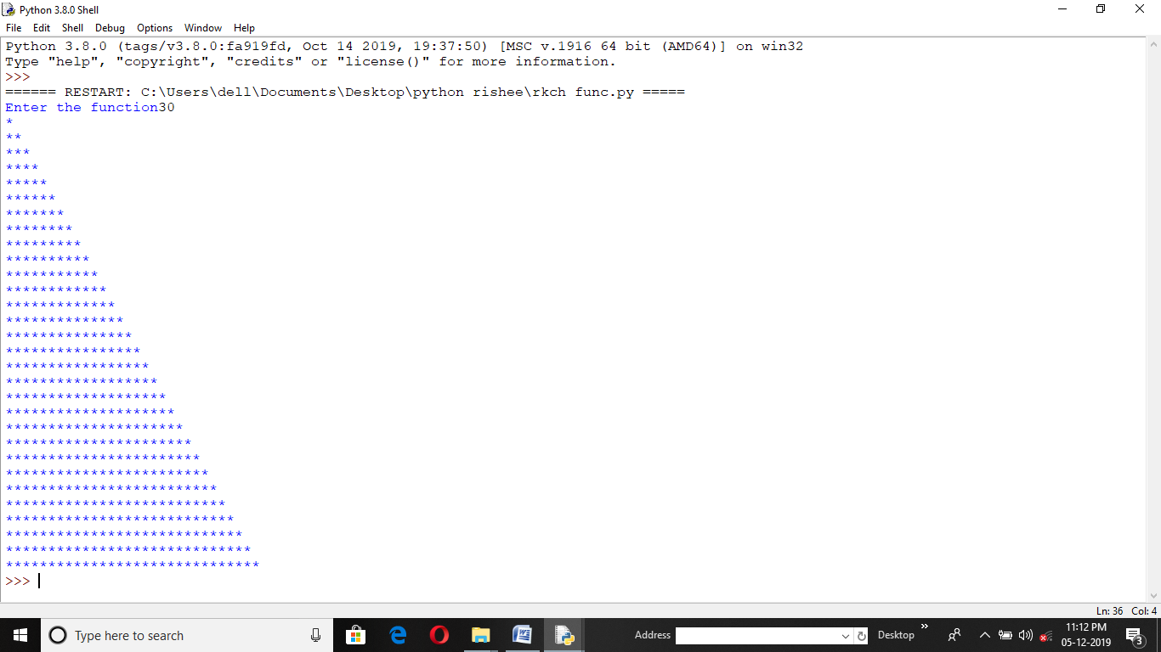

13. Program CODE for FUNCTION (COUNT) :-

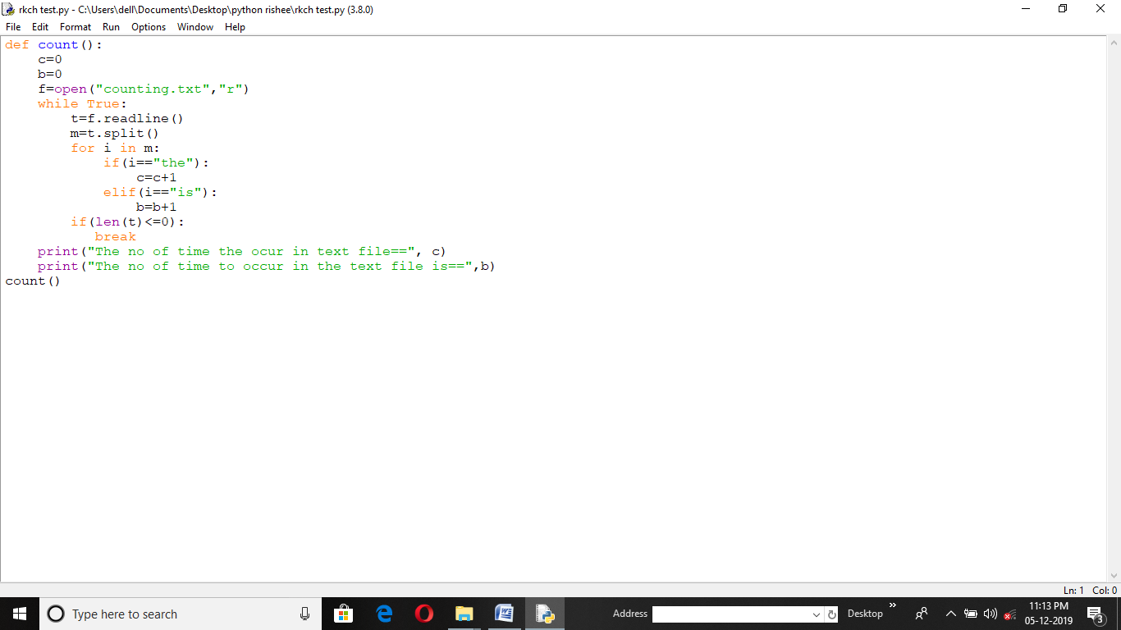

Output :- Notepad :-

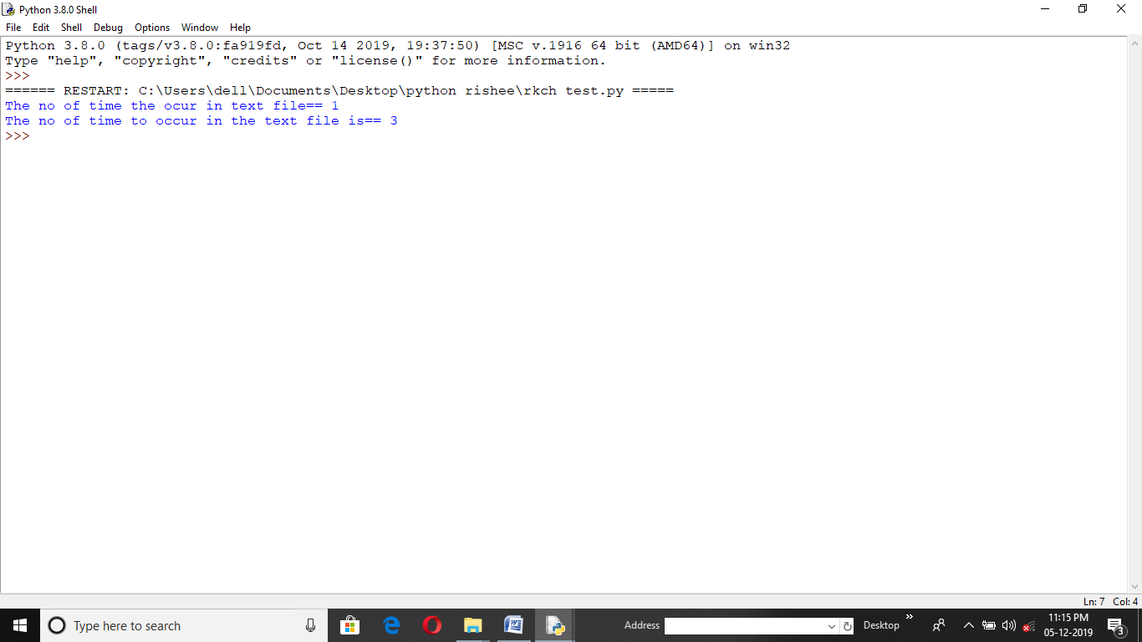 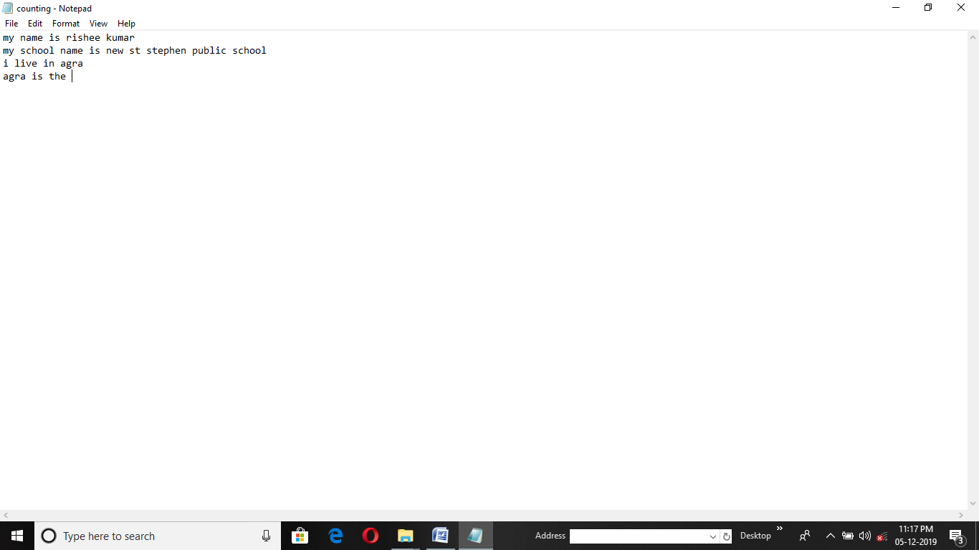

14. Program CODE for FUNCTION (LETTER COUNT) :-

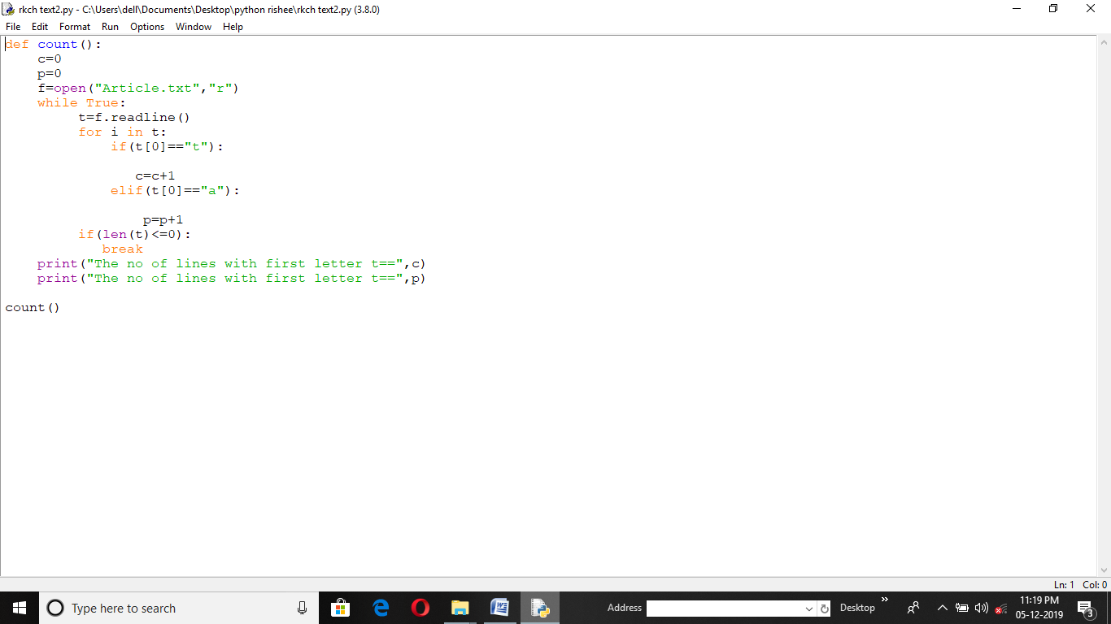

Output :- Notepad :-

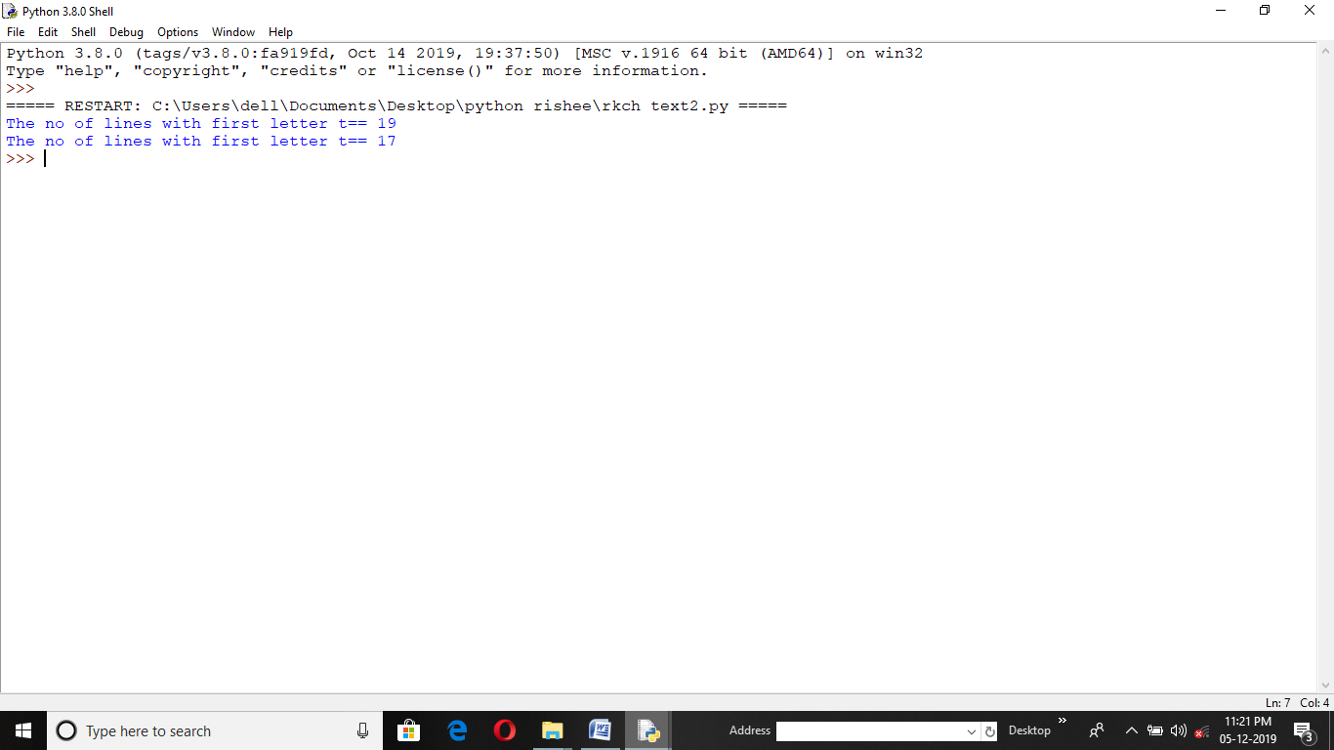 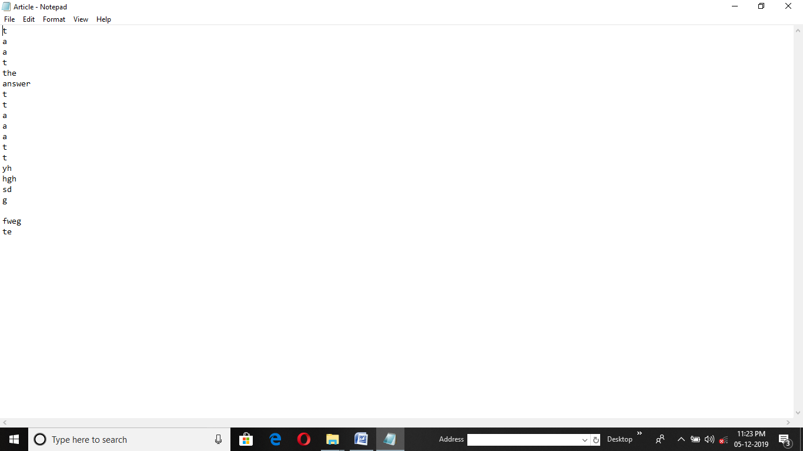

15. Program CODE for FUNCTION (VOWELS) :-

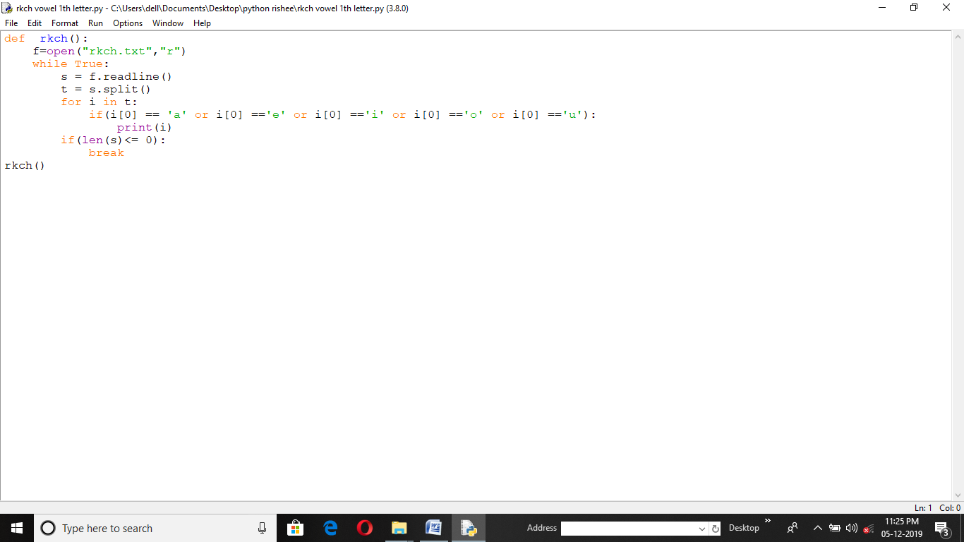

Output :- Notepad :-

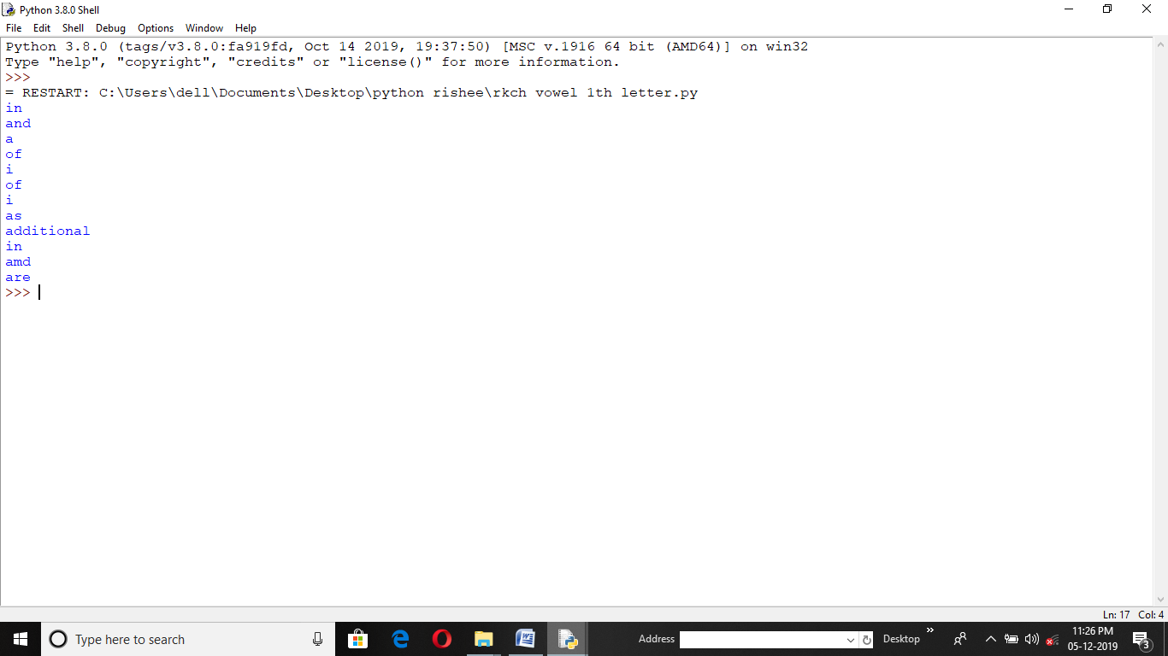 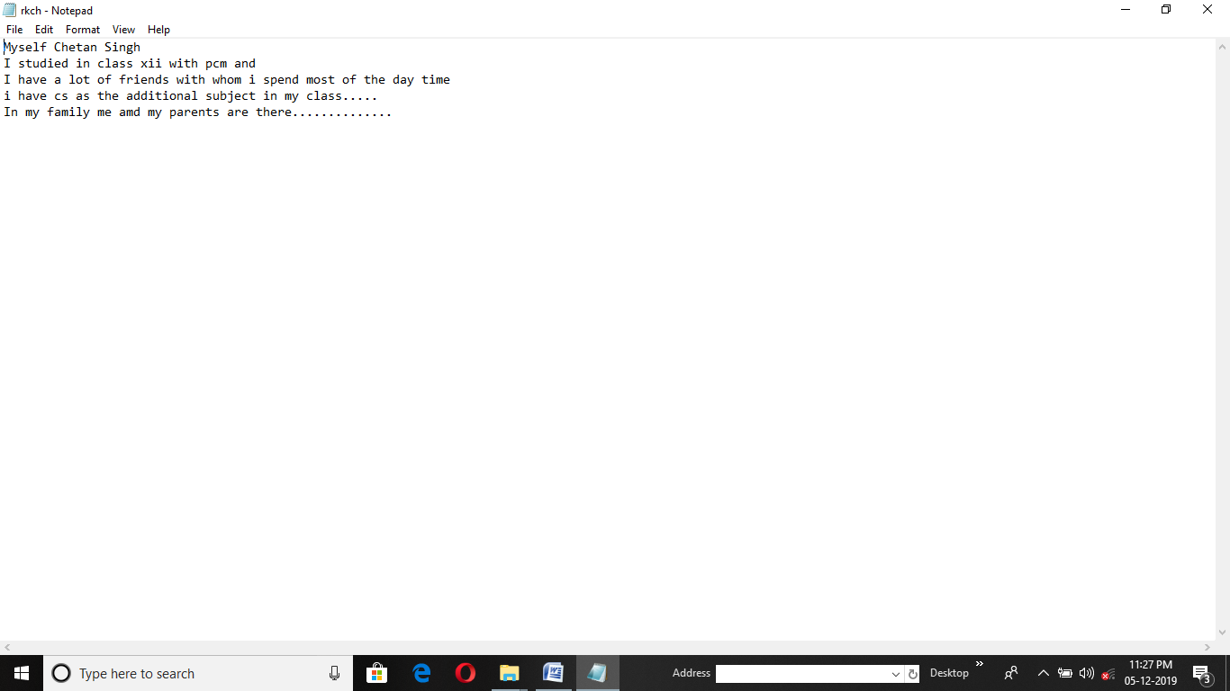

16. Program CODE for CONNECTOR (MYSQL) :-

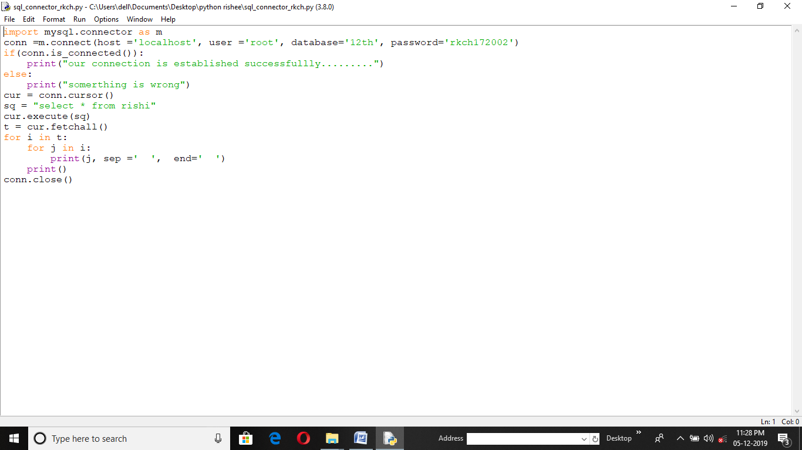

Output :-

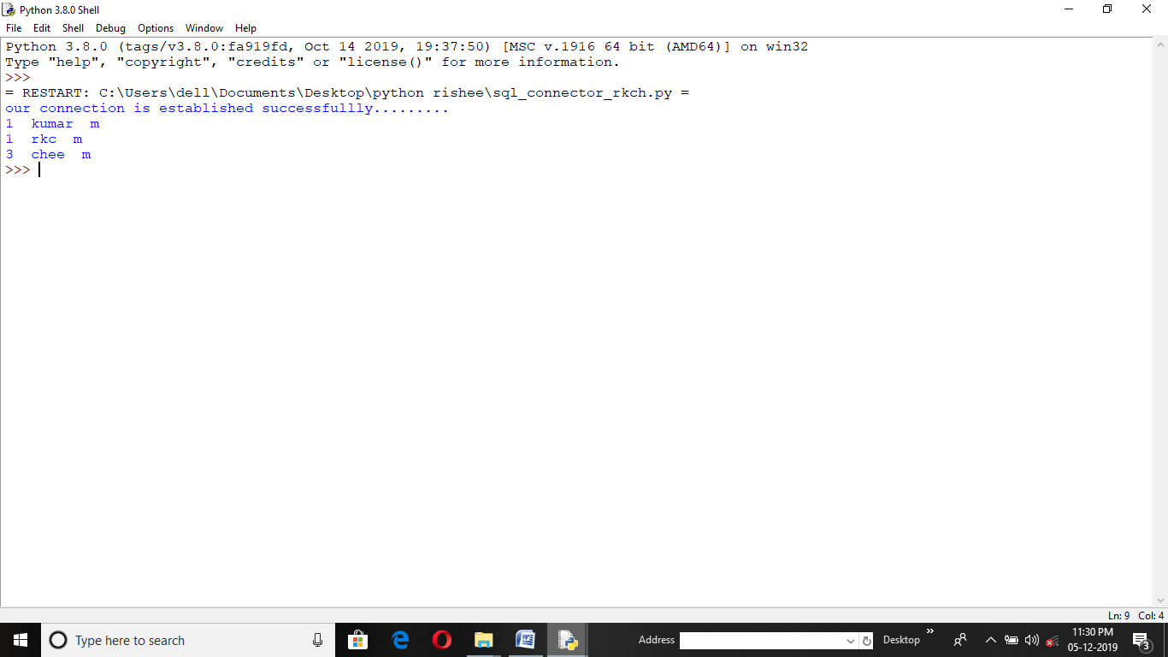

17. Program CODE for REPLACE (TEXT) :-

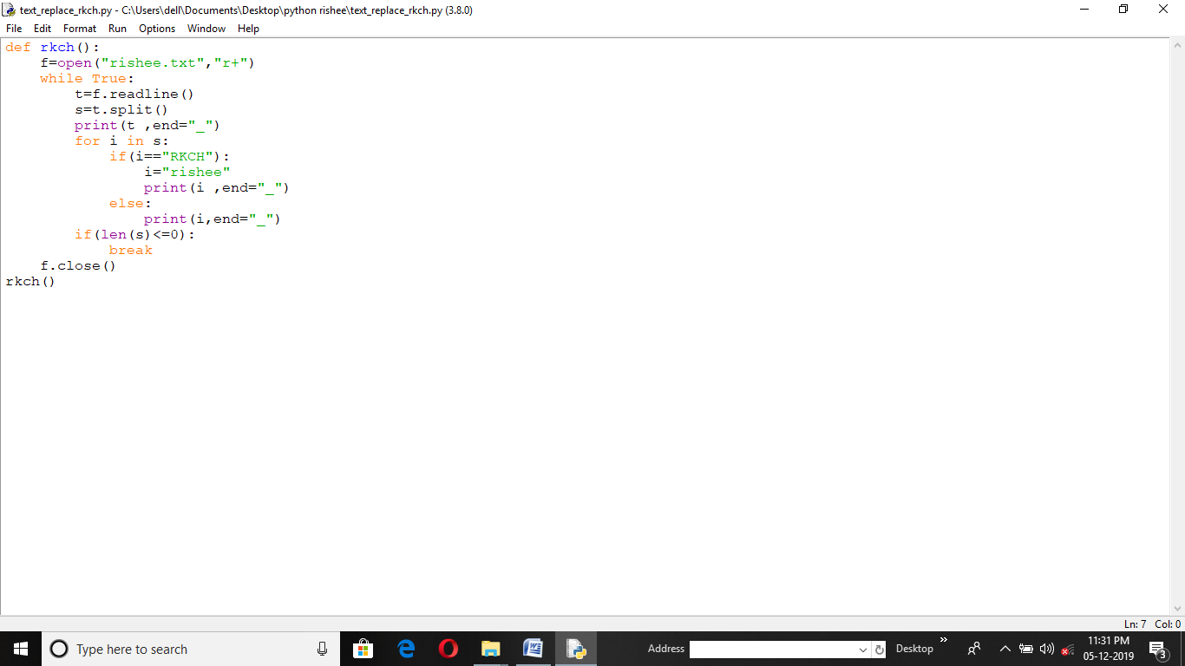

Output :- Notepad :-

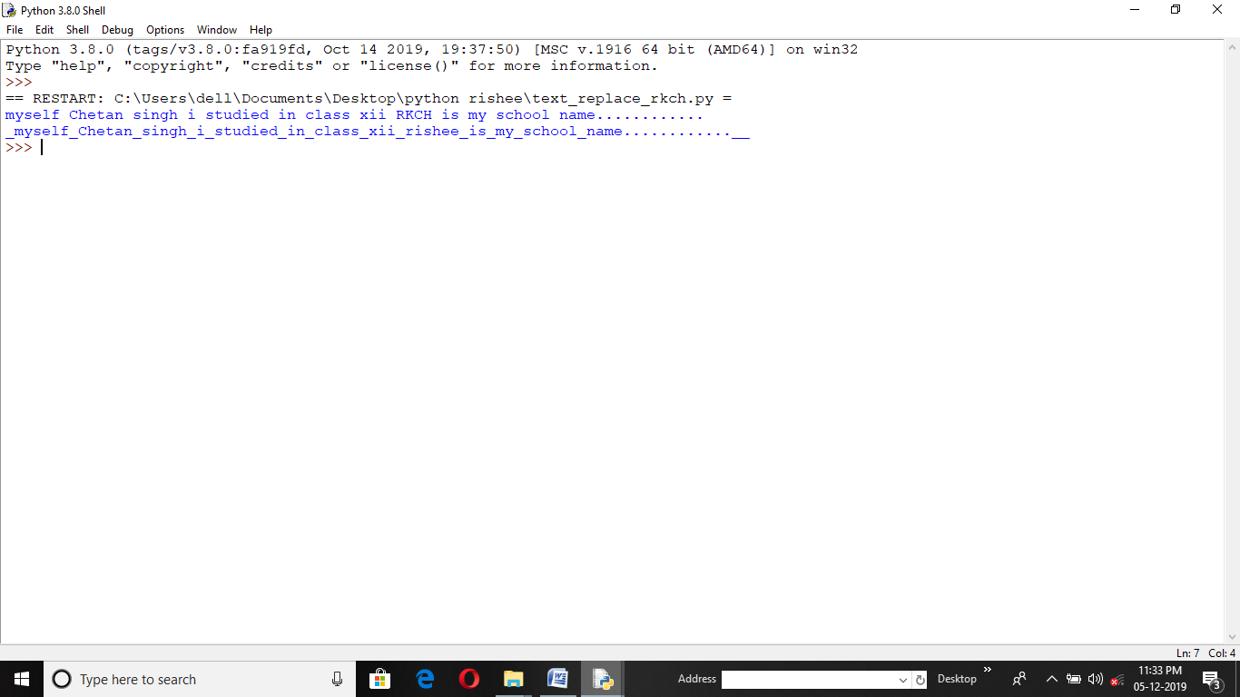 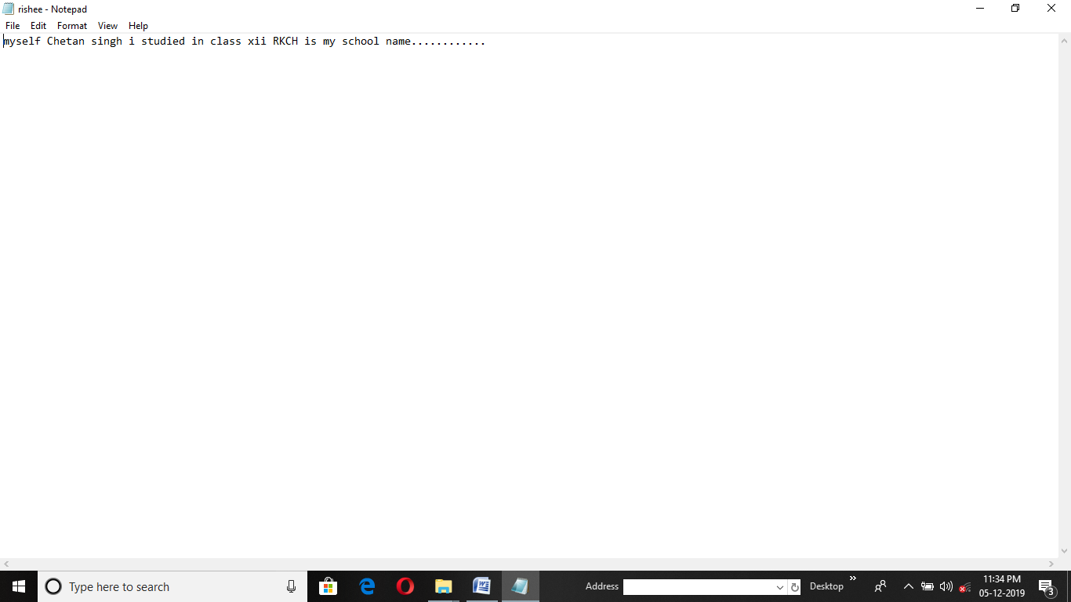

18. Program CODE for Finding all prem. of TRIANGAL :-

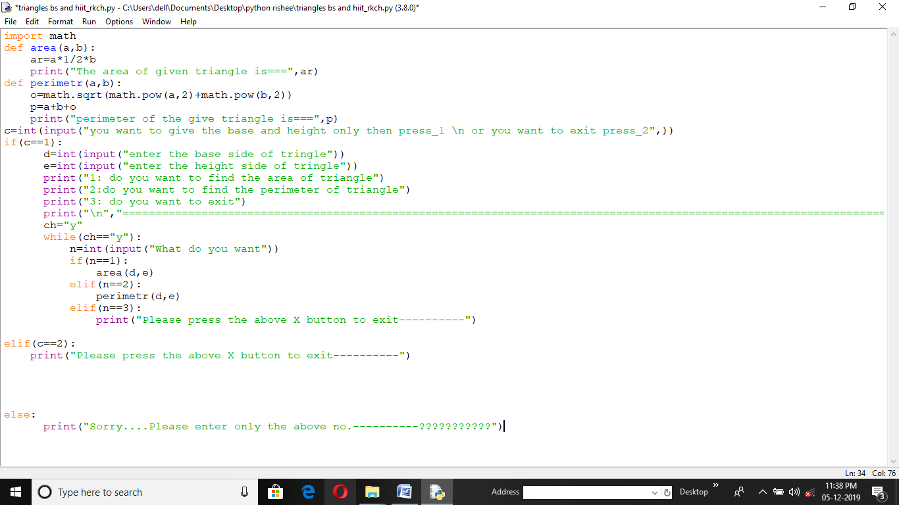

Output :-

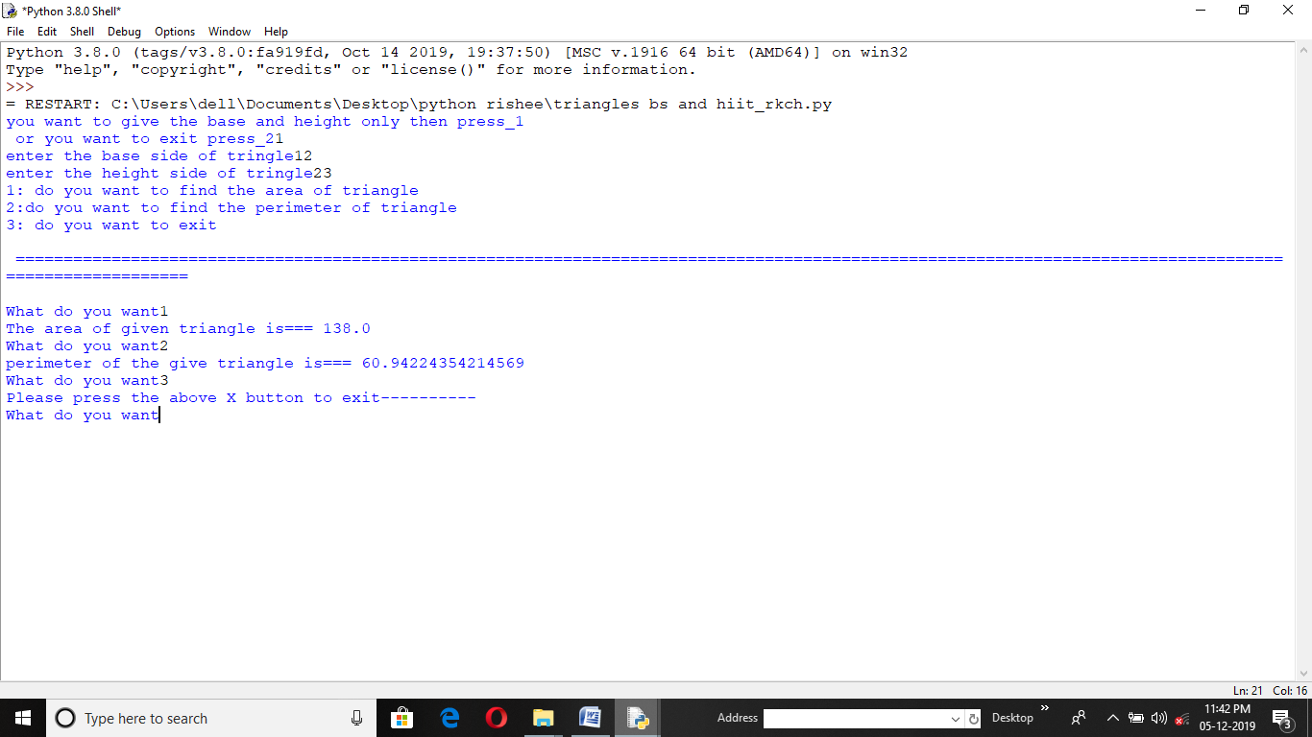

19. Program CODE for MAK ING P IECHART :-

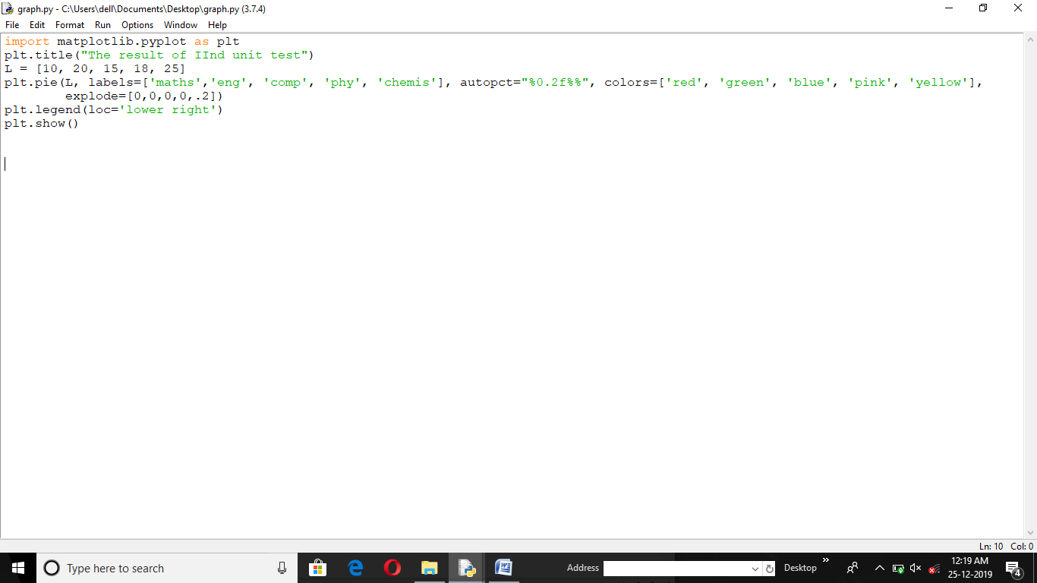

Output :-

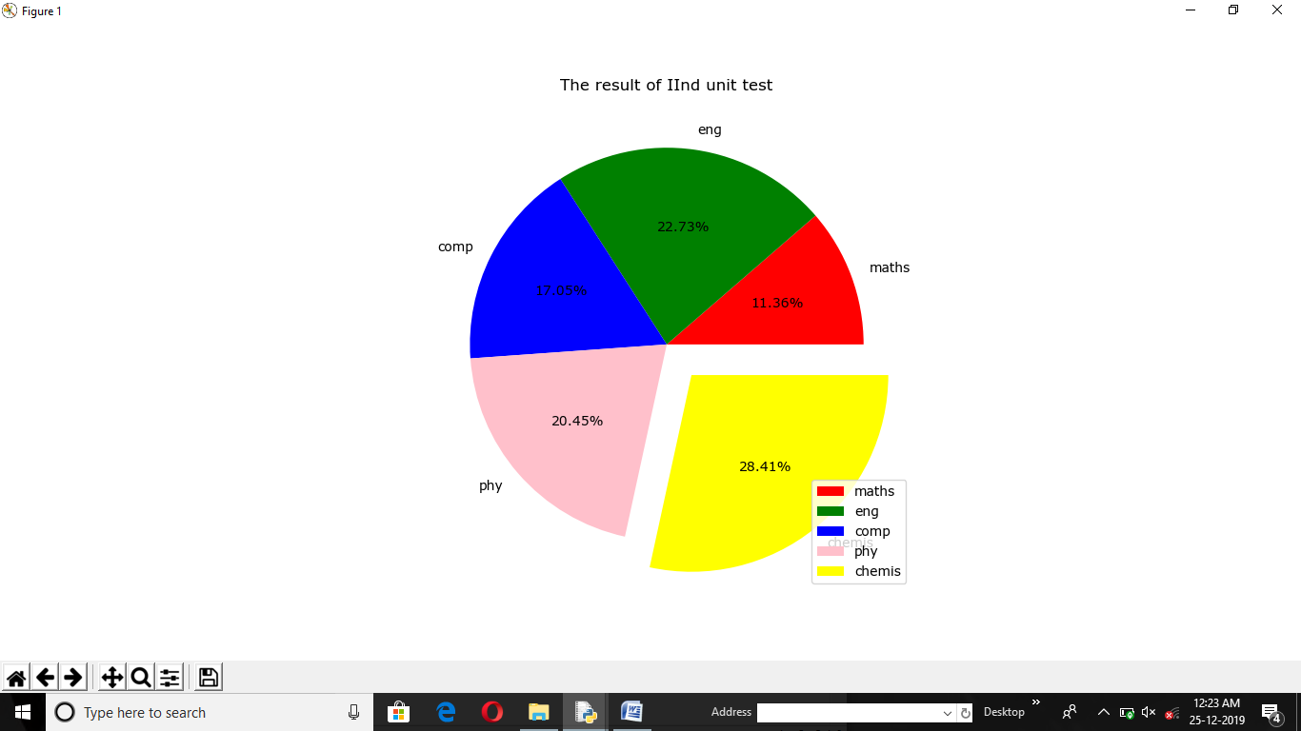

20. Program CODE for LINECHART :-

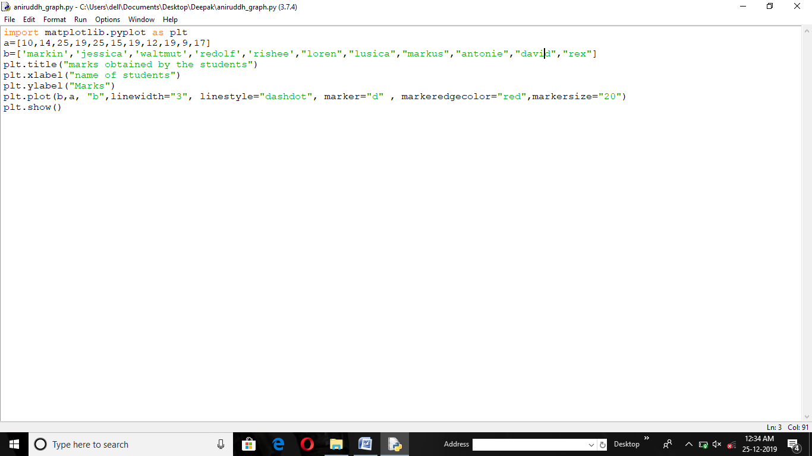

Output :-

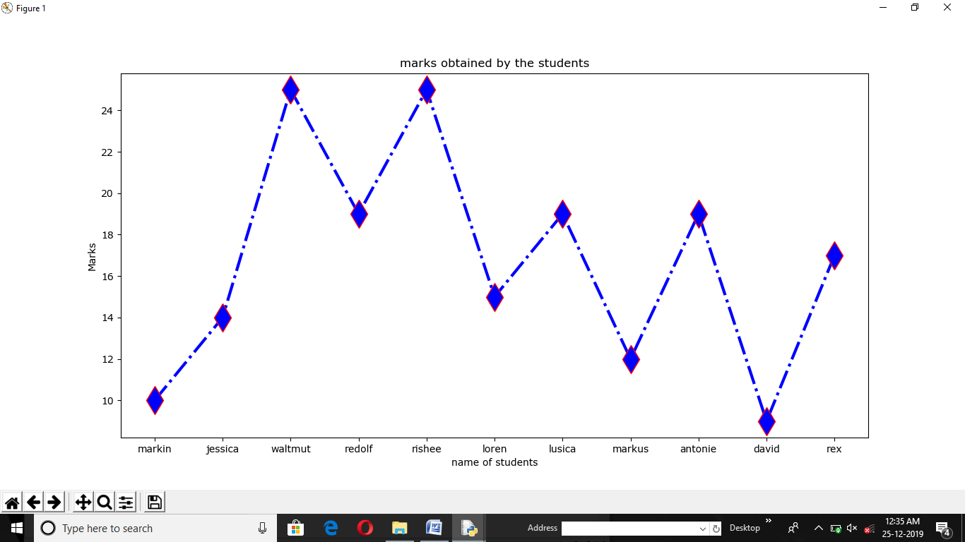

1 . MYSQL command (To show database):-

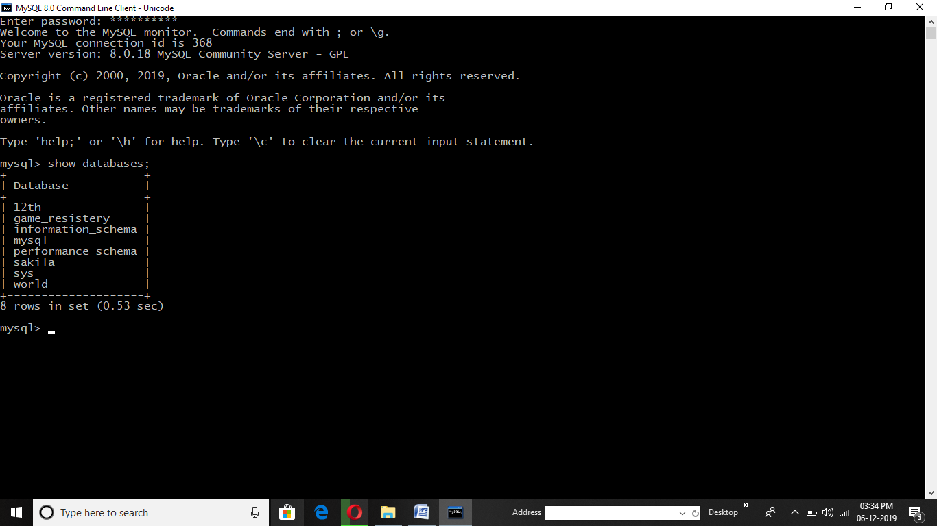

2 . MYSQL command (To select database and create table):-

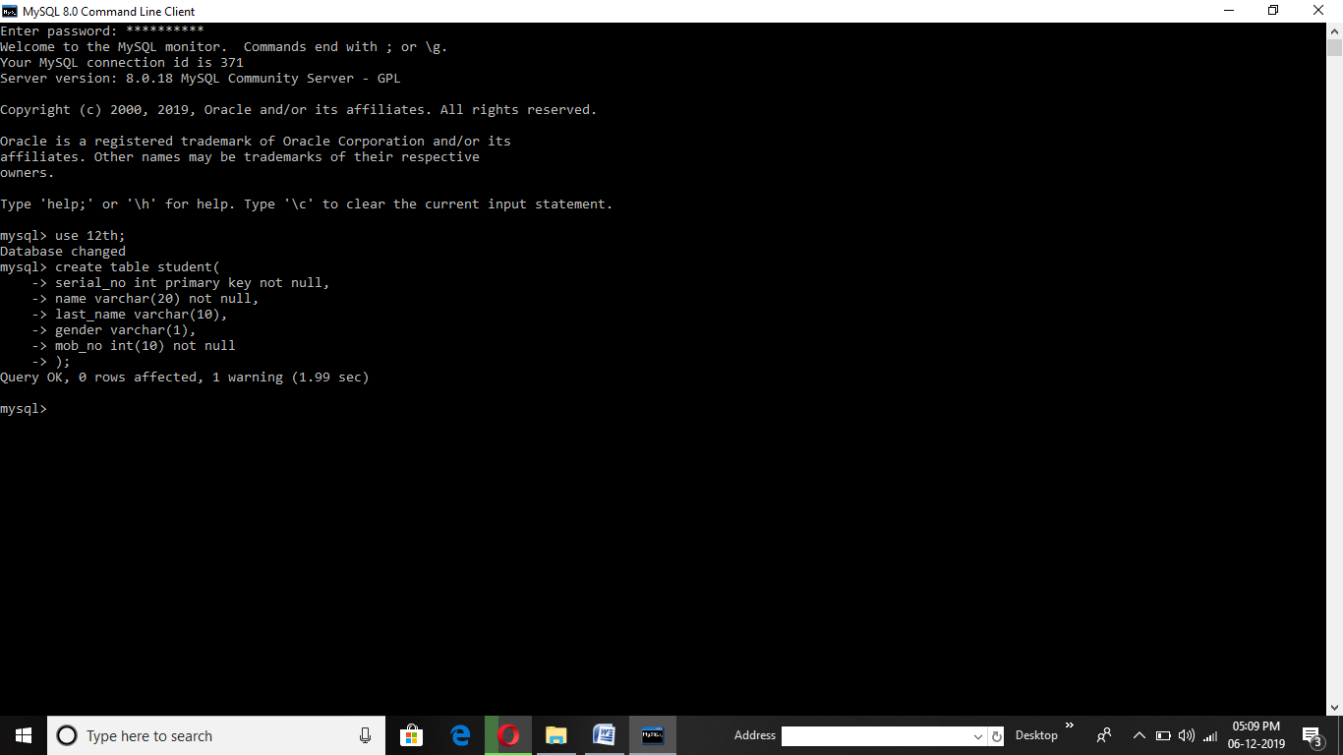

3 . MYSQL command (To show description of table):-

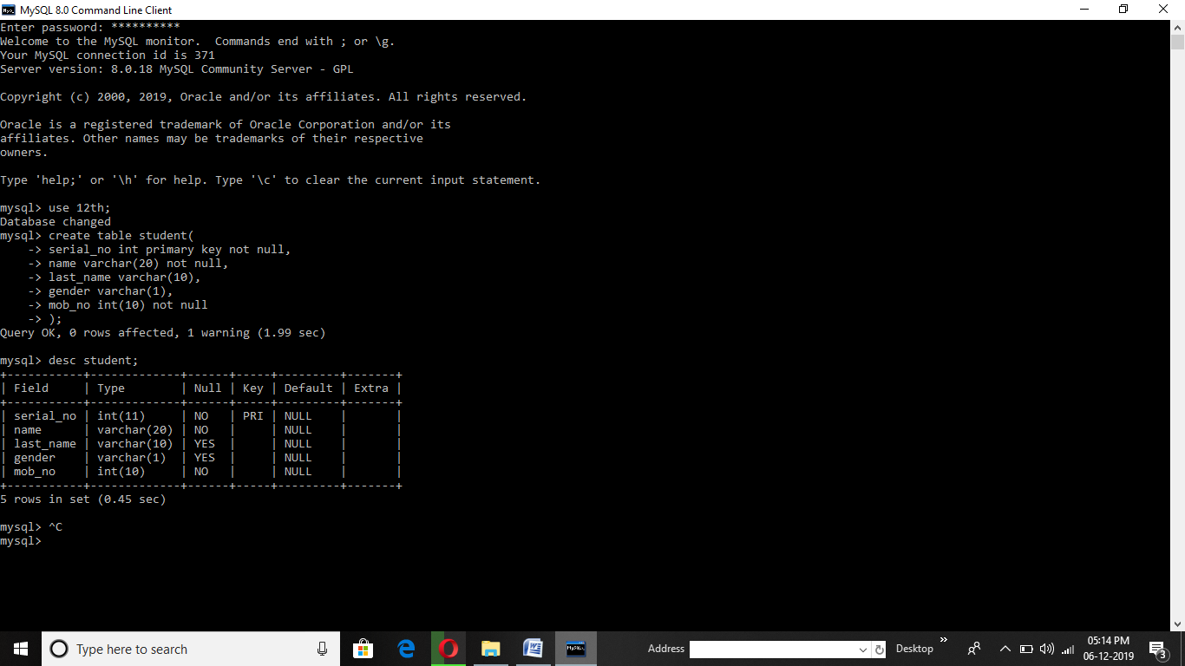

4 . MYSQL command (To show tables in database):-

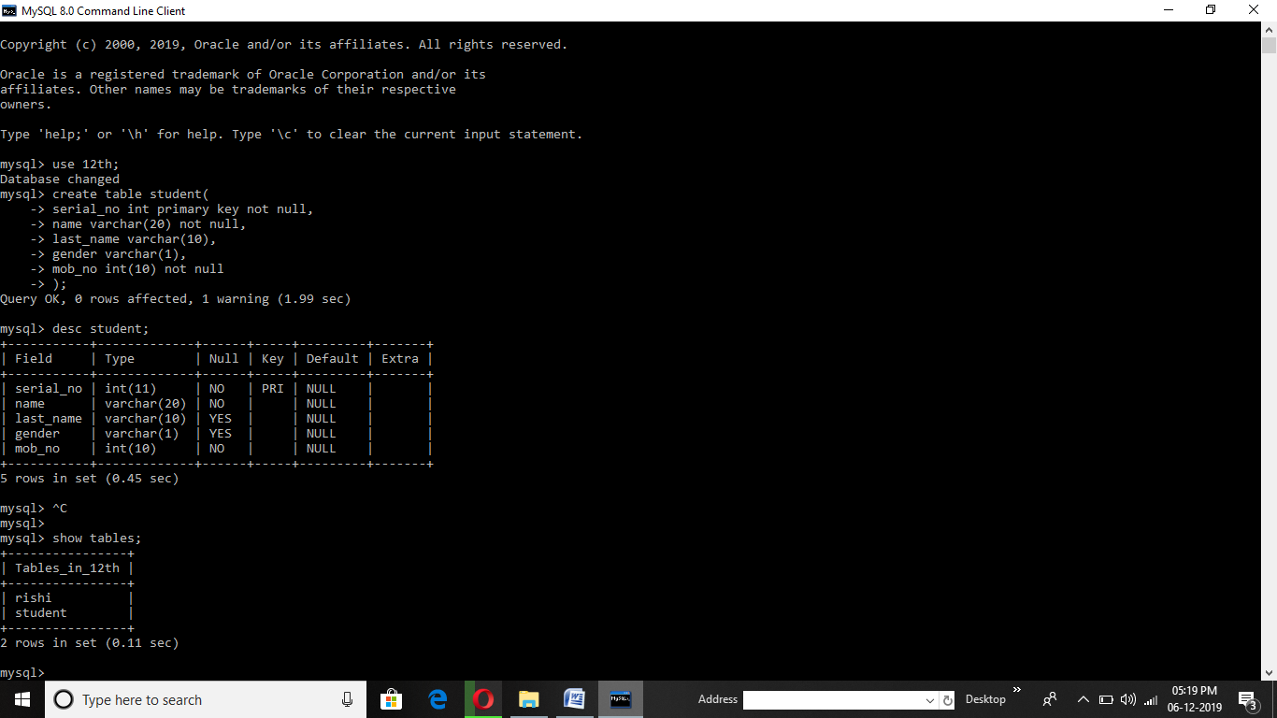

5. MYSQL command (To show all data in table):-

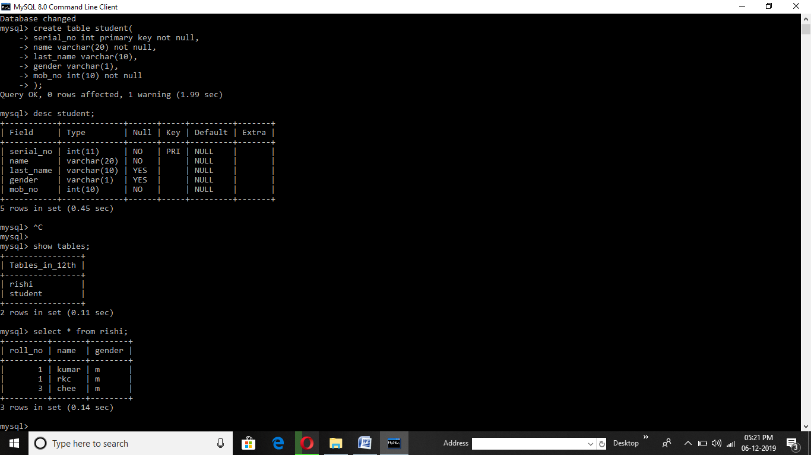

6. MYSQL command (To insert data in table):-

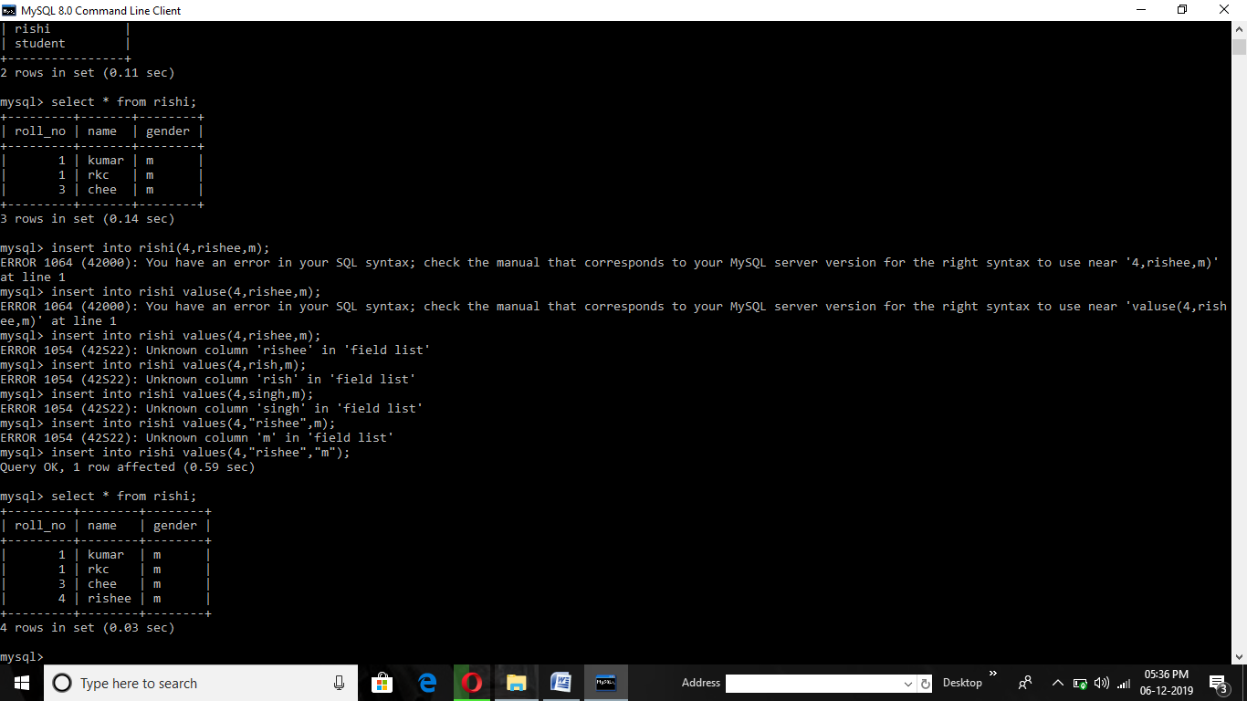

7. MYSQL command (To replace or update data in table):-

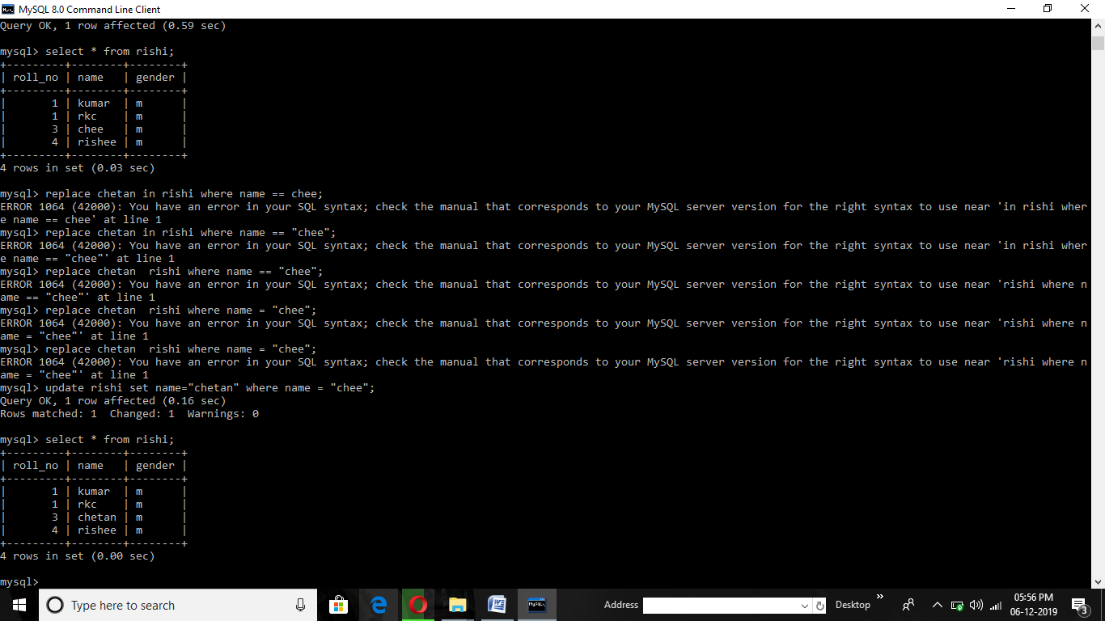

8. MYSQL command (To delete a particular data in table):-

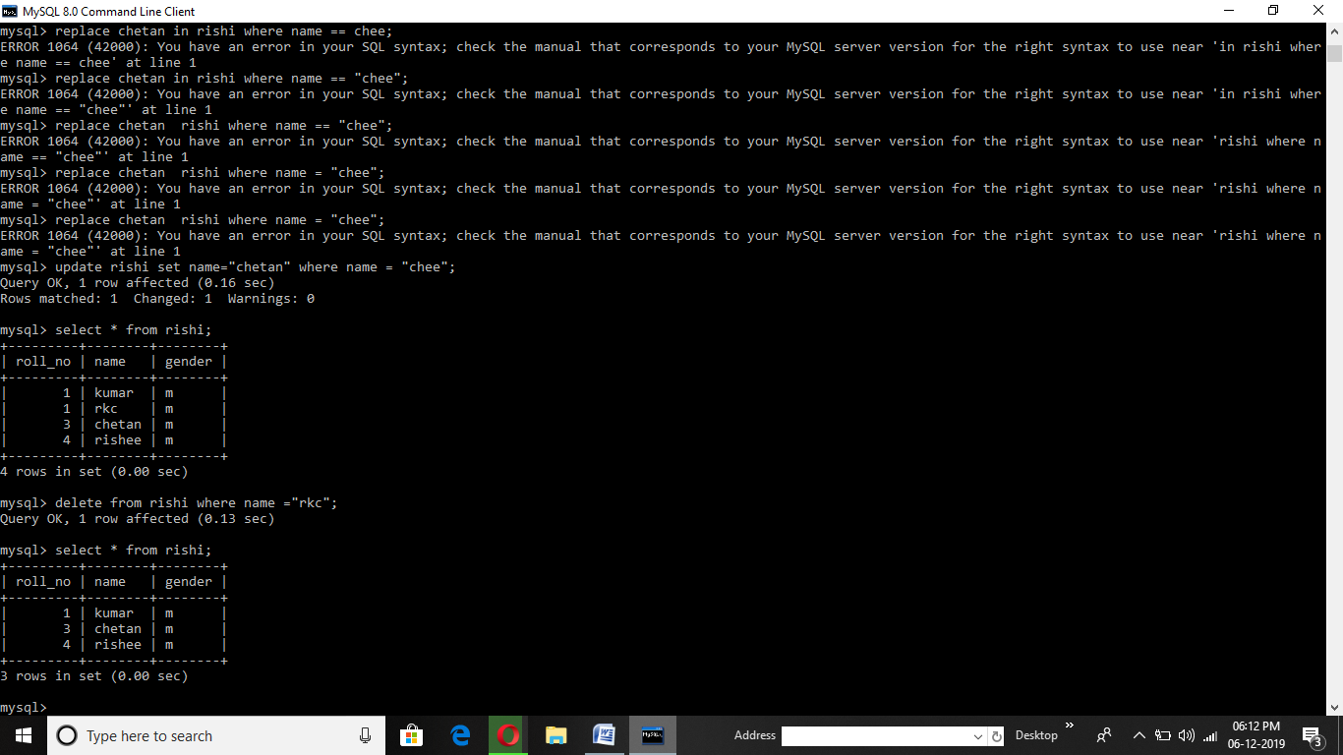

9. MYSQL command (To delete table from database):-

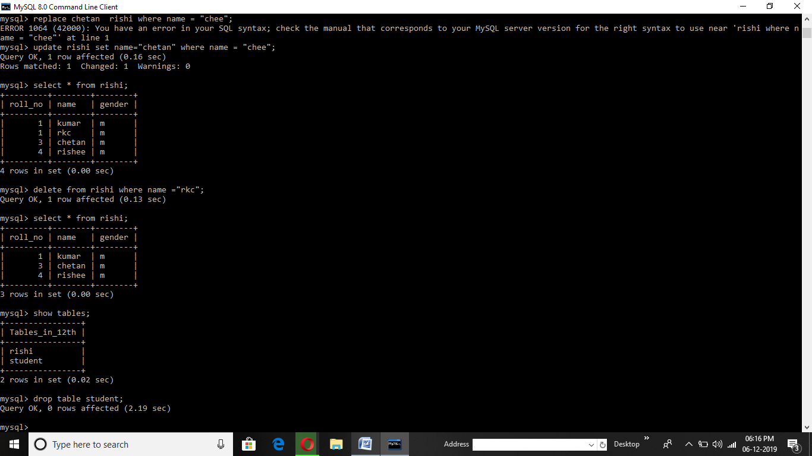

10. MYSQL command (To delete database from mysql ):-

