Experiment No.: 01
Title
Communication Between Two Networks Using Simple Router Configuration in Cisco Packet Tracer
Aim
To configure a Cisco router to establish communication between two different Local Area Networks (LANs) using static IP addressing in Cisco Packet Tracer.
Objectives
After completing this experiment, students will be able to:
- Understand the basic concept of routing.
- Configure IP addresses on PCs.
- Configure router interfaces using Cisco IOS commands.
- Verify communication between two different networks.
- Troubleshoot basic network connectivity problems.

Apparatus / Software Required
Hardware/Software | Quantity
Cisco Packet Tracer | 1
Cisco Router (1941/2911) | 1
Cisco Switch (2960) | 2
Personal Computer (PC) | 2
Copper Straight-Through Cable | As Required

Theory
A router is a Layer-3 networking device that connects multiple networks and forwards packets based on IP addresses. Every router interface belongs to a separate network and acts as the default gateway for devices connected to that network.
In this experiment, two LANs are connected through a router.
- LAN 1: 192.168.1.0/24
- LAN 2: 192.168.2.0/24
The router forwards packets between both networks, allowing communication.
Network Topology
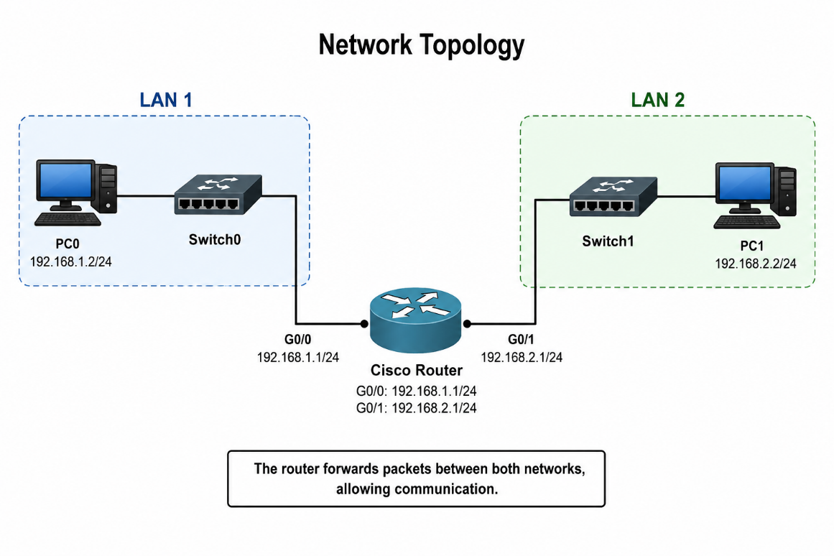

IP Addressing Table
Device | Interface | IP Address | Subnet Mask | Default Gateway
PC0 | NIC | 192.168.1.10 | 255.255.255.0 | 192.168.1.1
Router | G0/0 | 192.168.1.1 | 255.255.255.0 | —
Router | G0/1 | 192.168.2.1 | 255.255.255.0 | —
PC1 | NIC | 192.168.2.10 | 255.255.255.0 | 192.168.2.1

Procedure
Step 1: Create the Network Topology
- Open Cisco Packet Tracer.
- Add one Cisco Router (1941).
- Add two Cisco 2960 switches.
- Add two PCs.
- Connect devices using Copper Straight-Through cables.
Connections
From | To
PC0 | Switch0
Switch0 | Router G0/0
Router G0/1 | Switch1
Switch1 | PC1

Step 2: Configure PC0
Desktop → IP Configuration
Parameter | Value
IP Address | 192.168.1.10
Subnet Mask | 255.255.255.0
Default Gateway | 192.168.1.1

Step 3: Configure PC1
Desktop → IP Configuration
Parameter | Value
IP Address | 192.168.2.10
Subnet Mask | 255.255.255.0
Default Gateway | 192.168.2.1

Step 4: Configure Router
Enter the following commands in the router CLI.
Configure Interface G0/0
Router> enable
Router# configure terminal
Router(config)# interface gigabitEthernet0/0
Router(config-if)# ip address 192.168.1.1 255.255.255.0
Router(config-if)# no shutdown
Router(config-if)# exit

Configure Interface G0/1
Router(config)# interface gigabitEthernet0/1
Router(config-if)# ip address 192.168.2.1 255.255.255.0
Router(config-if)# no shutdown
Router(config-if)# exit
Router(config)# end

Save Configuration
Router# copy running-config startup-config
Press Enter when prompted.
Verification Commands
Check Interface Status
show ip interface brief
Expected Output
Interface | IP Address | Status
G0/0 | 192.168.1.1 | Up
G0/1 | 192.168.2.1 | Up

Check Routing Table
show ip route
Expected Output
C 192.168.1.0/24 is directly connected
C 192.168.2.0/24 is directly connected

Connectivity Test
From PC0
ping 192.168.2.10
From PC1
ping 192.168.1.10
Expected Result
Reply from destination.
Packets: Sent = 4, Received = 4, Lost = 0

Troubleshooting
Problem | Cause | Solution
Destination Host Unreachable | Wrong IP Address | Verify IP configuration
Request Timed Out | Router Interface Down | Use no shutdown
Cannot Ping | Incorrect Gateway | Verify Default Gateway
Interface Down | Cable Problem | Check Cable Connections
Routing Failure | Incorrect IP Address | Verify Router Configuration

Result
Communication between two different networks was successfully established using a Cisco router. The PCs were able to communicate with each other through proper IP addressing and router configuration.

Viva Questions
- What is the purpose of a router?
- What is routing?
- Why is a default gateway required?
- What does the no shutdown command do?
- What is the function of the show ip interface brief command?
- What is the difference between a switch and a router?
- What is a subnet mask?
- What command saves the router configuration?
- Which OSI layer does a router operate on?
- What happens if the default gateway is configured incorrectly?

