Lab2: Inheritance (Worksheet1-In class)

Section______1_______ Date_____9/11/2015___________

Student ID _____5731015621_________ Name_______Jirapat Atiwattanachai_____

# Part A: Problem Statement (10 points)

1. Download the lab package and unzip it
2. Read and try to understand the lab sheet
   1. How many classes do you have in the class diagram (Figure 3 on Page 4)?

5 classes

* 1. Explain the concept of the “abstract” class

An abstract class is something which is incomplete and you cannot create instance of abstract class. If you want to use it you need to make it complete or concrete by extending it.

* 1. In the class “Entity”, how many protected variables in this class? Explain the concept of “protected access modifier”.

9 protected variables

protected access modifier : If members are declared as protected then these are accessible to all classes in the package and to all subclasses of its class in any package where this class is visible.

* 1. (Section 3 on Page 3) Explain the concept of “tick” and “tickDelay”

tick : the game status keeps changing, so the concept of “Game Loop” as below is necessary in order to draw and update the game status . An execution of one iteration (loop) is called “tick.”

tickDelay : Normally an execution can happen so fast (in milliseconds) that any updates cannot be no-ticed by human eyes. Hence, some object does not need to be updated every tick and should be updated every ***n*** ticks instead. (Use for delay)

* 1. What is the key to pause the game?

spacebar

1. Run “Lab2_example.exe,” which is an example of the program. Note that it can be run only in Windows and the tanks in this example are slightly different from your assignment.
   1. Try to pause the game immediately when you start “Lab2_example.exe”
   2. Capture the screen of the game

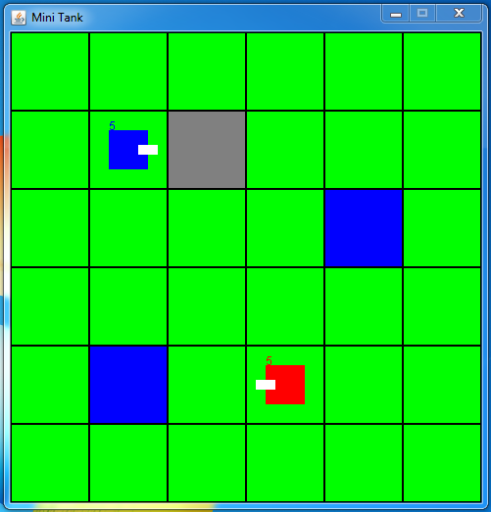

* 1. What are the positions of rock and pond terrains?

Rock : (2,1)

Pond : (1,4) and (4,2)

* 1. According to the class diagram (Figure 3 on Page 4), write a code to create those two tanks, assume that the movingDelay and firingDelay are 3 ticks.

Tank blueTank = new Tank(field,1,1,2,3,3,0,5,Color.blue);

Tank redTank = new Tank(field,3,4,0,3,3,1,5,Color.red);

* 1. In the example, which tank is the winner?

Red tank win

* 1. Does the game stops after having the winner?

No