Lab2: Inheritance (Worksheet2-Take Home)

Section______1_____ Date___________12/9/2558_______________________

Student ID ______5731015621____________ Name_____Jirapat Atiwattanachai_______

# Part A: Result (40 points)

1. Is your jar file correctly created (runnable with source codes)? (Yes/ No)

Yes

1. Capture the screen of your program at the beginning (before start moving)

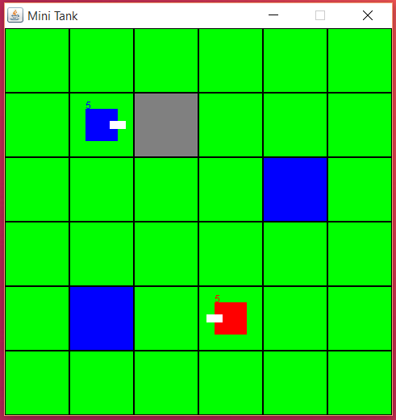

1. Capture the screen of your program when you get the winner.

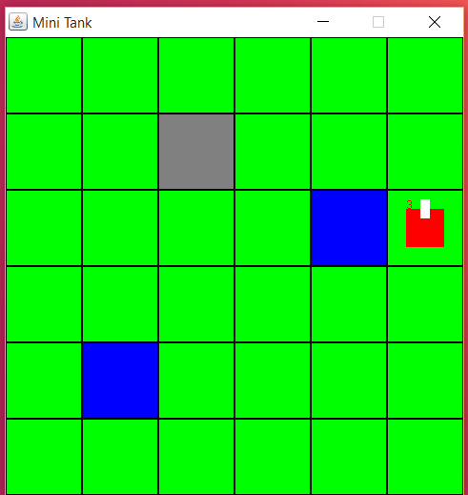

1. Run “TestBullet.java”, capture the result of Junit Test Case in Eclipse.

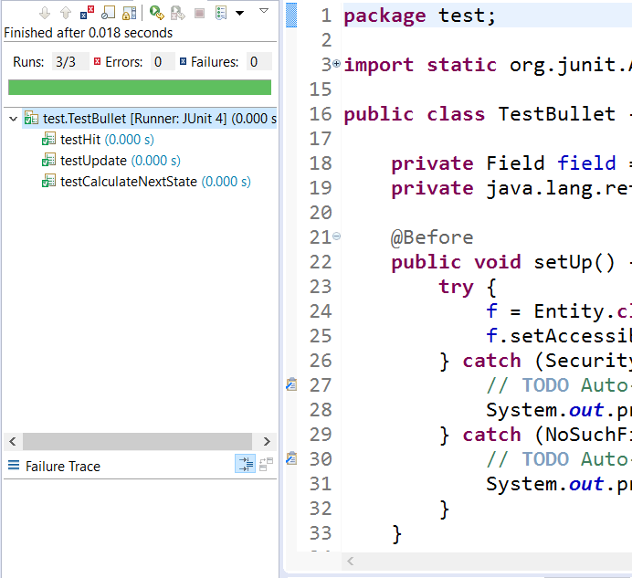

1. Run “TestEntity.java”, capture the result of Junit Test Case in Eclipse.

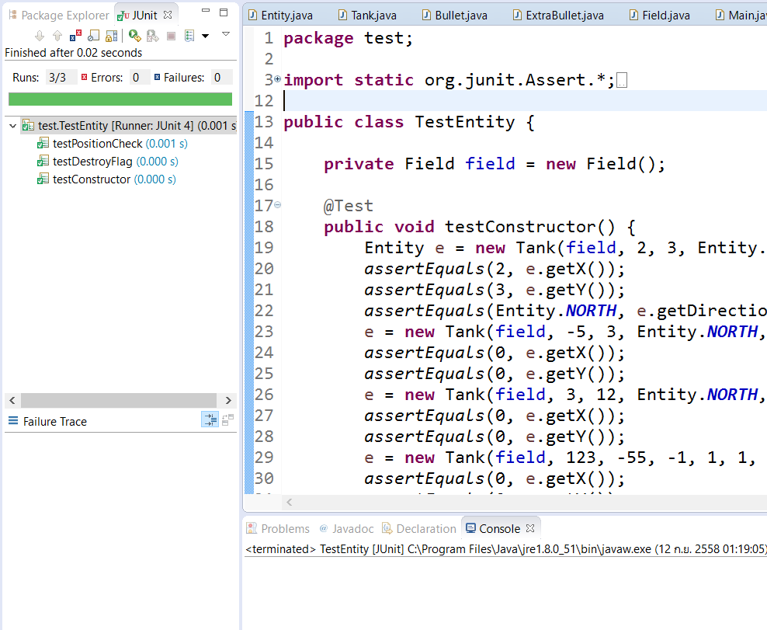

1. Run “TestField.java”, capture the result of Junit Test Case in Eclipse.

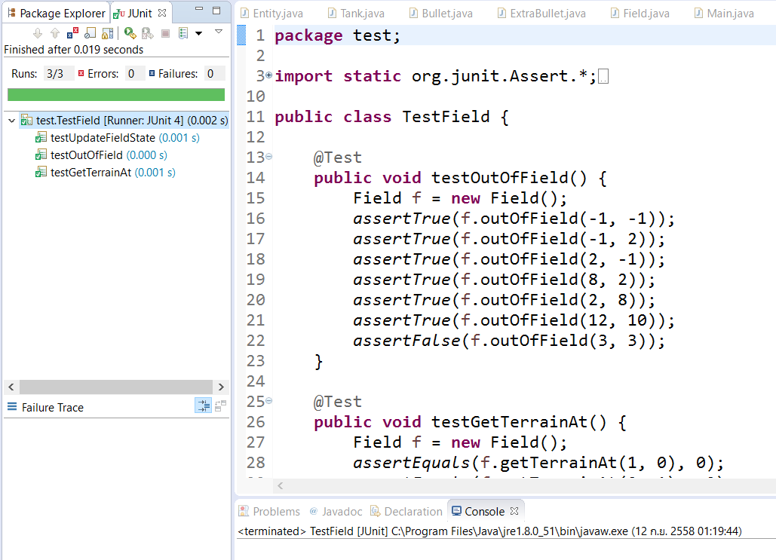

1. Run “TestTank.java”, capture the result of Junit Test Case in Eclipse.

