Lab3: Interface (Worksheet2-Take Home)

Section_____1______ Date_______26/09/58________

Student ID _______5731015621____________ Name________Jirapat Atiwattanachai__________

# Part A: Result

1. Can you run your runnable jar? (Yes/ No) Capture the game screen (after clicking “New Game”).

Yes, I can run my runnable jar.

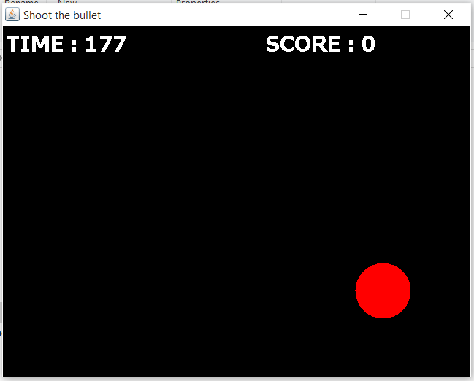

1. Open the runnable jar file with the zip program, such as WinZip, WinRAR. Copy and paste the folder “res” into the runnable jar file. Now run your program and, then, capture the game screen again.

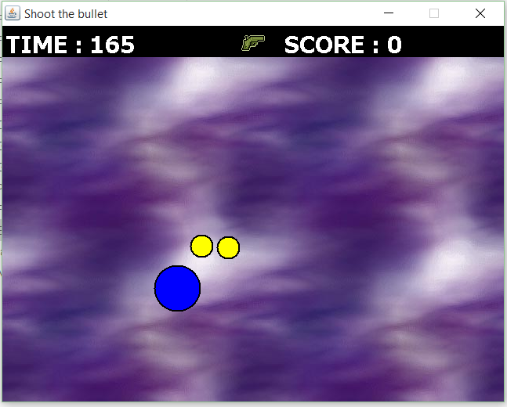

1. Start and pause the game, and, then, capture the game screen

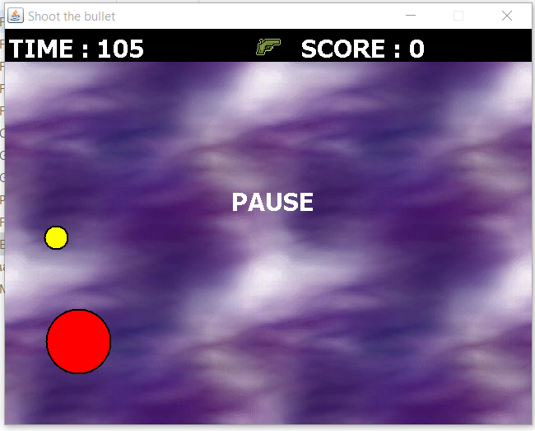

1. Finish game, and, then, capture the game screen

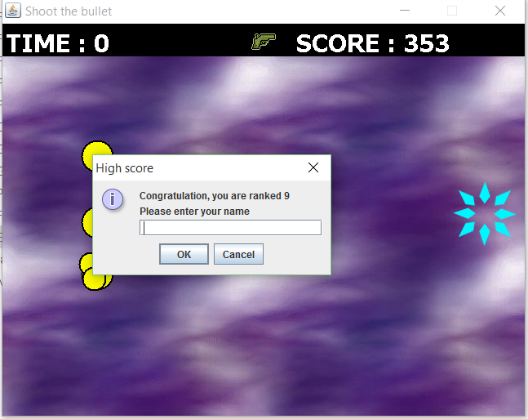

# Part B: JUnit Test Case

1. Run TestTargetObject and, then, capture the result of Junit Test Case in Eclipse.

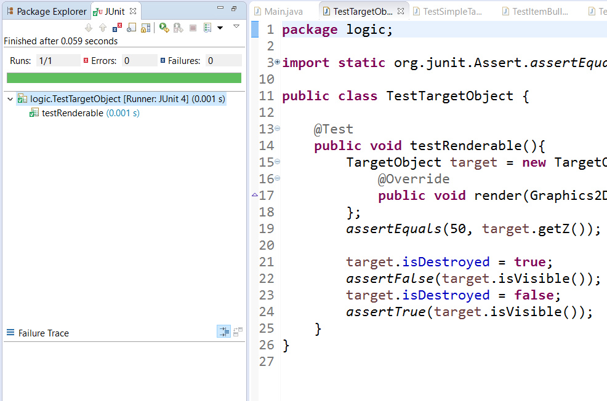

1. Run TestShootableObject and, then, capture the result of Junit Test Case in Eclipse.

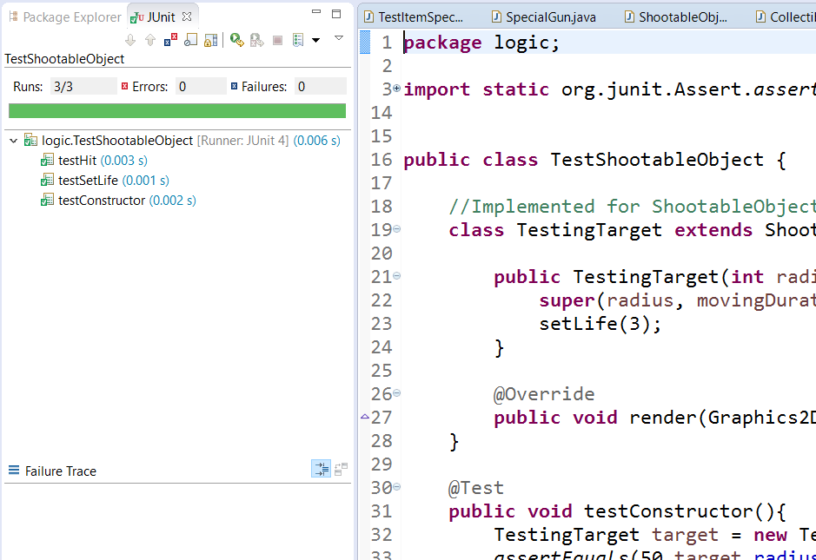

1. Run TestTestSimpleTarget and, then, capture the result of Junit Test Case in Eclipse.

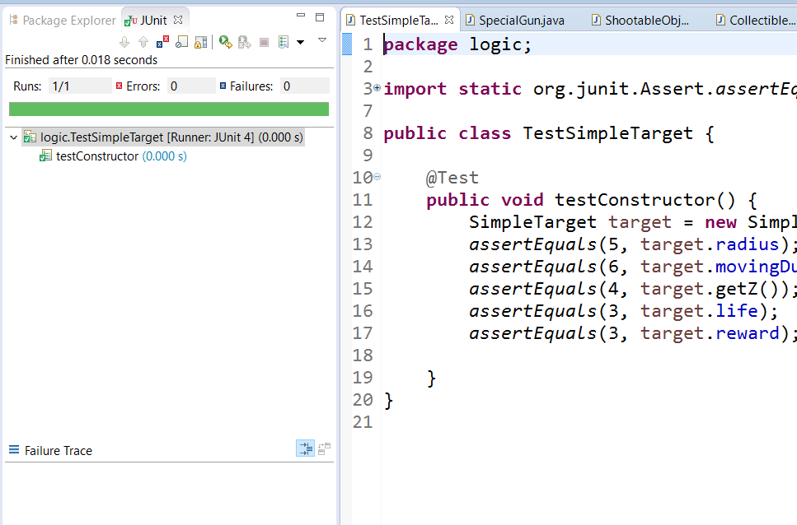

1. Run TestTestSmallTarget and, then, capture the result of Junit Test Case in Eclipse.

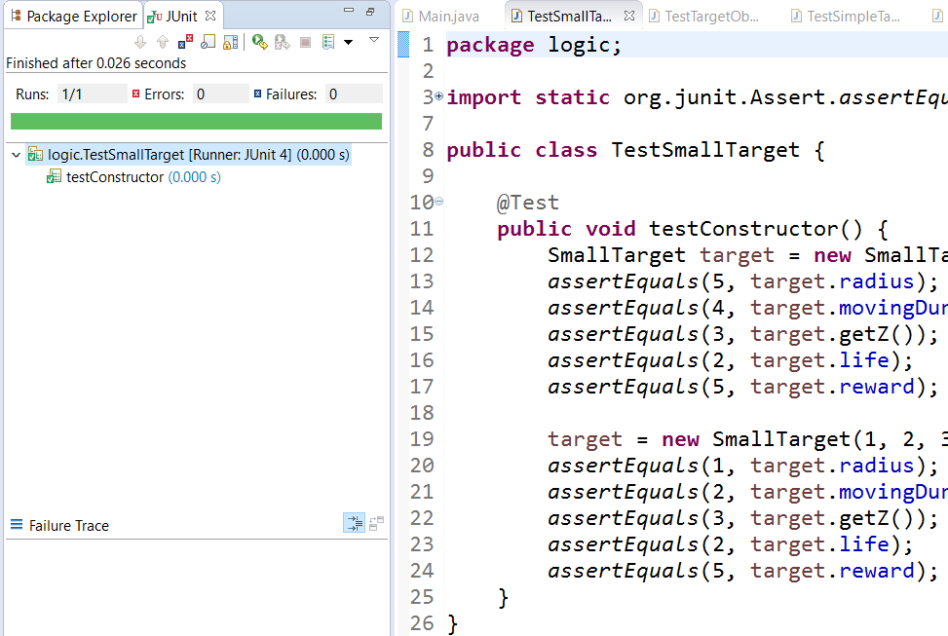

1. Run TestSplitterTarget and, then, capture the result of Junit Test Case in Eclipse.

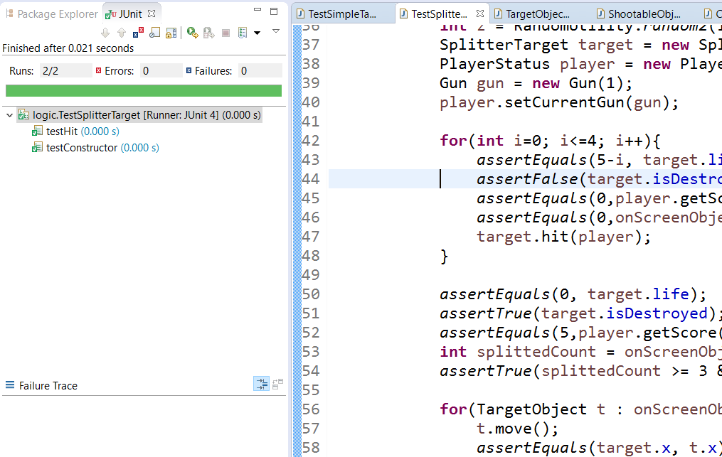

1. Run TestColectibleObject and, then, capture the result of Junit Test Case in Eclipse.

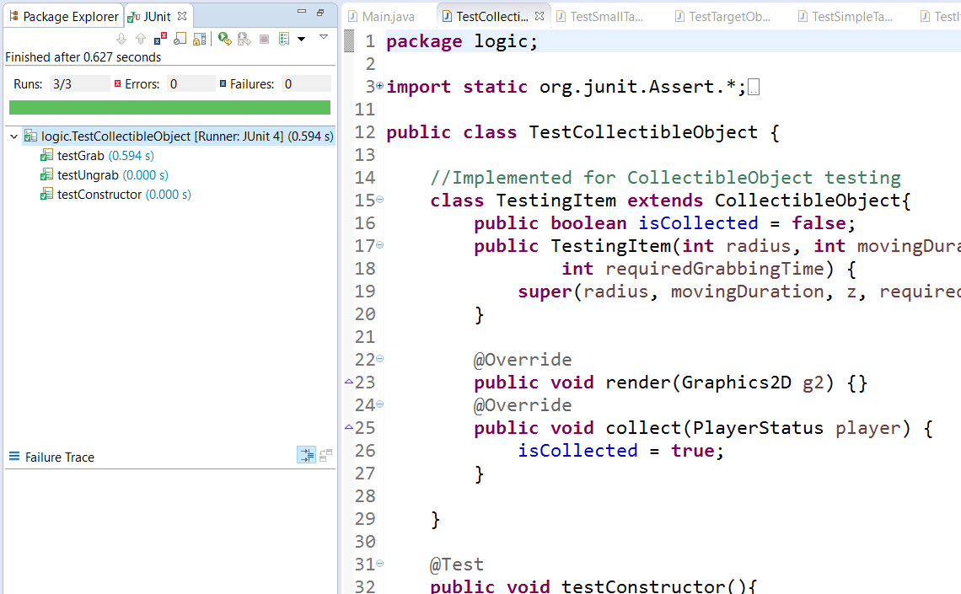

1. Run TestItemSpecialGun and, then, capture the result of Junit Test Case in Eclipse.

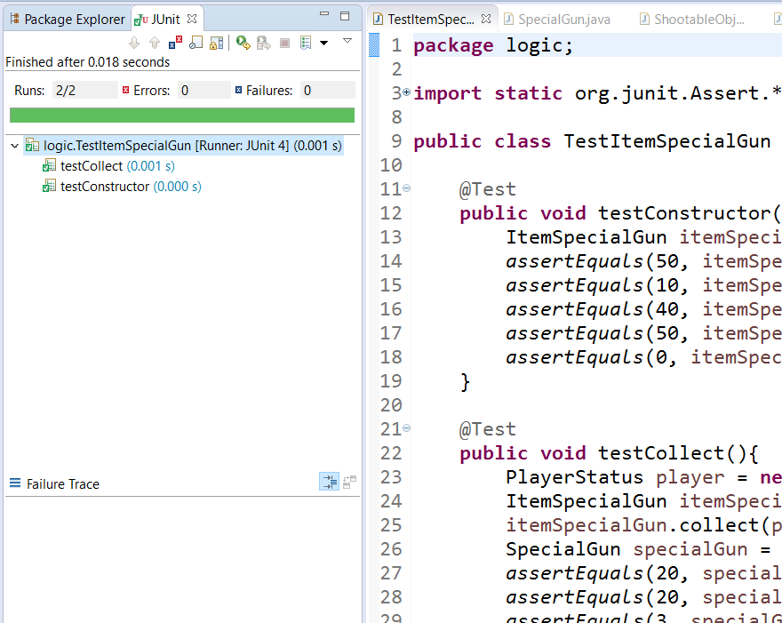

1. Run TestItemBullet and, then, capture the result of Junit Test Case in Eclipse.

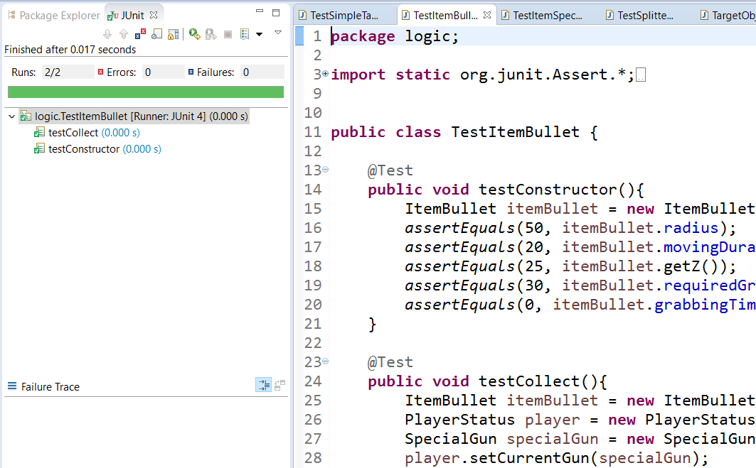

1. Run TestSpecialGun and, then, capture the result of Junit Test Case in Eclipse.

