Lab4: Exception & Swing Components (Worksheet1-In class)

Section 1 Date 30/10/2558

Student ID 5731015621 Name Jirapat Atiwattanachai

# Important Rules

* Any cheating (copying code, answer, picture, etc.) cause the lab’s score to be “**0**”.
* Any screenshots must be from YOUR own program.
* If the captured screenshot (e.g., JUnit Test Case) and the result of your program are different, the lab score will be “**0**”.
* Please put the following code in the top of ALL of your codes.

/**

* **@author** Your name (Your ID)

* **@version** 28 OCT 2015

* Lab4 (1/2015) in 2110215 ProgMeth

*/

# Objective

* Finish PART A (the GameTitle class) in Lab4 along with GUI
* The zip file must include JAR file and the worksheet (doc).

# Part A: Starting Screen’s GUI (In Class Work)

**\*\*\* In this part, the screenshot must be captured from YOUR OWN PROGRAM \*\*\***

1. List all of the fields in the *ConfigurableOption* class and their default values of the input on the GUI

screenWidth=640  
screenHeight=480  
timelimit=180   
objectCreationMinDelay=100   
objectCreationMaxDelay=200

objectMinDuration=200   
objectMaxDuration=700

1. Capture the screen shot of the game title
   * Make sure that the font, size, and color are configured correct!

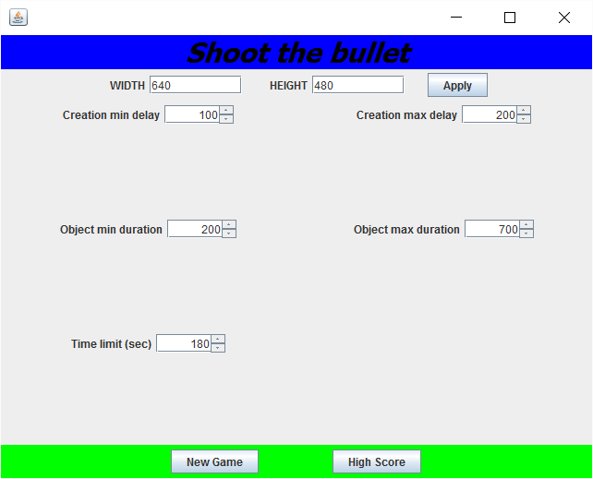

1. Capture the message dialog after click at the “New Game” button

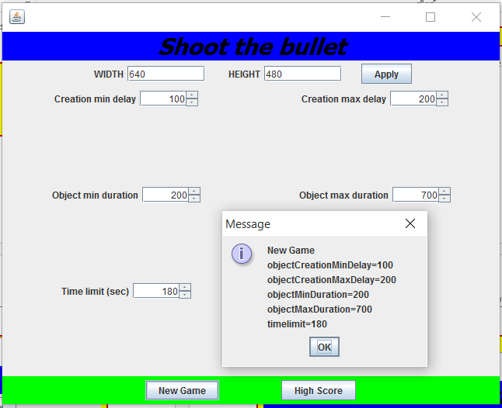

1. Capture the message dialog after click at the “High Score” button

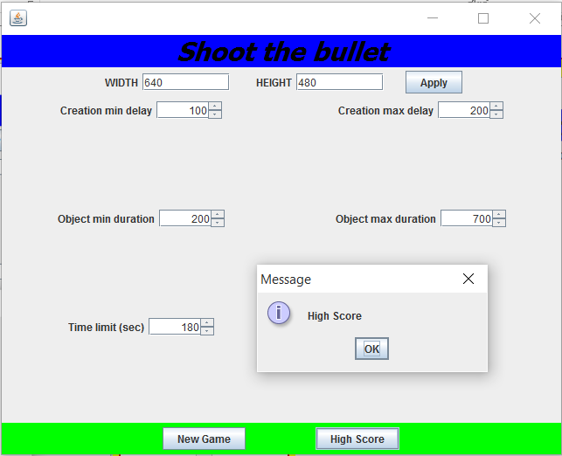

1. Capture the message dialog after click at the “Apply” button

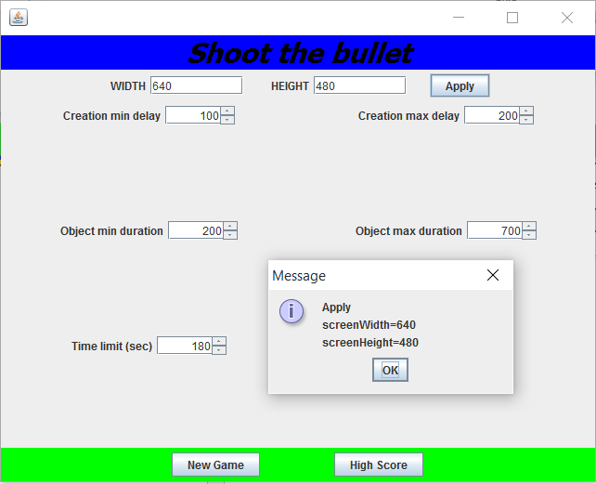

1. Enter non-numeric value into width or height and, then, press the “Apply” button. Capture the error message.

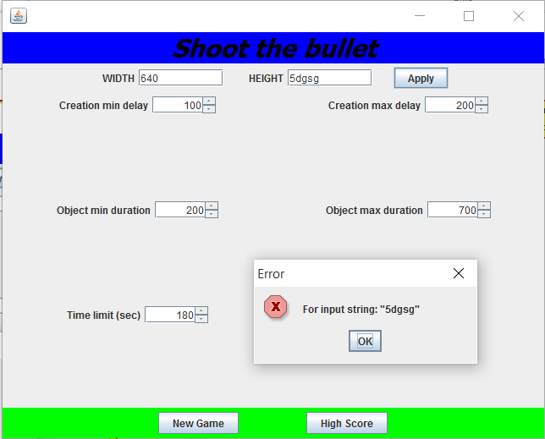

1. What happen if we enter non-numeric value in the variables using the JSpinner component?

Cannot increase or decrease value when your click arrow button

1. Show the code of how to create the JSpinner component along with Class “JSpinnerModel.”

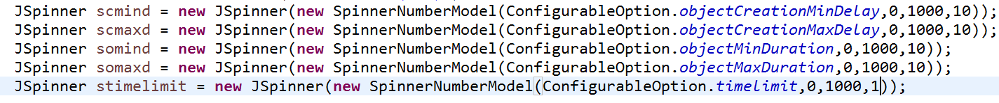

1. Explain the meaning of the field “step” in JSpinner. Also, what are the step values used in the program (there are 3 JSpinners, so answer all of them)?

Step mean that each time when your click arrow button the value in JSpinner will increase or decrease by value of step. All JSpinners using step equal 10 except timeLimit using 1.