Lab4: Exception & Swing Components (Worksheet2-Take Home)

Section 1 Date 1/11/2558

Student ID 5731015621 Name Jirapat Atiwattanachai

# Important Rules

* Any sheathing (copying code, answer, picture, etc.) cause the lab’s score to be “**0**”.
* Any screenshots must be from YOUR own program.
* If the captured screenshot (e.g., JUnit Test Case) and the result of your program are different, the lab score will be “**0**”.
* Please put the following code in the top of ALL of your codes.

/**

* **@author** Your name (Your ID)

* **@version** 28 OCT 2015

* Lab4 (1/2015) in 2110215 ProgMeth

*/

# Objective

* Finish PART B in Lab 4
* The submission deadline is on Thursday, November 5, 2015. The zip file must include JAR file and the worksheet (doc).

# Part A: Class “GameTitle” (Revisited)

1. Capture the screen shot of the game title
   1. Make sure that the font, size, and color are configured correct!

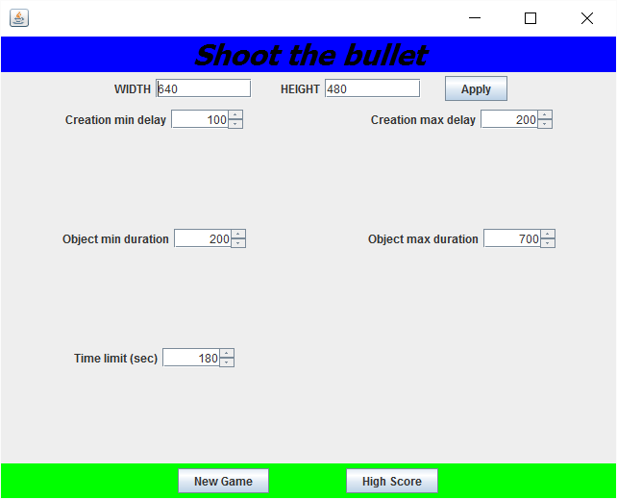

1. Check the “New Game” button
   1. Try to change all of the parameter on the game title page and, then, capture the screen (before press the “New Game” button)

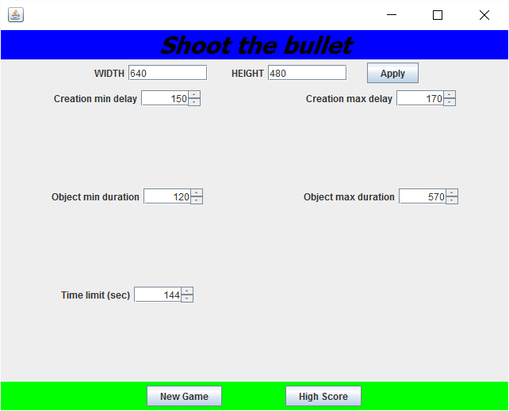

* 1. Press the “New Game” button and copy the result in the file “log.txt”

Width = 640

Hight = 480

Creation min delay = 150

Creation max delay = 170

Object min duration = 120

Object max duration = 570

Time Limit (sec) = 144

1. Check the “Apply” button
   1. Resize width and height and, then, capture the screen (before press the “Apply” button)

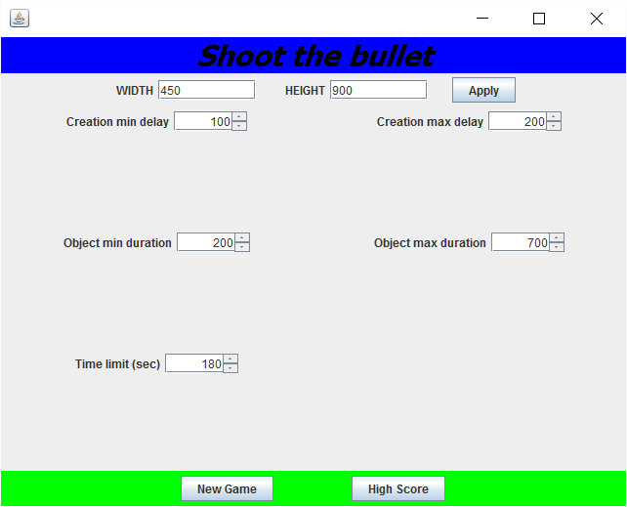

* 1. Press the “Apply” button and, then, capture the game title page

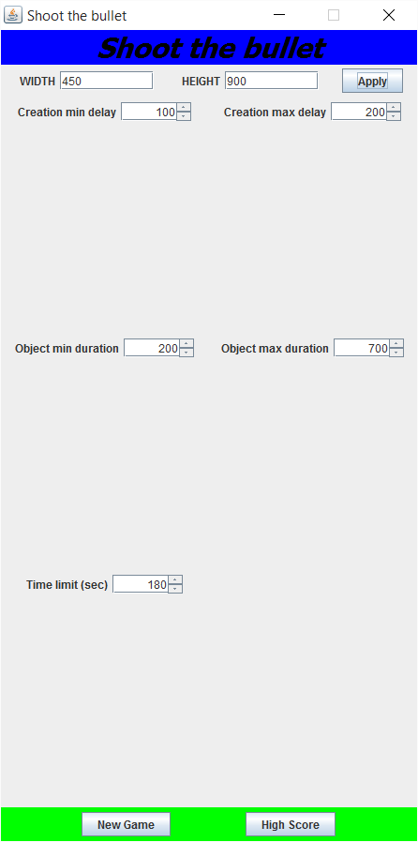

* 1. Press the “New Game” button and, then, capture the game screen page
     + GameScreen must be also resized.

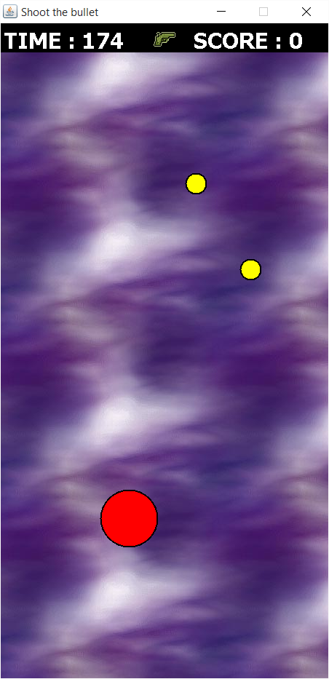

# Part B: Class “GameScreen”

1. Close the game and restart the game again using “the default setting”
2. Start playing the game and check the following action during playing the game
3. For MouseListener, the following items must perform correctly:
   1. Left click to shoot an object
   2. Left click can destroy an object
   3. Mouse over to collect the collectibleObject objects (such as special gun)
   4. Nothing happens when performing right click
   5. Press “Enter” to pause and “resume” the game
   6. Press “Spacebar” to shoot an object and capture the game screen

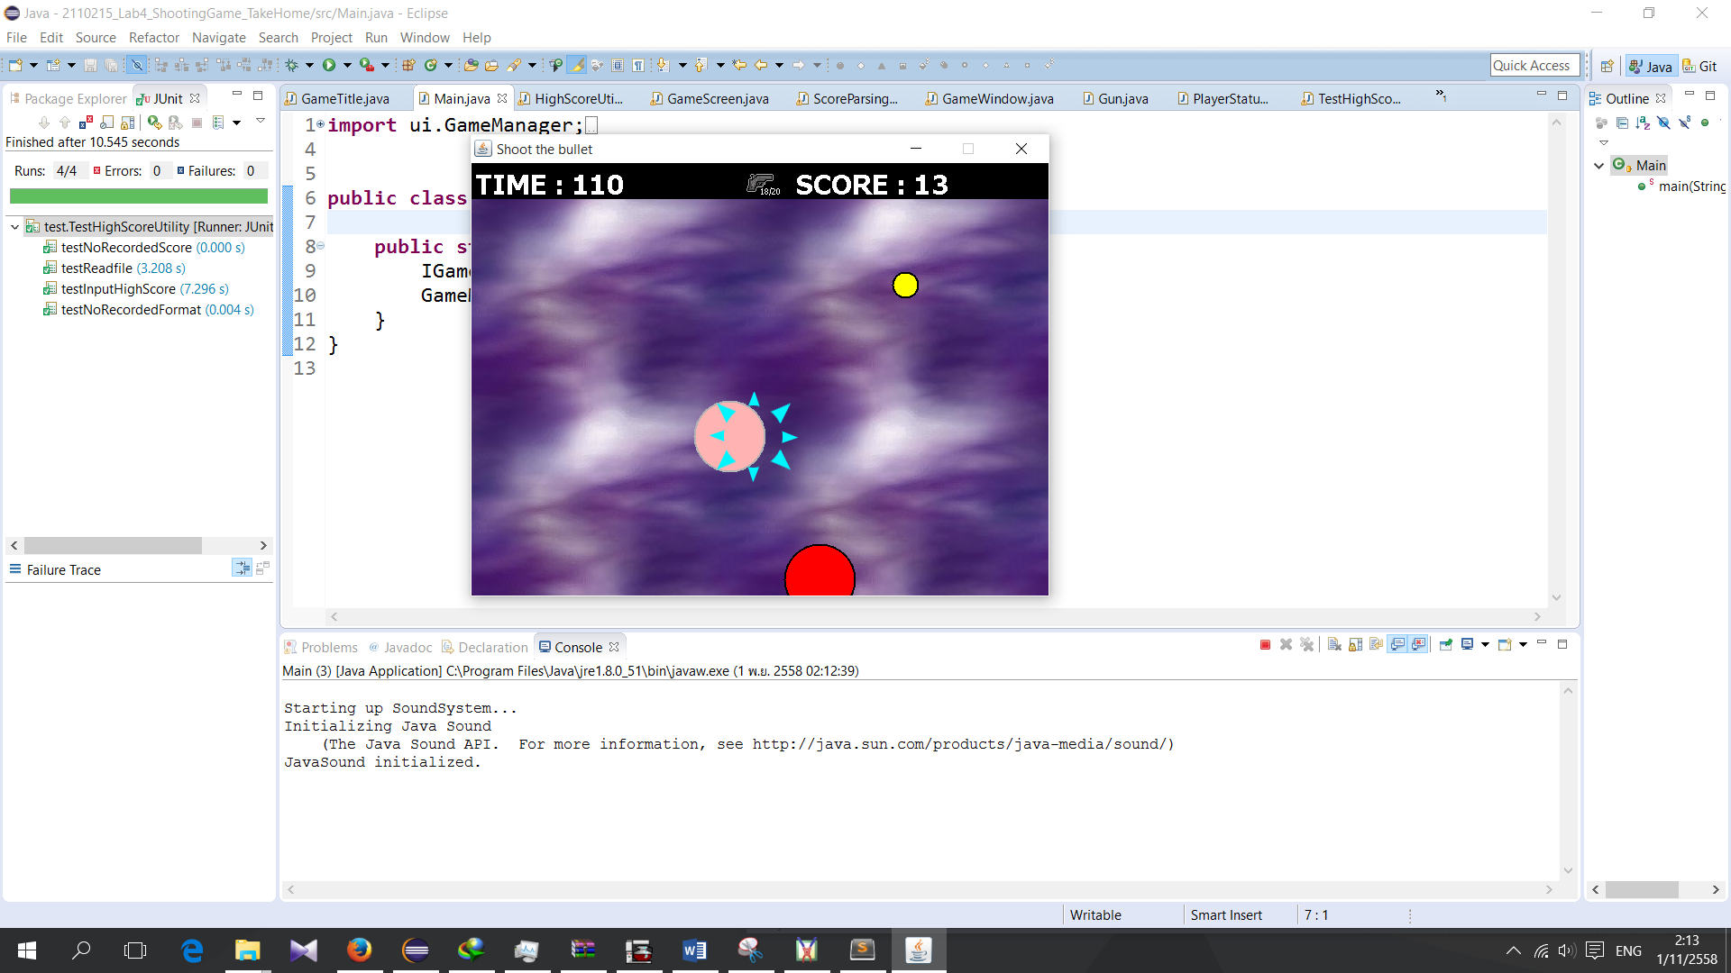

# Part C: Class “HighScoreUtility”

1. Finish the game, and, then, capture the input dialog

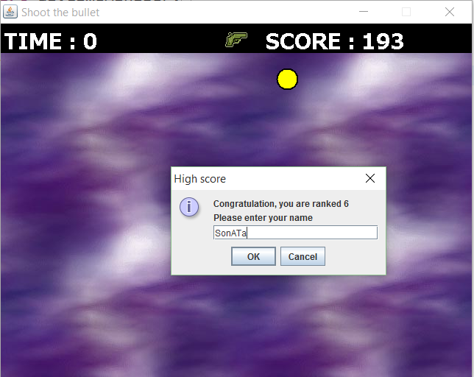

1. The game will return to the game title page. Press the “High Score” button and capture the screen.

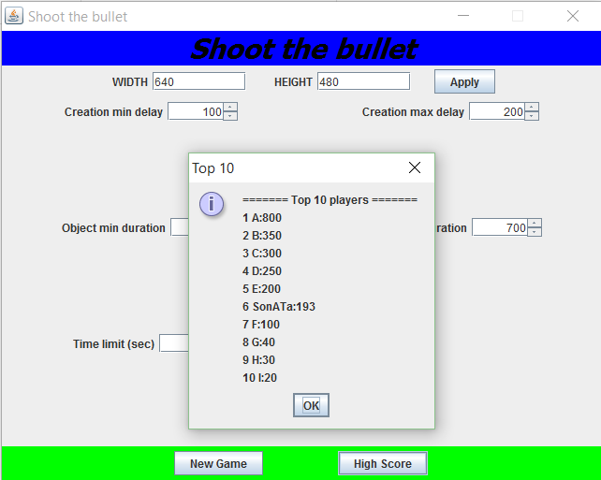

1. Create a package “test” and, then, add the JUnit “TestHighScoreUtility.java”. Finally, capture the JUnit screen. Note that there are 4 test methods.

