**General Dentistry:** This is the most common type of dentist, providing a wide range of preventive, restorative, and cosmetic dental services. They can handle routine cleanings, fillings, extractions, and other procedures.

[เปิดในหน้าต่างใหม่[](https://familychoicedentistry.com/blog/sign-you-should-visit-general-dentist/)familychoicedentistry.com](https://familychoicedentistry.com/blog/sign-you-should-visit-general-dentist/)

General Dentist

**Oral and Maxillofacial Surgery:** Oral surgeons specialize in the surgical aspects of dentistry, such as tooth extractions (including wisdom teeth), dental implant placement, jaw surgery, and treatment of facial injuries.

[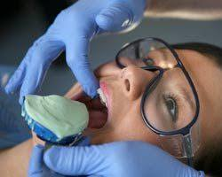เปิดในหน้าต่างใหม่[](https://mft.nhs.uk/dental/about/referral-information-for-dental-practitioners/oral-and-maxillofacial-surgery/)mft.nhs.uk](https://mft.nhs.uk/dental/about/referral-information-for-dental-practitioners/oral-and-maxillofacial-surgery/)

Oral and Maxillofacial Surgeon

**Endodontics (Root Canal Therapy):** Endodontists specialize in diagnosing and treating problems with the inside of the tooth, including the pulp (the soft tissue inside the tooth) and the roots. They perform root canals, which involve removing infected or inflamed tissue from the inside of the tooth.

[เปิดในหน้าต่างใหม่[](https://www.nsbendo.com/what-exactly-does-an-endodontist-do/)nsbendo.com](https://www.nsbendo.com/what-exactly-does-an-endodontist-do/)

Endodontist

**Periodontics (Gum Disease):** Periodontists specialize in the treatment of gum disease, which is an infection of the gums and tissues that support the teeth. They also perform procedures to restore lost bone and tissue around the teeth.

[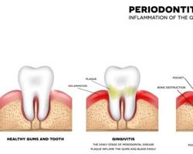เปิดในหน้าต่างใหม่[](https://www.aperiodoc.com/what-exactly-is-a-periodontist/)aperiodoc.com](https://www.aperiodoc.com/what-exactly-is-a-periodontist/)

Periodontist

**Orthodontics (Braces):** Orthodontists specialize in straightening teeth and correcting bite problems. They use braces, retainers, and other appliances to move teeth into the desired position.

[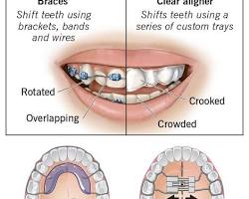เปิดในหน้าต่างใหม่[](https://my.clevelandclinic.org/health/treatments/24285-orthodontics)clevelandclinic.org](https://my.clevelandclinic.org/health/treatments/24285-orthodontics)

Orthodontist

**Pediatric Dentistry:** Pediatric dentists specialize in providing dental care for children from infancy through adolescence. They are trained to deal with the specific needs of children, both in terms of their development and their behavior.

[เปิดในหน้าต่างใหม่[](https://hurstpediatricdentistry.com/2020/06/28/what-is-the-difference-between-a-board-certified-pediatric-dentist-and-a-family-dentist/)hurstpediatricdentistry.com](https://hurstpediatricdentistry.com/2020/06/28/what-is-the-difference-between-a-board-certified-pediatric-dentist-and-a-family-dentist/)

Pediatric Dentist

**Prosthodontics (Dentures and Crowns):** Prosthodontists specialize in restoring missing teeth and improving the appearance of teeth. They create dentures, crowns, bridges, and other dental prosthetics.

[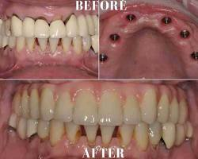เปิดในหน้าต่างใหม่[](https://oceanbreezeprosthodontics.com/best-prosthodontist-near-me/)oceanbreezeprosthodontics.com](https://oceanbreezeprosthodontics.com/best-prosthodontist-near-me/)

Prosthodontist

The choice of a dentist will depend on your individual needs and preferences. If you have a healthy mouth and only need routine care, a general dentist may be all you need. However, if you have a more complex dental problem, you may need to see a dentist who specializes in that area.