


Content Style Guide

5/16/2022
Table of Contents
The Importance of Branding 2
Our Target Audience 3
Voice, Style + Tone 4
Formatting Guidelines 5
Document Styles 5
Content Types + Standards 9
Business Cards 9
Email Signatures 9
Letterhead 10
Memoranda 10
Tip Sheet 11
Meeting Minutes & Agenda 12
News Releases 12
Presentations 12
Design Elements 15
Color Palette 15
Tinted Color Palette 16
Accents 17
Document Headers 17
Document Footers 17
Imagery 19
Logo Guidelines 20
Trademark Usage 21
Typography 22
General Writing Best Practices 23
General Style Guidelines 23
Social Media 23
Attributions 23
Appendix A: Abbreviations & Acronyms 25
Appendix B: Technical Report Styles 26
Appendix C: Writing & Usage Quick Guide 27

The Importance of Branding
“It is impossible to overemphasize the importance of brand consistency. Endless studies prove consistency increases awareness and helps cement an emotional connection to a brand. The more single-minded we are, the more powerful the… brand will be.”—I LOVE NEW YORK brand book

At O’Brien360, each of us is a business developer, networking and sharing our “Sustainability Expertise for the Built Environment” throughout the industry in ways that resonate among our colleagues and partners as we work together to catalyze a greener future. In terms of synergy, productivity, and intelligence, disseminating our message goes a long way toward our continued success, and our brand lies at the center of this endeavor. To manage and ensure a cohesive brand identity, it truly takes a village. Everyone involved must fully understand and believe in our vision and practice discipline in brand expression. This Style Guide was created to help us do just that.

Our Target Audience
O’Brien360’s main client base includes building and portfolio owners, architects, affordable housing developers, and government agencies who share our commitment to creating a more equitable, healthy, and sustainable built environment. Many of our clients seek to add value and performance to their built environment projects by prioritizing sustainability strategies. They look to O’Brien360 as a trusted collaborator and advocate that will support them through the full project arc. Through an independent, analysis-driven approach, O’Brien360 guides the client toward improving the sustainability, performance, operational efficiency, competitive advantage, and livability of their structures.

Voice, Style + Tone
Our brand voice is:
Professional and informative, but not boring
Brand Voice Statement:
We believe that we can help create a future that is equitable, healthy, and prosperous by improving the performance of the built environment.
Brand Tone Statement:
The brand tone of O’Brien360 that should come through in all communications
- Service-oriented
- Knowledgeable
- Reliable
- Versatile
- Determined

Formatting Guidelines

Document Styles

Headings & Titles

Title yu gothic bold caps, 2144 C, 20 pt.
Title2 Yu Gothic Bold, 2144 C, 20 pt.
Subtitle Yu Gothic Small Caps, 2144 C, 12 pt.

Heading 1 Yu Gothic Bold, 2613 C, 16 pt.
Body Text

Heading 2 Yu Gothic Bold, 7685 C, 14 pt.
Body Text

Heading 3 Yu Gothic Bold, 2118 C, 13 pt.
Body Text

Heading 4 Yu Gothic Bold, Black C, 11 pt.
Body Text

Yu Gothic Bold, 2613 C, 16 pt.
Title “1” style has 18 pt. above it and 0 after. Title 2 does not have space before because it is meant to follow Title and not meant to be used alone. Subtitle also does not have space before or after to help keep the space for titles consolidated. Title, Title 2, and Subtitle are typically centered but may be left justified on some templates that use the colored bar on the left margin.
All headings have 12 points of space before and 0 points after. The Appendix style has a page break before. Depending on the length of your document, or for some templates, you may want to change the Heading 1 style (for that document only) to have a page break before. Each style is automatically followed by ‘Body Text’ style which has an automatic 6 points between paragraphs.
When headings follow each other, and there is no body text between them, you will need to manually set the space before to 0 using the “Paragraph” pop-up in the “Home” ribbon to reduce the space between them.
Always maintain the hierarchy of headings and titles and do not skip levels with the following exceptions:
- You can skip Title 2 between Title and Subtitle
- You can skip down to Heading 4 after Heading 1 or 2 if there are no further levels below.

Note: The appendix style is technically equivalent to Heading 5, so when publishing a document to PDF, the appendix bookmarks will need to be manually moved out to level 1.

Body Styles
Body Text Yu Gothic, Black C, 10 pt., 6pt between paragraphs of same style
Body Text Italics Yu Gothic, Black C, 10 pt., 6pt between paragraphs of same style, italics
Emphasis Yu Gothic Bold Italic, Black C, 10 pt.

Hyperlink Calibri, 2144 C, 12 pt.
Followed Hyperlink Calibri, 2613 C, 12 pt.
Note that hyperlinks use the alternative font, Calibri, because Yu Gothic does not have a backslash
Table Caption Yu Gothic, Black C, 9 pt.
Figure Caption Yu Gothic, Black C, 9 pt.
List Paragraph (Bullets)
- Create a bulleted list by starting a new paragraph, then select the “Bullets” button in the “Paragraph” section of the “Home” ribbon
- The style will automatically update to List Paragraph, indent at 0.25,” hanging indent at 0.25”
  - The second level will look like this, indent at 0.75,” hanging indent at 0.25”
List Paragraph (Numbered lists)
- Create a numbered list by starting a new paragraph, then select the “Numbering” button in the “Paragraph” section of the “Home” ribbon
- The style will automatically update to List Paragraph
  - Default level 2, first line indent at 0.75”, hanging indent at 0.25”
    - Default level 3, first line indent at 1.25”, hanging indent at 0.25”
List Bullet
- Good for non-technical reports, proposals, and educational material (like tip sheets). Create this by applying the “List Bullet” style from the Styles menu on the “Home” ribbon.
- “List Bullet 2” style looks like this

Headers and Footers
Header Yu Gothic, left justified, publish date right justified, Black C, 10 pt.



Footer Yu Gothic Medium, 3 pt. space above, left justified, with right justified page number, 2118 C, 10 pt.



Tables
The following table style can be used with any of the colors in the OB360 primary palette. The default table style in branded templates is “OB360 Blue,” (2144 C). All new tables should default to this style.
Table 1. Default Table Style "OB360 Blue"
Heading 1 | Heading 2 | Heading 3…
This is the default table style | All text is Yu Gothic, 9 pt. | Text style is set by the table style, not paragraph styles
Lorem ipsum | Lorem ipsum | Lorem ipsum
To switch to one of the approved alternate styles, follow these steps:
- Click anywhere inside a Word table
- Select the “Table Design” ribbon
- Click the “more” arrow within the “Table Styles” section
- Select one of the custom table styles at the top of the drop-down (see below for examples of each style)
Table 2. Table Style "OB360 Blue with Blue Bands"
Heading 1 | Heading 2 | Heading 3…
This is the blue-banded version of the default style | Lorem ipsum | Lorem ipsum
Lorem ipsum | Lorem ipsum | Lorem ipsum
Lorem ipsum | Lorem ipsum | Lorem ipsum
Lorem ipsum | Lorem ipsum | Lorem ipsum
Table 3. Table Style "OB360 Blue w/ Gray Bands"
Heading 1 | Heading 2 | Heading 3…
This is the grey-banded version of the default style | Lorem ipsum | Lorem ipsum
Lorem ipsum | Lorem ipsum | Lorem ipsum
Lorem ipsum | Lorem ipsum | Lorem ipsum
Lorem ipsum | Lorem ipsum | Lorem ipsum
Table 4. Table Style "OB360 Technical"
Heading 1 | Heading 2 | Heading 3
This is the default table style for technical reports | Lorem ipsum | Lorem ipsum
Lorem ipsum | Lorem ipsum | Lorem ipsum

Excel Table Formatting
Proper formatting of Excel worksheets enables readers to locate important information quickly and facilitates more thorough comprehension of data. To these ends, judicious use of color, font, and table styles is a best practice. Following are some guidelines to keep in mind when creating Excel tables and worksheets.
- Avoid filling (or shading) multiple cells in large blocks of color.
- Limit shading to cell headers
- Do rely more on text styles such as bold, italics, and cell borders to draw attention to key data
- Do limit the number of colors used in your worksheet to three
- Do use the darker colors in the OB360 primary and secondary palette

Content Types + Standards
Several templates exist ready for use on the shared drive. All templates must be used as designed without any changes to color, font, or size of graphics, to maintain the uniformity of O’Brien360’s marketing identity. As a rule, it is an O’Brien360 best practice to convert all outgoing documents to PDF. Documents (e.g., proposals) that may require comments or additional content from the client do not require conversion.
For issues with template use, see Marketing.

Business Cards
As a rule, our cards do not feature titles or credentials, except for PE designations. In recognition of changing societal attitudes surrounding gender identity, we have elected to place pronouns on our cards. The content on the cards can be adjusted to suit individual needs. If you wish to change or add information, please let Marketing know.
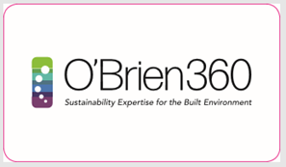
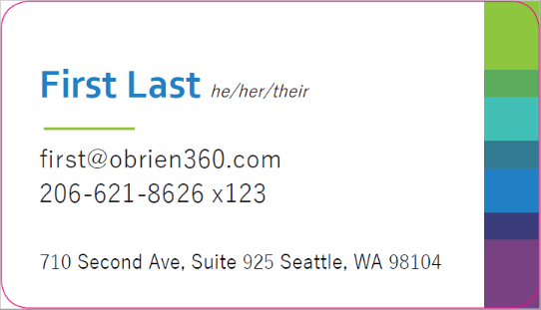

Email Signatures
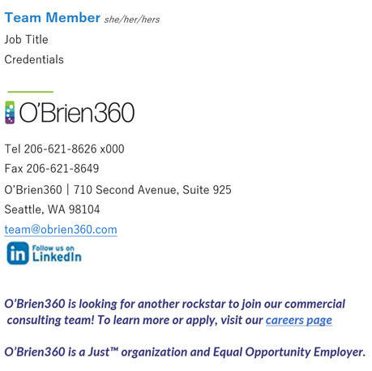
For many client communications, an important component of clarity is for us to identify ourselves and our organization while staying within our brand standards. Therefore, every email should be formatted automatically and sent following the guidelines shown below:
Use email signature blocks on all email messages to:
- Clients in the community regarding O’Brien360 services
- Vendors and external entities on behalf of O’Brien360
Email signature blocks are optional on:
- Internal email exchanges among O’Brien360 colleagues
- Repeat/multiple interactions with project teams, clients

Temporary Taglines
Occasionally, Marketing may ask that you add a tagline to your signature block. This tagline is typically a temporary message that publicizes a conference we’re attending, training we are facilitating, or other major events. This message goes 6 points below your email and should be 10-point, bold italic Lato font in dark purple (2118 C).
To maintain the integrity of our branding, please do not make any changes to the style or typeface of your email signature. If you wish to include additional information or amend your existing email signature, please contact Marketing.
Full instructions for email signature setup are in the shared marketing folder: Y:\Shared\OB360_Marketing\Forms & Templates\Email Signatures\Instructions for Branded Email Signature.docx
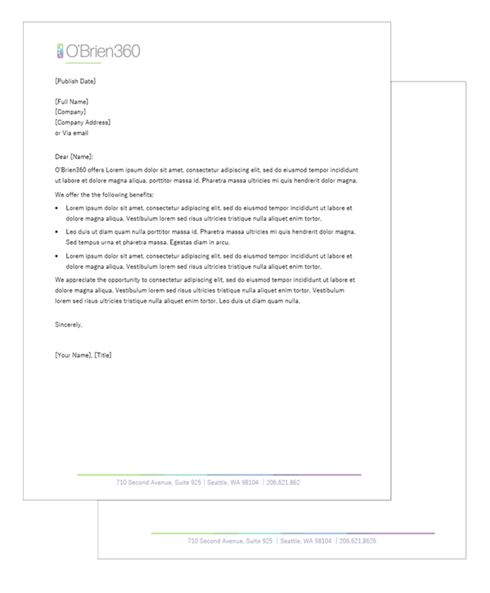

Letterhead
Pictured is the current letterhead for O’Brien360. The document shown below uses moderate margins, a left-oriented logo with a green accent bar, and a color bar footer with a centered, dark purple (2118 C) address line. Business Correspondence should be written in Formal Block Style, which aligns all content to the left and has no indented paragraphs. The second page and subsequent pages also feature the color bar footer with the address line. Please ensure that this is the letterhead used for all formal correspondence leaving the office.

Memoranda

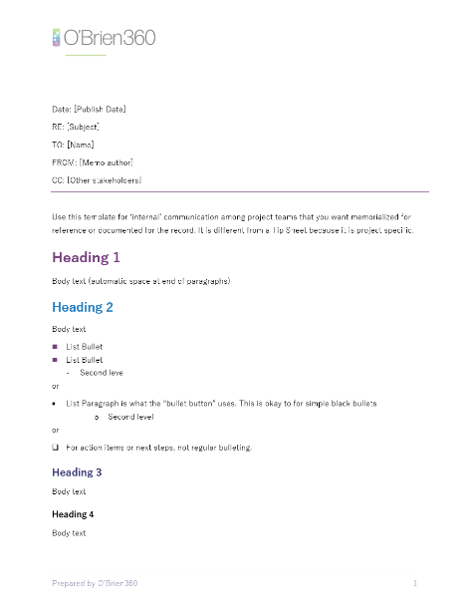
Memos are used for capturing and communicating project specific information vs. Tip Sheets which provide more general information and are not edited for project specific uses.
Memos do not have titles or signatures. That information is in the memo header. However, you may use subheadings for long memos
The template pictured below is for general office purposes and follows many of the same formatting standards as the O’Brien360 Letterhead. The body of the memo is written in Formal Block Style, aligning all content to the left with no indented paragraphs.

Tip Sheet
Like a fact sheet, a tip sheet is a brief document or publication meant to convey relevant information about a particular subject. The tip sheet differs from a fact sheet in that it contains certain information or tips relating to a specific business or type of activity. It may also serve as a ‘how to’ document. An example of this is the Tip Sheet explaining the ILFI JUST designation and how to obtain it. The tip sheet can function as an internal or external document.
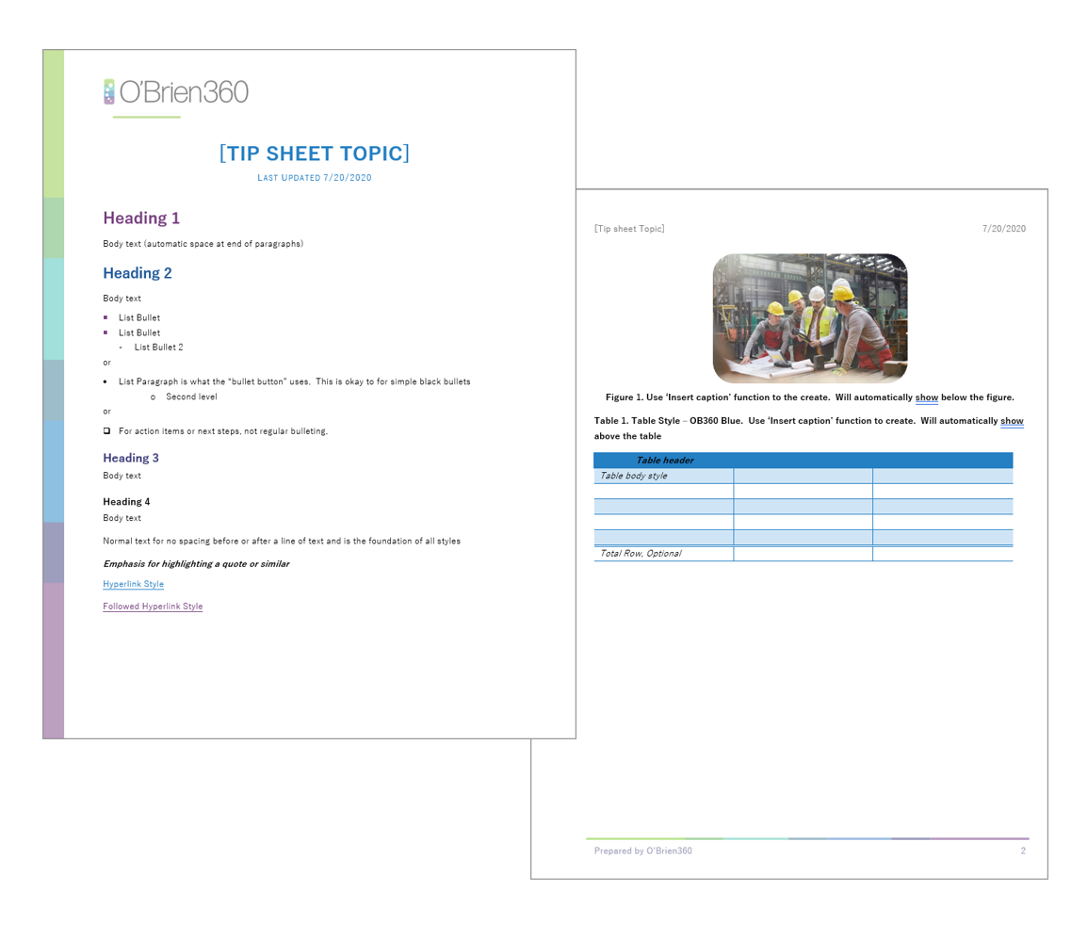

Meeting Minutes & Agenda
An all-purpose template exists for meetings and agendas that features five sections: date, time, and location of the meeting, (section 1); meeting objectives, (section 2); attendees, (section 3); agenda items, topics and subtopics,(section 4), and finally, next steps (section 5). The agenda footer adheres to the purple line standard.
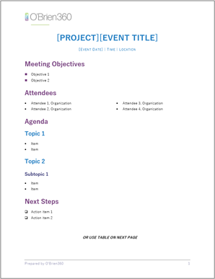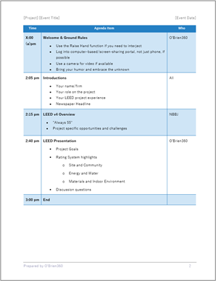

News Releases
There is a template for news releases (press releases) in the shared Marketing folder that follows established professional protocols. All news releases are to follow AP style guidelines. If you have a newsworthy item, you would like publicized via news release, please work with Marketing to get it drafted and released.
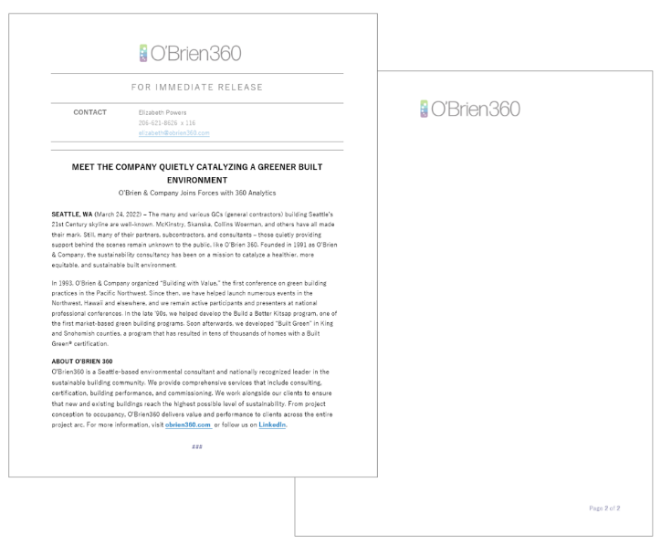

Presentations
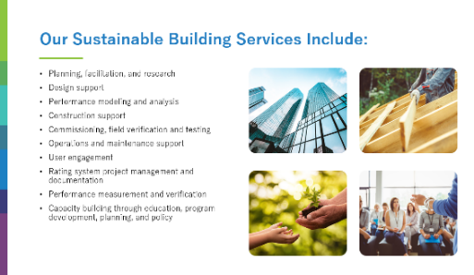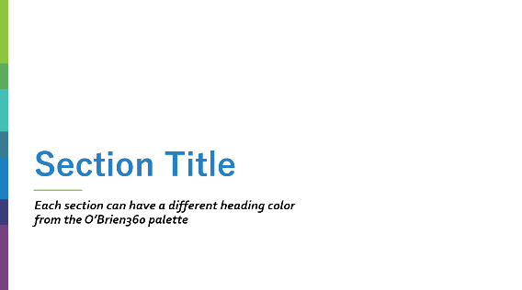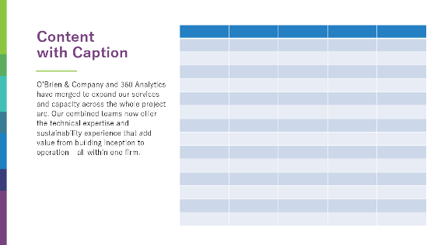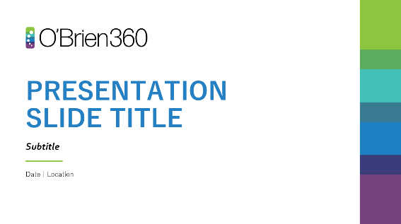
The purpose of your PowerPoint presentation is to relay information in a concise and visually compelling manner that neither bores nor overwhelms your audience. The PowerPoint template has been designed to aid in that endeavor. Presentation Dos & Don’ts
- Do not change or resize the main design elements of the template.
- Do not use the Reverse Section Header for presentations that you plan to print.
- Do pay attention to white space when employing images.
- Do not overload your slides with text; stick with a small number of bullet points for your main speaking points (you can expand on your thoughts in the PowerPoint’s notes section).
- Do not go overboard on animation, graphics, or photographs.
- Do not be afraid to split up slides if you can’t fit all you want on one.
- Do use a large enough font size so your presentation can be read.
- Do be mindful of accessibility issues. Marketing has prepared a tip sheet sourced from the Perkins School for the Blind on how to create accessible PowerPoint presentations:
Y:\Shared\OB360_Marketing\Presentations\Making Accessible PowerPoints.docx
- Proposal Cover Page
For O’Brien360 proposals, there are several cover page versions available. The standard Proposal Cover Page, which features a prominent color bar on the left (Figure 1), and a Proposal Cover Page meant for an image using alternative Title 2 formatting(Figure 2). In some instances, a fee-only proposal is required and the standard form of such a proposal is pictured here (Figure 3) There is also a template available for Contract Additions (Figure 4). Whichever cover is appropriate to your pursuit, please use the established template as designed.
Figure 2
Figure 1
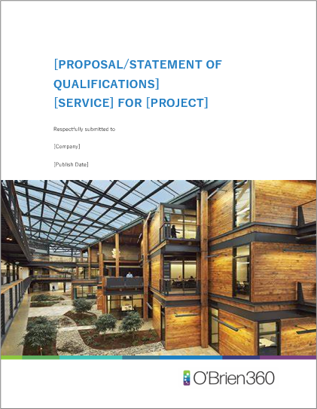
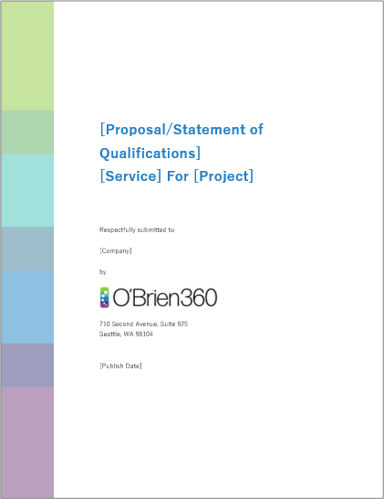

Figure 3
Figure 4
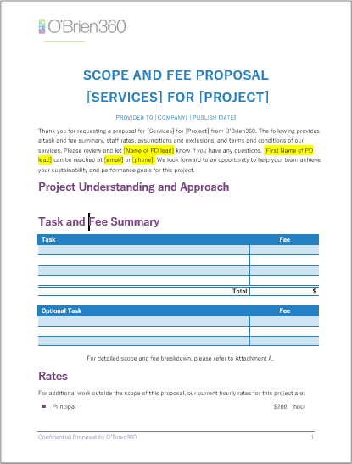
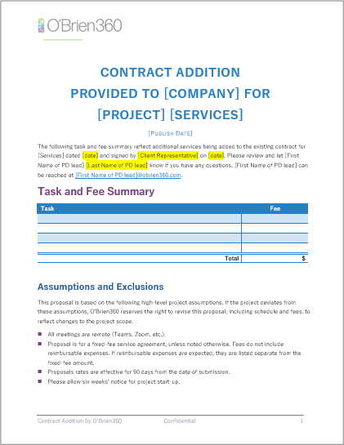

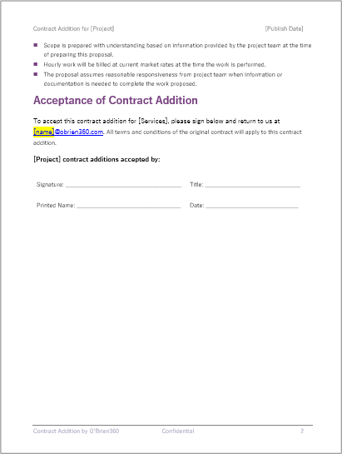
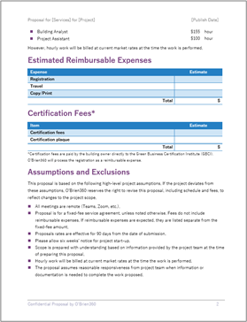

Design Elements

Color Palette
The following color palette has been approved for reproducing the O’Brien360’s business cards and other branded assets. Any departure from this is at the sole discretion of the O’Brien360 Marketing Committee.
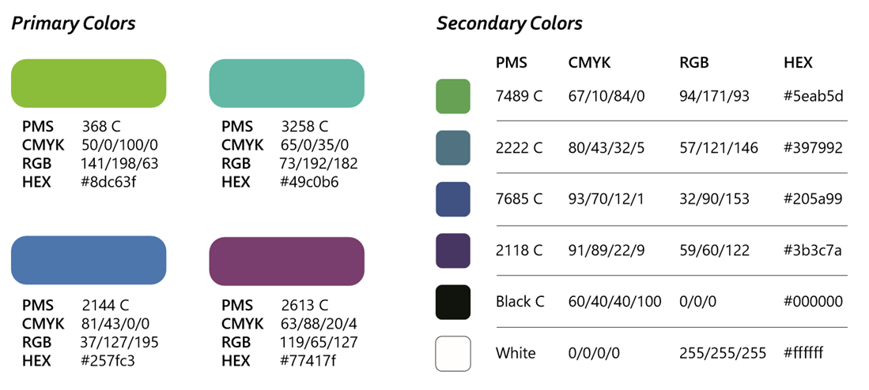

Color Palette Usage Best Practices
For collateral deviating from the templates provided, a best practice is to work with Marketing to create your document. When that is not feasible, some guidelines for using this palette are as follows:
- Use darker colors for titles and subtitles.
- Use lightest colors sparingly as highlight colors, never as text.
- Use white lettering, not black against the darkest colors.
- Please use only three colors in any one document.

Tinted Color Palette
Primary Tints Secondary Tints
368 C
RGB 203 / 229 / 169
3258 C
RGB 203 / 237 / 234
7489 C
RGB 203 / 228 / 202
7685 C
RGB 203 / 223 / 224
2144 C
RGB 203 / 227 / 245
2613 C
RGB 203 / 164 / 208

2613 C
RGB 203 / 229 / 169
2222 C
RGB 203 / 226 / 235

2222 C
RGB 203 / 226 / 235
2118 C
RGB 203 / 209 / 232
2613 C
RGB 203 / 229 / 169

Black C
RGB 203 / 203 / 203

2118 C
RGB 203 / 209 / 232

144 C
RGB 203 / 227 / 245

Tints Usage Best Practices

The tinted palette can be used to add a subtle touch of color to tables, graphs, and other designed collateral. A best practice is to stick to the primary Blue 2144 C and Green 3258 C and Black C tints. Please use no more than two tints in any one document.

For help or further guidance on using the color palette and accompanying tints, see Marketing.

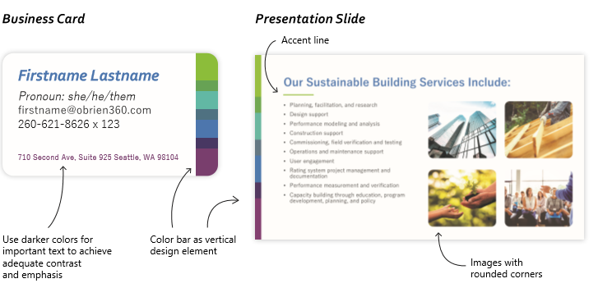
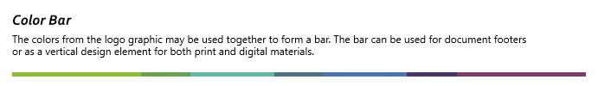
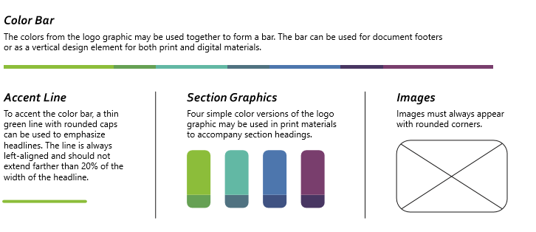
Accents

Document Headers
Left-align all headers for non-technical documents. Headers are one line, include only the title of the document and the date (right-aligned) and are Yu Gothic Medium, Purple 2118 C, 10 pt., as shown below. Technical headers differ; for additional guidance, see Appendix B., Technical Report Styles, page 24.

Document Footers
Document footers go from margin to margin, and all text under them is Yu Gothic Medium, 10 pt. font in deep purple (2118 C) for all proposals and other non-technical documents. Page numbers on these documents are always right aligned in the same font, color, and point size (Yu Gothic Medium, 10 pt., 2118C). Keep a space of 3 points between the footer bar and text. The bar symbol (encircled below in red) should always be used between elements in the footer where applicable. Below are formatting examples for various page footers.

Correspondence
Footer for correspondence, one-off marketing collateral, letterhead, envelopes, invoices:

710 Second Avenue, Suite 925 | Seattle, WA 98104 | 206-621-8626 | www.obrien360.com

Proposals
Bar symbol
Footer for proposals. Add page numbers where possible:
Prepared by O’Brien360 13

Reports

Non-Technical Reports
Non-technical reports use the plain, dark purple bar footer. Text is left-aligned, and page numbers are aligned to the right. The text and numbers are Yu Gothic Medium, 10 pt., dark purple. Reports do feature headers without a line and are always left-aligned. Text and numbers are also Yu Gothic medium, 10 pt. in dark purple, as shown below. Technical Report footers follow the same text alignment as non-technical reports, but all text is black. See Appendix B.

Non-Technical Report Footer



Imagery
O’Brien360’s approved photography falls into one of these six categories Project Exteriors, Project Interiors, Project Renderings, Personalized Photos, Site Visits, Green System Components. These categories reflect O’Brien360’s brand identity and core values, and they communicate information about our employees, areas of expertise, and company history.

Guidelines
- All photography should reflect O’Brien360’s best projects and work practices.
- Remove any information in a photo that identifies a client.
- Use real photos whenever possible. Clip art or stock photography must be approved by the Marketing Team.
- Do not use photography from other sources without obtaining a license.
- Do not use clearly outdated photos.
- Images for print applications must be at least 300 dpi. Images for digital applications can be around 96 ppi, but as low as 72 ppi is often acceptable.
- Choose photography that has a point of view. One good shot is infinitely better than too many shots that are mediocre quality.
- Pay attention to composition. Use the Rule of Thirds, a method of composing an image such that the focal point occurs at or near the intersection of a grid that divides the image into thirds horizontally and vertically.
- Look for opportunities to have the photography support the written message.
- Use full-color images when possible.
- Crop photos to remove unnecessary or distracting details.
- Show the diversity of the people who work for O’Brien360, which includes age, gender, dress, country of origin, and job responsibilities.
- Use rounded corner images for proposals and most marketing collateral, non-rounded corners on images meant to convey information in documents and technical reports are permissible.
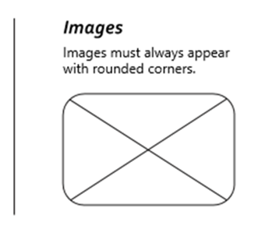

Figure 2. Image Example
Image Caption

Instructions for Rounding Image Corners
- Click on an image with square corners
- Navigate to the “Picture Format” ribbon
- Click the “Crop” drop-down arrow
- Mouse over the second option, “Crop to Shape”
- Select the second option under the “Rectangles” heading, “Rectangle: Rounded Corners”

Logo Guidelines
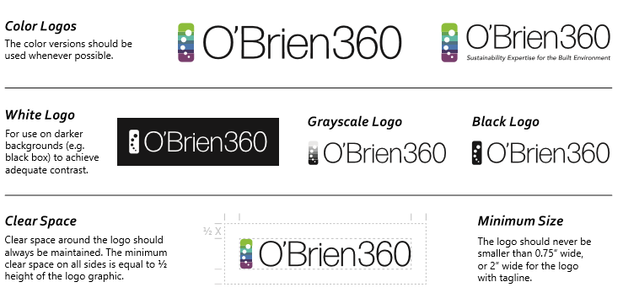
The O’Brien360 logo is the foundation of our company’s identity. Consistent use of our logo will continue to build on the strength and equity of O’Brien360’s brand. The following logos are the sole acceptable use assets for O’Brien360, and any outside entity wishing to use these logos must obtain permission from the Marketing Committee.


Logo Don’ts
- Do not try to replicate the logo. Use only the files supplied by the Marketing team.
- Do not use logos over busy backgrounds.
- Do not rearrange elements of the logo.
- Do not change the logo colors.
- Do not change the orientation of the logo (do not turn it upside down or sideways)

Logo with Green Accent Bar
Green Accent Bar is for use only on letterhead, 1st page of proposals without cover, and reports.
Place under the last dot of arc to the middle of “e” in O’Brien360 approximately 12 pt. from the logo as pictured.


Logo Placement
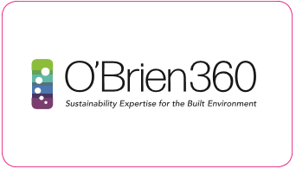
In all letterhead and multipage documents except for proposal covers, the logo is left justified, 0.75” in height and 2” in width, and should feature the green accent bar.

Tagline
Sustainability Expertise for the Built Environment
In client-facing applications, the tagline should be used with the logo whenever possible. The tagline is not meant to stand alone. The spatial relationship shown on this page is preferred. If your layout needs to differ, please contact Marketing for assistance.
Always italicize the tagline, even when it appears in body copy text. (e.g., Sustainability Expertise for the Built Environment).

Logo Usage Quick Guide
The Logo Usage Quick Guide is a single-page document meant to be a one-stop refresher on the O’Brien360 logo guidelines. The document lives in shared the Marketing folder
Y:\Shared\OB360_Marketing\Logos\Logo Usage Quick Guide.pdf

Trademark Usage
Many of the tools we use and companies we are affiliated with use a trademark for their organization name (e.g., ENERGY STAR®, LEED®, etc.). General usage guidelines for all trademarks in business writing, news releases, websites, and other documentation stipulate the use of the trademark symbol [superscript ® or TM] on the first instance only or with the most prominent use of the mark, as in a title. The remaining instances can leave out the symbol. Always use the full trademarked name and proper capitalization. You may omit the use of trademarks in O’Brien360 proposal documents.

Typography
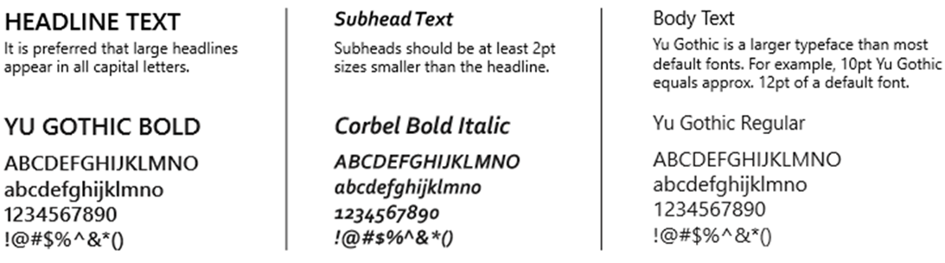
Subhead Text
Subheads should be at least
2pt sizes smaller than the
headline.

Yu Gothic Bold
ABCDEFGHIJKLMNO
abcdefghijklmno
1234567890
!@#$%^&*()

Body Text Alternative
Calibri is acceptable as an alternative
body text and is the standard body text
for O’Brien360 emails. Use 11 or 12 pt.
font for documents, and 10 pt.
for email correspondence.

Calibri Regular
ABCDEFGHIJKLMNO
Abcdefghijklmno
1234567890
!@#$%^&*()

General Writing Best Practices

General Style Guidelines
O’Brien360 refers to the Chicago Manual of Style Guide for proposal materials and all client-facing collateral except blog posts, PR pieces, and articles for publication. Those materials are created using the AP Style Manual with few exceptions. Merriam-Webster's is the designated dictionary of choice. For questions of spelling, use the online Merriam-Webster Dictionary. Use the first spelling presented and note that word presentations in the dictionary supersede the Stylebook.

Writing Voice and Point of View
- Where possible, write in the active voice
  - Example: We listen, adapt, and analyze to serve your needs, and we integrate into your team.
- The O’Brien360 Point of View is typically 1st person
  - When referring to O’Brien360 use the 1st person point of view
  - Examples: We learn and adapt; Our combined teams offer enhanced technical and sustainability expertise When referring to another company, use the third-person singular pronouns it and its. In the United States, a company is treated as a collective noun and requires a singular verb and a singular pronoun. e.g., the company anticipates an increase in its third-quarter spending. (Singular verb, singular possessive "its").

Social Media
O’Brien360 uses Adobe Spark to design social media posts. Use of this program lends our efforts a uniform look and feel consistent with our brand identity.

Rules of Usage
All boxes surrounding text must adhere to the rounded corners standard with narrow padding in the cutout style. Where the Yu Gothic font is not available, Raleway and Latoare acceptable substitutes. White or any brand color against a white background is the standard for text.

Please follow AP Style guide rules for all web and social media communications.

Attributions
Failure to properly cite sources could potentially result in legal action against the company. With that in mind, please remember to properly cite sources in all O’Brien360 publications, whether online, printed, or projected. If you've got a case not covered here, find a way to attribute your source that seems appropriate to the medium. Choosing not to cite a source is unacceptable.

Link Attribution
When including links to external content such as blog posts and eBooks, use anchor text when possible. Linking to other articles and websites is a best practice.
A Chinese city has the largest Passive House project in the world. (When including links in presentations, you can use the domain as anchor text.)

Images
Images or photos derived from Flickr or another online source under the creative commons license must be attributed. When attributing an image, please use the format shown below and link back to the source image using the photographer's name as anchor text.
Image Credit: linked source
- Abbreviations & Acronyms
Internal Jargon | Customer Friendly Language
CB | Commercial buildings
ChW | Chilled water
CDD | Cooling degree-day
CNC | Commercial new construction
EB | Existing buildings
HTF | Housing Trust Fund
IDIQ | Indefinite Delivery, Indefinite Quantity
LCCA | Life Cycle Cost Analysis
MSME | Master of Science in Mechanical Engineering
NC | New Construction
NTP | Notice to Proceed
PE | Professional Engineer
PD | Proposal Development
PSH | Permanent Supportive Housing
QCxP | Qualified Commissioning Provider
SOQ | Statement of Qualifications
UHEE | Ultra-High Energy Efficiency
The table below lists internal acronyms and abbreviations the company may use and text that should go into any external-facing content. Please remember to spell out the first use of all abbreviated terms and place the abbreviation in parenthesis, e.g., Certain multifamily rental and homeownership projects now have a funding source for Ultra-High Energy Efficiency (UHEE) enhancements. The Dept. of Commerce made funding available to affordable housing projects for UHEE.
For a more comprehensive list of internal and industry abbreviations, acronyms and definitions please see the Glossary of Terms located here: Y:\Shared\OB360_Tools\0_Company\Glossary of Terms.docx
If you have additions to this table, please email them to lynnel@obrien360.com.
- Technical Report Styles

Heading 1 Yu Gothic Bold, 2613 C, 18 pt.

Heading 2 Yu Gothic Bold, 7685 C, 16 pt.

Heading 3 Yu Gothic Bold, 2118 C, 13 pt.

Heading 4 Yu Gothic Bold, Black C, 11 pt.
Header Yu Gothic, center tab stop, Black C, 10 pt.
Table 1. Default Table Style "OB360 Technical"
Heading 1 | Heading 2 | Heading 3…
This is the default table style for technical reports | Lorem ipsum | Lorem ipsum
Lorem ipsum | Lorem ipsum | Lorem ipsum
Table 2. Revision Table Style "OB360 Technical Revision"
Revision | Date | Originator | Description
01 | <date> | Initials | Description of changes and revision number of repository.

Technical reports use the plain, thin black bar footer. Text is left-aligned with page numbers aligned to the right. The text and numbers are Yu Gothic Medium, 10 pt., Black C. Reports do feature headers without a line and are always left-aligned.

Yu Gothic Medium, left-aligned, Black C, 10 pt. Page 1 of 2
- Writing & Usage Quick Guide
Awards | Names of awards and prizes are capitalized; however, some generic terms used with the names are lowercased.
Capitalizing after a colon | When used within a sentence, the first word after the colon is lowercased unless it is a proper name.
Certifications and Degrees | No periods for PE or other degrees/certifications. Set off by comma when following a personal name.
Composition titles | Books, newspapers, magazines, movie titles, poems, plays, paintings, and album titles are set in italics. Titles of articles and individual songs are set in quotation marks.
Compound modifiers and hyphenation | A compound modifier is when two or more words act together to modify a noun. For example, “first-quarter touchdown.”
e.g. (exempli gratia) | Definition: for example. Do not confuse with, i.e., and use a comma after.
i.e. (id est) | Definition: that is. Do not confuse with, e.g., takes a comma after.
Introductory comma | Set off an introductory phrase with a comma unless the sentence is inverted, and the phrase immediately precedes the verb.
Number styles | Spell out numbers one through ninety-nine and use numerals for 100 and above.
Possessive of proper nouns ending in “s” | Add an apostrophe “s,” e.g., “Britney Spears’s album debuted at No. 1.”
Semi-colon | Used between two complete sentences not joined by a conjunction, e.g., Lara loved the ocean; she could not wait to leave.
Serial comma | Also known as the Oxford Comma is the comma before the “and” or “or” in a series. For example: red, white, and blue. The serial comma is the one after “white.”
Word spacing | Use a single character space between sentences and after colons used within a sentence.

For a full explanation of usage rules, please refer to the Chicago Manual of Style.

