Grandlin's Heirs
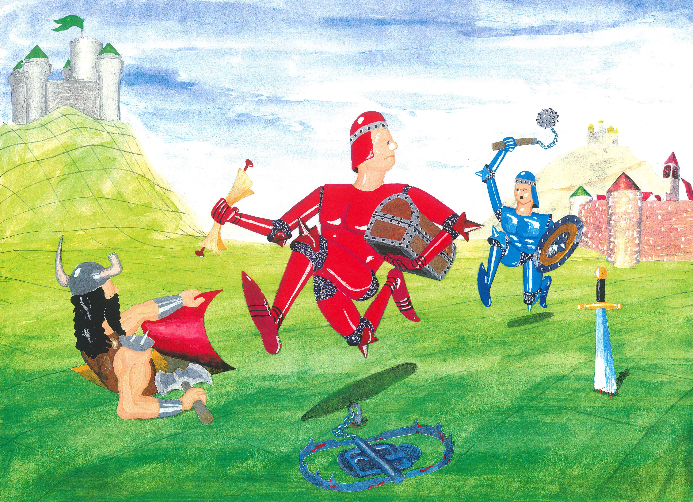

V2.1_en, 20.7.2022

Backstory
The sudden death of the archmage Grandlin, who ruled the Empire for many decades, has ignited a power struggle among his heirs, the Lords and Ladies of the realm, all vying to succeed him.
To identify the most competent successor, Grandlin hid the Empire’s insignia of power (Crowns, Goblets and Orbs) throughout the realm and required that his successor be the first to discover a certain number of these treasures and to secure them in their own castle. Grandlin reasoned that such a test would ensure the stability of the Empire: Having secured their treasures against all would-be thieves, his successor would be competent enough to secure the throne.
The fight for supremacy can be dangerous, and the Lords and Ladies do not leave their castles. Instead each sends their most loyal Henchman to search for the insignia of power by any means necessary. Nevertheless the Lords and Ladies have influence throughout the Empire and can assist their Henchman through conjurations and powerful spells.

Playing the game
Each turn corresponds to one day and consists of two parts: first moving your Henchman and then exerting your influence as a Lord or Lady, altering the terrain of the playing field to favor your Henchman and to thwart those of your opponents.

The Henchman's Journey
Your Henchman roams around in pursuit of Grandlin's treasures and tries to bring them back to his home castle. Roll your die; the result gives the maximum number of squares you may move your Henchman on this turn. He cannot move diagonally, but can alternate between moving forward, backward, left and right. As his Lord or Lady, you may direct the Henchman to move less than the maximum distance given by the die roll or even to remain on his square, i.e. to not to move at all. Staying in the castle will not help him collect treasures, though. If you have a Map on your hand, you might want to steer him towards the coordinates given, since there is a treasure hidden [on arrival see 3.1. Raise]. Otherwise, visiting the city might be a good idea [see then 4. City]. Of course, your Henchman cannot enter your opponents castles. Move your Henchman now.
Whenever he reaches a square with a card inserted or occupied by another Henchman, your Henchman must immediately stop moving and his journey ends here for the day. Read 5. Encounter.

The magic of the Lord or Lady
Once you have moved your Henchman and all has been resolved, you may perform a ritual in your role as Lord or Lady to secretly conjure a magical entity on the playing board. Take a playing card from your hand and insert it vertically into an unobserved playing square. So the square must not be occupied by a Henchman or by another playing card. In order to prevent the other players from seeing what you conjure, cover the front of the card with your cheatsheet, insert both and then pull out the cheatsheet alone.
Once inserted, a card is only revealed again if a Henchman visits it or by certain spells or special events.
For black magic, marked with a black symbol in the upper left corner, there are additional rules. For such a card to come into effect, you show it directly from your hand. You may show Spells at any time in your turn, even during or before your Henchman's movement or amidst a fight, to support him immediately. When you show a Map, and your Henchman ended his journey at the coordinates given, Grandlin's magical seal breaks and you uncover a treasure [see 3.1. Raise]. Discard a black magic card after use.
⛤
xy
Treasures may only be dropped in a castle, and in a castle only treasures.
The central rule for all cards is: You may play only one card per turn and only on your turn!
If you have more than four cards in your hand, you must play one, otherwise playing a card is voluntary. If you end your turn with fewer than four cards, you must draw from the draw-pile until you have four cards in your hand.

The Treasures
To win the game, you direct your Henchman to find Grandlin’s hidden treasures (the insignia of power: Crowns, Goblets and Orbs), bring them back to your castle and store them there. During transport, the treasures are on your hand and may easily get lost, since they are tied to your Henchman's life. If he returns safely to your castle, you can hide the treasures there, by inserting one treasure card per turn into the slow of your castle. Note, however, that you can play only one card on a turn; you can’t hide a treasure in your castle if you’ve played any other card on that turn.

Raise
All of the treasures that Grandlin hid so carefully in the Empire, need to first be raised. This can only be done using a map with the coordinates. They refer to the numbers and letters on the street and the river. If your henchman stands on a square, for which you have a Map on your hand, you may show it to your fellow players and raise a treasure. Simply draw it from the treasure pile.
xy
Remember that using the map counts as playing a card, so you can not play another card that day. The map goes to the discard pile. The treasure count to the four cards on your hand, so your magical power weakens with the number of treasures your Henchman carries.

Find
In rare cases, a Henchman just trips over a treasure that lies around ownerless, maybe because some henchman has succumbed to poison in that place. You can then simply pick up the treasure to your hand.

Raid
Much more common are fights for treasures. Your Henchman may quickly become your opponents' quarry, when he carries a treasure on your hand. If a villain or another player succeeds in killing you Henchman, your treasures change ownership together with your money [see 6. Fight and 7. Death].

City
The city is safe ground. Combat is prohibited and the guards have everything under control. People are only accepted into the city after staying a night in front of the city walls and having been inspected. So on the way in, every journey needs to pause there. The gates open the next day.
In the city, henchmen may roam around freely according to the roll of the die, as if there were no cards or other henchmen. They can pass through the buildings, don't need to stop for others and there is no inspection on the way out. In this direction, the gates are open.
Each day, your henchman can stop on one of the facilities of the city, to go about the following businesses:

Tavern
He can hire out as dishwasher and earn 2 gold.

Healer
He can have the healer detoxicate him, which is a complex process that costs 5 gold. It stops the poison, but does not restore health.
Restoring health is easy for the healer and he takes for 1 gold per 3 points. No time restrictions apply.

Gym
Training fee is 3 gold per day, which increases strength by 1 point. That's the daily maximum.

Blacksmith
Buy arming for 1 gold per point. The blacksmith has no limit to how much you can buy from him each day.

Encounter
Outside of the city, your Henchman can only walk over empty squares. If he encounters an inserted card, a treasure or another Henchman, he needs to stop and deal with the obstacles. This holds true even if he didn't travel but remained on the field.

Card
Reveal the cards of that playing square as soon as your Henchman enters it. The effect of a card is determined by its type, which is found in the upper left corner of the card.
A white symbol identifies a conjuration, which may now take effect depending on the type. Read the text on the card for details and see the hints on the left and right side. Possible negative effects are listed on the left side of the card, below the type symbol. The possible positive effects of the card are listed on the right side of the card. These effects may raise your Henchman’s attributes (Health, Gold, Strength and Arming according to the color), set them to a fixed value, reduce them or even divide them. However, the attributes cannot drop below 0 or rise above 15, excess is lost.
A circular arrow around a symbol indicated that the effect takes place daily. For example, if your Henchman is poisoned, he loses Health every day until he is detoxified, e.g. by a Detox playing card. As a reminder to deduct that Health from your Henchman every day, you lay him on his belly and he crawls.

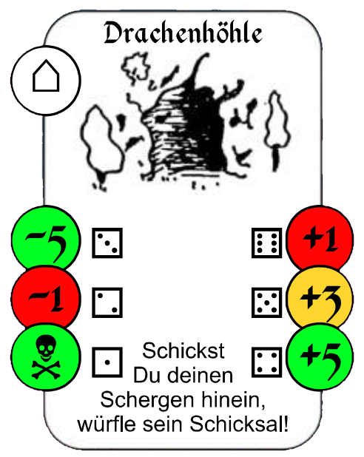  type, power or coordinates  negative  positive  description | Type | Effect
⚔ | Arming | Immediately increases your Henchman’s Arming attribute (blue flag) by the value given on the card. The card goes to the discard pile. The smallest weapon is the knife (1 point), the mightiest the battle-axe (6 points).
⚕ | Potion | Takes effect immediately, as described on the card, even if not desired or not applicable. The card goes to the discard pile.
 | Trap | Takes effect immediately, as described on the card. The card goes to the discard pile.
⌂ | Site | You can choose whether the card goes into effect. Unless otherwise noted on the card, it is not discarded remains in place, even after usage.
? | Villain | A villain attacks relentlessly until your Henchman flees or one of the combatants dies [see 6. Fight]. The Villain’s power is given in the card’s type symbol (upper left corner), ranging from the weakest bandit (2 points) to the fearsome War-Pig (20 points).

Your Henchman may land on a square with a black-background type card. After revealing it, you may simply add it to your hand; you need not play it immediately. However, if you have not yet played a card on your turn, you may play it on the same turn as it is uncovered.

Treasure
In rare cases, a Henchman just trips over a treasure that lies around ownerless. You can then simply pick up the treasure to your hand, as long as your Henchman is not currently fleeing. If there is another card on the square, it must be dealt with before.

Henchman
If your Henchman encounters another Henchman outside of the city, he might attack him [see 6. Fight].

Fight

Henchman versus Henchman
When your henchman meets another one outside of the city, and all playing cards on this field have been taken care of, he may attack him and combat starts. Determine the power of the combatants by summing up their strength and arming.
Then, a series of blows may be dealt. Roll a die to deliver a blow. Add the result to your henchman's power to calculate the impact value. Your opponent does the same. The Henchman with the higher impact value is successful and injures his opponent. Subtract the difference of the impact values from the health of the Henchman being hit.
Power = Strength + Arming Impact = Power + Roll
Due to wear and tear, the arming value of each combatant decreases by one point, with every blow.
So they deal blow after blow until one of them either flees [see 6.3. Flight] or dies due to his health dropping to 0 [see 7. Death].

Henchman versus Villain
If your henchman uncovers a Villain, the latter attacks relentlessly. The combat works as described above, with the following differences:
- Another player rolls the die for the Villain.
- A Villain always starts a fight with full health. Use the gray counters.
- The power of a Villain is given in the cards symbol, it needn't be calculated.
- The power of a Villain is constant, his arming never decreases.

Flight
If your henchman should try to get away, you can simply announce this before the next exchange of blows, even before the first one. Be careful, however, turning the back on your opponent, allows him to deal a blow without defence. Compare the impact value only to the power of your Henchman and subtract the difference from his health.
Since your Henchman doesn't use his weapons, he does not lose a point of arming.
If your Henchman survived the blow in the back, he may leave the field on the next turn. If the attacker was a Villain, he remains in the position and will attack again the next day, if your Henchman doesn't move.
If the opponent is another henchman, he ends the fight with the final blow but may try to follow and attack again the next day.

Death
When the health of your Henchman drops to zero – which may well happen! – he immediately draws his last breath and and expires on his current playing square. If another player’s Henchman slew yours, that player gets not only all the treasures from your hand, but also all your Gold. Otherwise insert all the treasure-cards in your hand into the square of your now deceased henchman. If a Villain slew your Henchman, he takes possession of those treasures and guards them on that square.
Discard all other cards in your hand and draw four new cards. Send out your next Henchman by placing the meeple back into your castle. The next day, he will start to continue on his predecessor's mission. Adjust the counters to the starting values of
15 Health, 5 Gold, 2 Strength, 0 Arming
or deal 15 status points which you might want to display on one of the Villain health counters to keep track. One status point makes for
4 Health or 2 Gold or 1 Arming or ½ Strength.
You may not spend more than 6 status points on one attribute.
If your Henchman kills a Villain, you receive his Gold and the Treasure he guarded, if applicable.

Variant
Try out these additional rules to add more variety!

Drop treasures
You may insert a treasure from your hand in the field occupied by your henchman.

Looting
If your henchman manages to invade the castle of another duke, he may comb through the rooms to find and steal treasures, if there are some hidden. Therefore, roll a die each day. If the result is smaller or identical to the number of days you're searching in direct succession, pick a treasure from the castle and put it on your hand. The search starts over, so to find another treasure, you need to roll a 1 the next day.

Grandlin's Catharsis
When the draw pile is empty, there is a cleansing sweep going through the Reich. Each duke discards one card from the board at will, except the city cards and treasures of course. This happens three times. After the three rounds of cleansing, shuffle the discard pile and make it the new draw pile as described before.

Summary and Tips

Conjuration and Black Magic
Conjurations (white type symbol) take effect only when a henchman discovers them.
Black Magic (black type symbol) take effect only when played as Lord or Lady directly from the hand.

One card only per turn
Using a black magic (casting a spell or use of a map to unlock a treasure) counts as playing a card, so does hiding a treasure in the castle. You can't use or insert another card on that turn.

Limit of cards
Always strive to have four cards on your hand, including the treasures your henchman carries. If you have fewer, you need to draw, if you have more, you need to play them one by one following the rule above.

Advantage in Fights
In a fight, it might be easier to use differences for calculation. A Henchman with a Power of 7 fighting against a Villain with a Power of 4 has an advantage of 3. If he rolls a 3 and the Villain rolls a 5, the Henchman still has an advantage of 1, which gets knocked of the Villains Health.

Toxication and Attrition
The toxication of a Henchman is marked by him being knocked over. He can still travel crawling on the belly, but loses one Healthpoint at the end of each day.
With every strike in a fight, using the die, the Arming of the striking Henchman drops by one Point.

Discard pile
If the draw pile is empty, shuffle the discard pile and place it upside down as a new draw pile. When all treasures have been unlocked and are in play, discard all maps you draw or have in your hand and draw new cards instead.

Cover cards
In some situations, you may peek into a card of the board, without having to show it to the other players. Use your cheatsheet and insert it behind the card and pull out both together. So no player sitting opposite of you can see the card. Cover the front with your hand.

Notes and Consultations
It is against the rules to take notes during the game. Consultations and agreements among the players on the other hand, are allowed explicitly

Portal (Conjuration)
When your henchman uncovers a “Portal”, read the following to see how it works. It is a special card, not to be confused with the spell “Teleportation”, with which your henchman may travel fast and far. Though there is a risk. Roll a die and choose the destination. A roll of 2, 3, 4 or 5 corresponds to a color and thus determines the land your stooge will travel to. For example rolling a 4 means the blue land. Within that land, you may choose any field as a destination. Rolling a 6 will let you choose any field in the whole Empire. Be careful not to roll a 1, since that will make your henchman vaporize in the Portal [see 7. Death]. If traveling succeeds and there is a card inserted in the destination, it must be uncovered and processed as usual.

