Grandlin's Heirs
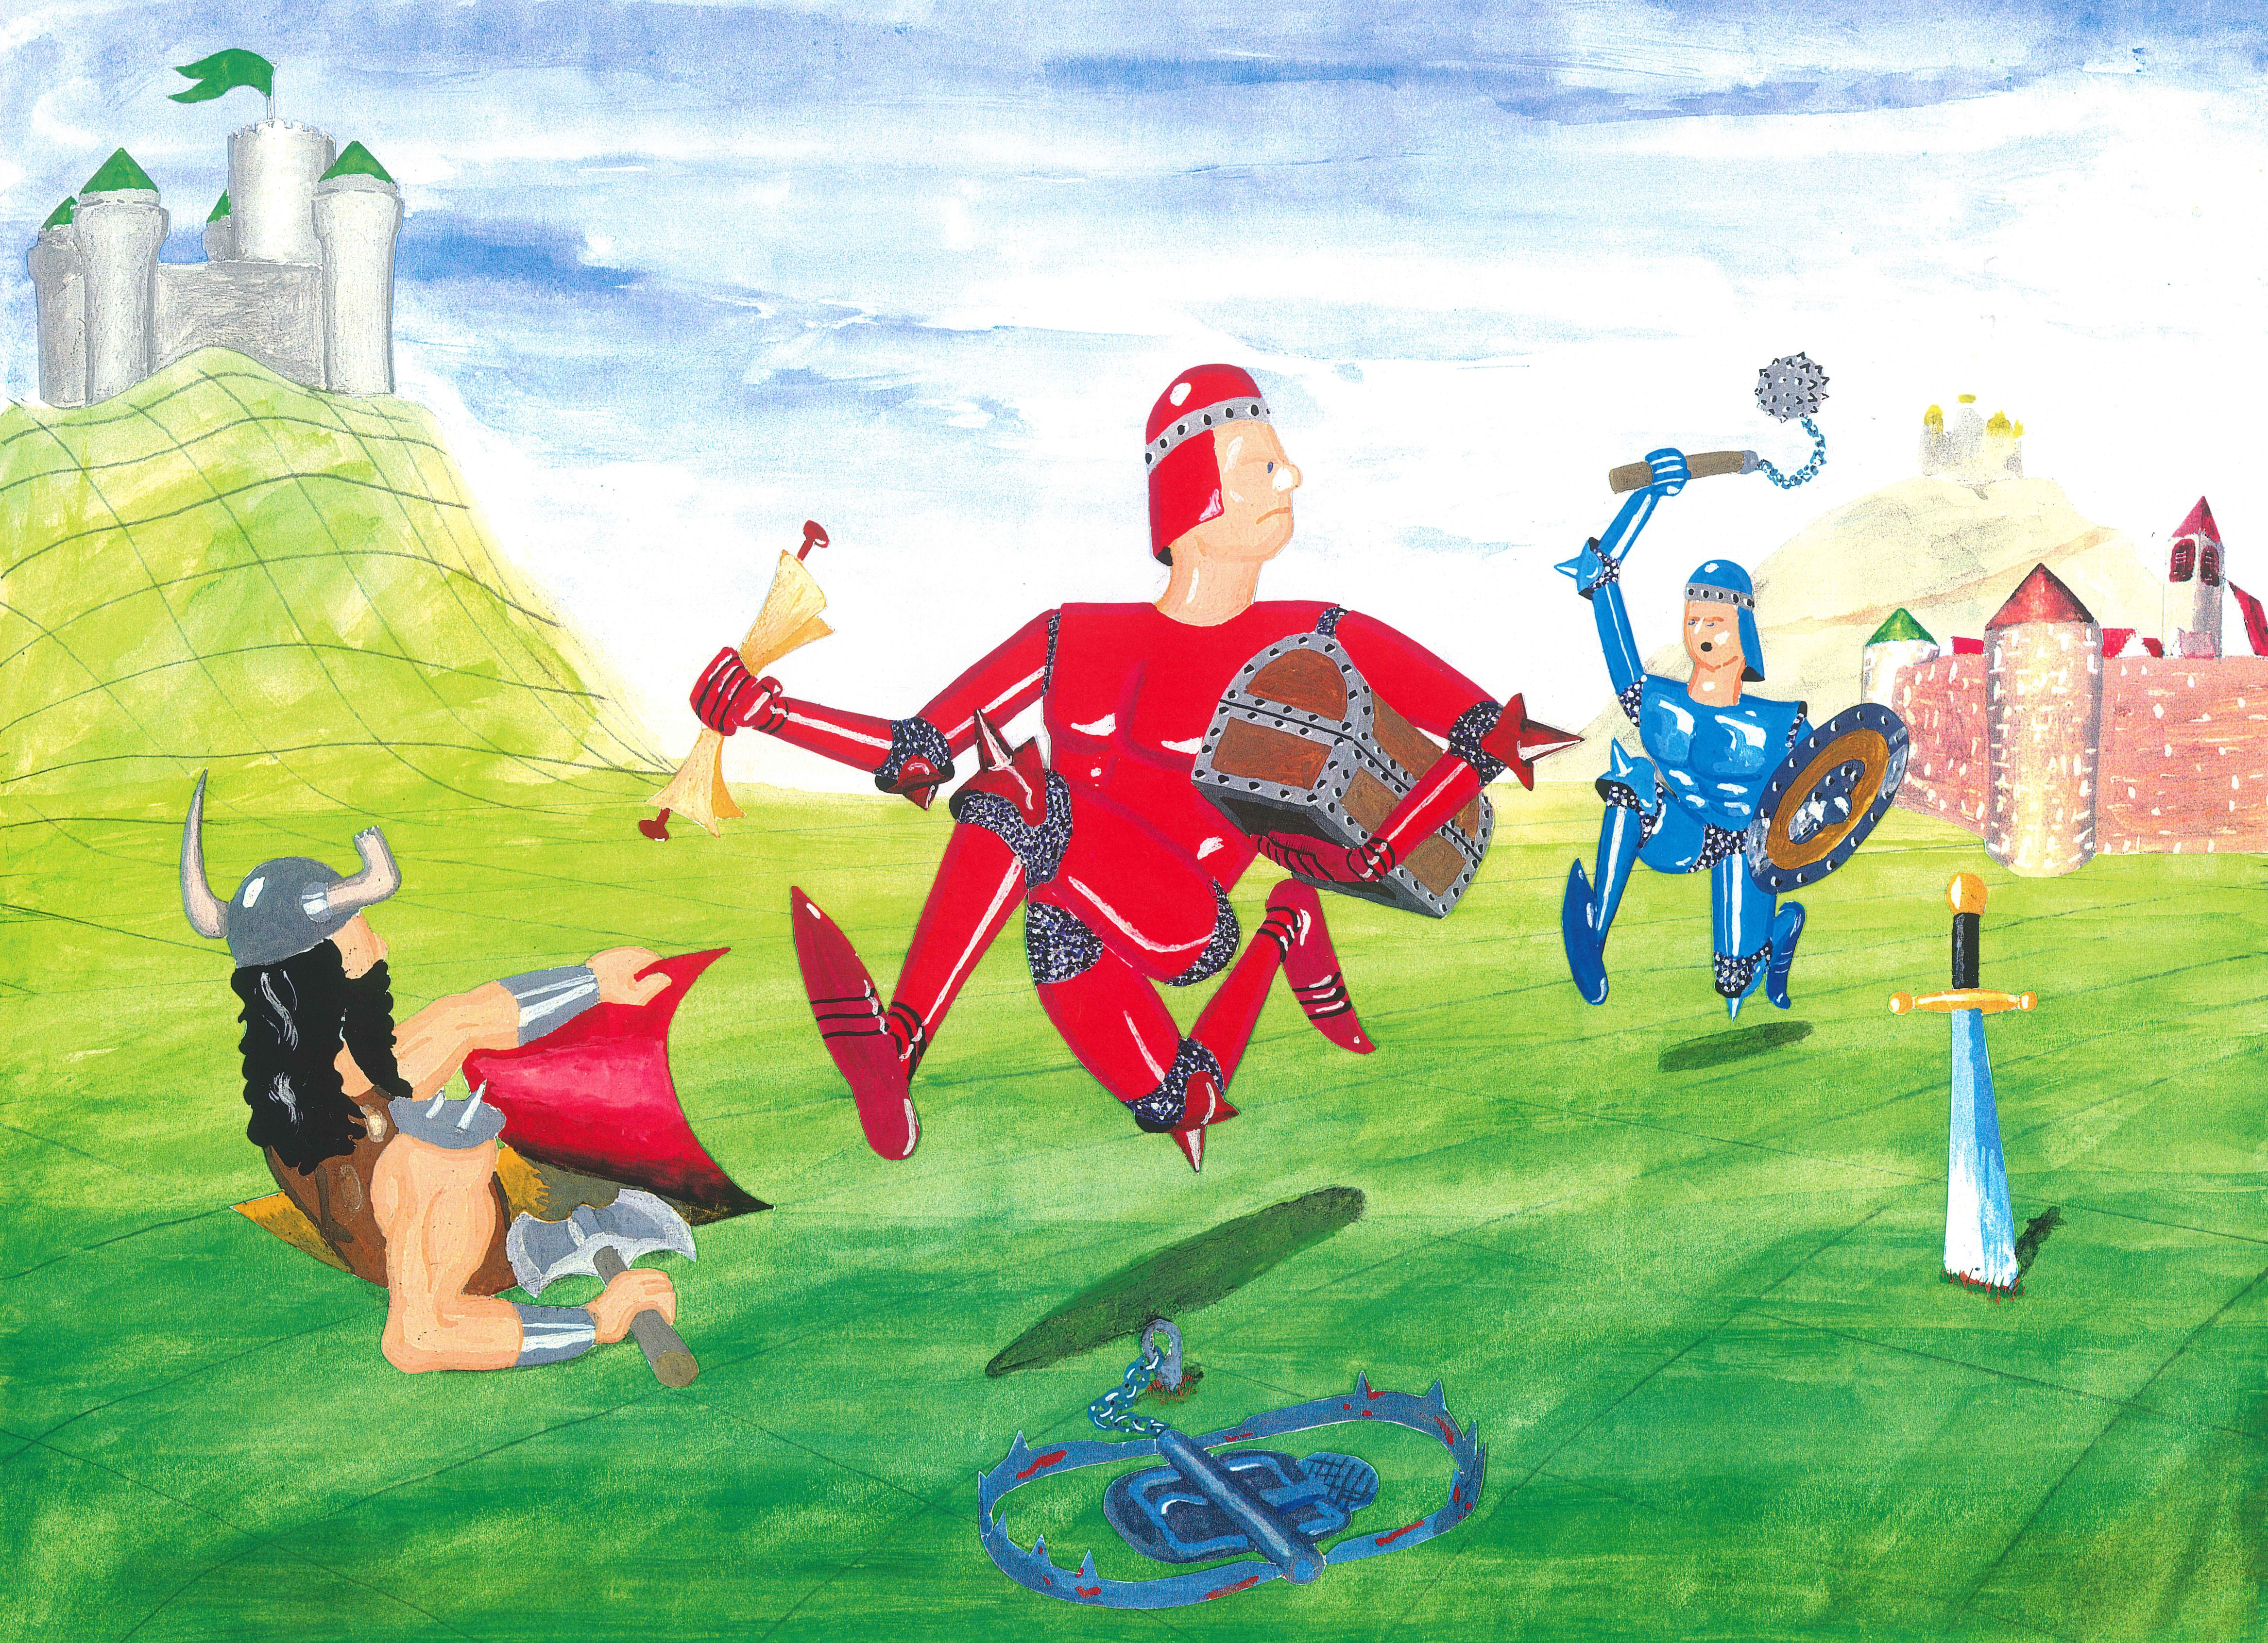

V2.1_en, 20.7.2022
Preparation & Assembly

Overview
Grandlin's Heirs is a challenging strategy game for 2–4 players from age 10 upwards. The goal of the game is to discover treasures (Goblets, Orbs and Crowns) hidden throughout the board and to return them successfully to your castle. The numbers and types of treasures needed to win the game is decided by the players themselves, which lets them adjust the length and complexity of the game.
You take the role of a Ruler of a county, who sends loyal Henchman (a pawn) throughout the board, to find the hidden treasures and bring them safely back to their castle. You can also cast spells or alter the terrain of the board to favor their own Henchman or to thwart others. As a result, the board becomes ever more complex in the course of the game; each game is unique.
The playing time 1–5 hours, depending on the conditions for winning decided by the players.

Preparation
- First, please check the game for completeness. You should have:
  - the box it came in (you’ll need both the bottom and the top for playing!),
  - the playing board,
  - two thick, gray cardboard strips (the “ridges”),
  - two thin, white cardboard sheets with 19 creases for fan-folding (with three slots),
  - four meeples (pawns) and four dice, colored red, yellow, green and blue,
  - and 18 white plastic flags.
  - 122 playing cards (with the running red knight on the back) plus 2 blank cards,
  - 12 golden-brown treasure cards (4 Crowns, 4 Goblets, 4 Orbs),
  - 4 „cheatsheet“ cards, one for each player, with a short summary of the rules,
  - 4 cards for the City (Training, Healing, Smithy and Tavern).
- please attach the stickers for Health , Strength , Arming and Money to the white plastic flags. Please make sure that both sides of a flag have the same sticker!
- fan-fold the two long white thin cardboard sheets along their 19 creases. These sheets will hold cards that are „hidden“ on the playing field.
- Examine the playing cards. In the upper left corner you'll find a black or white type symbol.
  - A white symbol defines a conjuration summoning the depicted entity somewhere on the board. They may bring advantages or disadvantages to the Henchmen stopping by. There are:
⚔ Arming, ⚕ Potions,  Traps, ⌂ Locations und Villains (the ? Is a number).
?
  - A black symbol defines black magic which works differently. There are:
Spells and Maps (xy is a coordinate on the board).
⛤
xy


Assemble the game
Ridge
Peg
Hole
Hole
Much of the fun and strategy of the Grandlins's Heirs lies in the cards hidden throughout the playing field. Cards can be hidden on every playing square, by dropping them through the slot. To catch and hold the cards dropped, we need to build a structure below the playing board; for this purpose we use the box (in which the game arrived), the two fan-folded sheets and the two thick cardboard strips.
- Place the top and bottom of the box, empty and open side up, next to each other on the gaming table. You’ll note that the box-top is slightly wider and longer than the box-bottom.
- Put the fan-folded cardboard sheets into the box-top and -bottom. You’ll notice that one sheet is slightly wider than the other; place the wider sheet into the box-top and the narrower sheet into the box-bottom, so that they both fit and are spread out evenly. The three slots in the sheets should not be nearer to the middle between the two boxes, but rather closer to the outside edges. The folds of the slots should point up.
- Insert the grey, thick cardboard strips (the ridges) vertically into the slots of the fanfolded sheets. You’ll note that one cardboard strip is slightly longer than the other; place the longer cardboard strip in the box-top and the shorter one in the box-bottom, so that the zigzag edge of the cardboard strip points down and matches the fan-folding. The opposite edge has two „pegs“ that should stick up; the playing board will lock onto these pegs.
- Unfold the playing board. You’ll notice four circular holes, each hole two playing squares away from a corner of the board. Fit the playing board onto the two boxes, so that the pegs of the cardboard strips pass through the circular holes. Your playing board should now be sturdy and ready for play!
- Remove the two blank cards from the deck of playing cards. They are for your own ideas to add to the game!
- Shuffle the remaining 122 playing cards and place them upside-down as a draw-pile which all players can easily reach. Set aside a space for a discard pile as well.
- In the very center of the playing board is the City with four playing squares and four slots for hiding cards. Place the four City cards (Training, Healing, Smithy and Tavern).
- Shuffle the 12 treasure cards (the Crowns, Orbs and Goblets) and place them as a separate deck upside-down on the table.
How to Play

Backstory
The sudden death of the archmage Grandlin, who reigned the Empire for many decades, has ignited a power struggle among his heirs, the Rulers of the counties, all vying to succeed him.
To identify the most competent successor, Grandlin hid the Empire’s insignia of power (Crowns, Goblets and Orbs) throughout the realm and required that his successor be the first to discover a certain number of these treasures and to secure them in their own castle. Grandlin reasoned that such a test would ensure the stability of the Empire: Having secured their treasures against all would-be thieves, his successor would be competent enough to secure the throne.
The fight for supremacy can be dangerous, and the Rulers do not leave their castles. Instead each sends their most loyal Henchman to search for the insignia of power by any means necessary. Nevertheless the Rulers have influence throughout the Empire and can assist their Henchman through conjurations and powerful spells.

Start the game

Win condition
Agree on the number and types of treasures the winning player must secure in their castle. A good choice for beginners and younger players would be: two treasures of any type (Crown, Goblet or Orb). The game is shorter and simpler then; the element of chance and surprises is higher and the role of strategy is reduced.

The game becomes ever deeper and more strategic as the number of players and treasures is increased. A good rule of thumb is to divide the number of treasure cards (12) by the number of players: 6 treasures to win for two players, 4 treasures for three players and 3 treasures for four players. Players are invited to experiment and find the winning conditions that suit them best!

An interesting variant is to define the types of treasures needed for winning. For example, the players might require that one treasure of each type (Crown, Goblet and Orb) be secured or three treaures of the same type (e.g., three Crowns).

Setup your Castle and Henchman
The board has 100 playing squares, labeled A–J along the long axis and 0–9 along the short axis. The four squares in the center (E–F,4–5) form the City, a kind of safe haven for all the Henchmen. The four corners of the playing board (A0, A9, J0 and J9) are the home castles of the players, whose towers are red, blue, green and yellow, respectively. If there are fewer than 4 players, some castles will remain unoccupied.
At the start of the game, each player chooses one of the four colors (red, blue, green and yellow) and places the meeple (pawn) of that color in their home castle. This pawn represents their Henchman, whom they will send around the board in search of the hidden treasures. The players also receive a six-sided die of the chosen color as well as a „cheatsheet“ card.
Each player also receives four white plastic flags, which keep track of the four attributes of their loyal Henchman: Health (green), Gold (yellow), Strength (red) and Arming (blue). Place the four flags along the edges of your corner of the playing field. Your first Henchman starts with these values:
- full health (green 15 )
- five gold (yellow 5 )
- two strength (red 2 )
- no arming (blue 0 )
Whenever an attribute changes due to combat, poison or other effects, please update the position of the corresponding flag.
The players roll dice to determine who moves first. The play moves clockwise around the table, passing from each player to the player on their left. Follow the instructions in the rulebook. You don't need to read everything at once. The game starts easy, so you can learn the rules while playing.

Playing the game
Each turn corresponds to one day and consists of two parts: first moving your Henchman and then exerting your influence as Ruler, altering the terrain of the playing field to favor your Henchman and to thwart those of your opponents.

The Henchman's Journey
Your Henchman roams around in pursuit of Grandlin's treasures and tries to bring them back to his home castle. Roll your die; the result gives the maximum number of squares you may move your Henchman on this turn. He cannot move diagonally, but can alternate between moving forward, backward, left and right. As his Ruler, you may direct the Henchman to move less than the maximum distance given by the die roll or even to remain on his square, i.e. to not to move at all. Staying in the castle will not help him collect treasures, though. If you have a Map on your hand, a card of black magic, you might want to steer him towards the coordinates given, since there is a treasure hidden [on arrival see 7.1. Raise]. Otherwise, visiting the city might be a good idea [see then 8. City]. Of course, your Henchman cannot enter your opponents castles. Move your Henchman now.
Whenever he reaches a square with a card inserted or occupied by another Henchman, your Henchman must immediately stop moving and his journey ends here for the day. In that case, read 9. Encounter.

The Ruler's Magic
Once you have moved your Henchman and all has been resolved, you may perform a ritual in your role as Ruler to secretly conjure a magical entity on the playing board. Take a playing card from your hand and insert it vertically into an unobserved playing square. So the square must not be occupied by a Henchman or by another playing card. In order to prevent the other players from seeing what you conjure, cover the front of the card with your cheatsheet, insert both and then pull out the cheatsheet alone.
Once inserted, a card is only revealed again if a Henchman visits it or by certain spells or special events.
For black magic, marked with a black symbol in the upper left corner, there are additional rules. For such a card to come into effect, you show it directly from your hand. You may show Spells at any time in your turn, even during or before your Henchman's movement or amidst a fight, to support him immediately. When you show a Map, and your Henchman ended his journey at the coordinates given, Grandlin's magical seal breaks and you uncover a treasure [see 7.1. Raise]. Discard a black magic card after use.
⛤
xy
Treasures may only be dropped in a castle, and in a castle only treasures.
The central rule for all cards is: You may play only one card per turn and only on your turn!
If you have more than four cards in your hand, you must play one, otherwise playing a card is voluntary. If you end your turn with fewer than four cards, you must draw from the draw-pile until you have four cards in your hand.

The Treasures
To win the game, you direct your Henchman to find Grandlin’s hidden treasures (the insignia of power: Crowns, Goblets and Orbs), bring them back to your castle and store them there. During transport, the treasures are on your hand and may easily get lost, since they are tied to your Henchman's life. If he returns safely to your castle, you can hide the treasures there, by inserting one treasure card per turn into the slow of your castle. Note, however, that you can play only one card on a turn; you can’t hide a treasure in your castle if you’ve played any other card on that turn.

Raise
All of the treasures that Grandlin hid so carefully in the Empire, need to first be raised. This can only be done using a map with the coordinates. They refer to the numbers and letters on the street and the river. If your henchman stands on a square, for which you have a Map on your hand, you may show it to your fellow players and raise a treasure. Simply draw it from the treasure pile.
xy
Remember that using the map counts as playing a card, so you can not play another card that day. The map goes to the discard pile. The treasure count to the four cards on your hand, so your magical power weakens with the number of treasures your Henchman carries.

Find
In rare cases, a Henchman just trips over a treasure that lies around ownerless, maybe because some henchman has succumbed to poison in that place. You can then simply pick up the treasure to your hand.

Raid
Much more common are fights for treasures. Your Henchman may quickly become your opponents' quarry, when he carries a treasure on your hand. If a villain or another player succeeds in killing you Henchman, your treasures change ownership together with your money [see 10. Fight and 11. Death].

City
The city is safe ground. Combat is prohibited and the guards have everything under control. People are only accepted into the city after staying a night in front of the city walls and having been inspected. So on the way in, every journey needs to pause there. The gates open the next day.
In the city, henchmen may roam around freely according to the roll of the die, as if there were no cards or other henchmen. They can pass through the buildings, don't need to stop for others and there is no inspection on the way out. In this direction, the gates are open.
Each day, your henchman can stop on one of the facilities of the city, to go about the following businesses:

Tavern
He can hire out as dishwasher and earn 2 gold.

Healer
He can have the healer detoxicate him, which is a complex process that costs 5 gold. It stops the poison, but does not restore health.
Restoring health is easy for the healer and he takes for 1 gold per 3 points. No time restrictions apply.

Gym
Training fee is 3 gold per day, which increases strength by 1 point. That's the daily maximum.

Blacksmith
Buy arming for 1 gold per point. The blacksmith has no limit to how much you can buy from him each day.

Encounter
Outside of the city, your Henchman can only walk over empty squares. If he encounters an inserted card, a treasure or another Henchman, he needs to stop and deal with the obstacles. This holds true even if he didn't travel but remained on the field.

Card
Reveal the cards of that playing square as soon as your Henchman enters it. The effect of a card is determined by its type, which is found in the upper left corner of the card.
A white symbol identifies a conjuration, which may now take effect depending on the type. Read the text on the card for details and see the hints on the left and right side. Possible negative effects are listed on the left side of the card, below the type symbol. The possible positive effects of the card are listed on the right side of the card. These effects may raise your Henchman’s attributes (Health, Gold, Strength and Arming according to the color), set them to a fixed value, reduce them or even divide them. However, the attributes cannot drop below 0 or rise above 15, excess is lost.
A circular arrow around a symbol indicated that the effect takes place daily. For example, if your Henchman is poisoned, he loses Health every day until he is detoxified, e.g. by a Detox playing card. As a reminder to deduct that Health from your Henchman every day, you lay him on his belly and he crawls.

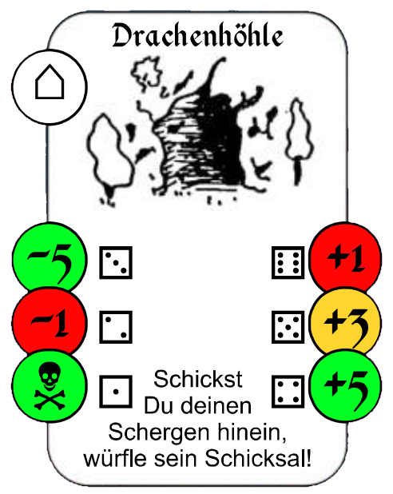  type, power or coordinates  negative  positive  description | Type | Effect
⚔ | Arming | Immediately increases your Henchman’s Arming attribute (blue flag) by the value given on the card. The card goes to the discard pile. The smallest weapon is the knife (1 point), the mightiest the battle-axe (6 points).
⚕ | Potion | Takes effect immediately, as described on the card, even if not desired or not applicable. The card goes to the discard pile.
 | Trap | Takes effect immediately, as described on the card. The card goes to the discard pile.
⌂ | Site | You can choose whether the card goes into effect. Unless otherwise noted on the card, it is not discarded remains in place, even after usage.
? | Villain | A villain attacks relentlessly until your Henchman flees or one of the combatants dies [see 10. Fight]. The Villain’s power is given in the card’s type symbol (upper left corner), ranging from the weakest bandit (2 points) to the fearsome War-Pig (20 points).

Your Henchman may land on a square with a black-background type card. After revealing it, you may simply add it to your hand; you need not play it immediately. However, if you have not yet played a card on your turn, you may play it on the same turn as it is uncovered.

Treasure
In rare cases, a Henchman just trips over a treasure that lies around ownerless. You can then simply pick up the treasure to your hand, as long as your Henchman is not currently fleeing. If there is another card on the square, it must be dealt with before.

Henchman
If your Henchman encounters another Henchman outside of the city, he might attack him [see 10. Fight].

Fight

Henchman versus Henchman
When your henchman meets another one outside of the city, and all playing cards on this field have been taken care of, he may attack him and combat starts. Determine the power of the combatants by summing up their strength and arming.
Then, a series of blows may be dealt. Roll a die to deliver a blow. Add the result to your henchman's power to calculate the impact value. Your opponent does the same. The Henchman with the higher impact value is successful and injures his opponent. Subtract the difference of the impact values from the health of the Henchman being hit.
Power = Strength + Arming Impact = Power + Roll
Due to wear and tear, the arming value of each combatant decreases by one point, with every blow.
So they deal blow after blow until one of them either flees [see 10.3. Flight] or dies due to his health dropping to 0 [see 11. Death].

Henchman versus Villain
If your henchman uncovers a Villain, the latter attacks relentlessly. The combat works as described above, with the following differences:
- Another player rolls the die for the Villain.
- A Villain always starts a fight with full health. Use the gray counters.
- The power of a Villain is given in the cards symbol, it needn't be calculated.
- The power of a Villain is constant, his arming never decreases.

Flight
If your henchman should try to get away, you can simply announce this before the next exchange of blows, even before the first one. Be careful, however, turning the back on your opponent, allows him to deal a blow without defence. Compare the impact value only to the power of your Henchman and subtract the difference from his health.
Since your Henchman doesn't use his weapons, he does not lose a point of arming.
If your Henchman survived the blow in the back, he may leave the field on the next turn. If the attacker was a Villain, he remains in the position and will attack again the next day, if your Henchman doesn't move.
If the opponent is another henchman, he ends the fight with the final blow but may try to follow and attack again the next day.

Death
When the health of your Henchman drops to zero – which may well happen! – he immediately draws his last breath and and expires on his current playing square. If another player’s Henchman slew yours, that player gets not only all the treasures from your hand, but also all your Gold. Otherwise insert all the treasure-cards in your hand into the square of your now deceased henchman. If a Villain slew your Henchman, he takes possession of those treasures and guards them on that square.
Discard all other cards in your hand and draw four new cards. Send out your next Henchman by placing the meeple back into your castle. The next day, he will start to continue on his predecessor's mission. Adjust the counters to the starting values of
15 Health, 5 Gold, 2 Strength, 0 Arming
or deal 15 status points which you might want to display on one of the Villain health counters to keep track. One status point makes for
4 Health or 2 Gold or 1 Arming or ½ Strength.
You may not spend more than 6 status points on one attribute.
If your Henchman kills a Villain, you receive his Gold and the Treasure he guarded, if applicable.

Summary and Tips

Conjuration and Black Magic
Conjurations (white type symbol) take effect only when a henchman discovers them.
Black Magic (black type symbol) take effect only when played as Ruler directly from the hand.

One card only per turn
Using a black magic (casting a spell or use of a map to unlock a treasure) counts as playing a card, so does hiding a treasure in the castle. You can't use or insert another card on that turn.

Limit of cards
Always strive to have four cards on your hand, including the treasures your henchman carries. If you have fewer, you need to draw, if you have more, you need to play them one by one following the rule above.

Advantage in Fights
In a fight, it might be easier to use differences for calculation. A Henchman with a Power of 7 fighting against a Villain with a Power of 4 has an advantage of 3. If he rolls a 3 and the Villain rolls a 5, the Henchman still has an advantage of 1, which gets knocked of the Villains Health.

Toxication and Attrition
The toxication of a Henchman is marked by him being knocked over. He can still travel crawling on the belly, but loses one Healthpoint at the end of each day.
With every strike in a fight, using the die, the Arming of the striking Henchman drops by one Point.

Discard pile
If the draw pile is empty, shuffle the discard pile and place it upside down as a new draw pile. When all treasures have been unlocked and are in play, discard all maps you draw or have in your hand and draw new cards instead.

Cover cards
In some situations, you may peek into a card of the board, without having to show it to the other players. Use your cheatsheet and insert it behind the card and pull out both together. So no player sitting opposite of you can see the card. Cover the front with your hand.

Notes and Consultations
It is against the rules to take notes during the game. Consultations and agreements among the players on the other hand, are allowed explicitly

Portal (Conjuration)
When your henchman uncovers a “Portal”, read the following to see how it works. It is a special card, not to be confused with the spell “Teleportation”, with which your henchman may travel fast and far. Though there is a risk. Roll a die and choose the destination. A roll of 2, 3, 4 or 5 corresponds to a color and thus determines the land your stooge will travel to. For example rolling a 4 means the blue land. Within that land, you may choose any field as a destination. Rolling a 6 will let you choose any field in the whole Empire. Be careful not to roll a 1, since that will make your henchman vaporize in the Portal [see 11. Death]. If traveling succeeds and there is a card inserted in the destination, it must be uncovered and processed as usual.

Variant
Try out these additional rules to add more variety!

Drop treasures
You may insert a treasure from your hand in the field occupied by your henchman.

Looting
If your henchman manages to invade the castle of another duke, he may comb through the rooms to find and steal treasures, if there are some hidden. Therefore, roll a die each day. If the result is smaller or identical to the number of days you're searching in direct succession, pick a treasure from the castle and put it on your hand. The search starts over, so to find another treasure, you need to roll a 1 the next day.

Grandlin's Catharsis
When the draw pile is empty, there is a cleansing sweep going through the Reich. Each duke discards one card from the board at will, except the city cards and treasures of course. This happens three times. After the three rounds of cleansing, shuffle the discard pile and make it the new draw pile as described before.
Example Turn

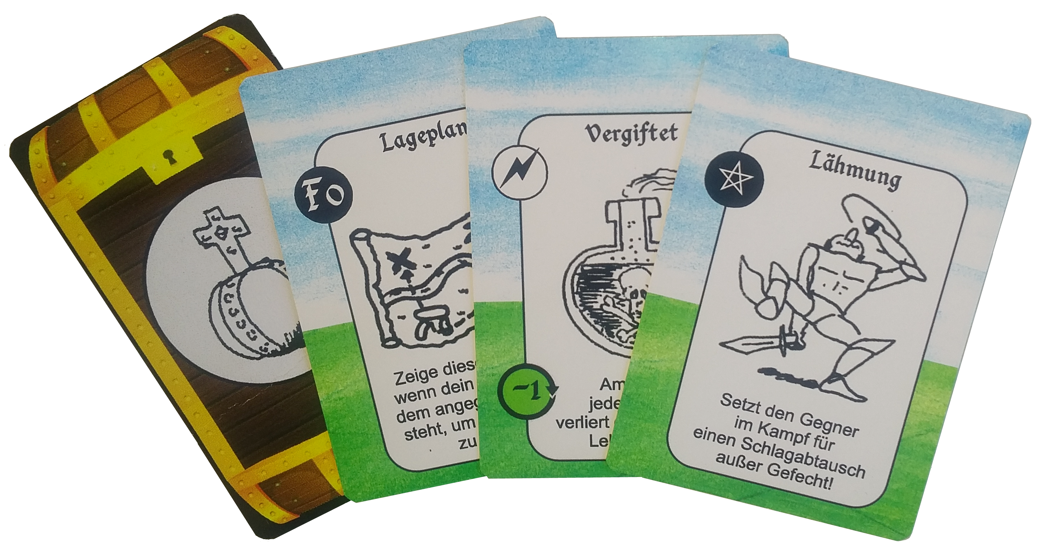
Situation
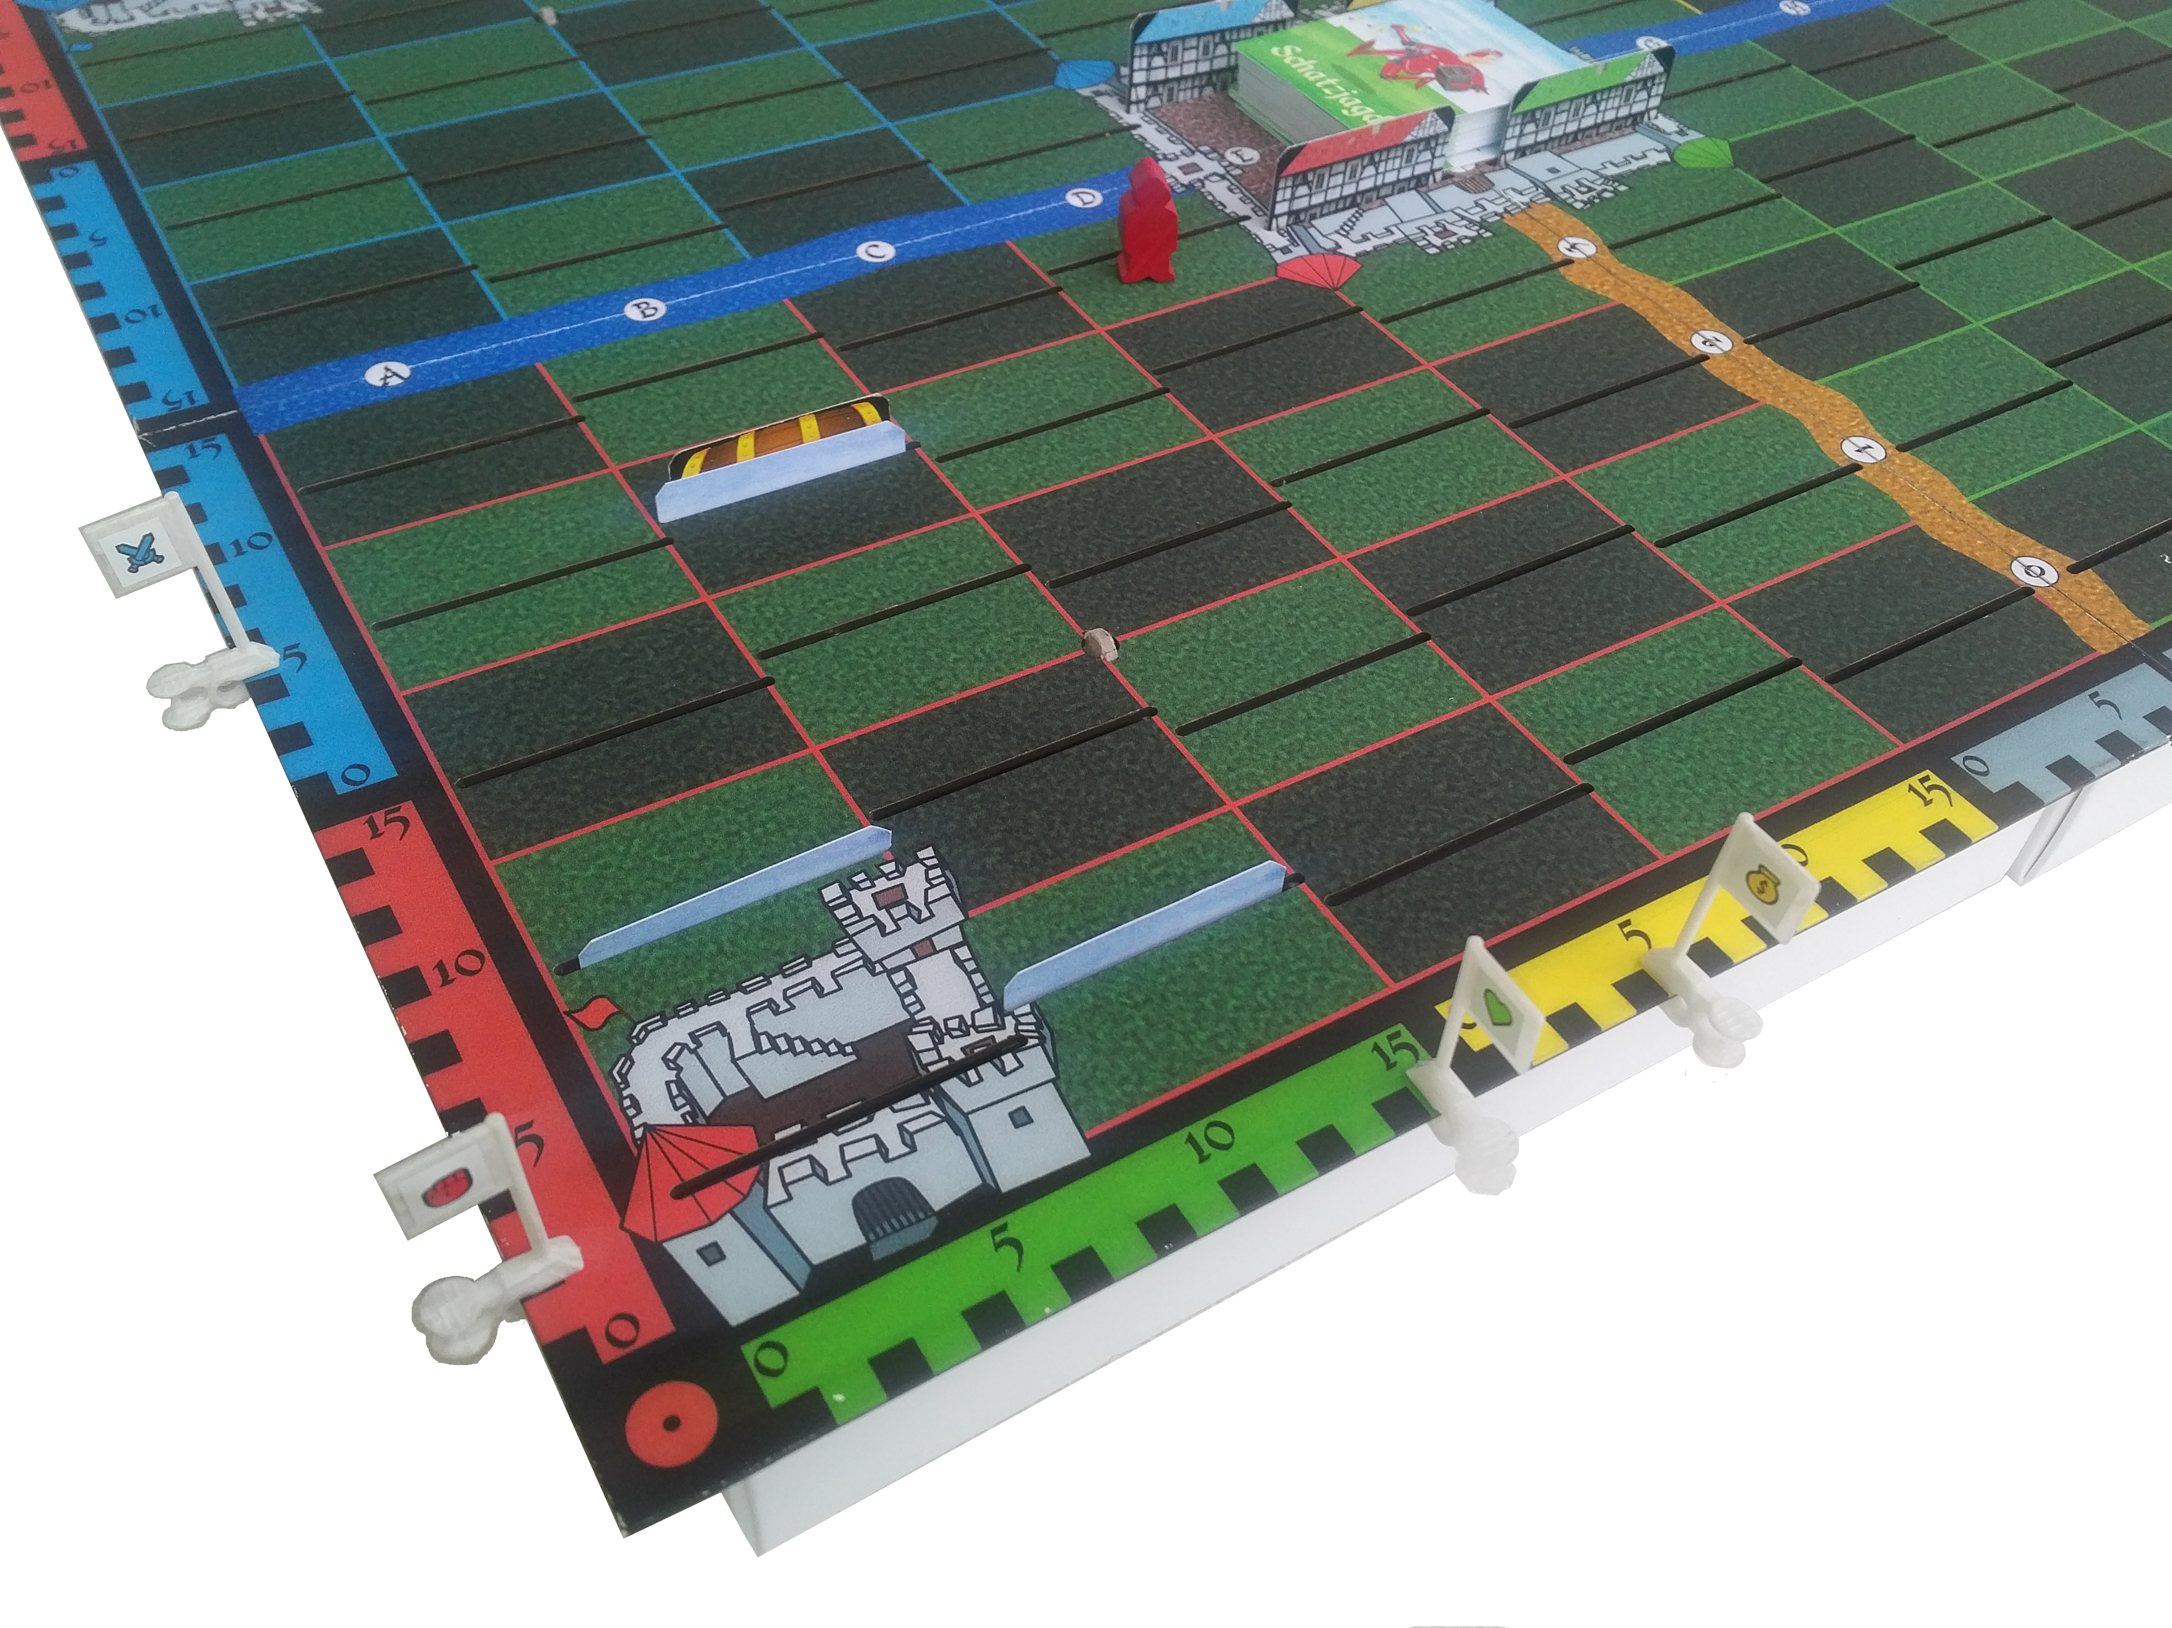
Draw Pile
Henchman
City
Treasure
5 Arming
(Started 0)
2 Strength
(Started 2)
Health 15
(Started 15)
5 Gold
(Started 5)
Villain's
Health
Card
(Assassin)
Castle of
the red ruler
You're the Ruler of the red castle and it's your turn. Your Henchman obviously made it through a few days successfully, since you've got a Treasure on your hand. And besides the start values of 5 Gold, 15 Health and 2 Strength, he has gained 5 Arming. At your hand, you've also got a poisonous trap, a map and a spell of paralyzation.

The Henchman's Journey
Your Henchman is on his way back to the red castle to hide the treasure there. He's on square D4. It's a good opportunity, to pick up the Treasure on F0 when passing by. You roll a die to navigate along the red route. You need to roll a 6 for this, but you rolled a 4. So you change your plan, since on B3 you see a Treasure inserted together with a playing card. Very tempting...

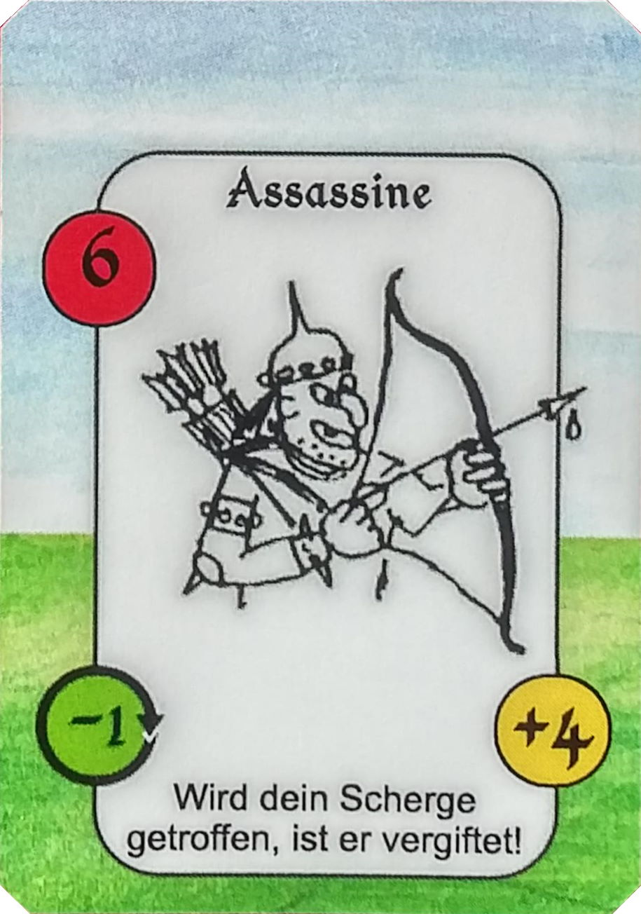
Uncover a card
You steer your Henchman along the blue route and uncovers the cards on B3. Did you forget that an assassin guards that treasure he snatched from another player before? With his Power of 6 he immediately attacks your Henchman, as is common for Villains. You decide not to flee but to fight, after all your Henchman's Power is 7 (2 Strength + 5 Arming), so he has an advantage of 1. And besides the treasure, there is a reward of 4 Gold to gain.
One of you fellow players rolls the die for the assassin and marks full Health on one of the Villain's Health counters. The following skirmish is condensed to the table below for overview.

Fight
So your Henchman has an advantage of 1 concerning his Power. For the first blow, you roll your die and yield a 5, your opponent a 2. Because of the difference of 3, your Henchman's advantage is now 4, so he hits and reduces the assassin's Health to 11 respectively. Due to attrition, reduce your Arming by 1.
The next blow follows. Your Henchman's advantage is gone, since he lost a point of Arming, so the combatants have equal Power. But for the blow, the assassin rolls a 6, you only roll a 3. That means that the assassin gained the advantage, hits, and the difference gets knocked off the Health of your Henchman. Not only is it reduced to 12 now, but the assassin injured your Henchman with a poisoned weapon. The toxication will have consequences. so lay your Henchman on his belly to mark this.
For the third blow, your Henchman has a disadvantage of 1, since he lost another point of Arming. Rolling the dice, they show 4 to 3 against the assassin, which equals out the disadvantage and results in a draw. None of the combatants hit and no Health is lost. But again, your Henchman loses another point of Arming.

Flight
Due to the toxication, your Henchman will lose 1 Health at the end of this and each following turn. By now, he also has a disadvantage of 2. So you decide to have him flee, which gives the assassine the chance for another blow without your Henchman striking back (you may not roll a die). So the assassin's impact value is compared only to your Henchman's Power. A loss of 3 to 8 Health is at stake (2 disadvantage of power + assassin's roll)

The Ruler's Magic
Originally, you planned on showing the map on square F0 to unlock a Treasure. Placing the trap near an opponent's castle was also an attractive option to use your magic. Looking at the current situations, you decide to help your Henchman with your Paralyze spell. This keeps the assassin from delivering his blow and no further Health will be lost. Since you have not played a card yet in this turn, and black magic may be played anytime in your turn, you simply show the spell to the other players and discard it after.

End of Turn
So your Henchman manages to flee without further losses and may crawl from the square in the next turn with still 12 Health. Fortunately, you remember where you placed the Potion of Detoxication earlier in the game and you can steer your Henchman there. Or should he first unlock the Treasure for which you have the map? However, the assassin stays on the square and refreshes quickly for the next fight, which he starts with full Health again. Will he face your Henchman soon again, better trained and prepared?

