Example of a turn including combat

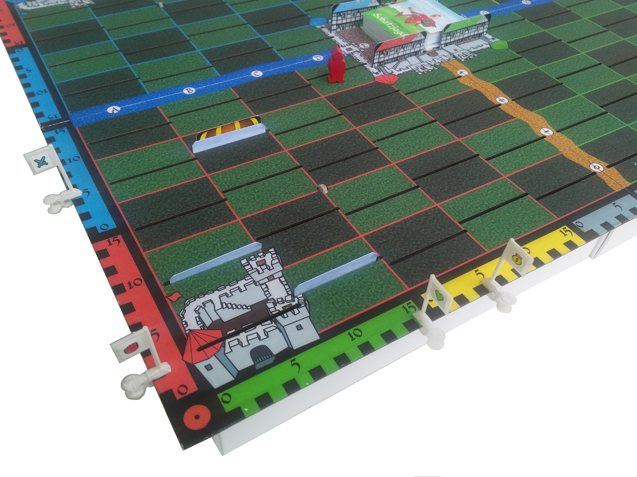
Draw Pile
Henchman
City
Treasure
5 Arms
(Start 0)
2 Strength
(Start 2)
Health 15
(Start 15)
5 Gulden
(Start 5)
Blackguard's
Health
Playing Card
(Assassin)
Castle of
the red duke

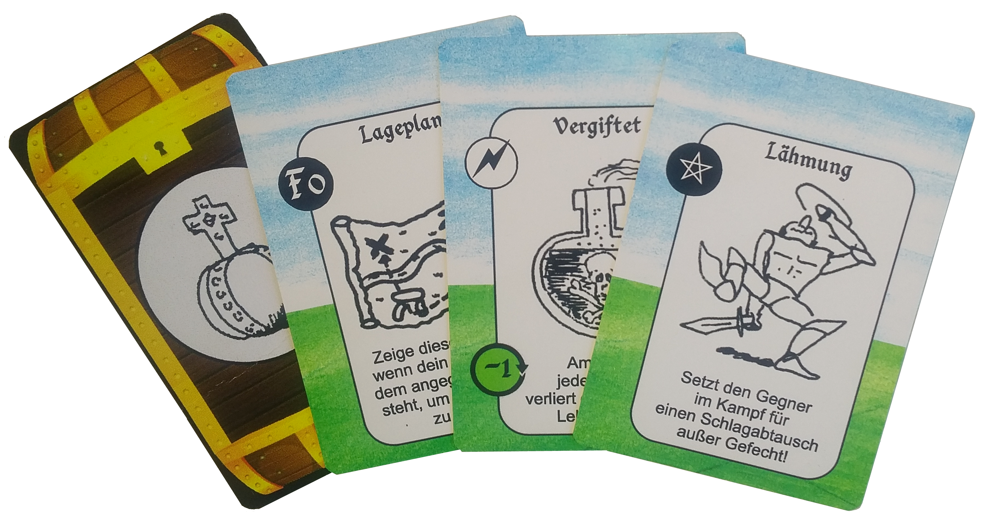
Situation
You play the red duke, it's your turn and you see the situation above. Obviously, your henchman made a few days successfully, because you have already got a treasure on your hand and besides the five gulden, the full health and the two strength points, he's got five additional points on his arms counter. You also have a poisoned trap, a spell of paralyzation and a map for field F0 on your hand.

The henchman's journey
Your henchman is on his way back to the red castle in order to store the treasure there. Currently, he stands on field D4. It would make sense to also raise the treasure on F0 on the way. So you roll a die to make your stooge travel to this destination along the route marked with the red arrow. A 6 is needed to do so, but you roll a 4. You change your plan, since on B3 there is a treasure in reach guarded by some other card.
Too tempting...

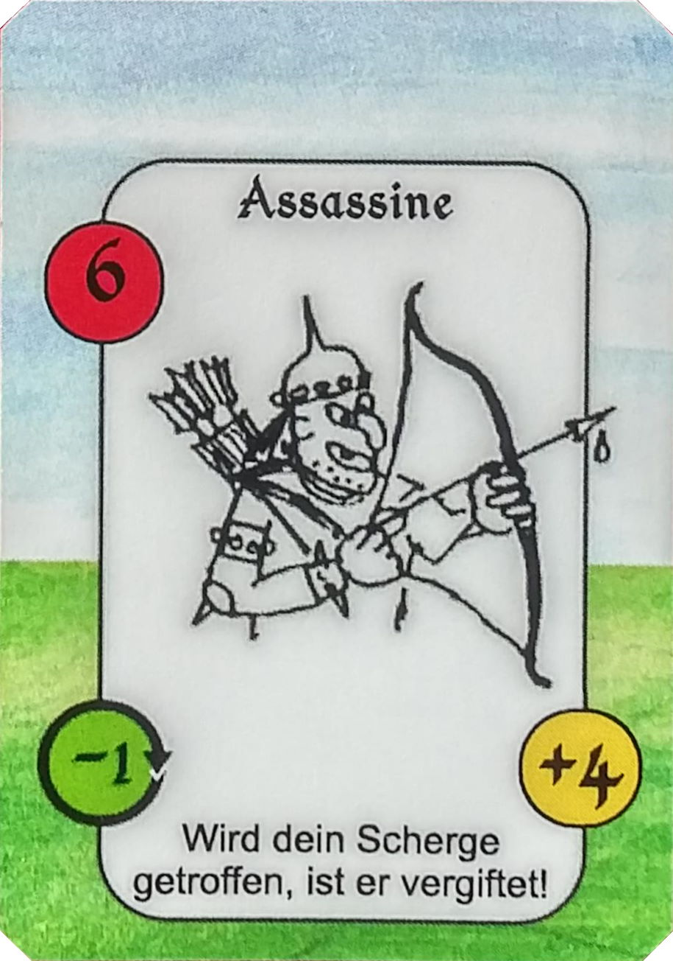
Uncover card
You steer your henchman along the blue route and uncover the cards. Have you forgotten that it is an assassin guarding the treasure he won before by raiding another players stooge? With a power of 6 he attacks immediately, just as blackguards do. You decide to enter the fight! After all, your henchman has a power of 7 (2 strength + 5 arms), therefore has an advantage of 1 point, and besides the treasure, you also expect a reward of 4 gulden for killing the assassin.
One of your fellow players rolls the die for the assassin and put 15 points on the blackguards health counter. The table at the bottom of this page shows an overview of the combat following.

Combat
So your henchman has an advantage of 1 concerning power. You roll a 5 to deal a blow, your opponent rolls a 2. The difference of the rolls is 3, so you successfully impact with 4 (power + roll). The assassins's health decreases by that amount down to 11. You, on the other hand, lose a point of arms.
The second exchange of blows follows. Due to the wear and tear of the weapons, your henchman's advantage is gone and the power of the adversaries is equal. Unfortunately though, the assassin rolls a 6 now, you only a 3. So the assassin's blow goes through and the difference of 3 is knocked off of your stooge's health, which is now at 12. Since the assassin injured with a poisoned weapon, there will be additional long term effects. You take a memo card on your hand in order not to forget this.
For the third exchange, your henchman already has a disadvantage of 1, because he lost another point of arms in the last. The dice now show 4 to 3 against the assassin. But due to the difference in power, the impact is identical, the blows are blocked and no health gets lost. But, as always when a blow is dealt, another point vanishes on your arms counter.

Flight
Due to the toxication, your henchman will lose a health point at the end of this and every following day. And his disadvantage in power is now already at 2. So you decide to try a getaway, which gives the assassin the opportunity to deal another blow without defense. His impact will be compared to your stooges power only, which is at 4 now (2 strength + 2 arms). So there is a threat to lose up to 8 points of health (2 disadvantage in power + maximum roll of 6).

The dukes sway
Originally, you wanted to present the map to raise the treasure there, had your henchman arrived at F0. It would have also been attractive to place the poisoned trap in front of another dukes castle. Considering the current situation though, you decide to use the paralyze spell to help your henchman. This will inhibit the assassin to deal his blow and averts a further loss of health. Since you haven't played a card yet, and you can play a spell any time in your turn, you simply present the spell to the other players and discard it.

End of turn
So your henchman successfully flees without further losses and may leave the field in the next turn with 12 points of health. Fortunately, you remember where you have placed the potion of detoxication before and can steer him there soon. Or should he first try to raise the treasure, for which you have got the map? In any case, the assassin stays in place together with the guarded treasure, recovers fast and starts his next fight again with full health. Will he meet your henchman, better prepared and further pimped, soon again?

