

Entwurf der
Studien- und Prüfungsordnung
des Studiengangs
Games & Immersive Media B.A.

Stand 18.4.23

Zusammengestellt von
Prof. Jirka Dell'Oro-Friedl

Inhaltsverzeichnis
Grundsätzliches 2
Qualifikationsziele 2
Überblick 3
Abhängigkeiten 4
Sound 1 Norbert Schnell 5
Sound 2 Norbert Schnell 6
STEM 1 Thomas Schneider 7
STEM 2 Thomas Schneider 8
STEM 3 Uwe Hahne 9
Theory 1 Thomas Schlegel 10
Theory 2 Jirka Dell'Oro-Friedl 11
Theory 3 N.N. 12
Visual 1 Christian Fries 13
Visual 2 Christoph Müller 14
Visual 3 Christoph Müller 15
Management1 N.N. 16
Management2 N.N. 17
Code1 Jirka Dell'Oro-Friedl 18
Code2 Jirka Dell'Oro-Friedl 19
Code 3 Uwe Hahne 20
Code 4 Ruxandra Lasowski 21
Project1: Entry Project Nikolaus Hottong 22
Project2: Physical Game 23
Project3: Simple Digital Project 24
Project4: Advanced Digital Project 25
Project5: Complex Digital Project 26
Project6: Final Assignment 27
Qualifikationszielmatrix 28

Grundsätzliches
- Name: Games & Immersive Media
- Abschlussbezeichnung: Bachelor of Arts
- Fächergruppe: Kunst, Musik, Gestaltung
- Studienbereich: VIII. 2 Neue Medien
- Grundstudium 2 Semester, Hauptstudium 5 Semester
- 210 ECTS
- 5. Semester ist Praxissemester
- Projektorientierung
- Vordringlich Blockunterricht
- Bilingual Deutsch/Englisch, Englischanteil > 50% angestrebt
- Dedizierte Räume für Kohorten
- Auslandssemester wird empfohlen und unterstützt
- Die Ordnung wurde inhaltsgetrieben erstellt. Um die zu erwartenden und konzipierten Lasten korrekt darstellen zu können, wurde neben der Auszeichnung nach Eckwertepapier (ECK) auch die Auszeichnung nach Akkreditierungsverordnung (ECTS) vorgenommen.

Qualifikationsziele
Section 1: Professional Skills
- Strong expertise in designing and implementing visual arts, software, sound, and interactive elements.
- In-depth knowledge and abilities in team management, production, and marketing.
- Comprehensive theoretical understanding of media design and technology.
- Experience in collaborating with diverse teams on multiple projects using agile methodologies.

Section 2: Interdisciplinary Skills
- Ability to effectively work within multicultural teams in both German and English.
- Sensitivity to the societal impact of the development and utilization of games and immersive media.
- Competence and self-assurance in employing complex technologies in creative and artistic contexts.

Section 3: Career-Oriented Goals
- Robust foundation for pursuing various careers in the gaming industry.
- Strong groundwork for exploring diverse professions within immersive media outside the gaming sector.
- Opportunities for further specialization in chosen fields such as computer science, media technologies, digital asset creation, media management, and media design.

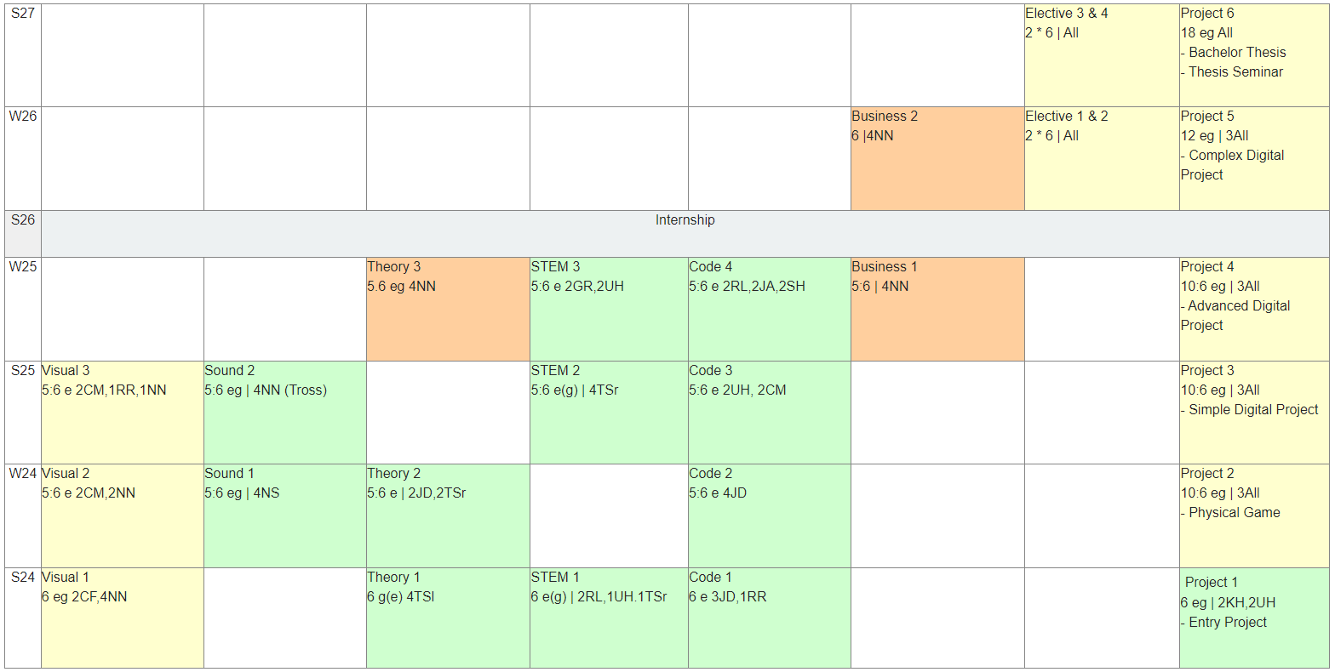
Überblick

Abhängigkeiten
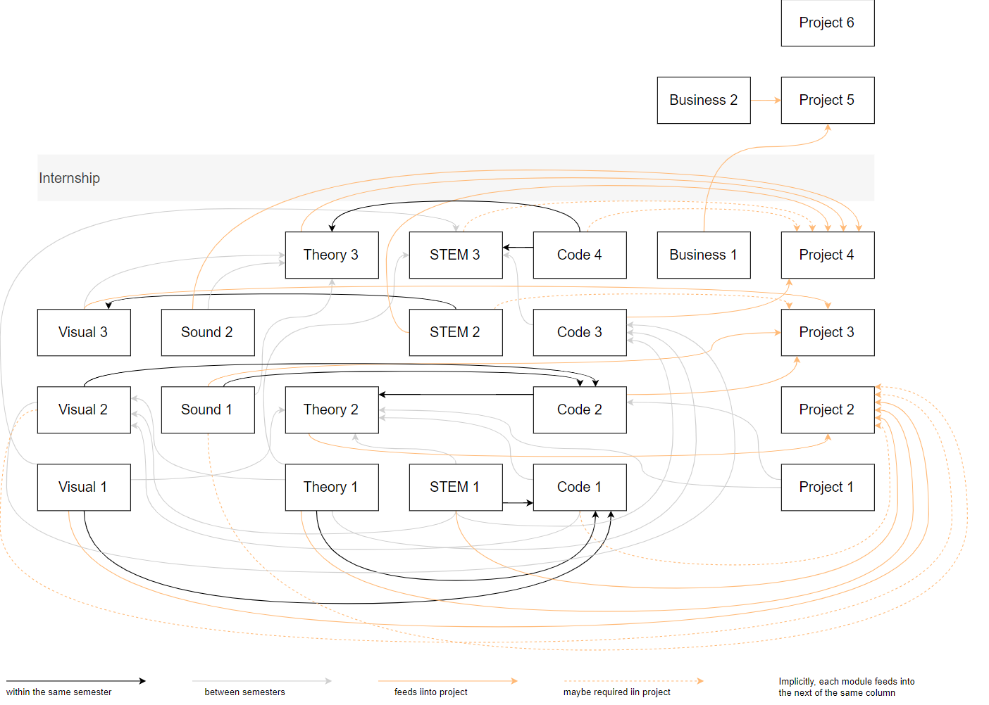

Sound 1 Norbert Schnell
Content
• Basics of sound, listening and sonic interaction
• Basics of acoustics and psychoaoustics
• Basics of digital audio (in sound and music processing)
• Interactive audio tools
• Spatial/immersive audio techniques
• Techniques of interactive audio design

Lecturer
• Norbert Schnell (4 SWS)

Credits
• 5 ECTS / 6 ECK

Language
• German / English

Teaching
• Seminar
• preferably 3 week block

Assessment
• 1 sbA

Sound 2 Norbert Schnell
Content
• Basics of sound design
• Foley and sound effects
• Sound libraries
• Music genres
• Music and emotion
• Music in context
• Music analysis
• Basics of composition (rhythm, melody, harmony)
• Basics of instrumentation and orchestration

Lecturer
• NN HfM Trossingen (4 SWS)

Credits
• 5 ECTS / 6 ECK

Language
• German / English

Teaching
• Seminar / eduScrum
• preferably 3 week block

Assessment
• 1 sbA

STEM 1 Thomas Schneider
Module STEM 1

Contents:

Geometry / Linear Algebra / Graphical projections:

- Geometry of 2D and 3D:
- Coordinates of Points and Vectors
- Change of Coordinate Frames
- Systems of Linear Equations
- Metric Spaces: Distances, Lengths, Angles
- Matrices and Linear Transformations
- Homogeneous Coordinates
- Matrices and Affine Transformations

- Graphical Representations of 3D Objects

- Parallel / Axonometric Projections
- Linear Perspective: Image Construction using Desargues' Theorem
- Points at Infinity and Vanishing Points
- Projection Matrices: Unified Approach

Lecturers
- Thomas Schneider, Ruxandra Lasowskis, Uwe Hahne
- Adjunct Lecturer(s)

Credit Point Assignments:
6 ECTS/ECK

Language
- English
- German upon consensual request of all participants

Teaching Format:
- Seminar (15 weeks plus exam period)

Assessment:
- 1 sbA (Practical Work)
- 1K (Final Examination)

STEM 2 Thomas Schneider

Module STEM 2

Contents:

- Foundations

- Basic Calculus
- Parametrized Curves in 2D and 3D
- Elements of Kinematics

- Dynamical Systems

- Deterministic Models, Differential Equations
- Setting up and Evalutating Models for Example Systems
- Project Work: Visualization of the Behavior of Simple Systems by Means of Web Applications

- Foundations of Camera Optics

- Paraxial Ray Tracing
- Camera Lenses and their cardinal points
- Focus, Magnification, Depth of Focus
- Comparison: Optical Properties of the Human Eye vs. Camera Optics

- Physics Engines

Lecturers

- Thomas Schneider
- Adjunct Lecturer(s)

Credit Point Assignments:

5 credit points (ECTS) / 6 credit point (ECK)

Language

- English
- German upon consensual request of all participants

Teaching Format:
Seminar
Three-Week Block

Assessment:

- 1 sbA (Practical Work)
- 1 sbK (Final Examination)

STEM 3 Uwe Hahne
Contents

- Practical electronics and signal processing
- Physical Computing
- Computer Vision for Extended Reality (XR)
- IoT, Tangible Interfaces

Lecturers

- 2SWS Gabriel Rausch
- 2SWS Uwe Hahne

Points
- 5 ECTS
- 6 ECK

Language
- English

Teaching
- Seminar / eduScrum
- preferably 3 week block

Assessment

- 1 sbA (small project with hardware)

Prerequisites | Obtained in
Foundations of digital information and graphics processing (Bits, Bytes, Pixel, Colorcodes, Bitmaps, etc.) | Theory1
Foundations of physics, basic calculus (differentiation) | STEM2
Foundations of hardware architectures (CPU, GPU) | Code3
Linear algebra | STEM1
Fundamental UI-Design | Visual1
Some knowledge of Human-Computer-Interaction | Theory1
Basic Machine Learning concepts | Code4

Theory 1 Thomas Schlegel
Theory 1

- Computer Science & Computing Introduction

- Interactive Systems

- Human Computer Interaction & User-Centered Design

- Cognition and Perception

Contents

- Why Computer Science?
- Current Research and Technology
- History of the Computer
- Technology Hardware, von Neumann
- Computer Science Basics: Bits & Bytes, Pixels
- Boolean Logic
- Perception (Visual, Auditive and Haptic), including Colors
- Cognition and Memory
- HCI topics
- User-Centered Design & User-Centered Design Process

Lecturers

- 5 SWS Thomas Schlegel

Points

- 6 ECTS

Language

- German (English on Request)

Teaching

- Seminar
- 3 week block or semester lecture

Assessment

- 1sbK

Theory 2 Jirka Dell'Oro-Friedl
Contents
Seminar 1: Game Design
- Game Studies
- Design Graphs
- Design Methodologies

Seminar 2: Probability and Strategy
- Elementary Combinatorics
- Finite Probability Spaces: Examples
- Bernoulli Processes and Binomial Distributions
- Expected Value and Variance
- Conditional Probabilities, Bayes' Theorem
- Game Theory
- Strategy

Lecturers
- Seminar 1: 2SWS Jirka Dell'Oro-Friedl
- Seminar 2: 2SWS Thomas Schneider

Points
- 5 ECTS
- 6 ECK

Language
- English

Teaching
- Seminar / eduScrum
- preferably 3 week block

Assessment

- Seminar 1: 1sbK (e-Test)
- Seminar 2: 1sbKO

Prerequisites | Obtained in
Theory 1 | Theory 1
Visualization, Storyboarding | Visual1
Design graphs | Code1, Code2
Design Thinking | Management1
Perspective | Visual1, STEM1

Theory 3 N.N.
Contents

- Level Design
- Mission Design
- Narrative Design
- Storytelling
- Environmental
- UX-Design

Lecturers

- 4SWS NN

Points

- 5 ECTS
- 6 ECK

Language

- English

Teaching

- Seminar / eduScrum
- preferably 3 week block

Assessment

- 1sbK (e-Test)

Prerequisites | Obtained in
Theory 2 | Theory 2
Sound1, Sound2 | Sound1, Sound2
Visual1, Visual2, Visual3 | Visual1, Visual2, Visual3
Game AI | Code4
Multiplayer | Code4

Visual 1 Christian Fries
Contents

• Draft and sketching
• Figurative thinking
• Storyboard
• Color theory and practical application
• Visual Character-Developement
• UI-Design-Basics

Lecturers

• 2 SWS Christian Fries
• 4 SWS nn

Points

• 6 ECTS / ECK

Language
• German / English

Teaching

• Seminar
• preferably 3 week block

Assessment
• 1 sbA

Visual 2 Christoph Müller

- 3D Modeling
- Box Modeling
- Sculpting
- Poly Modeling/Polygon Flow
- Retopology

- Materials Lights and Texturing
- UV Unwinding
- Texture painting
- Normal Mapping
- Material generation for Game Engines
- Light and Material

- Character
- From Concept Art to 3D-Primitive Block-Out

- Animation Basics
- Keyframe Animation
- Path Animation

- From Models to Assets
- Modeling for Realtime Engines
- Materials for Realtime Engines

Lecturers

- 2 SWS Christoph Müller
- 2 SWS NN

Points

- 5 ECTS / ECK

Language

- English

Teaching

- Seminar / eduScrum
- preferably 3 week block

Assessment 1 sbA (small project: from concept art to game engine asset)

Prerequisites | Obtained in
Creating Concept Art | Visual 1
Basic understanding of media file formats, especially Pixel and vector formats | Code 1 / Theory 1
Basic understanding of 3D Vectors, Normals, Dot Product | STEM 1

Visual 3 Christoph Müller

- Advanced Material and Shading
- 3D-Animation (Realtime)
- Non-linear animation
- Animation State-machines
- Animation Blending
- Combining Physics and scripted Animation

- Character Animation
- Rigging
- Forward / Inverse Kinematics
- Walk Cycles

- Visual Design
- 2D Animation

Lecturers

- 1 SWS Regina Reusch
- 2 SWS Christoph Müller
- 1 SWS NN

Points

- 5 ECTS / ECK

Language

- English

Teaching

- Seminar / eduScrum
- preferably 3 week block

Assessment 1 sbA (small project: simple animated character)

Prerequisites | Obtained in
Concept Art | Visual 1
3D Modelling for Realtime | Visual 2
Basic understanding of physical facts (mass, force, velocity, acceleration) | STEM 2

Management1 N.N.
Contents

- Producing
- Quality Management
- User Research
- Community Management
- Financial calculation

Lecturers

- 4SWS NN

Points

- 5 ECTS
- 6 ECK

Language

- ?

Teaching

- Seminar / eduScrum
- preferably 3 week block

Assessment

- 1sbK (e-Test)

Prerequisites | Obtained in

Management2 N.N.
Contents

- Publishing
- Entrepreneurship
- Monetization
- Marketing
- Lifecycle Management

Lecturers

- 4SWS NN

Points

- 6 ECTS / ECK

Language

- ?

Teaching

- Seminar / eduScrum
- preferably 3 week block

Assessment

- 1sbK (e-Test)

Prerequisites | Obtained in

Code1 Jirka Dell'Oro-Friedl
Contents

- Creative Coding
- Web Fundamentals
- 2D-Scenegraph
- Procedural Code
- Coding Audiovisuals
- Computational Thinking

Lecturers

- 3SWS Jirka Dell'Oro-Friedl
- 1SWS Regina Reusch

Points

- 6 ECTS / ECK

Language

- English

Teaching

- Seminar / eduScrum
- preferably 3 week block

Assessment

- 1 sbK (e-Test)

Prerequisites | Obtained in
Foundations of digital information and grafics processing (Bits, Bytes, Pixel, Colorcodes, Bitmaps, Vectorgrafics etc.) | Theory1
Foundations of digital sound (Sampling, Playback) | STEM1 (Matthias ist interessiert hier einen Beitrag zu leisten)
Experience in creating grafics manually | Visual1
Elementary linear algebra | STEM1
Fundamental UI-Design | Visual1
Some knowledge of Human-Computer-Interaction | Theory1

Code2 Jirka Dell'Oro-Friedl
Contents

- Software Design
- Object Orientation
- 3D-Scenegraph
- Game Patterns & Techniques
- Component Entities

Lecturers

- 4SWS Jirka Dell'Oro-Friedl

Points

- 5 ECTS
- 6 ECK

Language

- English

Teaching

- Seminar / eduScrum
- preferably 3 week block

Assessment

- 1sbK (e-Test)

Prerequisites | Obtained in
Code1 | Code1
Spatial audio | Sound1
Modelling, texturing, lighting | Visual2
Foundations of software engineering | Management1
Perspective | Visual1, STEM1

Code 3 Uwe Hahne
Contents

- Realtime Computer Graphics
- Shader
- Advanced SW design patterns
- Computation Performance
- Advanced Audiovisuals

Lecturers

- 2SWS Christoph Müller
- 2SWS Uwe Hahne

Points

- 5 ECTS
- 6 ECK

Language

- English

Teaching

- Seminar / eduScrum
- preferably 3 week block

Assessment

- 1 sbA (small project with GPU coding and review)

Prerequisites | Obtained in
Foundations of digital information and graphics processing (Bits, Bytes, Pixel, Colorcodes, Bitmaps, etc.) | Theory1
Computer Graphic basics (Vertices, Faces, Meshes, Scenegraphs, Textures, Lighting) | Visual2
Linear algebra (Matrix, Vector) | STEM1
Coding skills that allow to read any language | Code 2

Code 4 Ruxandra Lasowski
Contents
- Game AI
- Finite Automata und Behaviour Trees
- Agents, Search Problems, Uninformed Search
- Informed Search (A* and Heuristics)
- Adversarial Search and Games I: Minimax, Alpha-beta Pruning
- Adversarial Search and Games II: Expectimax, MCTS
- Reinforcement Learning
- Network
- Database
- Relational and NoSQL databases
- Network
- Server APIs
- Backend services
  - Network, Multiplayer:
  - Internet- and Streaming: Networking Protocols Basics
  - Optional: Dedicated Gameserver: Architectures, APIs
  - Networking Multiplayer-Gameserver:
  - a) Online: Client Server /P2P /MMOG Architectures and Protocols
  - b) Local: LAN/WLAN
  - c) Dedicated MMOG@home: NAT, DDNS, STUN
  - Cloud Gaming over public networks (Shadow/Blade/Google)

Lecturers

- 2SWS Ruxandra Lasowski
- 2SWS Stephanie Heintz
- 2SWS Jürgen Anders

Points
- 5 ECTS
- 6 ECK

Language

- English

Teaching

- Seminar / eduScrum
- preferably 3 week block

Assessment

- 1sbK
- 1sbA

Prerequisites | Obtained in
Basics in Computer science | Theory 1
Basics for AI | STEM 1, Theory 1 + 2

Project1: Entry Project Nikolaus Hottong

Contents

- No-Code/Low-Code Game Project
- Agile Mindset
- Methods (Scrum, Design Thinking, Team Building)
- Playful approach to media development
- Project-based learning
- Presentation and event planning

Lecturers

- Nikolaus Hottong (2 SWS)
- Uwe Hahne (2 SWS)

Points

- 6 ECTS/ECK

Language
- englisch

Teaching
- Seminar / eduScrum
- 3 week block, preferably first block of course (-> Teambuilding)

Assessment

- 1 sbA

Project2: Physical Game
Contents
- Design and creation of a physical game, optionally with digital augmentation
- Practical application of various skills acquired in previous modules
- Team- and projectmanagement
- Practice visualization, documentation, communication, presentation
- Work with physical material to create prototypes

Lecturers
- 3SWS in total for three docents as jury

Points
- 10 ECTS
- 6 ECK

Language
- English/German

Teaching
- Workshop / Scrum
- preferably 6 week block

Assessment
- 1A

Prerequisites | Obtained in
Visual Design | Visual1
Foundations of perception & cognition | Theory1
Perspective | Visual1, STEM1
Probability, strategy and game theory | STEM1, Theory2
Foundation of game design | Theory2
3D-Modelling for stills or 3D-printing, if applicable | Visual2
Audiodesign, if applicable | STEM1, Sound1
Generative design of stills if applicable | Code1

Project3: Simple Digital Project
Contents
- Design and creation of a simple interactive application
- Practical application of various skills acquired in previous modules
- Implemention of graphics, sound, behaviour, animation, text
- Team- and projectmanagement
- Practice visualization, documentation, communication, presentation
- Work with digital material to create prototypes

Lecturers
- 3SWS in total for three docents as jury

Points
- 10 ECTS
- 6 ECK

Language
- English/German

Teaching
- Workshop / Scrum
- preferably 6 week block

Assessment
- 1A

Prerequisites | Obtained in
Project1 | Project1
Interactive & immersive audio | Sound1
Software design, software engineering | Management1, Code2
2D and/or 3D-animation | Visual3
3D-modelling for interaction, if applicable | Visual2
Coding | Code1, Code2
Foundations of physics engines and dynamical systems, if applicable | STEM2

Project4: Advanced Digital Project

Contents
- Design and creation of an advanced interactive application
- Practical application of various skills acquired in previous modules
- Implemention of advanced technologies e.g. AR/VR, spatial audio/video, tangible interfaces
- Team- and projectmanagement
- Practice visualization, documentation, communication, presentation
- Work with digital material to create advanced prototypes

Lecturers
- 3SWS in total for three docents as jury

Points
- 10 ECTS / 6 ECK

Language
- English/German

Teaching
- Workshop / Scrum
- preferably 6 week block
Assessment
- 1A
Prerequisites | Obtained in
Project2 | Project2
Spatial audio | Sound1
Music & sound design | Sound2
Modelling and animation in 2D and 3D | Visual2, Visual3
3D-Modelling for interaction, if applicable | Visual2
Advanced coding | Code3
Foundation of physics engines & dynamical systems | STEM2
Storytelling, narrative design if applicable | Theory3
UX-Design | Theory3
Foundations of multiuser experiences, if applicable | Code4
Advanced computer-Interaction, if applicable | Code4
Tangible interfaces, computer vision, physical computing if applicable | STEM3

Project5: Complex Digital Project

Contents

- Professional Design and creation of a complex interactive application
- Practical application of various skills acquired in previous modules
- Consideration and calculation of professional publishing, marketing, monetization, quality assurance.
- Practice professional workflow

Lecturers

- 3SWS in total for three docents as jury

Points

- 12 ECTS / ECK

Language

- English/German

Teaching
- Workshop / Scrum
- preferably 8 week block

Assessment

- 1A

Prerequisites
Obtained in
Project3

Project3

Prerequisites | Obtained in
Project3 | Project3
Producing, business calculation, advanced management | Management 1+ 2

Project6: Final Assignment
Contents

- Bachelor Thesis
- Thesis Seminar

Lecturers

- 2SWS all docents

Points

- 18 ECTS / ECK

Language

- English/German

Teaching

Assessment

- 1 T: 12 ECTS/ECK
- 1 PN: 6 ECTS/ECK

Qualifikationszielmatrix
