Payroll computation
Every employee is required to pay income tax. Create a web page where the user can input the necessary income and deductions and the page will calculate how much the tax is and the net income.
Mandatory deductions (this are not the actual figures, for study purposes only).
- SSS = 2.5% of total compensation
- Philhealth = 3.5% of total compensation
- Pagibig = fix amount of 200.00

The formula are as follows
- Gross income = monthly compensation + other taxable income
- Less: Deductions = SSS + Philhealth + Pagibig
- Taxable income = 1 – 2
- Less: Personal Exemption
  - Single is 50,000.00
  - Married is 100,000.00
- Net taxable income = 3 – 4
- Apply tax brackets to net taxable income using the TAX TABLE.

Tax Table
- ₱0 to ₱250,000: 0% (tax-free)
- ₱250,001 to ₱400,000: 20% of excess over ₱250,000
- ₱400,001 to ₱800,000: ₱30,000 + 25% of excess over ₱400,000
- ₱800,001 to ₱2,000,000: ₱130,000 + 30% of excess over ₱800,000
- ₱2,000,001 to ₱8,000,000: ₱490,000 + 32% of excess over ₱2,000,000
- Over ₱8,000,000: ₱2,410,000 + 35% of excess over ₱8,000,000
Refer to attached Excel file to help you figure out further how the For a sample computation
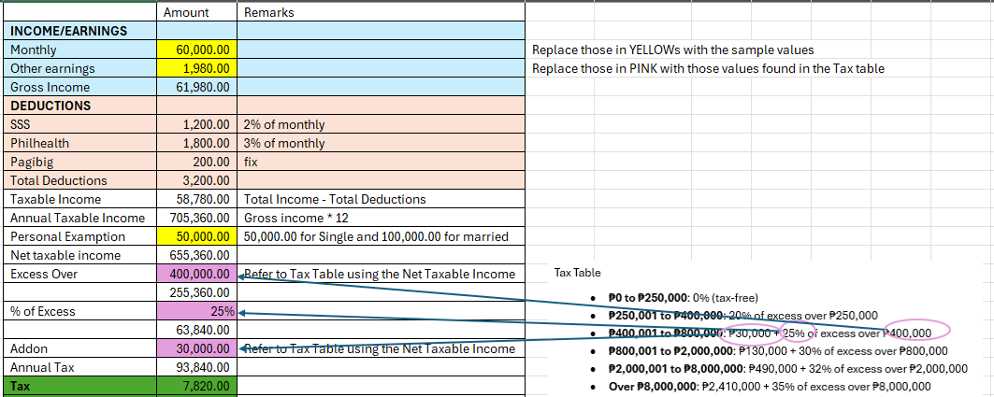
Your output will be similar to this. The user will only input the MONTHLY INCOME, OTHER INCOME, select Employee type if single or married. The SSS, Philhealth, Pagibig, Tax, and Takehome pay will be computed based on the given formula.
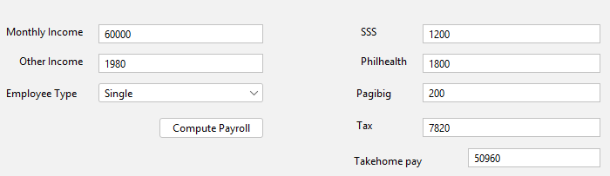

Grading
 | Weight | Excellent | Proficient | Developing | Beginning
 |  | 20 | 15 | 9 | 4
Problem solving | 30% | All calculations are correct  Proper formula application  Accurate results | Most calculations are correct  Minor computational errors  Generally accurate results | Some of the calculations are wrong  Inconsistent formula  Partially accurate | Frequent errors  Incorrect formula  Inaccurate results
JavaScript/ReactJS | 30% | Reads forms content, interprets it, and performs proper calculation | Either some forms can’t be read  or some formula not working | Many calculations not working | JS not working or very minimal
HTML | 20% | Proper form input is used to get user input  proper labeling  spacing  font size readable | Notable labeling not clear  Input types properly observed | Labels not clear  Input types not properly used  Use of basic HTML elements not properly observed | No output
CSS | 20% | Excellent color choice  Good typography is used  Consistent visual style  Professional appearance | Good color usage  Decent typography  Mostly consistent style  Clean appearance | Basic color application  Simple typography  Some style inconsistency  Acceptable appearance | Poor color choices  Bas typography  Inconsistent style  Unprofessional look

