**3.1 The Basic Reproductive Number**

Taking the expectation and plugging in $d=4$ then equating the desired expectation of 2 we get the relation:

$$P_{SI}=\frac{P_{IR}}{(1-P_{IR})}$$

**3.1.3**

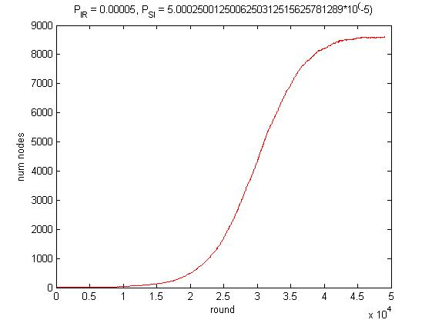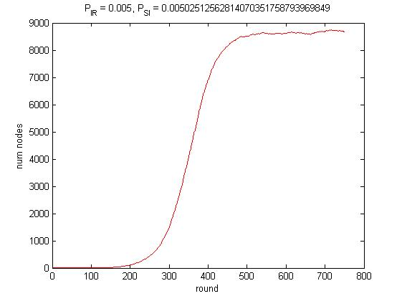Simulating the asked graphs under this relation will show us that epidemics may erupt

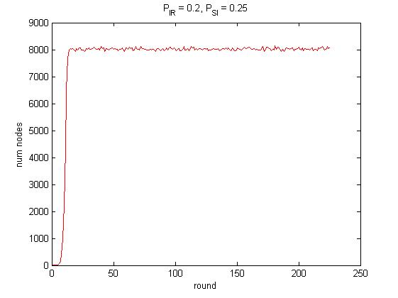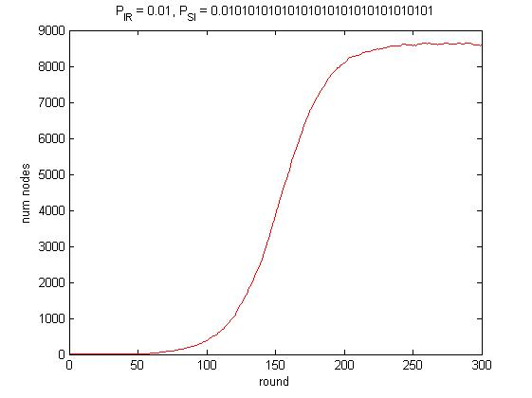

**3.1.4**

Taking the expectation and plugging in $d=4$ then equating the desired expectation of 0.5 we get the relation:

$$P_{SI}=\frac{P_{IR}}{7(1-P_{IR})}$$

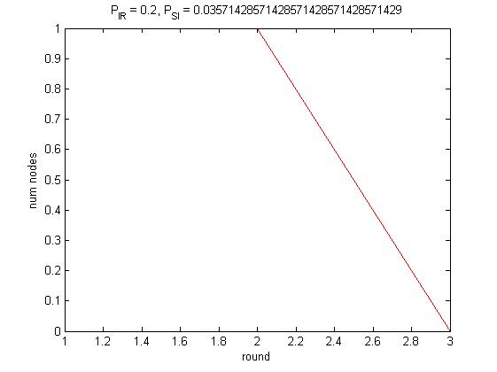Simulating the asked graphs under this relation will show us that in most of times epidemics will fade. Rarely we saw partial slow spread epidemic that had fluctuations between infected and susceptible like in the last figure.

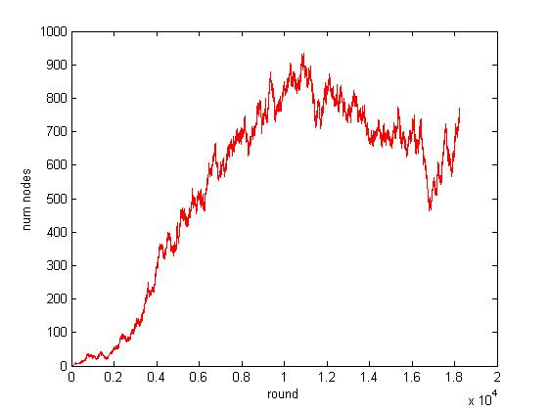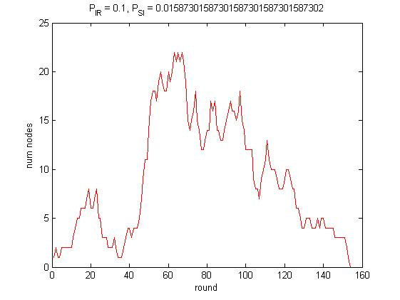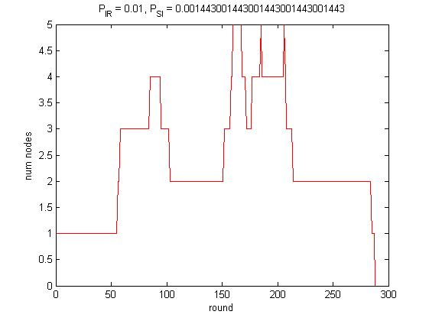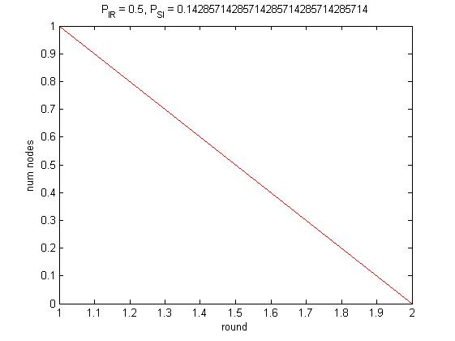

**3.2**  **Scale Free**

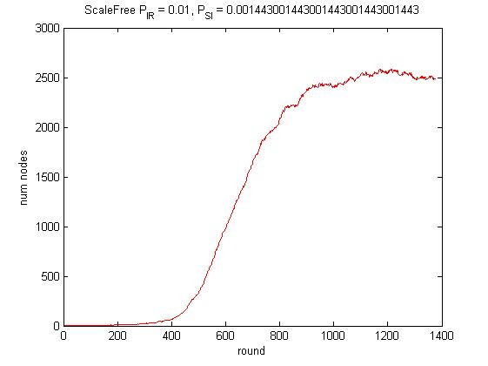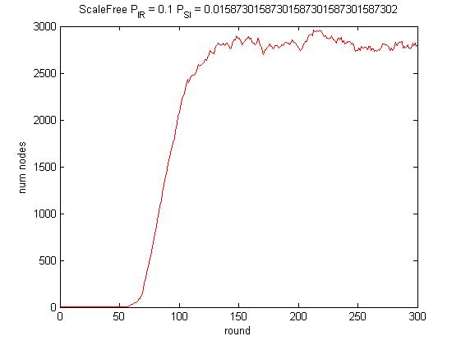Simulatingfree scale graphs with the same parameters as in uniform select showed us many times fast spread with a limit in the number of infested nodes.

**3.3.1 Small World**

For the next simulations $$P_{SI}=0.08, P_{IR}=0.15, P_{RS}=0.005$$

Simulating Small World graph with $N = 300, p_{rewire}=0$

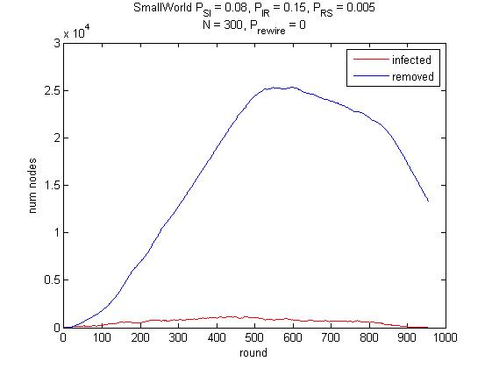

The epidemic spread fast but didn’t last too long because without rewiring, the epidemic didn't infested again in visited areas.

**3.3.2**

Simulating Small World graph with $N = 300, p_{rewire}=0.0002$

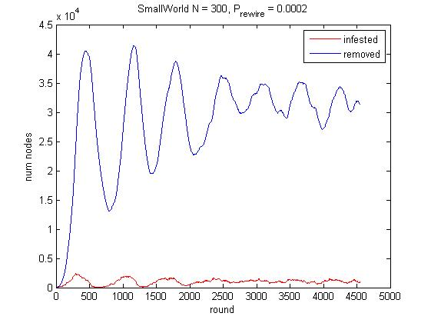

As we can see, now the epidemic last much longer than without rewiring and the number of infected individuals is fluctuating greatly. The reason is that without rewiring the epidemic is not infecting again where it already passes, while in this case the rewiring allows it to infect again visited areas using a long distance link.

**3.3.3**

Simulating Small World graph with $N = 300, p_{rewire}=0.01$

Now, the epidemic spread much faster using long distance links, that can be found in higher probability, but fades faster as well. The reason is that the graph is not wide enough, the epidemic spread very fast and the nodes are in remove state, so the epidemic still can't infest them again, so it's fades.