**Passenger_Data_Analysis_Report**

**Objective**

To explore, clean, analyze, and visualize the Titanic passenger dataset to extract meaningful insights, and present the findings in a clear, professional dashboard.

**Tasks Performed**

**Data Cleaning**

* Removed duplicate rows (0 found).

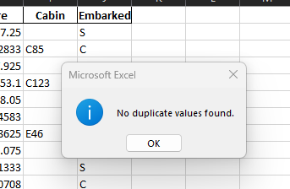

* Handled 16 missing values by filling them with 0.

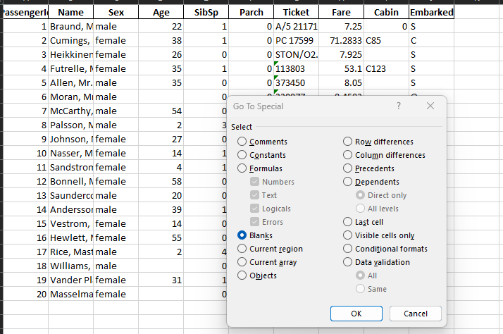

* Standardized inconsistent categories (e.g., gender labels).
* 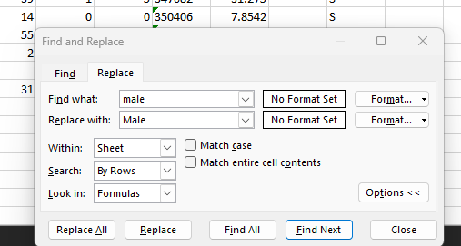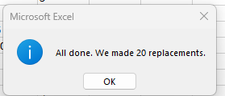
*  

**Data Analysis**

* Calculated highest, lowest, and average fares.
* 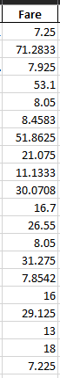 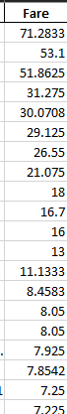
* LARGEST 
* SMALLEST 
* AVERAGE 
* Counted passengers by gender, embarked port, and class.
* 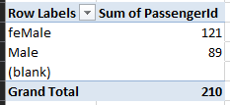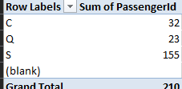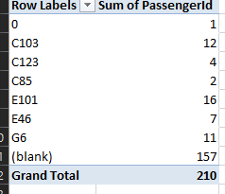
* Observed trends and anomalies in the data.

**Data Visualization**

* Created a **Bar Chart** to show passengers by embarkation port.

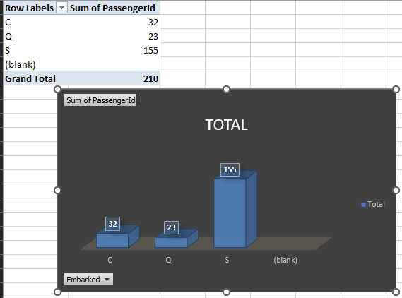

* Created a **Pie Chart** to show gender distribution.

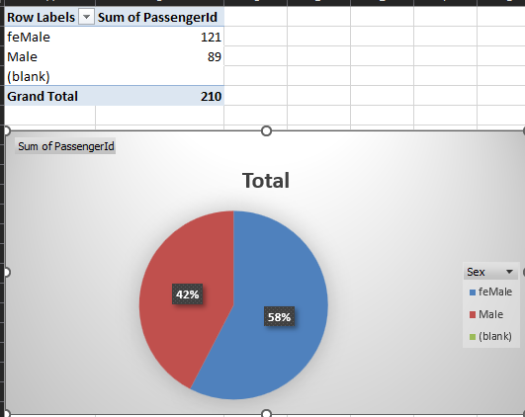

* Created a **Line Chart** to show fare trends across passengers.

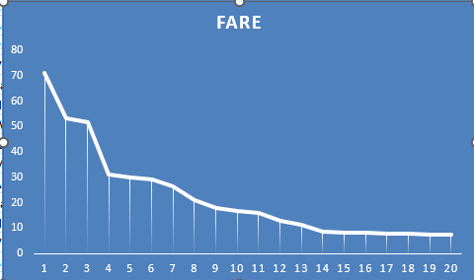

* Combined all charts into a professional dashboard.

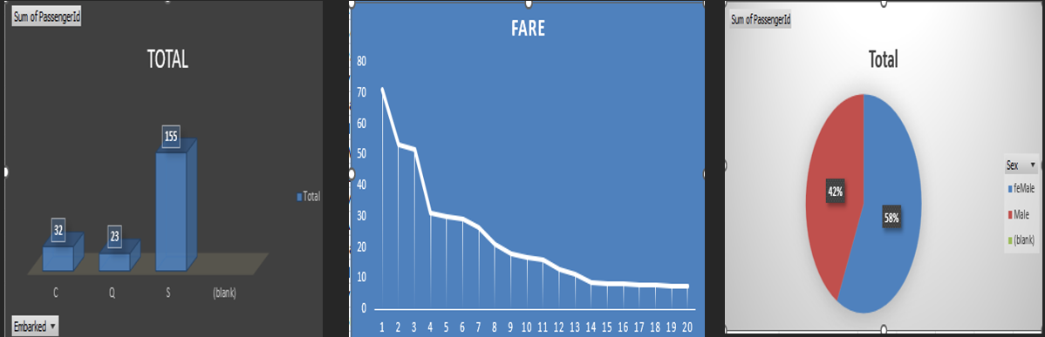

**Key Insights**

**Counted passengers by:**

* **Gender: Female (121), Male (89)**
* **Embarkation Port: S (155), C (32), Q (23)**

**Calculated Fare statistics:**

* **Largest Fare: 71.2833**
* **Smallest Fare: 7.225**
* **Average Fare: 22.19937**

**Visualizations**

**Dashboard**



**Bar Chart: Passengers by Embarkation Port**



**Pie Chart: Gender Distribution**

**Line Chart: Fare Trend**



**Skills Demonstrated**

**Step 1 — Data Exploration**

✔ Opened the Titanic dataset in Excel.  
✔ Understood the rows & columns (features like Name, Age, Fare, Embarked, etc.).  
✔ Identified numerical vs categorical columns.

**Step 2 — Data Cleaning**

✔ Checked for duplicate rows → found **0 duplicates**.  
✔ Found missing values → filled them (with 0 or appropriate values).  
✔ Standardized inconsistent categories (e.g., male, MALE → Male).

**Step 3 — Data Analysis**

✔ Counted passengers by:

* **Gender:** Female (121), Male (89)
* **Embarkation Port:** S (155), C (32), Q (23)  
  ✔ Calculated Fare statistics:
* **Largest Fare:** 71.2833
* **Smallest Fare:** 7.225
* **Average Fare:** 22.19937

**Step 4 — Data Visualization**

✔ Created key charts:

* **Bar Chart:** Passengers by Embarkation Port
* **Pie Chart:** Gender Distribution
* **Line Chart:** Fare trend across passengers  
  ✔ Combined the charts into a clean **Dashboard** in Excel.

**Step 5 — Reporting & Packaging**

✔ Drafted a professional project report template (Objective, Tasks, Insights, Visualizations, Skills).  
✔ Inserted your analysis results into the report.  
✔ Planned to add screenshots of charts & dashboard into the final PDF.  
✔ Learned how to save & name your files properly:

**Skills You Practiced**

* Data Cleaning
* Data Analysis (descriptive statistics & counts)
* Data Visualization (Bar, Pie, Line charts)
* Dashboard design
* Reporting & documentation
* Storytelling with data