Project Documentation Olist E-commerce Data Analysis

Olist is an E-commerce ecosystem from Brazil that helps businesses sell their products across multiple online marketplaces. It takes care of everything from getting orders to delivering products.

Introduction
This project is about exploring the Olist e-commerce data. This dataset contains orders, customers, products and reviews. The goal Is to analyse the data and uncover meaningful business insights.

Why I chose this data?
I chose this data because it reflects real world business operations like sales, customers, and delivery. It is also set up like a database with 9 csv files this make it perfect for uncovering meaningful insights.

Project Objectives
- Look at how sales are doing and how much money is being made
- Find the bestselling product categories
- See where sales are happening on map
- Look at what customers think and if they are happy
- Understand which category-based products are frequently brought by customers

Planned Approach
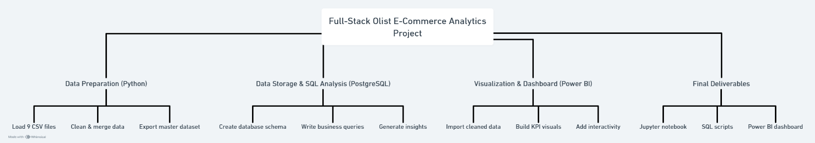
This project has a simple structured plan. First, we will use python to clean up the data so it is ready to use then we will merge the datasets together in to one master dataset. After that we will use PostgreSQL to store the clean data and write business queries to generate insights. Finally, we will use power BI to create interactive dashboards.

Tools used for this project
- Python
- PostgreSQL
- Power BI

Dataset Description
This dataset contains multiple tables including customers, orders, products, payments, reviews, sellers, and geolocation. It includes around 100,000 orders representing real e-commerce transactions.

Expected Outcomes
This project will result in a complete interactive dashboard and a set of business insights related to sales, customers, and delivery performance

