Reference

Reference : <https://www.freecodecamp.org/news/how-to-dockerize-a-flask-app/>

1, Venv in folder Sep2023

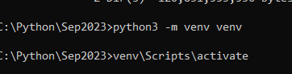

2. Docker file:



3. Docker image:



4. Run Image as ‘d’.



5. Postman

GET: <http://127.0.0.1:5000/books>

Docker hub:push

1. Login to docker hub

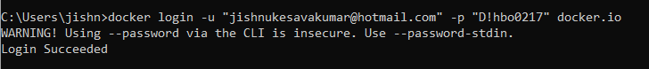

1. Create tag



1. Docker push

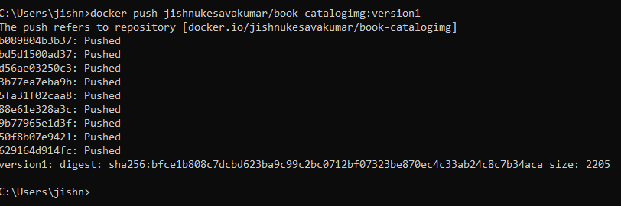

1. Docker hub

