Visualizations:

Confusion Matrix:
This confusion matrix shows how the model is predicting fraud and non fraud transactions. Most non fraud cases are predicted correctly which means the model learns normal behavior well. There are still some fraud cases predicted as non fraud which is risky, because fraud getting missed is more costly. Overall it gives a quick idea where the model is doing good and where it fails.

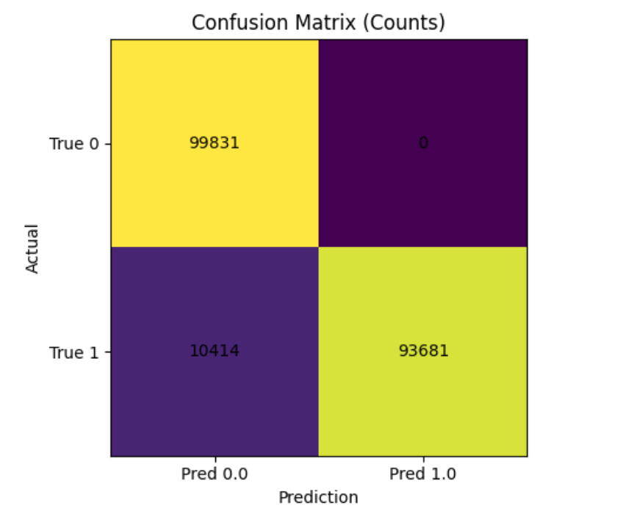
Individual Transaction Error Counts: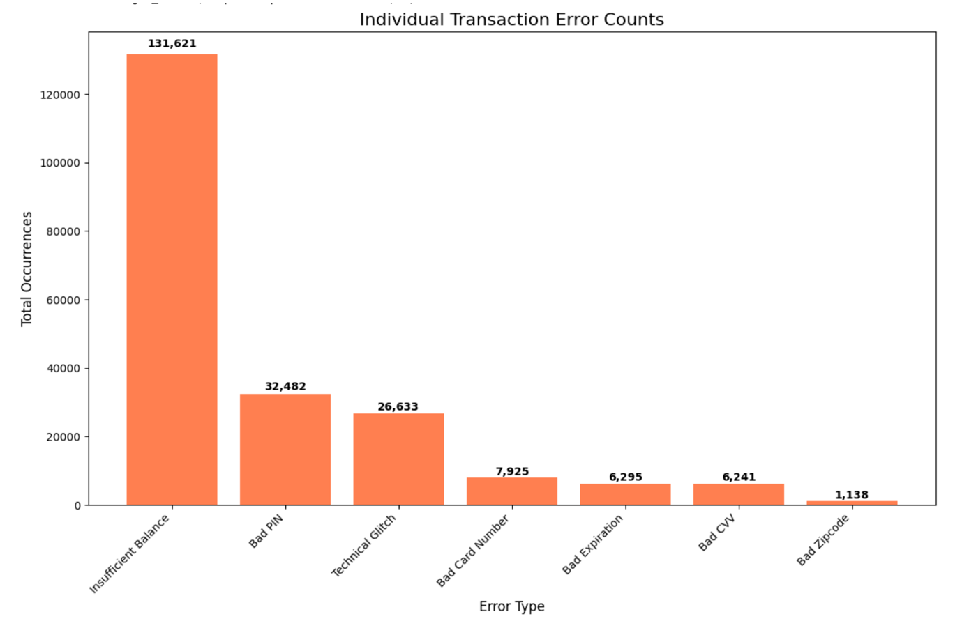
This graph shows how often different transaction errors happen. Insufficient balance happens the most, while errors like bad PIN and bad card number also appear often. Some of these errors can be linked to suspicious behavior like repeated wrong attempts. This helps in understanding which error features are more common in the data.
Transaction Errors by Age Group:
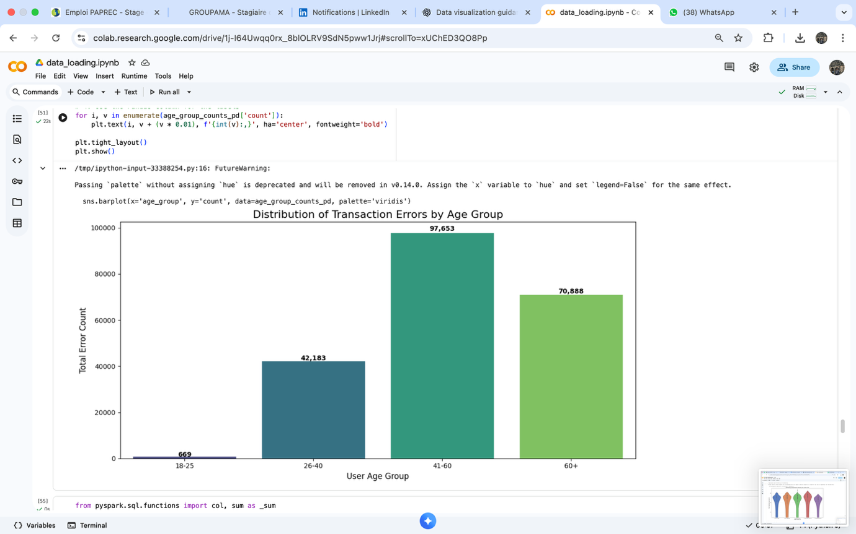
Here we see transaction errors across different age groups. Users between 41 and 60 have the highest number of errors, followed by users above 60. Younger users have very less errors. This may depend on usage frequency but still shows age related behavior differences.
Spending Distribution by Credit Tier:
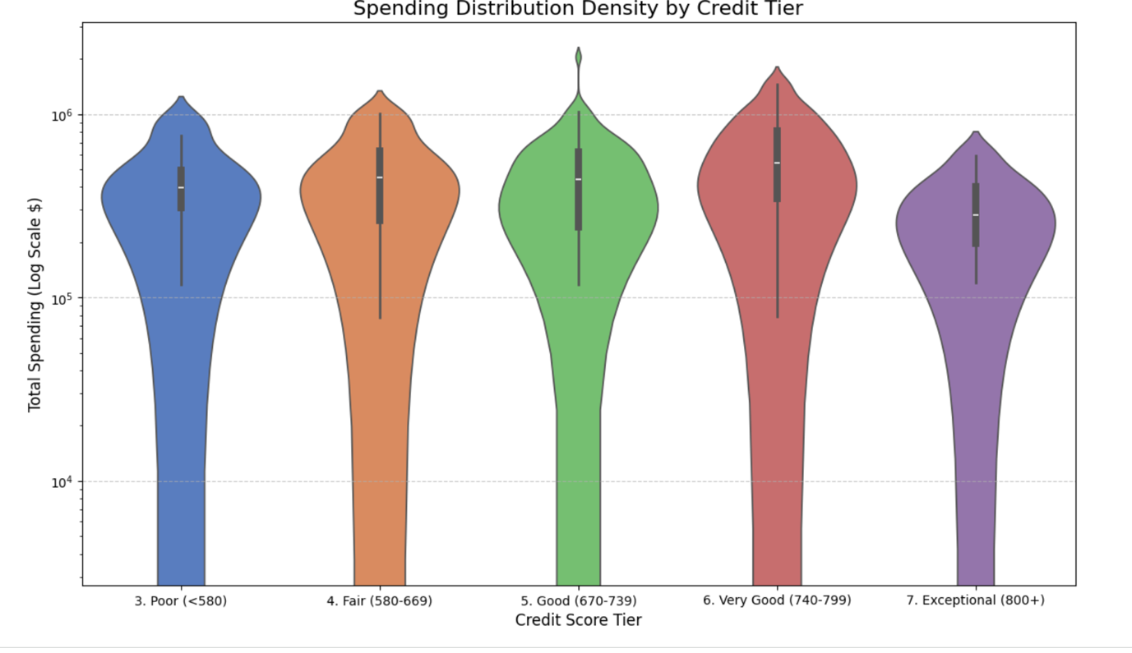

This plot shows how spending changes for different credit score tiers. Higher credit tiers usually spend more and have wider distribution. Lower tiers have smaller and more concentrated spending. This does not directly show fraud but helps understand user financial behavior.
High Velocity vs Fraud:
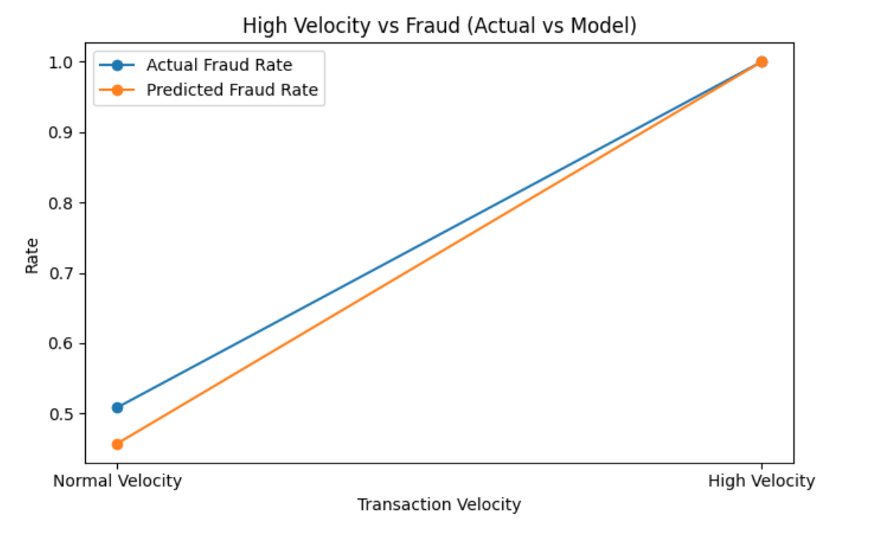
This plot compares fraud rate for normal and high velocity transactions. High velocity transactions clearly have higher fraud rate. The predicted fraud follows the actual trend closely, which means the model is capturing this pattern well. This confirms velocity is an important fraud indicator.
Fraud Rate by Hour of Day:
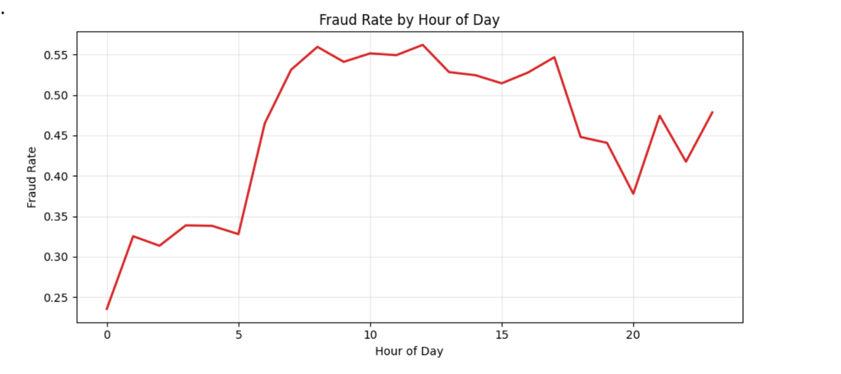
This graph shows how fraud rate changes during the day. Fraud is higher during morning and daytime hours and lower during night. This means fraud behavior depends on time and hour can be a useful feature in the model.
Transaction Amount Distribution by Class: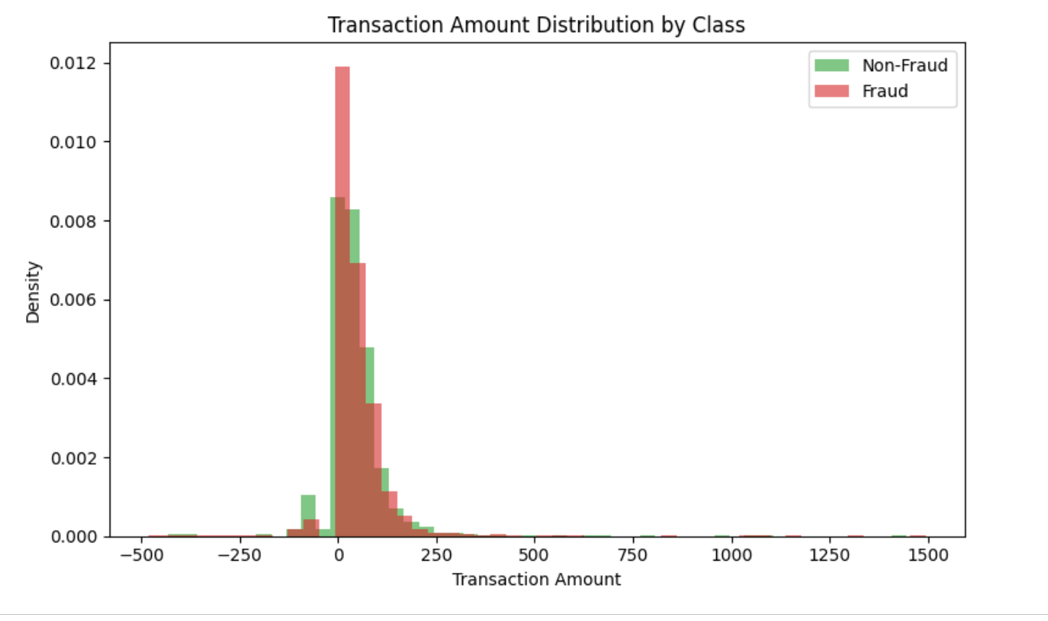

This graph compares transaction amounts for fraud and non fraud cases. Both overlap a lot at lower amounts, meaning small transactions can also be fraud. Fraud cases also have higher amount outliers. So amount alone is not enough to detect fraud but it helps with other features.

